AI-Based Wood Quality Assessment
Final project report: phases, mathematical model, full dataset and recoverability grading
Major Project, Dept. of CSBS, Dayananda Sagar College of Engineering, AY 2026-27 · Guide: Mrs. Aparna H D
Team 4: Gurugubelli Gayatri (1DS23CB014), Prakyat Pramod Shetty (1DS23CB033), Saiprasad Rao (1DS23CB041), Yasti Anil Kotak (1DS23CB063) · 15 October 2026

1. Summary
The project is complete. Everything proposed at the 50 % review has been implemented and measured on physical boards that were never used for training or for any choice of settings. The final review is on 24 October 2026.
At the 50 % review both detectors were stuck at 63-65 mAP50 over 8 defect classes, and the larger model did not help. The guide suggested a mathematical model to improve accuracy and shared the Board Recoverability Index (BRI).
Since then we built the mathematical model (class-balancing rule, weighted box fusion of detectors, Wise-IoU loss, per-class thresholds and statistical validation), trained the final models on the full public dataset (20,276 images from 407 boards instead of 4,000 from 81), and implemented, adapted and validated the guide's BRI. On the four main defect classes the final detector scores 76.9 mAP50 on the original 12 test boards (best single model at mid-term: 69.2) and 81.3 on 51 further unseen boards.
Item | Result (test boards never used for any choice)
Detection, 8 classes (50 % review) | YOLO11s 64.6 mAP50, YOLO11m 63.0 mAP50
Best single model, 4 main classes (4,000 images) | 69.2 mAP50, 33.3 mAP50-95
Mathematical model: fusion of four 4-class models | 74.7 mAP50, 36.7 mAP50-95; gain +2.7 to +7.1 (95 % CI), Wilcoxon p = 0.042
Final detector: fusion of two models trained on the full dataset | 76.9 / 39.3 on the 12 original test boards; 81.3 / 44.1 on 51 new test boards
Gain of the final detector on the same 12 boards | +2.2 mAP50 (95 % CI +0.5 to +4.3), with 2 models instead of 4
Grading (BRI) vs grades from the annotations | weighted kappa 0.87; exact 78.3 %, within one grade 97.4 %; 10 of 12 boards exact
Application | Web app on a laptop CPU (about 0.5 s per image): defects, heatmap, grade A / B / C / Reject, recoverable area, value estimate

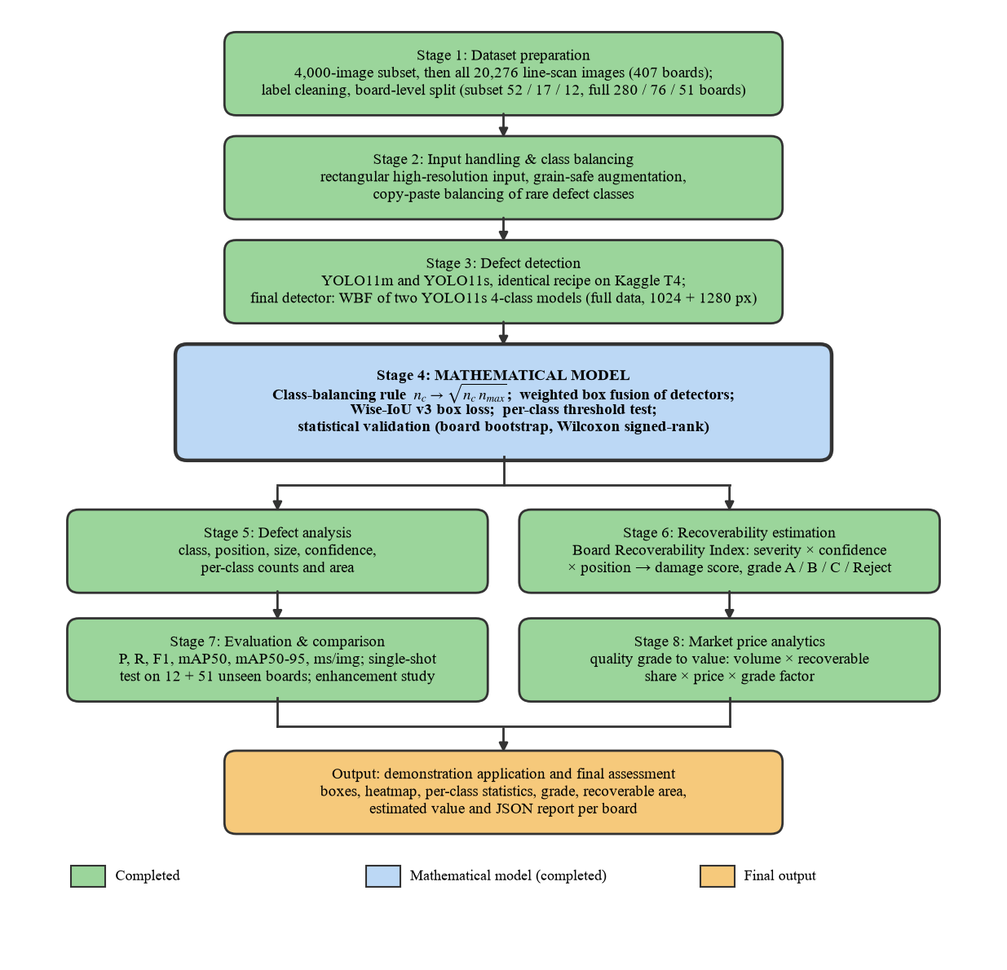
Fig. 1. Methodology as completed.

2. Phase 0: the starting point and the leakage problem
The team's first model was YOLO11s trained on square 640-px images for 83 epochs on a laptop CPU. It reported 62.2 mAP50 on its test set (validation 66.3). Before building on it we checked the pipeline and found three problems:
1. Board leakage. The data was split image by image. Each physical board is cut into about 49 images, so every one of the 81 boards appeared in training, validation and test. A model can then score well by remembering a board's grain and colour; the score measured memory of boards, not how the model would do on a new board.
2. Wrong class names. The class names in the configuration (Crack, Knot, Hole, Stain, Split, Warp, Decay, Scratch) were not the dataset's classes. The real classes are Quartzity, Live_Knot, Marrow, Resin, Dead_Knot, Knot_with_crack, Knot_missing and Crack (checked against the dataset's own label files).
3. Square input. The images are 2800 x 1024 strips. Squeezing them into a 640 x 640 square wasted 63 % of the input on padding and shrank hairline cracks to below one pixel.
Check | Earlier pipeline | Rebuilt pipeline
Boards shared between train / val / test | 100 % of boards in all three | 0 (asserted by the script)
Class names | 8 invented names | dataset's real names
Input | 640 x 640, 63 % padding | 1024 x 384 rectangular, no padding
Zero-size labels | 158 kept | removed
Augmentation | rotation 10°, vertical flip, heavy erasing | grain-safe: no rotation, no vertical flip

So the 62.2 was not a usable baseline. The honest numbers after the fix are lower at first sight (Section 3) but they predict performance on new boards, which is what a sawmill needs. Every later result in this report uses board-level splits.

3. Phase 1: up to the 50 % review (16 September)

3.1 What we did
- Dataset. 4,000 line-scan images of sawn timber (Kodytek, Bodzas and Bilik, F1000Research 2022), 8 classes, 9,053 boxes.
- Leakage-free split. Split by physical board: 52 boards for training, 17 for validation, 12 for test, zero overlap.
- Input. Rectangular 1024-px input, augmentation that respects the grain direction.
- Models. YOLO11m (20.0 M parameters) and YOLO11s (9.4 M), fine-tuned from COCO with one identical recipe on a Kaggle Tesla T4 GPU. Each model was evaluated on the test boards exactly once.
- Demo. A web application showing boxes, a heatmap, per-class statistics and a JSON report.

3.2 Results and the accuracy problem
Model (8 classes) | Precision | Recall | F1 | mAP50 | mAP50-95 | ms / image (T4)
YOLO11m | 63.4 | 66.2 | 64.7 | 63.0 | 34.0 | 33.2
YOLO11s | 71.0 | 64.1 | 67.4 | 64.6 | 33.4 | 11.7

Class | Test boxes | YOLO11m mAP50 | YOLO11s mAP50
Dead_Knot | 343 | 86.8 | 89.1
Marrow | 46 | 85.8 | 87.7
Live_Knot | 406 | 74.8 | 75.8
Knot_missing | 24 | 62.7 | 69.6
Knot_with_crack | 30 | 61.7 | 67.5
Resin | 69 | 59.5 | 60.4
Crack | 95 | 57.7 | 53.0
Quartzity | 10 | 15.4 | 13.4

The two models were tied, so a bigger network was not the answer. The score was held down by the data: Quartzity (125 training boxes) was not learned (13-15 mAP50), Crack is thin and faint (53-58), and the rare knot types were confused with each other. The training set is 37:1 imbalanced (2,899 Live_Knot boxes against 78 Knot_missing). This is the accuracy issue that led the guide to suggest a mathematical model.

4. Phase 2: from 50 % to completion (17 September - 8 October)
Every item promised at the 50 % review was implemented. Each choice was made on validation boards and each candidate final model was tested once, so the test numbers are not tuned to the test set.
Promised at 50 % | What we did | Outcome
More samples for rare classes | Kept the 4 most frequent classes; copy-paste balancing of real defect crops; later the full dataset | Balancing alone: not significant; full dataset: significant gain (Section 6)
Higher-resolution input | Trained at 1280 px (1280 x 480) as well as 1024 px | Alone not better; useful inside fusion
Mathematical model: fusion, Wise-IoU, thresholds, statistics | Implemented all four (Section 5) | Fusion adopted: significant gain
CWB-style architecture | Wise-IoU (the CWB loss) implemented and tested | Not better; CondConv / BiFormer left as future work
Image enhancement (CLAHE, denoising) | Study under 6 imaging conditions on validation | No gain on normal images (Section 4.3)
Recoverability grading rule | Guide's BRI implemented, adapted and validated (Section 7) | Weighted kappa 0.87
Market-price analytics | Grade-to-value estimate in the application | Done (inputs editable)
Multi-seed runs | Final setup repeated with 3 seeds | Spread 0.8 mAP50
Final evaluation and application | Single-shot tests; app with grading and value | Done; final deck V4.1 prepared

4.1 Why four classes
The final system detects the four defect classes with the most data: Live_Knot, Dead_Knot, Resin and Crack. Crack, the most severe defect, is kept. The other four classes have too few examples (78-125 training boxes in the subset) to learn or to measure reliably on 12 test boards. On these four classes the 8-class YOLO11s scores 69.6 mAP50 on test; that, not 64.6, is the fair starting point for every 4-class comparison.

4.2 All runs on the 4,000-image subset
Model (YOLO11s unless stated) | Val mAP50 | Test mAP50 | Test mAP50-95
8-class YOLO11s, scored on the 4 classes | 73.8 | 69.6 | 32.9
4 classes, no balancing, 1024 px | 73.1 | 71.7 | 33.4
4 classes, full balance 1:1 | 71.9 | not tested | -
4 classes, partial balance 3:1, 1024 px (best single) | 75.3 | 69.2 | 33.1
4 classes, partial balance, 1280 px | 74.6 | 71.6 | 34.3
4 classes, no balancing, 1280 px | 71.5 | 67.5 | 30.7
Wise-IoU loss, final setup | 74.6 | not tested | -
Seeds 42 / 1 / 2, final setup | 75.3 / 74.8 / 75.6 | - | -
Fusion of the four 4-class models | 78.1 | 74.7 | 36.7

Models without a test number were rejected on validation by rules written down before training; testing them anyway would have meant choosing on the test set.

4.3 Image-enhancement study (synopsis hypothesis H1)
Condition (validation mAP50) | Raw | CLAHE | Denoise | Sharpen
Normal | 74.8 | 65.8 | 75.3 | 73.8
Low light | 50.0 | 27.7 | 48.0 | 49.3
Over-exposed | 58.2 | 47.9 | 58.2 | 57.7
Blur | 73.3 | 62.2 | 72.9 | 75.1
Noise | 67.8 | 56.5 | 73.0 | 57.0
Low contrast | 61.3 | 62.6 | 61.6 | 62.6

CLAHE lowered accuracy significantly in 5 of 6 conditions; denoising helped only on noisy images (+3 to +7 points). Hypothesis H1 is therefore rejected for normal images. Lighting matters far more than enhancement: low light costs about 25 points, so controlled lighting is the main requirement for deployment.

5. The mathematical model for accuracy
This section answers the guide's question: can a mathematical model improve accuracy, and by how much? Yes: on the same data, weighted box fusion adds about 5.5 mAP50 points on the main defect classes, with a 95 % confidence interval that excludes zero.

5.1 Components
1. Class-balancing rule. Rare classes get more training examples by pasting real defect crops onto defect-free training boards (inside the wood, along the grain, training split only). The target count per class is the repeat-factor rule of LVIS (Gupta et al., 2019), related to the effective number of samples (Cui et al., 2019):
n_c* = √(n_c × n_max) (partial balance; full balance: n_c* = n_max)
It turns the 9.5 : 1 imbalance of the four classes into 3.1 : 1 (partial) or 1.06 : 1 (full).
2. Weighted box fusion (Solovyev et al., 2021). Several detectors look at the same board; overlapping boxes of the same class are merged into one box, averaged by confidence, and a box that only one model sees is down-weighted:
b_f = Σ w_m c_i b_i / Σ w_m c_i c_f = (Σ w_m c_i / Σ w_m) × min(Σ w_m, W) / W
b = box, c = confidence, w_m = weight of model m, W = sum of all model weights. The overlap threshold and the weights are chosen on validation from a fixed grid (IoU 0.45 / 0.55 / 0.65; equal weights or one model doubled).
3. Wise-IoU v3 box loss (Tong et al., 2023). The loss used by the CWB-YOLOv8 reference model, which focuses training on ordinary-quality boxes:
L = r × exp(d² / (W_g² + H_g²)) × (1 − IoU), r = β / (δ α^(β − δ))
4. Per-class confidence thresholds. One threshold per class, chosen to maximise F1 on validation.
5. Statistical validation. Board-level bootstrap (the test boards resampled 1,000 times) for a 95 % confidence interval of every improvement, and an exact Wilcoxon signed-rank test on per-board differences. Resampling boards rather than images respects the fact that images of one board are not independent.

5.2 Effect on the score (4,000-image subset)
Step (test, 4 classes) | mAP50 | mAP50-95 | Verdict
8-class YOLO11s (50 % review), on the 4 classes | 69.6 | 32.9 | starting point
4-class model, no balancing | 71.7 | 33.4 | not significant
+ partial class balancing (best single on validation) | 69.2 | 33.3 | not significant
+ 1280-px model | 71.6 | 34.3 | not chosen on validation
Weighted box fusion of the four 4-class models | 74.7 | 36.7 | significant gain

Fusion vs best single model (test) | Difference | 95 % interval | Boards better / worse | Wilcoxon p
4 classes, mAP50 | +5.5 | +2.7 to +7.1 | 10 / 2 | 0.042
4 classes, mAP50-95 | +3.4 | +1.8 to +4.7 | - | -
8 classes (YOLO11m + YOLO11s), mAP50 | +1.1 | -0.5 to +2.7 | 7 / 5 | 0.52
8 classes, mAP50-95 | +2.4 | +1.6 to +3.2 | - | -

Fusion helped every class, most of all Crack (+11.5) and Resin (+5.5), the two thinner and rarer defects. It works because the members make different mistakes (different input sizes and class balance); averaging cancels some errors and places boxes more precisely.

5.3 What did not help (also a finding)
- Class balancing alone helped on validation (+2.2) but not on test; full balance was worst, because only 160 cracks could be cut out cleanly and each was pasted up to 17 times.
- 1280-px input alone was not better on validation.
- Wise-IoU scored 74.6 vs 75.3 on validation, within the seed spread of 0.8: not adopted.
- Per-class thresholds lowered macro-F1 on test (71.2 vs 73.6 with one global threshold): they over-fit the few validation boxes.

6. Phase 3: the full dataset (14-15 October)
Section 5 showed that the limit was data, not the network. The public dataset our 4,000 images come from has 20,276 images from 407 boards (Kodytek et al., 2022), with 4-7 times more examples of the rare classes. We retrained the two strongest fusion members on all of it.

6.1 Data and split
 | 4,000-image subset | Full dataset
Images / boards | 4,000 / 81 | 20,276 / 407
Boards train / val / test | 52 / 17 / 12 | 280 / 76 / 51
4-class training boxes after partial balance | 7,502 | 36,165
Crack training boxes after partial balance | 942 | 4,612
Training time per model (one T4) | 1.6 h (1024 px), 2.1 h (1280 px) | 3.2 h (1024 px), 4.3 h (1280 px)

- Split. our 81 boards keep their split, so the original 12 test boards stay untouched; the 326 new boards are split 70 / 18 / 12 by board (seed 42).
- Data check. the full images come from a Kaggle copy of the published dataset. Before use we checked it: the same 43,974 boxes as the original release, and on our 4,000 images 3,953 label files identical and the rest within 1 pixel. Our 4,000 images keep their original files and labels, so the comparison with Section 5 is exact (checked by the notebook before training).
- Models. YOLO11s, 4 classes, partial balance, at 1024 and 1280 px; 40 epochs, patience 15, batch 32, lr0 0.001; a free CPU test of the whole pipeline ran before any GPU time was used.
- Decision rule. written down before training: the new system replaces the previous one only if its mAP50 on the original 714 validation images exceeds 78.1.

6.2 Results
mAP50 / mAP50-95 | Val, 714 original images | Test, 469 original images (12 boards) | Test, full split (2,488 images, 51 boards)
Fusion of four models, subset (previous) | 78.1 / 39.2 | 74.7 / 36.7 | -
YOLO11s full data, 1024 px | 79.1 / 39.9 | 75.7 / 37.9 | 80.5 / 42.8
YOLO11s full data, 1280 px | 79.9 / 40.5 | 76.1 / 38.8 | 80.1 / 43.0
Final detector: fusion of the two | 80.2 / 41.7 | 76.9 / 39.3 | 81.3 / 44.1

The rule was met (80.2 > 78.1), so the full-data fusion is the final detector. Fusion settings, chosen on the full validation split: IoU 0.65, equal weights.
Class (test AP50) | Best single, subset | Fusion, subset | Final, 12 original boards | Final, 51 new boards
Live_Knot | 76.4 | 78.6 | 79.3 | 87.1
Dead_Knot | 87.5 | 90.3 | 89.6 | 87.5
Resin | 64.2 | 69.7 | 76.6 | 83.3
Crack | 48.7 | 60.2 | 62.2 | 67.4

Final detector minus subset fusion (12 original test boards) | Value
mAP50 difference | +2.2
95 % interval (board bootstrap), mAP50 | +0.5 to +4.3
95 % interval, mAP50-95 | +0.5 to +5.2
Boards better / worse | 8 / 4
Wilcoxon p (12 boards) | 0.30

The gain is smaller than the gain from fusion but its interval excludes zero; with only 12 boards the Wilcoxon test cannot confirm it, which is why the 51-board test split matters: there the final detector reaches 81.3 mAP50, and Crack, the hardest class, 67.4. The final system also needs two models instead of four, so it is about twice as fast.
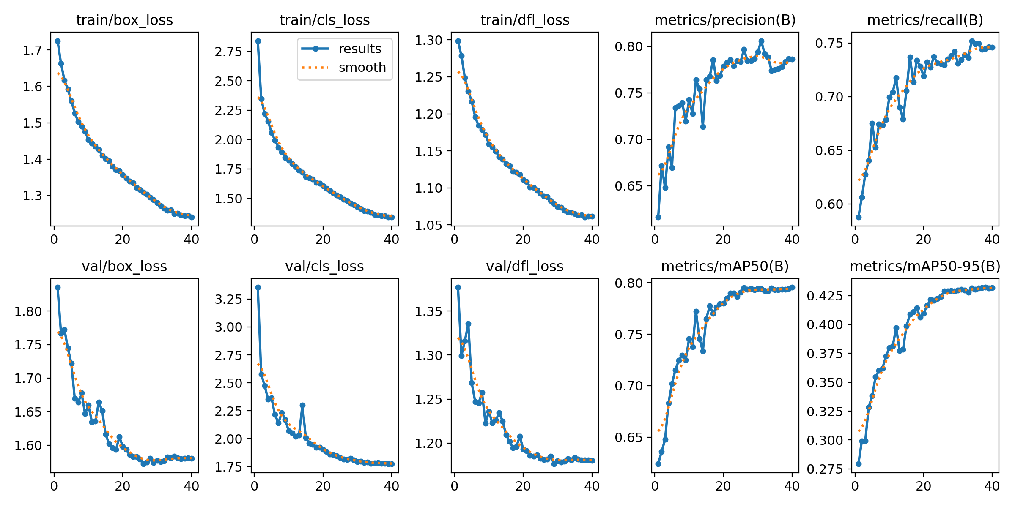
Fig. 2. Training and validation curves, full dataset, 1024 px.

6.3 What went wrong and how it was handled
The first attempt converted the original 140 GB release on a Kaggle CPU session; it hit the 12-hour session limit before finishing and the chained GPU run started without its input, so it was stopped and discarded (no result from it was used). The second attempt used the verified Kaggle copy, a CPU smoke test of the whole pipeline, and a time guard that ends training safely before the session limit. Both runs finished in about 3.5 and 4.6 hours.

7. The guide's Board Recoverability Index (BRI) and our changes
The guide's document proposed the BRI: it turns the detected defects into a damage score, a recoverable area and a grade A / B / C / Reject. It does not change detection accuracy; it is the quality-assessment part of the project. We implemented all six steps as given, and our code reproduces the document's worked example exactly (damage score 0.020860, grade B).
s_i = w_c × conf_i × p_i, p_i = 1 − exp(−d_i / λ), DIS = Σ max_i s_i / A_board, A_rec = A_board (1 − DIS)
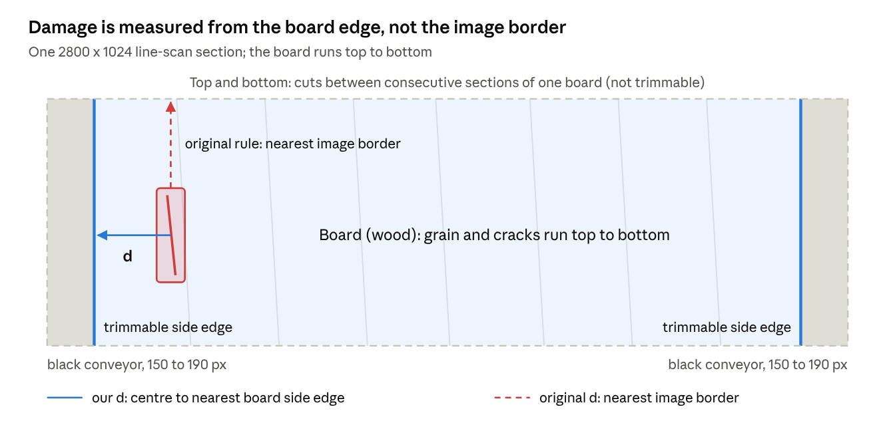
Fig. 3. Our images are sections of a board with black conveyor on both sides; the trimmable edges are the board's sides.
Part of BRI | Guide's version | Our change and why
Distance d_i | to the nearest image border | to the nearest side edge of the board (board mask): image borders include ~160 px of conveyor, and the top and bottom are cuts between sections, not edges a sawmill can trim
Board area | image width x height | wood pixels only: the conveyor is ~12 % of each image
Grade thresholds | 0.01 / 0.03 / 0.06 (illustrative) | fitted on validation boards: the defaults grade 72 % of our boards A; the detector gets its own thresholds (guide's calibrate_thresholds) because model confidences are below 1
Severity weights | 8-class placeholder table | same values for the 4 classes: Crack 1.00, Dead_Knot 0.60, Live_Knot 0.40, Resin 0.30 (awaiting the guide's ranking)

Validation (no expert grades yet): the reference grade is BRI computed on the annotators' boxes; the model grade is BRI on the detector's boxes; all thresholds are fitted on validation boards and agreement is measured on the 12 test boards.
Agreement with the annotation-based grade | Final detector, per image | Final detector, per board | Subset fusion, per image | Best single, per image
Exact grade | 78.3 % | 83.3 % | 78.3 % | 79.7 %
Within one grade | 97.4 % | 100.0 % | 96.2 % | 97.4 %
Quadratic weighted kappa | 0.87 | 0.73 | 0.83 | 0.86
Mean abs. error, recoverable area | 0.40 pts | 0.36 pts | 0.47 pts | 0.41 pts

Reference \ final detector (469 test images) | A | B | C | Reject
A (175 images) | 155 | 17 | 2 | 1
B (113 images) | 17 | 74 | 20 | 2
C (109 images) | 4 | 7 | 76 | 22
Reject (72 images) | 3 | 0 | 7 | 62

Most disagreements are one grade apart; a two-grade error happens for about 2-3 % of images. The grading feeds a value estimate in the application: value = board volume x recoverable share x grade-A price x grade factor (all inputs editable).
Points for the guide: (1) approve the changes above; (2) rank the four defect classes by severity, to replace the placeholder weights; (3) if possible, blind expert grading of 30-50 board images to calibrate the weights and thresholds and report kappa against an expert, as proposed in Section 5 of the BRI document.

8. System and application
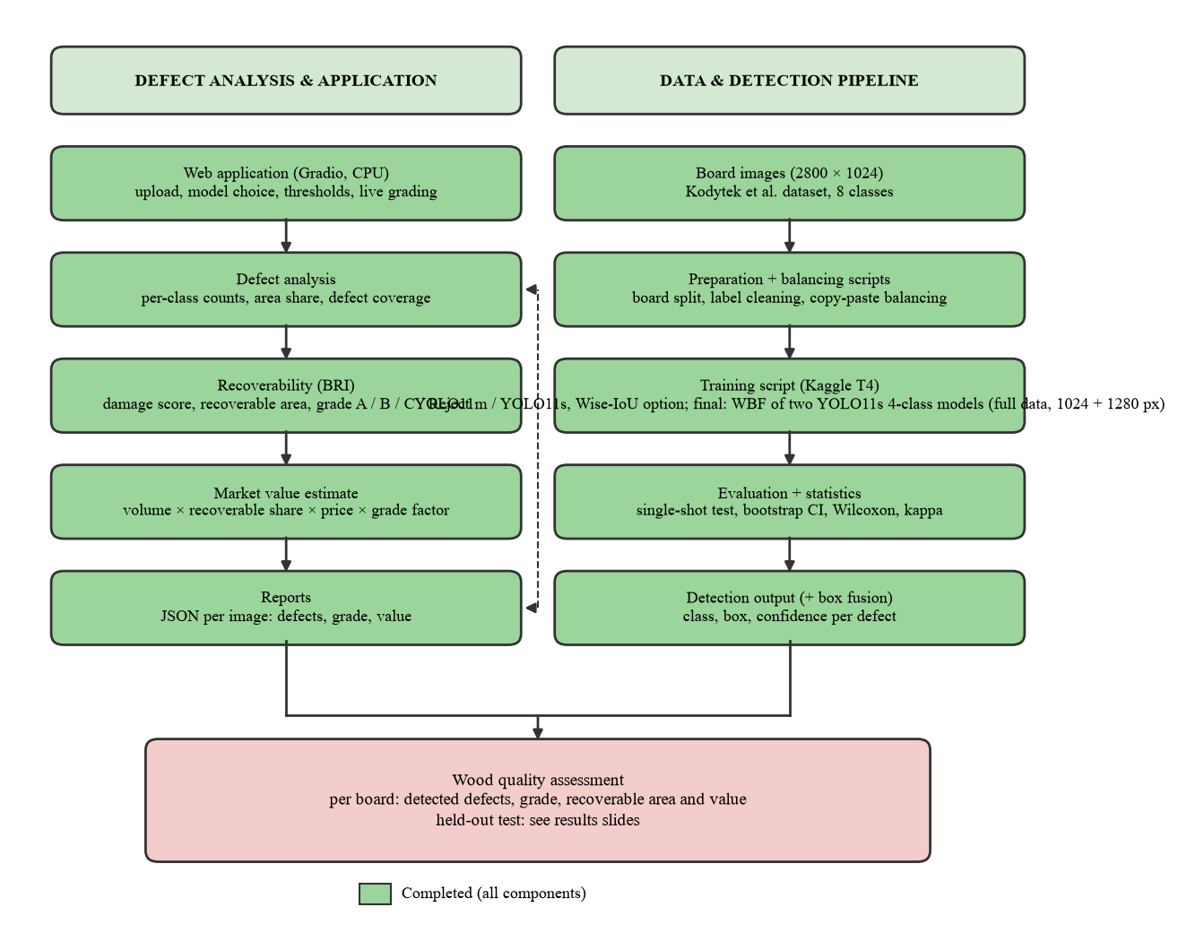
Fig. 4. System design as implemented.
- Detect: upload a board image; the final detector (two fused models) draws colour-coded boxes; heatmap, per-class counts and area.
- Grade: BRI grade A / B / C / Reject, damage score, recoverable area, and an editable market-value estimate.
- Compare: for the 12 test boards, the annotators' boxes and grade are shown next to the model's.
- Deployment: runs on a laptop CPU, about 0.5 s per 2800 x 1024 image for the final detector (0.8 s for the earlier four-model fusion); JSON report per image. Earlier models remain selectable for comparison.
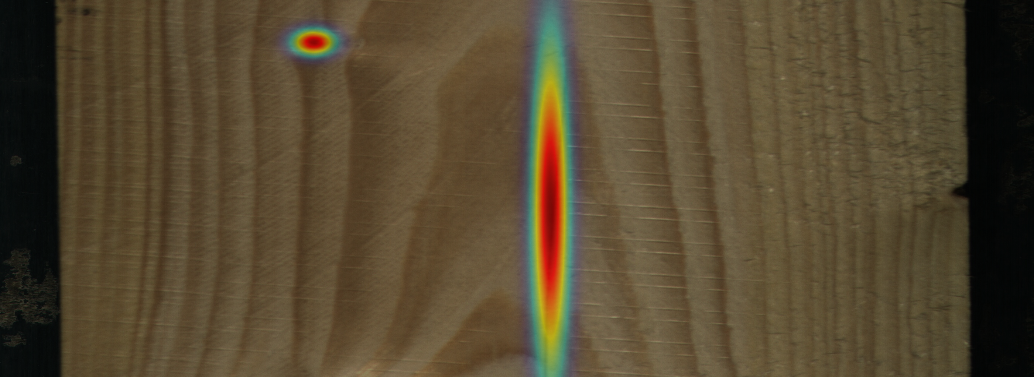
Fig. 5. Application: damage heatmap of a test board (BRI influence map).

9. Conclusions, limitations and future work
1. A leakage-free, board-level evaluation of YOLO11 on industrial line-scan timber images; the earlier 62.2 was inflated by board leakage, and model size (YOLO11m vs YOLO11s) is not the bottleneck.
2. A mathematical model (class-balancing rule + weighted box fusion + board-level statistics) that raises mAP50 from 69.2 to 74.7 on the same data, with a significant board-level interval.
3. More data, with the same recipe: the final detector reaches 76.9 on the original test boards and 81.3 / 44.1 (mAP50 / mAP50-95) on 51 new boards.
4. The guide's Board Recoverability Index, adapted to line-scan geometry and validated (weighted kappa 0.87).
5. Negative results reported with intervals: CLAHE enhancement, Wise-IoU, per-class thresholds and higher resolution alone did not help.
Limitations: the original test set has 12 boards (now complemented by 51); severity weights and grade thresholds await expert calibration; the four rare classes are out of scope; trained on controlled line-scan imagery, so field cameras need new data.
Future work: expert grading to calibrate BRI; k-fold validation over boards; the rare classes with the full dataset; segmentation masks for tighter defect area; the full CWB architecture (CondConv / BiFormer); plywood.

10. Deliverables
Deliverable | Where
Final presentation V4.1 (34 slides), review 24 October 2026, 9 AM | Major_Project_Final_Presentation_V4.1.pptx
This report | Final_Project_Report_2026-10-15.docx
Web application (final detector, grading, value) | app.py in the GitHub repository
Code, results and decision log (every run and deviation) | GitHub repository: scripts, eval/, runs_log/, NOTES.md
Training notebooks (Kaggle T4) | kaggle_upload/ in the repository

References
[1] P. Kodytek, A. Bodzas, P. Bilik, A large-scale image dataset of wood surface defects for automated vision-based quality control processes, F1000Research 10:581, 2022, doi:10.12688/f1000research.52903.2.
[2] G. Jocher, J. Qiu, Ultralytics YOLO11, 2024, github.com/ultralytics/ultralytics.
[3] R. Solovyev, W. Wang, T. Gabruseva, Weighted boxes fusion: ensembling boxes from different object detection models, Image and Vision Computing 107, 104117, 2021.
[4] A. Gupta, P. Dollár, R. Girshick, LVIS: a dataset for large vocabulary instance segmentation, CVPR 2019.
[5] Y. Cui, M. Jia, T.-Y. Lin, Y. Song, S. Belongie, Class-balanced loss based on effective number of samples, CVPR 2019.
[6] D. Dwibedi, I. Misra, M. Hebert, Cut, paste and learn: surprisingly easy synthesis for instance detection, ICCV 2017.
[7] Z. Tong, Y. Chen, Z. Xu, R. Yu, Wise-IoU: bounding box regression loss with dynamic focusing mechanism, arXiv:2301.10051, 2023.
[8] J. Cohen, Weighted kappa, Psychological Bulletin 70(4), 1968.
[9] B. Efron, R. J. Tibshirani, An Introduction to the Bootstrap, Chapman & Hall, 1993.
[10] F. Wilcoxon, Individual comparisons by ranking methods, Biometrics Bulletin 1(6), 1945.
[11] K. Zuiderveld, Contrast limited adaptive histogram equalization, Graphics Gems IV, 1994.

