BRI Model: Our Reading, Implementation and Changes
Oct 7, 2026 · Team 4
Prepared for Mrs. Aparna H D, project guide, AI-Based Wood Quality Assessment (Dept. of CSBS, DSCE). Team: Gurugubelli Gayatri, Prakyat Pramod Shetty, Saiprasad Rao, Yasti Anil Kotak.

1. Summary
We have studied the Board Recoverability Index (BRI) and implemented all six steps as given. Our code reproduces your worked example exactly: damage score 0.020860, grade B.
Applying BRI to our dataset showed four points that need adapting. Most come from the images themselves: each is a line-scan section of a board, with black conveyor on both sides. We have made these changes and kept your original rule as an option for comparison. Until expert grades exist, we validate BRI the way your Section 5 describes, with the annotators' boxes standing in for the expert.
- BRI is the quality-assessment part of our project. It turns detections into a damage score, a recoverable area and a grade (A, B, C or Reject).
- BRI does not change detection accuracy (mAP). Accuracy work follows your suggestions on class imbalance and validation separately (Section 7).
- We need your input on four items: the severity ranking, an expert for blind grading, approval of our changes and the market-value factors (Section 8).

2. The model as implemented
All six steps run in one function of our code (bri.py), in the order of your document. Before changing anything, we checked the code against your worked example.
Step | Your formula | Status in our code
1. Merge overlapping defects | A_def = |R1 ∪ R2 ∪ … ∪ Rn| | As given: mask union, connected patches
2. Severity weight | w_c in (0, 1] per class | As given: your placeholder table
3. Position penalty | p_i = 1 − exp(−d_i / λ), λ = 250 px | Formula as given; how d_i is measured changed (Section 4)
4. Influence of one defect | s_i = w_c × conf_i × p_i | As given
5. Impact map and damage score | I(x, y) = max_i s_i; DIS = ΣI / A_board; A_rec = A_board × (1 − DIS) | Max rule as given; A_board changed (Section 4)
6. Grade | A / B / C / Reject from τ1, τ2, τ3 | Rule as given; thresholds fitted on validation boards (Section 4)
Calibration | Quadratic weighted kappa, grid search of τ | As given: your quadratic_weighted_kappa and calibrate_thresholds
Your worked example (Section 7: one 2800 × 1024 board, four detections, λ = 250, image-border rule) gives the same result in our code:
Quantity | Your document | Our code
Union of the four boxes | 102,800 px | 102,800 px
Damage score DIS | 0.02086 | 0.020860
Recoverable area | 97.9 % | 97.91 %
Grade | B | B

3. What we found when applying BRI to our data
Your example treats one image as one whole board. Our images are different, and four things follow from that.
1. Image geometry. Each image is a 2800 × 1024 line-scan section of a longer board. The board runs top to bottom (grain and cracks are vertical). About 150–190 px on the left and right is black conveyor; over the 2,817 training images the median margins are 152 px and 172 px. Some sections also contain the end of the board.
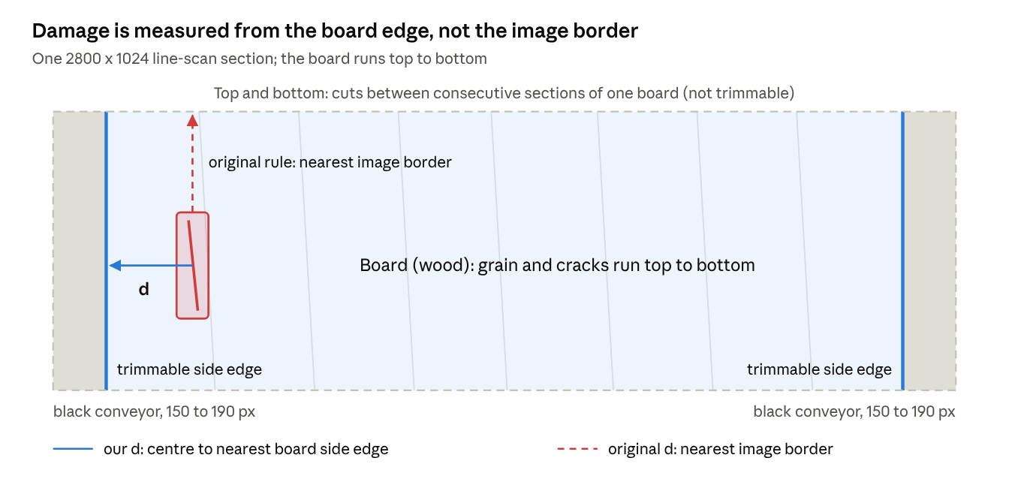
image geometry · board, conveyor and the two distance rules
With the original rule, the nearest border of this section is the cut above the crack, so a mid-board defect gets a small penalty. Our rule measures to the board's side edge, where trimming actually happens.
Three consequences for the formulas:
- Distance to the nearest image border includes roughly 160 px of conveyor, so defects near the board's side edges are over-penalised.
- The top and bottom of an image are cuts between consecutive sections of the same board. They are not edges that a sawmill can trim.
- A_board = W × H counts the conveyor (about 12 % of each image) as wood, which understates the damage per unit of wood.
2. Threshold scale. With your model unchanged (all 8 classes), the annotations of our 469 test images give damage scores from 0 to 0.086, with a median of 0.0028 and a 90th percentile of 0.021. Your illustrative thresholds (0.01, 0.03, 0.06) would grade 72 % of the images A, 23 % B, 4 % C and 1 % Reject. With almost no C or Reject boards, the grade would not separate boards.
3. Confidence weighting. An annotated defect enters with confidence 1, a detected one with its model confidence, which is below 1. The same board therefore gets a lower damage score from the detector than from its annotations. One set of thresholds for both would push the detector's grades towards A.
4. Defect classes. For the final system the team kept the four most frequent defect classes: Live_Knot, Dead_Knot, Resin and Crack (4,018 / 2,896 / 646 / 512 boxes). Crack, the most severe class in your table, is kept. From your severity table, only the weights 0.40, 0.60, 0.30 and 1.00 of these four apply.

4. Our modifications
We changed three inputs to the formulas and restricted the severity table; every formula and step stays as you wrote it. Your original rules remain available in the code for comparison.
Item | Your model | Our change | Reason
Distance d_i (Step 3) | Box centre to the nearest image border (or to the two short ends) | Box centre to the nearest side edge of the board, found per image with a board mask (dark regions joined to the image sides = conveyor; dark knots inside the wood stay wood) | Image borders include the conveyor; the top and bottom are section cuts, not trimmable edges
Board area A_board (Step 5) | W × H of the image | Number of wood pixels in the board mask; the impact map is also limited to the mask | The conveyor is about 12 % of each image and is not wood
Thresholds τ1, τ2, τ3 (Step 6) | 0.01, 0.03, 0.06 (illustrative) | Reference grades: 40th, 70th and 90th percentiles of the annotation damage score on the 17 validation boards, so about 40 % A, 30 % B, 20 % C and 10 % Reject. Detector grades: thresholds fitted with your calibrate_thresholds (maximum weighted kappa against the reference) on the same validation boards | Your values are illustrative and grade 72 % of our boards A; separate detector thresholds remove the confidence offset; nothing is fitted on the test boards
Severity weights (Step 2) | Placeholder table for 8 classes | Same values, limited to the 4 classes of the final model: Crack 1.00, Dead_Knot 0.60, Live_Knot 0.40, Resin 0.30 | Pending your ranking or an expert's (Section 8)
Unchanged: λ = 250 px (at the native 2800-px width), the max rule for overlaps, confidence weighting, the grade rule, and weighted kappa as the agreement measure.
The percentile thresholds are a stand-in, not a claim about how a sawmill grades. They will be replaced by thresholds fitted to blind expert grades, exactly as your Section 5 describes, once those grades exist.

5. Validation without expert grades yet
On the 469 test images, the grade from the detector matches the grade from the annotations on 79.7 % of images and is within one grade on 97.4 % (weighted kappa 0.86). We followed your Section 5 method, with the annotators' boxes standing in for the expert:
- Reference grade: BRI on the annotated boxes (confidence 1). Thresholds = 40th, 70th and 90th percentiles of the validation damage scores: 0.0020, 0.0062, 0.0179.
- Detector grade: BRI on the current model's detections (YOLO11s, 4 classes, confidence ≥ 0.25). Thresholds fitted on the validation boards with your calibrate_thresholds: 0.0014, 0.0035, 0.0121 (validation kappa 0.78). They are lower than the reference thresholds, which measures the confidence offset from Section 3.
- Test: the 12 test boards, never used for any fitting, scored per image and per physical board (mean damage over its sections).
Measure | Per image (469) | Per board (12)
Exact grade agreement | 79.7 % | 83.3 % (10 of 12)
Within one grade | 97.4 % | 100 %
Quadratic weighted kappa | 0.86 | 0.77
Spearman correlation of damage scores | 0.88 | 0.85
Mean absolute error of recoverable area | 0.41 percentage points | 0.38 percentage points
Grades per test image (rows: reference from annotations; columns: detector):
Reference \ Detector | A | B | C | Reject
A (175 images) | 162 | 11 | 1 | 1
B (113) | 23 | 74 | 15 | 1
C (109) | 4 | 7 | 85 | 13
Reject (72) | 4 | 1 | 14 | 53
Most disagreements are one grade apart. Eight images graded C or Reject from the annotations come out A, because the detector missed their main defect; an expert should look at these first.
This shows how well the detector reproduces BRI computed on human annotations. It does not yet show that BRI grades boards the way a grader would; that needs the expert step of your Section 5. We will repeat this check with the final detector.

6. How BRI is used in the system
The demonstration application now runs BRI on every analysed image, right after detection. For each image it shows:
- the grade (A, B, C or Reject) as a coloured badge, with the damage score, the recoverable share of the board area and the defect coverage;
- each defect's severity weight, position penalty and influence s_i, in the downloadable JSON report;
- on the held-out test boards, the grade computed from the annotations next to the grade computed from the model.
BRI also feeds the market-value step of our methodology (quality grade to price). The estimate is:
Value = V_{board} × (1 − DIS) × P_{A} × f_{grade}
Here V_board is the board volume, P_A the price of grade-A timber per cubic foot, and f_grade a factor per grade (defaults 1.00, 0.85, 0.65 and 0.30). All of these are inputs the user edits. The defaults are illustrative, not market data; a sawmill would enter its own price list.

7. Accuracy improvement, alongside BRI
Class balancing raised validation mAP50 by 1.5 points, but the gain did not hold on the test boards, and no difference between our 4-class models is statistically significant. We are now testing higher input resolution, Wise-IoU and detection fusion, as committed at the 50 % review.
Your suggestion | What we did
A. Class-balanced loss (effective number of samples) | Same principle applied to the data: boxes per class raised to n_max (full balance) or √(n_c × n_max) (partial balance). The loss form stays available if imbalance remains in the final setup.
B. Copy-paste of rare-class crops along the grain | Done: real defect crops pasted onto defect-free training images, inside the board, no rotation, training split only.
C. Per-class metrics and bootstrap intervals | Done: per-class AP, board-level bootstrap intervals and an exact Wilcoxon test on per-board differences.
1. k-fold cross-validation by board | Not run, for GPU time; replaced by three random seeds of the final setup plus board-level bootstrap.
2. Ablation table | Being built step by step: baseline, 4 classes, balancing, 1280-px input, Wise-IoU, fusion.
3. Paired significance test | Done (below).
4. Weighted kappa against expert grades | Reference-based kappa done (Section 5); expert step pending.
5. External check | Photos of college wood samples tested at the 50 % review.
6. Robustness to brightness, blur and contrast | Running: enhancement study under six imaging conditions.
YOLO11s, mAP50 averaged over Live_Knot, Dead_Knot, Resin and Crack:
Model | Validation (17 boards) | Test (12 boards)
8-class model, scored on these 4 classes | 73.8 | 69.6
4 classes, no balancing | 73.1 | 71.7
4 classes, full balance (1:1) | 71.9 | not tested
4 classes, partial balance (3:1), chosen on validation | 75.3 | 69.2
Partial balance against no balancing: +2.2 on validation (95 % interval −0.1 to +4.9) and −2.5 on test (−4.6 to +0.3); Wilcoxon p = 0.75 and 0.57. Against the 8-class model, both intervals also include zero. Full balance scored lowest: only 160 cracks could be cut out cleanly, so each was pasted up to 17 times.
Still to report from the 50 % plan: 1280-px input (training now), the Wise-IoU v3 box loss, weighted box fusion of YOLO11m and YOLO11s, and per-class confidence thresholds. Each will be chosen on validation and tested once.

8. What we need from you
- Severity ranking. Please rank the four defect classes, or adjust the weights below. If a grading standard should be cited, we propose EN 1611-1 (appearance grading of European softwoods), since our dataset comes from European sawn timber.
- Expert grading. Could your IWST contact grade 30 to 50 of our board images A, B, C or Reject without seeing the model's output? We would fit the thresholds on half of them and report weighted kappa on the other half, as in your Section 5.
- Approval of the changes in Section 4. These are the side-edge distance, the board area from the mask, and percentile thresholds as a stand-in until expert grades exist.
- Market-value factors. Are illustrative grade factors acceptable for the final review, or should we use a price source you recommend?
Defect class | Your placeholder weight | Your rank (1 = most severe) | Weight you suggest (0 to 1)
Crack | 1.00
Dead_Knot | 0.60
Live_Knot | 0.40
Resin | 0.30

9. Next steps
Everything below runs on the same 12 held-out test boards, with every setting chosen on the 17 validation boards.
- 7–8 Oct: results of the higher-resolution model (1280 px input); BRI validation repeated with the final detector; detection fusion and per-class thresholds on validation, then one test evaluation.
- 8–9 Oct: Wise-IoU training and two repeat runs with different random seeds, to measure run-to-run spread; image-enhancement study under low light, over-exposure, blur, noise and low contrast.
- On your reply: severity weights updated; expert grades used to fit the thresholds and report weighted kappa on unseen boards.
- Before the final review: final model fixed, statistical tests reported with confidence intervals, application and report updated, final presentation prepared.

