AI-Based Wood Quality Assessment
Surface defect detection on sawn timber with YOLO11: data audit, training, and evaluation on held-out boards
Progress report to the project guide

Item | Detail
Programme | VTU Major Project, Dayananda Sagar College of Engineering, Dept. of CSBS, AY 2026-27
Guide | Mrs. Aparna H D
Team | Prakyat Shetty and team [add teammate names and USNs]
Report date | 11 September 2026 (work carried out 5-7 September 2026)
Status | Phase 1 complete: clean dataset, two trained detectors, single held-out test evaluation per model, demo application

1. Executive summary
This report covers the work done to move the project from an early proof-of-concept to a defensible, reproducible result. We audited the dataset, found and fixed three problems that invalidated the earlier numbers, rebuilt the train/validation/test split so that test boards are physically separate from training boards, trained YOLO11m and YOLO11s under identical settings on Kaggle GPUs, and evaluated each model exactly once on the held-out test boards. We also built a demonstration application for live testing.
- Final held-out test results (12 boards, 469 images, 1,023 annotated defects): YOLO11s mAP50 64.6 / mAP50-95 33.4; YOLO11m mAP50 63.0 / mAP50-95 34.0. The two models are statistically tied on this test set.
- The earlier YOLO11s figure of 62.2 mAP50 was measured on a leaky split in which every test board also appeared in training, and under wrong class names. It is therefore not comparable and should be retired.
- The class the resolution fix targeted, Crack, improved from 42.2 (old, leaky) to 53.0 (YOLO11s) and 57.7 (YOLO11m) on a harder split.
- YOLO11s runs 2.8 times faster than YOLO11m at the same accuracy (11.7 vs 33.2 ms per image on a Tesla T4), which makes it the better deployment candidate on this dataset.
- The remaining bottleneck is data, not model capacity: the rarest class (Quartzity, 125 training boxes) is not learned by either model, and knot sub-types are confused with one another.

2. Problem statement and objective of this phase
The project aims to detect and localise surface defects on sawn timber boards from industrial line-scan images, as a step towards automated grading. The objective of this phase was a per-class table of Precision, Recall, F1, mAP50 and mAP50-95 on a test set of boards never seen in training, for a proposed model (YOLO11m) and a baseline (YOLO11s) trained under identical conditions, so that any claimed improvement is attributable to the model and not to differences in data or training.
Metrics used throughout: Precision (P), Recall (R), F1, mAP50 (mean average precision at IoU 0.5) and mAP50-95 (averaged over IoU 0.5 to 0.95). Accuracy is not reported because it is not meaningful for object detection.

3. Dataset
Source: the 4,000-image Kaggle subset (nomihsa965/large-scale-image-dataset-of-wood-surface-defects) of Kodytek, Bodzas and Bilik (2022), "A large-scale image dataset of wood surface defects for automated vision-based quality control processes", F1000Research 10:581, doi:10.12688/f1000research.52903.2. Images are sawn-timber line-scan strips of 2800 x 1024 pixels (aspect ratio 2.73:1) with the grain running along the scan axis. Labels are YOLO-format bounding boxes.
Property | Value
Images / annotated boxes | 4,000 / 9,211 (after cleaning: 9,053)
Background images (no defect) | 388 (9.7%)
Physical boards | 81 (first four digits of the file name)
Classes | 8 (see mapping below)
Class imbalance | Live_Knot 44.2% and Dead_Knot 31.9% of boxes; Knot_missing 1.3%, Quartzity 1.9%, Marrow 2.2%

3.1 Class mapping correction
The team's earlier data.yaml used the names Crack, Knot, Hole, Stain, Split, Warp, Decay and Scratch. These are not the dataset's classes. The Kaggle data card, the geometry of the boxes per class id, and the class-frequency ranking in the source paper all agree on the following mapping. Label ids are unchanged, only the names.
id | Real class | Description | Earlier (wrong) name | Share of boxes
0 | Quartzity | faint streak along the grain | Crack | 1.9%
1 | Live_Knot | healthy, intergrown knot | Knot | 44.2%
2 | Marrow | pith line, long streak along the grain | Hole | 2.2%
3 | Resin | resin pocket, elongated dark patch | Stain | 7.1%
4 | Dead_Knot | dark, loose or encased knot | Split | 31.9%
5 | Knot_with_crack | knot with a radial crack | Warp | 5.9%
6 | Knot_missing | hole left by a fallen knot | Decay | 1.3%
7 | Crack | long thin fissure along the grain | Scratch | 5.6%

Consequence: every per-class statement in the earlier reports referred to a different defect than it named. For example, the earlier "Split 88.1 mAP50" was Dead_Knot and "Crack 19.2" was Quartzity.

4. Data audit: what was wrong and how it was fixed
Problem found | Effect on earlier results | Fix applied
Board leakage: the earlier split was made per image tile, so all 81 physical boards appeared in train, validation and test. | The model could memorise grain and lighting of each board. The reported 62.2% test mAP50 is inflated by an unknown amount. | Group-stratified split by board id (seed 42): 52 / 17 / 12 boards for train / val / test. Zero overlap, asserted by the script.
Wrong class names (section 3.1). | Per-class analysis and failure-mode discussion were about the wrong defects. | Real names adopted in data.yaml, code, plots and this report.
Letterboxing: at 640 x 640 square input, a 2.73:1 image leaves 63% of the tensor as black padding and shrinks the active image to 640 x 234. | Thin defects lost resolution; compute was wasted on padding. | imgsz 1024 with rectangular batches: the network sees 1024 x 384 with almost no padding, 1.6x more pixels per defect.
158 degenerate boxes with a side of 0 to 1 pixel (export artefacts). | Zero-area targets destabilise box regression. | Dropped after clipping to the image. Every dropped box was inspected; no real defect was removed.
Augmentation unsuited to oriented grain (rotation 10 degrees, vertical flips, random erasing 0.4, strong saturation jitter). | Unphysical grain directions; erasing removed small defects from positives. | degrees 0, flipud 0, erasing 0.05, mild HSV (0.01 / 0.3 / 0.2), horizontal flip 0.5, translate 0.08, scale 0.3.

4.1 Final split
Split | Boards | Images | Background | Quartzity | Live_Knot | Marrow | Resin | Dead_Knot | Knot_w_crack | Knot_missing | Crack
train | 52 | 2817 | 272 | 125 | 2899 | 94 | 489 | 2071 | 377 | 78 | 306
val | 17 | 714 | 71 | 20 | 713 | 64 | 88 | 482 | 98 | 15 | 111
test | 12 | 469 | 45 | 10 | 406 | 46 | 69 | 343 | 30 | 24 | 95

Every class is present in all three splits. The test set has only 10 Quartzity and 24 Knot_missing boxes, so those two per-class figures carry wide uncertainty and are labelled as such below.

5. Method

5.1 Models and training configuration
Both models are Ultralytics YOLO11 detectors fine-tuned from COCO-pretrained weights (yolo11m.pt, 20.0 M parameters, 68 GFLOPs; yolo11s.pt, 9.4 M parameters, 21 GFLOPs). Everything below is identical for the two models.
Setting | Value | Reason
Input | imgsz 1024, rectangular batches | matches the 2.73:1 strips without padding
Optimiser | AdamW, lr0 0.001, lrf 0.01, cosine schedule, 3 warm-up epochs, weight decay 5e-4 | lr0 lowered from 0.002 after run 1 showed an unstable curve
Batch / epochs / patience | 32 / 100 / 40 | batch raised from 16 for stability; patience widened for the same reason
Loss gains | cls 1.0, box 7.5, dfl 1.5 | classification weight doubled from the Ultralytics default for rare classes
Augmentation | hsv 0.01 / 0.3 / 0.2, degrees 0, translate 0.08, scale 0.3, fliplr 0.5, flipud 0, mosaic 0, mixup 0, erasing 0.05 | grain-safe; mosaic is disabled by rectangular mode anyway
Determinism | seed 42, deterministic=True | reproducibility
Model selection | best.pt by validation fitness; last.pt never used
Test protocol | test split evaluated exactly once per model, conf 0.001, NMS IoU 0.6 | no threshold or hyperparameter was chosen using the test split

5.2 Compute
Training ran on Kaggle on a single NVIDIA Tesla T4 (15 GB). Two T4s were tried first but Ultralytics disables rectangular training under multi-GPU and falls back to padded square input, which defeats the purpose and also runs out of memory at batch 32, so single-GPU training was used. A full 100-epoch YOLO11m run takes about 2.6 GPU-hours; YOLO11s about 1.4. Total GPU used for all runs, including failed setup attempts: 6.8 of the 30 weekly hours.

5.3 Pipeline and reproducibility
- prepare_dataset.py: pairs images and labels, clips and drops degenerate boxes, performs the board-level split, prefixes file names with a seeded hash so that rectangular batches (which iterate in sorted order without shuffling) still mix boards, writes data.yaml and board_split.json.
- train_yolo11m.py: holds the full configuration, auto-resumes from last.pt, accepts overrides for model, batch, lr0, patience and image size; every override is logged.
- evaluate.py: runs best.pt on the test split once and writes per-class P / R / F1 / mAP50 / mAP50-95 as CSV and Markdown, plus PR and F1 curves and confusion matrices.
- All code, logs, curves and tables are version-controlled in the team repository; weights (40 MB each) are stored on Kaggle. NOTES.md records every deviation from the base configuration with its reason.

6. Experiments
Run | Model | Settings | Epochs / time | Best epoch | Val mAP50 | Val mAP50-95 | Outcome
1 | YOLO11m | batch 16, lr0 0.002, patience 25 | 89 (early stop) / 2.54 h | 64 | 62.6 | 33.7 | Unstable curve: several 10-15 point drops in val mAP50, two large classification-loss spikes
2 | YOLO11m | batch 32, lr0 0.001, patience 40 | 100 / 2.64 h | 73 | 65.7 | 36.2 | Stable; every class improved or held. Adopted as final YOLO11m
3 | YOLO11s | identical to run 2 | 90 (early stop) / 1.43 h | 50 | 65.3 | 36.0 | Baseline with identical data and settings

Run 2 was chosen over run 1 on validation results only. Per-class validation mAP50, run 1 to run 2: Crack 51.1 to 58.0, Knot_missing 81.4 to 88.8, Marrow 72.8 to 76.0, Knot_with_crack 61.7 to 64.3, Dead_Knot 81.8 to 83.4, Live_Knot 76.7 to 77.6, Resin 71.2 to 71.9, Quartzity 4.3 to 5.4.
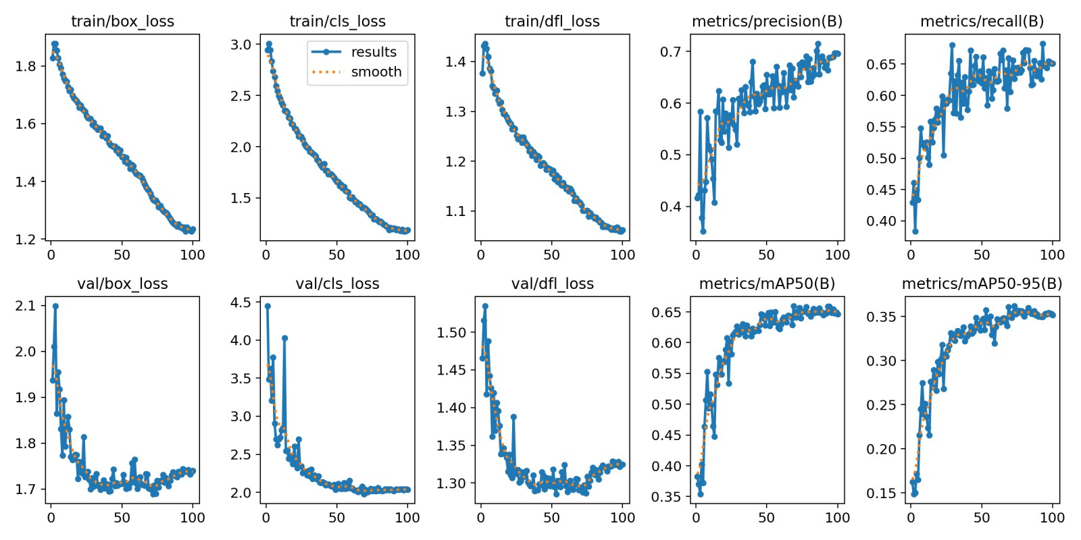
Figure 1. Training and validation curves, YOLO11m run 2 (adopted).
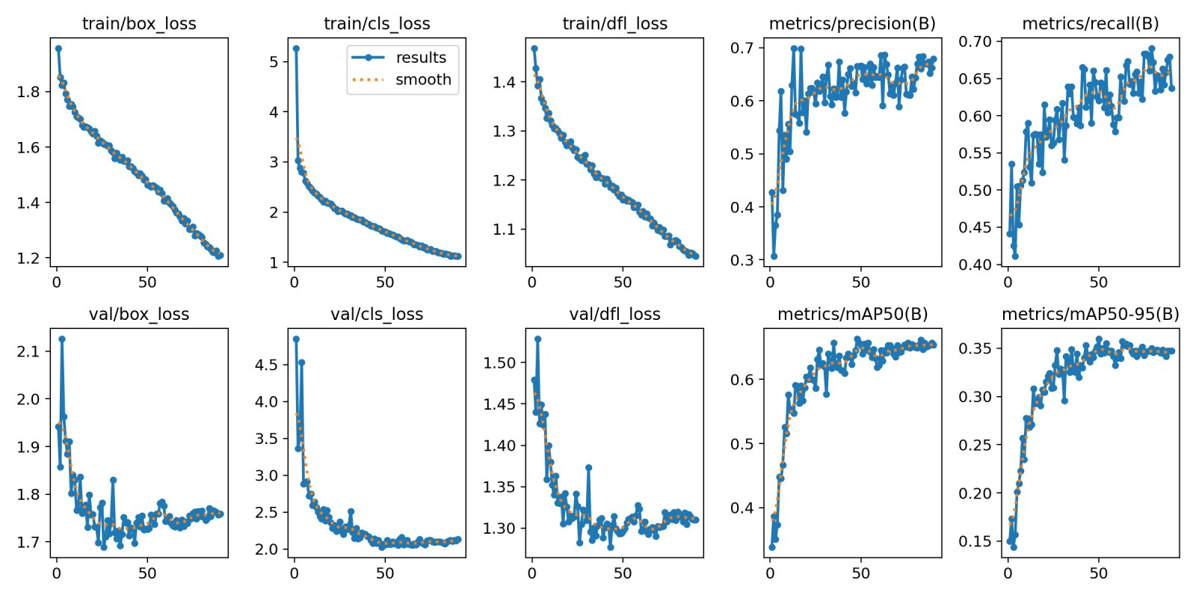
Figure 2. Training and validation curves, YOLO11s baseline (run 3).

7. Final results on held-out test boards
Test set: 12 boards, 469 images, 1,023 annotated defects, none of which were used for training, validation, model selection or threshold choice. Each model was evaluated once.

7.1 Overall
Model | Training split | P | R | F1 | mAP50 | mAP50-95 | ms / image (T4) | Params
YOLO11s, 640 square (earlier run) | leaky, per tile | 73.1 | n/a | n/a | 62.2 | n/a | n/a | 9.4 M
YOLO11s, 1024 rect (clean baseline) | by board, seed 42 | 71.0 | 64.1 | 67.4 | 64.6 | 33.4 | 11.7 | 9.4 M
YOLO11m, 1024 rect (proposed) | by board, seed 42 | 63.4 | 66.2 | 64.7 | 63.0 | 34.0 | 33.2 | 20.0 M

The first row is included only for context. It was produced on a different, leaky split under wrong class names and is not comparable with the other two rows.

7.2 Per class
Class | Test boxes | 11s P | 11s R | 11s F1 | 11s mAP50 | 11s mAP50-95 | 11m P | 11m R | 11m F1 | 11m mAP50 | 11m mAP50-95
Dead_Knot | 343 | 83.0 | 84.3 | 83.6 | 89.1 | 43.3 | 77.2 | 88.0 | 82.3 | 86.8 | 41.8
Marrow | 46 | 89.3 | 72.7 | 80.2 | 87.7 | 55.2 | 79.6 | 84.9 | 82.2 | 85.8 | 57.4
Live_Knot | 406 | 75.2 | 75.1 | 75.2 | 75.8 | 32.6 | 73.5 | 79.2 | 76.3 | 74.8 | 32.0
Knot_missing * | 24 | 80.8 | 70.8 | 75.5 | 69.6 | 34.1 | 57.9 | 62.5 | 60.1 | 62.7 | 35.7
Knot_with_crack | 30 | 80.9 | 63.3 | 71.1 | 67.5 | 42.8 | 63.2 | 63.3 | 63.3 | 61.7 | 38.4
Resin | 69 | 81.9 | 53.6 | 64.8 | 60.4 | 29.5 | 68.0 | 56.5 | 61.7 | 59.5 | 29.9
Crack | 95 | 60.5 | 63.2 | 61.8 | 53.0 | 26.3 | 56.8 | 72.6 | 63.7 | 57.7 | 31.0
Quartzity * | 10 | 16.7 | 30.0 | 21.5 | 13.4 | 3.0 | 30.7 | 22.3 | 25.8 | 15.4 | 5.7
ALL | 1023 | 71.0 | 64.1 | 67.4 | 64.6 | 33.4 | 63.4 | 66.2 | 64.7 | 63.0 | 34.0

* Fewer than 25 test boxes; treat as indicative only.
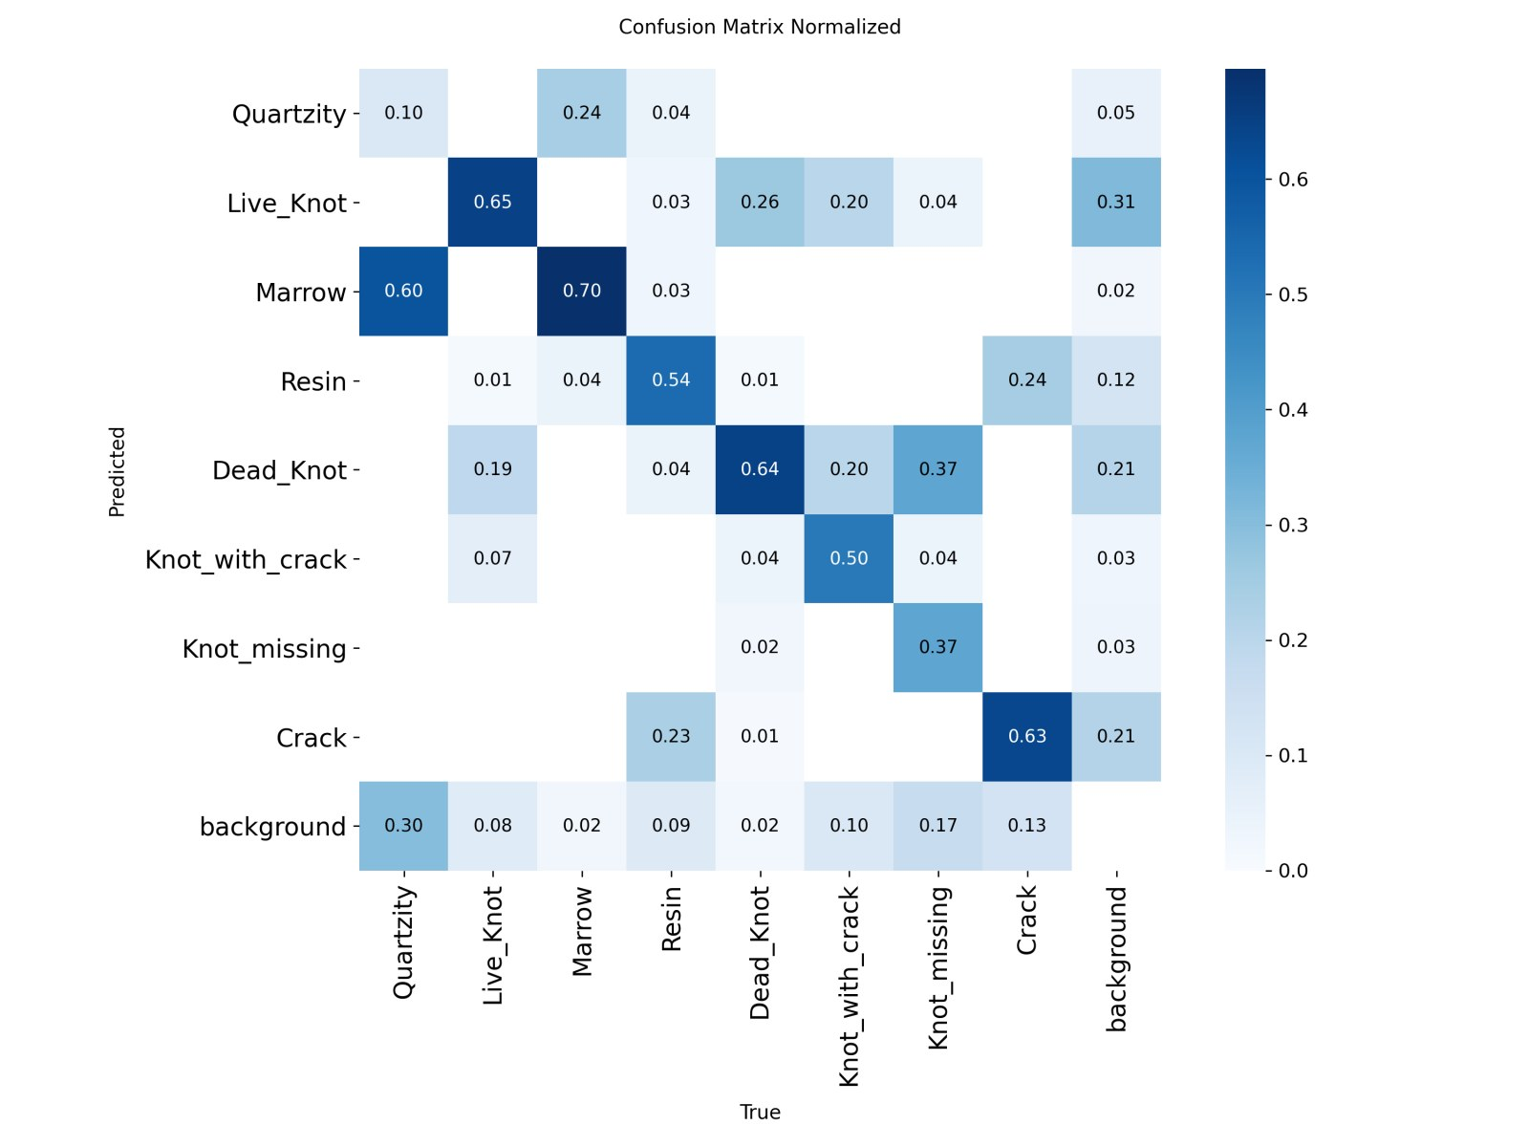
Figure 3. Normalised confusion matrix on the test set, YOLO11m. Columns are true classes.
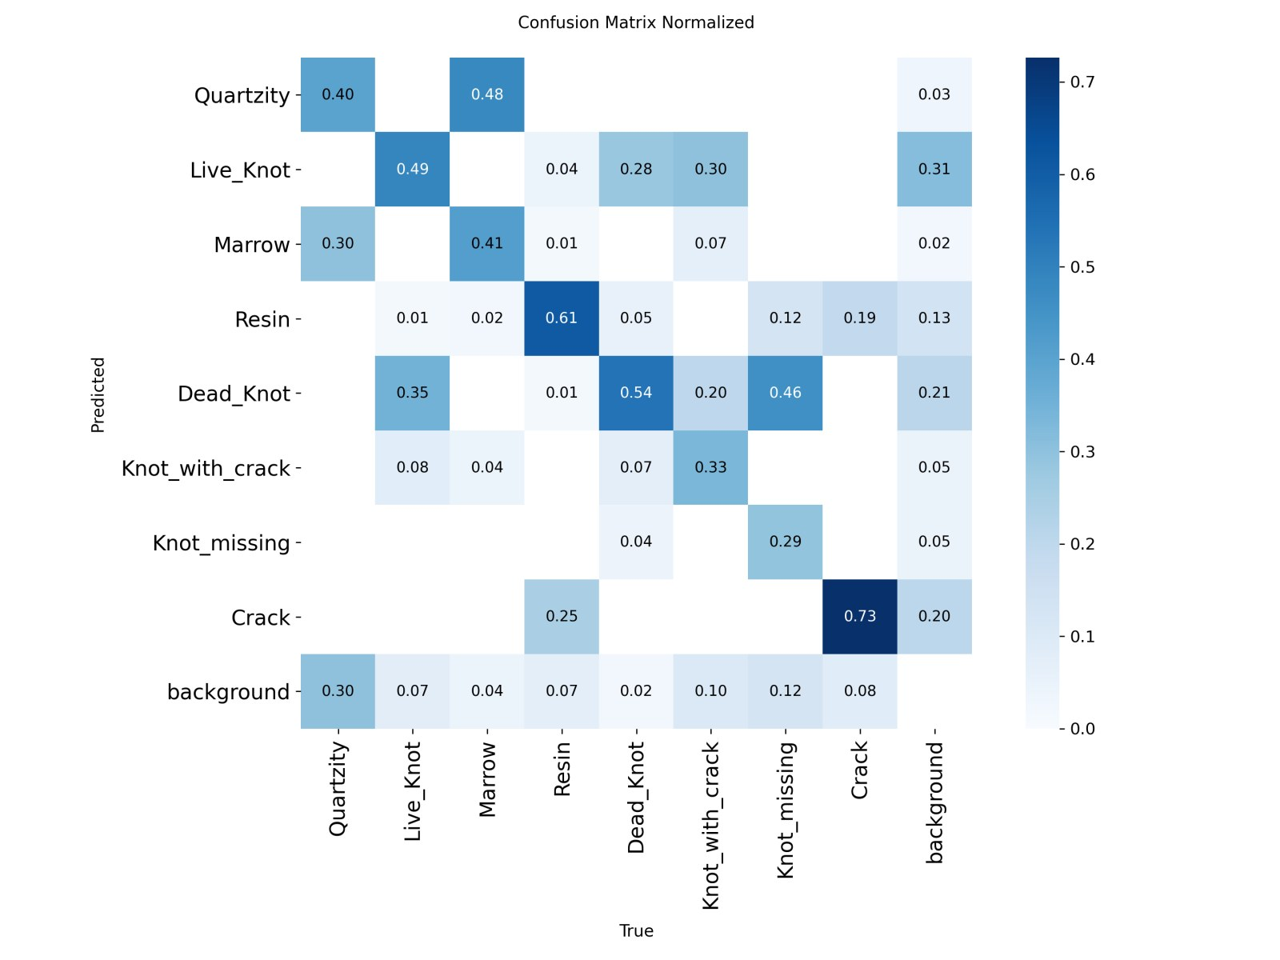
Figure 4. Normalised confusion matrix on the test set, YOLO11s.
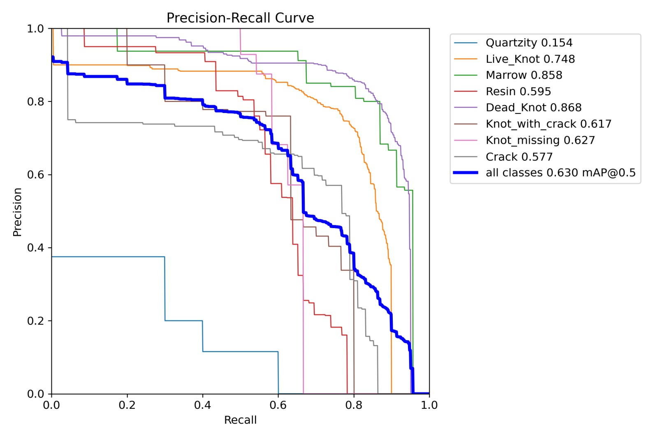
Figure 5. Precision-recall curves per class on the test set, YOLO11m.
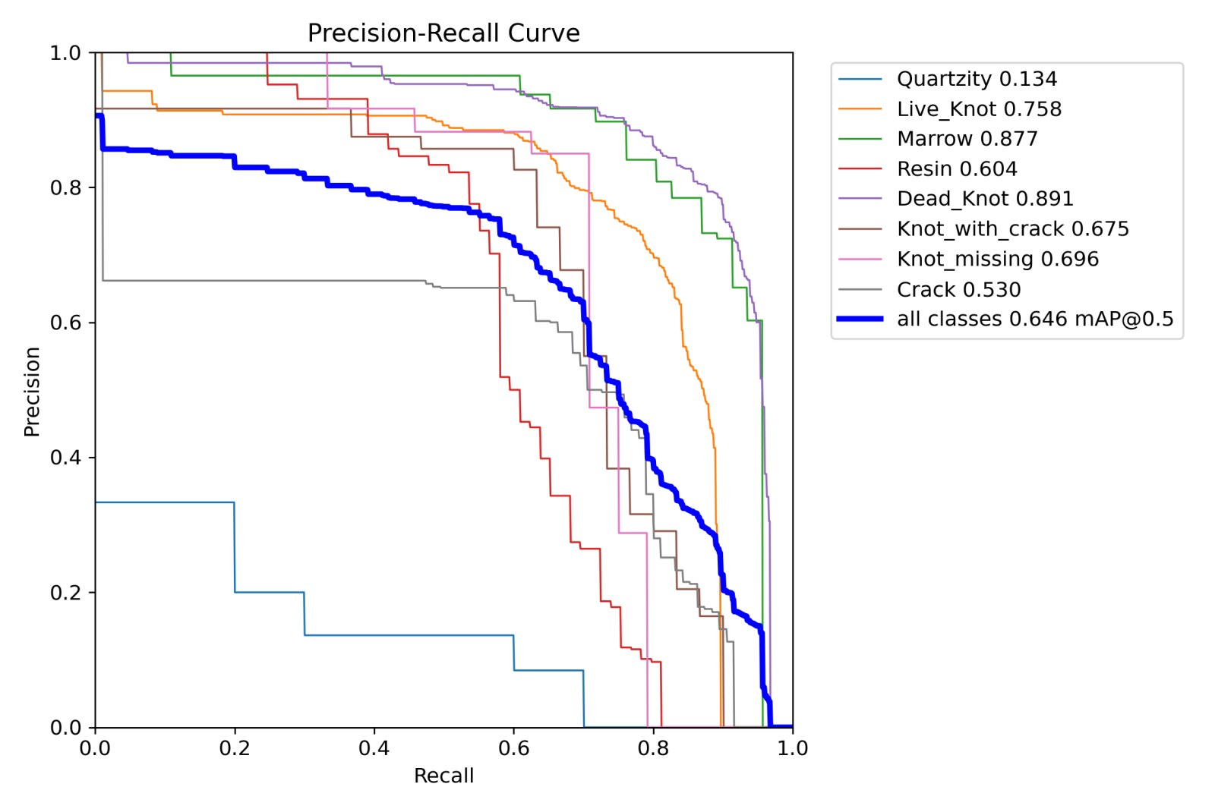
Figure 6. Precision-recall curves per class on the test set, YOLO11s.

8. Model comparison: YOLO11m versus YOLO11s
Because both models were trained on the same split with the same settings and seed, differences between them are attributable to model size alone. The comparison below is on the held-out test set.
Aspect | YOLO11s (9.4 M) | YOLO11m (20.0 M) | Difference (m minus s) | Reading
mAP50 | 64.6 | 63.0 | -1.6 | within noise for a 12-board test set
mAP50-95 | 33.4 | 34.0 | +0.6 | slightly tighter boxes from the larger model; within noise
Precision | 71.0 | 63.4 | -7.6 | YOLO11m raises more false alarms at conf 0.001 evaluation
Recall | 64.1 | 66.2 | +2.1 | YOLO11m finds slightly more defects
F1 | 67.4 | 64.7 | -2.7 | driven by the precision gap
Crack mAP50 | 53.0 | 57.7 | +4.7 | largest per-class gain for YOLO11m; the thin-defect class
Crack recall | 63.2 | 72.6 | +9.4 | consistent with higher capacity helping thin structures
Knot_missing mAP50 * | 69.6 | 62.7 | -6.9 | 24 test boxes; not reliable
Dead_Knot / Live_Knot mAP50 | 89.1 / 75.8 | 86.8 / 74.8 | -2.3 / -1.0 | the two dominant classes; effectively equal
Inference, T4, 1024 rect, batch 16 | 11.7 ms (86 FPS) | 33.2 ms (30 FPS) | 2.8x slower | decisive for deployment
Inference, laptop CPU, single image | about 0.2-0.3 s | about 0.5-0.6 s | 2x slower | measured in the demo application
Training cost | 1.43 h (90 epochs) | 2.64 h (100 epochs) | 1.8x
Validation mAP50 (best epoch) | 65.3 | 65.7 | +0.4 | tie on validation as well

Interpretation. The two detectors are tied in accuracy on this dataset. YOLO11m trades precision for recall and is better on the thin Crack class; YOLO11s is more precise and almost three times faster. Because the earlier audit showed the small model was not capacity-limited (its training loss kept falling while validation loss plateaued), this outcome was expected: the gains in this phase came from the data fixes, not from model size. On this evidence YOLO11s is the better deployment choice, and YOLO11m is justified only where Crack recall is the priority.
Both models agree on the failure modes (Figures 3 and 4): Quartzity is mostly predicted as background or as Marrow; about a quarter to a third of Knot_with_crack is predicted as Live_Knot and of Knot_missing as Dead_Knot; and roughly a third of Crack instances are missed. These are properties of the data (rare classes, visually similar knot sub-types, faint streaks) rather than of either architecture.

9. Qualitative examples
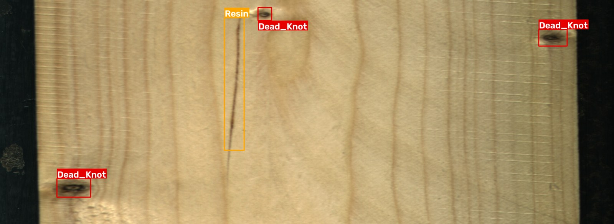
Figure 7. Held-out test board 9990: annotator's ground truth (Resin x1, Dead_Knot x3).
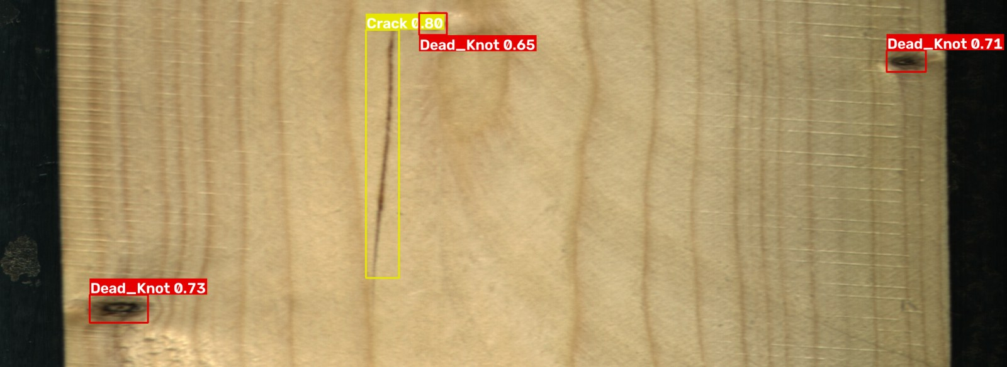
Figure 8. Same image, YOLO11m prediction at confidence 0.35: three Dead_Knot correct; the resin streak is predicted as Crack, an example of the thin-streak confusion.
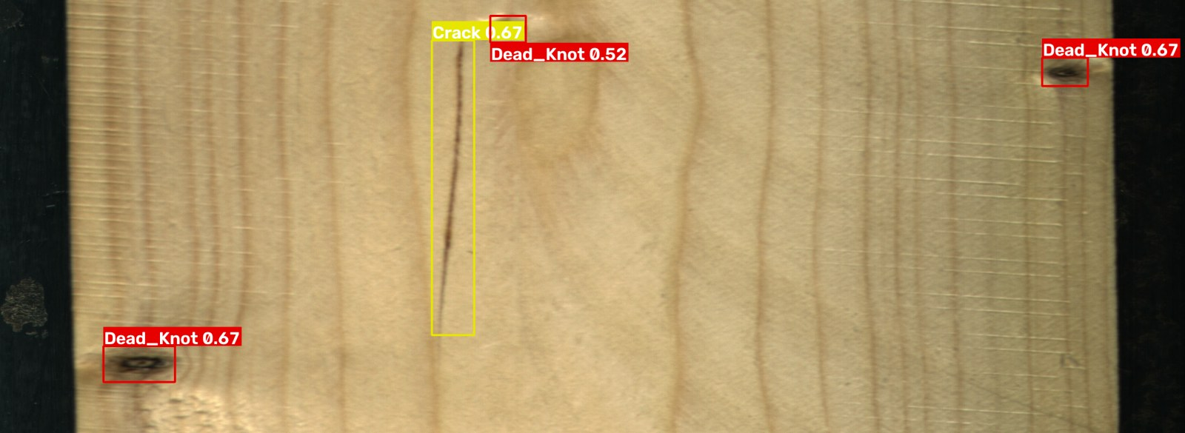
Figure 9. Same image, YOLO11s prediction at confidence 0.35.
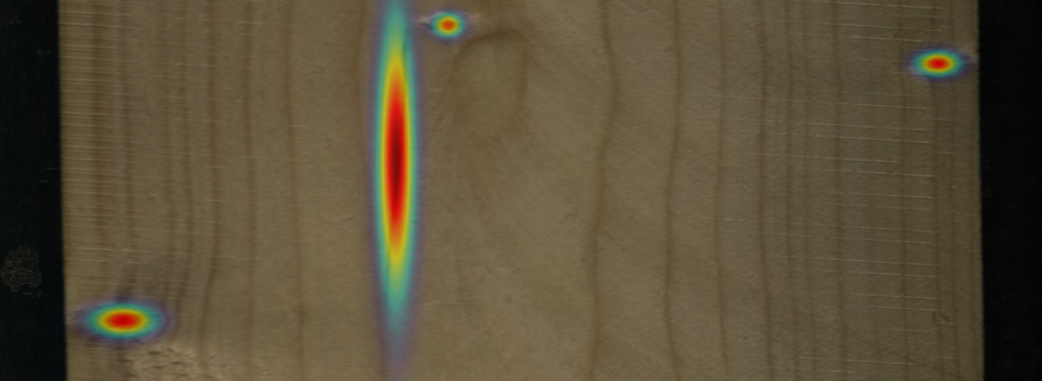
Figure 10. Confidence-weighted defect heatmap from the demo application for the same board (YOLO11m).
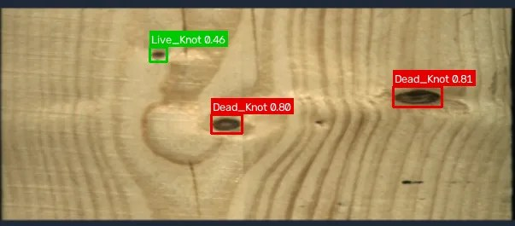
Figure 11. Demo application on a downscaled board image (600 px wide): YOLO11m finds both dead knots (0.80, 0.81) and the small live knot (0.46).

10. Demonstration application
A local web application (Gradio, runs on CPU) was built for live testing and presentation. It loads both final models and offers:
- Detect on an uploaded board image, with model choice, side-by-side comparison of both models, confidence and NMS thresholds, and an automatic input-size rule (full strips at 1024, small photos near native resolution, because upscaling small photos to 1024 produced spurious detections).
- Bounding boxes with per-class colours, a confidence-weighted heatmap, a per-class count and area table, defect coverage as a share of the surface, and a JSON report download.
- A test-board tab that shows the annotator's ground truth next to the model's prediction for images from the 12 held-out boards.
- A results tab with the tables and confusion matrices in this report.
- A packaged copy for free hosting on Hugging Face Spaces, so the demo can be shared by URL.
Defect coverage is presented as a transparent area heuristic. No quality grade or recoverability score is shown because no grading rule has been defined or validated in this project; this is recorded as future work.

11. Limitations and threats to validity
- Small test set: 12 boards and 1,023 boxes. Per-class figures for Quartzity (10 boxes) and Knot_missing (24 boxes) are not reliable; differences of 1-2 mAP points overall are within noise.
- Single seed: each configuration was trained once (seed 42). A multi-seed estimate of run-to-run variance would quantify the noise floor and is planned.
- Domain: models were trained on line-scan images under controlled lighting. On phone photos or stock images they produce plausible but less reliable results; the demo application states this.
- 99 annotation boxes under 5 x 5 pixels remain in the data (1.1%). They are effectively unlearnable and count as misses in recall.
- The test split was evaluated once per model. Any further model change would require a new, single test evaluation, and the total number of test evaluations must be stated in the final report.

12. Next steps
- Write-up of this phase with the tables above, stating the leakage finding, the class-name correction, and the single-shot test protocol.
- Rework the synopsis: sawn timber instead of plywood, the real class names, YOLO11 instead of YOLOv8, the Kodytek et al. citation, and "YOLO11s vs YOLO11m at equal data and training budget" as the comparison.
- Optional, validation-only experiments with the remaining GPU budget (about 23 hours this week): multi-seed YOLO11s runs to estimate variance; removal of sub-5-pixel boxes; a 1280-pixel rectangular input for the thin classes. Results would be reported separately from the main table.
- Decide with the guide whether a defect-based grading rule (for example thresholds on defect coverage and on counts of structural defects such as Crack and Knot_with_crack) should be defined, so that a quality grade can be shown and defended.
- Decide whether a CWB-style architecture experiment is still in scope given that model capacity is not the bottleneck on this dataset.

13. Brief summary
Between 5 and 7 September the team replaced an unreliable early result with a defensible one. The dataset was audited and three defects in the earlier setup were corrected: a board-level data leak, wrong class names, and square letterboxing of very wide images. A clean split with physically separate test boards was built, and YOLO11m and YOLO11s were trained on Kaggle under identical, fully logged settings. On the held-out test boards the two models are tied at about 63 to 65 mAP50 and 33 to 34 mAP50-95, with YOLO11m better on the thin Crack class and recall, and YOLO11s more precise and 2.8 times faster. The previously targeted Crack class improved from 42 to 53-58 mAP50 despite the harder split. The evidence indicates that further gains will come from data (more examples of rare classes, cleaner annotation of knot sub-types) rather than from a larger detector. A demonstration application with heatmaps, per-class statistics and ground-truth comparison is available for the review, and all code, logs and results are version-controlled for reproducibility.

References
- Kodytek P., Bodzas A., Bilik P. (2022). A large-scale image dataset of wood surface defects for automated vision-based quality control processes. F1000Research 10:581. doi:10.12688/f1000research.52903.2
- Kaggle dataset: nomihsa965/large-scale-image-dataset-of-wood-surface-defects (4,000-image subset, 2800 x 1024, YOLO labels, CC BY 4.0).
- Ultralytics YOLO11, version 8.4.142. https://docs.ultralytics.com
- Team repository: github.com/prakyats/Major_project (scripts, NOTES.md decision log, docs/PROGRESS.md, eval/ tables and curves, runs_log/ per run).

