KCC 360 Master Software Requirements Specification
Version 3.8 Planning execution monitoring and evaluation ecosystem
26 October 2026

Revision authority and precedence
This revision incorporates the requirements confirmed in the project conversation through 26 October 2026. The 35-module catalogue normalizes existing functional headings and adds research, interclub events, partnerships, external achievements and meetings. It is a requirements baseline, not a declaration of implementation or production readiness.
AP-001 All plans require responsible-unit review, then Finance Administrator review immediately before Principal final approval, including plans with no expenditure. Review is not approval. Revisions to approved scope, budget or commitments repeat this route. This rule supersedes earlier optional finance/admin or mentor-final plan approval wording and applies to main-body sections, tables and annexes. It does not change academic evaluation, certificate, document, personnel or signing authorities unless expressly stated.
AP-002 Annex J defines M01–M35 and their workflows. Annex K defines numbered connections and Annex L defines acceptance criteria. Annex M adds authoritative approved-plan locking and change-request controls for every unit. Existing safeguards remain effective. Where historical workflow text differs, AP-001 and the explicit module amendments take precedence. Named role holders, rubric weights, selection method, term duration, AI activation and integration contracts remain configurable prerequisites; no new values are inferred. Annex N governs event operations; Annex O governs public publication, registration and payment; Annex P defines new acceptance criteria and adoption boundaries. Annex Q defines manual official MIS imports, uploadable planning and distinct assignment routes; Annex R defines semester reconciliation and API transition; Annex S adds acceptance and amendment traceability. Annex T defines strategic target allocation and Student Affairs responsibilities; Annex U defines monitoring and evaluation in every dashboard; Annex V defines placement outcomes, connections and acceptance. Annex W defines the canonical event completion record, linked reports/reflections, review states and closure evidence. Annex X consolidates the approved ecosystem decisions, proportional activity templates, authority boundaries, canonical reflection states and improvement cycle. It governs these subjects where older wording or figures differs.
AP-003 No new workflow is certified as implemented by this document. Annex G remains historical evidence for the earlier prototype, not evidence that version 3.8 passes tests. Formal HR appraisal and authenticated external guest access retain their existing release boundaries.
This consolidated draft preserves the version 3.0 requirements and incorporates prototype decisions, the consistency review and six positions confirmed by Dr. Pralhad Karki on 20 October 2026. This clean copy omits amendment highlighting; the retained review copy and amendment register provide comparison history. Target requirements, implementation evidence and institutional decisions remain separate. Confirmation of six positions is not blanket approval of unresolved policies, final prototype acceptance or production readiness.

Document control
Source lineage: v3.0–v3.5 retained. Version 3.6 adds strategic target allocation to all departments, linked club execution plans, Student Affairs planning/monitoring/evaluation, automatic internal calendars, placement outcomes and monitoring/evaluation in every dashboard. Annexes T–V govern these additions. Previous implementation reports remain historical; new checks are NOT RUN. Version 3.7 adds Annex W event completion records, workflow and acceptance criteria. New criteria are NOT RUN; the catalogue remains 35 modules. Version 3.8 incorporates the 12 approved decisions and proportional workflow simplifications into the body and Annex X. Preserve 35 modules and connections C001–C168; C169–C172 extend integration. New acceptance criteria remain NOT RUN.

Normative language and navigation
Shall denotes a mandatory requirement within its designated release. May denotes an optional configurable capability. Recommendations using should require a documented implementation decision. Annex requirements carry stable identifiers; main-body references use module heading and business-rule label together. Explicit reconciled rules in this revision replace superseded version 2.1 wording. Any unresolved contradiction must be recorded as a change request before implementation.

Version 3.8 ecosystem guide
Start with Annex X for the consolidated planning, execution, monitoring, evaluation and improvement workflow, decision responsibilities and simple/standard/complex templates. The retained 35-module catalogue remains the functional reference. Principal approves plans after Finance Administrator review; operational assignments and human evaluation retain their own authorities. Annex X reconciles reflection state terminology; older figures are read with its mapping.

Reading order
Main specification: purpose, scope, architecture, functional modules, non-functional requirements and boundaries. Annex A: release and ownership. Annex B: workflows. Annex C: permissions. Annex D: MIS and LMS contracts. Annex E: data, metrics and acceptance. Annex F: institutional configuration decisions. Annex G: prototype implementation and acceptance status. Annex H: amendment traceability. Annex I: six confirmed positions. Evidence and traceability annexes do not reduce normative release obligations.

Introduction

Purpose
The purpose of this document is to provide a comprehensive and detailed description of the KCC 360 system, including its functional and non-functional requirements. This document is intended for stakeholders, developers, project managers, and investors to ensure a shared understanding of the system's objectives, features, and constraints.
It serves as:
- A blueprint for development
- A reference for system validation
- A communication tool for stakeholders

Scope
KCC 360 is a web platform for academic activities, projects, club governance, verified portfolios, controlled documents and institutional notices across authorized institutional scopes.
The platform aims to:
- Digitize project lifecycle management
- Enhance collaboration between students and mentors
- Standardize evaluation processes
- Automatically generate verified student portfolios
- Provide certification based on performance
Manage academic structures across faculties, departments, programmes, batches, semesters, sections, and courses
Manage semester-wise projects, workshops, seminars, field activities, and other experiential learning activities
Support complete club governance, planning, execution, evaluation, handover, and institutional portfolio lifecycles
Provide role-based dashboards, action indicators, contextual communication, notifications, and escalation workflows
The core release shall be web based. Release scope and deployment modes are defined in the consolidation annexes.
The core platform shall provide configurable execution workspaces, granular permissions, verified presentation profiles and secure QR sharing. AI reflection assistance and advanced predictive analytics are controlled extensions under Annex A.

Curriculum linked experiential learning
Academic projects, workshops and seminars linked to the curriculum remain core KCC360 functions. Their workflow includes initiation or assignment, approval, mentor allocation, tasks, individual participation, evidence, reflection, evaluation and verified achievements. The future LMS does not replace these experiential workflows. Clubs, impact projects, independent research, internships and leadership remain within the specified activity scope.
Support deployment across a multi-institution hierarchy in which a university may govern multiple constituent or affiliated colleges, while each college retains its authorized local operational scope.
Provide controlled access to applicable policies, SOPs, forms, formats, templates, manuals, guidelines, and institutional reference documents through a role- and scope-aware My Documents area.
Support university-wide, college-level, faculty, department, programme, semester, section, club, project, and user-targeted notices, circulars, directives, and implementation instructions.
Preserve the integrity of externally issued university notices while allowing KCC or another college to issue a separate local implementation instruction without altering the original notice.

Intended Audience
- Developers (Backend & Frontend)
- Project Managers
- Institutional Administrators
- Investors
- QA/Test Engineers

Definition and Terminology

University / Parent Institution
The top-level institution that may govern, affiliate, regulate, or communicate with multiple colleges or campuses.

College / Campus
An operational institutional unit, such as KCC, within a wider university or multi-institution structure.

Controlled Document
An approved policy, SOP, form, format, template, manual, guideline, checklist, or other institutional document governed by version, effective date, access, retention, and withdrawal rules.

Institutional Notice / Circular
An official announcement, directive, deadline, circular, or implementation instruction issued to one or more authorized target audiences.
Term | Description
Student | User who participates in or creates projects
Project Mentor | Teacher assigned to supervise and evaluate a specific project or activity within current authority
Admin | Authorized administrator within assigned scope; no unrestricted access to all institutions
Project | Academic or extracurricular work
Task | Unit of work within a project
Reflection | Learning report submitted by student
Portfolio | Auto-generated record of student achievements
ECA | Extracurricular Activities
Class Advisor | Teacher with an authoritative class/cohort advisory assignment; a scoped KCC360 development view, with no automatic project approval or evaluation rights

Overall Description

Product Perspective
KCC 360 shall operate with KCC MIS for KCC deployment. Other institutions may use an approved MIS adapter or standalone identity mode as specified in Annex A.

KCC deployment ownership
For KCC deployment, KCC MIS means the existing E-Digital Nepal MIS. It remains the authoritative source for institutional identity, base roles, official student details, enrolment and official academic results. Authorized fee and dues views shall refer to MIS financial records rather than create a parallel student fee ledger. Exact API capabilities, service contracts and source freshness shall be confirmed before integration.
KCC360 retains ownership of its experiential activity, contribution, evidence and development records. The planned LMS retains its course materials, quizzes and original LMS submissions. A single sign-in experience shall use approved identity federation under DEP-001 and INT-002; it shall not copy passwords or imply unrestricted access across portals. Existing standalone and multi-institution requirements remain applicable to their designated releases.
Where experiential evaluation supports internal course assessment, the approved university and course mapping shall specify the applicable share, scale, rounding and finalization authority. No universal percentage shall be inferred. No KCC360 portfolio or task score shall automatically replace a final university/MIS result.
The system follows a hybrid role architecture, where base user roles are managed by KCC MIS, while application-specific roles are managed within KCC 360.

System Context

Multi-Institution Deployment Context
KCC shall authenticate institutional users through KCC MIS. Other adopting institutions may use integrated or standalone mode. University and college scopes shall be enforced independently of deployment mode.
Organizational scope: Parent institution → College → Faculty or School → Department. Programme, academic period, batch, section, course offering, enrolment and user assignments are related records rather than a single organizational chain.
In KCC integrated mode, KCC 360 depends on KCC MIS for:
- User authentication (login)
- User identity and profile data
- Base role information (e.g., Student, Teacher)
The system acts as a specialized module focused on:
- Project lifecycle management
- Task tracking
- Evaluation and certification
- Portfolio generation
Additionally, KCC 360 manages application-level roles required for project execution and collaboration.

Integration with KCC MIS
KCC 360 integrates directly with the KCC MIS system to ensure consistency and avoid duplication of user data.

Integration Responsibilities

KCC MIS Provides:

KCC Deployment Authentication Rule
All KCC students, teachers, staff, administrators, and institutional users shall log in through KCC MIS. KCC 360 shall not provide routine local password registration for KCC users.

Standalone Deployment for Other Institutions
Where an adopting institution does not have an MIS, KCC 360 may operate in standalone mode and become the authoritative source for local identity, academic structure, enrolment, and base-role data. This mode shall not replace mandatory KCC MIS authentication for KCC.
- User registration and account management
- Authentication (login system / SSO)
- User details:
  - Name
  - Email
  - Academic information
  - Personal Information
- Base role (institutional role):
  - Student
  - Teacher
KCC 360 Uses:
- Authenticated session or token from MIS
- User identity for project-related operations
- Base role for initial access control
- Additional application-level roles managed internally
Application Role (Managed in KCC 360)
Defines user responsibilities within the system
Examples:
- Project Lead
- Project Member
- Mentor (project-level)
- Admin (system-level)
Characteristics:
- Dynamically assigned
- Context-based (project/system level)
- A user can have multiple roles simultaneously

Granular Permission Catalogue
The system shall maintain configurable permission codes for specific actions, including project approval, task-board management, reflection evaluation, contribution verification, AI-result override, audit-log access, portfolio publication, and institutional analytics access.
Effective access shall be calculated from role, scope, record relationship, workflow status, delegation and classification. Access is denied unless an applicable permission grants it; classification restrictions and explicit denials take precedence.
Application navigation, dashboards, action controls, and backend API authorization shall reflect the effective permission set of the active user session.
Creation or modification of custom roles and permissions shall require authorized administrative approval and shall be fully audited.

Authentication Flow
- User attempts to log in via KCC 360
- User is redirected/authenticated through KCC MIS (via API / SSO)
- KCC MIS returns:
  - Authentication token / session
  - User details (including base role)
- KCC 360 validates the token
- KCC 360 maps user to internal record (if exists)
- Application-level roles are fetched from KCC 360 database
- User gains access based on combined role permissions

Data Ownership & Responsibility

Additional Ownership Rules
University-issued notices and controlled documents shall remain owned by the issuing university or parent institution. A receiving college may classify, distribute, acknowledge, and attach a separate implementation instruction, but shall not overwrite the original content.
College-issued policies, SOPs, forms, formats, notices, and implementation instructions shall be owned and controlled by the authorized college-level authority.
Document and notice operational records shall be held by KCC 360 under the relevant issuing or receiving institutional custodianship; the software is not the legal owner of institutional records.
Data Type | Owned By | Accessed By
User credentials | MIS in integrated mode; KCC 360 in standalone mode | KCC 360
User profile data | MIS in integrated mode; KCC 360 in standalone mode | KCC 360
Base role (Student/Teacher) | MIS in integrated mode; KCC 360 in standalone mode | KCC 360
Application roles | KCC 360 | Internal
Projects | KCC 360 | Internal
Tasks | KCC 360 | Internal
Evaluations | KCC 360 | Internal
Certificates | KCC 360 | Internal
Portfolio | KCC 360 | Internal

Independence vs Dependency
Component | Dependency
Authentication | MIS in integrated mode; local authority in standalone mode
User identity | MIS in integrated mode; local authority in standalone mode
Base roles | MIS in integrated mode; local authority in standalone mode
Application roles | Managed by KCC 360
Project system | Independent
Task system | Independent
Evaluation system | Independent
Certification | Independent

Product functions
The system provides:
- User authentication and role management
- Project creation and lifecycle management
- Task assignment and tracking
- Mentorship and evaluation workflows
- Reflection-based learning assessment
- Certificate generation
- Portfolio creation
- Notification system
- Admin monitoring dashboard
Role-based dashboards may include verified task completion velocity, evaluation turnaround time, portfolio completeness, activity participation, contribution hours, competency progression, SDG distribution, approval bottlenecks, and public portfolio engagement indicators.
All institutional and executive analytics shall be generated from verified or clearly classified data and shall provide drill-down access only where the user has permission.
Academic structure and master data synchronization
Department-, programme-, semester-, course-, and club-level planning and dashboards
Workshop, seminar, project, and learning activity lifecycle management
Club strategic planning, governance, budgeting, evaluation, and handover
Integrated student, project, club, mentor, and institutional impact portfolios
Dashboard Action Centre, task indicators, contextual messaging, and escalation management
Multi-institution hierarchy and delegated college-level administration
Controlled document repository with role- and scope-based My Documents access
Policies, SOPs, forms, formats, templates, manuals, and guideline version control
University-to-college and college-level notice, circular, directive, and acknowledgment workflows
Read, acknowledgment, expiry, escalation, withdrawal, and archival tracking for mandatory communications

User Classes and Characteristics

Students
- Basic technical knowledge
- Use system frequently
- Create and manage projects

Mentors/Teachers
- Moderate system usage
- Evaluate projects and reflections
- Provide feedback

Administrators
- Advanced access
- Manage users, approvals, and system monitoring

Operating Environment
- Web Browsers: Chrome, Firefox, Edge
- Backend technology shall be selected through an approved architecture decision before implementation; Django or Go are candidate options.
- Frontend technology shall be selected through an approved architecture decision; React or Next.js are candidate options.
- Database: PostgreSQL
- Deployment provider shall be selected through an approved architecture decision; AWS or DigitalOcean are candidate options.
- Storage: S3 / MinIO

Assumptions
- Users have stable internet access
- Institutions provide valid credentials
- Mentors actively evaluate projects
- Students update tasks regularly

Constraints
- Web-only system (Phase 1)
- Must comply with institutional policies
- Data privacy laws must be followed
- Performance depends on hosting

Functional Requirements

User and access management

Academic Structure and Master Data Management

Description
The Academic Structure and Master Data Management module shall organize users, learning activities, projects, assessments, and portfolios according to the formal academic structure of KCC. The module shall consume official academic master data from KCC MIS wherever available and shall avoid duplication of authoritative records.

Academic Hierarchy

Institutional Hierarchy Extension
The system shall optionally place the academic hierarchy within the following parent structure:
University / Parent Institution
College / Campus
Faculty / School
Department
Programme and lower academic structures
Each scoped record shall identify one accountable owning college or parent institution and may have additional authorized audience or academic mappings. Multi-scope targeting shall not imply unrestricted access.
The system shall support the following hierarchical structure:
● Institution
● Faculty / School
● Department
● Programme
● Academic year or session
● Intake / batch
● Semester or year level
● Section
● Course / subject
● Learning activity

Academic Master Data
The system shall maintain or synchronize the following records:
● Faculty, school, department, and programme
● Programme code, duration, and semester structure
● Academic year, intake, batch, semester, and section
● Course title, course code, credit hours, and semester mapping
● Student enrolment and current academic status
● Teacher, mentor, programme coordinator, and departmental assignment

Class Advisor and Project Mentor assignments
Project Mentor denotes supervision of a specific project or activity. Class Advisor denotes a teacher with an authoritative class or cohort advisory assignment. One teacher may hold both assignments under the same account, with separate scope and effective-dated history.
The Class Advisor facility shall be a scoped KCC360 development view using authoritative cohort and advisor assignments where available. It shall show only authorized students’ KCC360 participation, responsibilities and development. Advisor status shall not automatically grant project approval, academic scoring, certificate issuance or confidential-record access. Separate class administration and confidential counseling records remain deferred; no additional class-administration module is authorized. Trusted assignment sources and grants are required before activation.
● Academic calendar, teaching period, examination period, holidays, and institutional activity dates

Data Ownership and Synchronization
● KCC MIS shall remain the authoritative source for identity, programme, enrolment, course, and base-role information.
● KCC 360 shall own learning activities, projects, tasks, evidence, evaluation, certificates, and portfolios.
● Changes in MIS enrolment or academic status shall be synchronized with KCC 360 according to a defined integration schedule.
● Historical academic mappings shall be retained even when a student changes programme, section, semester, or status.

Business rules and constraints
● Every academic project, seminar, workshop, and assessed learning activity shall be linked to an academic year and responsible organizational unit.
● A semester-based activity shall be linked to the relevant programme, batch, semester, and course where applicable.
● Cross-department and interdisciplinary activities may be linked to multiple departments and programmes, with one designated primary owner.
In integrated mode, authoritative MIS master data shall not be directly edited in KCC 360 except through a documented temporary override. Standalone mode permits authorized local administration.
● Completed records shall not be remapped to a different academic period without an authorized amendment and audit record.

Validation Rules
● Department, programme, batch, semester, and course references must be valid and active for the selected academic period.
● A student must have valid enrolment or explicit authorized participation before joining an academic activity.
● A faculty member must be authorized for the relevant department, programme, course, or activity role.

Semester wise bulk progression business rule
WF-013 Semester progression shall be a single controlled cohort operation for each programme, batch, academic session and current semester. Authorized Academic Department staff shall select those fields and the applicable progression date or schedule. The preview shall show total students, students progressing and students excluded because they officially left college with an exit date effective for the progression.
Only an official Left College status with an applicable effective exit date shall exclude a student. Every other cohort student shall progress to the next semester together after authorized confirmation. Pending fees, failed subjects, backlogs, incomplete evaluations, attendance and other administrative matters shall not block progression. Exceptional statuses may be flagged for review but shall not introduce additional exclusions.
The operation shall preserve earlier academic results, backlogs, attendance, financial obligations, evaluations and portfolios; update current semester enrolment and dashboards consistently; prevent duplicates; and retain an audit trail. Authorized corrections and controlled reversal shall preserve prior versions and reconcile dependent records. Programmes and batches may follow different approved calendars. Final-semester completion and graduation approval shall be handled separately.
Progression activation remains deferred. Before activation, approve the MIS versus KCC360 writer, synchronization direction, official status/exit-date mapping, schedule semantics and reversal reconciliation. Existing integrated-mode master-data ownership remains in force until an approved writer contract is established. This final progression rule supersedes earlier proposed academic, fee, attendance or administrative progression restrictions. It does not change activity-specific participation rules.
● Duplicate programme, course, batch, and semester mappings shall be prevented.
Identity and access management shall enforce the configured deployment mode and permission catalogue.
KCC deployment shall use MIS identity management. Standalone identity and registration are permitted only for adopting institutions configured for standalone mode.

Semester Learning Activity Management

Description
The Semester Learning Activity Management module shall plan, schedule, execute, evaluate, verify, and archive academic learning activities conducted by departments, programmes, semesters, courses, clubs, and interdisciplinary teams.

Supported Learning Activity Types
● Academic project
● Course project
● Semester project
● Capstone project
● Research project
● SDG impact project
● Workshop
● Seminar and student-led seminar
● Presentation
● Laboratory or practical activity
● Field visit, survey camp, and educational tour
● Competition, exhibition, and demonstration
● Community engagement activity
● Internship or professional exposure
● Publication and conference participation
● Club and extracurricular activity

Common Activity Fields
● Activity title, type, description, and unique activity ID
● Faculty / school, department, programme, batch, semester, section, and course
● Academic year, start date, end date, venue, and delivery mode
● Responsible faculty, mentor, coordinator, facilitator, and approving authority
● Learning objectives, expected outputs, competency mapping, and SDG alignment
● Participant eligibility, target number, assigned students, and team structure
● Assessment method, rubric, evidence requirements, and portfolio eligibility
● Budget, resources, risk level, approval requirements, and completion status

Activity Lifecycle
DRAFT → SUBMITTED → UNDER_REVIEW → APPROVED → SCHEDULED → IN_PROGRESS → EVIDENCE_PENDING → EVALUATION_PENDING → VERIFIED → PORTFOLIO_PUBLISHED → ARCHIVED

Workshop Management
Each workshop record shall include:
● Workshop title, course, semester, duration, facilitator, and learning outcomes
● Pre-workshop preparation, participant roles, materials, and activity instructions
● Attendance, individual or group outputs, photographs, files, and other evidence
● Assessment rubric, faculty evaluation, student reflection, and verification status

Workshop Lifecycle
DRAFT → SUBMITTED → APPROVED → SCHEDULED → CONDUCTED → EVIDENCE_PENDING → EVALUATED → VERIFIED → PORTFOLIO_PUBLISHED → ARCHIVED

Seminar Management
Each seminar record shall include:
● Seminar title, theme, course, semester, presenter or team, and faculty moderator
● Approved topic, abstract, seminar paper, presentation slides, and references
● Attendance, audience questions, discussion record, feedback, and evaluation
● Recording, photographs, reflection, verification, and portfolio status

Seminar Lifecycle
PROPOSED → TOPIC_APPROVAL_PENDING → TOPIC_APPROVED → PREPARATION → SCHEDULED → PRESENTED → EVALUATED → VERIFIED → PUBLISHED → ARCHIVED

Project Classification and Mapping
● Every project shall be classified by type, including course, semester, capstone, club, SDG, research, institutional, or external collaboration project.
● Every project shall be linked to one primary department and may be linked to additional departments or programmes.
● Academic projects shall be mapped to the relevant academic year, batch, semester, course, and faculty mentor where applicable.
● Project evidence and evaluation shall be mapped to individual students and their verified contributions.

Student Eligibility and Enrolment Rules
● Students shall see and join activities according to programme, semester, course, section, club membership, and activity eligibility.
● Cross-programme activities shall explicitly define eligible programmes and semesters.
● Students repeating a subject may be enrolled in relevant activities without changing their historical batch record.
● Transferred, withdrawn, or graduated students shall retain historical evidence but shall not receive new active assignments unless authorized.

Concurrent Activity and Workload Rules
● A student may participate in multiple approved projects and learning activities simultaneously.
● The single active-project restriction shall apply only to configurable categories of student-created proposals awaiting approval, not to assigned or approved institutional activities.
● Workshops and seminars shall not be counted as active projects.
● The institution may configure workload limits by programme, semester, course, activity type, and student role.
● The system shall warn students, mentors, and coordinators when assigned workload exceeds a configured threshold.

Formal internship letter and readiness controls
WF-017 After placement approval, the authorized issuer shall issue a versioned formal approach letter that the student can privately open and print for the organization. Letter issuance, host acceptance, verified learning agreement, permission to commence, execution and final review shall remain separate. A letter alone shall not authorize commencement or award completion, credit or payment.
Host evidence, supervisor confirmation, learning objectives and assessment arrangements shall bind to the current placement/letter version. Date or host changes shall retain earlier records and their current, superseded or revoked status, and shall require fresh verification where dependencies change. Institutional signatory authority, letterhead and host-proof requirements shall be confirmed before real issuance.

Project Management System
The Project Management module enables students to create, manage, and execute academic or extracurricular projects. This module enforces strict workflow rules to ensure structured project handling, mentor validation, and quality control.
Concurrent Project and Workload Control
- A student may participate in multiple approved academic, club, research, and impact projects, subject to configurable workload limits.
- A student may maintain multiple drafts, but may have only one submitted self-created proposal awaiting approval per configured category and owning institution.
- If a student already has a self-created proposal awaiting approval in the same category:
  - The system shall prevent a second submission awaiting approval in that category; draft creation remains permitted.
Project Creation Restriction
- A student cannot submit another self-created proposal in the same configured category while an existing proposal is PENDING_APPROVAL.
- The system should display:
You already have a proposal awaiting approval in this category. You may save a draft or wait for a decision before submitting another.
Project Approval Workflow
The submission and decision states form the approval segment of the authoritative project workflow in Annex B.

Student initiated proposals and first review
A student may initiate an academic project, internship, impact project or independent research proposal without a pre-existing annual-plan item. Required eligibility, alignment, review, mentor acceptance and approval still apply. Plan conversion shall retain WF-012 source references and duplicate prevention; initiation alone grants no execution, spending, credit or publication authorization.
WF-014 Student academic proposals receive Academic Department oversight; course-linked work first routes to assigned subject faculty or Academic Coordinator when unavailable. All student research proposals, including multidisciplinary research, pass Academic Department screening and endorsement before Research Department review and mentor coordination. Mentor acceptance, departmental endorsement and Principal plan approval remain distinct. Every plan follows responsible-unit review, Finance Administrator review and Principal final approval under AP-001. Preserve one accountable reviewer and one proposal record across forwarding.
First review, mentor assignment, mentor acceptance, final approval and execution authorization shall remain distinct recorded stages or decisions. Changes to the team, proposal or authoritative reviewer assignment shall invalidate stale routing and trigger current review/notification reconciliation while preserving lifecycle history. Students may suggest a preferred mentor; authorized assignment and the mentor’s acceptance remain required. Preference shall not establish an appointment or approval right.
WF-015 The team lead shall invite eligible students from an authorized minimum-data directory using stable identities. Invitees shall accept or decline; selection by the lead alone shall not establish confirmed team membership. Team and invitation revisions shall be retained. Current programme, batch, semester and course membership shall be verified where applicable; only the current confirmed team shall support routing and assignments. Conflicting, stale or missing trusted assignments shall enter a visible resolution path without arbitrary reviewer selection.
CREATED → PENDING_APPROVAL → APPROVED. A return or rejection is a retained decision that returns the proposal to CREATED for a new versioned draft under WF-002; REJECTED is not a separate current execution state.
State Definitions
- CREATED
  - Initial state when a student creates a project
- PENDING_APPROVAL
  - Project submitted for the current assigned review and approval responsibilities. First review and final approval remain distinct under WF-014; mentor/admin titles alone do not override configured authority.
- APPROVED
  - Project is accepted and can proceed
- Rejected proposal decision
  - A rejection decision and findings are retained against the submitted version; the current proposal returns to CREATED for a controlled revision.
Approval Dependency
- Students can only Start working after approval
- Students may participate in other authorized activities, but cannot submit a duplicate pending proposal in the same category.
- Cannot bypass approval workflow
Post-Approval Behavior
Once a project is:
APPROVED
      - Student can:
        - Start tasks
        - Continue execution
      - Cannot delete the project
After a rejected decision and return to CREATED
      - Student can:
        - Create a new project
        - Revise and resubmit through a new proposal version; previous decisions remain available.

Project Deletion Rules
- A student:
  - Can delete only an unsubmitted CREATED draft with no retained submission/decision history or linked official records. Returned drafts retain their history and require authorized disposition rather than ordinary deletion.
    - CREATED
  - Cannot delete project if status is:
    - PENDING_APPROVAL
    - APPROVED
    - Any proposal with retained submission/decision history or linked official records, even if its current state is CREATED
Status Transition Rules
Current State | Allowed Next State | Allowed Actor
CREATED | PENDING_APPROVAL | Student with eligible scope
PENDING_APPROVAL | APPROVED / CREATED after return or rejection | Assigned mentor or scoped approver
APPROVED | STARTED | Authorized project lead or mentor
STARTED | IN_PROGRESS | Authorized project lead
IN_PROGRESS | EXECUTION_COMPLETED | Lead submits required deliverables
EXECUTION_COMPLETED | REFLECTION_PENDING | System opens individual reflections
REFLECTION_PENDING | EVALUATION_PENDING | System as individual submissions become ready
EVALUATION_PENDING | COMPLETION_VERIFIED | Assigned verifier after guarded checks
COMPLETION_VERIFIED | CLOSED | Authorized owner after settlement or waiver
CLOSED | ARCHIVED | Authorized retention process
Validation Rules
- The system shall enforce configurable concurrent activity and workload limits by programme, semester, course, and activity type.
- Status transitions must follow defined workflow only
- Unauthorized transitions should be rejected by the system
- System must enforce backend-level validation (not just UI)
- Execution completion requires the deliverables defined by the approved activity template; a final project document is required only where the template specifies it.

Task Management

Four domain task assessment
MET-002 Domain reporting shall distinguish assigned opportunities, currently verified work and assessed quality across Concept Mastery, Skill Activation, Leadership in Practice and SDG Impact Alignment. Reports shall disclose the relevant denominators, academic period, rubric/scale and current verification basis. Missing, zero and not-applicable values shall remain distinct. Returned/reopened work, superseded evidence and cancellation shall update dependent analytics without deleting history. Task completion and participation counts shall not automatically constitute strong performance or an official course grade.
Allows structured execution of projects via tasks.

Features
- Create tasks within projects
- Assign tasks to members
- Default task execution states shall be TO_DO, IN_PROGRESS, UNDER_REVIEW and DONE. A task template may omit UNDER_REVIEW where no review is required.
- Progress updates
- Comments and collaboration at task level

Configurable Agile Execution Workspace
Projects and complex learning activities may use a configurable Kanban workspace with the default states TO_DO, IN_PROGRESS, UNDER_REVIEW, and DONE.
The institution shall be able to select different execution templates for projects, workshops, seminars, club activities, research activities, and other learning formats; the Kanban workflow shall not be mandatory for activities that do not require task-level execution.
Each task may include an assignee, due date, priority, milestone, estimated effort, evidence requirement, review authority, and mapping to one or more KCC learning dimensions: Concept, Skills, Leadership, and SDG Impact.
SDG mapping shall be mandatory at the project or activity level where institutionally applicable and may be added at task level when the task has a direct and meaningful SDG contribution.
Evidence requirements shall be configurable according to task type and assessment rules. The system shall not require multimedia evidence for every task unless defined by the applicable activity template or evaluator.

Group / Club Management

Description
The Group / Club Management module enables the structured formation and management of student communities within the KCC 360 system.
Unlike open group systems, groups/clubs are officially created and governed by Mentors or Admins, ensuring authenticity, control, and alignment with institutional objectives.
These groups/clubs serve as:
- Collaboration hubs for students
- Project ownership units
- Spaces for sharing agendas, activities, and achievements

Features

Group/Club Creation
- Institutional groups/clubs can only be created by authorized:
  - Mentor (Teacher)
  - Admin
- Students:
  - Cannot directly create an authorized institutional group or club. A student may initiate a project proposal and invite a proposal team under WF-015; this does not create a club or institutional group.
Membership Management

Join Methods
Students can join groups/clubs through:
      - Invitation-Based Joining
  - Group Admin sends invitation to students
  - Student accepts → becomes member
- Request-Based Joining
  - Student sends join request
  - Group Admin reviews and approves/rejects
Group Admin Role
- Each group or club shall have one accountable primary administrator and may have authorized delegated administrators.
- Admin responsibilities:
  - Approve/reject membership requests
  - Invite users
  - Manage members
  - Manage group content
  - Link projects to the group
Club Page & Content Management
Each group/club has a dedicated page that includes:
- Club description
- Objectives / agenda
- Activities and announcements
- Associated projects
This acts as a central hub for all club-related information.

Group-Based Project Integration
- Projects can be linked to a specific group/club
- When a project is linked to a group:
Task Assignment Rules
- Tasks may be assigned only to authorized participants in the linked project. Club membership alone does not establish project participation.
  - Members of that group/club
- Non-members:
  - Non-club participants require explicit project participation authorization before task assignment.
External / Volunteer Users
- External participation shall distinguish internal non-club users, external participant records without login, and authenticated external guests. Authenticated guests are deferred unless explicitly included in a later release.
  - Marked as: “External User” or “Volunteer”
Rules for External Users
- An external person may be recorded as a participant without granting an account or task access.
- Clearly labeled in UI/system
- Limited permissions compared to group members
- Helps maintain transparency
Project Visibility within Club
      - Linked projects shall expose an authorized summary within the club page; sensitive details remain restricted.
        - Are visible within the club page
      - Members can:
        - View permitted project summary fields
        - Track progress
        - See authorized contribution summaries

Business rules and constraints

BR-1: Group Creation Restriction
- Only an authorized Mentor or Admin can create institutional group/club records. Student proposal teams under WF-015 are a separate membership context and do not confer club-administrator authority.
- Students shall not directly activate or create authorized institutional groups/clubs; this restriction does not prohibit preparing a student proposal team with accepted invitations.

BR-2: Membership Control
- Users cannot directly join groups without:
  - Admin approval OR
  - Invitation

BR-3: Single Group Admin
- Each group shall have one primary administrator; delegation is separately recorded with scope and expiry.
- Admin role is mandatory for group operation

BR-4: Project Linking Rule
- A project can optionally be linked to a group
- If linked:
  - Project operates under group context

BR-5: Task Assignment Restriction
- If project is linked to a group:
  - Tasks may be assigned only to explicitly authorized project participants, including eligible internal non-club users.
- External users:
  - Can participate but must be explicitly marked

BR-6: External User Identification
- External/volunteer users must:
  - Be clearly labeled
  - Not be treated as full members

BR-7: Project Visibility
      - All projects linked to a group:
        - A permitted project summary shall be visible to club members; restricted evidence, finance, evaluations and communication shall retain record-level permissions.

Validation Rules
      - A group must have one accountable primary administrator and may have delegated administrators.
      - Duplicate membership requests should be prevented
      - In KCC mode, invitations granting authenticated access require active MIS identities. External participant records do not grant login access.
      - External users must be flagged properly
      - Task assignment must respect group membership constraints

Club Lifecycle Management
The Club Lifecycle Management module governs the complete institutional cycle of a student club, from proposal and authorization through planning, execution, evaluation, renewal, leadership handover, and archival. It extends the Group / Club Management module beyond membership and project linking by establishing formal governance, accountability, continuity, and institutional memory.

Lifecycle Stages
- Club proposal and institutional authorization
- Executive committee formation and role assignment
- Strategic and annual operational planning
- Activity and project proposal, approval, and implementation
- Monitoring, evidence collection, and financial settlement
- Annual evaluation, portfolio verification, and reporting
- Leadership handover, renewal, suspension, or archival

Club Status Lifecycle
PROPOSED → UNDER_REVIEW → APPROVED → ACTIVE. ACTIVE may become SUSPENDED, RENEWAL_DUE or ARCHIVED; authorized renewal or reactivation may return to ACTIVE.

State Definitions
PROPOSED
- A club concept has been submitted with its purpose, objectives, proposed mentor, and expected institutional contribution.
UNDER_REVIEW
- The proposal is being reviewed by the assigned authority, Student Affairs unit, or Admin.
APPROVED
- The club has received institutional authorization but has not yet completed activation requirements.
ACTIVE
- The club has an approved leadership team, mentor and annual plan. APPROVED clubs may prepare and submit activation plans before becoming ACTIVE.
SUSPENDED
- Club operations are temporarily restricted due to inactivity, governance concerns, non-compliance, or pending corrective action.
RENEWAL_DUE
- The club has reached the end of its annual cycle and must submit its annual report, financial clearance, leadership handover, and next-year plan.
ARCHIVED
- The club is closed or inactive, while its verified records remain available as institutional history.

Business rules and constraints
BR-1: Institutional Authorization
- No club may become ACTIVE without approval from the authorized institutional role.
BR-2: Mandatory Mentor
- Each club must have at least one assigned mentor throughout its active period.
BR-3: Annual Renewal
- Every active club must complete annual evaluation and renewal requirements before beginning a new operational cycle.
BR-4: Record Preservation
- Archiving a club must not delete its projects, reports, financial records, memberships, leadership history, or portfolio items.
BR-5: Status-Based Access
- Suspended and archived clubs cannot initiate new activities or projects unless reactivated by an authorized user.

Club Governance and Leadership Management
This module defines the formal leadership structure of each club and maintains role history, eligibility, appointments, term periods, performance records, and succession.

Executive Committee Structure
- President / Club Lead
- Vice-President / Deputy Lead
- Secretary
- Treasurer or Finance Coordinator
- Programme or Activity Coordinator
- Communication and Documentation Coordinator
- Project Leads and other institution-approved positions

Features
- Create and configure club-specific leadership positions
- Define position descriptions, authority, and responsibilities
- Nominate or select eligible students
- Verify academic, participation, conduct, or institutional eligibility criteria
- Record appointment date, term start, term end, and appointment authority
- Assign multiple responsibilities where permitted
- Record resignation, replacement, suspension, or completion of term
- Maintain a permanent leadership history

Committee authority and continuity decision
Student Affairs shall review a proposed new club executive committee; the Principal or a formally delegated authority shall provide final approval. Delegation shall be explicit, scoped, effective-dated and auditable. Existing appointment records shall not be represented as this complete approval chain unless its required decisions are recorded. Current and former committees, roles, terms, decisions and handover history shall remain traceable. Public website presentation shall use separately approved public fields and publication authority. Named grants and activation remain implementation prerequisites.

Leadership Status Lifecycle
NOMINATED → ELIGIBILITY_REVIEW → APPOINTED → ACTIVE → HANDOVER_PENDING → TERM_COMPLETED

Business rules and constraints
BR-1: Defined Authority
- Only authorized mentors or administrators can confirm leadership appointments.
BR-2: Term Validity
- A leadership role must include a defined term or academic cycle.
BR-3: Role Accountability
- Each leadership role must be linked to responsibilities, assigned activities, and performance evidence.
BR-4: Handover Requirement
- A leader cannot be marked TERM_COMPLETED until required handover records are submitted or formally waived.
BR-5: Historical Integrity
- Past leadership records cannot be overwritten when a new committee is appointed.

Club Strategic and Annual Planning System
The Club Strategic and Annual Planning System enables clubs to translate their institutional purpose into approved objectives, activities, key performance indicators, timelines, responsibilities, budgets, evidence requirements, and expected impact. Club plan items shall link to Student Affairs annual target allocations; after Principal approval their names and dates appear automatically in Student Affairs and authorized Principal calendars under STR-004.

Strategic Plan
Each club may prepare a multi-year strategic plan containing:
- Vision, purpose, and institutional alignment
- Strategic priorities and intended beneficiaries
- Student leadership and capacity-development objectives
- SDG alignment and expected contribution
- Partnership and resource-development priorities
- Multi-year outcomes and key performance indicators
- Risks, assumptions, and sustainability measures

Annual Operational Plan
Each annual plan must contain:
- Annual objectives
- Planned activities and projects
- Activity category and priority
- Expected outputs and outcomes
- Target participants or beneficiaries
- Responsible executive member or project lead
- Start date, end date, and major milestones
- Proposed budget and funding source
- Evidence of achievement required
- Relevant KPI and target value
- SDG or institutional strategic-pillar alignment
- Risk level and mitigation action

Plan Approval Workflow
DRAFT → SUBMITTED → MENTOR_REVIEW → STUDENT_AFFAIRS_REVIEW → FINANCE_ADMIN_REVIEW → PRINCIPAL_REVIEW → APPROVED → IN_PROGRESS → UNDER_EVALUATION → COMPLETED → ARCHIVED. Return/reject remains versioned; plan approval and evaluation are separate decisions.

Revision and Version Control
- Plans may be revised only by authorized club leaders before approval.
- Changes after approval require a revision request and approving authority.
- The system must preserve the original plan, revised versions, reasons for revision, approving user, and approval date.
- Cancelled activities must remain visible with cancellation reasons and approval records.

Plan-to-Project Conversion
- An approved activity may be converted into a project manually or automatically.
- The generated project must inherit its title, objective, club, responsible person, schedule, KPI, budget reference, and evidence requirements.
- Changes in project status must update the corresponding annual-plan progress.

Business rules and constraints
BR-1: Active Club Requirement
- APPROVED, ACTIVE and RENEWAL_DUE clubs may prepare and submit annual plans. Ordinary activity execution requires ACTIVE status; authorized exceptions shall be logged.
BR-2: Approved Plan Requirement
- A club cannot begin an institutional activity unless it is included in an approved plan or receives exceptional approval.
BR-3: Responsibility Assignment
- Every planned activity must have an accountable owner.
BR-4: Measurable Achievement
- Each activity must define at least one output, target, KPI, or evidence requirement.
BR-5: Annual Closure
- An annual plan cannot be closed until all activities are completed, cancelled with approval, or transferred with authorization.

Club Activity and Event Management
This module manages workshops, seminars, competitions, exhibitions, meetings, awareness campaigns, community activities, field visits, hiking programmes, podcasts, publications, and other club-led events that may not require a full academic-project structure.

Activity Types
- Workshop or training
- Seminar, conference, or guest session
- Competition, exhibition, or showcase
- Community or SDG impact activity
- Meeting or leadership-development activity
- Field visit, hiking, or outdoor activity
- Media, podcast, publication, or campaign
- Other institution-approved activity

Activity Proposal Requirements
- Title, type, purpose, and expected outcomes
- Alignment with the club plan and institutional priorities
- Date, time, venue, and implementation mode
- Target participants and expected attendance
- Activity team and assigned responsibilities
- Guest, facilitator, partner, or external participant information
- Budget and required resources
- Risk assessment and safety requirements where applicable
- Communication, branding, and publicity requirements
- Required evidence and post-activity reporting deadline

Activity Status Lifecycle
Event delivery, reporting, learning verification and financial settlement use independent dimensions under EV-002 in Annex N. Administrative closure requires the applicable report and settlement guards; pending financial settlement does not automatically block individually verified learning.

Attendance and Participation
- Register members, participants, guests, volunteers, facilitators, and beneficiaries

Event enrolment and volunteer execution
WF-016 On new club event creation, an authorized organizer shall explicitly choose All active club members or Selected volunteers. Selected-volunteer mode shall start with the designated student lead. Club membership, application or a selection decision alone shall not enrol another student; enrolment requires confirmed handoff of the current selected roster. The creation mode shall not replace an existing roster. Repeated creation shall not duplicate an event or change its original mode; existing events and historical records shall remain intact.
The designated lead’s organizing responsibility shall be distinguished from volunteer positions. The lead consumes a position only if separately selected for that position. Mentor oversight shall not count as student participation. Enrolment shall not automatically create an achievement, grade, credit or certificate.
Organizers shall define task domains, volunteer positions and capacities. Initial openings shall notify only eligible active general members of the organizing club. Wider recruitment requires a separate authorized decision; no automatic all-KCC broadcast shall occur. Authorized independent organizers shall record selection decisions within capacity, with correction history and confirmed handoff.
Current domain leads may assign and monitor work only within their authorized domain and eligible event roster. A domain lead appointment shall not confer general project approval or final evaluation powers. Contributions shall follow evidence, independent evaluation and verification controls before portfolios and reports recognize achievements.
- Support manual, QR-based, or imported attendance
- Record attendance status, role, participation hours, and contribution
- Prevent duplicate attendance records
- Use verified participation records in student and club portfolios

Completion Requirements
- Activity report
- Attendance or beneficiary record
- Photographs, media, or documentary evidence
- Participant feedback where applicable
- Outputs or deliverables
- Budget settlement and supporting documents where applicable
- Mentor or authorized verifier approval

Club Budget and Resource Management
The Club Budget and Resource Management module provides institutional control over proposed expenditure, funding sources, approvals, advances, procurement requests, actual expenses, supporting documents, and financial settlement.

Budget Features
- Prepare item-wise activity budgets
- Specify quantity, unit cost, estimated amount, and justification
- Identify institutional allocation, sponsorship, participant contribution, club fund, or other approved funding source
- Submit every plan and budget through its responsible reviewers, then Finance Administrator review and Principal final plan approval under AP-001.
- Record approved, revised, and actual amounts
- Request advance or reimbursement where permitted
- Upload invoices, bills, vouchers, receipts, and approval documents
- Calculate budget variance automatically
- Track pending settlement and financial clearance

Budget Status Lifecycle
DRAFT → SUBMITTED → UNDER_REVIEW → APPROVED → FUNDS_RELEASED → EXPENSE_RECORDED → SETTLEMENT_REVIEW → CLEARED

Business rules and constraints
BR-1: No Unauthorized Spending
- Expenses cannot be recorded against an activity without an approved budget or documented exceptional approval.
BR-2: Evidence Requirement
- Each reimbursable expense must be supported by required financial evidence.
BR-3: Variance Control
- Expenditure above the approved amount must require revised approval.
BR-4: Closure Dependency
- An activity with financial transactions cannot be marked CLOSED until settlement is CLEARED or formally waived.
BR-5: Role Separation
- Where separation is required by the institution, the system shall prevent the proposer from approving their own budget or acting as its final financial verifier. Exceptions require separate authorized approval.

Club Digital Portfolio and Institutional Memory
The Club Digital Portfolio automatically compiles verified governance, planning, activity, impact, financial, and leadership records into a permanent institutional profile. It is distinct from the student portfolio and serves as both a public showcase and an internal evidence repository.

Automatic Portfolio Content
- Club profile, purpose, objectives, and institutional alignment
- Mentor and executive committee history
- Strategic plans and approved annual operational plans
- Ongoing and completed activities and projects
- KPI achievement and annual performance summaries
- Verified attendance, participation, and leadership contributions
- Reports, outputs, publications, photographs, and media
- Awards, recognitions, partnerships, and sponsorships
- SDG alignment and impact evidence
- Annual reports, evaluations, and handover records

Portfolio Item Status Lifecycle
Club portfolio evidence shall follow the unified verification lifecycle. Public publication and archival are independent decisions under WF-007.

Portfolio Visibility and Access
- Internal evidence may be restricted to authorized institutional users.
- Public content must be explicitly approved before publication.
- Sensitive personal, financial, disciplinary, or private evaluation data must not appear publicly.
- Public club pages may display verified activities, achievements, leadership, projects, media, and impact summaries.

Data Integrity
- System-generated and verified records cannot be edited directly by students or club leaders.
- Corrections must follow an amendment request and approval process.
- Removing an item from public display must not delete the institutional record.
- The system must retain authorship, verifier, verification date, and version history.

Club Monitoring, Evaluation, Annual Review, and Handover
This module evaluates the club as an organizational unit and links annual performance to renewal, recognition, improvement planning, and leadership transition.

Club Performance Indicators
- Planned activities versus completed activities
- Participation and membership engagement
- Leadership development and role fulfilment
- Quality and timeliness of execution
- Budget compliance and financial clearance
- Documentation and evidence quality
- Student, participant, or beneficiary feedback
- SDG and community impact
- Partnership, publication, media, or innovation outputs
- Governance compliance and continuity

Annual Review Workflow
REPORT_DRAFT → SUBMITTED → MENTOR_REVIEW → ADMIN_EVALUATION → CORRECTION_REQUIRED | VERIFIED → RENEWED | SUSPENDED | ARCHIVED

Annual Report Requirements
- Executive summary and major achievements
- Planned-versus-actual activity table
- KPI achievement and reasons for variance
- Participation and beneficiary summary
- Budget and settlement summary
- Impact evidence and selected success stories
- Challenges, lessons learned, and improvement actions
- Pending responsibilities and recommendations for the next cycle

Leadership Handover
- Outgoing leadership report
- List of ongoing projects and pending tasks
- Financial and resource clearance
- Transfer of files, credentials, assets, and institutional records
- Summary of partnerships, commitments, and scheduled activities
- Incoming committee acknowledgement
- Mentor verification and handover completion date

Business rules and constraints
BR-1: Evaluation Before Renewal
- A club cannot be renewed for the next cycle until its annual review is completed or conditionally approved.
BR-2: Evidence-Based Scoring
- Club performance scores must be supported by verified system records and authorized qualitative assessment.
BR-3: No Loss of Continuity
- Leadership change must not remove access to approved club records, plans, projects, or portfolios.
BR-4: Pending Obligation Disclosure
- All incomplete activities, liabilities, and commitments must be included in the handover record.
BR-5: Improvement Planning
- Clubs receiving conditional renewal must record corrective actions, responsible persons, and deadlines.

Mentorship & Evaluation System

Description
The Mentorship & Evaluation System provides a structured framework for assigning mentors to projects, monitoring progress, and evaluating student performance based on defined criteria.
This module ensures that:
- Every project is guided by a mentor
- Student work is continuously monitored
- Evaluation is standardized, transparent, and based on measurable outcomes

Features

Mentor Assignment
- Each project shall have one accountable primary mentor and may have authorized supporting mentors. Final evaluation authority shall be assigned explicitly.
- Mentor is typically:
  - A Teacher (from MIS base role)
- Mentor assignment can be:
  - Done during project creation OR
  - Assigned by Admin
Project Approval Workflow
Mentors are responsible for validating projects through structured approval stages:

1. Project Approval
Mentor reviews project details:
      - Title
      - Objectives
      - Scope
Decision:
      - Approve → Project moves forward
      - Reject → Student must revise

2. Project Completion Approval
- After project execution:
  - Mentor reviews:
    - Task completion
    - Deliverables
    - Reflection report
- Decision:
  - Approve completion
  - Request changes
3. Continuous Monitoring
Mentors can:
- Track project progress in real-time
- Monitor:
  - Task updates
  - Student contributions
  - Activity logs
- Identify delays or issues
- Provide ongoing guidance
4. Structured Feedback System
- Mentors can provide feedback at:
  - Project level
  - Task level
  - Reflection level
- Feedback includes:
  - Comments
  - Suggestions
  - Improvement areas
Evaluation System
After project completion, mentors evaluate students based on reflection and predefined criteria.

Evaluation Basis
- Student reflection report
- Project outcomes
- Participation and contribution
Evaluation Criteria
Evaluation is based on multiple criteria:
- Concept Understanding
  - Clarity of project idea
  - Depth of knowledge
- Technical / Practical Skills
  - Implementation quality
  - Problem-solving ability
- Leadership & Collaboration
  - Team coordination
  - Role effectiveness
- SDG Impact (Sustainable Development Goals)
  - Social/environmental impact
  - Relevance to real-world problems
Scoring & Feedback
- Each criterion may include:
  - Score (e.g., rating scale)
  - Qualitative feedback
- Final evaluation:
  - Aggregated score
  - Overall mentor remarks

Faculty responsibility monitoring
KCC360 shall retain faculty responsibility monitoring based on recorded mentoring, review assignments, timeliness and verified outputs. A workload report shall not be treated as an HR performance rating. Formal faculty appraisal is deferred to an approved HR process with evaluator authority, criteria, review/appeal procedure and privacy rules. Holding multiple roles shall not merge them into unrestricted evaluation access.

Reflection & Learning Assessment

Corrected Completion Workflow
CREATED → PENDING_APPROVAL → APPROVED → STARTED → IN_PROGRESS → EXECUTION_COMPLETED → REFLECTION_PENDING → EVALUATION_PENDING → COMPLETION_VERIFIED → CLOSED → ARCHIVED. Annex B defines exceptions and transition guards.
Reflections become available at EXECUTION_COMPLETED. Project verification requires mandatory deliverables and resolution of each participant as verified, partially completed, withdrawn or formally exempted. Individual certificate eligibility is assessed separately.
The Reflection & Learning Assessment module captures individual learning outcomes of each student after project completion.
Unlike group-level reporting, this module ensures that every project member submits their own reflection, enabling fair and personalized evaluation.
This module plays a critical role in:
      - Measuring individual contribution
      - Assessing learning outcomes
      - Supporting mentor evaluation
      - Generating accurate student portfolios

Features

Individual Reflection Submission
- All project members are required to submit their own reflection
- Reflection is:
  - Individual (not shared)
  - Linked to both:
    - Project
    - User
- Reflection submission is permitted when project execution is completed:
  - Project status = EXECUTION_COMPLETED or REFLECTION_PENDING
Reflection Components
Each student must complete the following sections:
- Learning Outcomes in four required sections: Knowledge, Skills, Leadership and Impact, with linked evidence
  - Knowledge and skills gained
- Challenges Faced
  - Issues encountered during the project
- Solutions Implemented
  - How challenges were addressed

File Upload Support
- Each student can upload supporting files:
  - Documents (PDF, DOC)
  - Reports
  - Evidence of work
- Files are:
  - Stored securely (S3 / MinIO)
  - Linked to individual reflection

Multi-Level Feedback System

1. Project Lead Evaluation
- Project Lead evaluates each member’s reflection
- Focus:
  - Contribution
  - Collaboration
  - Effort

2. Mentor Evaluation
- Mentor evaluates each student individually
- Based on:
  - Reflection quality
  - Project contribution
  - Overall performance

Evaluation Integration
- Each reflection is evaluated independently

AI-Assisted Reflection Pre-Screening
After a student submits a reflection, the system may perform AI-assisted pre-screening against the applicable reflection format, academic level, activity objectives, evidence, competency framework, SDG alignment, and approved rubric.
The AI service may identify missing sections, weak evidence links, possible inconsistencies, probable competency indicators, suggested rubric scores, and diagnostic feedback for the student and evaluator.
AI output shall be advisory only. The system shall not automatically reject, approve, verify, certify, or publish a student record solely on the basis of an AI confidence score.
The authorized human evaluator shall make the final evaluation decision and may accept, modify, or reject the AI suggestion with a recorded reason where required.
The system shall support different prompts, rubrics, descriptors, language expectations, and evidence standards according to programme, semester, year level, activity type, and learning objective.
AI pre-screening shall support multilingual and mixed-language reflections where configured, including English and Nepali, and shall not penalize students solely for language simplicity when the required learning evidence is present.
AI audit records shall retain model and prompt versions, rubric version, input references, output, processing time, human decision and timestamp. Confidence fields are optional diagnostic metadata and shall not control academic decisions.
Reflection review: DRAFT → SUBMITTED → HUMAN_REVIEW_PENDING → VERIFIED or REVISION_REQUIRED. AI processing is an independent optional state: NOT_REQUESTED, QUEUED, PROCESSING, COMPLETED or FAILED.

Business Rules Constraints

BR-1: Mandatory Individual Reflection
- Every project member:
  - Must submit their own reflection
- Project cannot move to COMPLETION_VERIFIED until:
  - Required reflections and evaluations are resolved for each active participant, or an authorized withdrawal or exemption is recorded. An unresolved member shall not block other individually eligible members from recognition where the configured certificate policy permits it.

BR-2: Submission Timing
- Reflection can be submitted after:
  - Project status = EXECUTION_COMPLETED or REFLECTION_PENDING
BR-3: Evaluation Authority
- Each reflection receives required human mentor evaluation and applicable project-lead feedback; approved rubric rules determine weighting.
  - Project Lead
  - Mentor

BR-4: Evaluation Dependency
- Evaluation cannot begin until:
  - The respective student submits reflection

BR-5: Independent Evaluation
- Each student’s reflection:
  - Is evaluated separately
  - Has its own score and feedback

BR-6: Edit Restrictions
- Students can edit reflection:
  - In DRAFT or REVISION_REQUIRED status only, subject to version control.
- Once evaluated:
  - A submitted or evaluated version is immutable. An authorized revision or appeal creates a new version and preserves the prior record.

BR-7: File Attachment Rules
      - File upload is optional but recommended
      - Must follow:
        - Supported formats
        - Size limits

Validation Rules
      - Each project member shall have one logical reflection record per project, containing versioned submissions.
      - Reflection must include all required sections
      - Only project members can submit reflection
      - Evaluation must be linked to valid reflection
      - Duplicate logical records are prohibited; authorized revised versions are permitted.

Certification System
The Certification System is responsible for generating and issuing digital certificates to students upon successful completion of projects.
Certificates are not issued immediately after generation. Instead, they must go through a verification process by a Mentor or Admin to ensure accuracy, authenticity, and compliance with evaluation standards.
Each certificate includes a QR code for validation, enabling secure and public verification.

Features
Automated Certificate Generation (Pending State)
- Certificates are automatically generated when:
  - The individual has verified qualifying contribution and the applicable completion milestone is satisfied
  - All evaluation criteria are satisfied
- Generated certificates are initially marked as:
  - PENDING_VERIFICATION
Verification Workflow
Certificates must be verified before being issued.

Verification Authority
- Certificate can be verified by:
  - Assigned Mentor
  - Admin
Verification Actions
- Approve → Certificate becomes ISSUED
- Reject → Certificate marked as REJECTED (with reason)
Verification Checks
Verifier reviews:
- Project completion status
- Task completion
- Reflection submissions
- Evaluation results
Criteria-Based Issuance
Certificate can only move to ISSUED state if:
- Required tasks for that individual are completed or formally resolved according to the approved template
- That individual has submitted the required reflection or has an authorized exemption
- Required evaluations for that individual are completed; lead feedback is advisory unless the approved rubric assigns it a weight
- The mentor has verified the applicable completion milestone and individual contribution
- Certificate is verified by Mentor/Admin
PDF Certificate Generation
- Certificates are generated in PDF format
- Includes:
  - Student name
  - Project title
  - Role (Lead/Member)
  - Completion date
  - Certificate ID
  - Verification status
  - QR code
QR Code Validation
- Each certificate contains a unique QR code
- QR links to:
  - Public verification page

Verification Page Displays
- Minimum approved public identity fields, without private identifiers or contact details
- Project details
- Certificate status:
  - Valid (Issued)
  - Pending
  - Rejected
Certificate Access & Download
Students can:
      - View certificate status
      - Download certificate only after verification (ISSUED state)
Certificates are:
      - Linked to student portfolio

Certificate Status Lifecycle
GENERATED → PENDING_VERIFICATION → ISSUED or REJECTED. REJECTED may return to PENDING_VERIFICATION after correction. ISSUED may become REVOKED or SUPERSEDED through authorized action.

State Definitions
GENERATED
- System created certificate
PENDING_VERIFICATION
- Awaiting Mentor/Admin approval
ISSUED
- Verified and available for download
REJECTED
- Verification failed

Business rules and constraints

BR-1: Mandatory Verification
- No certificate can be issued without:
  - Mentor/Admin verification

BR-2: Access Restriction
- Students cannot download certificate unless:
  - Status = ISSUED

BR-3: Verification Authority
- Only:
  - Assigned Mentor OR
  - Admin
can verify certificates

BR-4: Individual Certification
- Each student receives:
  - Individual certificate
- Verification applies per student

BR-5: Rejection Handling
- If certificate is rejected:
  - Reason must be provided
  - Student may:
    - Request correction through a versioned review; prior rejection remains in history.

BR-6: QR Integrity
- Only ISSUED certificates should be considered valid
- QR validation must reflect current status

Validation Rules
- Certificate ID must be unique
- Verification must be performed before issuing
- Only authorized users can verify
- Certificate must meet all eligibility criteria

Digital Portfolio System

Description
The Digital Portfolio System automatically generates a comprehensive student portfolio that showcases academic achievements, project work, and overall performance.
The portfolio acts as a professional digital profile, enabling students to present their skills, experience, and accomplishments to external audiences such as recruiters or institutions.
It supports both:
- Auto-generated data from the system
- User-managed customization

Features

Automatic Portfolio Generation
- Portfolio is automatically created for each student
- Includes system-generated data such as:
  - Completed projects
  - Roles and contributions
  - Certificates
  - Mentor feedback
Academic & Student Information
Portfolio displays:
- Student details (name, program, etc.)
- GPA (Grade Point Average)
- Total credits completed

Project Showcase
- Displays all completed projects:
  - Project title
  - Description
  - Role (Lead/Member)
  - Contribution summary
- Students can:
  - Select or hide projects in presentation profiles without deleting official records
  - Highlight selected projects

Certificates Section
- Displays all earned certificates
- Includes:
  - Certificate name
  - Issued date
  - Verification status
- Students can:
  - Select or hide certificates for presentation; official certificate records remain unchanged
Experience & Custom Sections
Students can add:
- Work experience
- Internships
- Achievements
- Additional skills

CV / Resume Generation
- Students can:
  - Download portfolio as CV (PDF format)
- CV includes:
  - Academic details
  - Projects
  - Certificates
  - Experience

Student declarations in private CVs
DATA-007 Students shall be able to update self-declared school/education, outside training, professional skills, experience and summary information for their CV without changing verified institutional portfolio records. Declarations shall be visibly distinguished from KCC-verified achievements and shall not require achievement verification merely to update the CV.
Authorized private CV exports may combine explicitly selected current verified achievements with selected declarations and valid own certificate summaries. Export shall recheck source versions and current access. Public portfolio sharing, consent and QR verification shall remain separate actions. External declarations shall never become KCC-verified solely because they appear in a CV. Existing PDF/export requirements remain target requirements pending browser acceptance.

Public Portfolio Sharing
- Each student can generate a public portfolio link
Example:
Public profile URLs shall use opaque revocable share tokens rather than exposing institutional student identifiers.
- Features:
  - Publicly accessible
  - View-only mode
  - No authentication required

Portfolio Visibility Control
- Students can control:
  - Public / Private visibility
  - What sections are visible

Business rules and constraints

BR-1: Auto + Manual Hybrid System
      - Portfolio includes:
        - Auto-generated data (mandatory)
        - User-managed content (optional)

BR-2: Data Integrity
- System-generated data (projects, evaluations, certificates):
  - Cannot be modified directly
- Students can:
  - Hide/show content
BR-3: Certificate Validation
- Only verified (ISSUED) certificates:
  - Should be displayed by default
BR-4: Public Access Control
- Portfolio is:
  - Private by default
- Public sharing requires:

Verified Portfolio Presentation Profiles
A student may create multiple presentation profiles from the same verified portfolio core, including employment, leadership, technical, research, entrepreneurship, or SDG-impact profiles.
Each presentation profile may contain selected verified items, student-authored descriptions, section order, visibility settings, and a distinct public or restricted sharing link.
Students shall not be able to alter the official content, verification status, evaluator record, or institutional source data of a verified item.
Each shareable profile may generate a unique QR code and verification reference. The link shall be revocable and may support an expiry date or access restriction where configured.
The system may provide privacy-respecting analytics such as profile views and QR scans, without exposing the identity of visitors unless legally permitted and explicitly disclosed.
External achievements may be added only with a visible classification such as EXTERNALLY_VERIFIED, STUDENT_DECLARED, or VERIFICATION_PENDING; they shall not be presented as institutionally verified KCC records unless formally verified.
  - Explicit user action

BR-5: CV Generation
- CV must reflect:
  - Latest portfolio data
- Format must be:
  - Standardized PDF

Integrated Portfolio Lifecycle Management

Description
The Integrated Portfolio Lifecycle Management module governs the creation, collection, verification, publication, maintenance, correction, sharing, archiving, retention, and authorized disposal of evidence across student, project, club, mentor, and institutional portfolios.

Portfolio Types
Student Learning and Achievement Portfolio
Project Evidence Portfolio
Club Governance and Impact Portfolio
Mentor / Facilitator Contribution Portfolio
KCC Institutional Impact Portfolio

Unified Portfolio Item Lifecycle
Evidence verification: CAPTURED → DRAFT → SUBMITTED → UNDER_VERIFICATION → VERIFIED or REVISION_REQUIRED. Visibility is PRIVATE, INTERNAL, RESTRICTED or PUBLIC; record disposition is ACTIVE, ARCHIVED or DISPOSED. Amendments create a new version requiring re-verification.

State Definitions
CAPTURED
Evidence is created automatically from an approved system activity, project, attendance record, evaluation, certificate, report, or verified institutional process.
DRAFT
The owner may add descriptions, tags, captions, reflections, competency mapping, and supporting evidence.
SUBMITTED
The item is submitted for verification and is temporarily locked from ordinary editing.
UNDER_VERIFICATION
An authorized verifier checks authenticity, completeness, ownership, relevance, contribution, privacy classification, and institutional compliance.
VERIFIED
The item becomes an official institutional record and may contribute to reports, certificates, analytics, and portfolios.
INTERNAL
The verified item remains visible only to authorized institutional users.
PUBLISHED
The verified item is approved for public or shared portfolio display.
UPDATED
A revised version is created through an approved amendment process without deleting the original verified record.
ARCHIVED
The item is removed from active display but retained as institutional history.
RETAINED / DELETED
The record is retained or disposed of according to institutional policy, applicable law, record type, and authorized approval.

Evidence Metadata Requirements
Unique evidence ID
Evidence title and type
Owner and contributors
Related project, activity, club, annual plan, programme, and academic period
Creator, submission date, verifier, verification date, and status
Student role and contribution summary
Relevant competency, learning outcome, strategic pillar, and SDG mapping
Public, private, restricted, or internal classification
File version, source-system reference, amendment history, and retention category

Competency and Learning Outcome Mapping
Each verified student portfolio item should be mapped to one or more institutional learning dimensions, including Concept, Skills, Leadership, and SDG Impact. Additional mappings may include communication, collaboration, innovation, ethical responsibility, problem-solving, and reflective development.

Individual Contribution Verification
A group project shall appear as a verified student achievement only after the student’s role, participation, contribution, reflection, and evaluation are verified.
Verification may use assigned tasks, completed outputs, attendance, contribution hours, project-lead feedback, mentor feedback, and individual reflection.
The system may distinguish Led, Successfully Completed, Participated, Partially Completed, and Contribution Not Verified.

Amendment, Appeal, and Re-verification Workflow
AMENDMENT_REQUESTED → UNDER_REVIEW → APPROVED or REJECTED. Only APPROVED requests create a REVISED_VERSION, which must be REVERIFIED before becoming official.
The system must retain the original verified record and a complete audit history.
Amendment requests must include the reason, requester, affected item, proposed correction, reviewer, decision, and decision date.
Students and club leaders may request review of an incorrect role, contribution record, evaluation, certificate, missing evidence, or misattributed portfolio item. Formal evaluation appeals shall follow ECO-012 with an independent authorized reviewer, conflict checks, configured deadlines and traceable downstream correction.
Verified records must not be silently overwritten or permanently removed by ordinary users.

Certificate Correction and Revocation
Correction creates a replacement certificate version: GENERATED → PENDING_VERIFICATION → ISSUED. The previous issued version becomes SUPERSEDED. Revocation is a separate authorized transition to REVOKED.
Corrected certificates replace the visible version while preserving the prior version and reason for correction.
Revoked certificates remain in the audit record and must be removed from public portfolio display.
QR verification must always display the current certificate status.
Project, evaluation, certificate, and portfolio status must remain synchronized.

Portfolio Ownership and Continuing Access
KCC retains ownership and custodianship of official institutional records.
Students retain access to their verified portfolios according to institutional and alumni-access policy.
Graduated, transferred, or withdrawn students may receive read-only or export access as authorized.
Departing club leaders lose administrative privileges but retain recognition for verified contributions.
Inactive and archived clubs remain searchable to authorized institutional users.

Retention and Disposal
Retention periods must be configurable by record type and institutional policy.
Issued certificate verification records, approved annual reports, and verified project records should be retained long term or permanently where required.
Draft, rejected, duplicate, temporary, and sensitive records may have limited retention periods.
Financial records must follow applicable accounting, audit, and legal retention requirements.
Deletion must require authorization and must preserve an audit record where legally and institutionally required.

Privacy, Consent, and Public Display
Student portfolios are private by default.
Public publication requires explicit authorization and, where applicable, consent for photographs, video, audio, and personal information.
Users may control visibility at portfolio, section, and item levels, subject to institutional record requirements.
Public pages must not display private evaluations, financial records, disciplinary information, personal contact details, or restricted identifiers.
Public portfolios must distinguish institutionally verified content, student-entered content, and externally issued credentials.
Withdrawal from public display must not delete the official institutional record.

Portfolio Completeness Indicators
Student portfolio completeness may consider profile, verified projects, contribution records, reflections, competency mapping, certificates, visibility decisions, and CV generation.
Club portfolio completeness may consider verified profile, mentor, executive committee, strategic plan, annual plan, activities, settlements, annual evaluation, and handover.
Completeness statuses may include Complete, Substantially Complete, Incomplete, Verification Pending, and Annual Review Overdue.

KCC Institutional Impact Portfolio
The institutional portfolio shall aggregate only verified and appropriately classified evidence.
It may include student participation, leadership roles, projects, activities, SDG contributions, community beneficiaries, publications, partnerships, innovation outputs, awards, strategic-pillar achievements, and annual impact reports.
The institutional portfolio shall support QAA, accreditation, annual reporting, strategic evaluation, stakeholder communication, and partnership development.

Featured Reflection and Public Showcase Workflow
Authorized mentors or evaluators may nominate exceptional verified reflections, projects, or portfolio items for institutional showcase.
Nominated items shall pass through an editorial and consent review before publication. Publication authority shall be permission-based and may be delegated to an authorized communications, academic, or institutional role.
The workflow shall preserve nomination, review, consent, approval, publication, withdrawal, and archival history.

Publication categories and website delivery
WF-018 Eligible reflection-derived work, seminar papers, research papers and impact-project papers may use the controlled publication-request workflow with an explicit content category and exact submitted version. Source verification, mentor nomination where required, editorial review, author consent, publication approval and website delivery shall remain distinct. Author consent shall bind to the exact proposed public version before publication approval. Internal verification shall not require publication. This facility does not establish a journal submission system, accredited peer review or automatic plagiarism clearance.
WF-019 Controlled public listings may describe events, workshops, seminars and conferences using approved public title/description, organizer, intended eligibility, explicit dates/times/timezone, venue/mode and an approved registration link where applicable. Eligibility may include KCC, national, international and course/programme-based audiences; these labels shall not expose participant identities or create accounts, registration processing, payment or enrolment.
Activity approval shall not constitute website publication approval. Listings and publication requests shall exclude private evaluation, counseling and unrelated student records. Approval or queuing shall not be reported as actual publication without a valid receiver acknowledgment. Source changes, withdrawal, correction and removal shall be version-bound and traceable; outdated versions shall cease authorizing delivery.

Search, Retrieval, and Evidence Collections
Authorized users must be able to search and filter evidence by student, club, project, programme, academic year, semester, mentor, role, competency, strategic pillar, SDG, evidence type, and verification status.
Authorized users may create evidence collections for QAA, accreditation, programme review, annual reporting, or strategic-plan evaluation.

Export and Portability
Students may export authorized portfolio packages containing portfolio PDF, CV, verified credentials, project summaries, competency profile, and verification references.
Exports must include generation date, verification status, unique report or portfolio ID, and appropriate QR or verification reference.
Institutional users may export authorized reports in PDF, Excel, CSV, or machine-readable formats where supported.

Accessibility Requirements
Public and internal portfolio pages must be responsive and keyboard accessible.
Images should support alternative text and audiovisual evidence should support captions or transcripts where practical.
Generated PDFs should use readable structure, scalable text, and accessible document formatting.

Business rules and constraints
BR-1: Verified Evidence Integrity
Verified portfolio records cannot be directly edited or deleted by ordinary users.
BR-2: Contribution-Based Recognition
Group membership alone is insufficient for verified individual portfolio recognition.
BR-3: Status Synchronization
Project, reflection, evaluation, certificate, and portfolio status changes must remain consistent.
BR-4: Privacy by Default
Public visibility requires an explicit authorized action.
BR-5: Auditability
Every verification, correction, revocation, publication, archival, and deletion action must be logged.
BR-6: Retention Compliance
Records must follow the applicable institutional retention category and authorized disposal process.
BR-7: Institutional Reporting
Official achievement and impact reports shall use verified evidence. Operational reports may include pending records with explicit status labels and shall not count them as verified achievements.

Semester-Wise Student Learning Portfolio

Description
The student portfolio shall present a structured, verified learning journey organized by academic year and semester, rather than only a general list of completed projects and certificates.

Portfolio Structure
● Academic profile: programme, batch, current semester, completed credits, and academic standing
● Semester-wise projects, workshops, seminars, presentations, practical activities, field activities, leadership roles, and impact work
● Individual role, contribution, attendance, evidence, reflection, feedback, and evaluation
● Competencies demonstrated through Concept, Skills, Leadership, and SDG Impact
● Verified certificates, recognitions, publications, internships, and external achievements
● Cumulative development profile across semesters

Semester Portfolio Rules
● An activity shall appear in a semester portfolio only when its academic mapping and the student contribution are verified.
● The system shall distinguish participation, partial completion, successful completion, leadership, and unverified contribution.
● Students may select verified items for public display but may not alter official evidence or evaluation data.
● The cumulative portfolio shall show progression across semesters and competency domains.
● Departmental and programme dashboards shall calculate portfolio completeness by semester and cohort.

Portfolio Completeness Indicators
● Academic profile synchronized
● Required activities completed
● Individual reflections submitted
● Evaluations completed
● Evidence verified
● Competencies mapped
● Eligible certificates issued
● Visibility and consent decisions completed

Notification, Contextual Messaging, and Escalation System
The system shall provide in-app notifications and configurable email messages for record changes and required actions. Delivery reliability follows NFR-007.

Triggers
- Task assignment
- Project updates
- Feedback received

Delivery Channels
- In-app notifications
- Email notifications

Contextual Messaging and Collaboration System

Description
The Contextual Messaging and Collaboration System shall support work-related communication directly within the relevant plan, activity, project, task, workshop, seminar, reflection, evaluation, portfolio item, budget, or settlement record. General real-time social chat shall remain outside Phase 1.

Communication Features
● Comments and threaded replies
● User mentions and targeted notifications
● File and evidence attachments
● Feedback and clarification requests
● Approval comments and mandatory rejection reasons
● Correction and revision requests
● Resolution status and responsible user
● Date and time stamps
● Edit history and deleted-message audit status
● Read and unread status
● Searchable communication history

Communication Types
● Information
● Action required
● Feedback
● Clarification requested
● Approval requested
● Correction requested
● Warning
● Escalation
● System-generated reminder

Context Rules
● Every message shall be linked to a valid system record or authorized institutional announcement channel.
● Only users with access to the related record shall view or participate in its communication thread.
● Rejection, revision, and correction requests shall require a reason.
● Resolved discussions shall remain available as part of the audit history.
● Sensitive evaluation, financial, or personal messages shall follow role-based access controls.

Out-of-Scope Communication
● Unrestricted person-to-person social chat
● Public social networking feed
● Voice and video calling
● End-to-end encrypted private messaging unrelated to system work

Notification Centre and Escalation Management

Description
The Notification Centre shall generate, deliver, track, and escalate system events requiring information or action. Notifications shall be available through in-app channels and configurable email delivery, with future extensibility to mobile push notifications.

Notification Record
Each notification shall include:
● Notification title and message
● Notification type and priority
● Sender or system source
● Recipient or recipient role
● Related record and direct link
● Created date and time
● Due date, where action is required
● Read, unread, acknowledged, and resolved status
● Escalation level and escalation history

Notification Triggers
Controlled document publication, revision, supersession, withdrawal, mandatory reading, and acknowledgment deadline
University, college, faculty, department, programme, semester, section, club, project, role, or user-targeted notice publication
Notice read or acknowledgment requirement, approaching due date, overdue status, escalation, correction, withdrawal, and expiry
● Task assignment, reassignment, approaching deadline, overdue status, and completion
● Project, plan, activity, workshop, or seminar submission
● Approval, rejection, revision, cancellation, or status change
● Feedback, mention, comment, or clarification request
● Reflection submission requirement and evaluation requirement
● Missing attendance, evidence, report, or completion document
● Budget approval, expenditure query, and settlement deadline
● Portfolio verification, rejection, amendment, publication, or archival
● Certificate issuance, correction, revocation, or verification failure
● Leadership appointment, term expiry, handover, renewal, or annual closure
● Risk, delay, blocked dependency, or policy-compliance alert

Reminder and Escalation Workflow
REMINDER → OVERDUE NOTICE → SUPERVISOR ESCALATION → COORDINATOR ESCALATION → ADMINISTRATIVE ESCALATION → RESOLVED

Escalation Rules
● The first reminder shall be sent to the responsible user before or on the due date according to configurable rules.
● An overdue notice shall be generated when the action remains incomplete after the due date.
● Unresolved overdue actions may escalate to the project lead, mentor, coordinator, department head, Student Affairs, Finance, or administrator according to workflow ownership.
● Escalation intervals shall be configurable by action type, priority, and institutional policy.
● Critical risks and compliance failures may bypass ordinary reminder stages and escalate immediately.
● The system shall record who received, acknowledged, acted on, and resolved each escalated notification.

Notification Preferences
● Users may configure non-critical email and in-app notification preferences.
● Mandatory academic, financial, safety, privacy, and compliance notifications cannot be disabled.
● The system may provide daily or weekly digests for low-priority notifications while delivering urgent notifications immediately.

Controlled Policies, SOPs, Forms, Formats, and Institutional Document Repository

Description
The Controlled Document Repository shall provide each user with easy access to the current approved policies, SOPs, forms, formats, templates, manuals, guidelines, checklists, and other documents applicable to the user’s role, scope, programme, department, club, project, or responsibility.

My Documents
Each authenticated user shall have a My Documents area that displays applicable current documents, recently revised documents, mandatory reading, frequently used forms, and searchable institutional guidance.

Document Types
Policies; regulations; procedures; SOPs; forms; formats; templates; manuals; handbooks; guidelines; checklists; rubrics; approved instructions; and other controlled institutional references.

Document Lifecycle
DRAFT → UNDER_REVIEW → APPROVED → EFFECTIVE → SUPERSEDED or WITHDRAWN → ARCHIVED. Rejected reviews return to a versioned DRAFT; approval does not imply immediate effectiveness.

Document Control Requirements
Each controlled document shall include a unique document code, title, owner, issuing authority, version number, approval date, effective date, review date, status, applicable institution and scope, audience, classification, retention category, and file record.
Only the latest approved effective version shall be displayed by default. Superseded, withdrawn, and archived versions shall remain restricted to authorized users for audit, legal, historical, or quality-assurance purposes.
Mandatory documents may require acknowledgment. The acknowledgment record shall include user, document version, delivery date, read date, acknowledgment date, and overdue or escalation status.

Business rules and constraints
Only an authorized document controller may register, revise, classify, publish, supersede, withdraw, or archive a controlled document.
A document approver shall be independent from the document author where institutional policy requires separation of duty.
Users shall not edit official controlled documents. They may download or complete authorized forms according to the document’s usage rules.
A revised document shall create a new version and shall not overwrite the approved historical version.

Institutional Notice, Circular, Directive, and Announcement Management

Description
The Institutional Notice and Circular Management module shall enable authorized university and college users to issue, distribute, track, acknowledge, expire, withdraw, and archive official notices, circulars, directives, deadlines, and implementation instructions.

Notice Scope and Targeting
Notices may be targeted to all institutions, selected colleges, faculties, departments, programmes, semesters, sections, courses, clubs, projects, roles, individual users, or any authorized combination of these audiences.

Notice Lifecycle
Notice publication lifecycle: DRAFT → UNDER_REVIEW → APPROVED → PUBLISHED → EXPIRED or WITHDRAWN → ARCHIVED. Recipient delivery, read, acknowledgment and overdue conditions are tracked separately under Annex B.

University-to-College Distribution
A university may publish a notice to all or selected colleges. KCC, as one receiving college, shall display the notice to the intended local audience according to the university-defined scope and any authorized KCC distribution mapping.
The original university notice, issuer, reference number, issue date, attachments, and content shall remain immutable at the college level. KCC may attach a separately identified local implementation instruction, clarification, responsible office, or internal deadline without modifying the original notice.

Notice Record Requirements
Each notice shall include title, reference number, issuer, source institution, issue date, publication date, priority, classification, target audience, attachments, effective period, acknowledgment requirement, due date, expiry date, related controlled documents, and responsible contact.

Delivery and Acknowledgment
The system shall record audience resolution, delivery, unread/read state, acknowledgment, due date, overdue status, reminder, escalation, and archival history.

Business rules and constraints
Only authorized publishers may approve and publish notices within their assigned institutional scope.
A college shall not edit or silently replace a notice issued by the university.
A withdrawn or corrected notice shall preserve the original record and display the current valid status.
Mandatory acknowledgment shall refer to the exact notice or document version received by the user.
Sensitive notices shall be visible only to authorized recipients and shall not be exposed through public links.

File Management
Handles upload and storage of files.

Features
- Upload:
- Documents
  - Images
  - Reports
- Secure storage (cloud-based)
- File access control

Role-Based Academic, Club, Portfolio, and Action Dashboards
Description
Role-scoped dashboards shall provide authorized operational summaries and direct actions for students, faculty, coordinators, administrators and institutional leaders.

Features
- User management
- Project monitoring
- Group verification
- Activity logs
- System analytics (basic)

Club and Portfolio Analytics Dashboard
The dashboard provides institution-level visibility into club plans, activities, participation, leadership, performance, budget status, impact, and portfolio completeness.

Dashboard Indicators
- Number of active, suspended, renewal-due, and archived clubs
- Approved annual plans and plan-completion percentage
- Upcoming, delayed, completed, and unverified activities
- Student participation, leadership roles, and contribution hours
- Budget approved, spent, unsettled, and variance by club
- KPI achievement by club, activity type, strategic pillar, and SDG
- Portfolio completeness and pending verification items
- Annual performance ranking or rating where institutionally approved
- Handover, renewal, and compliance status

Reporting and Export
- Export club plans, activity calendars, KPI reports, attendance, budgets, annual reports, and portfolio summaries in PDF, Excel, or CSV formats as authorized.
- Filter reports by academic year, club, programme, activity type, mentor, SDG, status, or date range.
- Maintain audit logs for approvals, status changes, corrections, and publication actions.

Department, Programme, Semester, and Course Dashboards

Description
Role-based dashboards shall provide real-time visibility of plans, activities, participation, evaluation, evidence, portfolio readiness, risks, and pending actions at institutional, departmental, programme, semester, course, club, project, and individual-user levels.

Department Dashboard
● Active programmes, batches, semesters, sections, students, and faculty
● Planned versus started, completed, verified, and overdue activities
● Workshop, seminar, project, field activity, and club-activity performance
● Student participation and non-participation
● Faculty engagement and pending faculty actions
● Evaluation completion and delayed evaluations
● Portfolio completeness and evidence-verification status
● Learning-outcome, competency, strategic-pillar, and SDG achievement
● Budget status, activity risks, and unresolved escalations

Programme Dashboard
● Semester-wise and course-wise activity progress
● Student participation, project completion, reflections, and evaluations
● Faculty compliance, mentor workload, and approval bottlenecks
● Portfolio readiness, certificates, and competency-development trends

Semester Dashboard
● Courses and assigned faculty
● Planned and completed workshops, seminars, projects, and other activities
● Student groups, schedules, attendance, evidence, and assessment status
● Missing reflections, pending evaluation, overdue reports, and incomplete portfolios

Course Dashboard
● Course learning outcomes and mapped activities
● Student participation and group formation
● Workshop, seminar, project, assessment, and evidence status
● Faculty feedback, evaluation completion, and portfolio publication

Filtering and Drill-Down
● Dashboards shall support filtering by academic year, department, programme, batch, semester, section, course, activity type, mentor, status, competency, SDG, and date range.
● Summary indicators shall provide direct links to underlying records and required actions.
● Authorized users shall be able to export dashboard summaries and detailed evidence reports.

Dashboard scope and responsible interpretation
Dashboards shall connect actual responsibilities, pending approvals, notifications and verified records for Student, Faculty, Project Mentor, Academic Coordinator/HoD, Research, Student Affairs, Clubs, Administration and Institutional Leadership. One account may hold multiple authorized scoped assignments. Switching views shall not grant additional permissions. Preserve Dashboard → Module Overview → Detailed Process navigation. Every dashboard shall contain role-scoped Monitoring and Evaluation views under ME-001–ME-006. Monitoring access is not evaluation authority.
Operational summaries shall distinguish applicable planned, ongoing, completed, overdue and incomplete activities, recorded reasons where available, current assignments, verified achievements, pending submissions and self-declared information. Department/programme/semester/student filters shall use authoritative mappings when available; demonstration labels shall not be treated as official cohort scope.
Student follow-up views shall show factual reasons such as overdue work or missing submissions. Active, less-active, inactive and critical-student labels shall remain deferred until institutional criteria and permissions are approved. The system shall not infer clinical interpretations or confidential counseling access from operational indicators. Advanced prediction remains a controlled extension, not a prerequisite for core reporting.

Dashboard Action Centre and Task Indicators

Description
The Dashboard Action Centre shall provide each user with a personalized, role-based overview of assigned responsibilities, deadlines, approvals, risks, messages, and unresolved actions. It shall function as an operational control centre rather than only an informational dashboard.

Action Centre Categories
Mandatory policy, SOP, form, or guideline acknowledgment
Unread or unacknowledged university and college notices
Document review, approval, supersession, or withdrawal actions for document controllers
● Tasks assigned to me
● Tasks due today and this week
● Overdue and blocked tasks
● Projects and activities awaiting approval
● Reflections awaiting submission or review
● Evaluations awaiting completion

Current source notification controls
Assigned action reminders shall recheck current recipient, task/review state, deadline, source version and permission. Return, resubmission, reassignment, cancellation and resolution shall supersede or resolve obsolete reminders while preserving history. In-app responsibility queues shall remain available independently of email/SMS transport. Persistent scheduling, retries and operator review remain governed by NFR-007; an in-app notice shall not imply external delivery.
● Plans awaiting review or revision
● Reports and evidence awaiting submission
● Budgets and financial settlements pending
● Portfolio items awaiting verification
● Certificates awaiting verification, correction, or issuance
● Leadership handover and annual closure actions pending

Task Indicator Lifecycle
Action execution: NOT_STARTED → IN_PROGRESS → COMPLETED → VERIFIED where verification is required; CANCELLED is an authorized exception. UPCOMING, OVERDUE, BLOCKED and ATTENTION_REQUIRED are derived conditions rather than mandatory sequential states.

Priority Levels
● Low
● Normal
● High
● Critical

Indicator Information
Every dashboard action indicator shall display:
● Item title and activity type
● Related department, programme, semester, course, club, project, or plan
● Responsible user and supervising user
● Current status, priority, and due date
● Days remaining or days overdue
● Blocking issue or dependency, where applicable
● Direct action button or link to the relevant record

Role-Based Action Indicators

Student
● Assigned tasks, upcoming activities, pending reflections, feedback, portfolio completeness, certificate status, and deadlines

Project Lead
● Team progress, incomplete tasks, missing evidence, attendance, member reflections, member evaluations, risks, and delays

Mentor / Faculty
● Projects and activities awaiting approval, feedback requests, evaluations, completion requests, and evidence awaiting verification

Department / Programme Coordinator
● Semester progress, planned-versus-completed activities, delayed actions, faculty compliance, student participation, and portfolio readiness

Club Mentor / Student Affairs
● Annual plans, club activities, reports, settlements, KPI status, handover, and club portfolio completeness

Administrator
● Institution-wide pending actions, overdue records, approval bottlenecks, escalated cases, and system compliance trends

Business rules and constraints
● Every assigned task and approval request shall have an owner, assignment date, due date, and status.
● Overdue items shall remain visible until completed, cancelled, reassigned, or formally resolved.
● Users shall not delete mandatory system-generated compliance indicators.
● Critical institutional actions shall remain visible regardless of personal notification preferences.
● Completion of an action shall update related dashboards and dependent workflows automatically.

Integrated Academic, Departmental, Club, and Annual Activity Planning

Academic Planning and Plan-to-Activity Management

Description
The Academic Planning and Plan-to-Activity Management module shall connect institutional, departmental, programme, semester, and course-level plans with executable workshops, seminars, projects, and other learning activities. Every departmental plan shall reference the applicable Principal-issued yearly target and existing strategic KPI; see STR-001–STR-006. Departments shall maintain multi-year contribution plans aligned to the unchanged institutional strategic framework; annual and semester/service plans operationalize them under ECO-001. No duplicate planning record is required for each hierarchy label.

Planning Hierarchy
Institutional strategy and KPI → Department multi-year contribution plan → Principal yearly target → Department annual implementation plan → Applicable semester/course or service plan → Authorized activity/project → Tasks and evidence → Verified evaluation → Review and improvement → Next planning cycle. Use only applicable levels; reference shared records under ECO-001–ECO-004.

Plan Requirements
Each applicable planning record shall include the fields below; use conditional requirements under ECO-002 and retain authoritative parent references instead of repeated manual entry:
● Academic year, department, programme, batch, semester, and course
● Planned activity type and title
● Responsible faculty, mentor, coordinator, and support personnel
● Planned date, duration, expected participants, and venue
● Learning outcomes, competencies, expected outputs, and SDG alignment
● Evidence requirements, evaluation method, portfolio destination, and reporting deadline
● Estimated budget, resource needs, risk controls, and approval authority
● Target KPI, baseline where applicable, and expected achievement

Plan-to-Activity Conversion
Only an approved plan item may be converted manually or automatically into its configured activity type. Conversion shall be idempotent and preserve the source plan-item identifier. A sufficiently detailed Principal-approved semester plan can authorize its named sessions under EV-001; routine assignments within that exact scope do not require another plan approval. Incomplete items remain PLANNING_ONLY.
● The generated activity shall inherit academic mappings, ownership, timeline, expected outputs, KPI, and evidence requirements from the plan.
● Changes to an approved plan shall follow revision control and approval workflow.
● The system shall compare planned, started, completed, verified, and overdue activities.

Plan Status Lifecycle
DRAFT → SUBMITTED → MENTOR / COORDINATOR REVIEW → RESPONSIBLE_UNIT_REVIEW → FINANCE_ADMIN_REVIEW → PRINCIPAL_REVIEW → APPROVED → IN_PROGRESS → UNDER_EVALUATION → COMPLETED → ARCHIVED. Annex M governs changes after approval.

Business rules and constraints
For planned regular semester activity execution, an approved semester activity plan shall be available. Independently initiated academic projects, internships, impact projects and research proposals do not require a pre-existing plan item; they shall follow the applicable intake, eligibility, review and approval controls. Authorized emergency or special activities retain their separate controls.
● Only approved plan items shall be included in official planned-versus-completed reporting.
Independently initiated academic projects, internships, impact projects and research proposals shall follow their applicable intake and approval workflow without an advance plan-item prerequisite. Other activities outside an approved plan shall require the authorized emergency or special-activity exception process. No activity may execute before its applicable approvals are complete.
● Activity completion shall update the corresponding plan item automatically.
Planning imports shall support Excel or CSV and manual entry. Each executable plan item shall provide the required academic mappings, owner, start and end dates, template, KPI and evidence rules. Import shall validate every row, report errors, prevent duplicates and preserve source references. Scheduling shall distinguish upcoming reminders, delayed starts and completion overdue conditions. Only approved items may be converted, once per item or authorized recurrence, under WF-012.

Additional Integrated Business Rules
● All academic activities, action indicators, messages, notifications, evaluations, and portfolio items shall use consistent role-based authorization.
● Status changes in one module shall update dependent modules, dashboards, notifications, and portfolio eligibility.
● System-generated records shall preserve timestamps, actor identity, previous status, new status, and reason for change.
● Academic, club, project, and institutional reporting shall use verified records by default.
● Draft, rejected, or unverified records shall be clearly distinguished from official institutional evidence.
● The system shall maintain a complete audit trail for approvals, messages, escalations, evidence verification, portfolio amendments, and certificate changes.

Non Functional Requirements

Performance
- Performance shall be tested against the approved workload profile in Annex F.
- At least 95 percent of standard interactive requests shall return an initial usable view within three seconds under the agreed test workload.
- Efficient database queries
Large uploads and asynchronous AI jobs are measured separately; normal-load assumptions shall be documented in the acceptance test report.
AI pre-screening may run asynchronously. The interface shall display QUEUED, PROCESSING, COMPLETED, or FAILED status and shall notify the user or evaluator when processing is complete.
Performance testing shall define the expected concurrent-user load, five-year data volume, dashboard query complexity, and acceptable response-time percentiles before production acceptance.

Security

Multi-Institution Isolation and Delegation
Access shall be constrained by institutional hierarchy and scope. University-level users may act only within authorized university-wide or delegated scopes, while college-level administrators shall not access or modify another college’s restricted records.

Controlled Document and Notice Integrity
Approved document versions and published notices shall be tamper-evident, versioned, access-controlled, and fully auditable. Original university-issued records shall be immutable for receiving colleges.
- HTTPS encryption
- Secure authentication (JWT)
- Role-based authorization
Protection against:
- SQL Injection
- XSS
- CSRF
Communication between KCC 360 and KCC MIS shall use encrypted transport and authenticated service-to-service integration, such as OAuth 2.0, signed tokens, or an institutionally approved equivalent.
Emergency manual overrides of MIS-synchronized data shall require an authorized role, a documented reason, an expiry or review condition where appropriate, and a complete audit trail.
QR verification and exported documents shall use tamper-evident verification references; the system shall avoid claims of absolute authenticity and shall display the current verification, correction, revocation, or expiry status.
AI services shall receive only the minimum data required for processing, and sensitive data handling shall comply with institutional privacy, retention, and vendor-governance requirements.

Scalability
- Modular backend architecture
- Horizontal scaling capability

Usability
- User-friendly interface
- Minimal learning curve
Responsive design

Reliability
- Monthly service availability shall be at least 99 percent, measured against scheduled service minutes; any excluded maintenance shall be approved and separately reported.
- Automated backups and restore tests shall follow the approved recovery point, recovery time and retention configuration in Annex F.
- Error handling and logging

Maintainability
- Clean and modular codebase
- API documentation
- Version control

System Boundaries

Included
Academic structures, semester learning activities, club governance, planning, dashboards, contextual communication, and integrated portfolios
- Internal institutional users
- Project lifecycle
- Evaluation and certification

Excluded
Unstructured social networking and unrestricted general-purpose chat
- External authenticated guests are deferred; public profile and certificate verification remain supported. External participation records without login are included.
- Unspecified third-party integrations are excluded from the core release. KCC MIS integration is mandatory for KCC; LMS adapters belong to the designated LMS integration release.

Excluded features
- Real-time chat system
- Job portal integration
- AI recommendations
- Mobile apps (Phase 1)

Success Criteria
Department- and semester-wise plans and activities are traceable from planning through verified portfolio evidence
Users can identify pending actions, overdue work, approvals, and escalations from role-based dashboards
Club and institutional portfolios preserve verified evidence, annual review, and leadership continuity
The system will be successful if:
- High student engagement
- Consistent mentor evaluations
- Accurate portfolio generation
- Reliable certificate issuance
- Improved project completion rates
AI assistance reduces evaluator workload without replacing human academic judgement or creating unfair rejection outcomes.
Configurable task workspaces improve execution transparency for complex projects while allowing simpler activity workflows where appropriate.
Students can generate multiple secure presentation profiles from verified records without compromising institutional data integrity.
Permission, AI, publication, QR verification, and override actions are traceable through complete audit records.

Value Proposition
KCC 360:
- Bridges academic and real-world skills
- Creates verifiable portfolios
- Standardizes evaluation
- Enables institutional digital transformation

Future Scope

Federated University Document and Notice Exchange
Future releases may support standards-based exchange of verified notices, circulars, controlled documents, acknowledgments, and compliance reports between university and college systems.
Advanced AI-assisted workload risk detection and portfolio recommendations
Inter-institutional verified credential and portfolio exchange
- AI-based recommendations
- Internship and job portal integrations
- Advanced analytics dashboards
- Mobile apps
- Cross-institution collaborative project execution and interoperable credential exchange; hierarchical university and college administration is included in the core release.
AI assistance and advanced predictive analytics are controlled extensions. Core permissions, portfolio presentation profiles, QR verification and configurable task execution remain part of the core release.

Annex A Release scope and authoritative ownership
Release | Included capabilities
Core | Integrated and standalone deployment modes; hierarchical institutional administration; academic structure; activities; projects; configurable task boards; clubs and budgets; reflections and human evaluation; verified portfolios and certificates; controlled documents; notices; contextual communication; operational dashboards; MIS integration for KCC.
LMS integration | Course and enrolment mapping, resource and assignment links, approved assessment exchange, eligible evidence references and integration monitoring. Activation requires selection of the target LMS and approved adapter contract.
Controlled extensions | AI reflection assistance, advanced predictive analytics, authenticated external guests, collaborative projects across institutions, external job portals and credential interoperability.
Excluded | Unrestricted social chat, social networking, voice or video calling and native mobile apps in the core release.
DEP-001 KCC institutional users shall authenticate through KCC MIS; routine local passwords shall not be created. An approved emergency-access procedure may grant limited technical recovery access, with separate authorization and audit.
DEP-002 An adopting institution shall select integrated or standalone identity mode before activation. Standalone mode shall support invitation or approved registration, account recovery, deactivation and secure local credential storage. Mode changes require an approved migration and identity reconciliation plan.
DEP-003 University administration shall not imply unrestricted access to affiliated-college personal records. Each delegated action shall carry an explicit scope, permission, effective date and expiry or revocation condition.
Record | Authority | Exchange rule
Identity and official enrolment | MIS for integrated mode; local master in standalone mode | Stable identifiers; imported fields read-only
Course materials and LMS submissions | LMS | Link or authorized evidence reference; avoid duplicate editing
KCC 360 activities and verified contributions | KCC 360 under institution custody | LMS references do not replace local verification
Official final academic results | Institution-designated examination or MIS system | No automatic replacement by portfolio scores
Documents and notices | Issuing institution | Receiving college retains immutable source and separate implementation record

Annex B Authoritative workflow controls
WF-001 Every transition shall validate current state, actor permission, institutional scope, prerequisites and record version atomically. Denied transitions shall leave the record unchanged. Concurrent updates shall return a conflict for user review rather than silently overwrite a decision.
WF-002 Project execution shall use the main transition table. PENDING_APPROVAL rejection returns a versioned proposal to CREATED. Pre-verification cancellation requires an authorized decision, reason and participant disposition. Suspension preserves the previous execution state and requires authorized resumption. CLOSED records may reopen only through an approved amendment; official evidence is not silently unlocked.
WF-003 REFLECTION_PENDING and EVALUATION_PENDING describe the overall project stage; individual evaluations may proceed as each reflection is submitted. Verification shall resolve each participant separately. Withdrawn, exempted and partially completed participants shall remain identifiable and shall not be counted as successfully completed.
WF-004 Default task states are TO_DO, IN_PROGRESS, UNDER_REVIEW and DONE. Authorized rejection from UNDER_REVIEW returns to IN_PROGRESS with a reason. Reopening DONE requires an authorized reason. Deadline and blocked conditions shall be separate derived flags.
WF-005 Workshop, seminar and club-event templates may retain their specialized preparation and execution stages. Each template shall define its corresponding common activity stage, required evidence, verifier and completion conditions before activation. Portfolio publication is optional and shall not prevent internal verification or closure.
WF-006 Club APPROVED and RENEWAL_DUE states shall permit plan submission, review and handover. Activation requires approved leadership, mentor and annual plan. Renewal returns the club to ACTIVE after required review or authorized conditional approval. Archived or suspended clubs require explicit reactivation before ordinary execution.
WF-007 Evidence verification, public visibility and disposition shall be independent dimensions. VERIFIED evidence can remain INTERNAL indefinitely. Any material amendment shall create a new version whose verification begins again; the previous official version remains traceable.
WF-008 Certificate issue shall be individual and policy driven. No certificate shall be ISSUED without human authorization and satisfied individual eligibility. Lead feedback on the lead shall be supplied by an authorized alternate reviewer; students shall not finalize their own academic evaluation.
WF-009 Certificate corrections shall create a replacement version with a distinct version reference and linkage to the original certificate. The original becomes SUPERSEDED only when the replacement is issued. Revoked and superseded references shall display their current status and shall never report valid issuance.
WF-010 Notice publication shall be separate from recipient tracking. Recipient records shall contain delivery state, delivered time, first read time, acknowledgment time and derived overdue condition. Reading is not acknowledgment; email delivery is not proof of reading. Acknowledgment shall bind to the exact version.
WF-011 Document EFFECTIVE status shall begin on the approved effective date. A successor shall supersede the prior effective version within the same applicability scope when it becomes effective. Withdrawal shall preserve history and notify affected users. Mandatory acknowledgment of a material revision shall require a new version-specific acknowledgment.
WF-012 Plan conversion shall create one target activity per plan item and template unless an approved recurrence explicitly creates separate occurrences. Start and completion dates are required for executable plan items; open-ended strategic plans shall have separately dated milestones. Failed conversion shall remain visible for retry without duplicate records.

Additional authoritative workflow rules
WF-013–WF-019 are defined in the main-body sections Semester wise bulk progression business rule, Student initiated proposals and first review, Event enrolment and volunteer execution, Formal internship letter and readiness controls, and Publication categories and website delivery. These numbered rules are normative within their assigned release and remain subject to WF-001 atomic authorization/version controls. Deferred activation shall not delete the requirement or imply acceptance.

Annex C Permission and delegation catalogue
All permissions below are scoped to owning institution, academic assignment, project participation or approved delegation. A role name alone does not grant institution-wide access. Technical operators receive no routine academic or financial approval authority.
Permission code | Eligible role | Scope and guard
ACTIVITY.CREATE | Student, faculty, authorized coordinator | Own eligible scope; proposal and workload restrictions
ACTIVITY.APPROVE | Assigned mentor or designated approver | Assigned record; no unauthorized self approval
TASK.MANAGE | Lead, mentor, delegated coordinator | Assigned activity and authorized participants
REFLECTION.SUBMIT | Participant | Own logical reflection; permitted submission stage
EVALUATION.FINALIZE | Assigned human evaluator | Approved rubric; self evaluation cannot finalize own result
EVIDENCE.VERIFY | Assigned verifier | Evidence ownership and contribution checked
CERTIFICATE.ISSUE | Assigned mentor or scoped issuer | Individual eligibility and verification
CERTIFICATE.REVOKE | Designated institutional authority | Reason and audit required
DOCUMENT.CONTROL | Document controller | Assigned issuer scope; version control
DOCUMENT.APPROVE | Designated document approver | Separation of duties where required
NOTICE.PUBLISH | Authorized publisher | Permitted audience scope; approval required
BUDGET.APPROVE | Designated financial approver | Approved amount and separation rules
SETTLEMENT.VERIFY | Financial verifier | Evidence and clearance requirements
PORTFOLIO.PUBLISH | Owner plus required publisher | Verified items and required consent
ROLE.DELEGATE | Scoped role administrator | Cannot delegate beyond own approved grant
AUDIT.READ | Authorized auditor | Approved scope; sensitive-field restrictions
INTEGRATION.MANAGE | Integration operator | Service configuration; no academic finalization
DATA.OVERRIDE | Designated master-data authority | Reason, time limit, reconciliation and audit
ACTIVITY.FIRST_REVIEW | Assigned Research Coordinator, subject faculty or Academic Coordinator | One current lead reviewer; trusted routing/team scope; no final approval inferred
ACTIVITY.ASSIGN_MENTOR | Designated Academic or Research assignment authority | Applicable first-review policy; current activity/team; fit, availability, acceptance and history
ACADEMIC.PROGRESS | Authorized Academic Department | Exact cohort and progression schedule; WF-013 exclusions only; confirmed atomic bulk action
ACADEMIC.PROGRESSION_CORRECT | Designated academic correction authority | Reasoned versioned correction or controlled reversal; prior records and MIS reconciliation retained
SEC-001 Every API, export, attachment, search index query and background job shall enforce the same tenant and record permissions as the interface. Automated tests shall attempt unauthorized cross-college access for each access surface.
SEC-002 Privilege grants and revocations shall be versioned and audited. Revoked privileges shall cease authorizing subsequent requests; cached permissions shall be invalidated. Delegation shall not permit the delegate to grant broader authority.
SEC-003 Share links shall use opaque revocable tokens, minimal public fields and configurable expiry. Public verification shall not disclose private evaluation, contact details or restricted institutional identifiers. Public certificate lookup shall disclose no details for an unknown reference.
SEC-004 Files shall be validated against an approved MIME/type and size allowlist, scanned before availability, and served through permission-checked private downloads or explicitly approved public derivatives. Storage object identifiers shall not grant access by themselves.
SEC-005 Locally managed credentials shall be stored as secure one-way password hashes. Privileged users shall use approved multi-factor authentication where the identity provider supports it. Sessions shall expire and be revocable; exact timeout and provider configuration shall be approved before deployment.

Annex D MIS and LMS integration requirements
INT-001 The adapter shall maintain stable source-system, institution, user, enrolment, course and course-offering identifiers. Matching solely by name shall be prohibited. Conflicting or missing mappings shall enter a visible reconciliation queue.
INT-002 KCC MIS shall provide authenticated identity and authorized base-role data. The approved contract shall specify token issuer, intended audience, validation keys, expiry, revocation, redirect behavior and service authentication. Passwords shall not be copied into KCC 360.
INT-003 Each synchronization shall record source, source version or updated timestamp, received time, operation identifier and outcome. Retry shall be idempotent. Invalid data shall not overwrite the last valid record; errors shall be reported to the responsible operator.
INT-004 Source deactivation shall remove new-assignment and login eligibility according to policy while retaining historical evidence. Existing authorized sessions shall expire or be revoked according to the identity contract. Alumni access requires an approved continuing-access identity.
INT-005 MIS outages shall fail new authentication safely. Existing sessions may continue only until their approved validity ends; no outage shall authorize a local password bypass. Last synchronized data shall display freshness where it affects operational decisions.
LMS-001 LMS integration shall be optional for core deployment and required only within an approved LMS integration release. It shall not duplicate the authoritative MIS academic master. Course enrolment differences between MIS and LMS shall be reconciled explicitly.
LMS-002 Authorized users shall link an LMS course resource or assignment to a KCC 360 activity. Links shall preserve source identifiers and respect LMS permissions; possession of a KCC 360 link shall not grant additional LMS access.
LMS-003 The LMS shall retain ownership of its original materials, submissions and quiz results. KCC 360 shall store references and authorized snapshots only where required for evidence retention, including source timestamp, checksum where available and access classification.
LMS-004 Assessment transfer shall follow an approved course assessment mapping specifying direction, rubric version, scale, maximum score, weighting, rounding, pass rule and finalization authority. Pending, advisory or AI-generated scores shall not be exported as final grades.
LMS-005 Exported results shall identify student, course offering, assessment, originating evaluation version and approval timestamp. A correction shall create a new result version and replace only the mapped assessment through authorized reconciliation; it shall not overwrite an unrelated or manually locked final result.
LMS-006 A completed LMS assignment shall not automatically become verified KCC 360 evidence. Portfolio admission requires the configured contribution, evidence and verification checks. An LMS grade shall not automatically issue a certificate.
LMS-007 Attendance imports shall identify event/session, participant, source and status. Duplicates shall be rejected using a stable occurrence and participant key. Imported attendance remains source-labelled until required verification is complete.
LMS-008 The adapter shall define authenticated endpoints, request and response fields, pagination, rate limits, errors, retry limits and duplicate handling. Selection of a target LMS and protocol is an implementation decision; no universal LMS compatibility is claimed.
LMS-009 Synchronization failures shall leave the last valid records intact, display pending or failed state and permit authorized retry. Completion of work in KCC 360 shall not depend on live LMS availability unless the approved activity explicitly requires an unavailable source submission.
INT-006 Minimum exchanged metadata shall include institution identifier, source record identifier, source version, updated time, classification, correlation identifier and outcome. Secrets and personal data unnecessary for the transaction shall be excluded from logs.

Annex E Data model metrics and acceptance
Entity group | Minimum relationships and constraints
Institution and scope | Parent institution and college; organizational units; explicit delegation; one accountable record owner
Academic structure | Programme curriculum → course; course offering → academic period and section; enrolment → student and offering; historical effective dates
Activity and project | Type and template version; primary owner; multiple academic mappings; participant records; plan-item source; mentor history
Task and contribution | Activity reference; authorized assignee; execution state; due date; contribution and evidence references
Reflection and evaluation | Unique participant/activity logical reflection; submission versions; rubric version; evaluator; finalization and appeal records
Evidence and portfolio | Immutable evidence versions; verifier; source; visibility; consent; retention category; profile selection references
Certificate | Unique certificate and version reference; individual eligibility; issuer; replacement/revocation linkage
Document and notice | Issuer-scoped document code and version; notice version; recipient delivery and acknowledgment records
Integration and audit | Source mapping; event operation key; source version; retry state; actor; old/new state; reason and timestamp
DATA-001 Tenant ownership shall be required on scoped records and checked on all cross-record references. University notices may have recipient-college references without transferring source ownership. Cross-tenant associations require explicit authorization.
DATA-002 Academic transfers, mentor changes and leadership changes shall create effective-dated history rather than overwrite historical assignments. Reporting shall use the applicable assignment at the event date.
DATA-003 Rubrics shall have a version, scale, criteria, weights and applicability dates. Weights shall total the configured overall maximum. Missing required scores shall prevent finalization; zero and not-applicable shall be distinct. No unapproved default pass threshold shall be inferred.
DATA-004 Financial records shall preserve currency, precision, approved budget, actual expenditure and settlement status. The budget module records authorization and settlement evidence; bank payment execution and a full accounting ledger are outside core scope.
DATA-005 Consent shall reference subject, item/version, intended audience, permitted use, grant time and withdrawal. Withdrawal shall remove public access and invalidate dependent share views while preserving required official records.
DATA-006 Retention shall be configured by record category. Legal or institutional holds shall suspend disposal. Authorized disposal shall record category, decision, date and responsible actor; backup deletion follows the approved backup retention schedule.
AI-001 AI availability shall never be a prerequisite for human review. Failed or timed-out jobs shall provide a visible fallback to human evaluation. AI requests shall use approved data minimization and provider retention controls; student text shall be treated as untrusted input, not operational instructions.
AI-002 AI output shall be advisory and attributable to model, prompt and rubric versions. The human finalizer shall retain responsibility. Enabling the extension requires an approved privacy configuration and evaluation of English, Nepali and configured mixed-language inputs.

Metric definitions
Metric | Definition
Plan completion | Verified completed plan items / approved non-cancelled plan items in the period × 100; zero denominator displays not applicable
Participation | Distinct verified participants / eligible participants in the defined cohort × 100; distinguish attendance from successful completion
Portfolio completeness | Satisfied mandatory components / applicable required components × 100; configuration and cohort shown
Budget variance | Actual recorded expenditure minus approved current budget; unsettled advances displayed separately
Evaluation turnaround | Finalized timestamp minus qualifying submission timestamp; active and completed cases reported separately
Overdue action | Unresolved action with deadline earlier than current institution-local time; authorized cancellation or resolution stops reminders
Impact counts | Deduplicated verified records with stated unit and period; beneficiary estimates labelled separately from confirmed unique persons
MET-001 Each dashboard shall show reporting period, filters, freshness timestamp and verification basis. Multi-mapped activities shall count once in institutional totals; departmental totals shall disclose whether shared records are included.

Additional data and metrics rules
DATA-007 is defined under Student declarations in private CVs. MET-002 is defined under Four domain task assessment. Their source/verification boundaries apply consistently to dashboards, exports, portfolios and controlled publication.

Acceptance and traceability matrix
Test | Requirements | Pass condition
AT-01 | DEP-001, INT-002, INT-005 | KCC local registration is unavailable; invalid/expired identity tokens fail; MIS outage causes no password bypass
AT-02 | DEP-002 | Standalone authorized registration, recovery and deactivation work without KCC MIS
AT-03 | SEC-001, DATA-001 | Unauthorized second-college records fail in APIs, files, search, export and worker processing
AT-04 | WF-001, WF-002 | Each legal project transition succeeds with prerequisites; illegal and concurrent stale transitions leave records unchanged
AT-05 | WF-006 | An APPROVED club submits and approves a plan, becomes ACTIVE and completes renewal without circular prerequisites
AT-06 | WF-003, WF-008 | A withdrawn member is retained in history; individually eligible participants receive recognition under the approved policy
AT-07 | WF-007, DATA-005 | Verified evidence stays internal without forced publication; consent withdrawal removes public access
AT-08 | WF-009, SEC-003 | Original QR reports SUPERSEDED after replacement issuance; revoked references never report valid
AT-09 | WF-010, WF-011 | Two recipients retain different read/acknowledgment states; revised mandatory document requires a version-specific acknowledgment
AT-10 | WF-012, INT-003 | Repeated conversion and synchronization create no duplicates; invalid inputs preserve last valid data
AT-11 | LMS-002 to LMS-009 | Authorized course links and approved mapped results transfer; correction and outage scenarios preserve evidence and unrelated results
AT-12 | DATA-003, AI-001, AI-002 | Missing scores prevent finalization; lead cannot finalize own score; AI failure permits human review
AT-13 | SEC-004 | Disallowed or malicious uploads remain unavailable; unauthorized downloads fail
AT-14 | MET-001 | Known fixture data reproduces formulas and institutional totals without multi-mapping duplicates
AT-15 | NFR-001 to NFR-004 | Approved workload, availability, restore and accessibility checks meet the agreed measurable targets
AT-16 | WF-013, DATA-002, INT-001, INT-003 | Preview includes the exact cohort and effective-date Left College exclusions only; fees, backlogs and attendance do not block bulk progression. Authorized commit, duplicate denial, history, correction/reversal, dashboard consistency and distinct final-semester handling pass under an approved writer contract. Activation deferred.
AT-17 | WF-014–WF-015, WF-001, SEC-001–SEC-002 | Confirmed-team research routes to Research Coordinator; same-batch work routes to assigned available faculty or explicit Coordinator fallback. One current reviewer, configurable approval authority, independent decisions, stale-source/revocation denial and lifecycle notifications are verified using trusted inputs.
AT-18 | WF-016, WF-006, WF-012 | New-event enrolment choice is explicit; selected mode starts with lead only, application/selection do not enrol, confirmed handoff adds eligible selected students, existing rosters remain intact and repetition cannot switch mode or duplicate an event.
AT-19 | DATA-007, WF-007, SEC-001, MET-002 | Self-declared CV updates cannot alter verified records. Own selected private export rechecks current sources and distinguishes declarations; public consent remains separate. Assigned/verified/assessed values, zero and missing scores reconcile across graphs and reports.
AT-20 | WF-018, WF-007, DATA-005 | Each supported paper category retains exact submission, independent review where required, consent and approval history. Private records are not published; queuing is not reported as acknowledged website publication, and withdrawal/revocation stops stale delivery.
AT-21 | WF-019, WF-001, SEC-001 | Approved public activity fields retain explicit eligibility/timezone and independent publication approval. Changes/removal use exact versions and receiver acknowledgment; no participant identity, account, payment or event enrolment is created by listing approval.
Detailed test scripts shall cover each main-module business rule in addition to this cross-module matrix. Requirements excluded from a release shall be recorded as not applicable with release justification, rather than counted as passed.

Annex F Non functional targets and institutional decisions
NFR-001 Before production acceptance, the sponsor shall approve concurrent-user load, five-year data volume, test mix and file volume. At least 95 percent of standard interactive requests shall render an initial usable view within three seconds under that workload. Report percentile distribution and failed-request rate.
NFR-002 Monthly availability shall meet the main specification target of at least 99 percent. The approved monitoring plan shall define probes, incident boundaries and maintenance exclusions; exclusions shall be reported separately.
NFR-003 Before production, approve recovery point, recovery time and backup retention. A restore rehearsal shall demonstrate restored records, files, permissions and valid certificate references within these targets. Backup success alone is insufficient acceptance.
NFR-004 Core workflows shall support keyboard navigation, visible focus, labelled controls and comprehensible validation errors. Responsive layouts shall be verified for the institution-approved browser and viewport matrix. Public media shall provide text alternatives or an approved documented exception.
NFR-005 Stored event timestamps shall use a consistent reference timezone and display in the institution-selected timezone. Academic dates and deadlines shall preserve their intended local meaning; scheduled jobs shall evaluate the relevant local deadline.
NFR-006 Audit records shall capture actor or service identity, institution, record/version, action, old and new state, reason, timestamp and correlation identifier. Ordinary users shall not alter them; retention and access shall follow the approved classification policy.
NFR-007 Notifications shall use persistent event identifiers and recipient/version deduplication. Failed delivery shall retry according to configured limits, then enter operator review. Resolved actions shall stop further scheduled escalation; email failure shall not remove the in-app action.
Decision | Responsible authority | Required before
Rubric weights, scoring scale, rounding, pass and certificate thresholds | Academic authority | Assessment configuration and acceptance
Member withdrawal, partial completion and exemption eligibility | Academic and Student Affairs authorities | Individual completion acceptance
Permission assignments and separation-of-duty exceptions | Institutional sponsor and process owners | Role configuration
Target LMS, interface protocol, grade direction and assessment mapping | Academic authority and integration team | LMS adapter implementation
MIS authentication contract and synchronization intervals | MIS owner and integration team | Integrated-mode implementation
Concurrent workload, data volumes and infrastructure sizing | Sponsor and technical lead | Performance acceptance
Recovery point/time, backup retention and restore schedule | Sponsor and operations lead | Production acceptance
Record retention, privacy, consent and alumni-access policy | Designated institutional authorities | Production activation
File types, upload size, timeouts and notification escalation intervals | Process owners and technical lead | Operational configuration
Backend, frontend, hosting, identity controls and browser matrix | Technical lead with sponsor approval | Architecture baseline
AI provider, data handling and multilingual validation | Academic and privacy authorities | AI extension activation
Progression writer, calendar, official exit status/date and controlled reversal | Academic Administration and MIS owner | WF-013 activation; no extra academic/financial exclusions permitted
Trusted group, faculty/course reviewer, availability and final approval mapping | Academic and Research authorities with MIS owner | WF-014–WF-015 activation
Confirmed Class Advisor scope; assignment source and grants pending | Academic authority and MIS owner | Scoped KCC360 development view only; authoritative cohort/advisor assignments required before activation
Confirmed committee chain; named grants and public team fields pending | Student Affairs review; Principal or formally delegated final approval | Configure scoped authority before live committee approval; separate public-field/publication approval remains required
Confirmed mentor preference and appraisal boundary | Academic assignment authority; HR/institutional authority for any future formal appraisal | Students may suggest mentors; assignment and acceptance required. Responsibility monitoring retained; formal HR appraisal deferred
Confirmed factual follow-up; engagement labels deferred | Academic and Student Affairs authorities | Show factual follow-up reasons; approve criteria and access before inactive/critical labels or restricted support reporting
Confirmed separate editorial review, author consent and publication approval; category/grant/receiver details pending | Academic/Research/communications and integration owners | Exact-version author consent for authored work; configured editorial/publisher grants and receiver contract before live website delivery
Prototype acceptance scope and full demonstration data preparation | Prototype owner and designated institutional testers | Prototype finalization, then full requested sample population
These are explicit configuration decisions, not hidden developer assumptions. The SRS may be approved as a functional baseline with tracked decisions, but production or the affected integration shall not pass acceptance until its prerequisite decisions are recorded and tested. Any change to release scope or institutional authority requires versioned change control.

Revision summary
Version 3.1 retains the version 3.0 baseline and consolidates curriculum-linked scope, MIS/LMS ownership, advisor/mentor separation, bulk progression, initiation/team consent, first-review routing, event enrolment, analytics, CV declarations, internship letters, controlled publication and current-source reminders. The consistency review distinguishes institutional groups from student project teams and aligns rejected proposals with versioned drafts under WF-002. Six positions were confirmed on 20 October 2026 and are recorded in Annex I. Other Annex F prerequisites and all implementation/acceptance limits remain explicit; no unrelated module or requirement is removed.

Annex G Prototype implementation and acceptance status
Reference only. Published version 178, development Stage 157, source revision 4c5dbc110cc827f2f5887a2a4c4495558d05bb81. This annex describes implementation evidence; it does not replace normative requirements or approve release exclusions.
Working prototype with local evidence: coordinator-led intake, mentor/support acceptance, experiential tasks, workshop/seminar delivery, attendance/contributions, human evaluation and four-domain graphs, internships, clubs and volunteer execution, new-event enrolment choices, private CV declarations/exports, portfolio/certificate controls, responsibility reports and in-app follow-ups.
Partial or inactive: multidisciplinary/faculty first-review routing and trusted team invitation integration remain isolated/default-disabled pilots; real multi-role grants and scoped identity are not live. The Student Affairs review and Principal/formally delegated final approval position is confirmed, but the whole-committee workflow and named grants remain inactive. Website preparation/review models do not establish real sending, acknowledgment or public removal. Broader discussions/audit coverage, closed-record amendments and operational controls remain incomplete.
Integration dependencies: verify E-Digital Nepal API/identity/cohort contracts, future LMS selection and assessment mapping, authoritative department/advisor/faculty assignments, website receiver, persistent notification transport and real revocation. Production scanning, retention/restore, isolation, performance and accessibility require separate measured acceptance.
Deferred: semester/year progression activation, separate class administration/confidential counseling records and full requested demonstration data. Full sample preparation follows prototype finalization. Deferral is not deletion or a passed test.
Acceptance evidence: the clean Stage 157 rerun passed 140/140 local regression scripts, plus TypeScript and build. Initial evidence records a workbook byte-comparison failure followed by an unchanged successful retry and clean full rerun. Browser, keyboard, PDF and institutional acceptance remain Not run; 21 existing SRS gaps remain open. New AT-16–AT-21 are target acceptance criteria and are not declared passed.
Execution shall use W-01–W-09 with tester, site revision, record IDs/versions, expected/observed behaviour, Pass/Fail/Blocked/Not run and defect references. Missing prerequisites shall not be bypassed through invented grants, seeded live records or disabled guards. Prototype finalization and institutional SRS approval remain separate decisions.

Annex H Amendment traceability
Companion amendment register: KCC360_SRS_v3_1_Amendment_Register_Draft.md. The following index connects each AM entry to its consolidation location. Retain the complete register with the handover package.
AM01 Curriculum linked experiential learning
AM02 KCC deployment ownership; INT-001–INT-006 and LMS-001–LMS-009 retained
AM03 Class Advisor and Project Mentor assignments; terminology table
AM04 WF-013; AT-16; Annex F progression decision
AM05 Student initiated proposals and first review; versioned rejection semantics aligned with WF-002
AM06 WF-014; AT-17; Annex F routing and mentor preference
AM07 WF-015; AT-17; institutional group restrictions distinguished from project teams
AM08 WF-016; AT-18
AM09 Event enrolment and volunteer execution
AM10 Committee authority and continuity decision; Annex F
AM11 MET-002; AT-19
AM12 Dashboard scope and responsible interpretation
AM13 Dashboard scope; existing granular role permissions retained
AM14 DATA-007; AT-19
AM15 Faculty responsibility monitoring; Annex F
AM16 WF-017; existing internship acceptance guides
AM17 WF-018; AT-20
AM18 WF-019; AT-21
AM19 Current source notification controls; NFR-007 retained
AM20 Existing My Documents, notices and WF-010–WF-011 retained unchanged
AM21 Annex G; acceptance/activation decisions in Annex F

Annex I Confirmed institutional positions
Confirmed by Dr. Pralhad Karki in the project conversation on 20 October 2026. The confirmation covers the following six positions for the SRS. It does not activate permissions, approve unnamed delegations, resolve other Annex F settings or certify the prototype/production application.

1 Club executive committee
Student Affairs reviews. The Principal or a formally delegated authority provides final approval. Named grants and the live workflow remain to be configured.

2 Mentor preference
Students may suggest a mentor. Authorized assignment and the mentor’s acceptance remain required; preference is not an appointment.

3 Faculty evaluation
Retain responsibility monitoring now. Formal HR appraisal remains deferred to an approved process.

4 Student engagement
Show factual follow-up reasons. Inactive or critical labels remain deferred until institutional criteria and permissions are approved.

5 Website publication
Editorial review, author consent and publication approval are separate. Consent for authored work binds to the exact proposed public version; live transport and receiver details remain pending.

6 Class Advisor
Provide a scoped KCC360 development view using authoritative cohort/advisor assignments where available. It grants no automatic Project Mentor evaluation or approval rights.

Remaining handover prerequisites
Academic rubrics/recognition and participant exceptions require approved policy. MIS/LMS and website contracts, identity/role grants, scanning, notification transport, hosting, retention/restore and measured acceptance remain assigned prerequisites. Semester progression activation and full demonstration data remain deferred. Full institutional SRS approval and prototype finalization are separate decisions.

Annex J Module catalogue and workflows
The following 35 modules are specification units, not necessarily separate services. M20 produces notification events, M22 delivers them and M29 exposes actionable obligations. M26–M28 are distinct dashboard views over shared authorization and data. M30 owns common plan approval; operating modules call it rather than duplicate approval decisions.
Diagram notation: numbered boxes show the normal path; the return arrow shows a correction loop. Not every module creates a plan. For modules that do, execution requires the approved M30 plan version. Exceptions and denial controls are defined in the text beneath each diagram.
ID | Module | Accountable roles
M01 | User and access management | System manager and authorized assignment owners
M02 | Academic structure and master data | Academic Administration and MIS owner
M03 | Semester learning activities | Subject teacher or designated activity owner
M04 | Project management | Student lead and Academic Department
M05 | Task management | Event or project lead and domain leads
M06 | Group and club membership | Club membership reviewers
M07 | Club lifecycle | Student Affairs and club mentor
M08 | Club governance and leadership | Student Affairs and system manager
M09 | Club strategic and annual planning | Club President and mentor
M10 | Club activities and events | Club event lead and mentor
M11 | Club budgets and resources | Finance Administrator and financial verifier
M12 | Club portfolio and institutional memory | Club mentor and authorized publisher
M13 | Club evaluation annual review and handover | Club mentor and Student Affairs
M14 | Mentorship and evaluation | Assignment authority and human evaluator
M15 | Reflection and learning assessment | Student and assigned human evaluator
M16 | Certification | Authorized certificate issuer
M17 | Digital portfolio and CV | Student and authorized verifier
M18 | Integrated portfolio lifecycle | Evidence verifier and portfolio owner
M19 | Semester student learning portfolio | Student and academic coordinator
M20 | Notification and communication triggers | Workflow event producer
M21 | Contextual messaging and collaboration | Authorized record participants
M22 | Notification Centre and escalation | Notification service and action owner
M23 | Controlled documents and My Documents | Document controller and approver
M24 | Notices and announcements | Authorized publisher
M25 | File management | Uploader and record custodian
M26 | Role based dashboards | Scoped dashboard user
M27 | Club and portfolio analytics | Authorized analyst and Student Affairs
M28 | Academic dashboards | HoD programme coordinator and advisor
M29 | Dashboard Action Centre | Assigned action owner
M30 | Academic and institutional planning | Plan owner Finance Administrator and Principal
M31 | Research project management | Academic Department Research Department and faculty lead
M32 | Interclub joint event management | Coordinating club and participating mentors
M33 | Club partnership management | Club mentor Student Affairs and authorized signatory
M34 | External achievement verification | Student and category assigned reviewer
M35 | Meeting and action management | Meeting convener and designated minutes reviewer

M01 User and access management
Accountable roles: System manager and authorized assignment owners.
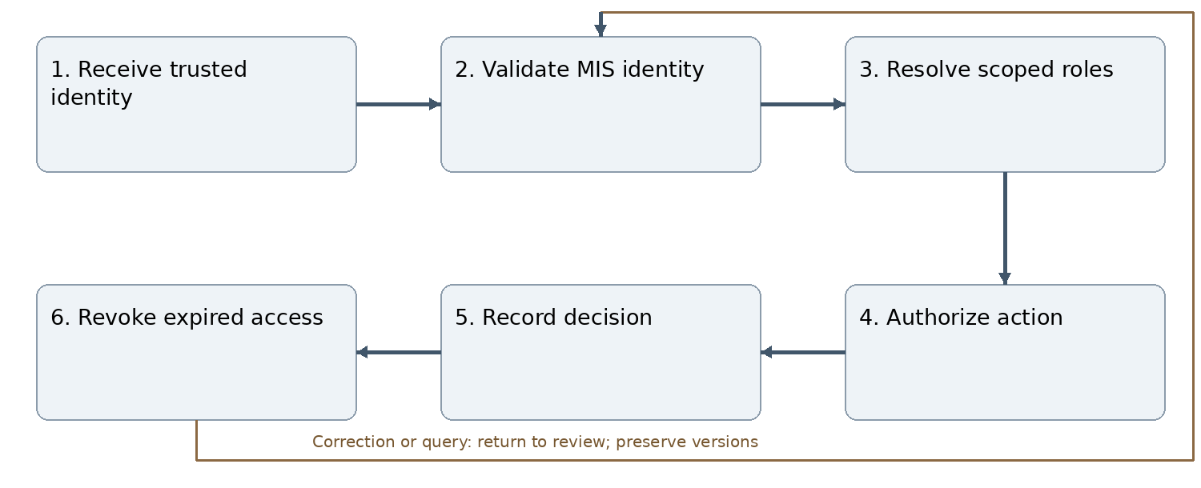
Figure J01 Normal workflow and correction path
KCC users use approved E-Digital Nepal SSO; no invented endpoint or routine local-password bypass. Role grants require scope, effective dates and source authority. Student Affairs appointment letter and approved committee decision precede system-manager activation of a club President. Presidents delegate only approved club role templates; never institutional signing or financial authority.
Inputs and outputs: Receive trusted identity produces a linked, versioned record; the workflow ends with revoke expired access. All decisions retain actor, scope, source record, exact version, time, reason and current status.
Connections: C001 M02; C002 M06; C003 M08; C004 M14; C005 M20; C006 M22; C007 M23; C008 M25; C009 M26; C010 M29; C011 M30.
Acceptance reference: AT-M01. Deny unauthorized or stale-version transitions without mutation. Return/reject with reasons; retain history and prevent duplicate side effects. See Annex L for module-specific expected behavior.

M02 Academic structure and master data
Accountable roles: Academic Administration and MIS owner.
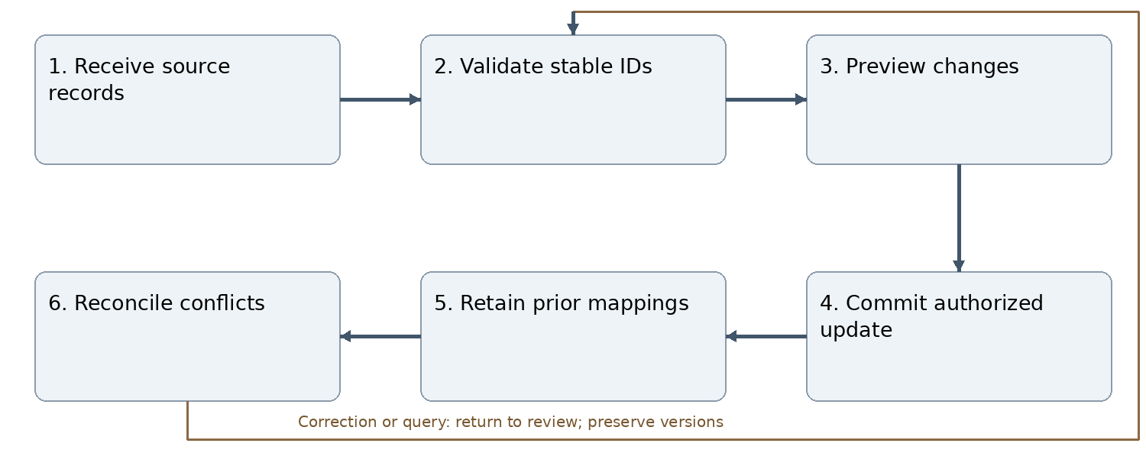
Figure J02 Normal workflow and correction path
Maintain departments, programmes, batches, semesters, sections, offerings and effective faculty assignments. Bulk semester progression excludes only official Left College cases effective on the progression date; fees, attendance and backlogs do not block progression. Final-semester handling remains separate. Unavailable source mappings enter reconciliation. Before API availability, authorized staff manually export official MIS records and import files under Annex Q. Imported records remain MIS-sourced and use the same stable mappings as the future adapter.
Inputs and outputs: Receive source records produces a linked, versioned record; the workflow ends with reconcile conflicts. All decisions retain actor, scope, source record, exact version, time, reason and current status.
Connections: C001 M01; C012 M03; C013 M04; C014 M14; C015 M19; C016 M24; C017 M28; C018 M30; C019 M31; C020 M34.
Acceptance reference: AT-M02. Deny unauthorized or stale-version transitions without mutation. Return/reject with reasons; retain history and prevent duplicate side effects. See Annex L for module-specific expected behavior.

M03 Semester learning activities
Accountable roles: Subject teacher or designated activity owner.
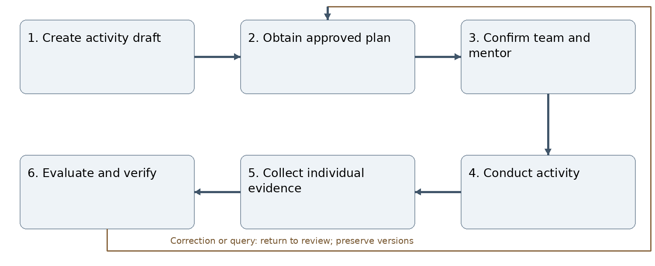
Figure J03 Normal workflow and correction path
Support course/class and institutional workshops, subject/research seminars, organized conferences, visits and other activities. Distinguish conference organization from external attendance. Store event scope separately from participant eligibility. Assign lead and mentor before execution. Plan approval uses M30, including zero-cost plans. Academic workshop/seminar tasks are directly assigned by the responsible Academic Department and assigned teacher/mentor using the class roster, not competitive student applications; see ASG-001.
Inputs and outputs: Create activity draft produces a linked, versioned record; the workflow ends with evaluate and verify. All decisions retain actor, scope, source record, exact version, time, reason and current status.
Connections: C012 M02; C021 M04; C022 M05; C023 M14; C024 M15; C025 M19; C026 M28; C027 M30; C028 M35.
Acceptance reference: AT-M03. Deny unauthorized or stale-version transitions without mutation. Return/reject with reasons; retain history and prevent duplicate side effects. See Annex L for module-specific expected behavior.

M04 Project management
Accountable roles: Student lead and Academic Department.
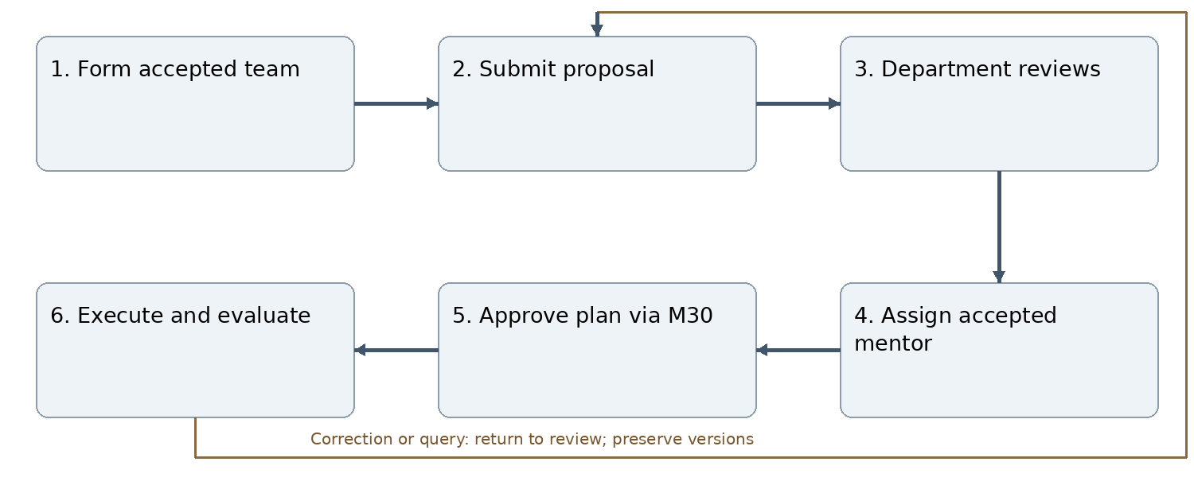
Figure J04 Normal workflow and correction path
Students invite eligible peers who accept membership. Course projects first reach assigned subject faculty under departmental oversight, or Academic Coordinator if unavailable. Department confirms mentor/evaluator. Research proposals forward through Academic Department to Research Department in M31. Keep one versioned proposal, current reviewer and independent approval decisions.
Inputs and outputs: Form accepted team produces a linked, versioned record; the workflow ends with execute and evaluate. All decisions retain actor, scope, source record, exact version, time, reason and current status.
Connections: C013 M02; C021 M03; C029 M05; C030 M14; C031 M15; C032 M30; C033 M31.
Acceptance reference: AT-M04. Deny unauthorized or stale-version transitions without mutation. Return/reject with reasons; retain history and prevent duplicate side effects. See Annex L for module-specific expected behavior.

M05 Task management
Accountable roles: Event or project lead and domain leads.
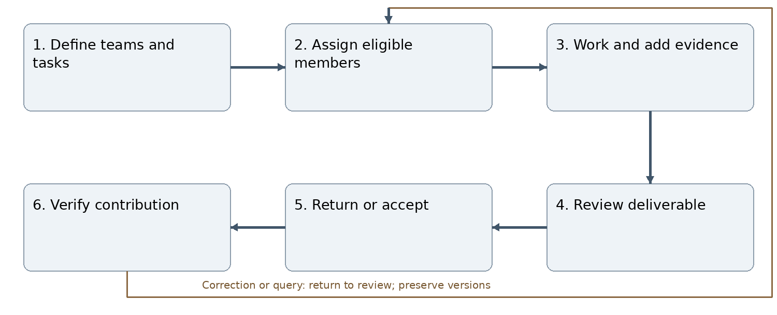
Figure J05 Normal workflow and correction path
Record number of teams, member capacity per team, lead, skills, deliverables, due dates, evidence and reviewer. Only confirmed activity participants receive assignments. TO_DO, IN_PROGRESS, UNDER_REVIEW and DONE remain execution states; blocked/overdue are separate flags. Reopening needs authority and reason.
Inputs and outputs: Define teams and tasks produces a linked, versioned record; the workflow ends with verify contribution. All decisions retain actor, scope, source record, exact version, time, reason and current status.
Connections: C022 M03; C029 M04; C034 M10; C035 M14; C036 M15; C037 M21; C038 M29; C039 M31; C040 M32; C041 M35.
Acceptance reference: AT-M05. Deny unauthorized or stale-version transitions without mutation. Return/reject with reasons; retain history and prevent duplicate side effects. See Annex L for module-specific expected behavior.

M06 Group and club membership
Accountable roles: Club membership reviewers.
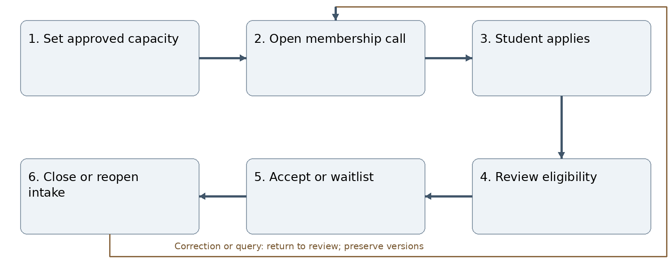
Figure J06 Normal workflow and correction path
Capacity counts accepted active members, not pending applications. Enforce concurrent acceptance atomically so the final vacancy cannot be allocated twice. Prevent duplicate active applications. Vacancies permit approved reopening or waitlist offers. Club membership alone grants neither event enrollment nor task access.
Inputs and outputs: Set approved capacity produces a linked, versioned record; the workflow ends with close or reopen intake. All decisions retain actor, scope, source record, exact version, time, reason and current status.
Connections: C002 M01; C042 M07; C043 M08; C044 M10; C045 M24.
Acceptance reference: AT-M06. Deny unauthorized or stale-version transitions without mutation. Return/reject with reasons; retain history and prevent duplicate side effects. See Annex L for module-specific expected behavior.

M07 Club lifecycle
Accountable roles: Student Affairs and club mentor.
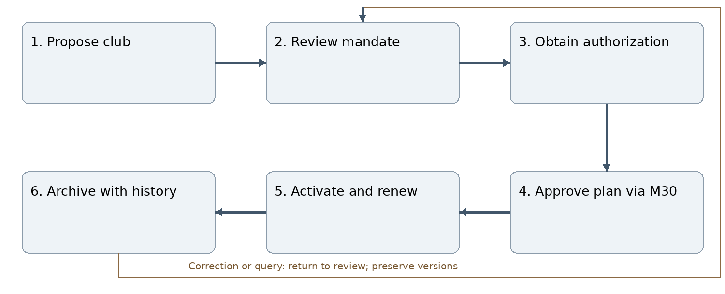
Figure J07 Normal workflow and correction path
Retain existing activation/renewal safeguards without circular prerequisites. Club formation authority remains distinct from plan approval. Suspension blocks new ordinary execution while allowing authorized handover and settlement. Archival retains all historical membership, work, evaluations and obligations.
Inputs and outputs: Propose club produces a linked, versioned record; the workflow ends with archive with history. All decisions retain actor, scope, source record, exact version, time, reason and current status.
Connections: C042 M06; C046 M08; C047 M09; C048 M12; C049 M13; C050 M30.
Acceptance reference: AT-M07. Deny unauthorized or stale-version transitions without mutation. Return/reject with reasons; retain history and prevent duplicate side effects. See Annex L for module-specific expected behavior.

M08 Club governance and leadership
Accountable roles: Student Affairs and system manager.
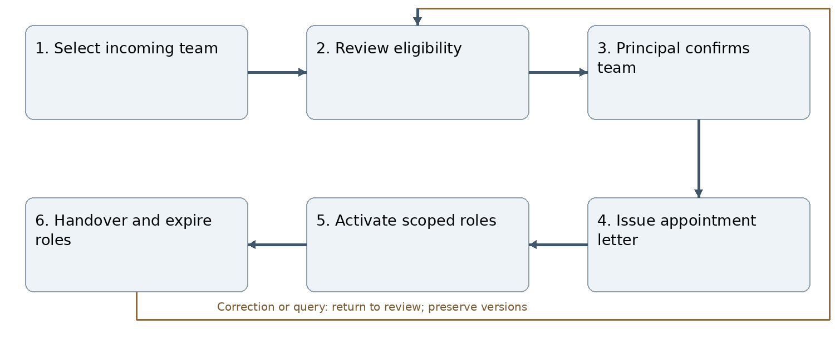
Figure J08 Normal workflow and correction path
Executive committee has 9–11 members selected from approved club membership. Complete incoming selection three months before expiry. President is in semester six at appointment; later progression does not end the term. Student Affairs reviews and Principal confirms committee; this personnel decision is separate from M30 plan review. All semester-six club members mentor juniors. Preparation access cannot transfer current accountability early.
Inputs and outputs: Select incoming team produces a linked, versioned record; the workflow ends with handover and expire roles. All decisions retain actor, scope, source record, exact version, time, reason and current status.
Connections: C003 M01; C043 M06; C046 M07; C051 M09; C052 M12; C053 M13; C054 M14; C055 M20; C056 M23; C057 M33.
Acceptance reference: AT-M08. Deny unauthorized or stale-version transitions without mutation. Return/reject with reasons; retain history and prevent duplicate side effects. See Annex L for module-specific expected behavior.

M09 Club strategic and annual planning
Accountable roles: Club President and mentor.
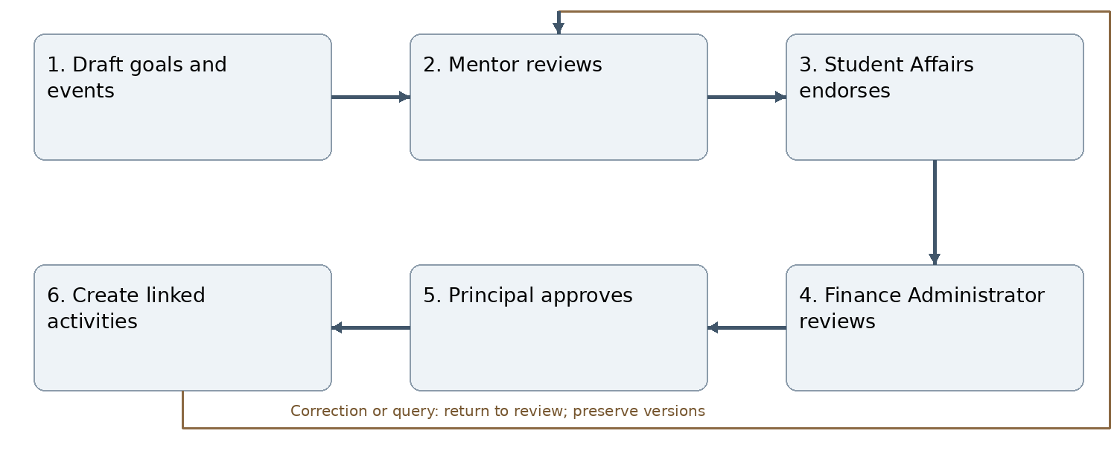
Figure J09 Normal workflow and correction path
Record targets, event calendar, responsibilities, resources, funding and evidence rules. Every club plan and revised plan follows M30. Plan conversion is idempotent; approved annual envelopes do not automatically approve later material event changes. Preserve outgoing commitments and links to successor plans.
Inputs and outputs: Draft goals and events produces a linked, versioned record; the workflow ends with create linked activities. All decisions retain actor, scope, source record, exact version, time, reason and current status.
Connections: C047 M07; C051 M08; C058 M10; C059 M11; C060 M13; C061 M30.
Acceptance reference: AT-M09. Deny unauthorized or stale-version transitions without mutation. Return/reject with reasons; retain history and prevent duplicate side effects. See Annex L for module-specific expected behavior.

M10 Club activities and events
Accountable roles: Club event lead and mentor.
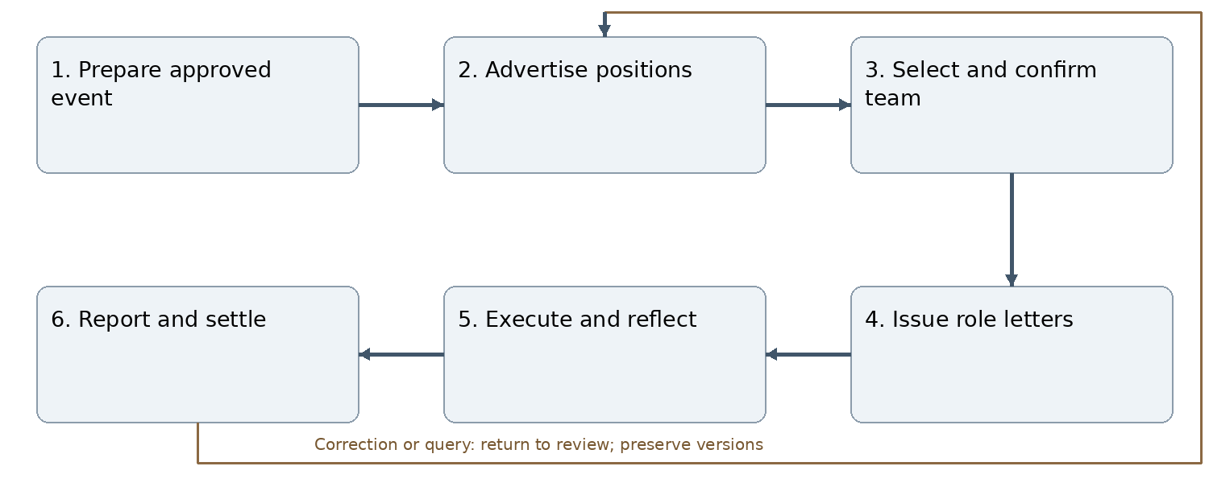
Figure J10 Normal workflow and correction path
Record task-domain capacities and application deadlines. Support same-domain/cross-domain eligibility with authorized wider recruitment. Applications and selection alone do not enroll students; confirmed roster handoff does. All-member mode does not imply verified achievement. Generate letters only after roster approval. Report route: committee, mentor, Student Affairs, Principal, Finance.
Inputs and outputs: Prepare approved event produces a linked, versioned record; the workflow ends with report and settle. All decisions retain actor, scope, source record, exact version, time, reason and current status.
Connections: C034 M05; C044 M06; C058 M09; C062 M11; C063 M12; C064 M14; C065 M15; C066 M30; C067 M32; C068 M33; C069 M35.
Acceptance reference: AT-M10. Deny unauthorized or stale-version transitions without mutation. Return/reject with reasons; retain history and prevent duplicate side effects. See Annex L for module-specific expected behavior.

M11 Club budgets and resources
Accountable roles: Finance Administrator and financial verifier.
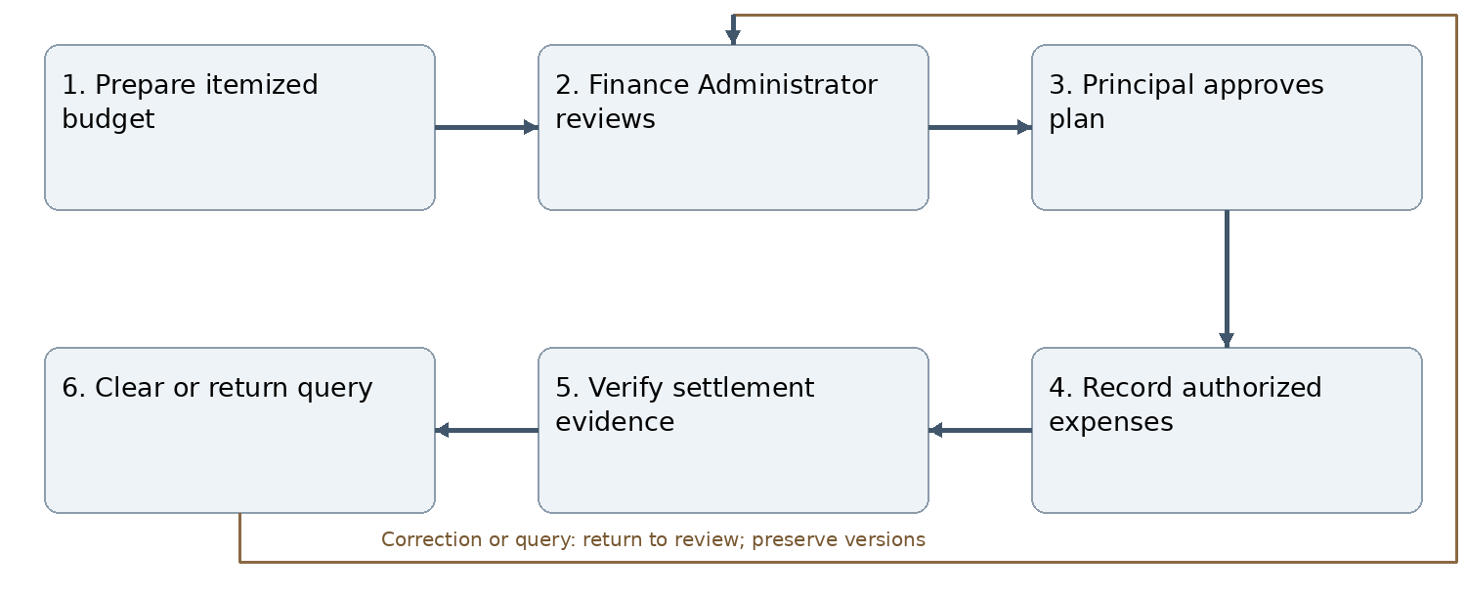
Figure J11 Normal workflow and correction path
M30 approval is required before planned expenditure. Record currency, quantity, unit cost, funding, approved amount, advances, invoices and variance. Overspend or material revision returns through M30. Payment follows separate approved financial controls; this module is not a bank ledger. Event closure needs financial clearance or authorized waiver; student learning verification may proceed earlier.
Inputs and outputs: Prepare itemized budget produces a linked, versioned record; the workflow ends with clear or return query. All decisions retain actor, scope, source record, exact version, time, reason and current status.
Connections: C059 M09; C062 M10; C070 M13; C071 M25; C072 M27; C073 M30; C074 M32.
Acceptance reference: AT-M11. Deny unauthorized or stale-version transitions without mutation. Return/reject with reasons; retain history and prevent duplicate side effects. See Annex L for module-specific expected behavior.

M12 Club portfolio and institutional memory
Accountable roles: Club mentor and authorized publisher.
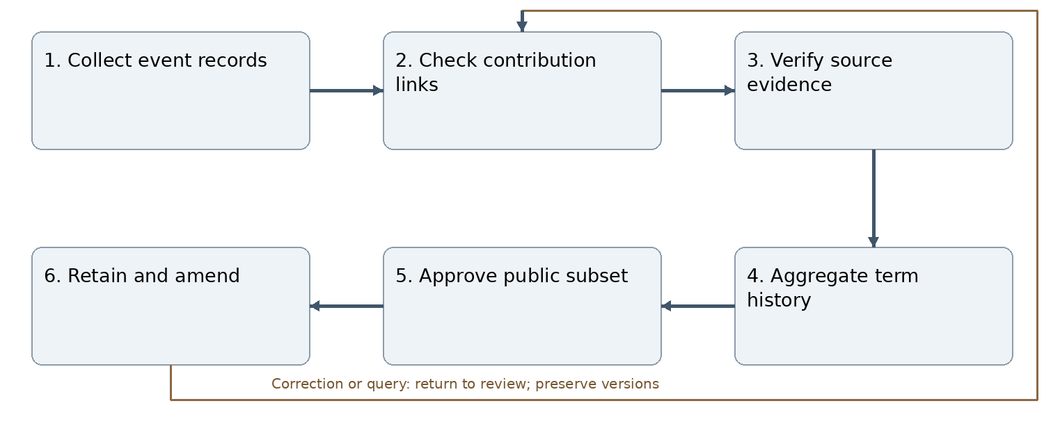
Figure J12 Normal workflow and correction path
Retain plans, committee work, activities, partnerships, evaluations, finance references and handover by term. Sensitive finance and individual evaluations remain internal. Verified records are corrected through versioned amendment; public removal does not delete the institutional record.
Inputs and outputs: Collect event records produces a linked, versioned record; the workflow ends with retain and amend. All decisions retain actor, scope, source record, exact version, time, reason and current status.
Connections: C048 M07; C052 M08; C063 M10; C075 M13; C076 M17; C077 M18; C078 M27; C079 M33.
Acceptance reference: AT-M12. Deny unauthorized or stale-version transitions without mutation. Return/reject with reasons; retain history and prevent duplicate side effects. See Annex L for module-specific expected behavior.

M13 Club evaluation annual review and handover
Accountable roles: Club mentor and Student Affairs.
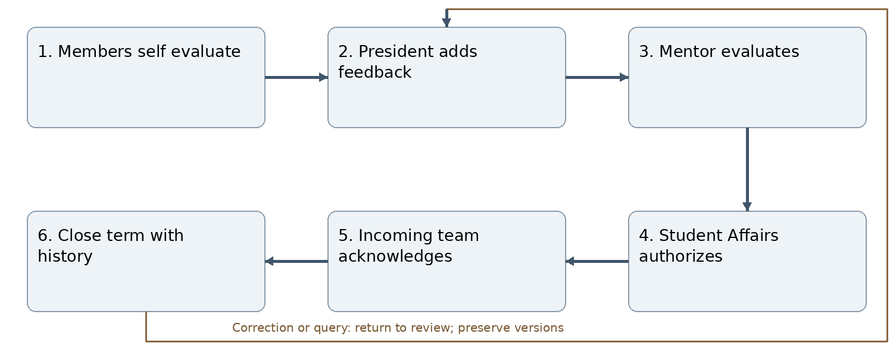
Figure J13 Normal workflow and correction path
Evaluate each member and the committee against approved responsibilities, knowledge, skills, leadership, impact, engagement, finance and handover quality. Mentor or authorized alternate evaluates President; no self-finalization. Record pending tasks, assets, settlements and partnership commitments. Preserve outgoing responsibilities after handover; renewal plans still use M30.
Inputs and outputs: Members self evaluate produces a linked, versioned record; the workflow ends with close term with history. All decisions retain actor, scope, source record, exact version, time, reason and current status.
Connections: C049 M07; C053 M08; C060 M09; C070 M11; C075 M12; C080 M14; C081 M27; C082 M33; C083 M35.
Acceptance reference: AT-M13. Deny unauthorized or stale-version transitions without mutation. Return/reject with reasons; retain history and prevent duplicate side effects. See Annex L for module-specific expected behavior.

M14 Mentorship and evaluation
Accountable roles: Assignment authority and human evaluator.
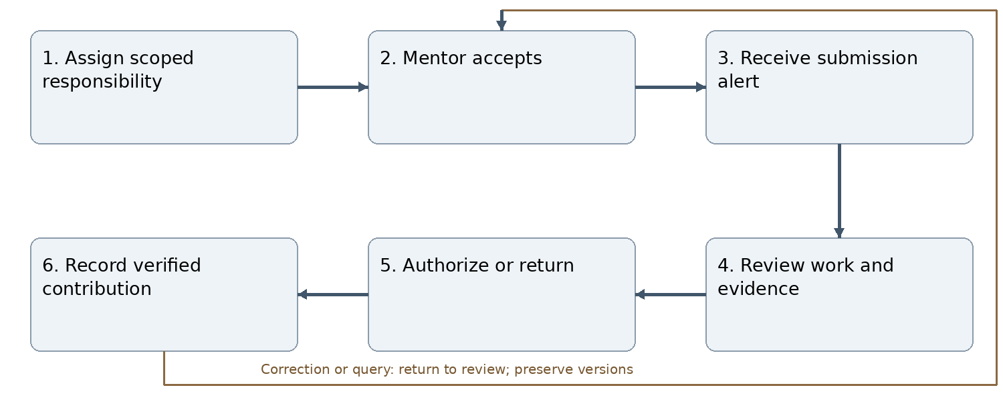
Figure J14 Normal workflow and correction path
One faculty account may hold subject teacher, club mentor, academic/research mentor, event lead, evaluator, HoD and coordinator roles with separate scope and dates. Assign evaluator before submissions open. Authorized reassignment preserves history. Event leadership alone confers no scoring power. Monitor workload and timeliness; formal HR appraisal remains deferred.
Inputs and outputs: Assign scoped responsibility produces a linked, versioned record; the workflow ends with record verified contribution. All decisions retain actor, scope, source record, exact version, time, reason and current status.
Connections: C004 M01; C014 M02; C023 M03; C030 M04; C035 M05; C054 M08; C064 M10; C080 M13; C084 M15; C085 M16; C086 M22; C087 M26; C088 M28; C089 M29; C090 M31; C091 M32; C092 M34.
Acceptance reference: AT-M14. Deny unauthorized or stale-version transitions without mutation. Return/reject with reasons; retain history and prevent duplicate side effects. See Annex L for module-specific expected behavior.

M15 Reflection and learning assessment
Accountable roles: Student and assigned human evaluator.
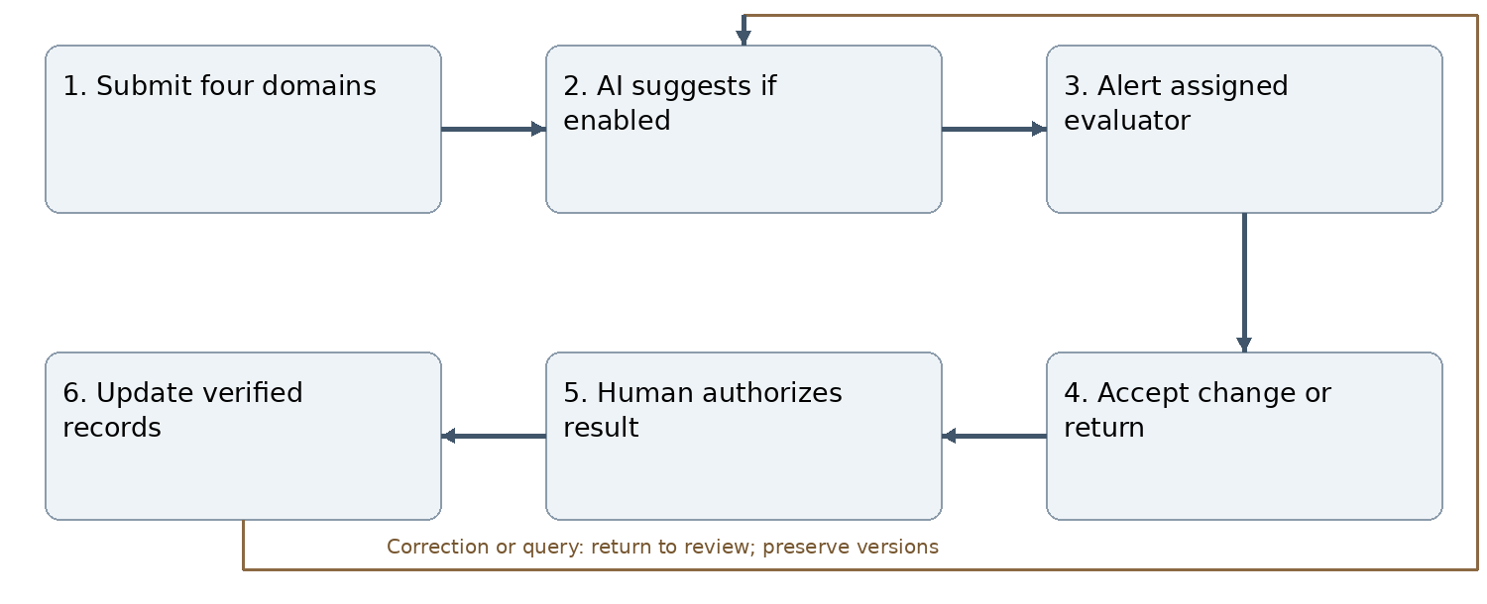
Figure J15 Normal workflow and correction path
Require knowledge, skills, leadership and impact sections with task-linked evidence. External achievements may use justified not-applicable domains under approved rubric. Retain challenges and solutions as supporting reflection. AI is advisory; failure permits human review. Record score changes, reasons, rubric/model/prompt versions and timestamps. No evaluator finalizes own result.
Inputs and outputs: Submit four domains produces a linked, versioned record; the workflow ends with update verified records. All decisions retain actor, scope, source record, exact version, time, reason and current status.
Connections: C024 M03; C031 M04; C036 M05; C065 M10; C084 M14; C093 M16; C094 M18; C095 M19; C096 M20; C097 M22; C098 M25; C099 M31; C100 M34.
Acceptance reference: AT-M15. Deny unauthorized or stale-version transitions without mutation. Return/reject with reasons; retain history and prevent duplicate side effects. See Annex L for module-specific expected behavior.

M16 Certification
Accountable roles: Authorized certificate issuer.
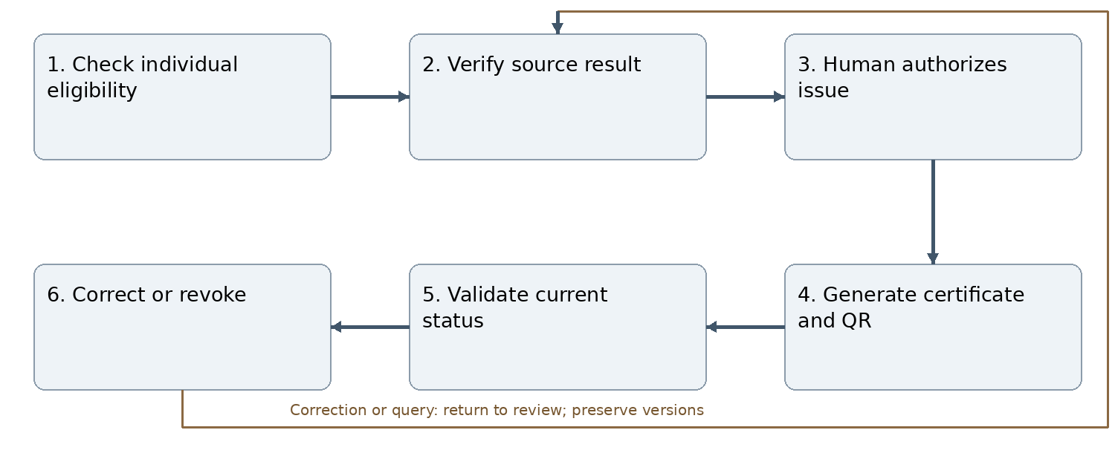
Figure J16 Normal workflow and correction path
Only verified individual contribution and approved eligibility permit issuance. No automatic certificate from enrollment, AI score or group membership. Replacements link to superseded versions; revoked/expired credentials never validate as current. External credentials retain their external issuer and are not reissued as KCC qualifications.
Inputs and outputs: Check individual eligibility produces a linked, versioned record; the workflow ends with correct or revoke. All decisions retain actor, scope, source record, exact version, time, reason and current status.
Connections: C085 M14; C093 M15; C101 M17; C102 M18; C103 M34.
Acceptance reference: AT-M16. Deny unauthorized or stale-version transitions without mutation. Return/reject with reasons; retain history and prevent duplicate side effects. See Annex L for module-specific expected behavior.

M17 Digital portfolio and CV
Accountable roles: Student and authorized verifier.
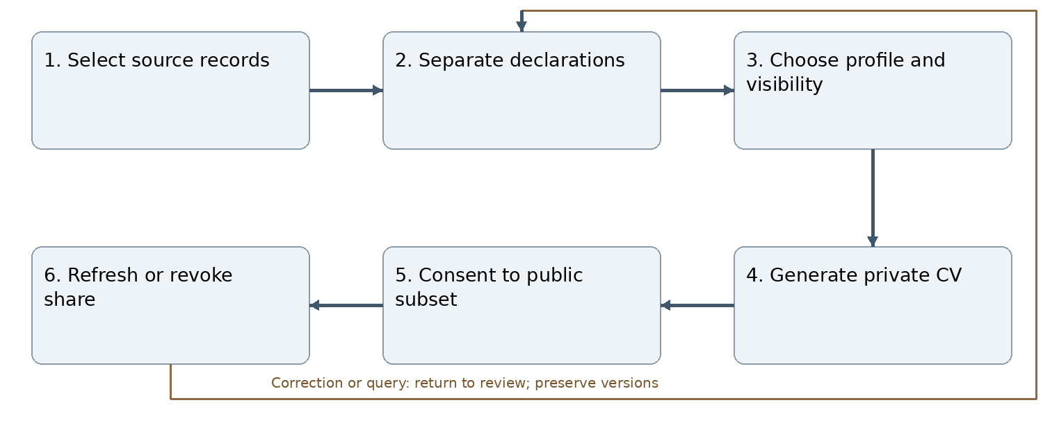
Figure J17 Normal workflow and correction path
Students can edit self-declared CV details without changing verified records. Distinguish declared, verification-pending, externally verified and KCC-verified evidence. Support lead achievements, professional credentials and verified roles. Recheck permissions at export and sharing; public QR uses minimal revocable references.
Inputs and outputs: Select source records produces a linked, versioned record; the workflow ends with refresh or revoke share. All decisions retain actor, scope, source record, exact version, time, reason and current status.
Connections: C076 M12; C101 M16; C104 M18; C105 M19; C106 M34.
Acceptance reference: AT-M17. Deny unauthorized or stale-version transitions without mutation. Return/reject with reasons; retain history and prevent duplicate side effects. See Annex L for module-specific expected behavior.

M18 Integrated portfolio lifecycle
Accountable roles: Evidence verifier and portfolio owner.
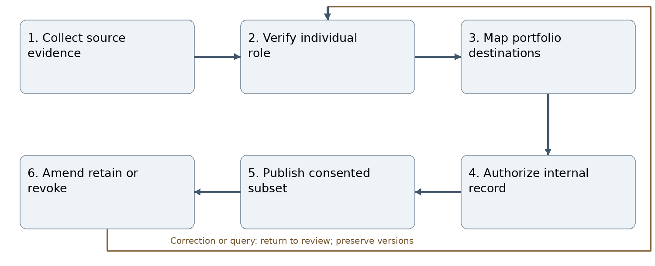
Figure J18 Normal workflow and correction path
Explicit destinations include student, lead contribution, mentor/faculty, club, department and institution. One shared evidence source may serve several portfolios without double counting institutional totals. Verification, public visibility and retention are independent. Pending financial settlement must not automatically block individually eligible recognition.
Inputs and outputs: Collect source evidence produces a linked, versioned record; the workflow ends with amend retain or revoke. All decisions retain actor, scope, source record, exact version, time, reason and current status.
Connections: C077 M12; C094 M15; C102 M16; C104 M17; C107 M19; C108 M25; C109 M27; C110 M31; C111 M32; C112 M34.
Acceptance reference: AT-M18. Deny unauthorized or stale-version transitions without mutation. Return/reject with reasons; retain history and prevent duplicate side effects. See Annex L for module-specific expected behavior.

M19 Semester student learning portfolio
Accountable roles: Student and academic coordinator.
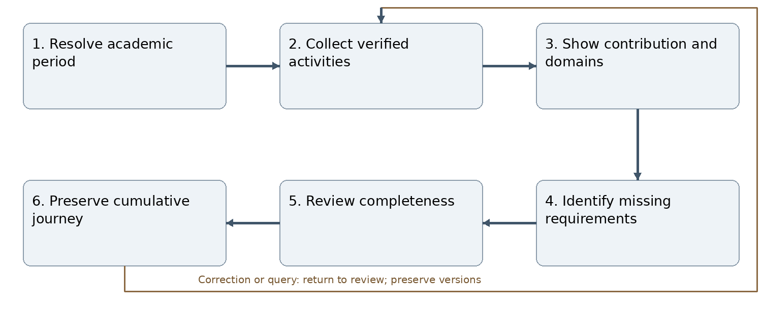
Figure J19 Normal workflow and correction path
Use historical activity dates and enrollment mappings. Include verified external achievements earned during enrollment, with external issuer and recognition status. Do not remap old records when a cohort progresses. Completeness uses applicable required items and distinguishes missing from zero.
Inputs and outputs: Resolve academic period produces a linked, versioned record; the workflow ends with preserve cumulative journey. All decisions retain actor, scope, source record, exact version, time, reason and current status.
Connections: C015 M02; C025 M03; C095 M15; C105 M17; C107 M18; C113 M28; C114 M34.
Acceptance reference: AT-M19. Deny unauthorized or stale-version transitions without mutation. Return/reject with reasons; retain history and prevent duplicate side effects. See Annex L for module-specific expected behavior.

M20 Notification and communication triggers
Accountable roles: Workflow event producer.
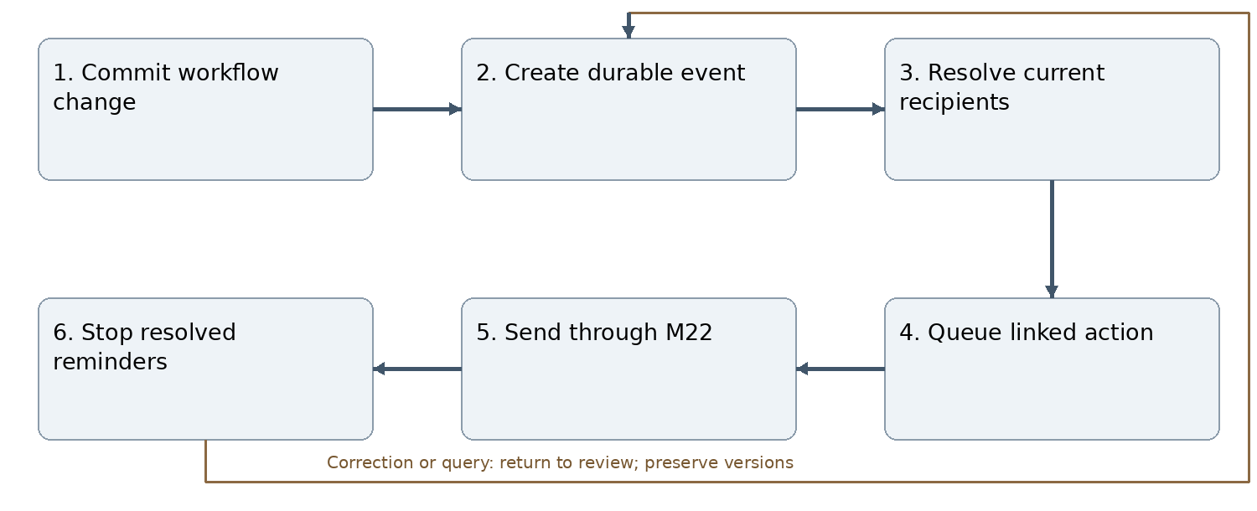
Figure J20 Normal workflow and correction path
This is the trigger layer, not a second inbox. Events include membership capacity, succession deadlines, applications, invitations, assignments, Principal review, reflections and report returns. Use persistent IDs and recipient/version deduplication. Resolve effective scope at delivery; stale approval notices cannot authorize action. Also produce exact-version approved-calendar, target-allocation, review and corrective-action events under STR-004 and ME-005.
Inputs and outputs: Commit workflow change produces a linked, versioned record; the workflow ends with stop resolved reminders. All decisions retain actor, scope, source record, exact version, time, reason and current status.
Connections: C005 M01; C055 M08; C096 M15; C115 M21; C116 M22; C117 M24; C118 M29; C119 M30.
Acceptance reference: AT-M20. Deny unauthorized or stale-version transitions without mutation. Return/reject with reasons; retain history and prevent duplicate side effects. See Annex L for module-specific expected behavior.

M21 Contextual messaging and collaboration
Accountable roles: Authorized record participants.
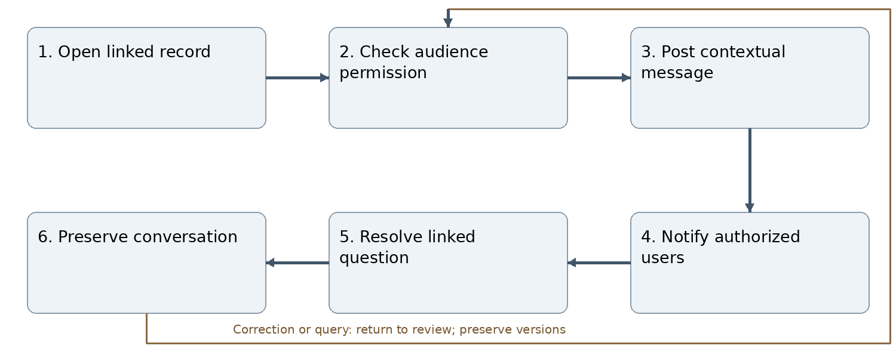
Figure J21 Normal workflow and correction path
Restrict discussion to the linked plan, activity, task, reflection, budget or report. Messages do not substitute for formal decisions or meeting minutes. No unrestricted social chat, voice or video calling. Recheck attachment and recipient access; record correction history.
Inputs and outputs: Open linked record produces a linked, versioned record; the workflow ends with preserve conversation. All decisions retain actor, scope, source record, exact version, time, reason and current status.
Connections: C037 M05; C115 M20; C120 M22; C121 M25; C122 M35.
Acceptance reference: AT-M21. Deny unauthorized or stale-version transitions without mutation. Return/reject with reasons; retain history and prevent duplicate side effects. See Annex L for module-specific expected behavior.

M22 Notification Centre and escalation
Accountable roles: Notification service and action owner.
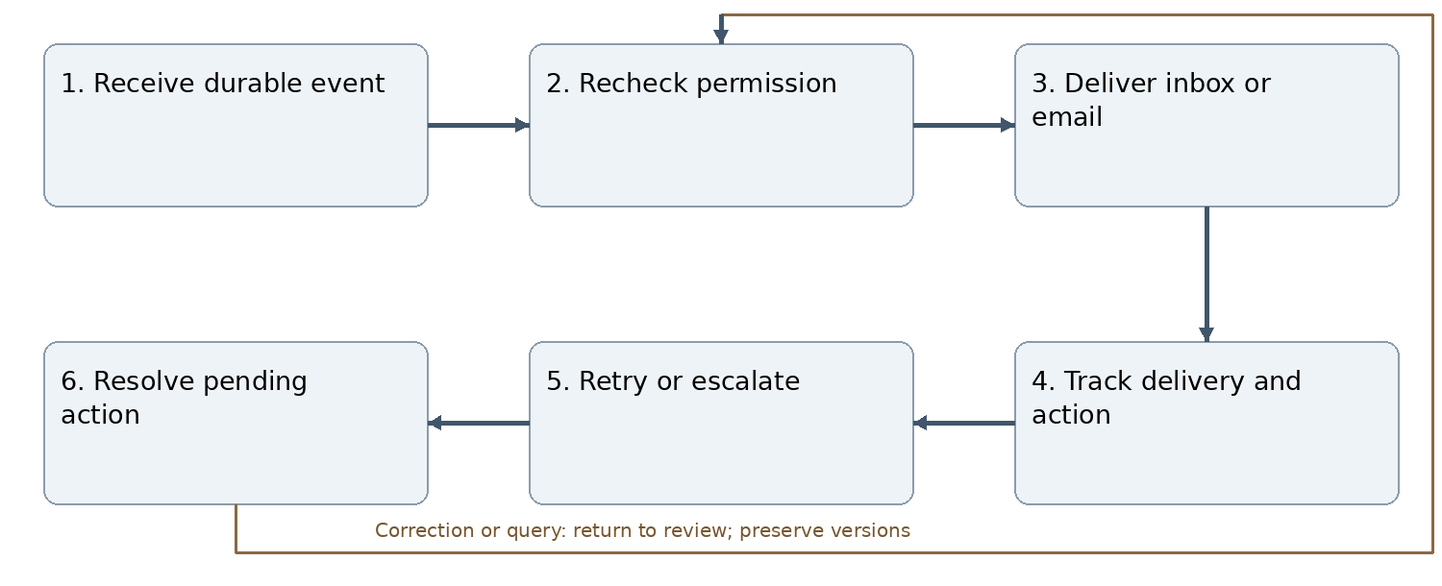
Figure J22 Normal workflow and correction path
This is the delivery/escalation layer used by M20. In-app action persists after email failure. Read, acknowledgment and action completion differ. Escalate through configured owners without inventing authority; stop escalation when resolved. Pending evaluation alerts identify current assigned mentor.
Inputs and outputs: Receive durable event produces a linked, versioned record; the workflow ends with resolve pending action. All decisions retain actor, scope, source record, exact version, time, reason and current status.
Connections: C006 M01; C086 M14; C097 M15; C116 M20; C120 M21; C123 M24; C124 M26; C125 M29; C126 M30; C127 M35.
Acceptance reference: AT-M22. Deny unauthorized or stale-version transitions without mutation. Return/reject with reasons; retain history and prevent duplicate side effects. See Annex L for module-specific expected behavior.

M23 Controlled documents and My Documents
Accountable roles: Document controller and approver.
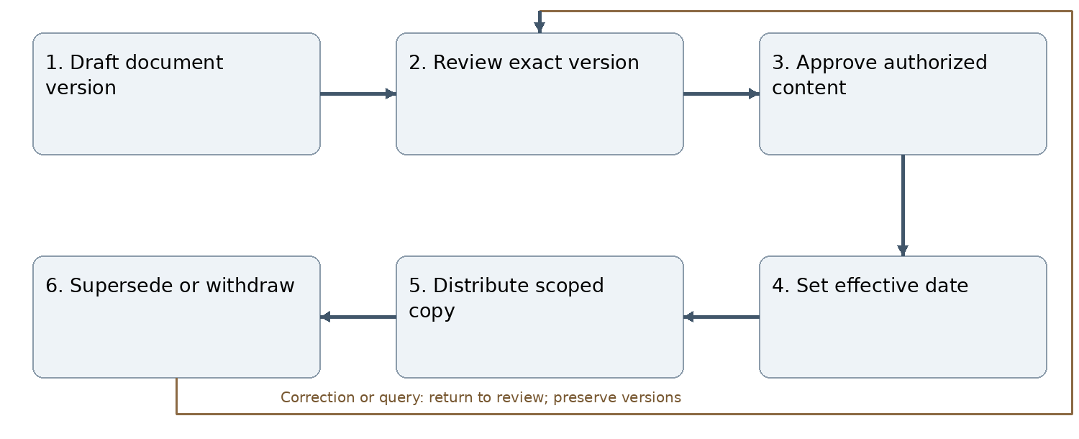
Figure J23 Normal workflow and correction path
Maintain SOPs, templates and formal appointment letters with reference, issuer, signatory, role and dates. Auto-generation follows the approved appointment; never fabricate a signature. Principal approval of plans is not blanket approval of every document. Preserve original university-issued content and local instructions separately.
Inputs and outputs: Draft document version produces a linked, versioned record; the workflow ends with supersede or withdraw. All decisions retain actor, scope, source record, exact version, time, reason and current status.
Connections: C007 M01; C056 M08; C128 M24; C129 M25; C130 M30; C131 M33.
Acceptance reference: AT-M23. Deny unauthorized or stale-version transitions without mutation. Return/reject with reasons; retain history and prevent duplicate side effects. See Annex L for module-specific expected behavior.

M24 Notices and announcements
Accountable roles: Authorized publisher.
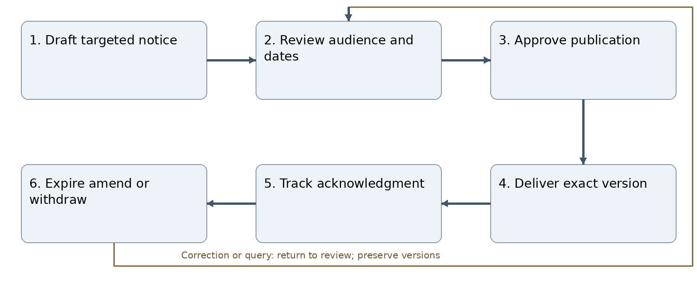
Figure J24 Normal workflow and correction path
Target institution, programme, semester, club or individual using current permission and approved eligibility. Recruitment notices link to applications but do not enroll students. External public listings require separate publication controls and must not expose private participant identity.
Inputs and outputs: Draft targeted notice produces a linked, versioned record; the workflow ends with expire amend or withdraw. All decisions retain actor, scope, source record, exact version, time, reason and current status.
Connections: C016 M02; C045 M06; C117 M20; C123 M22; C128 M23; C132 M33.
Acceptance reference: AT-M24. Deny unauthorized or stale-version transitions without mutation. Return/reject with reasons; retain history and prevent duplicate side effects. See Annex L for module-specific expected behavior.

M25 File management
Accountable roles: Uploader and record custodian.
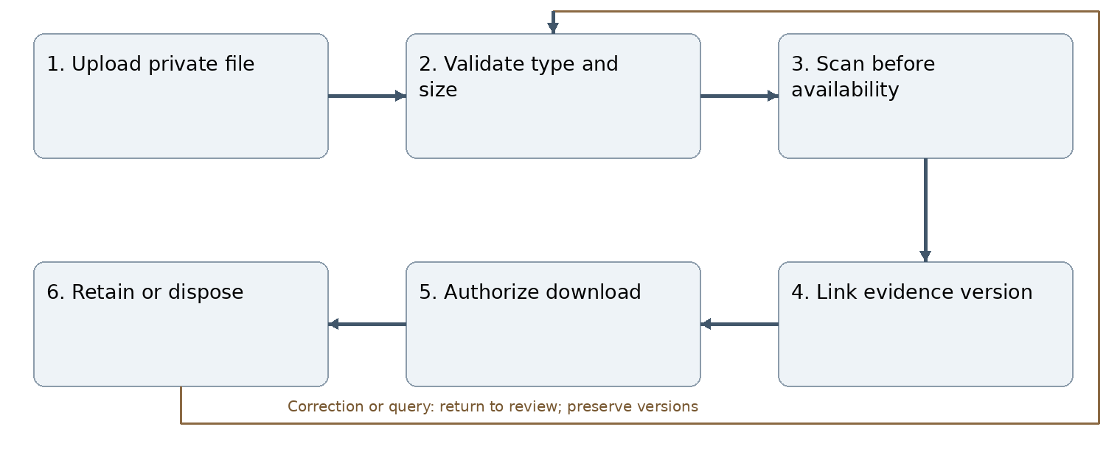
Figure J25 Normal workflow and correction path
Enforce MIME/type allowlist, size, malware checks and record-level access for every download. Storage IDs are not authorization. Preserve evidence versions and source references; research confidentiality and retention rules apply. Scanning failures keep files unavailable.
Inputs and outputs: Upload private file produces a linked, versioned record; the workflow ends with retain or dispose. All decisions retain actor, scope, source record, exact version, time, reason and current status.
Connections: C008 M01; C071 M11; C098 M15; C108 M18; C121 M21; C129 M23; C133 M31; C134 M34.
Acceptance reference: AT-M25. Deny unauthorized or stale-version transitions without mutation. Return/reject with reasons; retain history and prevent duplicate side effects. See Annex L for module-specific expected behavior.

M26 Role based dashboards
Accountable roles: Scoped dashboard user.
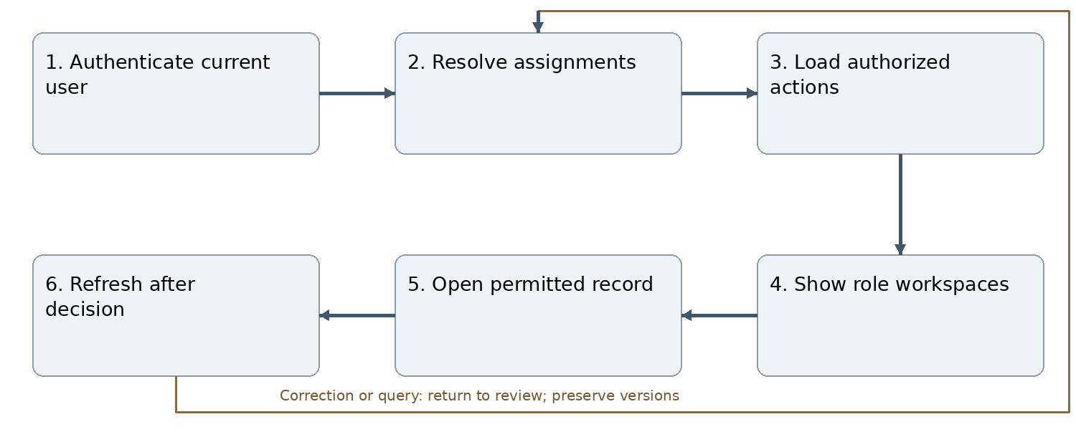
Figure J26 Normal workflow and correction path
One account supports multiple distinct responsibilities. Principal sees plan decisions; Finance Administrator sees preceding review; mentors see assigned evaluations; club President sees only authorized club management. Show factual follow-up reasons, not unapproved inactive/critical labels. Each role dashboard exposes monitoring and evaluation results appropriate to its current scope, with finalization buttons only for assigned evaluators.
Inputs and outputs: Authenticate current user produces a linked, versioned record; the workflow ends with refresh after decision. All decisions retain actor, scope, source record, exact version, time, reason and current status.
Connections: C009 M01; C087 M14; C124 M22; C135 M27; C136 M28; C137 M29; C138 M30.
Acceptance reference: AT-M26. Deny unauthorized or stale-version transitions without mutation. Return/reject with reasons; retain history and prevent duplicate side effects. See Annex L for module-specific expected behavior.

M27 Club and portfolio analytics
Accountable roles: Authorized analyst and Student Affairs.
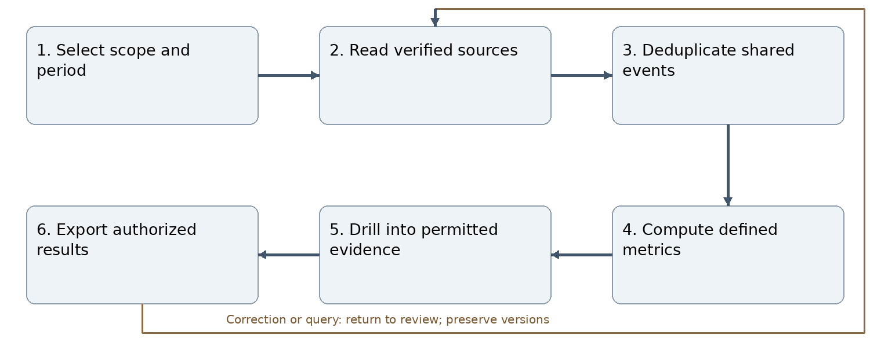
Figure J27 Normal workflow and correction path
Report plans versus outcomes, committee contributions, partnerships, engagement, budget variance and portfolio completion. Shared interclub events count once at institutional level. Label estimated beneficiaries, declarations and pending verification separately. Deny confidential drill-down without permission.
Inputs and outputs: Select scope and period produces a linked, versioned record; the workflow ends with export authorized results. All decisions retain actor, scope, source record, exact version, time, reason and current status.
Connections: C072 M11; C078 M12; C081 M13; C109 M18; C135 M26; C139 M32; C140 M33.
Acceptance reference: AT-M27. Deny unauthorized or stale-version transitions without mutation. Return/reject with reasons; retain history and prevent duplicate side effects. See Annex L for module-specific expected behavior.

M28 Academic dashboards
Accountable roles: HoD programme coordinator and advisor.
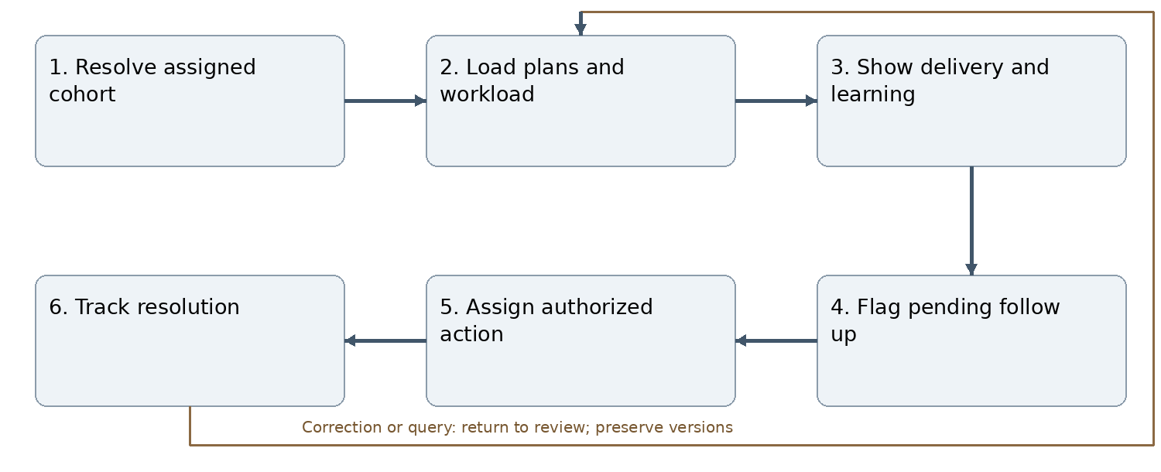
Figure J28 Normal workflow and correction path
Show faculty roles, schedule overlaps, vacancies, missing reflections, pending evaluations and reports. Class Advisor view is a scoped development view, not automatic project approval/evaluation access. Department portfolio summarizes verified evidence; maintain boundaries of confidential counseling and HR records.
Inputs and outputs: Resolve assigned cohort produces a linked, versioned record; the workflow ends with track resolution. All decisions retain actor, scope, source record, exact version, time, reason and current status.
Connections: C017 M02; C026 M03; C088 M14; C113 M19; C136 M26; C141 M29; C142 M30; C143 M31.
Acceptance reference: AT-M28. Deny unauthorized or stale-version transitions without mutation. Return/reject with reasons; retain history and prevent duplicate side effects. See Annex L for module-specific expected behavior.

M29 Dashboard Action Centre
Accountable roles: Assigned action owner.
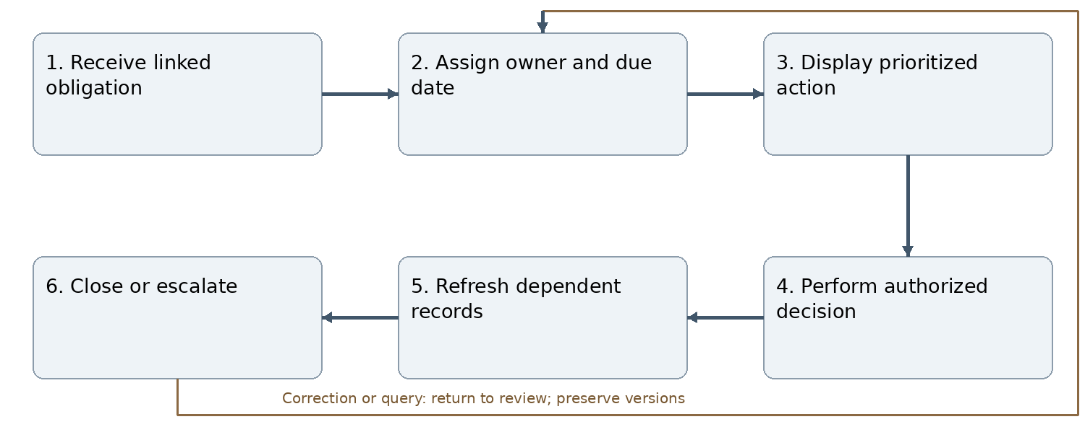
Figure J29 Normal workflow and correction path
Every action has source record/version, owner, due date and status. Priorities do not grant authority. Deep links revalidate current rights and versions. Keep financial review, Principal plan approval, mentor evaluation and publication actions distinct.
Inputs and outputs: Receive linked obligation produces a linked, versioned record; the workflow ends with close or escalate. All decisions retain actor, scope, source record, exact version, time, reason and current status.
Connections: C010 M01; C038 M05; C089 M14; C118 M20; C125 M22; C137 M26; C141 M28; C144 M30; C145 M35.
Acceptance reference: AT-M29. Deny unauthorized or stale-version transitions without mutation. Return/reject with reasons; retain history and prevent duplicate side effects. See Annex L for module-specific expected behavior.

M30 Academic and institutional planning
Accountable roles: Plan owner Finance Administrator and Principal.
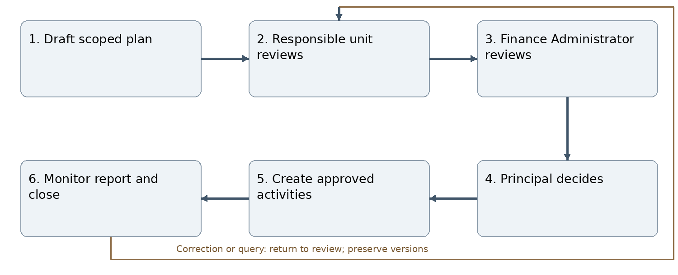
Figure J30 Normal workflow and correction path
All institutional, academic, course, club, research, joint-event and partnership plans, including zero-cost plans, require Finance Administrator review immediately before Principal final approval. Return/reject decisions retain reasons. Material changes create a new version and repeat review. No automatic payment, signing, publication or student scoring authority arises from plan approval. Approved plans remain locked; every addition, date extension or material amendment follows CR-001–CR-012 in Annex M. Submission never unlocks the baseline.
Inputs and outputs: Draft scoped plan produces a linked, versioned record; the workflow ends with monitor report and close. All decisions retain actor, scope, source record, exact version, time, reason and current status.
Connections: C011 M01; C018 M02; C027 M03; C032 M04; C050 M07; C061 M09; C066 M10; C073 M11; C119 M20; C126 M22; C130 M23; C138 M26; C142 M28; C144 M29; C146 M31; C147 M32; C148 M33; C149 M35.
Acceptance reference: AT-M30. Deny unauthorized or stale-version transitions without mutation. Return/reject with reasons; retain history and prevent duplicate side effects. See Annex L for module-specific expected behavior.

M31 Research project management
Accountable roles: Academic Department Research Department and faculty lead.
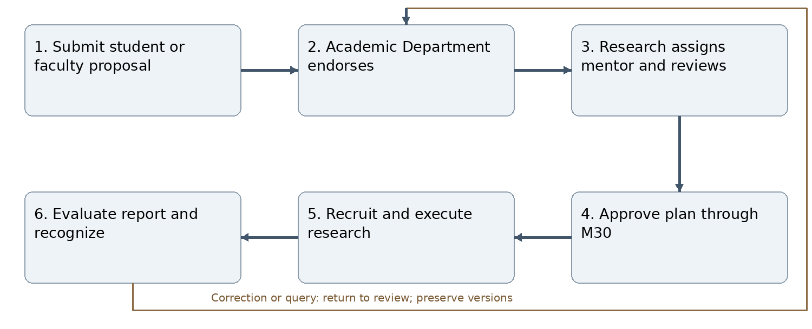
Figure J31 Normal workflow and correction path
Student research and faculty-led projects share one proposal across forwarding. Faculty projects record principal investigator, co-investigators, student leads, invited/applied students, consent, appointments and dates. Research Department coordinates multidisciplinary, ethics and safety review. Keep mentor acceptance and final approval distinct. Record actual authorship/acknowledgment contributions, confidentiality and IP policy. Independent reviewer assesses faculty lead outputs without creating HR appraisal.
Inputs and outputs: Submit student or faculty proposal produces a linked, versioned record; the workflow ends with evaluate report and recognize. All decisions retain actor, scope, source record, exact version, time, reason and current status.
Connections: C019 M02; C033 M04; C039 M05; C090 M14; C099 M15; C110 M18; C133 M25; C143 M28; C146 M30; C150 M35.
Acceptance reference: AT-M31. Deny unauthorized or stale-version transitions without mutation. Return/reject with reasons; retain history and prevent duplicate side effects. See Annex L for module-specific expected behavior.

M32 Interclub joint event management
Accountable roles: Coordinating club and participating mentors.
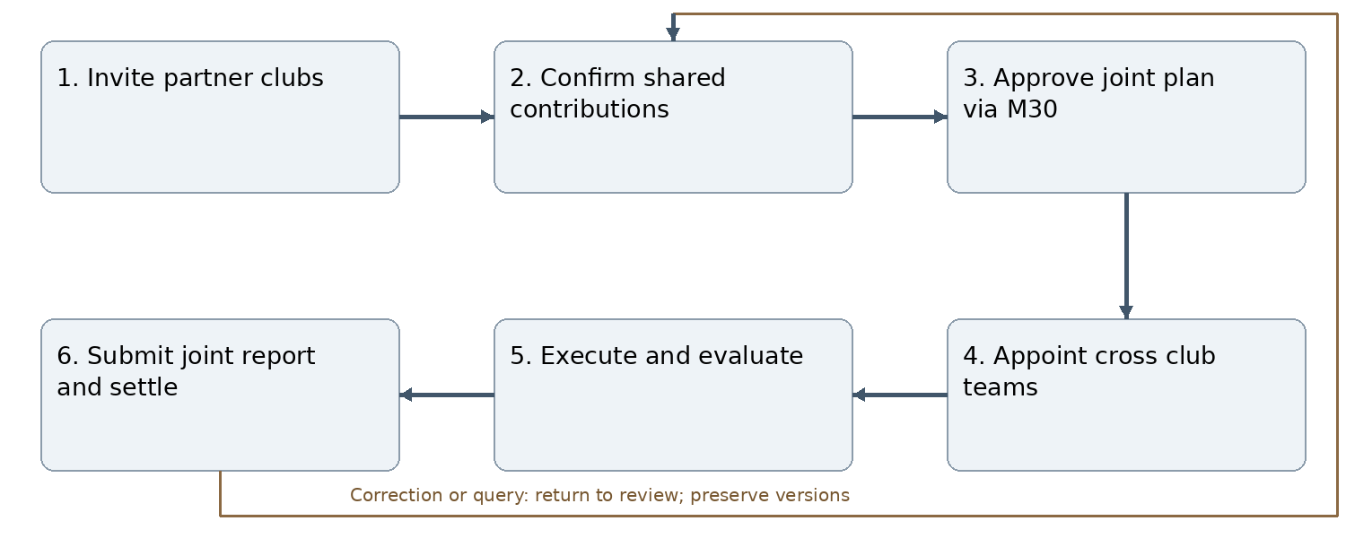
Figure J32 Normal workflow and correction path
Support KCC and approved external partner clubs. One owner, lead, lead mentor, event record, consolidated budget and joint report; each club has explicit obligations. Assign one accountable evaluator per student. Changes/withdrawals require approval and history. External accounts remain a controlled extension; participant records alone grant no login. Report through mentors, Student Affairs, Principal and Finance.
Inputs and outputs: Invite partner clubs produces a linked, versioned record; the workflow ends with submit joint report and settle. All decisions retain actor, scope, source record, exact version, time, reason and current status.
Connections: C040 M05; C067 M10; C074 M11; C091 M14; C111 M18; C139 M27; C147 M30; C151 M33; C152 M35.
Acceptance reference: AT-M32. Deny unauthorized or stale-version transitions without mutation. Return/reject with reasons; retain history and prevent duplicate side effects. See Annex L for module-specific expected behavior.

M33 Club partnership management
Accountable roles: Club mentor Student Affairs and authorized signatory.
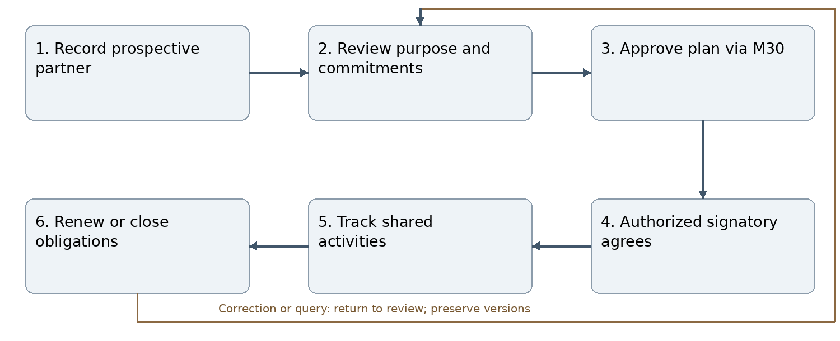
Figure J33 Normal workflow and correction path
Record national/international partner, country, contacts, objectives, costs, commitments, agreement term and approvals. Principal plan approval does not execute a contract. Only institutional signing authority binds KCC. Monitor deliverables, expiry and outstanding commitments; club committee handover preserves partner history.
Inputs and outputs: Record prospective partner produces a linked, versioned record; the workflow ends with renew or close obligations. All decisions retain actor, scope, source record, exact version, time, reason and current status.
Connections: C057 M08; C068 M10; C079 M12; C082 M13; C131 M23; C132 M24; C140 M27; C148 M30; C151 M32.
Acceptance reference: AT-M33. Deny unauthorized or stale-version transitions without mutation. Return/reject with reasons; retain history and prevent duplicate side effects. See Annex L for module-specific expected behavior.

M34 External achievement verification
Accountable roles: Student and category assigned reviewer.
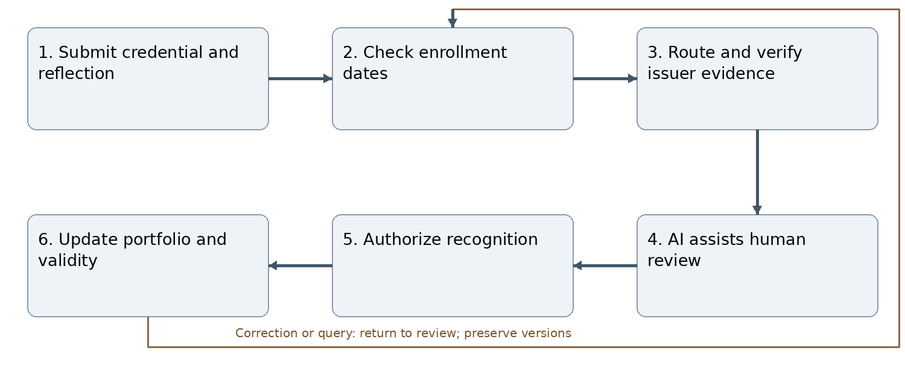
Figure J34 Normal workflow and correction path
Cover conferences, presentations, professional certification/credits, courses, awards, publications, internships and service earned during enrollment. Store issuer, dates, role, credential ID/link, hours, original units, expiry and evidence. Exceptions need authorized review. Academic/professional items route to relevant department, research papers to Research, extracurricular to Student Affairs. Separate authenticity from learning evaluation; AI authenticates nothing. No automatic academic credit conversion; prevent duplicate recognition and retain appeals/revocation.
Inputs and outputs: Submit credential and reflection produces a linked, versioned record; the workflow ends with update portfolio and validity. All decisions retain actor, scope, source record, exact version, time, reason and current status.
Connections: C020 M02; C092 M14; C100 M15; C103 M16; C106 M17; C112 M18; C114 M19; C134 M25.
Acceptance reference: AT-M34. Deny unauthorized or stale-version transitions without mutation. Return/reject with reasons; retain history and prevent duplicate side effects. See Annex L for module-specific expected behavior.

M35 Meeting and action management
Accountable roles: Meeting convener and designated minutes reviewer.
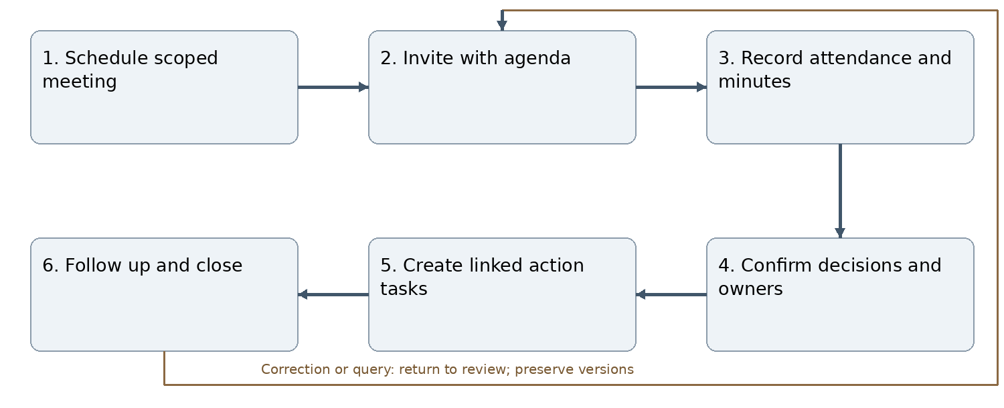
Figure J35 Normal workflow and correction path
Link meetings to department, club, research, joint event or plan. Record date/timezone, attendees, agenda, evidence, decisions, owners and deadlines. Minutes cannot substitute for Principal plan approval or Finance clearance. Version corrections, restrict confidential discussion and track actions through M05/M29.
Inputs and outputs: Schedule scoped meeting produces a linked, versioned record; the workflow ends with follow up and close. All decisions retain actor, scope, source record, exact version, time, reason and current status.
Connections: C028 M03; C041 M05; C069 M10; C083 M13; C122 M21; C127 M22; C145 M29; C149 M30; C150 M31; C152 M32.
Acceptance reference: AT-M35. Deny unauthorized or stale-version transitions without mutation. Return/reject with reasons; retain history and prevent duplicate side effects. See Annex L for module-specific expected behavior.

Annex K Numbered module connections
Connection identifiers name shared data/workflow contracts, not necessarily external APIs. The catalogue below is authoritative for this revision and supersedes the preliminary C01–C15 discussion numbering. Each connection carries owning institution, record ID, version, actor/service scope, timestamp and idempotency key. Consumers recheck permissions. Failed processing remains retryable and does not silently overwrite valid records.
Connection | Modules | Contract
C001 | M01 ↔ M02 | Trusted identity, effective assignment and least-privilege authorization; revocation invalidates subsequent access.
C002 | M01 ↔ M06 | Trusted identity, effective assignment and least-privilege authorization; revocation invalidates subsequent access.
C003 | M01 ↔ M08 | Trusted identity, effective assignment and least-privilege authorization; revocation invalidates subsequent access.
C004 | M01 ↔ M14 | Trusted identity, effective assignment and least-privilege authorization; revocation invalidates subsequent access.
C005 | M01 ↔ M20 | Trusted identity, effective assignment and least-privilege authorization; revocation invalidates subsequent access.
C006 | M01 ↔ M22 | Trusted identity, effective assignment and least-privilege authorization; revocation invalidates subsequent access.
C007 | M01 ↔ M23 | Trusted identity, effective assignment and least-privilege authorization; revocation invalidates subsequent access.
C008 | M01 ↔ M25 | Trusted identity, effective assignment and least-privilege authorization; revocation invalidates subsequent access.
C009 | M01 ↔ M26 | Trusted identity, effective assignment and least-privilege authorization; revocation invalidates subsequent access.
C010 | M01 ↔ M29 | Trusted identity, effective assignment and least-privilege authorization; revocation invalidates subsequent access.
C011 | M01 ↔ M30 | Plan version, review decisions, financial review and Principal approval; source-linked execution/status return.
C012 | M02 ↔ M03 | Stable academic IDs, enrollment, historical period and effective faculty mappings; conflicts enter reconciliation.
C013 | M02 ↔ M04 | Stable academic IDs, enrollment, historical period and effective faculty mappings; conflicts enter reconciliation.
C014 | M02 ↔ M14 | Stable academic IDs, enrollment, historical period and effective faculty mappings; conflicts enter reconciliation.
C015 | M02 ↔ M19 | Stable academic IDs, enrollment, historical period and effective faculty mappings; conflicts enter reconciliation.
C016 | M02 ↔ M24 | Stable academic IDs, enrollment, historical period and effective faculty mappings; conflicts enter reconciliation.
C017 | M02 ↔ M28 | Stable academic IDs, enrollment, historical period and effective faculty mappings; conflicts enter reconciliation.
C018 | M02 ↔ M30 | Plan version, review decisions, financial review and Principal approval; source-linked execution/status return.
C019 | M02 ↔ M31 | Stable academic IDs, enrollment, historical period and effective faculty mappings; conflicts enter reconciliation.
C020 | M02 ↔ M34 | Stable academic IDs, enrollment, historical period and effective faculty mappings; conflicts enter reconciliation.
C021 | M03 ↔ M04 | Scoped source record/version, assignment or outcome reference and authorized status updates; preserve history.
C022 | M03 ↔ M05 | Scoped source record/version, assignment or outcome reference and authorized status updates; preserve history.
C023 | M03 ↔ M14 | Accepted evaluator assignment, individual evidence/reflection, rubric and human-authorized outcome.
C024 | M03 ↔ M15 | Accepted evaluator assignment, individual evidence/reflection, rubric and human-authorized outcome.
C025 | M03 ↔ M19 | Verified source, role/contribution, issuer, classification and visibility; deduplicate shared achievements.
C026 | M03 ↔ M28 | Scoped source record/version, assignment or outcome reference and authorized status updates; preserve history.
C027 | M03 ↔ M30 | Plan version, review decisions, financial review and Principal approval; source-linked execution/status return.
C028 | M03 ↔ M35 | Meeting ID, agenda/minutes versions, decisions and action owners/deadlines; no implied formal approval.
C029 | M04 ↔ M05 | Scoped source record/version, assignment or outcome reference and authorized status updates; preserve history.
C030 | M04 ↔ M14 | Accepted evaluator assignment, individual evidence/reflection, rubric and human-authorized outcome.
C031 | M04 ↔ M15 | Accepted evaluator assignment, individual evidence/reflection, rubric and human-authorized outcome.
C032 | M04 ↔ M30 | Plan version, review decisions, financial review and Principal approval; source-linked execution/status return.
C033 | M04 ↔ M31 | Scoped source record/version, assignment or outcome reference and authorized status updates; preserve history.
C034 | M05 ↔ M10 | Scoped source record/version, assignment or outcome reference and authorized status updates; preserve history.
C035 | M05 ↔ M14 | Accepted evaluator assignment, individual evidence/reflection, rubric and human-authorized outcome.
C036 | M05 ↔ M15 | Accepted evaluator assignment, individual evidence/reflection, rubric and human-authorized outcome.
C037 | M05 ↔ M21 | Source-bound notification/message/action ID, current recipient, due date and resolution; deduplicate retries.
C038 | M05 ↔ M29 | Source-bound notification/message/action ID, current recipient, due date and resolution; deduplicate retries.
C039 | M05 ↔ M31 | Scoped source record/version, assignment or outcome reference and authorized status updates; preserve history.
C040 | M05 ↔ M32 | Scoped source record/version, assignment or outcome reference and authorized status updates; preserve history.
C041 | M05 ↔ M35 | Meeting ID, agenda/minutes versions, decisions and action owners/deadlines; no implied formal approval.
C042 | M06 ↔ M07 | Scoped source record/version, assignment or outcome reference and authorized status updates; preserve history.
C043 | M06 ↔ M08 | Scoped source record/version, assignment or outcome reference and authorized status updates; preserve history.
C044 | M06 ↔ M10 | Scoped source record/version, assignment or outcome reference and authorized status updates; preserve history.
C045 | M06 ↔ M24 | Scoped source record/version, assignment or outcome reference and authorized status updates; preserve history.
C046 | M07 ↔ M08 | Scoped source record/version, assignment or outcome reference and authorized status updates; preserve history.
C047 | M07 ↔ M09 | Scoped source record/version, assignment or outcome reference and authorized status updates; preserve history.
C048 | M07 ↔ M12 | Verified source, role/contribution, issuer, classification and visibility; deduplicate shared achievements.
C049 | M07 ↔ M13 | Scoped source record/version, assignment or outcome reference and authorized status updates; preserve history.
C050 | M07 ↔ M30 | Plan version, review decisions, financial review and Principal approval; source-linked execution/status return.
C051 | M08 ↔ M09 | Scoped source record/version, assignment or outcome reference and authorized status updates; preserve history.
C052 | M08 ↔ M12 | Verified source, role/contribution, issuer, classification and visibility; deduplicate shared achievements.
C053 | M08 ↔ M13 | Scoped source record/version, assignment or outcome reference and authorized status updates; preserve history.
C054 | M08 ↔ M14 | Accepted evaluator assignment, individual evidence/reflection, rubric and human-authorized outcome.
C055 | M08 ↔ M20 | Source-bound notification/message/action ID, current recipient, due date and resolution; deduplicate retries.
C056 | M08 ↔ M23 | Scoped source record/version, assignment or outcome reference and authorized status updates; preserve history.
C057 | M08 ↔ M33 | Scoped source record/version, assignment or outcome reference and authorized status updates; preserve history.
C058 | M09 ↔ M10 | Scoped source record/version, assignment or outcome reference and authorized status updates; preserve history.
C059 | M09 ↔ M11 | Budget version, club allocation, expenditure evidence and clearance; no automatic bank payment.
C060 | M09 ↔ M13 | Scoped source record/version, assignment or outcome reference and authorized status updates; preserve history.
C061 | M09 ↔ M30 | Plan version, review decisions, financial review and Principal approval; source-linked execution/status return.
C062 | M10 ↔ M11 | Budget version, club allocation, expenditure evidence and clearance; no automatic bank payment.
C063 | M10 ↔ M12 | Verified source, role/contribution, issuer, classification and visibility; deduplicate shared achievements.
C064 | M10 ↔ M14 | Accepted evaluator assignment, individual evidence/reflection, rubric and human-authorized outcome.
C065 | M10 ↔ M15 | Accepted evaluator assignment, individual evidence/reflection, rubric and human-authorized outcome.
C066 | M10 ↔ M30 | Plan version, review decisions, financial review and Principal approval; source-linked execution/status return.
C067 | M10 ↔ M32 | Scoped source record/version, assignment or outcome reference and authorized status updates; preserve history.
C068 | M10 ↔ M33 | Scoped source record/version, assignment or outcome reference and authorized status updates; preserve history.
C069 | M10 ↔ M35 | Meeting ID, agenda/minutes versions, decisions and action owners/deadlines; no implied formal approval.
C070 | M11 ↔ M13 | Budget version, club allocation, expenditure evidence and clearance; no automatic bank payment.
C071 | M11 ↔ M25 | Private evidence ID/version, scan state and permission-checked retrieval; no raw storage access.
C072 | M11 ↔ M27 | Budget version, club allocation, expenditure evidence and clearance; no automatic bank payment.
C073 | M11 ↔ M30 | Plan version, review decisions, financial review and Principal approval; source-linked execution/status return.
C074 | M11 ↔ M32 | Budget version, club allocation, expenditure evidence and clearance; no automatic bank payment.
C075 | M12 ↔ M13 | Verified source, role/contribution, issuer, classification and visibility; deduplicate shared achievements.
C076 | M12 ↔ M17 | Verified source, role/contribution, issuer, classification and visibility; deduplicate shared achievements.
C077 | M12 ↔ M18 | Verified source, role/contribution, issuer, classification and visibility; deduplicate shared achievements.
C078 | M12 ↔ M27 | Verified source, role/contribution, issuer, classification and visibility; deduplicate shared achievements.
C079 | M12 ↔ M33 | Verified source, role/contribution, issuer, classification and visibility; deduplicate shared achievements.
C080 | M13 ↔ M14 | Accepted evaluator assignment, individual evidence/reflection, rubric and human-authorized outcome.
C081 | M13 ↔ M27 | Verified source, role/contribution, issuer, classification and visibility; deduplicate shared achievements.
C082 | M13 ↔ M33 | Scoped source record/version, assignment or outcome reference and authorized status updates; preserve history.
C083 | M13 ↔ M35 | Meeting ID, agenda/minutes versions, decisions and action owners/deadlines; no implied formal approval.
C084 | M14 ↔ M15 | Accepted evaluator assignment, individual evidence/reflection, rubric and human-authorized outcome.
C085 | M14 ↔ M16 | Accepted evaluator assignment, individual evidence/reflection, rubric and human-authorized outcome.
C086 | M14 ↔ M22 | Accepted evaluator assignment, individual evidence/reflection, rubric and human-authorized outcome.
C087 | M14 ↔ M26 | Accepted evaluator assignment, individual evidence/reflection, rubric and human-authorized outcome.
C088 | M14 ↔ M28 | Accepted evaluator assignment, individual evidence/reflection, rubric and human-authorized outcome.
C089 | M14 ↔ M29 | Accepted evaluator assignment, individual evidence/reflection, rubric and human-authorized outcome.
C090 | M14 ↔ M31 | Accepted evaluator assignment, individual evidence/reflection, rubric and human-authorized outcome.
C091 | M14 ↔ M32 | Accepted evaluator assignment, individual evidence/reflection, rubric and human-authorized outcome.
C092 | M14 ↔ M34 | Accepted evaluator assignment, individual evidence/reflection, rubric and human-authorized outcome.
C093 | M15 ↔ M16 | Accepted evaluator assignment, individual evidence/reflection, rubric and human-authorized outcome.
C094 | M15 ↔ M18 | Accepted evaluator assignment, individual evidence/reflection, rubric and human-authorized outcome.
C095 | M15 ↔ M19 | Accepted evaluator assignment, individual evidence/reflection, rubric and human-authorized outcome.
C096 | M15 ↔ M20 | Accepted evaluator assignment, individual evidence/reflection, rubric and human-authorized outcome.
C097 | M15 ↔ M22 | Accepted evaluator assignment, individual evidence/reflection, rubric and human-authorized outcome.
C098 | M15 ↔ M25 | Private evidence ID/version, scan state and permission-checked retrieval; no raw storage access.
C099 | M15 ↔ M31 | Accepted evaluator assignment, individual evidence/reflection, rubric and human-authorized outcome.
C100 | M15 ↔ M34 | Accepted evaluator assignment, individual evidence/reflection, rubric and human-authorized outcome.
C101 | M16 ↔ M17 | Verified source, role/contribution, issuer, classification and visibility; deduplicate shared achievements.
C102 | M16 ↔ M18 | Verified source, role/contribution, issuer, classification and visibility; deduplicate shared achievements.
C103 | M16 ↔ M34 | Verified source, role/contribution, issuer, classification and visibility; deduplicate shared achievements.
C104 | M17 ↔ M18 | Verified source, role/contribution, issuer, classification and visibility; deduplicate shared achievements.
C105 | M17 ↔ M19 | Verified source, role/contribution, issuer, classification and visibility; deduplicate shared achievements.
C106 | M17 ↔ M34 | Verified source, role/contribution, issuer, classification and visibility; deduplicate shared achievements.
C107 | M18 ↔ M19 | Verified source, role/contribution, issuer, classification and visibility; deduplicate shared achievements.
C108 | M18 ↔ M25 | Private evidence ID/version, scan state and permission-checked retrieval; no raw storage access.
C109 | M18 ↔ M27 | Verified source, role/contribution, issuer, classification and visibility; deduplicate shared achievements.
C110 | M18 ↔ M31 | Verified source, role/contribution, issuer, classification and visibility; deduplicate shared achievements.
C111 | M18 ↔ M32 | Verified source, role/contribution, issuer, classification and visibility; deduplicate shared achievements.
C112 | M18 ↔ M34 | Verified source, role/contribution, issuer, classification and visibility; deduplicate shared achievements.
C113 | M19 ↔ M28 | Verified source, role/contribution, issuer, classification and visibility; deduplicate shared achievements.
C114 | M19 ↔ M34 | Verified source, role/contribution, issuer, classification and visibility; deduplicate shared achievements.
C115 | M20 ↔ M21 | Source-bound notification/message/action ID, current recipient, due date and resolution; deduplicate retries.
C116 | M20 ↔ M22 | Source-bound notification/message/action ID, current recipient, due date and resolution; deduplicate retries.
C117 | M20 ↔ M24 | Source-bound notification/message/action ID, current recipient, due date and resolution; deduplicate retries.
C118 | M20 ↔ M29 | Source-bound notification/message/action ID, current recipient, due date and resolution; deduplicate retries.
C119 | M20 ↔ M30 | Plan version, review decisions, financial review and Principal approval; source-linked execution/status return.
C120 | M21 ↔ M22 | Source-bound notification/message/action ID, current recipient, due date and resolution; deduplicate retries.
C121 | M21 ↔ M25 | Private evidence ID/version, scan state and permission-checked retrieval; no raw storage access.
C122 | M21 ↔ M35 | Meeting ID, agenda/minutes versions, decisions and action owners/deadlines; no implied formal approval.
C123 | M22 ↔ M24 | Source-bound notification/message/action ID, current recipient, due date and resolution; deduplicate retries.
C124 | M22 ↔ M26 | Source-bound notification/message/action ID, current recipient, due date and resolution; deduplicate retries.
C125 | M22 ↔ M29 | Source-bound notification/message/action ID, current recipient, due date and resolution; deduplicate retries.
C126 | M22 ↔ M30 | Plan version, review decisions, financial review and Principal approval; source-linked execution/status return.
C127 | M22 ↔ M35 | Meeting ID, agenda/minutes versions, decisions and action owners/deadlines; no implied formal approval.
C128 | M23 ↔ M24 | Scoped source record/version, assignment or outcome reference and authorized status updates; preserve history.
C129 | M23 ↔ M25 | Private evidence ID/version, scan state and permission-checked retrieval; no raw storage access.
C130 | M23 ↔ M30 | Plan version, review decisions, financial review and Principal approval; source-linked execution/status return.
C131 | M23 ↔ M33 | Scoped source record/version, assignment or outcome reference and authorized status updates; preserve history.
C132 | M24 ↔ M33 | Scoped source record/version, assignment or outcome reference and authorized status updates; preserve history.
C133 | M25 ↔ M31 | Private evidence ID/version, scan state and permission-checked retrieval; no raw storage access.
C134 | M25 ↔ M34 | Private evidence ID/version, scan state and permission-checked retrieval; no raw storage access.
C135 | M26 ↔ M27 | Verified source, role/contribution, issuer, classification and visibility; deduplicate shared achievements.
C136 | M26 ↔ M28 | Scoped source record/version, assignment or outcome reference and authorized status updates; preserve history.
C137 | M26 ↔ M29 | Source-bound notification/message/action ID, current recipient, due date and resolution; deduplicate retries.
C138 | M26 ↔ M30 | Plan version, review decisions, financial review and Principal approval; source-linked execution/status return.
C139 | M27 ↔ M32 | Verified source, role/contribution, issuer, classification and visibility; deduplicate shared achievements.
C140 | M27 ↔ M33 | Verified source, role/contribution, issuer, classification and visibility; deduplicate shared achievements.
C141 | M28 ↔ M29 | Source-bound notification/message/action ID, current recipient, due date and resolution; deduplicate retries.
C142 | M28 ↔ M30 | Plan version, review decisions, financial review and Principal approval; source-linked execution/status return.
C143 | M28 ↔ M31 | Scoped source record/version, assignment or outcome reference and authorized status updates; preserve history.
C144 | M29 ↔ M30 | Plan version, review decisions, financial review and Principal approval; source-linked execution/status return.
C145 | M29 ↔ M35 | Meeting ID, agenda/minutes versions, decisions and action owners/deadlines; no implied formal approval.
C146 | M30 ↔ M31 | Plan version, review decisions, financial review and Principal approval; source-linked execution/status return.
C147 | M30 ↔ M32 | Plan version, review decisions, financial review and Principal approval; source-linked execution/status return.
C148 | M30 ↔ M33 | Plan version, review decisions, financial review and Principal approval; source-linked execution/status return.
C149 | M30 ↔ M35 | Plan version, review decisions, financial review and Principal approval; source-linked execution/status return.
C150 | M31 ↔ M35 | Meeting ID, agenda/minutes versions, decisions and action owners/deadlines; no implied formal approval.
C151 | M32 ↔ M33 | Scoped source record/version, assignment or outcome reference and authorized status updates; preserve history.
C152 | M32 ↔ M35 | Meeting ID, agenda/minutes versions, decisions and action owners/deadlines; no implied formal approval.

Participant management across activity types
PM-001 Participant management is a shared capability within M03 and reused by M10, M31 and M32; it does not add a thirty sixth top-level module. It manages attendees separately from execution-team recruitment and task assignment.
Mode | Roster and entry | Controls
Inhouse class based academic | Use assigned course offering/class roster from M02. No competitive application is required for the assigned class. | Store roster snapshot and source date; resolve later enrollment changes without rewriting historical attendance. Enrollment is not attendance, completion or achievement.
Other internal events | Eligible KCC students/staff enter by invitation, application or registration, as configured in the approved event. | Support college-wide, programme, semester, department, club and cross-domain eligibility; capacity, deadlines, confirmation and waiting lists.
Intercollege national or international | Record institution, country, participant role and approved entry method. Permit invitation/application/registration within approved eligibility. | External records do not confer login. Authenticated external self-service remains gated by the existing guest-access release; authorized staff can record external participants.
Organizer and execution team | Use approved selection and appointment workflow in M05/M10/M32. | Task access requires confirmed team membership. Participation registration alone never grants management, task or evaluation authority.
PM-002 Roles include attendee, student organizer, volunteer, presenter, author, speaker, facilitator, mentor, judge, guest and beneficiary where appropriate. One person may hold several roles with distinct obligations. Distinguish an individual beneficiary record from an aggregate beneficiary estimate; do not create fictional individual identities.
PM-003 Entry states are INVITED or APPLIED or REGISTERED, followed as applicable by UNDER_REVIEW, CONFIRMED, WAITLISTED, DECLINED, CANCELLED or WITHDRAWN. Direct class-roster confirmation uses the approved academic assignment. Track attendance per session and completion/recognition separately. Selection and waiting-list offers do not consume confirmed places until the approved confirmation step. Enforce capacity atomically; prevent duplicate registration and attendance.
PM-004 Store person/source identifier, affiliation, role, eligibility basis, registration/decision timestamps, session choices, communication consent where needed, attendance and evidence. Minimize personal data. Support authorized manual or QR check-in, correction reasons, no-shows, cancellations and waitlist promotion. Report registered, confirmed, attended and completed counts separately, deduplicating people across roles.
PM-005 Configure reflection/evaluation and certificate eligibility by participant role under approved policy. Organizing student teams retain required individual reflections. Do not require speakers, guests or all attendees to undergo student assessment automatically. Certificate category must distinguish attendance, presentation, organization and assessed completion. Version 3.4 Annex O now specifies public registration and hosted gateway payment, subject to its activation prerequisites. No live payment capability is implied.
AT-PM01 NOT RUN: verify class roster entry, open internal event application, invited external speaker without login, last-seat concurrency, waiting-list promotion, duplicate check-in denial, multi-role counting, session attendance and role-specific recognition. Connections use M02, M03, M10, M16, M22, M25 and M32 contracts in this annex.

External integration boundaries
ID | Boundary | Requirement
X01 | E-Digital Nepal MIS → M01/M02 | Official contract required for SSO, stable identity and academic source fields. Clearly marked fictional adapter data may support independent development; never invent endpoints or use real student data for mocks.
X02 | Planned LMS ↔ M03/M15 | Preserve existing LMS ownership and approved assessment mappings; no automatic final grade or certificate.
X03 | Optional AI ↔ M15/M34 | Provider and privacy approval required; advisory suggestions only, with model/rubric audit and human fallback.
X04 | Website ↔ M18/M24/M33 | Separate editorial review, exact-version consent, publication approval and acknowledged delivery. Public listing does not register a participant.
X05 | Email delivery ↔ M22 | Configured transport, retries and delivery state; in-app actions survive transport failure.

Annex L Acceptance and amendment traceability
All following checks are target acceptance criteria with status NOT RUN for this revision. Execute against actual application code and environment; report evidence, record versions, expected/observed results, defects and blockers. Prior regression counts do not establish these checks as passed.

AT-M01 User and access management
Verify the complete path: Receive trusted identity → Validate MIS identity → Resolve scoped roles → Authorize action → Record decision → Revoke expired access. Verify the module-specific rules in M01, including one authorized success, a return/revision, an unauthorized denial, a stale-version conflict and a repeated request without duplicate results. Confirm connected records, dashboard actions and audit history remain consistent. Status: NOT RUN.

AT-M02 Academic structure and master data
Verify the complete path: Receive source records → Validate stable IDs → Preview changes → Commit authorized update → Retain prior mappings → Reconcile conflicts. Verify the module-specific rules in M02, including one authorized success, a return/revision, an unauthorized denial, a stale-version conflict and a repeated request without duplicate results. Confirm connected records, dashboard actions and audit history remain consistent. Status: NOT RUN.

AT-M03 Semester learning activities
Verify the complete path: Create activity draft → Obtain approved plan → Confirm team and mentor → Conduct activity → Collect individual evidence → Evaluate and verify. Verify the module-specific rules in M03, including one authorized success, a return/revision, an unauthorized denial, a stale-version conflict and a repeated request without duplicate results. Confirm connected records, dashboard actions and audit history remain consistent. Status: NOT RUN.

AT-M04 Project management
Verify the complete path: Form accepted team → Submit proposal → Department reviews → Assign accepted mentor → Approve plan via M30 → Execute and evaluate. Verify the module-specific rules in M04, including one authorized success, a return/revision, an unauthorized denial, a stale-version conflict and a repeated request without duplicate results. Confirm connected records, dashboard actions and audit history remain consistent. Status: NOT RUN.

AT-M05 Task management
Verify the complete path: Define teams and tasks → Assign eligible members → Work and add evidence → Review deliverable → Return or accept → Verify contribution. Verify the module-specific rules in M05, including one authorized success, a return/revision, an unauthorized denial, a stale-version conflict and a repeated request without duplicate results. Confirm connected records, dashboard actions and audit history remain consistent. Status: NOT RUN.

AT-M06 Group and club membership
Verify the complete path: Set approved capacity → Open membership call → Student applies → Review eligibility → Accept or waitlist → Close or reopen intake. Verify the module-specific rules in M06, including one authorized success, a return/revision, an unauthorized denial, a stale-version conflict and a repeated request without duplicate results. Confirm connected records, dashboard actions and audit history remain consistent. Status: NOT RUN.

AT-M07 Club lifecycle
Verify the complete path: Propose club → Review mandate → Obtain authorization → Approve plan via M30 → Activate and renew → Archive with history. Verify the module-specific rules in M07, including one authorized success, a return/revision, an unauthorized denial, a stale-version conflict and a repeated request without duplicate results. Confirm connected records, dashboard actions and audit history remain consistent. Status: NOT RUN.

AT-M08 Club governance and leadership
Verify the complete path: Select incoming team → Review eligibility → Principal confirms team → Issue appointment letter → Activate scoped roles → Handover and expire roles. Verify the module-specific rules in M08, including one authorized success, a return/revision, an unauthorized denial, a stale-version conflict and a repeated request without duplicate results. Confirm connected records, dashboard actions and audit history remain consistent. Status: NOT RUN.

AT-M09 Club strategic and annual planning
Verify the complete path: Draft goals and events → Mentor reviews → Student Affairs endorses → Finance Administrator reviews → Principal approves → Create linked activities. Verify the module-specific rules in M09, including one authorized success, a return/revision, an unauthorized denial, a stale-version conflict and a repeated request without duplicate results. Confirm connected records, dashboard actions and audit history remain consistent. Status: NOT RUN.

AT-M10 Club activities and events
Verify the complete path: Prepare approved event → Advertise positions → Select and confirm team → Issue role letters → Execute and reflect → Report and settle. Verify the module-specific rules in M10, including one authorized success, a return/revision, an unauthorized denial, a stale-version conflict and a repeated request without duplicate results. Confirm connected records, dashboard actions and audit history remain consistent. Status: NOT RUN.

AT-M11 Club budgets and resources
Verify the complete path: Prepare itemized budget → Finance Administrator reviews → Principal approves plan → Record authorized expenses → Verify settlement evidence → Clear or return query. Verify the module-specific rules in M11, including one authorized success, a return/revision, an unauthorized denial, a stale-version conflict and a repeated request without duplicate results. Confirm connected records, dashboard actions and audit history remain consistent. Status: NOT RUN.

AT-M12 Club portfolio and institutional memory
Verify the complete path: Collect event records → Check contribution links → Verify source evidence → Aggregate term history → Approve public subset → Retain and amend. Verify the module-specific rules in M12, including one authorized success, a return/revision, an unauthorized denial, a stale-version conflict and a repeated request without duplicate results. Confirm connected records, dashboard actions and audit history remain consistent. Status: NOT RUN.

AT-M13 Club evaluation annual review and handover
Verify the complete path: Members self evaluate → President adds feedback → Mentor evaluates → Student Affairs authorizes → Incoming team acknowledges → Close term with history. Verify the module-specific rules in M13, including one authorized success, a return/revision, an unauthorized denial, a stale-version conflict and a repeated request without duplicate results. Confirm connected records, dashboard actions and audit history remain consistent. Status: NOT RUN.

AT-M14 Mentorship and evaluation
Verify the complete path: Assign scoped responsibility → Mentor accepts → Receive submission alert → Review work and evidence → Authorize or return → Record verified contribution. Verify the module-specific rules in M14, including one authorized success, a return/revision, an unauthorized denial, a stale-version conflict and a repeated request without duplicate results. Confirm connected records, dashboard actions and audit history remain consistent. Status: NOT RUN.

AT-M15 Reflection and learning assessment
Verify the complete path: Submit four domains → AI suggests if enabled → Alert assigned evaluator → Accept change or return → Human authorizes result → Update verified records. Verify the module-specific rules in M15, including one authorized success, a return/revision, an unauthorized denial, a stale-version conflict and a repeated request without duplicate results. Confirm connected records, dashboard actions and audit history remain consistent. Status: NOT RUN.

AT-M16 Certification
Verify the complete path: Check individual eligibility → Verify source result → Human authorizes issue → Generate certificate and QR → Validate current status → Correct or revoke. Verify the module-specific rules in M16, including one authorized success, a return/revision, an unauthorized denial, a stale-version conflict and a repeated request without duplicate results. Confirm connected records, dashboard actions and audit history remain consistent. Status: NOT RUN.

AT-M17 Digital portfolio and CV
Verify the complete path: Select source records → Separate declarations → Choose profile and visibility → Generate private CV → Consent to public subset → Refresh or revoke share. Verify the module-specific rules in M17, including one authorized success, a return/revision, an unauthorized denial, a stale-version conflict and a repeated request without duplicate results. Confirm connected records, dashboard actions and audit history remain consistent. Status: NOT RUN.

AT-M18 Integrated portfolio lifecycle
Verify the complete path: Collect source evidence → Verify individual role → Map portfolio destinations → Authorize internal record → Publish consented subset → Amend retain or revoke. Verify the module-specific rules in M18, including one authorized success, a return/revision, an unauthorized denial, a stale-version conflict and a repeated request without duplicate results. Confirm connected records, dashboard actions and audit history remain consistent. Status: NOT RUN.

AT-M19 Semester student learning portfolio
Verify the complete path: Resolve academic period → Collect verified activities → Show contribution and domains → Identify missing requirements → Review completeness → Preserve cumulative journey. Verify the module-specific rules in M19, including one authorized success, a return/revision, an unauthorized denial, a stale-version conflict and a repeated request without duplicate results. Confirm connected records, dashboard actions and audit history remain consistent. Status: NOT RUN.

AT-M20 Notification and communication triggers
Verify the complete path: Commit workflow change → Create durable event → Resolve current recipients → Queue linked action → Send through M22 → Stop resolved reminders. Verify the module-specific rules in M20, including one authorized success, a return/revision, an unauthorized denial, a stale-version conflict and a repeated request without duplicate results. Confirm connected records, dashboard actions and audit history remain consistent. Status: NOT RUN.

AT-M21 Contextual messaging and collaboration
Verify the complete path: Open linked record → Check audience permission → Post contextual message → Notify authorized users → Resolve linked question → Preserve conversation. Verify the module-specific rules in M21, including one authorized success, a return/revision, an unauthorized denial, a stale-version conflict and a repeated request without duplicate results. Confirm connected records, dashboard actions and audit history remain consistent. Status: NOT RUN.

AT-M22 Notification Centre and escalation
Verify the complete path: Receive durable event → Recheck permission → Deliver inbox or email → Track delivery and action → Retry or escalate → Resolve pending action. Verify the module-specific rules in M22, including one authorized success, a return/revision, an unauthorized denial, a stale-version conflict and a repeated request without duplicate results. Confirm connected records, dashboard actions and audit history remain consistent. Status: NOT RUN.

AT-M23 Controlled documents and My Documents
Verify the complete path: Draft document version → Review exact version → Approve authorized content → Set effective date → Distribute scoped copy → Supersede or withdraw. Verify the module-specific rules in M23, including one authorized success, a return/revision, an unauthorized denial, a stale-version conflict and a repeated request without duplicate results. Confirm connected records, dashboard actions and audit history remain consistent. Status: NOT RUN.

AT-M24 Notices and announcements
Verify the complete path: Draft targeted notice → Review audience and dates → Approve publication → Deliver exact version → Track acknowledgment → Expire amend or withdraw. Verify the module-specific rules in M24, including one authorized success, a return/revision, an unauthorized denial, a stale-version conflict and a repeated request without duplicate results. Confirm connected records, dashboard actions and audit history remain consistent. Status: NOT RUN.

AT-M25 File management
Verify the complete path: Upload private file → Validate type and size → Scan before availability → Link evidence version → Authorize download → Retain or dispose. Verify the module-specific rules in M25, including one authorized success, a return/revision, an unauthorized denial, a stale-version conflict and a repeated request without duplicate results. Confirm connected records, dashboard actions and audit history remain consistent. Status: NOT RUN.

AT-M26 Role based dashboards
Verify the complete path: Authenticate current user → Resolve assignments → Load authorized actions → Show role workspaces → Open permitted record → Refresh after decision. Verify the module-specific rules in M26, including one authorized success, a return/revision, an unauthorized denial, a stale-version conflict and a repeated request without duplicate results. Confirm connected records, dashboard actions and audit history remain consistent. Status: NOT RUN.

AT-M27 Club and portfolio analytics
Verify the complete path: Select scope and period → Read verified sources → Deduplicate shared events → Compute defined metrics → Drill into permitted evidence → Export authorized results. Verify the module-specific rules in M27, including one authorized success, a return/revision, an unauthorized denial, a stale-version conflict and a repeated request without duplicate results. Confirm connected records, dashboard actions and audit history remain consistent. Status: NOT RUN.

AT-M28 Academic dashboards
Verify the complete path: Resolve assigned cohort → Load plans and workload → Show delivery and learning → Flag pending follow up → Assign authorized action → Track resolution. Verify the module-specific rules in M28, including one authorized success, a return/revision, an unauthorized denial, a stale-version conflict and a repeated request without duplicate results. Confirm connected records, dashboard actions and audit history remain consistent. Status: NOT RUN.

AT-M29 Dashboard Action Centre
Verify the complete path: Receive linked obligation → Assign owner and due date → Display prioritized action → Perform authorized decision → Refresh dependent records → Close or escalate. Verify the module-specific rules in M29, including one authorized success, a return/revision, an unauthorized denial, a stale-version conflict and a repeated request without duplicate results. Confirm connected records, dashboard actions and audit history remain consistent. Status: NOT RUN.

AT-M30 Academic and institutional planning
Verify the complete path: Draft scoped plan → Responsible unit reviews → Finance Administrator reviews → Principal decides → Create approved activities → Monitor report and close. Verify the module-specific rules in M30, including one authorized success, a return/revision, an unauthorized denial, a stale-version conflict and a repeated request without duplicate results. Confirm connected records, dashboard actions and audit history remain consistent. Status: NOT RUN.

AT-M31 Research project management
Verify the complete path: Submit student or faculty proposal → Academic Department endorses → Research assigns mentor and reviews → Approve plan through M30 → Recruit and execute research → Evaluate report and recognize. Verify the module-specific rules in M31, including one authorized success, a return/revision, an unauthorized denial, a stale-version conflict and a repeated request without duplicate results. Confirm connected records, dashboard actions and audit history remain consistent. Status: NOT RUN.

AT-M32 Interclub joint event management
Verify the complete path: Invite partner clubs → Confirm shared contributions → Approve joint plan via M30 → Appoint cross club teams → Execute and evaluate → Submit joint report and settle. Verify the module-specific rules in M32, including one authorized success, a return/revision, an unauthorized denial, a stale-version conflict and a repeated request without duplicate results. Confirm connected records, dashboard actions and audit history remain consistent. Status: NOT RUN.

AT-M33 Club partnership management
Verify the complete path: Record prospective partner → Review purpose and commitments → Approve plan via M30 → Authorized signatory agrees → Track shared activities → Renew or close obligations. Verify the module-specific rules in M33, including one authorized success, a return/revision, an unauthorized denial, a stale-version conflict and a repeated request without duplicate results. Confirm connected records, dashboard actions and audit history remain consistent. Status: NOT RUN.

AT-M34 External achievement verification
Verify the complete path: Submit credential and reflection → Check enrollment dates → Route and verify issuer evidence → AI assists human review → Authorize recognition → Update portfolio and validity. Verify the module-specific rules in M34, including one authorized success, a return/revision, an unauthorized denial, a stale-version conflict and a repeated request without duplicate results. Confirm connected records, dashboard actions and audit history remain consistent. Status: NOT RUN.

AT-M35 Meeting and action management
Verify the complete path: Schedule scoped meeting → Invite with agenda → Record attendance and minutes → Confirm decisions and owners → Create linked action tasks → Follow up and close. Verify the module-specific rules in M35, including one authorized success, a return/revision, an unauthorized denial, a stale-version conflict and a repeated request without duplicate results. Confirm connected records, dashboard actions and audit history remain consistent. Status: NOT RUN.

Critical cross module acceptance scenarios
AT-X01 Every category of plan, including no-expenditure plans, reaches Finance Administrator review before Principal final approval. Mentor, HoD, Research and Student Affairs cannot substitute final plan approval. Revised scope/budget invalidates old execution authority for the changed work.
AT-X02 Membership accepts the last available vacancy once under concurrent requests. Committee size 9–11, sixth-semester President and three-month succession validate correctly. Formal letter precedes club access; outgoing access expires without deleting history.
AT-X03 Student research passes Academic Department endorsement and Research Department review; course projects retain faculty/Coordinator routing. Faculty-led research recruits accepted students and independently evaluates the faculty lead outputs.
AT-X04 Four separate reflection domains reach the assigned evaluator. AI failure permits human authorization; self-finalization fails. Eligible student portfolios update while unrelated financial settlement is pending.
AT-X05 Joint event appears in each partner portfolio but counts once institutionally. One student has one accountable evaluator. Partner withdrawal preserves allocations, obligations and contribution history.
AT-X06 External achievement date, issuer, original credit units, role and expiry remain visible. Duplicate evidence cannot award twice. Professional credit cannot silently become academic credit.
AT-X07 Final report routes by organizer: club through mentor/Student Affairs, academic through responsible department, institutional through coordinator; then Principal and Finance settlement. This post-event route is distinct from pre-execution Finance Administrator then Principal plan approval.
AT-X08 Meeting decisions create tracked actions without bypassing any plan, signing, financial, evaluation or publication authority.

Amendment register for this revision
ID | Change | Normative location
AM22 | All-plan Finance Administrator review before Principal approval | AP-001; M09/M11/M30; AT-X01
AM23 | Unified events, team capacities, recruitment and appointment letters | M03/M05/M10/M23; AT-M03/M05/M10/M23
AM24 | Committee size, succession, sixth-semester rules and scoped activation | M06/M08/M13/M14; AT-X02
AM25 | Four-domain reflections and departmental/lead portfolios | M15/M18/M19; AT-X04
AM26 | Academic Department forwarding of student research | WF-014 replacement; M04/M31; AT-X03
AM27 | Faculty research with student groups | M31; AT-X03
AM28 | Joint events and partnership lifecycle | M32/M33; AT-X05
AM29 | External achievements and professional credits | M34; AT-X06
AM30 | Meetings and accountable actions | M35; AT-X08
AM31 | Organizer-specific final report and settlement routes | M10/M11/M31/M32; AT-X07
AM32 | 35-module catalogue and canonical numbered contracts | Annex J/K/L; replaces preliminary connection numbering
Open configuration decisions: committee term length and selection method; named approvers and formal signatories; rubric weights/thresholds; Principal-originated plan handling without unauthorized self-approval; notification periods; external credit-recognition authority; research ethics/IP and retention rules; final production integration contracts. These decisions must be recorded before the affected live action, while independent development continues.

Annex M Approved plan locking and change requests
Version 3.3 amendment dated 25 October 2026. All units use the same controlled amendment route. This annex extends M30 and applies to departments, programmes, courses, clubs, research units, partnerships, interclub teams and institutional committees. The module count remains 35 and C001–C152 remain unchanged. This annex takes precedence over any earlier wording that permits editing an approved baseline without a new approval.

CR-001 Approved baseline lock
Principal approval creates an immutable plan version. Lock approved activities, scope, objectives, schedule, reporting dates, responsibilities, participant/team capacities, budget, resources and commitments. Enforce the lock in interfaces, APIs, bulk imports and background jobs. Only approved revisions can change these fields.

CR-002 Execution remains usable
Authorized users may update actual progress, task execution status, attendance, evidence, reflections and reports under the approved baseline. Such updates cannot change planned commitments, dates, capacities or amounts. Moving a task to DONE is an execution update; adding an activity, extending a deadline or expanding approved scope is a change request.

CR-003 Request types and contents
Allow additions, date extensions/rescheduling, scope changes, budget/resource changes, responsibility or capacity changes, cancellations and replacements. Capture request ID, owning unit, affected plan/item IDs, exact baseline version, old/proposed values, justification, supporting evidence and effects on budget, people, dependencies, outputs and risks. Allow a zero-cost or no-financial-impact explanation without skipping review.

CR-004 Approval route
Plan owner submits → responsible unit reviews → Finance Administrator reviews → Principal decides. Finance Administrator review is mandatory for date-only and zero-cost requests. Reviewers recommend, forward or return; only the Principal grants final plan-change approval. Existing academic, club and research specialist reviews occur before Finance Administrator review.

Plan amendment workflow diagram
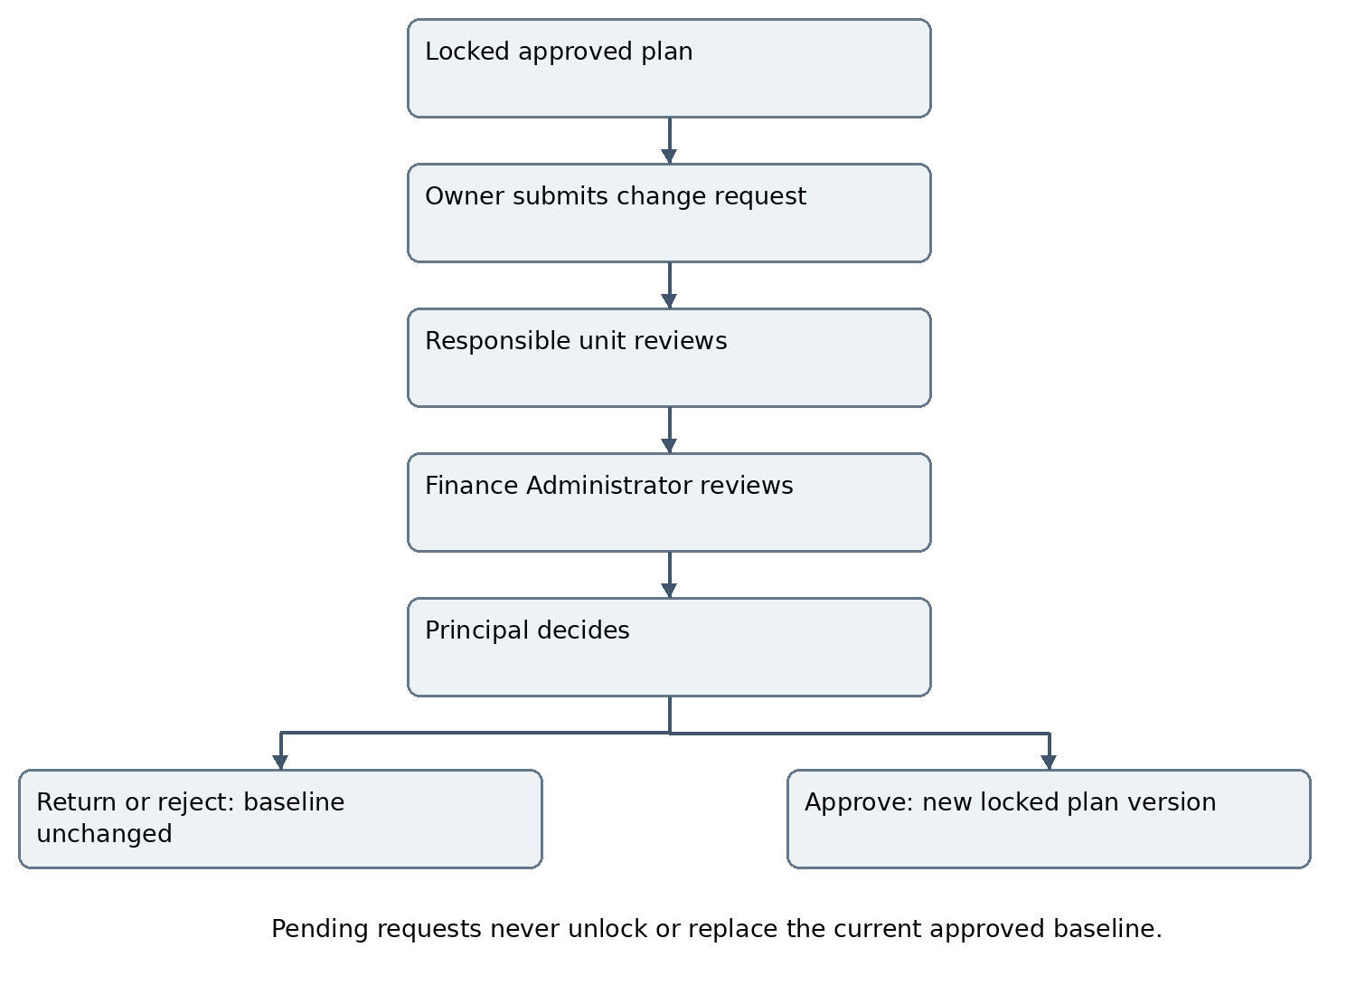
Figure M01 Approval produces a new locked version. Revisions return through review; rejection preserves the original baseline.

CR-005 Decisions and request states
DRAFT → SUBMITTED → UNIT_REVIEW → FINANCE_ADMIN_REVIEW → PRINCIPAL_REVIEW → APPROVED or REJECTED or REVISION_REQUIRED. Authorized reviewers may return for revision with reasons. A revised request is versioned, then re-enters unit review so later decisions apply to current content. The owner may withdraw a pending request with retained history; approved requests cannot be deleted or withdrawn to erase their effect.

CR-006 Pending and rejected requests
Submitting a request never unlocks the existing plan. The currently approved baseline remains authoritative. Pending additions must not execute; pending extensions do not extend permission beyond an existing deadline. Rejection leaves the baseline unchanged. Withdrawal or return stops stale approval reminders but preserves history.

CR-007 Atomic approval and new version
At approval revalidate the exact plan baseline, current request version, reviewer authority and all prerequisites atomically. Create the successor approved plan version, link the request and decision, and lock the new version. Preserve the prior version. Do not expose a temporary editable approved plan. Duplicate approval retries cannot create multiple versions or downstream activities.

CR-008 Concurrent changes
Requests may coexist, but each references its baseline. If another approval changes that baseline, mark the request NEEDS_REBASE and block final approval. Reconcile proposed differences against the current baseline, create a revised request and repeat affected reviews. Never silently merge conflicting dates, budgets or responsibilities.

CR-009 Dates and late requests
Keep original deadline, requested deadline, actual decision timestamp and revised approved deadline. Show pending, overdue and late-approved status factually. A request received or approved after expiry must not erase the missed deadline, backdate authorization or automatically validate work performed without approval. Resumption and treatment of affected work require an explicit recorded decision.

CR-010 Connected propagation
After approval, update applicable future schedules, task due dates, recruitment notices, team assignments, budgets and dashboard actions using versioned idempotent operations. Record each affected item, desired version, outcome and retry status. Block affected changed execution when a required dependent update fails; leave unrelated authorized work available. Notify affected leads, mentors, participants and units.

CR-011 Historical protection and authority
Never automatically rewrite completed attendance, actual execution timestamps, finalized evaluations, issued certificates or verified contributions. Corrections use their own authorized amendment controls. Plan approval grants no payment, contract-signing, publication or academic scoring authority. Principal-originated plan handling requires an explicit institutional rule; no unauthorized self-approval exception is inferred.

CR-012 Audit and access
Record every request version, attachment, review, reason, approval/rejection, withdrawal, rebase, propagation result and notification with actor, institution, scope and timestamp. Owners may view their own requests; reviewers see only assigned scope. Technical administrators cannot bypass approval by unlocking rows or editing approved records. Retention/disposition follows existing institutional policy.

Module connections and change notifications
M30 owns requests and approvals. Reuse its existing C-series contracts with M01 authorization, M02 academic mappings, M03/M04 activities/projects, M09 club plans, M11 budgets, M29 actions, M31 research, M32 joint events and M33 partnerships. Notifications use M20 trigger events and M22 delivery; M05 tasks, M24 notices, M26–M28 dashboards and M35 meeting decisions consume approved source changes through existing contracts. This adds no new independent plan-approval service.
The request screen shall show approved baseline beside requested changes, current reviewer, overdue state and approval history. Review screens shall show financial effects even when zero, previous decisions and stale-baseline warnings. The plan dashboard shall display current approved version and pending change requests separately.

Acceptance criteria for version 3.3
AT-CR01 — NOT RUN. Try changing an approved date/activity/budget through UI, API and import. All unauthorized mutations fail; execution evidence updates remain permitted.
AT-CR02 — NOT RUN. Submit a new activity and a date-only extension from department and club plans. Both route through responsible unit, Finance Administrator and Principal; no bypass for zero cost.
AT-CR03 — NOT RUN. Return, revise, reject and withdraw separate requests. Verify reasons, current reviewer, version-bound decisions and an unchanged approved baseline.
AT-CR04 — NOT RUN. Approve one request twice and retry propagation. Exactly one successor plan version and each required dependent change are created.
AT-CR05 — NOT RUN. Submit two requests on the same baseline; approve one. The other cannot finalize until rebased and reviewed again.
AT-CR06 — NOT RUN. Approve an extension after expiry. Original deadline and late approval remain visible; prior unauthorized execution is not automatically legitimized.
AT-CR07 — NOT RUN. Fail a downstream schedule update, retry and revoke reviewer access during review. Show failed propagation, block affected changed execution, allow unrelated work and reject revoked authority.
AT-CR08 — NOT RUN. Verify completed attendance, final evaluations, certificates and historical contributions remain unchanged after a future date extension.
AT-CR09 — NOT RUN. Attempt approval as mentor, HoD, Finance Administrator or technical administrator. Final approval fails for each; authorized Principal approval succeeds with prerequisites.
AT-CR10 — NOT RUN. Verify plan versions, notices, task dates, budget records, reviewer alerts and participant notifications refer to the same approved amendment and preserve audit history.

Revision register and adoption
AM33 introduces all-unit approved-plan locking, additions, date extensions and controlled amendments: CR-001–CR-012; Figure M01; AT-CR01–AT-CR10. All v3.2 module and participant-management requirements remain in force. The 35-module catalogue, original 35 diagrams and 152 connection numbers are retained; this revision adds one shared change-control diagram. Do not interpret a document revision as completed development.
Adoption in ongoing v3.1 development: checkpoint the current task, compare current code with v3.3 and implement incremental migrations. Preserve existing approved records as historical baselines without fabricating missing approvals. Identify legacy records requiring reconciliation. Do not restart the application or wait for the MIS API to develop independent change-control functions.

Annex N Event operations and delivery controls
This annex closes the event-management gaps identified after v3.3. It extends M03, M05, M10, M11, M14–M16, M20–M30, M32, M33 and M35 without increasing the 35-module count. All approved-plan locks and changes under Annex M remain effective. Principal approval follows responsible-unit and Finance Administrator review. Readiness is an execution check, not another plan approval authority.

EV-001 Annual plan and event authorization
Each annual-plan item shall state PLANNING_ONLY or EXECUTION_AUTHORIZED. The Principal explicitly authorizes execution only when the item contains its required event scope, dates, budget, lead, mentor, eligibility and resources. Annual-plan approval alone must not silently authorize incomplete events. A PLANNING_ONLY item requires a detailed event submission through the same unit → Finance Administrator → Principal route. A fully specified approved event needs no duplicate plan approval merely to begin preparation; its readiness checks still apply. New activities, additions and material changes follow Annex M.

EV-002 Independent event status dimensions
Replace the older single club-event chain where settlement precedes verification with independent states. Retain prior transitions and map legacy records through a reviewed migration; do not infer missing approvals. A cancelled event may still have reporting, learning or financial obligations. Public registration closure and event cancellation are distinct.
Dimension | States and guards
Plan approval | DRAFT / UNDER_REVIEW / FINANCE_ADMIN_REVIEW / PRINCIPAL_REVIEW / APPROVED / RETURNED / REJECTED; exact version and AP-001 apply.
Delivery | PREPARING / READY / IN_PROGRESS / INTERRUPTED / COMPLETED / CANCELLED. POSTPONED requires linked date-change request; no new date is effective while pending.
Registration | NOT_OPEN / OPEN / FULL / CLOSED / CANCELLED. OPEN requires the published current approved event and entry prerequisites.
Learning | NOT_REQUIRED / PENDING / UNDER_EVALUATION / PARTIALLY_VERIFIED / VERIFIED; individual eligibility and human authorization apply.
Report | PENDING / SUBMITTED / RETURNED / APPROVED; routing follows organizer and preserves versions.
Finance | NO_EXPENDITURE / PENDING / UNDER_REVIEW / CLEARED / WAIVED. Record receipt/refund reconciliation separately; cleared status needs assigned financial authority.
Administrative closure | CLOSE_PENDING / CLOSED / ARCHIVED. Close only when report approved, required participant cases resolved, bookings/assets released, and expenses plus receipts/refunds settled or explicitly waived. Public portfolio publication is not a closure prerequisite.

EV-003 Venue and resource reservations
Maintain venue/room, capacity, equipment, availability and responsible custodian. Reservations include setup, delivery and cleanup intervals, timezone, provisional hold expiry, confirmation and release. Atomically prevent conflicting confirmed bookings or over-allocation of exclusive equipment. A venue approval is not plan approval. Rescheduling rechecks availability; cancellation releases reservations and records remaining commitments. Provisional booking does not imply expenditure authority.

EV-004 Programme and parallel sessions
Events may have days, sessions, tracks, rooms, speakers, moderators, session capacities and planned/actual times. Validate overlapping rooms, assigned personnel and participant session selections. Store timetable versions and notify affected registrants when approved changes alter their sessions. Record session cancellation or replacement without rewriting completed sessions. Session capacities cannot exceed venue or approved event limits.

EV-005 Readiness and run of show
Before READY, the designated event lead and responsible mentor/coordinator confirm the configured checklist: approved plan, accepted team, confirmed venue, speakers, resources, communications, safety arrangements and required funding authorization. Show failed checks and accountable owners. Maintain a timed running order, duty roster, escalation contacts and issue log. Readiness does not approve a changed budget or date; material changes return through Annex M.

EV-006 Emergency interruption and resumption
Authorized on-site event leads, responsible staff or the designated safety officer may immediately pause/stop an unsafe activity without waiting for plan-change approval. Log incident, time, actions and notifications promptly. Restrict sensitive incident details. Record an authorized readiness reassessment before resuming within unchanged approved scope; resumption involving new dates, material scope or commitments requires the normal change route. Emergency stopping grants no new spending or signing authority.

EV-007 Postponement cancellation and partial delivery
A formal postponement/cancellation request follows Annex M; emergency suspension may occur immediately under EV-006. Freeze affected registrations/checkouts, notify participants, release or amend bookings, address supplier/partner liabilities and initiate applicable refunds. Preserve delivered sessions and actual attendance. Apply approved partial-delivery recognition rules individually. Never cancel all certificates or erase contributions merely because the event is interrupted.

EV-008 Attendance and connectivity
Maintain session-level check-in/out, attendance duration, late/no-show status, source and correction reason. QR must be event/session bound and validated by an authorized scanner; prevent replay or duplicate check-in. Configure minimum attendance under approved recognition policy, without inventing a universal percentage. Allow authorized temporary offline capture with minimal data, device/operator/time references and an auditable synchronization conflict queue. Imported/offline evidence remains provisional until reconciliation; no automatic certificate from check-in.

EV-009 Speakers guests and logistics
Track invitation, acceptance, biography/topic, materials, access needs, arrival/joining instructions, responsible host and substitution. Link procurement requests, suppliers, delivery/receipt verification and asset issue/return to approved budget references. Use the existing institutional procurement/accounting process; this annex does not create a parallel ledger. Outstanding assets, bills and commitments remain visible at handover/closure.

EV-010 Communications feedback and improvement
Send registration acknowledgments, confirmation, location/joining instructions, session changes, reminders, postponement/cancellation and follow-up through M20/M22. Retain delivery and failed-delivery review without treating delivery as acknowledgment. Collect role-appropriate feedback separately from learning assessment. Record complaints, assigned resolver, due date, privacy classification and outcome; do not expose complaints publicly. Carry approved improvement actions into future plans.

Event approval and operational readiness diagram
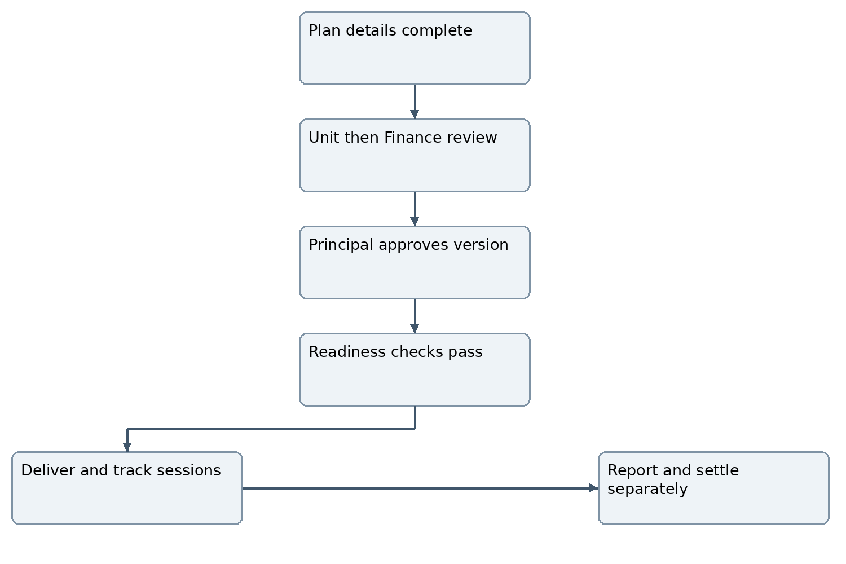
Figure N01 Normal execution requires an approved plan and readiness. Correction and emergency routes follow EV-001–EV-010.

EV-011 Conference scope boundary
Session and speaker management applies to conferences. Full scholarly abstract/paper submission, independent peer review, proceedings and journal publishing remain a separately scoped extension. A conference label does not imply scholarly acceptance or accredited peer review. If activated later, define reviewer conflicts, revisions, authorship and publication consent explicitly.

Annex O Website publication registration and payment
Public registration and payment are new version 3.4 target capabilities. This annex supersedes PM-005’s prior fee exclusion and WF-019’s listing-only boundary for specifically enabled public-registration events. Public listing alone continues to create no registration, payment or account. Authenticated external KCC360 guest access remains deferred; a limited attendee self-service token is not institutional login. All new provider contracts and production activation gates remain separate from specification acceptance.

PUB-001 System ownership and publishing authority
KCC360 owns event plans, canonical event occurrences, registrations, seats, participation and recognition under institutional custody. KCC website/CMS displays approved public event content and public registration forms. Its backend calls the authorized KCC360 registration service; do not maintain a second authoritative attendee roster. Payment gateway processes money; KCC360 records verified transaction references and Finance reconciles them with the accounting system. This integration is independent of E-Digital Nepal MIS APIs; official MIS identity remains required for institutional users.

PUB-002 Publication lifecycle and payload
Principal approves the plan; designated publisher separately approves the exact public version. Maintain DRAFT_PUBLIC / REVIEW_PENDING / APPROVED_FOR_PUBLICATION / DELIVERY_PENDING / PUBLISHED_ACKNOWLEDGED / UPDATE_PENDING / WITHDRAWN. Send stable event/occurrence ID, public version, title, description, organizer, venue/mode, explicit timezone/dates, audience eligibility, registration mode/deadline, approved fee/currency and public media. Do not send private budgets, identity lists, academic scores or internal comments. Receiver returns accepted version, delivery reference, URL and timestamp. Queueing is not acknowledged publication. Consent applies to exact authored/media content where required.

PUB-003 Publication reliability and withdrawal
Use authenticated server-to-server service identity with least scope and agreed protocol; never expose service credentials to public browser code. Validate schema, event ownership, approved source version, intended destination and replay/idempotency key. Reject stale deliveries. Retry failed updates, retain dead-letter/operator review and reconcile receiver state. Withdrawal disables new registration immediately at the authoritative backend and requests website removal; a stale cached page cannot accept a closed event. Removal acknowledgments must identify exact version. Secrets remain environment managed, rotated and audited.

REG-001 Entry modes and identity
Support FREE_DIRECT, APPLICATION_REVIEW, PAID_DIRECT and APPLICATION_THEN_PAYMENT as explicit event configuration. Assigned inhouse class events retain the M02 roster flow and do not require public registration. Public applicants supply minimum required contact, affiliation, country, role and session choices, accept versioned terms/privacy notices, and receive an opaque registration reference. Verify contact using an approved method before privileged self-service; do not match or merge institutional identity solely by email. External registration creates no student/faculty account. Provide secure time-limited revocable links for viewing/cancelling own registration; never expose other participants or sequential identifiers.

REG-002 Eligibility capacity and temporary holds
Validate current event version, eligibility, deadline, session conflicts, event capacity and session capacity server-side. For direct free entry, allocate a confirmed seat atomically. For reviewed applications, acceptance alone is not final participation until confirmation/required payment. Use bounded OFFERED or HELD seats with configurable expiry. Capacity invariant: confirmed seats plus unexpired exclusive holds cannot exceed approved capacity. Waitlisted applicants have no seat and must not be charged for a seat that is unavailable. Expiry/cancellation releases holds once; promotion creates a new expiring offer. Recheck limits under concurrent requests and retries.

REG-003 Registration and payment are separate states
Registration states: DRAFT, SUBMITTED, UNDER_REVIEW, OFFERED, HELD, CONFIRMED, WAITLISTED, DECLINED, EXPIRED, CANCELLED or WITHDRAWN as applicable. Payment states are independent under PAY-002. Paid registration requires both current eligibility and a settled verified payment/approved fee waiver plus a valid seat allocation. Paid/unconfirmed conflicts enter reconciliation; do not invent capacity. Completion, attendance, evaluation and certificates remain separate. A free or waived event has NOT_REQUIRED payment, not a fabricated successful transaction.

REG-004 Privacy access and abuse controls
Apply request validation, rate limits, bot/abuse mitigation, duplicate detection and controlled file-upload scanning. Record separate consent for publicity/marketing; registration must not silently opt in to either. Limit staff exports and public participant display. Configurable retention, cancellation rights and access assistance require institutional policy. Public forms must be keyboard accessible, mobile responsive and show clear fee, eligibility, deadline, privacy and cancellation information. Reject cross-event and cross-person access even with a valid reference belonging elsewhere.

PAY-001 Hosted checkout and production prerequisites
Use an approved hosted payment checkout or equivalent provider-managed payment surface. KCC360 and website shall not store payment credentials, PINs, OTPs or card security data. Server calculates payable amount and currency from approved fee/concession version, never from browser input. Create one order with unique reference and separate retry attempts. Live activation requires chosen provider’s official API contract, KCC merchant credentials, environment separation, callback validation, approved fees, refund rules and Finance reconciliation owner. Do not invent provider URLs, signatures or authentication. Fictional sandbox/mocked payment events must remain visibly non-production.

PAY-002 Verification idempotency and late payments
Payment attempt states: CREATED, PENDING, SUCCEEDED, FAILED, EXPIRED or CANCELLED; aggregate order status derives from verified attempts and amounts. Treat browser redirect as informational only. Confirm success using authenticated provider server notification and/or official transaction-status verification under the agreed contract; verify merchant, order, amount, currency and unique provider transaction. Deduplicate callbacks and reject replay, stale or conflicting updates without downgrading confirmed success. One provider transaction cannot settle two orders. Expired holds, event cancellation, mismatched amounts and late/duplicate successful payments enter Finance reconciliation; do not auto-confirm over capacity. Reserve/confirm seats atomically with valid state or route to approved refund/reallocation handling.

PAY-003 Receipts refunds and reconciliation
Issue one receipt per verified successful payment, with stable reference, issuer details, event/order, amount/currency, provider reference and time. Receipt format/tax treatment follows approved Finance policy, not inferred legal rules. Refund lifecycle: REQUESTED → UNDER_REVIEW → AUTHORIZED → PROVIDER_PENDING → REFUNDED / PARTIALLY_REFUNDED / FAILED. Record authorized financial actor, reason, policy version, amount and provider reference. Refund totals cannot exceed settled payment less prior refunds. Retry safely and verify provider status before marking refunded. Refund failure remains visible. Reconcile gross receipts, gateway charges, settlement amounts, disputes, duplicate/unmatched payments and refunds; no full general ledger is introduced.

PAY-004 Fees cancellation and authority
Fees, concessions, seat-hold periods, cancellation cutoffs, refund eligibility and refund approvers must be explicit institutional configuration. Fee changes follow approved-plan change control and apply prospectively; retain the accepted price/terms on existing orders. Event cancellation stops new checkout and starts the applicable refund review; it does not erase financial records. Principal plan approval is not payment execution or automatic refund authorization. Outages allow safe status enquiry and queued reconciliation, not browser-trusted success.

Public event publication and registration diagram
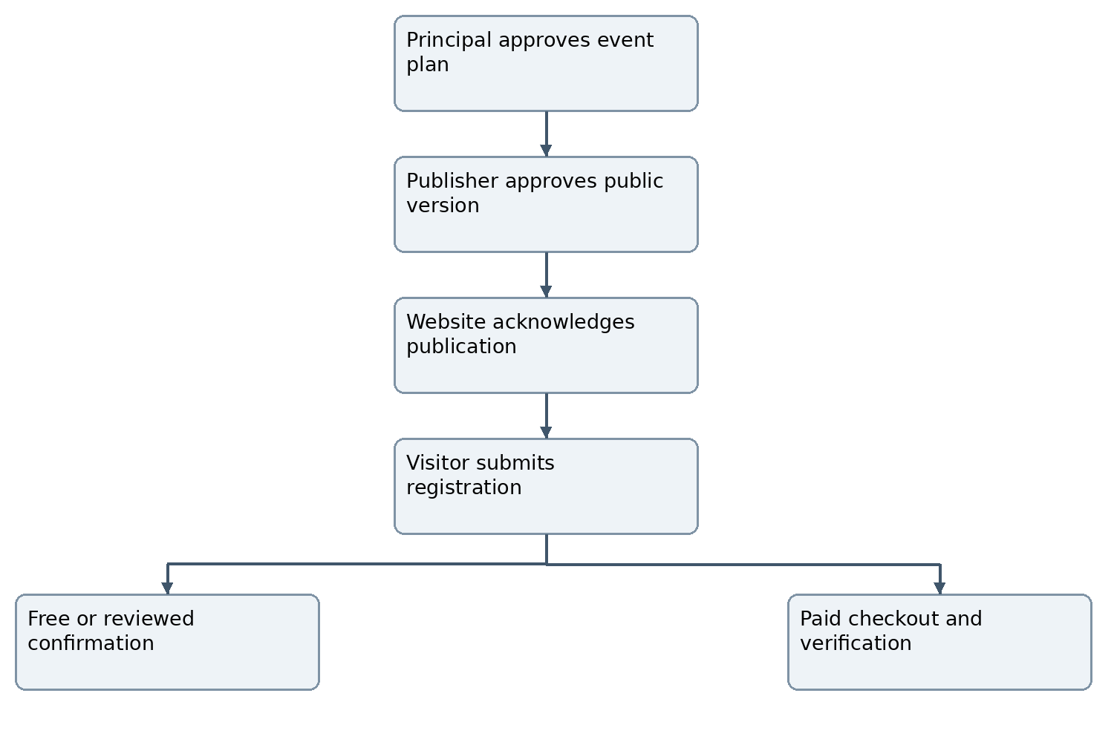
Figure O01 Public publication and participant entry do not grant institutional account access. Application-first events collect payment only after acceptance and seat offer.

Payment confirmation and exception diagram
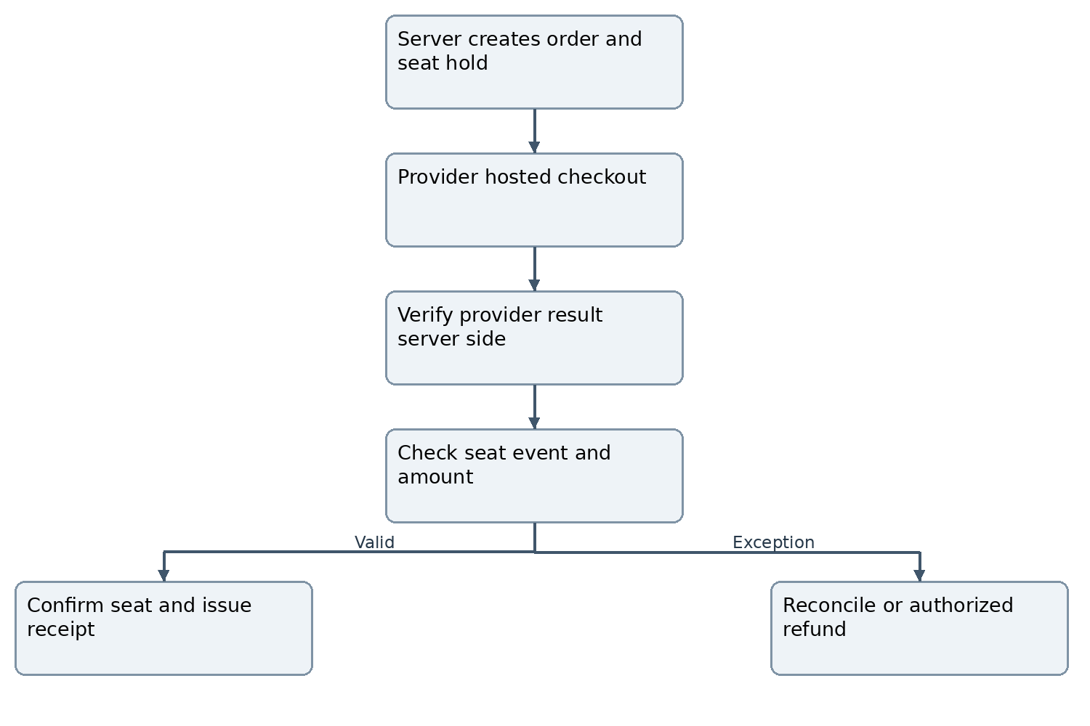
Figure O02 A browser success page is insufficient. Pending/failed payments do not confirm a paid registration; late success cannot overbook an event.

Integration contracts and identifiers
The following extend X01–X05 and C001–C152. They are requirements for interfaces, not deployed endpoints. The implementation team must publish the actual schema and approved API specification. Do not interpret operation labels as invented E-Digital Nepal or gateway APIs.
ID | Boundary and operations | Minimum contract
X06 | KCC360 → website: publish, update, withdraw | Source event/public version, service identity, approved payload, operation ID, acknowledgment, URL, retry and reconciliation.
X07 | Website backend ↔ KCC360: eligibility, apply/register, status, cancel | Opaque reference, contact verification/self-service token, minimal personal fields, seat/offer version, consent/terms, idempotency and denial states.
X08 | KCC360 ↔ payment provider: create order, verify status, notification, refund | Merchant/environment, order/attempt/provider transaction IDs, amount/currency, official authentication, replay controls, timeout and error mapping.
X09 | KCC360 ↔ Finance/accounting reconciliation | Verified receipt/refund reference, gross/fees/net settlement, currency, dates, export/batch ID and review outcome; authorized read/export only unless separate write contract approved.
C153 | M03/M10/M32 ↔ M30: event execution authorization | Exact plan/item version, PLANNING_ONLY/EXECUTION_AUTHORIZED and current approved dates; operational readiness is separately recorded.
C154 | M03/M10/M32 ↔ M02/M05: schedule and resources | Venue/equipment IDs, reservation intervals, sessions, leads and conflicts; shared service may implement this capability.
C155 | M03/M10/M32 ↔ M24/M22: public registration | Registration/session reference, eligibility, capacity/offer expiry, current status, message/event ID; never transfer private data to public listing.
C156 | M03/M10/M32 ↔ M11: event receipts and refunds | Order/receipt/refund references, verified amounts and reconciliation state independent of expenditure settlement.
C157 | M03/M10/M32 ↔ M16/M18: role based recognition | Confirmed participation, actual attendance, role/evidence, approved evaluation and certificate category; payment is not learning evidence.

Additional records permissions and ownership
Record or permission | Required fields or guard
Event occurrence and session | Canonical owner, approved plan/item version, local timezone, sessions/rooms, current public version, readiness checks and independent state dimensions.
Booking and readiness | Resource quantity, capacity, interval, hold expiry, custodian, checklist result and authorized confirmer; reserve/release permission never grants plan approval.
Registration and offer | Person/contact verification reference, source, role, session, eligibility basis, terms version, capacity/hold token, expiry, decisions and actual attendance.
Order attempt receipt refund | Distinct immutable references, quoted fee/terms version, amount/currency, provider result, financial authorization and reconciliation history.
EVENT.OPERATE / EVENT.STOP | Assigned event scope; operational changes stay within approved baseline. Stop may act immediately for safety with recorded reason.
EVENT.PUBLISH / REGISTRATION.REVIEW | Explicit event/publisher scope and exact approved public version; review cannot grant institutional identity or change approved capacity.
PAYMENT.RECONCILE / REFUND.AUTHORIZE | Named Finance authority, provider evidence, separation rules and amount limits; technical integration operator gets neither power by default.

Annex P Acceptance tests revision register and adoption
All criteria below are NOT RUN. Prior build/regression reports and diagram completion do not establish working event registration or payment. Tests use fictional records and provider sandbox/mocks until official contracts and credentials are available. No live charges, refunds, publications or messages are authorized merely by creating this specification.

AT-EV01 Not run
An annual planning-only item cannot execute. A fully specified Principal-authorized item passes without duplicate plan approval; changed dates require Annex M.

AT-EV02 Not run
Concurrent venue/session/resource bookings reject conflicts including setup and cleanup. Cancellation releases resources once and keeps commitments/history.

AT-EV03 Not run
Missing readiness blocks READY. An authorized emergency stop is immediate; changed-scope resumption cannot bypass Finance Administrator and Principal review.

AT-EV04 Not run
Partial cancellation preserves delivered attendance and individual eligible recognition. Learning verification can proceed while finance/report closure is pending.

AT-EV05 Not run
Offline check-in synchronization detects duplicate/replayed scans, role conflicts and corrections. No certificate appears solely from registration, payment or check-in.

AT-PUB01 Not run
Only approved exact public version is sent; unapproved/private fields are denied. Receiver acknowledgment, retries, out-of-order update and withdrawal preserve canonical version.

AT-PUB02 Not run
A cached event page cannot register/check out after backend closure. Publication queuing is not reported as acknowledged live publication.

AT-REG01 Not run
Class-roster, free direct, application-review, paid-direct and application-then-payment paths create appropriate distinct states without institutional accounts.

AT-REG02 Not run
Simultaneous final-seat requests and unexpired holds never exceed event/session capacity. Waitlist promotion/expiry/retry allocate a place only once.

AT-REG03 Not run
A registration reference alone exposes no private record. Expired/revoked self-service tokens, cross-person access, unscanned files and abusive repeated requests fail.

AT-PAY01 Not run
Browser success spoofing cannot settle an order. Invalid merchant, signature/protocol authentication, amount/currency, unknown order or replayed callback fails verification.

AT-PAY02 Not run
Duplicate and out-of-order callbacks do not double-confirm, double-receipt or downgrade success. Separate attempts cannot reuse a provider transaction across orders.

AT-PAY03 Not run
Late success after hold expiry, cancelled event, duplicate successful attempts and full capacity enter reconciliation rather than overbooking or losing payment history.

AT-PAY04 Not run
Refund authorization respects role and net paid balance. Repeated notifications and failed/retried refunds never over-refund or report success without provider verification.

AT-PAY05 Not run
Finance reconciliation identifies gross, fees, net, refunds and unmatched transactions. Fee changes preserve existing quoted order terms; gateway outages leave accurate pending status.

AT-INT01 Not run
Full browser → website backend → KCC360 → provider sandbox → verified notification → confirmation path preserves session/contact continuity and audit references. External self-service never grants internal dashboards.

AT-INT02 Not run
Event postponement with pending orders updates notices, reservations and affected sessions only after approval; completed learning and accepted payment history remain immutable.

Version 3 point 4 amendment register
ID | Change | Location
AM34 | Annual versus event approval and independent states | EV-001/EV-002; overrides older settlement-before-verification chain.
AM35 | Bookings sessions readiness interruption attendance logistics | EV-003–EV-010; Figure N01.
AM36 | Publication API ownership and acknowledged delivery | PUB-001–PUB-003; X06; Figure O01.
AM37 | Public applications registration offers and privacy | REG-001–REG-004; X07; supersedes listing-only scope only for activated registration events.
AM38 | Hosted checkout verification refunds reconciliation | PAY-001–PAY-004; X08/X09; Figure O02; replaces prior payment exclusion.
AM39 | Connection extensions permissions and acceptance | C153–C157; Annex P; 35 modules retained.

Activation prerequisites and development sequence
Develop incrementally after checkpointing ongoing v3.1 work. Review v3.2/v3.3/v3.4 differences against actual implementation; preserve all records and tests. First establish event states and approval/locking, then bookings/readiness and participant/session controls, then versioned publication, public registration and finally provider sandbox payment/refund reconciliation. Existing MIS-dependent identity/role activation remains gated by official contract; independent event and adapter development may continue.
Before live activation record named operational reviewers, readiness/safety authority, publication authority, fees/concessions, hold and cancellation periods, refund policy/approvers, privacy/retention/consent rules, accounting receipt requirements, gateway merchant/provider contract, website receiver/API specification and measured acceptance. These are configuration decisions, not permission to invent provider details. Full scholarly conference peer review and external authenticated collaboration remain separately scoped extensions. Production payments remain disabled until their prerequisites and acceptance pass.

Annex Q Manual MIS imports and planning uploads
KCC will manually export available records from E-Digital Nepal MIS and upload them to KCC360 before API integration. These are official MIS-sourced records, not fictional test data. This changes transport only; MIS retains identity and official enrollment ownership. The 35-module structure and prior plan approval, public registration and payment boundaries remain in force. This annex supersedes wording that makes an API the only permitted master-data transfer method.

IMP-001 Official source and authorized operators
Authorized Academic Administration/data-import staff may upload exported CSV or Excel files for students, academic structures, enrollment/class rosters, faculty/subject assignments and official student status/exit dates where the export supplies them. Do not assume unavailable export fields. Version template/column mapping against a real authorized export. Import rights are scoped to institution and data category; import permission grants neither Principal approval nor academic scoring rights. Official records may be used in the authorized production import workflow; development tests use fictional fixtures or separately approved protected test data.

IMP-002 Stable identities and input contract
Match source system + owning institution + stable MIS entity ID; retain a separate internal KCC360 ID and source mapping. Names/emails alone never merge people or confer roles. Preserve identifiers as text including leading zeros. Require academic period and applicable programme/batch/semester/course references. Capture source export timestamp, timezone, coverage scope, full-snapshot/incremental mode and schema/mapping version. Mark unknown source freshness explicitly; missing trusted IDs/timestamps needed for a change enter resolution rather than invented values.

IMP-003 Stage validate preview confirm
Use UPLOADED → VALIDATING → PREVIEW_READY → CONFIRMED → COMMITTING → COMMITTED, with VALIDATION_FAILED, NEEDS_RECONCILIATION, FAILED or CANCELLED exceptions. Scan and validate file type, size, structure, required fields, dates, duplicate keys, parent references and operator scope. Preview counts and row differences: new, changed, unchanged, invalid, duplicate and conflicting. Validation alone changes no active record. Fix errors and revalidate before authorized confirmation of the exact file fingerprint, mapping and preview version.

IMP-004 Commit atomicity and repeat protection
Commit each confirmed import batch atomically after rechecking current record versions and authority; on failure roll back its changes and retain the error report. A valid subset may be imported only as an explicitly selected new batch with a fresh preview, disclosed exclusions and confirmation. Commit academic master entities before dependent enrollments/assignments, using linked batch references. File fingerprint plus source scope/version and row keys prevent duplicate effects; a repeated unchanged upload reports no change. Concurrent imports or intervening changes invalidate stale previews.

IMP-005 No destructive inference or stale overwrite
Absence from a file never means Left College, deletion, account deactivation, faculty removal or loss of project membership—even for a full snapshot. Flag absence for authorized review. Only explicit trusted source status/effective dates may propose status changes, preserving the source record. Older/conflicting enrollment updates enter reconciliation and do not overwrite a newer valid state. Blank cells mean no update unless a separately explicit, permitted clearing operation is reviewed. Preserve history; corrections never erase verified learning or prior import decisions.

IMP-006 Audit correction and security
Retain import ID, actor, original private file reference/hash, export/import times, source scope, mapping/preview versions, counts, row errors, old/new values, outcome and timestamps. Restrict raw personal-data download and error-report access. Apply file scanning, retention and privacy controls to imports and exports. Do not execute macros/formulas; safely encode spreadsheet exports. Imported records do not create passwords, sessions or privileged grants. Correct committed data by versioned compensating changes after dependency review, not deletion of audit history or blind rollback over later edits.

Manual MIS import workflow
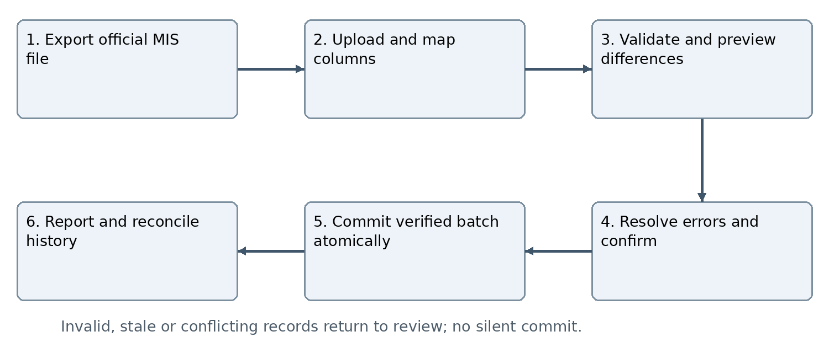
Figure Q01 Import confirmation is a data-administration action, separate from plan approval and authentication.

Minimum import template groups
Template | Required references and validation
Academic structures | Stable unit/programme/batch/academic-period/section/course-offering source IDs as available; dependencies and effective dates validated. No invented MIS codes.
Students and enrollment | Stable MIS student ID; minimal profile; enrollment/offering ID where available; programme/batch/semester/section/academic period; official status and effective date when supplied.
Faculty and assignments | Stable MIS staff ID; department/course-offering/cohort assignment references; responsibility type; effective dates. Role grants require trusted assignment and explicit authorization.
Import manifest | Institution, source system, source file/export time, snapshot/incremental mode, coverage, mapping version, fingerprint and operator. Unavailable fields produce a visible resolution path.

UPL-001 Linked strategic plan event and task uploads
Provide downloadable CSV/Excel templates or mapped sheets for strategic/annual plans, event items, teams/task groups, tasks and assignments. Preserve hierarchy plan → event → team/domain → task → assigned person, with stable external/import keys and internal links. Upload objectives, outcomes, KPI/evidence requirements, dates, budget references, team numbers, members per team, responsibilities, mentor/evaluator and assignment mode where applicable. Validate scope, type, required parents, valid periods, totals/capacities and references before committing drafts; repeating conversion/import must not duplicate events or tasks.

UPL-002 Drafts locked plans and approvals
New uploads create drafts, not approved/executing activities. Existing approved plan commitments remain locked; uploaded additions, dates, scope, capacity, budget or responsibility changes create proposed change requests rather than overwrite the baseline. All plan approval and material amendments route responsible unit → Finance Administrator → Principal, including zero-cost/date-only requests. Routine roster-to-task allocation within an already approved academic team/role envelope may be operational assignment under ASG-001; changing approved team capacity, named accountable lead, mentor or material responsibility requires the applicable amendment/reassignment controls.

UPL-003 Upload feedback and ownership
Reuse IMP-003/004 staging, exact preview confirmation, row-error reports, stale-version checks and duplicate controls for planning uploads. Show imported drafts separately from source-approved plans. Student-entered proposals remain student-owned submissions with department routing; importing them does not confer approval or bypass member acceptance. Only the owning authorized unit can upload or allocate work in its scope. Downloadable examples use fictional students and codes.

Planning upload and approved baseline workflow
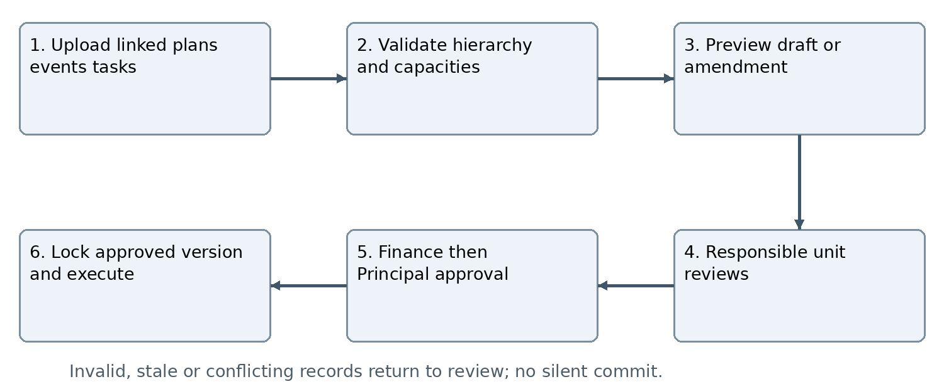
Figure Q02 Uploading is not approval. Existing locked plans receive change requests under Annex M.

ASG-001 Department led academic assignments
For academic workshops and seminars, the responsible Academic Department and assigned subject teacher/mentor directly allocate all required event tasks to eligible students or class groups. Use the current authoritative imported class/course roster, recording source snapshot and event period. Support UI and CSV/Excel assignment, individual/team allocation, leads, due dates, deliverables and evidence. These assigned academic tasks do not require student applications or competitive selection. Check department/course/event scope, roster eligibility, workload and approved capacities. Unassigned/unavailable subject teacher routes to Academic Coordinator for authorized coordination; no arbitrary evaluator selection.

ASG-002 Club recruitment and student proposals
Club event task positions retain approved task domains, available places, application deadlines, student applications, authorized selection and confirmed roster handoff. Club membership/application/selection alone creates no event enrollment or achievement. Student academic projects retain accepted team invitations and subject-faculty/Coordinator review; student research passes Academic Department endorsement then Research Department review and mentor coordination. Do not turn assigned class events into club applications, or club recruitment into silent compulsory allocation.

ASG-003 Assignment notification and evaluation
For direct academic assignments, notify each student of role, task, lead, mentor, due date, instructions and evidence; track read/acknowledgment separately without treating it as an application requirement. Authorized corrections/reassignment preserve prior responsibility and contributions. Update assigned evaluators through scoped accepted appointments; the assigned department/mentor reviews submissions and authorizes individual evaluation under the existing reflection workflow. Imported task completion or roster membership never automatically awards marks, credit, certificates or verified portfolio recognition.

Distinct academic and club assignment workflows
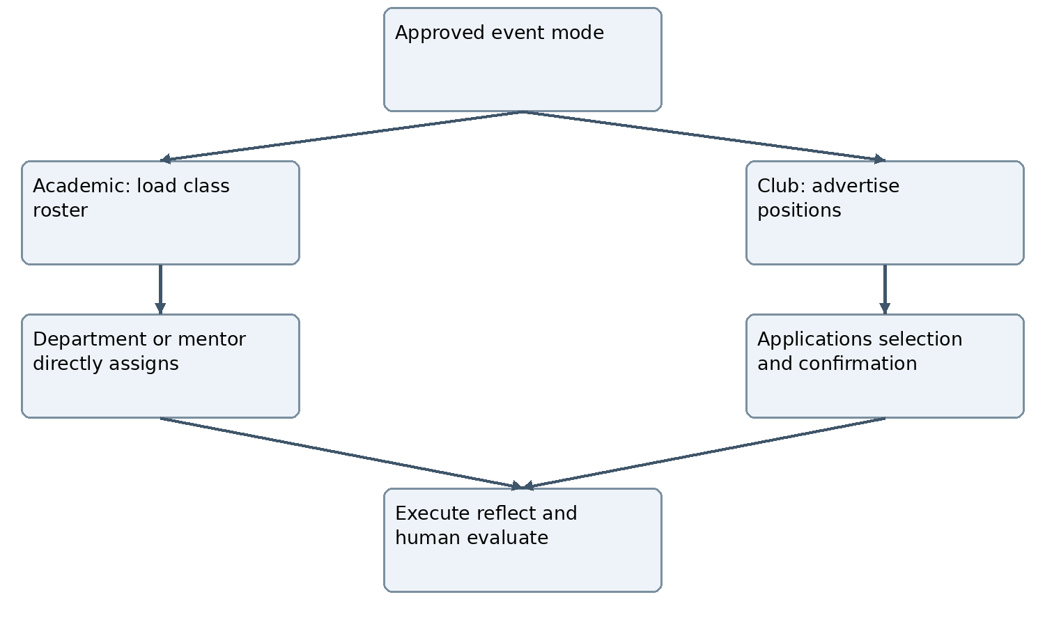
Figure Q03 Alternative entry routes converge at execution and evaluation. Student proposals use the separate M04/M31 review route; direct allocation does not bypass plan approval.

Annex R Semester progression reconciliation and API transition

PRG-001 Controlled cohort progression
Authorized Academic Department staff select institution/programme, batch, academic session, current semester and effective date. Preview exact cohort, official source freshness, students progressing and only applicable Left College exclusions. Exclude only an official Left College record whose exit date is effective for the operation. Fees, attendance, failed subjects, backlogs, incomplete evaluations and administrative dues do not block progression. Missing/conflicting eligibility/exit dates require data resolution rather than invented exclusion. Final-semester completion has its own controlled process, not a fictitious next semester.

PRG-002 Atomic commit and local history
Confirm and commit progression as one guarded cohort operation with stable operation ID, source cohort/version, authorized actor and timestamp. Repeated requests cannot progress twice. Retain previous enrollment periods and activity mappings. Record this as KCC360 local progression pending MIS reconciliation, not a successful MIS write. Planned future progression does not change the effective semester before its date. Corrections require designated authority, reason, conflict checks and preserved prior operation history.

PRG-003 Reconcile later exports
Keep last imported official MIS enrollment and local progression as distinct source/effective-dated records. A later export matching the local target marks reconciliation complete with source reference; it does not trigger another progression. An older unchanged source does not silently reverse the local operation. A conflicting newer source creates a reconciliation case with both values, dates, operation, affected records and responsible reviewer. Resolve by accepted official-source correction or separately authorized local correction; preserve all prior evidence. Do not claim the MIS database was updated from a KCC360 local action.

PRG-004 Display and assignment use
Dashboards and previews show both the latest official imported semester and local effective semester where they differ, plus export date and reconciliation state. Department-approved local progression may govern current KCC360 operational cohort/task views while flagged pending reconciliation; it does not alter official university results. Existing event rosters and completed work retain historical mapping. Unresolved identity/cohort conflicts enter review before new affected assignments rather than silently choosing a semester.

INT-007 Transition from manual transfer to API
Manual imports and future MIS API use the same source IDs, schema validation, staging/reconciliation and audit services. Track transport as MANUAL_EXPORT or API without changing source ownership. Validate actual provider contract before activation, reconcile a baseline and assign one controlled ingestion writer per entity/scope to avoid concurrent stale file/API writes. Switching transport must not recreate users/enrollments or lose history. E-Digital Nepal endpoints and protocols must not be invented. Authentication/SSO is a separate dependency; loading official records does not authorize local passwords or login bypass.

Semester progression and later MIS reconciliation workflow
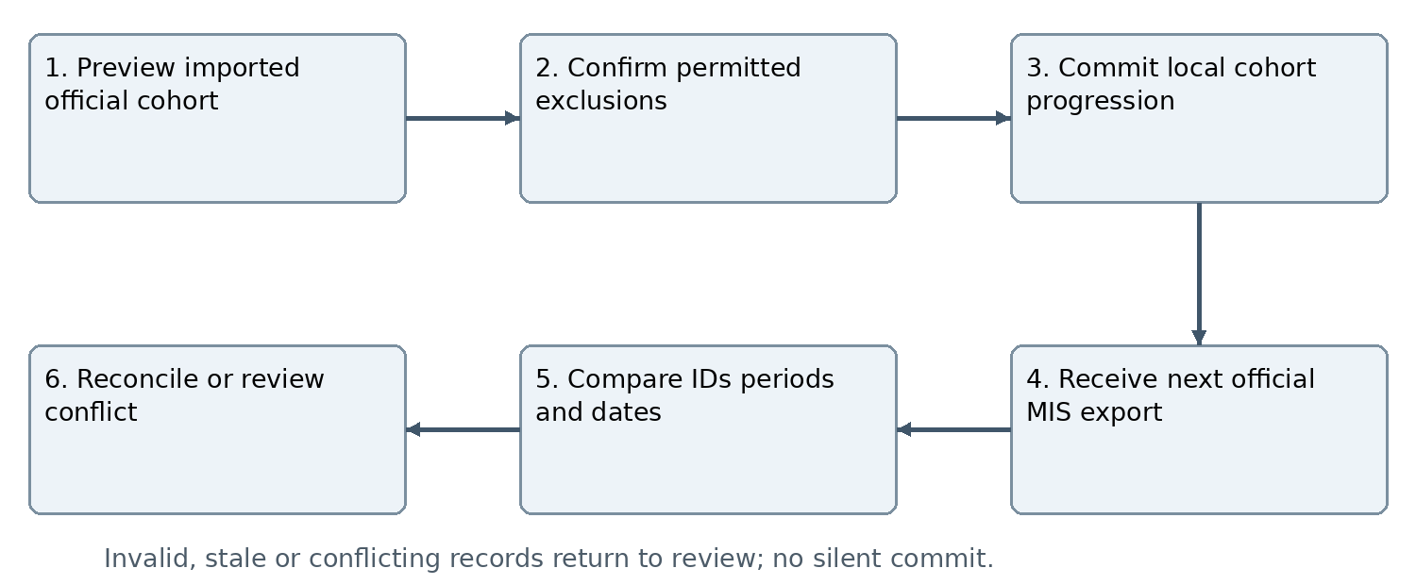
Figure R01 Local progression and official source enrollment remain separately traceable until reconciled; no unacknowledged MIS write is claimed.

Connection extensions for import and assignments
ID | Connected modules | Data and guards
C158 | M01/M02 ↔ M25 | Private official source file, import manifest, scoped operator, stable identities; import never grants login or privilege.
C159 | M02 ↔ M03/M05/M14 | Historical course/class roster, academic direct assignments and scoped mentor/evaluator; validate current source and approved envelope.
C160 | M30/M09 ↔ M03/M05/M10 | Plan/event/team/task import keys, preview, draft/locked version and change request reference; no duplicate conversion or approval bypass.
C161 | M02 ↔ M20/M22/M28/M29 | Progression operation, official/local semester, conflict status, import error owner and current action deadline; no silent history rewrite.
X10 | Manual E-Digital Nepal export → KCC360 | File-based official source contract: scope, IDs, export time, mode, schema/mapping and import audit. Reuses X01 source authority; does not supply SSO.

Annex S Import assignment and progression acceptance
These are target criteria, all NOT RUN in this document. Use fictional fixtures to test; real exports belong only in the authorized protected import workflow. Report current source revision, record IDs/versions, expected/observed behavior, pass/fail/blocker and defects. Existing software must be reviewed before claiming these additions are implemented.

AT-IMP01 Not run
Import valid academic parent records, students/rosters and faculty assignments; confirm stable mapping, source/freshness labels, counts and scoped visibility.

AT-IMP02 Not run
Reject or queue missing stable IDs, malformed dates, unknown parents, leading-zero conversion errors, duplicate identity keys and mismatched scope; never match by name/email alone.

AT-IMP03 Not run
Repeat the exact file and a re-export of identical records. No duplicate people, enrollment, tasks or assignments are created.

AT-IMP04 Not run
A full snapshot missing a student does not delete/deactivate or mark Left College. Blank and stale values do not silently erase newer records.

AT-IMP05 Not run
Inject failure during commit and an intervening update after preview. Atomic commit preserves prior data; stale preview requires revalidation; excluded-row subsets need a new confirmed batch.

AT-IMP06 Not run
Unauthorized uploader cannot read source/error files, grant roles, create credentials or import outside scope. Malicious files/formulas remain unavailable or inert.

AT-UPL01 Not run
Upload strategic plan through event/team/task/assignment, validate links and capacities, then repeat import. Drafts remain unapproved and no duplicate conversion occurs.

AT-UPL02 Not run
Upload an addition/date/budget change against a locked plan. It creates a change request; Finance Administrator and Principal review are required before changed commitments take effect.

AT-ASG01 Not run
Department/assigned mentor directly allocates workshop/seminar tasks to roster students without application. A different department or unassigned mentor is denied.

AT-ASG02 Not run
Club event still requires application/selection/confirmed roster. Student project teams require member acceptance and correct academic/research routing; direct class allocation cannot bypass this.

AT-ASG03 Not run
Reassign a task/evaluator with authority and reasons; preserve prior contributions, notifications and evaluation integrity. Importing membership or completion awards no automatic achievement.

AT-PRG01 Not run
Preview and progress the full cohort; fees, attendance/backlogs/incomplete evaluation do not exclude. Only effective official Left College is excluded. Final semester does not create a next semester.

AT-PRG02 Not run
Retry progression, import an old source, then a matching new source. No second advancement or silent reversal occurs; reconciliation uses the correct source version.

AT-PRG03 Not run
Import a conflicting newer semester/exit record. Create a review case; show both sources and block affected ambiguous new assignments while preserving history.

AT-INT03 Not run
Switch fictional ingestion from manual file to API adapter with identical stable IDs. Preserve existing internal IDs and history, prevent dual-writer overwrite, and do not activate unavailable SSO.

Revision register and implementation adoption
ID | Change | Location
AM40 | Official manual MIS exports before API | IMP-001–IMP-006; Figure Q01; X10.
AM41 | Strategic event and individual task uploads | UPL-001–UPL-003; Figure Q02; C160.
AM42 | Distinct direct academic and club application routes | ASG-001–ASG-003; Figure Q03; C159.
AM43 | Local progression and later source reconciliation | PRG-001–PRG-004; Figure R01; C161.
AM44 | Shared ingestion mapping and future API transition | INT-007; C158–C161; Annex S acceptance.
Retain all v3.4 event/public-registration/payment requirements. This revision keeps 35 modules, retains C001–C157 and adds C158–C161 plus X10. Official file import confirmation is authorized data administration, not Principal plan approval. Review actual MIS export columns, source date reliability, import operators, protected file retention, workload rules and progression conflict ownership before activating affected operations. Continue independent work while official API/SSO remains pending; do not restart the existing application or fabricate old approvals.

Annex T Strategic targets and departmental accountability
This revision makes the responsibility chain explicit across every department and subordinate execution unit. It uses existing M09, M13, M14, M26–M30 and related activity modules; the catalogue remains 35 modules. Preserve the approved strategic pillar/goal/KPI architecture. This specification neither changes strategic targets itself nor declares implementation complete.

STR-001 Principal yearly target allocation
Principal assigns each department yearly targets against existing approved strategic goals/KPIs. Record strategic plan/version, pillar/goal/KPI ID, academic/fiscal reporting year, target value/unit, baseline, responsible department/head, due dates or review periods, evidence rules, verifier and dependencies. Keep target issuance separate from departmental implementation-plan approval. Department proposals to change assigned targets require a reasoned versioned decision by the Principal and any wider strategic governance authority required by policy; no automatic reduction to hide shortfall.

STR-002 Department plans and subordinate contributions
Every department maintains a multi-year contribution plan linked to approved institutional goals/KPIs and prepares its annual implementation plan from Principal-issued yearly targets. Specify activities, deliverables, owners, schedule, budget, resources, review milestones and evidence. Academic uses applicable programme/course/mentor plans; Student Affairs uses club/service/placement plans; Research uses research teams. Use stable parent links, one accountable owner and supporting contributions without duplicating activities. See ECO-001–ECO-004.

STR-003 Common approval and locked baselines
Responsible-unit review → Finance Administrator review → Principal final approval applies to each department plan and each submitted subordinate plan, including zero cost. Club review includes mentor and Student Affairs before Finance Administrator. Target issuance, departmental endorsement, annual-plan approval and event execution authorization remain distinct. Apply EV-001 planning-only/execution-authorized item controls; do not invent a second approval when the exact event is already fully authorized. Lock approved versions and route later additions, date changes, capacity/budget/responsibility changes through Annex M.

STR-004 Automatic internal calendar and dashboard propagation
On Principal approval of a club, department or subordinate plan, automatically display its approved activity names, start/end dates, owner, responsible unit, linked KPI, budget status and execution authorization in the owning dashboard, supervising department dashboard and authorized Principal dashboard. Club items appear in Student Affairs. Keep one canonical plan/activity occurrence; internal display does not wait for manual event recreation and does not create duplicate tasks/attendance. Draft/rejected records are separately labelled and excluded from approved calendars and target delivery. Public website publication remains a separate controlled workflow.

STR-005 Targets and named activity schedules
Allow numeric annual targets before the detailed schedule is ready, but show unscheduled/unallocated shortfall. Named approved event items carry dates; missing dates cannot be fabricated from a count. Example only: an SDSN plan with 3 major and 12 minor events has separate target units/categories, and named dated activities contributing to each. Categories major/minor require institutional definitions and cannot be inferred from fee or attendance. A named plan is not achieved merely because it is approved or displayed.

STR-006 Traceability and controlled changes
Retain target → department plan → club/team/course plan → activity/session → tasks → individual contributions → verified KPI outcome. Import these stable parent references using Annex Q previews/validation. New approval/cancellation/amendment events update downstream calendars and alerts idempotently; failed propagation is visible for retry and stale actions are not authorizing. An approved target or schedule revision preserves the original comparison and reasons; past reports retain their source versions.

Strategic targets and approved execution workflow
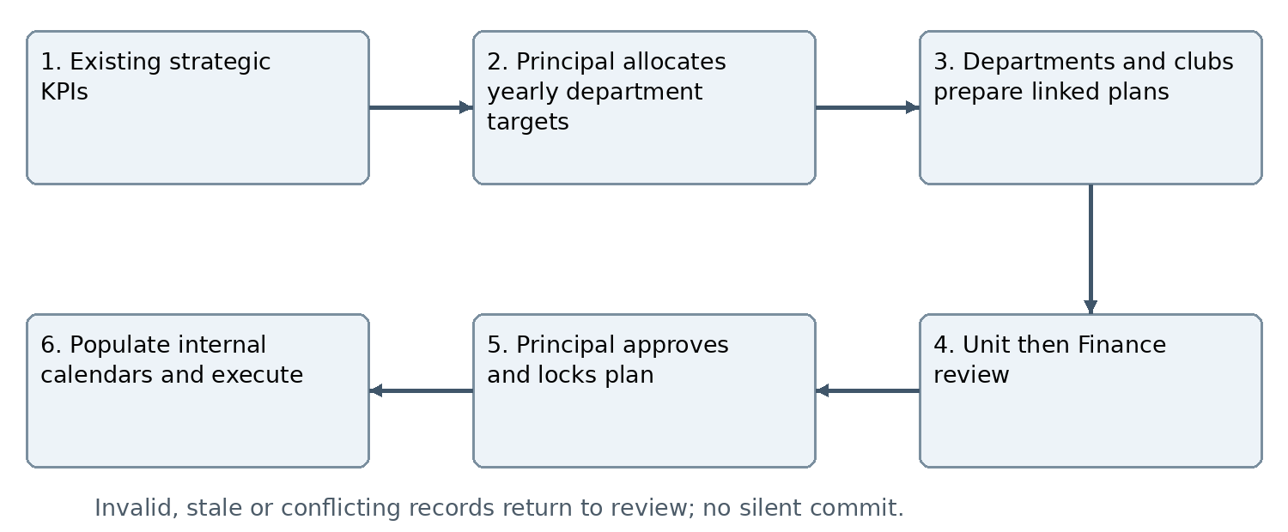
Figure T01 Strategic targets guide all departmental plans. Approved named events and dates populate supervising dashboards; publication to the public website remains separate.

Student Affairs planning monitoring and evaluation

SA-001 Assigned service responsibility register
Student Affairs shall maintain an approved register of its planning, coordination, monitoring and evaluation responsibilities. Include club governance/events, student leadership/development, career readiness, internships/placement coordination, employer engagement and other formally assigned student services. Record responsible officer, supporting unit, target, calendar, evidence, confidentiality and escalation route. Shared Academic/Research/counseling responsibilities require explicit scope; Student Affairs status alone grants no confidential academic, counseling or HR-record access.

SA-002 Planning and coordination
Prepare departmental targets and linked club/service plans, review their alignment, budgets, calendars, responsible leads and contribution rules. Coordinate conflicting venues, dates and student workload, while preserving Academic’s direct workshop/seminar assignment route and clubs’ application/selection route. Review committee succession, mentoring and handover requirements. Notify accountable officers of missing plans, unallocated targets and unconfirmed assignments; only the Principal provides final plan approval after Finance Administrator review.

SA-003 Monitoring evaluation and reporting
Student Affairs dashboard shall show target allocations, approved schedules, current progress, participation, budgets/settlements, missing reflections/evidence, pending evaluations, overdue reports and recorded reasons. Authorized Student Affairs reviewers evaluate unit/club outcomes using approved criteria and verified source evidence; individual academic scoring remains with assigned evaluators. Submit consolidated periodic/year-end review to Principal with shortfalls, corrective actions, pending commitments and source-linked results. Finance verification remains separate from departmental performance review.

Annex U Monitoring and evaluation in every dashboard

ME-001 Universal role scoped views
Each dashboard, including student, lead, faculty/mentor, club, Student Affairs, HoD/coordinator, Research, Finance Administrator, Principal, and technical administrator, shall expose Monitoring and Evaluation views appropriate to its actual responsibilities. Multiple role views share one account but retain distinct permissions. Monitoring summarizes current work; evaluation shows reviewed quality/outcomes and relevant feedback. No role receives finalization rights merely because it can monitor or view a score.
Dashboard | Monitoring | Evaluation and authority
Student | Own assignments, participation, deadlines, reflections and missing actions. | Own feedback, four-domain development and verified achievements; no self-finalization.
Team or event lead | Team tasks, meetings, deliverables, blockers and roster. | Contribution feedback and event outcomes; finalize only if separately authorized and never own result.
Faculty or mentor | Assigned course/project/club work and pending reviews. | Assigned student assessment with rubric/evidence, revision and human authorization.
Club | Annual targets, calendar, membership, budgets, partnerships and commitments. | Event/committee results and verified target contribution; President evaluated independently.
Student Affairs | Club/service/placement plans, milestones, exceptions and pending reviews. | Departmental/club outcomes and verified student-development/placement results within assigned scope.
HoD or coordinator | Department/course plans, faculty responsibilities, delivery and overdue work. | Learning/activity quality and departmental KPI results; no implied formal HR appraisal.
Research | Proposals, mentoring, milestones, publications and research outputs. | Authorized research quality/contribution/impact review; publication membership alone is not authorship.
Finance Administrator | Budgets, expenditure, receipts, advances and settlement actions. | Financial variance/compliance/reconciliation; no academic scoring rights.
Principal | All assigned departmental targets, approved plans and institutional exceptions. | Consolidated verified performance and department review decisions within approved authority.
Technical administrator | Imports, availability, permissions, file delivery and integration failures. | Technical service reliability and incident resolution; no default access to academic evaluation or private personnel records.

ME-002 Consistent measures and status separation
For each target show annual/period target, approved planned contribution, scheduled work, ongoing, delivery-completed and verified achievement as separate measures, not one sequential progress state. Also show overdue/incomplete/cancelled/unverified counts and recorded reasons. Use event lifecycle dimensions under EV-002; learning verification and financial clearance are independent. Attendance, payment, plan approval and task completion cannot alone be interpreted as verified learning or impact.

ME-003 KPI definitions and aggregation
Each KPI has a versioned unit, formula, denominator/population, reporting period, source, evidence threshold and verifier. For event counts, use distinct verified eligible occurrence IDs and category. For people outcomes count distinct eligible persons in the defined period. Sum additive metrics only; calculate percentages/averages from underlying approved numerator/denominator, not by summing or averaging departmental percentages blindly. Do not aggregate incompatible units. Missing and zero differ; no denominator displays not applicable. Record uncapped actual attainment; any capped/weighted rating requires an approved explicit rule.

ME-004 Deduplicated rollup and review
An event or outcome may contribute to several strategic mappings but is counted once in an institutional metric unless that metric explicitly defines multiple units. Parent departments roll up child contributions without counting a separate copy of the same event. Track individual → activity/team → club/department → institution using stable source IDs, with attributable contribution roles. Corrected/revoked evidence recalculates current totals and records the effect; frozen prior reports remain versioned and traceable.

ME-005 Review cycle and corrective actions
Monitor operational work continuously, review institutional progress quarterly and evaluate annually; academic semester reviews align with the academic calendar. Configure exact periods, reviewer, due date, evidence and review outcome before activation. Distinguish self-report from verified results. Every material finding requires an action, an authorized accepted risk or a reasoned no-action decision. Actions require owner, deadline, implementation evidence and independent effectiveness verification before closure; unresolved actions remain visible in subsequent reviews. Link results to next-cycle planning under ECO-009–ECO-011. No automatic target reduction or punitive student classification is permitted.

ME-006 Filtering freshness and privacy
Provide relevant year, department, programme, semester, club, activity, KPI, owner, date and status filters and authorized drill-down. Show source/as-of time, last verification and calculation version; exports retain filter/metric definitions. Current internal approved-calendar display is not public publication. Recheck record permissions on drill-down/export and background updates. Technical monitoring can see failure metadata without exposing restricted reflections, complaints, counseling or payment secrets.

Monitoring evaluation and corrective action workflow
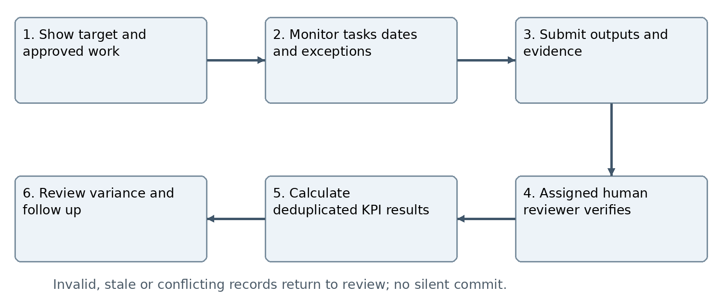
Figure U01 Monitoring supports action; verified evaluation supports institutional achievement. Corrective actions link to owners and existing plan-change controls.

Annex V Placement outcomes integration and acceptance

PLC-001 Career and placement pipeline
Track career preparation, employer engagement, verified opportunities, eligible student interest/referral, interviews, offers, acceptance and verified commencement as separate stages/events with dates and evidence. This is internal institutional coordination/outcome tracking, not authorization to build an unrestricted external job portal. Reuse internship/experiential controls where applicable. External employer contacts receive no internal access by default.

PLC-002 Placement outcome verification
Record employer/opportunity reference, student stable ID, role, opportunity type, start date, source/evidence, consent/visibility and assigned verifier. Internship, employment and self-employment are distinct outcome categories. A workshop, referral, interview or offer is not employment commencement. Withdrawal/decline/cancellation and unverified self-report remain identifiable. Verify updates and correct history through authorized amendments; avoid duplicate outcomes for the same student/opportunity. Any placement-rate metric requires an approved cohort, eligible denominator, observation window and definition of successful outcome; no default rate is inferred.

PLC-003 Student Affairs and Academic coordination
Student Affairs coordinates opportunities, preparation, employer follow-up and placement outcomes within assigned remit. Academic Department owns applicable academic suitability, learning objectives, mentor assessment and credit mapping. Named responsibility and handoff dates are recorded so neither unit claims the same unverified result. Student Affairs may view consolidated outcomes without receiving all confidential host/academic evidence. Existing formal internship letter, host acceptance, permission-to-start and human evaluation controls remain effective.

Department target and student service connection extensions
ID | Modules | Contract
C162 | M30 ↔ M09/M13 | Strategic KPI/version, Principal yearly allocation, department/club plan links, category/target and responsible owner; preserve locked baselines.
C163 | M30/M09 ↔ M26/M27/M28 | Approved canonical named activity dates, current version, execution status and as-of time; automatic internal calendars without duplicate activity creation.
C164 | M05/M14/M15/M18 ↔ M27/M28 | Verified evidence/contributions, metric source/version and deduplicated results; scoring authority distinct from visibility.
C165 | M26/M28/M29 ↔ M20/M22/M35 | Review period, responsible reviewer, variance, corrective action and overdue resolution; recheck current source and grants.
C166 | M03/M14/M18/M28 | Career/internship/placement milestones and verified outcomes, shared responsibility and cohort metric definitions; no automatic employment or academic credit.

SDSN annual target acceptance example
Illustrative configuration only: Principal assigns Student Affairs an annual target that includes SDSN delivery of 3 major and 12 minor events. Student Affairs allocates the linked contribution; SDSN submits 15 named dated items, categorized under approved definitions. Mentor and Student Affairs review, Finance Administrator reviews and Principal approves. The exact activities/dates appear on SDSN, Student Affairs and authorized Principal dashboards. Planned counts are 3/12; verified achievement begins at zero. A named event contributes only when its applicable evidence and outcome verification pass. An amendment changes future dates through Annex M without creating a sixteenth event. A jointly organized occurrence counts once institutionally.

Acceptance criteria for version 3 point 6

AT-STR01 Not run
Allocate yearly targets to Student Affairs, Academic and Research against existing KPI IDs. Plans/child units retain stable parent references and no strategic architecture is rewritten.

AT-STR02 Not run
Run club and department plan review: unit/mentor/Student Affairs as applicable, Finance Administrator, then Principal. Review-only roles cannot finalize plan approval.

AT-STR03 Not run
Approve the illustrative SDSN plan and retry delivery. Names/dates appear once in all authorized calendars; draft/rejected items remain separate and public website publication is not triggered.

AT-STR04 Not run
A plan with numeric targets but no named dates shows unallocated/unscheduled work. A dated planning-only item does not become execution-authorized by dashboard display.

AT-ME01 Not run
Every dashboard exposes Monitoring and Evaluation for its own scope. Student/technical administrator cannot finalize academic evaluation; one multi-role account retains role/scope restrictions.

AT-ME02 Not run
Complete an event without verification and leave its settlement pending. Show delivery completed, achievement unverified and finance pending independently; authorized individual learning may verify without financial clearance.

AT-ME03 Not run
Verify one jointly organized event linked to two departments and several KPIs. Each scoped view shows attributed contribution; institution counts one occurrence for a single-event metric.

AT-ME04 Not run
Calculate percentages from mixed cohort denominators, plus zero/missing/not-applicable cases. Results use approved formula and definitions rather than summed percentages or invented weights.

AT-ME05 Not run
Amend/cancel a future event and revoke prior evidence. Current totals and actions update; original target, schedule, evidence versions and prior report remain traceable.

AT-ME06 Not run
Run periodic review, variance explanation and corrective follow-up. Each action has owner/deadline; no target reduction, ranking or unapproved critical-student label is inferred.

AT-PLC01 Not run
Process career workshop → referral → interview → offer → acceptance → verified commencement. Only the defined verified outcome contributes to the approved placement metric; internship stays distinct.

AT-PLC02 Not run
Import or enter the same placement twice, change verification, and request unauthorized export. Duplicates do not inflate counts, corrections preserve history and restricted evidence remains private.

Revision register and activation boundaries
Amendment | Change | Normative location
AM45 | Strategic targets and departmental/club contribution plans | STR-001–STR-006; Figure T01; C162/C163.
AM46 | Student Affairs planning monitoring and evaluation remit | SA-001–SA-003.
AM47 | Monitoring and evaluation in every dashboard | ME-001–ME-006; Figure U01; C164/C165.
AM48 | Career and placement outcomes and responsibility handoffs | PLC-001–PLC-003; C166; AT-PLC01/02.
Version 3.8 Planning execution monitoring and evaluation ecosystem

Annex W Event completion records and reflections
Every completed event/activity shall have one canonical Event Completion Record linked to its approved plan version, event ID and responsible unit. This clarification applies to academic, club, interclub and institutional events and extends the existing modules without creating a new module. Earlier approval, privacy, payment and plan-lock controls remain effective.

ECR-001 Report and supporting attachments
The execution lead/committee shall submit a versioned completion report with objectives, actual dates, activities delivered, participant/attendance reconciliation, outputs, outcomes, KPI evidence, issues and follow-up. Attach or link attendance records, photographs or other permitted evidence, deliverables and relevant budget/financial-settlement references. Configure required evidence by event type before execution; mark justified not-applicable items explicitly. Pending finance may be referenced as pending, never represented as cleared. Uploading a file does not submit or approve a report.

ECR-002 Individual learning reflections
Each required student participant/team member shall submit an individual reflection covering knowledge, skills, leadership and impact, with role/contribution and supporting evidence. A team report does not replace individual reflections. The expected roster is derived from confirmed eligible participation and assigned reflection obligations, with auditable withdrawals, exemptions and no-show dispositions. External guests, speakers and beneficiaries are not automatically required to submit student reflections. Record due dates and reminders; late submissions remain traceable.

ECR-003 Mentor evaluation and authorization
Submission alerts the assigned mentor, who reviews the reflection and evidence, may request revisions, and authorizes the final evaluation and sets the reflection to VERIFIED under ECO-007. AI suggestions are optional, advisory and separately recorded; AI failure shall not block human review. The mentor can accept or change a suggestion with an attributable decision and reason for changes. No student or execution lead may authorize their own evaluation. Authorized results update student, lead, mentor and unit portfolios through links to canonical records, subject to role visibility and existing evaluation rules.

ECR-004 Report review and closure
Report review follows the responsible route: club committee → mentor → Student Affairs → Principal → Finance; academic department committee → responsible head → Principal → Finance; institutional coordinator → Principal → Finance. A combined event records a lead unit and required partner endorsements without duplicate reports. Post-event Finance clearance is distinct from pre-execution plan review by Finance Administrator before Principal final approval. Administrative closure requires required report approvals, participant dispositions, resource returns and finance clearance or an authorized policy-based waiver. Eligible individual learning recognition may proceed while unrelated report/finance matters remain pending.

Completion workflow and independent states
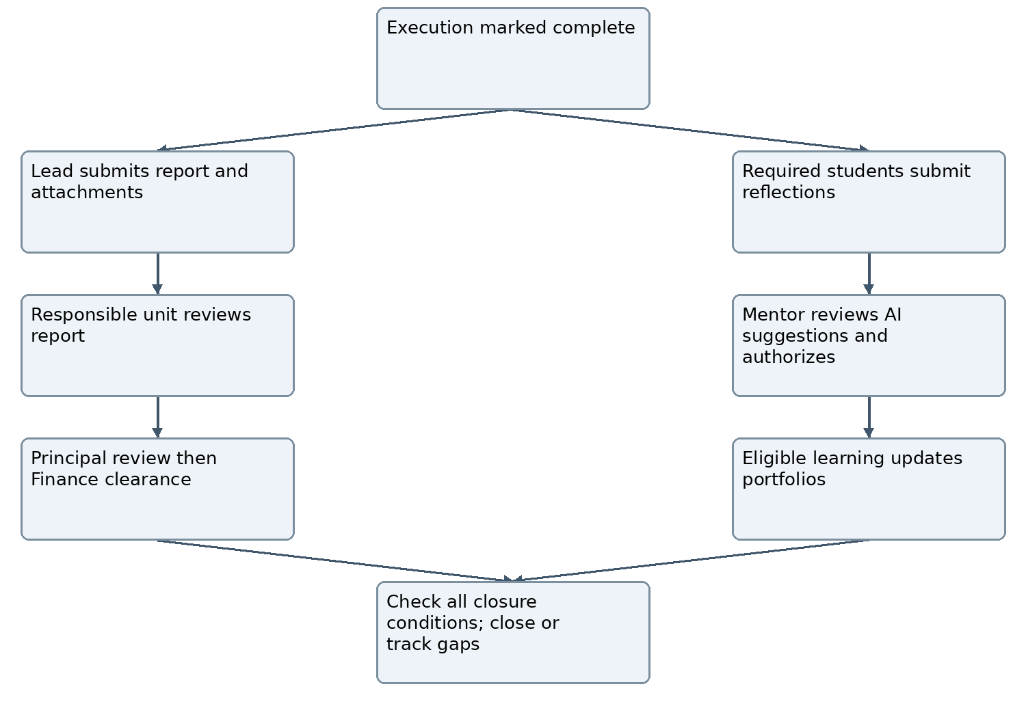
Figure W01 Parallel report and learning workflows. Returned submissions produce a new version; they do not overwrite reviewed evidence. Report approval is not a prerequisite for opening student reflections.
Track | States and boundary
Report | DRAFT → SUBMITTED → UNIT_REVIEW → PRINCIPAL_REVIEW → ACCEPTED; RETURNED/REJECTED are explicit. Finance is tracked separately.
Reflection | DRAFT → SUBMITTED → HUMAN_REVIEW_PENDING → VERIFIED or REVISION_REQUIRED. A revision returns to DRAFT. Human authorization produces VERIFIED; AI processing remains separate.
Finance / closure | Finance: pending, under review, cleared or authorized waiver. Event: execution complete, closure pending, administratively closed. No status is inferred from file presence.

Completion dashboards and integration contracts

ECR-005 Monitoring and evaluation in dashboards
Role-scoped dashboards shall show report attached/submitted/reviewed separately; required, submitted, returned and authorized reflection counts; overdue mentor reviews; missing evidence; outstanding financial documents; and closure blockers with owners and deadlines. Show denominator, exemptions/withdrawals and as-of time. Submission counts are not verified learning or KPI achievement. Student Affairs monitors clubs and assigned services; departments monitor their events; Principal sees authorized consolidated progress. Monitoring access alone grants no evaluation authority.

ECR-006 Canonical links privacy and audit
Store a completion record ID, event/approved-plan version, responsible lead/unit, report versions, attachment references, reflection IDs, assigned reviewers, decisions, deadlines, timestamps and closure checklist. Retain immutable submitted versions with attributable revision and decision history. Recheck permissions for every file access/export; scan uploads using existing file controls. Confidential individual reflections shall not be bundled into public reports or website publication. Consolidated exports include only authorized content. Linking does not create extra copies in each portfolio. Existing retention and audit policies apply.
ID | Modules | Integration contract
C167 | M03/M10/M32 ↔ M14/M15/M18/M25 | Canonical completion/event IDs, report and evidence versions, individual reflection obligations, reviewer decisions and authorized portfolio links. Retry-safe updates; enforce access on linked records.
C168 | Completion records ↔ M26/M27/M28/M29 | Scoped completion counters, verification states, closure blockers, owners/deadlines and source/as-of references. Reconcile on corrections; deduplicate shared events.

Amendment traceability
AM49: Event activities completion reflection report will be attached. Implemented in the specification by ECR-001–ECR-006, Figure W01 and C167–C168. This is a specification change; implementation and test execution are not certified by this revision.

Event completion acceptance criteria
All criteria below are NOT RUN and require evidence from the implemented application.

AT-W01 Separate upload and approval
Attach a report without submitting it: dashboard shows attached/draft and no approval or closure.

AT-W02 Parallel submissions
Mark execution complete: report preparation and required student reflection submissions open independently.

AT-W03 Individual obligations
Submit one group report for ten required students: ten individual reflection obligations remain until individually resolved.

AT-W04 Human authorization
AI suggests a score: no portfolio authorization occurs until the assigned human mentor acts. Simulate AI failure and complete human review.

AT-W05 Review revision
Return a report/reflection: retain the prior submitted version, feedback, author and timestamps; a new revision re-enters review.

AT-W06 Correct routes
Club report enters Student Affairs after mentor review; department report enters its responsible head. Verify Principal review before post-event Finance clearance.

AT-W07 Independent recognition
Authorize one eligible student while finance is pending: publish authorized learning only within permitted portfolio scope; event administrative closure stays pending.

AT-W08 Accurate dashboard counts
Reconcile required, exempted, withdrawn, submitted and authorized counts against canonical roster/records; no-show does not become verified attendance.

AT-W09 Privacy and permissions
An unauthorized user cannot access a reflection through its report link/export. Public reports omit private reflections and payment secrets.

AT-W10 Closure and deduplication
Missing mandatory evidence blocks administrative closure. An interclub event has one canonical report and is counted once per metric definition; retrying updates creates no duplicate records.

Annex X Consolidated workflow ecosystem
The ecosystem links institutional intent to verified educational and organizational results. The 12 approved decisions and proportional workflow simplifications are normative in this revision. This annex refines existing M03–M05, M09–M15, M18, M20–M22 and M26–M35; it does not create new applications or certify implementation. Preserve existing code, records, audit history, MIS ownership and the rule that only official Left College status excludes ordinary cohort progression.
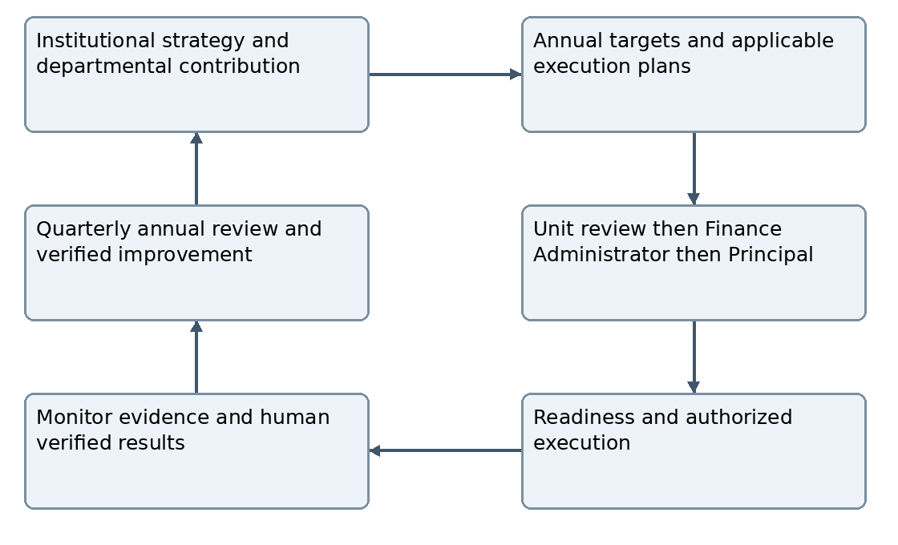
Figure X01 Closed planning and improvement cycle. Material amendments return to the approval route; monitoring and evaluation keep their assigned decision authorities.

ECO-001 Applicable planning hierarchy
Each department shall maintain a multi-year contribution plan within the approved institutional strategy period, referencing existing pillar/goal/KPI IDs, intended outcomes, baseline, annual milestones, accountable head, assumptions and dependencies. Do not change KCC strategic architecture. Principal-issued yearly targets inform annual implementation plans and applicable semester/course/service plans. Require only relevant levels; a shared record may fulfill multiple planning views when it retains the necessary mappings and decisions. Student-initiated proposals may enter without a pre-existing annual item under WF-013–WF-015; approval creates or links their contribution rather than requiring duplicate submission.

ECO-002 Proportional activity requirements
Use simple, standard and complex templates over the same canonical activity record and shared services. Select by actual requirements and risk, not title alone. Required ethics/safety, participant, budget and evidence controls cannot be bypassed by choosing simple. Version the template and applicable checklist before authorization. Show short relevant forms and role workspaces; the 35-module catalogue is not mandatory navigation.

Activity templates and approval boundaries
Template | Typical use | Required operation
Simple | Class workshop, seminar or guest session with limited coordination | Approved scope, teacher/mentor, applicable class roster, date, learning objectives, evidence, required reflection/evaluation and report fields. Task board and meeting are optional. A structured completion record may serve as the report where the approved template allows; do not require a duplicate document.
Standard | Club event or departmental programme | Named lead/mentor, confirmed team or participants, budget and resource controls, evidence, completion report and applicable individual evaluation. Tasks and meetings only where coordination requires them.
Complex | Research, conference, joint or externally partnered activity where relevant | Milestones, lead/supporting units, partner responsibilities, resources, risk and applicable external/ethics approvals. Add public registration/payment controls only when those services are used.

ECO-003 One approval for a fully specified scope
Every plan, including zero-cost plans, follows responsible-unit review → Finance Administrator review → Principal final approval. A detailed semester/annual plan may authorize its identified activities when required scope, dates, budget, lead, mentor/evaluator, eligibility, resources, evidence and readiness prerequisites are specified under EV-001. Otherwise record PLANNING_ONLY and submit missing event details through the same route. No duplicate approval is required for an unchanged fully authorized activity. Readiness does not confer additional plan approval authority.

ECO-004 Material amendments and routine operations
Approved baselines remain locked. Added activities, date extensions/changes and changes to approved scope, budget, capacity, accountable responsibility or required safeguards use Annex M. Routine task assignments within approved scope, progress updates, attendance entry and typographical corrections that do not change an approved commitment use scoped operational permissions with audit history. A typo cannot conceal a date, amount or eligibility change. Routine faculty/team assignments must satisfy eligibility, acceptance and workload rules; replacing an approved accountable lead, mentor/evaluator or other material responsibility uses the applicable reassignment and amendment controls. No operational role may redefine the material-change boundary to evade Principal approval.

ECO-005 Obligations and assessment basis
Tag academic work as curriculum-required, institution-required or discretionary; record source document/version, applicable course/cohort and requirement. Plans must disclose omissions of applicable mandatory work for resolution and cannot waive an external academic obligation through ordinary plan approval. Before execution identify outcomes, deliverables, rubric/version, evidence standard, assigned evaluator, reflection obligations, deadlines and closure conditions. Communicate these to affected participants; material changes retain the original basis and require applicable approval. Do not apply undisclosed retrospective scoring rules.

Execution responsibilities and proposal routes

ECO-006 Assignment and shared commitments
For class-based workshops/seminars, the Academic Department and assigned teacher/mentor directly assign work using the applicable roster. Club recruitment uses announced positions, deadlines, eligibility, capacity, selection and confirmed handoff. Project-team invitations require each eligible member to accept. Lead responsibility, student participation and mentor oversight remain separate roles. Joint work has one canonical activity/proposal, one accountable lead unit and explicit supporting-unit commitments, deliverables, cost allocation and verification responsibilities. Partner endorsement does not replace Principal approval.
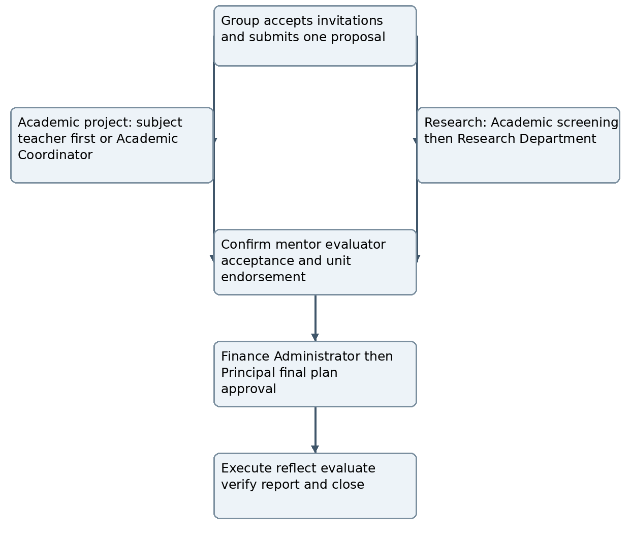
Figure X02 Student group proposals retain one record across forwarding. Research review coordinates interdisciplinary consultation and applicable ethics, safety or external approvals before execution.
Proposal fields: student lead, accepted members, classification, objectives, methodology, expected outputs, timeline, tasks, resources and proposed budget. Course-linked first review is under departmental oversight. The department confirms or assigns academic mentors/evaluators; Research coordinates research mentor assignment after Academic endorsement. Students see the current reviewer, status, next action and reasons. Return, rejection, mentor acceptance/reassignment and decisions retain history. Students cannot approve their own proposal or evaluation. Faculty-led research may include accepted student members under M31 and the same applicable approval/evidence controls.

Monitoring authority and evaluation decisions
Role | Responsibility | Authority boundary
Principal | Issue annual targets; approve plans; review consolidated performance and exceptions | Plan approval does not authorize grades, publication, expenditure release or every individual evaluation.
Department head / Student Affairs | Prepare unit plans; monitor assigned activities; review unit outcomes and corrective actions | Student Affairs oversees clubs/assigned services. Academic scoring stays with assigned evaluators.
Lead / teacher / mentor | Assign eligible work, monitor execution or learning and submit evidence within scope | Lead cannot self-verify achievements. Mentor evaluates only assigned records.
Finance Administrator / Finance | Review feasibility before Principal approval; reconcile and clear financial obligations after execution | No academic scoring rights; review, release, spending and settlement are distinct actions.
Assigned evaluator / KPI verifier | Verify individual/group results or metric outcomes under approved definitions | Visibility grants no authority. Separate decisions and resolve conflicts of interest.
Technical administrator | Manage technical services and authorized grants | No default right to confidential reflections or academic evaluation.

ECO-007 Canonical reflection and separate evaluation levels
Use DRAFT → SUBMITTED → HUMAN_REVIEW_PENDING → VERIFIED or REVISION_REQUIRED. REVISION_REQUIRED permits a new DRAFT version and resubmission; preserve submitted evidence and prior decisions. Human authorization produces VERIFIED. Older AUTHORIZED labels map to VERIFIED and RETURNED labels to REVISION_REQUIRED for reflection records only; MENTOR_REVIEW maps to HUMAN_REVIEW_PENDING. Never infer a historical human decision from an upload or AI result. AI retains independent NOT_REQUESTED/QUEUED/PROCESSING/COMPLETED/FAILED status and remains optional. Record rubric, model/prompt metadata where used, reviewer and final decision. Evaluate applicable individual learning, group outputs, event effectiveness, department performance and institutional KPI achievement separately. Department/institution reviews aggregate evidence, not rescore every student. No automatic HR appraisal arises from operational portfolios.

ECO-008 Shared resources and workload
Before authorization/readiness, check known venue, equipment, mentor/faculty, student workload, dates, dependencies and committed budget against existing canonical records. Show conflicts, source freshness and missing confirmations. A named authorized coordinator resolves conflicts; capacity, budget or date changes use Annex M. Configure workload rules and applicable thresholds rather than inventing universal limits. Task boards and meetings are optional unless the selected activity requires them. Meeting minutes do not substitute for approval.

Review improvement and reporting continuity

ECO-009 Operational and periodic review
Leads/mentors monitor current tasks and learning, units monitor their approved work, and Principal monitors consolidated targets/exceptions. Use continuous operational monitoring, quarterly institutional review, annual evaluation and applicable semester reviews. Configure dates, responsible reviewer, submission/review deadlines, reminder intervals and escalation recipients before activation. No approval by silence. Reviewer absence/conflict requires authorized scoped effective-dated reassignment, preserved history and invalidation of stale actions. Dashboard summaries distinguish planned, delivery-complete, evidence-submitted, verified, overdue and financially pending records; display owners and required next actions.

ECO-010 Findings and effectiveness verification
Record each material finding with source review, affected goal/KPI/activity, cause, severity and disposition: corrective action, authorized accepted risk, or reasoned no-action decision. Actions require owner, due date, implementation evidence, assigned effectiveness reviewer and decision. Owner self-report does not close an action. Use OPEN → IN_PROGRESS → IMPLEMENTED_PENDING_VERIFICATION → EFFECTIVE_CLOSED; ineffective actions return to IN_PROGRESS with reasons and follow-up. Authorized accepted risks have review dates and cannot waive mandatory external requirements. Link findings and verified improvements to next-cycle planning; unresolved work remains visible across review periods.

ECO-011 Outcomes annual cut off and carry forward
Separate immediate outputs, assessed learning outcomes and longer-term impact. Schedule later evidence only where approved objectives/KPIs require it, with owner, due date, source and verifier; keep it visible after delivery closure without blocking eligible individual recognition. Annual reports distinguish target, verified results, unverified claims, shortfall, budget variance, pending obligations and lessons. Set reporting cutoff, source versions and approval date; freeze issued snapshots. Late verification/corrections produce attributable revised reports or clearly labelled subsequent-period adjustments under approved metric rules. Carry unfinished work forward only through authorized approval, retaining original year shortfall, source activity ID, remaining scope/budget obligations, new owner/deadline and target links. No automatic duplicate activity or achievement count.

ECO-012 Moderation appeals and correction
Use approved programme/activity rubrics and versioned mappings before comparing scores; moderate where institutional policy requires. Formal appeals use an independent authorized reviewer with conflict checks, configured deadline, evidence, decision and reasons. Ordinary clarification may remain with the original evaluator. Preserve original and revised decisions, notify affected parties and reconcile portfolios, certificates and analytics when a result changes. An appeal does not authorize silent evidence editing or automatic execution/spending.

Improvement verification workflow
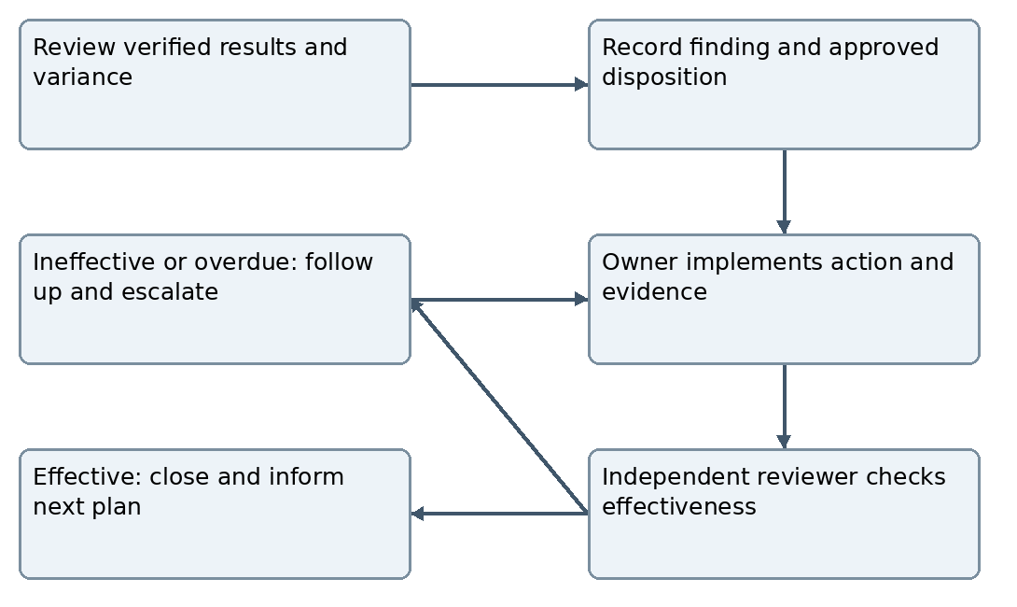
Figure X03 Review closes only with an attributable disposition and verified action effectiveness. Accepted-risk and no-action decisions retain reasons and review dates.

Integration and development acceptance
Connection | Modules | Contract
C169 | M30 ↔ M09/M03/M31/M28 | Multi-year departmental contribution, annual target and applicable execution-plan versions; mandatory-work source; canonical parent links.
C170 | M03/M10/M30/M32 ↔ M05/M14/M29 | Applicable template, resources/workload, accountable and supporting units, readiness conflicts and resolution; no duplicate approval.
C171 | M14/M15/M18 ↔ M26/M27/M28 | Canonical reflection-state mapping, rubric/version and separate evaluation decisions; permission-checked correction and deduplicated rollup.
C172 | M13/M28/M30/M35 ↔ M05/M20/M22/M29 | Review/finding/action IDs, owner/deadline, effectiveness evidence, escalations, annual snapshots and approved carry-forward links.

Configuration and implementation evidence
Before activating each workflow, authorized institutional owners shall configure the applicable role holders and scopes, reporting periods/cutoffs, review and appeal deadlines, delegation rules, activity templates, material-change rules, evidence/closure requirements, rubrics, KPI definitions, workload limits and conflict-resolution owners. No software default may invent institutional authority or academic weights. Preserve development architecture and records; extend existing shared services incrementally. Maintain a requirement matrix with requirement ID, affected modules/connections, existing behavior, change, dependency, implemented/partial/missing/untested status and linked acceptance evidence. No implementation status is inferred from this SRS.
Approved decision | Requirement
1 | ECO-001 multi-year contribution
2 | ECO-003 detailed semester approval
3 | ECO-006 activity-specific assignment
4 | ECO-007 separate evaluation levels
5 | ECO-007 canonical reflection states
6 | ECO-009 distributed monitoring
7 | ECO-009 review frequency
8 | ECO-008 shared resources
9 | ECO-010 effectiveness verification
10 | ECO-011 outcome follow-up
11 | ECO-011 approved carry-forward
12 | ECO-012 independent appeal
AM50: Incorporate all 12 approved ecosystem decisions. AM51: Proportional templates and removal of duplicate operational work. AM52: Reconcile canonical states, assessment basis, review continuity and integration contracts. Normative coverage: ECO-001–ECO-012, Figures X01–X03 and C169–C172. The catalogue remains 35 modules. All new application acceptance criteria below are NOT RUN.

End to end acceptance journeys

AT-ECO01 Academic semester cycle
Create a departmental multi-year contribution and annual target using existing institutional KPI IDs. Submit a detailed semester plan through unit → Finance Administrator → Principal. Start a specified fully authorized workshop without duplicate approval; keep an incomplete seminar planning-only. Verify class assignment, workload checks, individual reflections, evaluator permissions, report, portfolios, review and next-semester improvement.

AT-ECO02 Student academic and research proposals
Create an accepted student group and one proposal. Test academic routing to subject teacher or Academic Coordinator fallback; test research forwarding through Academic endorsement to Research review and mentor coordination. Check mentor acceptance, Principal approval after Finance Administrator, alerts, current reviewer/next action, permissions, revisions, evaluation and portfolio evidence. No resubmission copy, self-approval or execution before authorization.

AT-ECO03 Club annual execution
Allocate Student Affairs targets to a club plan. Approve named dated activities; show them once on club, Student Affairs and Principal dashboards. Recruit within authorized membership/capacity, confirm handoff, execute and separately verify learning/event outcomes. Test report routing, pending settlement, eligible individual recognition and closure guards.

AT-ECO04 Joint event and amendment
Create one event with lead/supporting units, contributions and costs. Detect a resource conflict and resolve it through the assigned coordinator. Submit a date extension: current approval stays locked until the amendment passes Finance Administrator and Principal. Count one occurrence in the applicable institutional metric and preserve partner attribution.

AT-ECO05 Canonical evaluation and appeal
Return a reflection to REVISION_REQUIRED and resubmit a new version. Simulate AI failure and complete human verification. Confirm old labels map only with retained human decision evidence. Process an independent formal appeal and reconcile dependent portfolio/certificate/analytics records without deleting the original.

AT-ECO06 Corrective action effectiveness
Record a quarterly finding; assign action owner/deadline and implementation evidence. Owner completion leaves effectiveness pending. Independent reviewer rejects ineffective action, then verifies a later effective revision. Check reminders, overdue escalation and next-plan linkage; no approval by silence.

AT-ECO07 Annual reporting and carry forward
Freeze an annual report with pending evidence and original shortfalls. Verify late evidence creates a labelled revision/adjustment. Carry unfinished work through approved transfer with remaining obligations and new deadline; no duplicate achievement or erased shortfall. Later impact follow-up remains assigned and visible.

AT-ECO08 Proportional forms and preserved boundaries
Run simple classroom seminar without unnecessary board/meeting/duplicate report; run a complex event with required risk/ethics controls. Ensure template selection cannot bypass approval or mandatory safeguards. Verify scoped access, confidential export denial, source IDs, audit records, database persistence and retry-safe notifications using fictional test fixtures.

