UX Check Results

Heuristic: Visibility of system status

Severity: 4
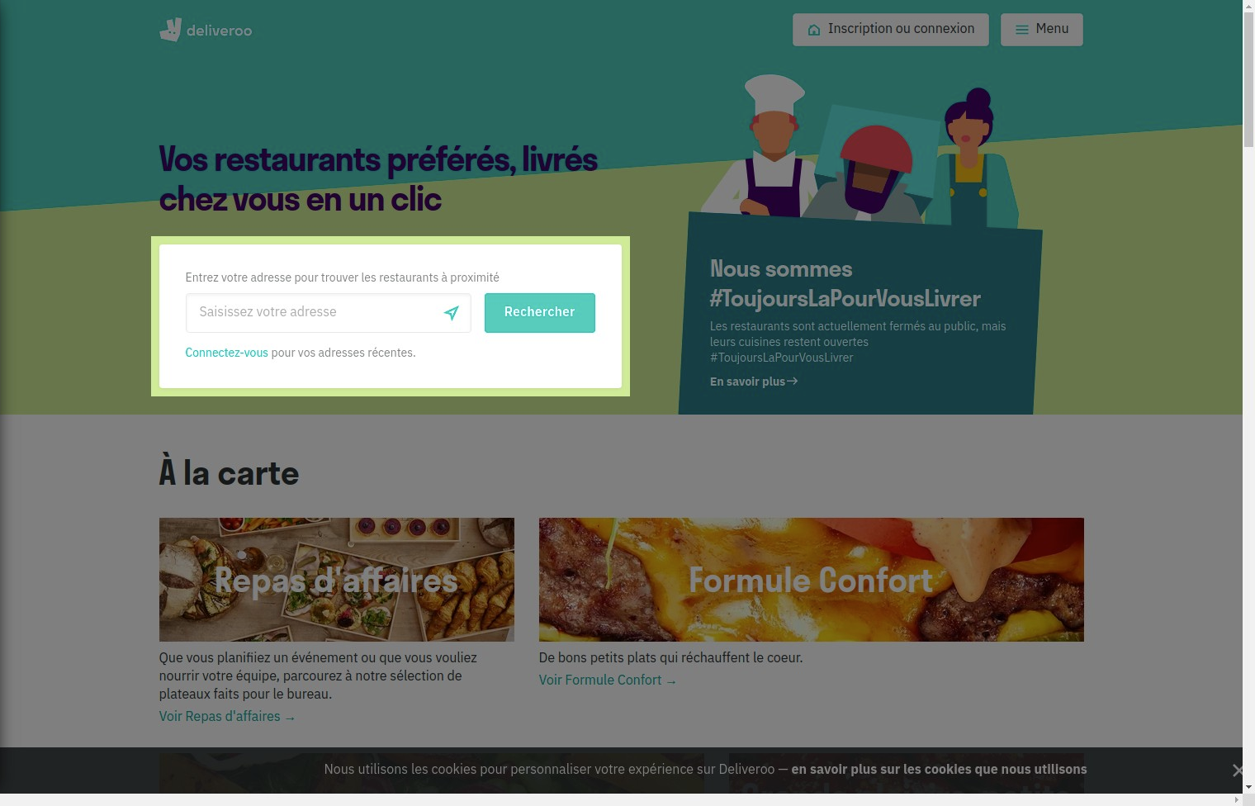

Notes:
good visibility, essential to find nearest restaurants

Heuristic: Visibility of system status

Severity: 4
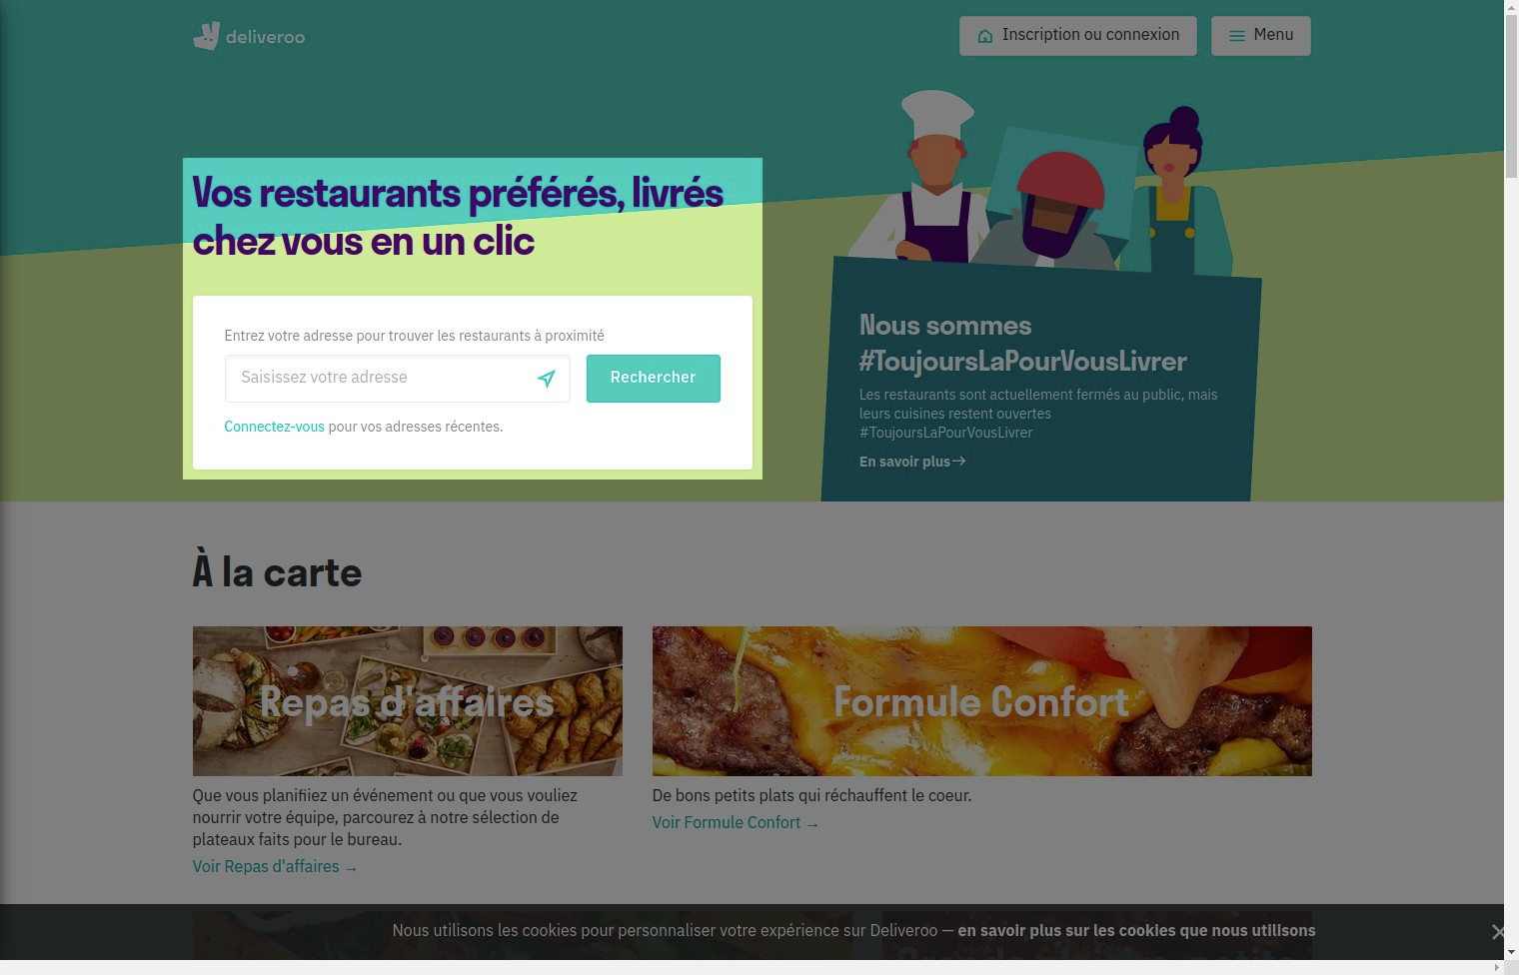

Notes:
Good visibility, essential to find nearest restaurants

Heuristic: Help recognize &amp; recover from errors

Severity: 4
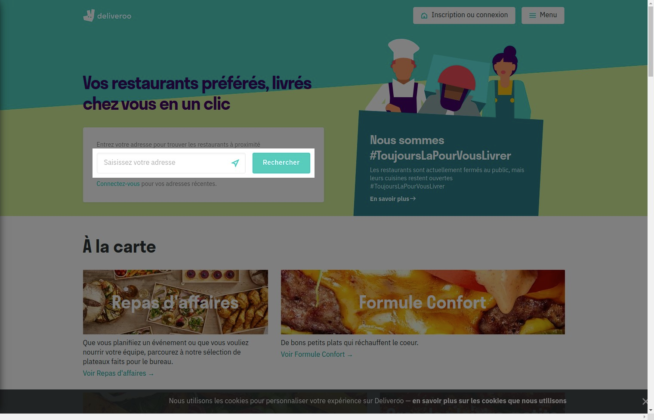

Notes:
Tells the user if Deliveroo is present or not in his location

Heuristic: Visibility of system status

Severity: 3
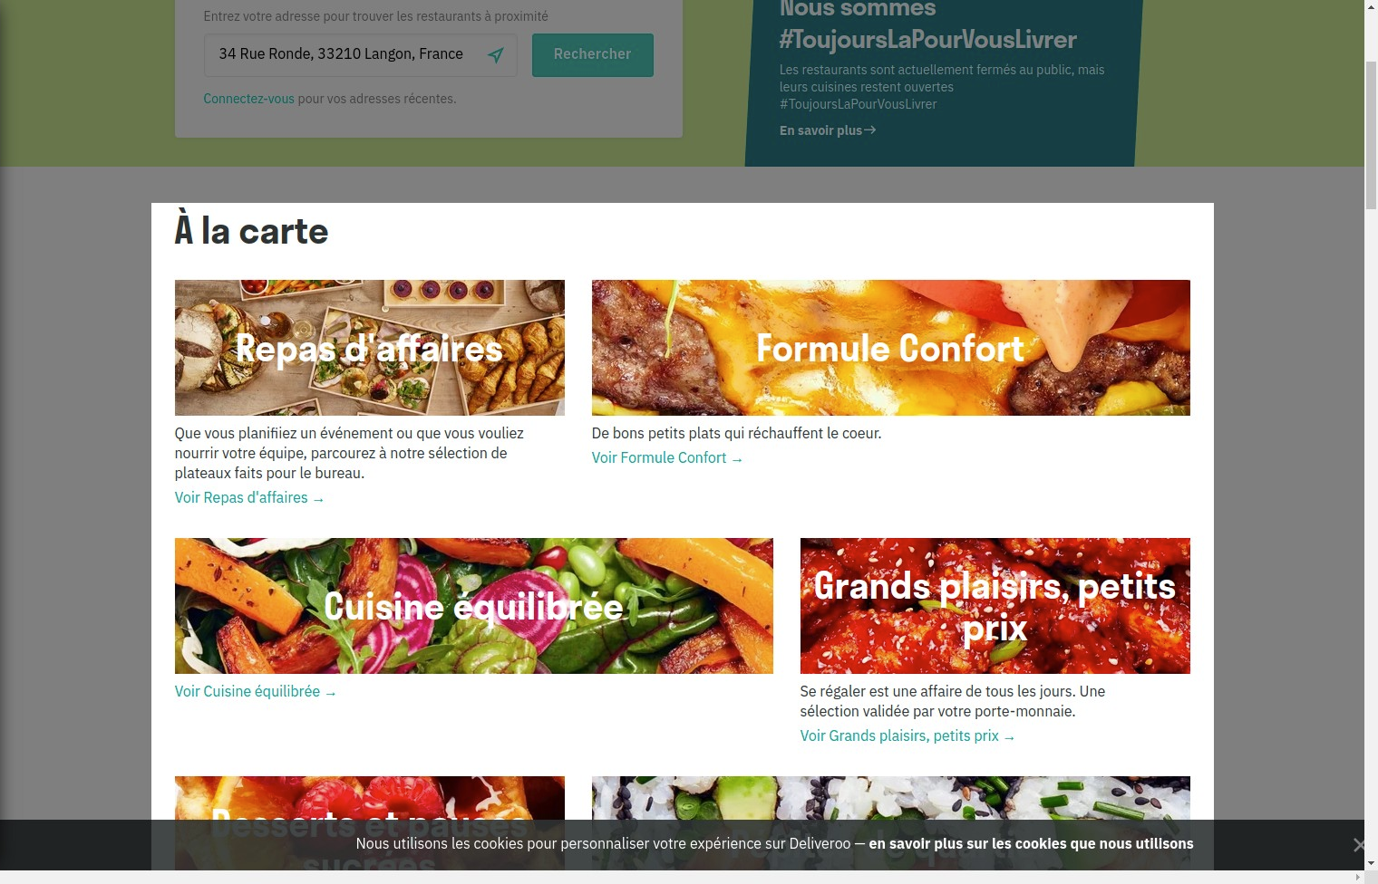

Notes:
bad visibility, images are too big and does not show the user a global display of the menus

Recommendation:
Make images littler

Heuristic: Visibility of system status

Severity: 3
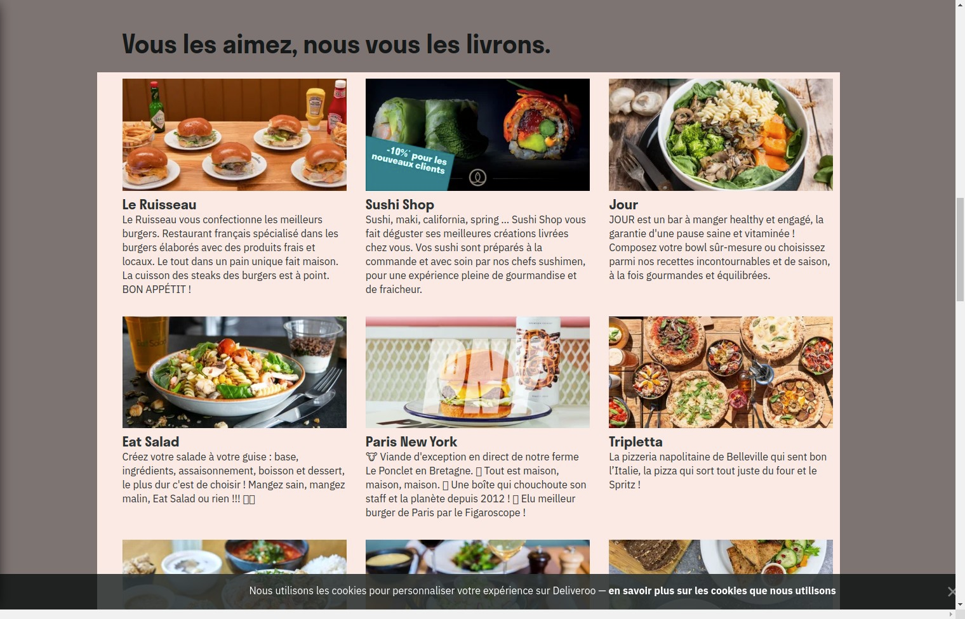

Notes:
Excelent visibility, images are just the good size.

Heuristic: Flexibility and efficiency of use

Severity: 3
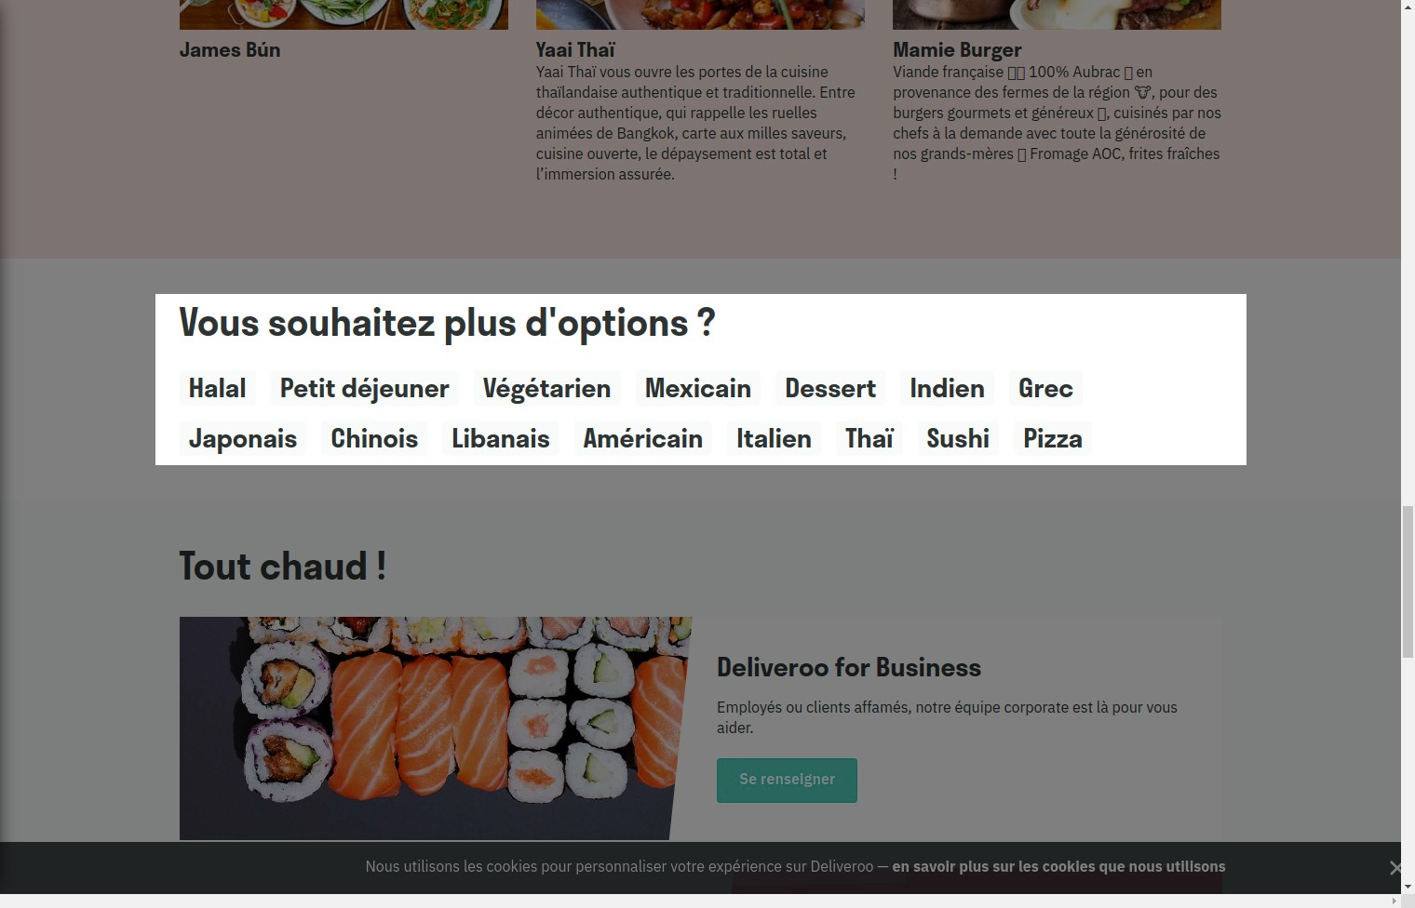

Notes:
good, direct key words to access what we need.

Heuristic: Aesthetic and minimalist design

Severity: 0
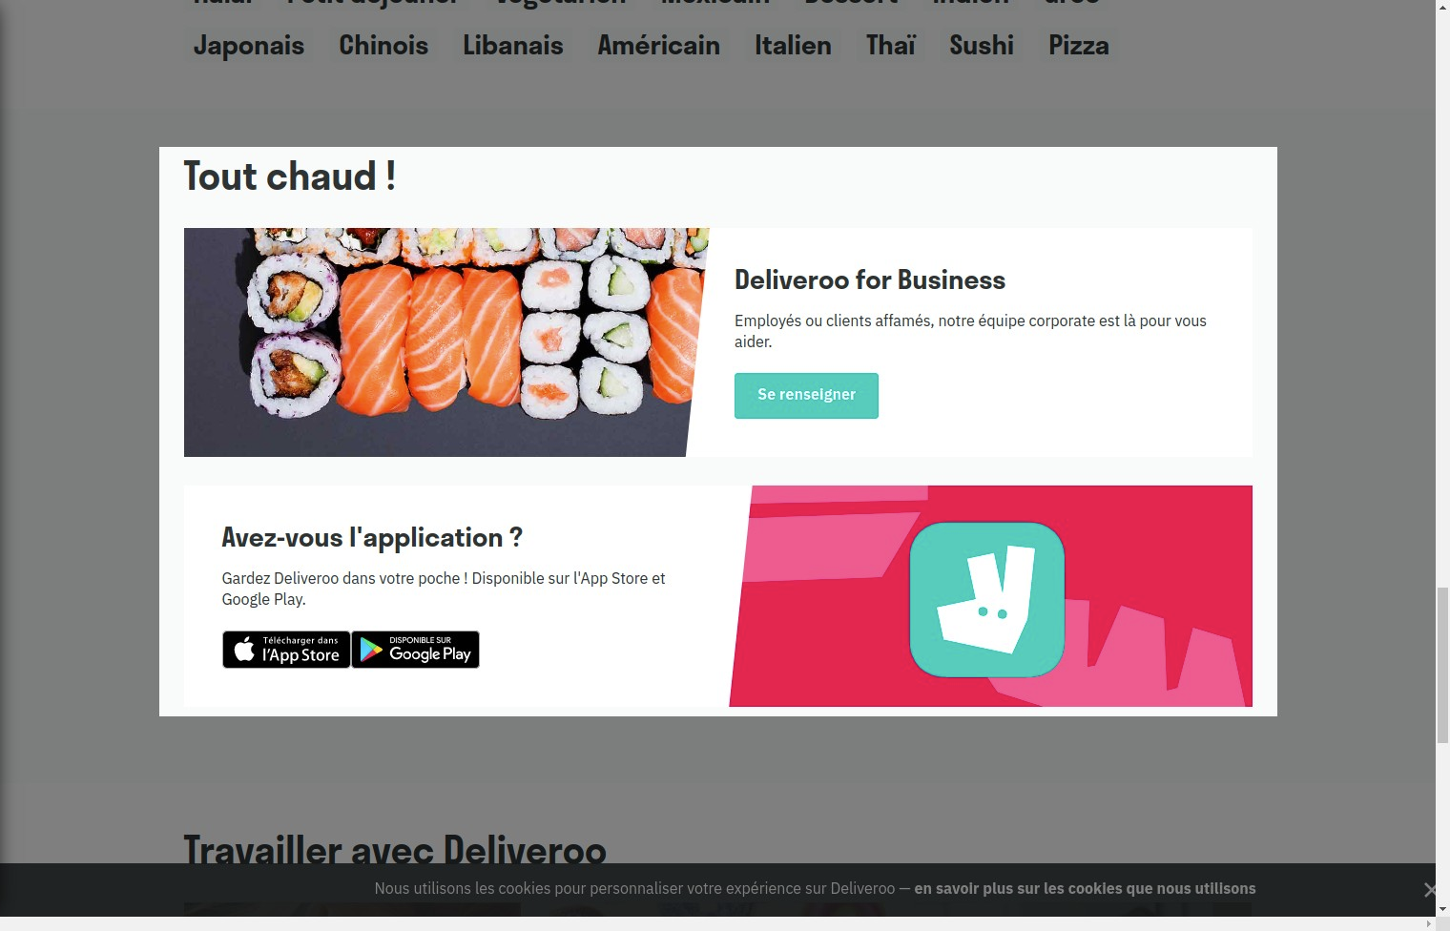

Notes:
Very bad, too big for so less recommendations. If the user wants the mobile application, he can find it by himself at the bottom of the page.

Heuristic: Aesthetic and minimalist design

Severity: 0
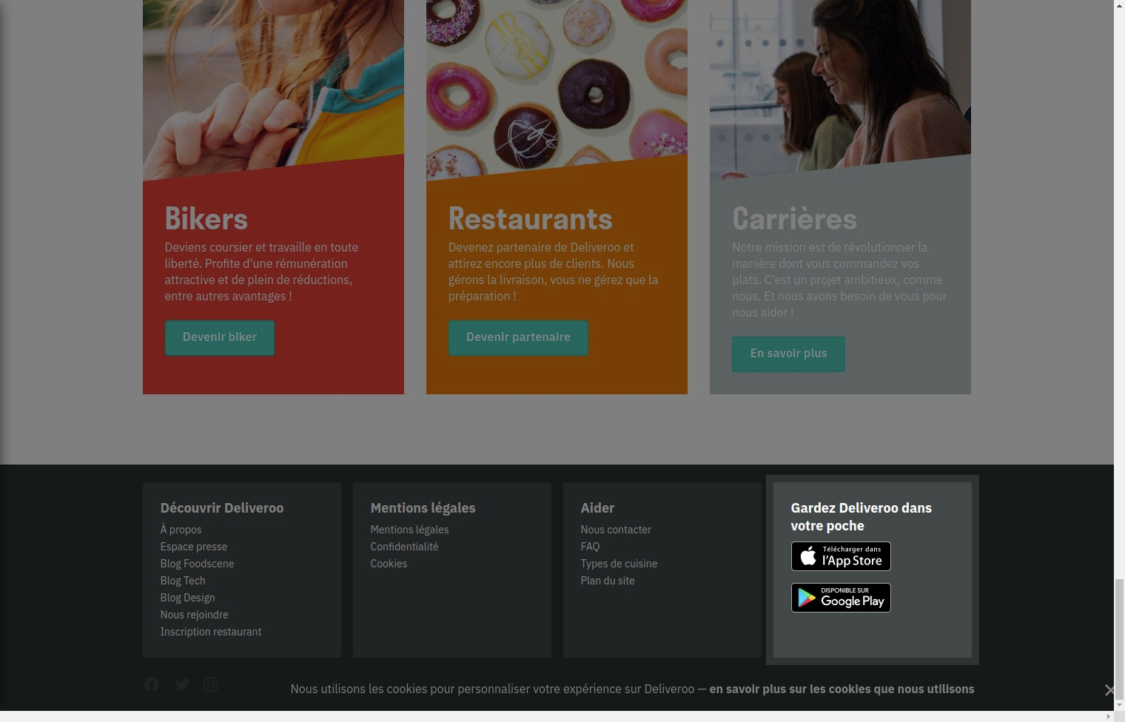

Notes:
Very good, here the mobile applications are in the bottom of the page.

Heuristic: Recognition rather than recall

Severity: 3
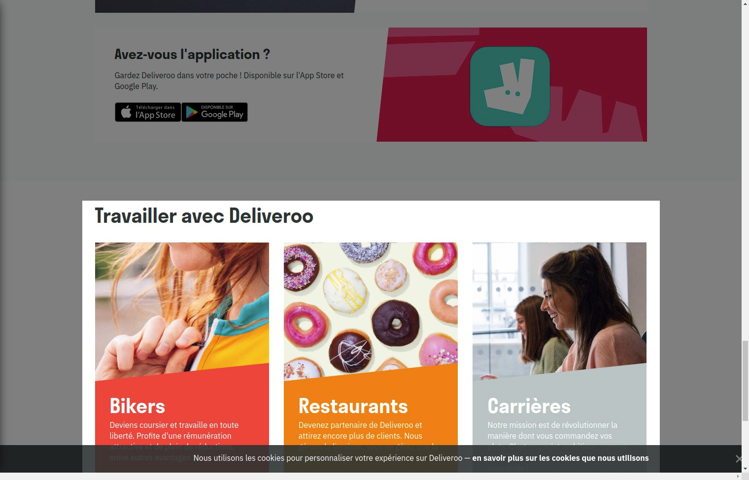

Notes:
Perfect. Here the user which is interested to work for deliveroo, as a biker deliver or a restaurant chef, can't miss it !!However images are too big. So the Aestetic is bad

Heuristic: Aesthetic and minimalist design

Severity: 3
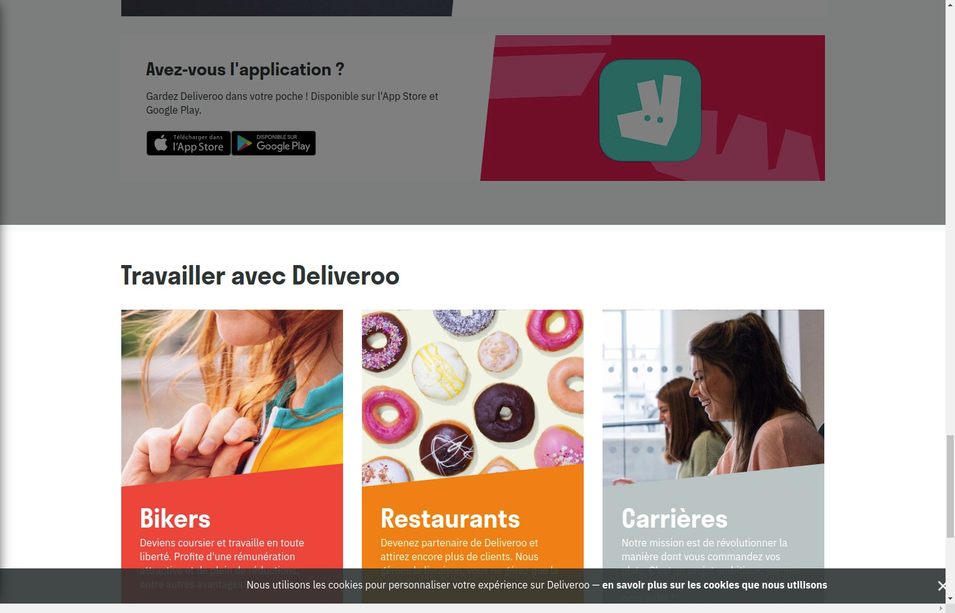

Notes:
Too big. The apply topics should only be displayed at the bottom of the page.

