* WAP in C to find area of rectangle.

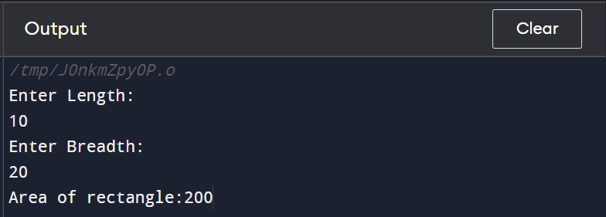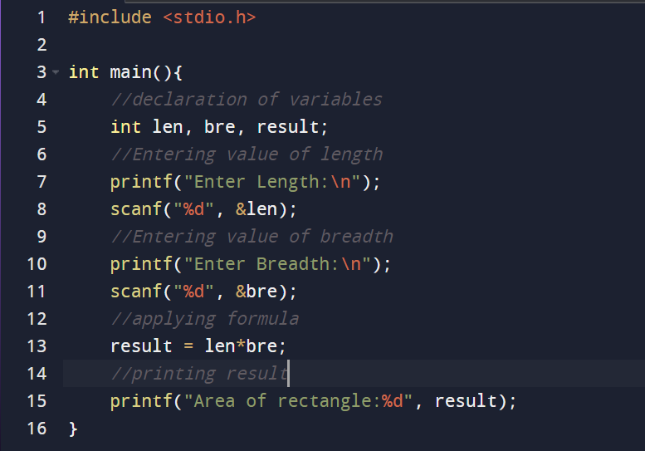

* 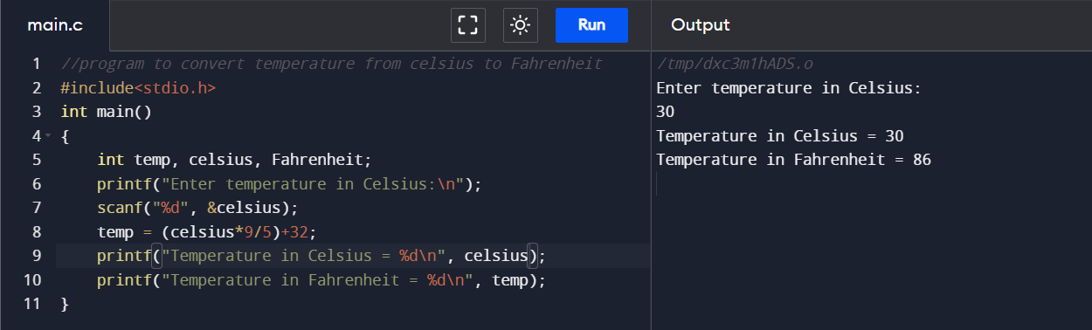WAP in c to convert temperature from Celsius to Fahrenheit
* WAP in c to convert days into years, weeks and days

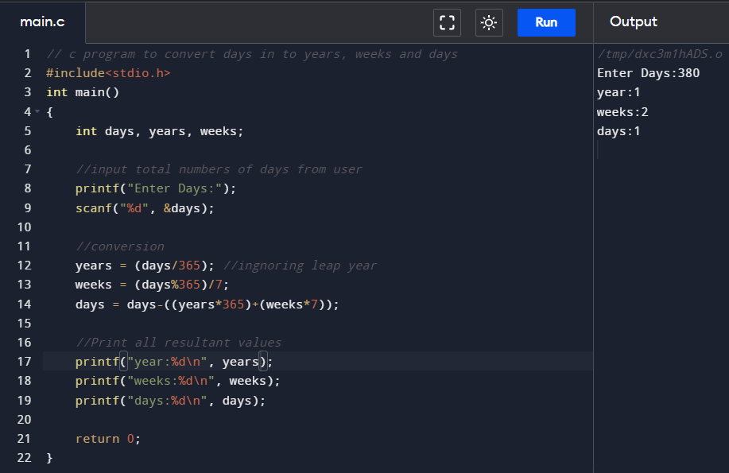

* WAP in c to find power of any number

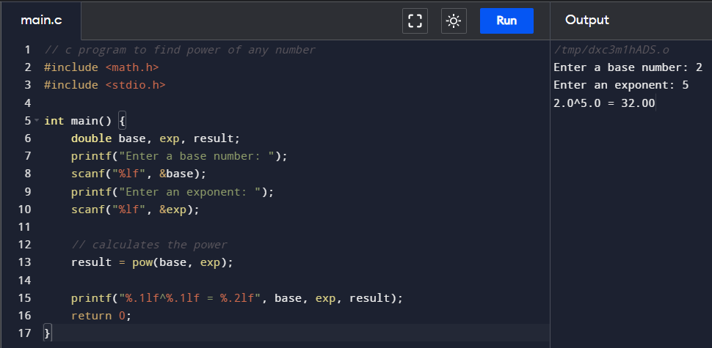

* WAP in c to calculate compound Interest

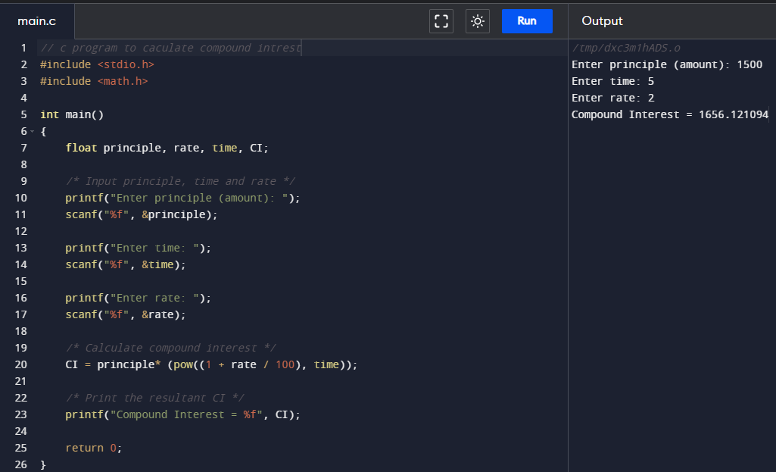

* WAP to calculate find area of equilateral triangle

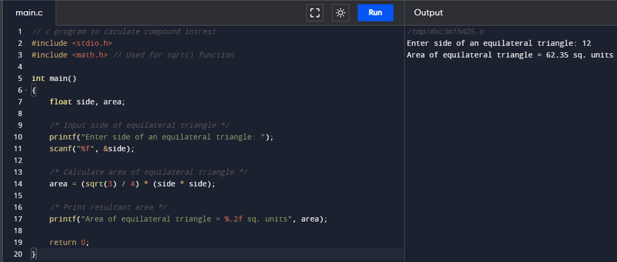

* WAP to calculate diameter, circumference and area of circle

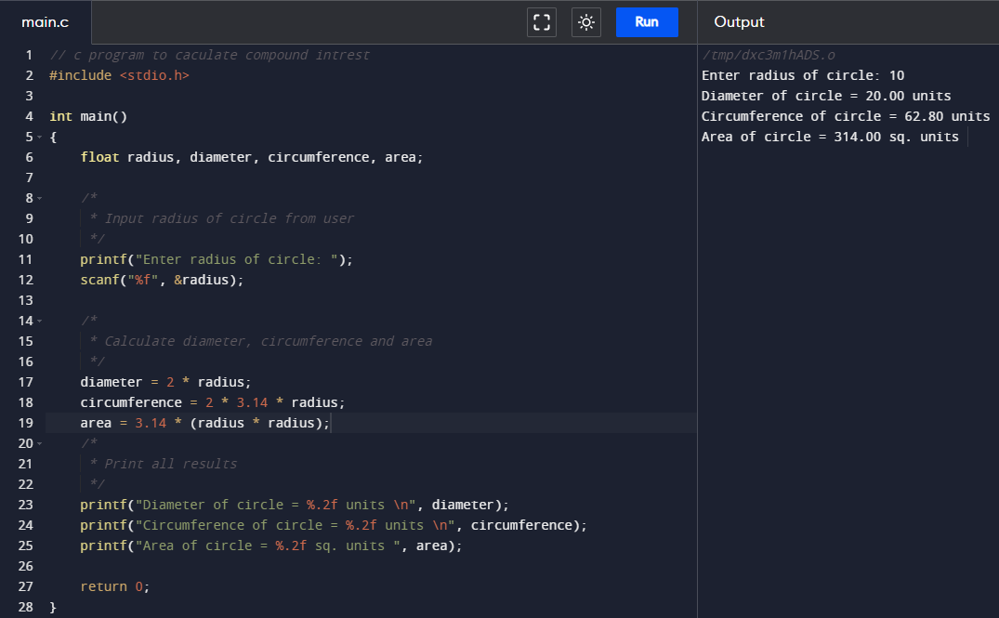

* WAP to find square root of a number

