Weekly Assessment
Name: Ankush Pramanik
Date: 23 April 2026

1. Initial Transactions View
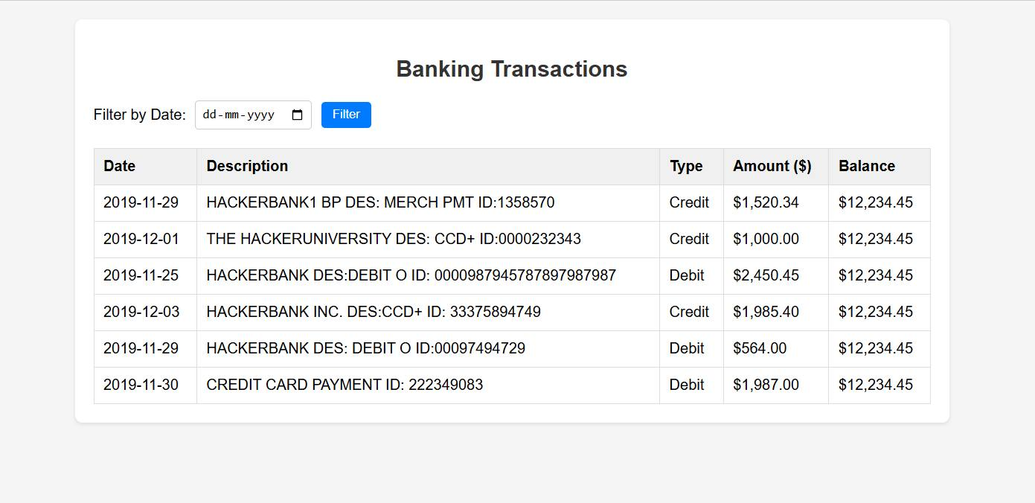

2. Sorted by Amount (Ascending)
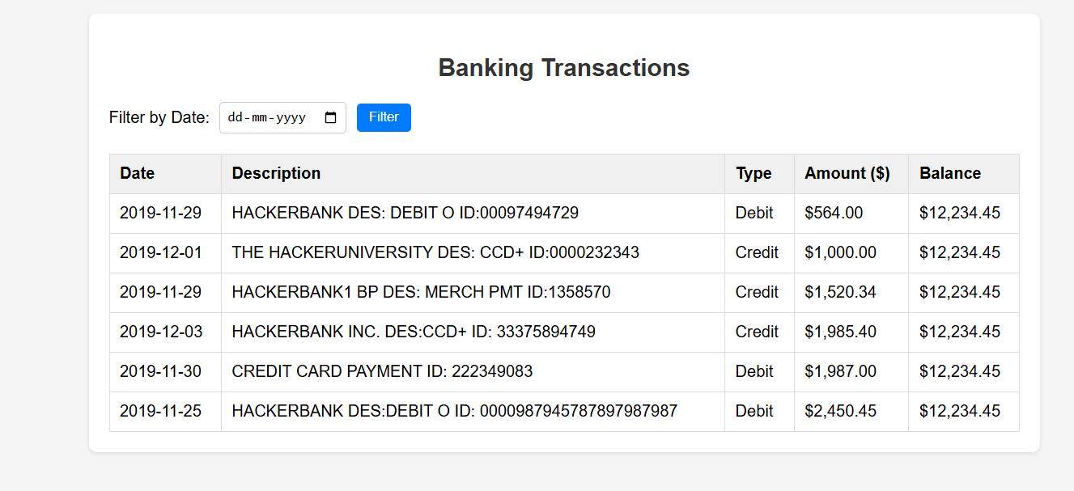

3. Filtered by Date (29-11-2019)
