**Chapter 6**

**Pin Diagram and Description**

* 1. **LM 7805**

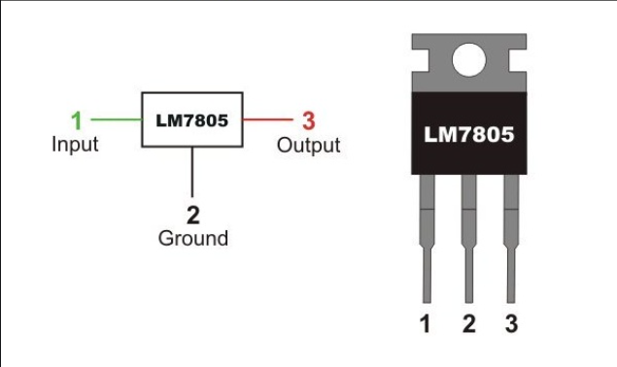

Figure 6.1 LM 7805 Pin Diagram

* 1. **Transistor 547B**

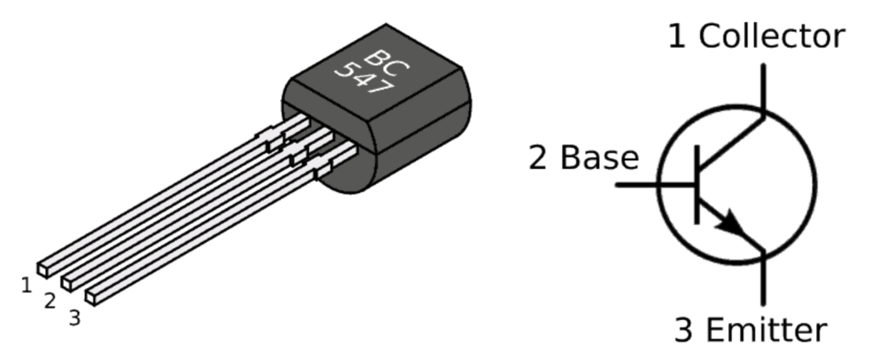

Figure 6.2 547B Pin Diagram

* 1. **ULN2003**

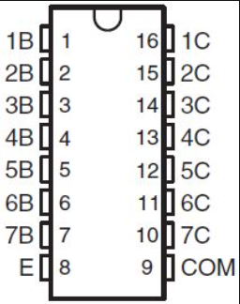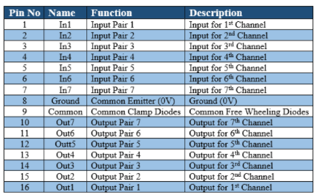

Figure 6.3 ULN2003 Pin Diagram

* 1. **HC-05**

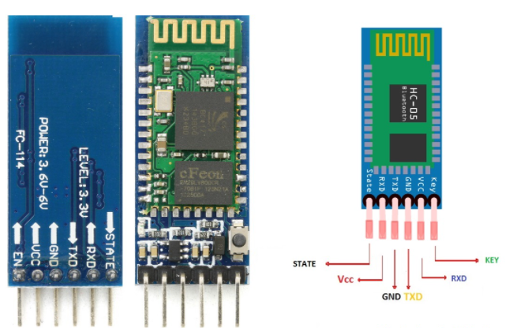

Figure 6.4 HC-05 Pin Diagram

* 1. **LCD**

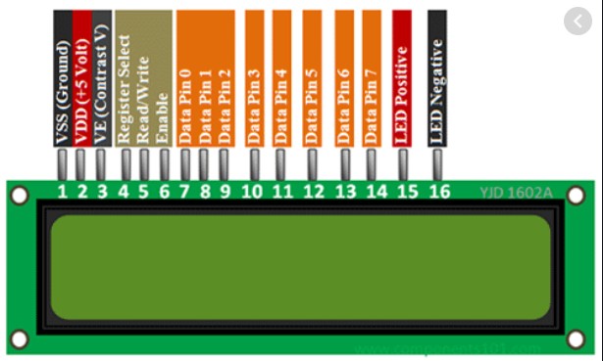

Figure 6.5 LCD Pin Diagram

* 1. **GSM Module**

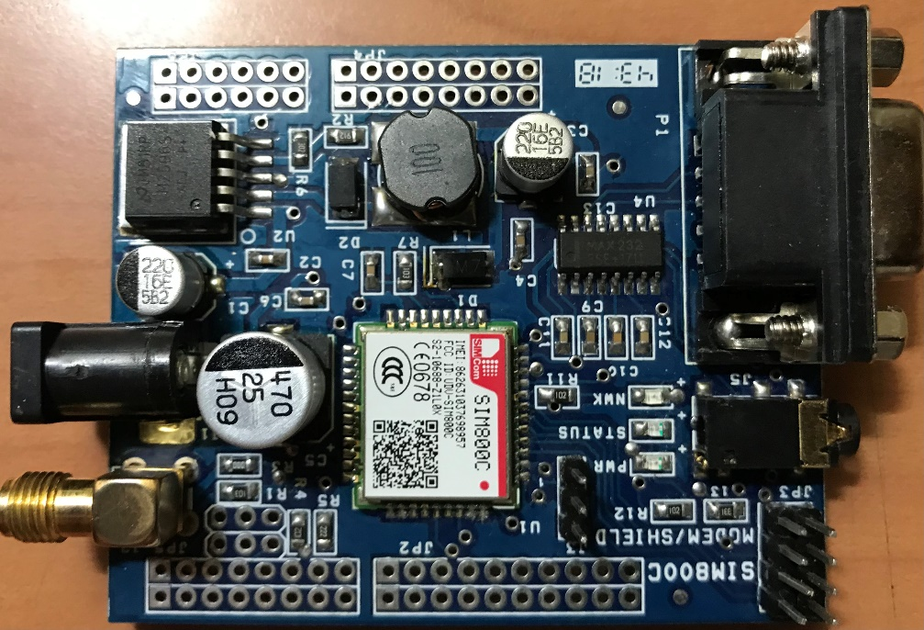

GND

RX

Figure 6.6 GSM Module

* 1. **IR Sensor**

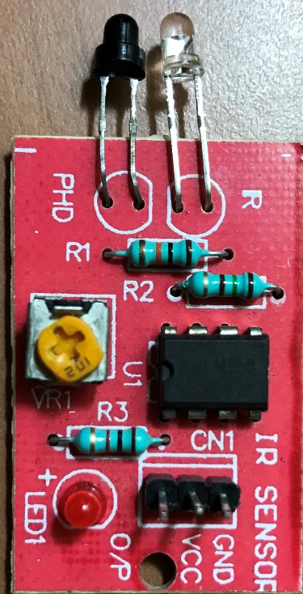

Figure 6.7 IR Sensor Pin out