**Chapter 1**

**Introduction**

* 1. **Literature Survey**

Medication adherence is a growing concern throughout the healthcare industry with doctors, healthcare systems, and other stakeholders (insurance companies) since the elderly or senior patients’ medication has a big issue of drugs misuse. It is very likely for them to forget to take their pills on time. Especially, those who take multiple medications at the same time. Also, they might take wrong dosage accidentally which may lead to unfortunate consequences such as death. This is a clear proof that it is a widespread problem and clearly related to adverse patient outcomes and higher healthcare costs.

According to a survey it is found that one-fourth of the total elderly population (approximately 26 million people) in India live alone. The United Nations Department of Economic and Social Affairs projected that the elderly population in India is going to rise from 8% in 2015 to 11.5% in 2025 and 19% in 2050.

* 1. **Aim & Objective**

he main purpose of SMD system is to help the patients, primarily seniors, take their medications on time in an easy way without the possibility of missing pills. It can also reduce the risk of over or under dosing accidentally. The smart medicine dispenser (SMD) could solve such problems by informing and alerting the patients to take the appropriate dose at the right time.

**The following is description of following chapters:**

* **Chapter 2** provides the necessary theoretical background and specifications about the Microcontroller 8051, Stepper Motor Interface specification and LCD, buzzer, IR Sensor, GSM Module and Bluetooth Module.
* **Chapter 3** gives the detailed information about the schematic diagram, Flow Chart and the software used in this project.
* **Chapter 4** describes the simulation tool used and other softwares utilised. It also describes the testing carried out on hardware and software.
* **Chapter 5** details about the results obtained, conclusions derived and scope for the future expansion of the project.

**CHAPTER 2**

**Working Principle and Functional**

**Description**

* 1. **Block Diagram**

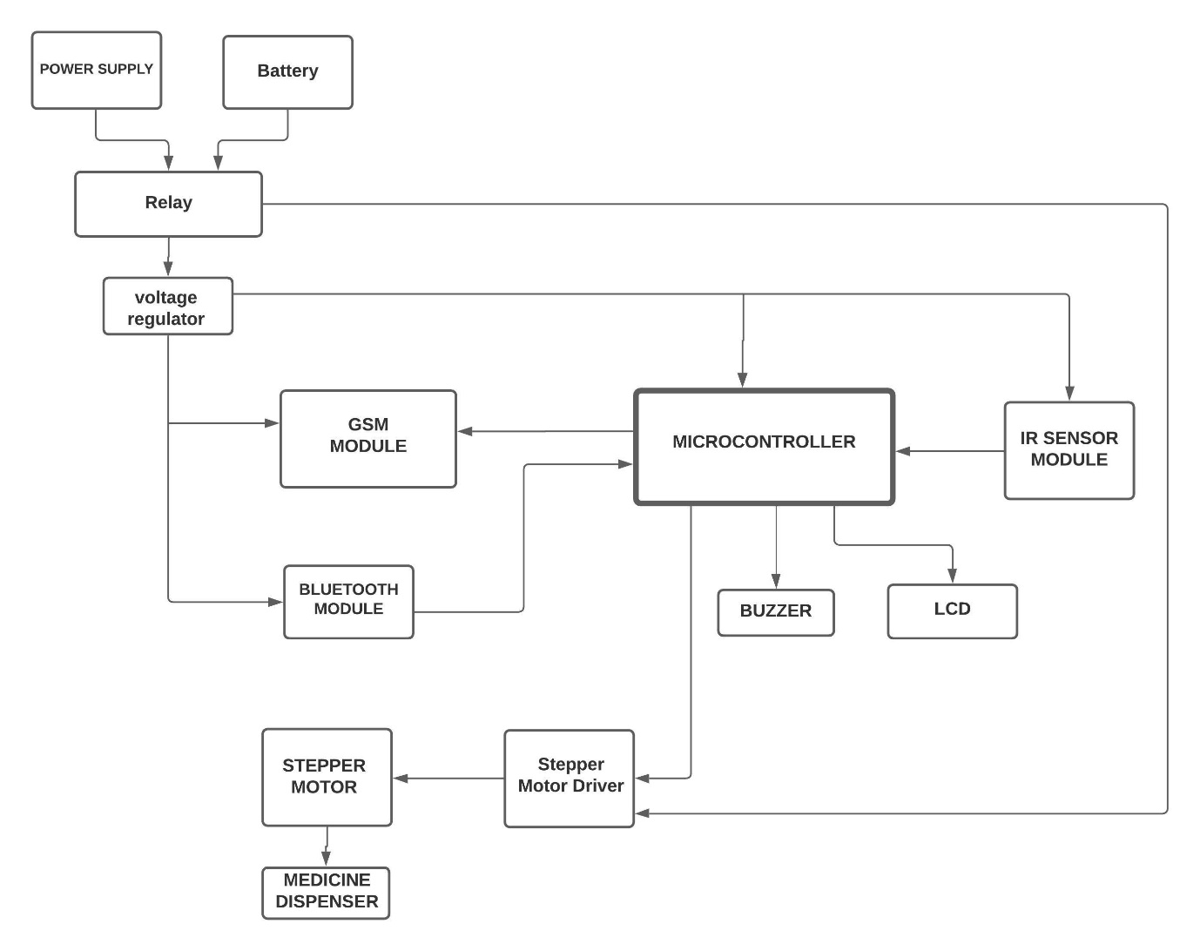

**Figure 2.1: Block Diagram**

* 1. **Description of Block Diagram**
     1. **Microcontroller**

This is the main controller of device. And it controls sensors and modules connected to device.

It controls all the important timings of all the operations of the device.

* + 1. **GSM Module**

When the patient fails to take the medicine on the prescribed time even after alerting him/her two times, the GSM module sends a missed call to the caretaker to alert them that medicine is yet not taken.

* + 1. **Bluetooth Module**

Using this Bluetooth module the user can interface the device. The timing schedule of when the medicine is to be dispensed out to the patient is taken using this Bluetooth module.

* + 1. **Stepper Motor**

The stepper motor is used to rotate the medicine compartments of the box at the time of dispensing the medicine.

* + 1. **IR Sensor Module**

The IR sensor module is used to detect if the patient has arrived to collect the medicine at the prescribed time and indicate that the medicine has been taken successfully.

* + 1. **Buzzer**

Buzzer is used to alert the patient at the time of medication.

* + 1. **LCD**

It is used to display the present time. Also it displays the time entered by the user while configuring the medication schedule.

* + 1. **Relay**

Relay is used to switch between the AC mains supply and the Battery during power failure.

* 1. **List of Components**
* AT89s52 Microcontroller
* IR Sensor
* SIM 800c Module
* Stepper Motor (28byj-48)
* Stepper Motor Driver (L293D)
* Buzzer (5V)
* HC-05 Bluetooth Module
* Medicine Dispenser Box
* Battery (12V , 2.5AH)
* Relay (5-12 VDC 10A)
* 11.0592 MHz Crystal Oscillator
* Power Supply (12VDC, 2A)
* 7805 Voltage Regulator IC
  1. **Description of Components**
     1. **At89S52**

In this Project we required a microcontroller which had sufficient pins for interfacing various modules. Also, we needed a microcontroller which supported UART communication Protocol and had built in Timers in it. Enough memory is also required to store the program code as our program code exceeded 4KiB of memory.

Keeping the requirements in mind we decided to use AT89S52 microcontroller of the 8051 Family. This controller has 8 KiB in system programmable memory which is more than enough for our project code. Important specifications of AT89S52 are given below:

**AT89S52**

* 8K Bytes of In-System-Programmable (ISP) Flash Memory
* Operating frequency: 0 Hz to 33MHz
* 256 Bytes of RAM
* Three 16-bit Timers/Counters
* Full Duplex UART serial channel
* Four 8-bit I/O pins

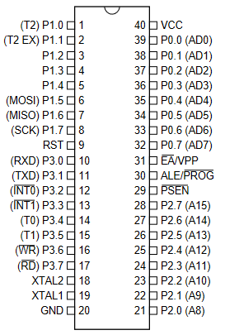

**Figure 2.2: Pin Diagram of AT89S52**

**Pin Description:**

|  |  |  |  |
| --- | --- | --- | --- |
| **PIN No.** | **Function of the pin** | | **Pin Name** |
| 1 | external count input to Timer/Counter 2, clock-out. | | P1.0 / T2 |
| 2 | Timer/Counter 2 capture/reload trigger and direction control | | P1.1 / T2EX |
| 3 | I/O pins | | P1.2 |
| 4 | P1.3 |
| 5 | P1.4 |
| 6 | Used for In-System Programming | | P1.5 / MOSI |
| 7 | Used for In-System Programming | | P1.6 / MISO |
| 8 | Used for In-System Programming | | P1.7 / SCK |
| 9 | Resets the controller when high | | RST |
| 10 | Receiver for the serial UART Communication | I/O pins | P3.0 / RXD |
| 11 | Transmitter for the serial UART Communication | P3.1 / TXD |
| 12 | External Interrupt 0 (Active Low) | P3.2 / INT0 |
| 13 | External Interrupt 1 (Active Low) | P3.3 / INT1 |
| 14 | Counter 0 external input | P3.4 / T0 |
| 15 | Counter 1 external input | P3.5/ T1 |
| 16 | external data memory write strobe (Active Low) | P3.6/ WR |
| 17 | external data memory read strobe (Active Low) | P3.7 / RD |
| 18 | Output from the inverting oscillator amplifier | | XTAL2 |
| 19 | Input to the inverting oscillator amplifier and input to the internal clock operating circuit | | XTAL1 |
| 20 | Ground Pin (0 V) | | GND |
| 21 | Higher order Address bits when using external memory | I/O pins | P2.0 / AD8 |
| 22 | P2.1 / AD9 |
| 23 | P2.2 / AD10 |
| 24 | P2.3 / AD11 |
| 25 | P2.4 / AD12 |
| 26 | P2.5/ AD13 |
| 27 | P2.6/ AD14 |
| 28 | P2.7 / AD15 |
| 29 | Program Store Enable; Used as read strobe for external memory | | PSEN |
| 30 | Address Latch Enable | | ALE/PROG |
| 31 | External Access enable; used when using external memory. (For internal memory operation strap it to Vcc) | | EA/VPP |
| 32 | Higher order Address bits when using external memory | I/O pins | P0.0 / AD7 |
| 33 | P0.1 / AD6 |
| 34 | P0.2 / AD5 |
| 35 | P0.3 / AD4 |
| 36 | P0.4 / AD3 |
| 37 | P0.5/ AD2 |
| 38 | P0.6/ AD1 |
| 39 | P0.7 / AD0 |
| 40 | Supply Voltage ( 5V ) | | Vcc |

**Table 2.1: Pin Description of AT89S52**

* + 1. **Sim800c GSM module**

The GSM module is used to send a missed call to the caretaker when the patient fails to take the medicine on time.

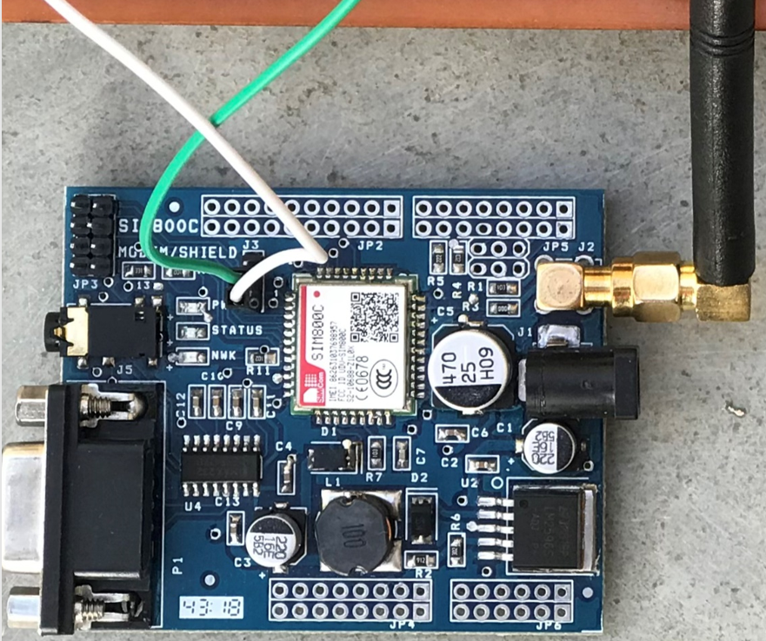

**Figure 2.3: Sim800C GSM Module**

The GSM 800C module is equipped with RS-232 connector for use and also supports UART serial communication Protocol. It has fully integrated sim card holder, power supply regulator, audio jack, etc.

It is easy to use with many low-cost microcontrollers as it supports UART communication. SIM800C is a low power quad-band GSM/GPRS module, that works on frequencies GSM850MHz, EGSM900MHz, DCS1800MHz and PCS1900MHz. SIM800H features GPRS multi-slot class 12/ class 10 (optional) and supports the GPRS coding schemes CS-1, CS-2, CS-3 and CS-4.

The module can be configured easily by sending the AT Commands to the module via the Tx pin of Controller connected to the Rx pin of the module. The module has three led indicators namely PWR, Status and NWK.

**PWR** led glows when the module receives the 5V power supply.

**NWK** led indicates if the module is yet registered to the network or not. When registered to a network the led is ON for 64ms and OFF for 3000ms.

**Status** led indicates if the module is ready to function or not.

Features of Sim800c GSM module:

* UART interface for communication with microcontrollers.
* RS-232 interface for connection with computers.
* Baud Rate: 1200 bps to 115200bps.
* Operating Voltage: 3.6 – 4.5V DC.
* Easily controllable using AT commands.
  + 1. **HC-05 Bluetooth Module**

In this project we use the HC-05 Bluetooth module to take the medication schedule data from the user.

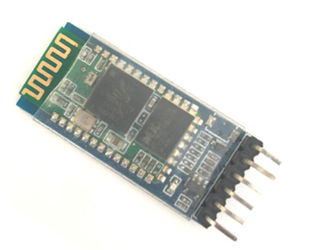

**Figure 2.4: HC-05 Bluetooth Module**

HC-05 Bluetooth Modules an easy-to-use Bluetooth SPP (Serial Port Protocol) module, designed for transparent wireless serial connection setup. Its communications via serial communication which makes an easy way to interface with controller or PC. serial port Bluetooth module is fully qualified Bluetooth V2.0+EDR (Enhanced Data Rate) 3Mbps Modulation with complete 2.4GHz radio transceiver and baseband.

This module can be easily configured by sending the AT commands to the HC-05 module from the controller or any other master device.

There is a led on the module that indicates the status of the module. When led blinks once in 2 seconds then it is in command mode. In this mode we send the AT commands to the module.

When led blinks twice every one second it indicates that the connection between the module and other device has been established.

If the led blinks continuously then it indicates that the module is not yet connected to the other device.

The pin description of the module is given below:

|  |  |  |
| --- | --- | --- |
| **PIN No.** | **Pin Name** | **Description** |
| **1** | Enable / Key | This pin is used to toggle between Data Mode (set low) and AT command mode (set high). By default, it is in Data mode |
| **2** | Vcc | Powers the module. Connect to +5V Supply voltage |
| **3** | Ground | Ground pin of module, connect to system ground. |
| **4** | TX | Transmits Serial Data. Everything received via Bluetooth will be given out by this pin as serial data |
| **5** | RX | Receive Serial Data. Every serial data given to this pin will be transmitted via Bluetooth |
| **6** | State | The state pin is connected to on board LED, it can be used as a feedback to check if Bluetooth is working properly. |

**Table 2.2: Pin Description of HC-05**

**HC-05 Bluetooth Module Specifications:**

* Operating Voltage: 4V to 6V (Typically +5V)
* Operating Current: 30mA
* Range: <100m Typical -80dBm sensitivity
* Up to +4dBm RF transmit power.
* Works with Serial communication (USART) and TTL compatible
* Supported baud rate: 9600,19200,38400,57600,115200,230400,460800.
* Can be easily interfaced with Laptop or Mobile phones with Bluetooth.
* With integrated antenna
  + 1. **28byj-48 Stepper Motor**

28-BYJ48 Stepper Motors are commonly used stepper motors easily available in the market. The motor has a 4-coil unipolar arrangement, and each coil is rated for +5V hence it is relatively easy to control with any basic microcontrollers. These motors have a stride angle of 5.625°/64, this means that the motor will have to make 64 steps to complete one rotation and for every step it will cover a 5.625° hence the level of control is also high. The pull in torque provided by this stepper motor is of 300gf.cm. So, as this motor is small, compact and easy to use we used this motor for our project.

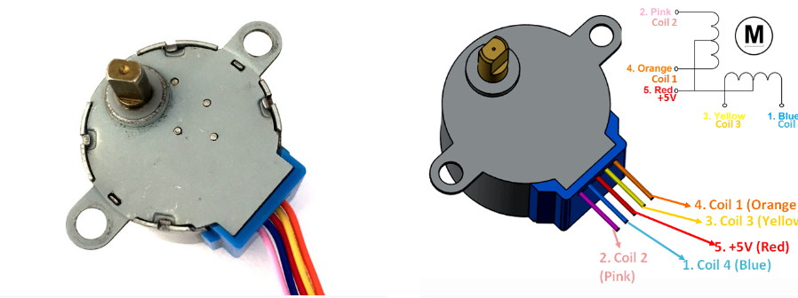

**Figure 2.5: 28-BYJ48 Stepper Motor**

**Theory of Operation:**

These stepper motors consume high current and hence a driver IC like the ULN2003 is mandatory. To know how to make this motor rotate we should look into the coil diagram below.

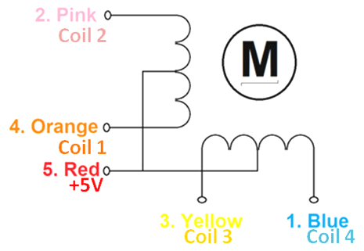

**Figure 2.6: Internal connection of 28byj-48 Stepper motor**

As we can see there are four coils in the motor and one end of all the coil is tied to +5V (Red) and the other ends (Orange, Pink, Yellow and Blue) are taken out as wires. The Red wire is always provided with a constant +5V supply and this +5V will be across (energize) the coil only if the other end of the coil is grounded. A stepper motor can be made to rotate only if the coils are energized (grounded) in a logical sequence. This logical sequence can be programmed using a microcontroller or by designing a digital circuit. The sequence in which each coil should be triggered is shown in the table below. Here “1” represent the coil is held at +5V, since both the ends of coil is at +5V (red and other end) the coil will not be energized. Similarly, “0” represents the coil is held to ground, now one end will be +5V and the other one is grounded so the coil will be energized.

|  |  |  |  |  |  |  |  |  |
| --- | --- | --- | --- | --- | --- | --- | --- | --- |
| **Motor Wire Color** | **Sequence to Rotate in clockwise Direction** | | | | | | | |
| **Step 1** | **Step 2** | **Step 3** | **Step 4** | **Step 5** | **Step 6** | **Step 7** | **Step 8** |
| Orange | 0 | 0 | 1 | 1 | 1 | 1 | 1 | 0 |
| Yellow | 1 | 0 | 0 | 0 | 1 | 1 | 1 | 1 |
| Pink | 1 | 1 | 1 | 0 | 0 | 0 | 1 | 1 |
| Blue | 1 | 1 | 1 | 1 | 1 | 0 | 0 | 0 |
| Red | 1 | 1 | 1 | 1 | 1 | 1 | 1 | 1 |

**Table 2.3: switching sequence of stepper motor**

* + 1. **ULN2003**

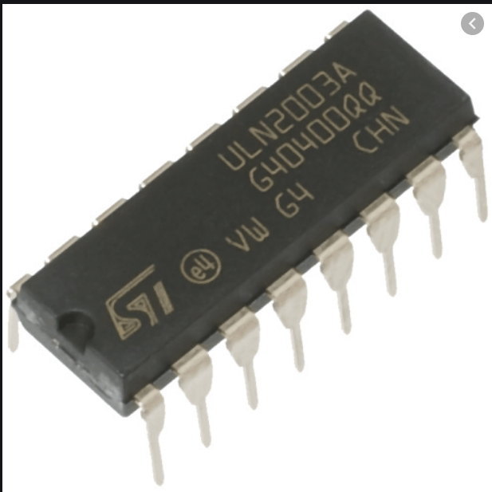

**Figure 2.7: IC ULN2003 Pin Diagram**

The eight NPN Darlington connected transistors in this family of arrays are ideally suited for interfacing between low logic level digital circuitry (such as TTL, CMOS or PMOS/NMOS) and the higher current/voltage requirements of lamps, relays, printer hammers or other similar loads for a broad range of computer, industrial, and consumer applications. All devices feature open–collector outputs and freewheeling clamp diodes for transient suppression.

The ULN2803 is designed to be compatible with standard TTL families while the ULN2804 is optimized for 6 to 15 volt high level CMOS or PMOS.

* + 1. **IR Sensor Module**

The IR sensor module is used to detect if the patient has arrived to collect the medicine at the prescribed time and indicate that the medicine has been taken successfully. This is done by sensing the hand of the patient below the medicine outlet. When patient keeps the hand below the open part the IR sensor detects his/her hand and signals the device that patient has come to take the medicine and then controller takes further action.

* + 1. **Buzzer**

The Buzzer is used to alert the patient at the time of medication if he/she is away from the device. Also, if the patient is unable to find the device the buzzer would help them find it at the time of medication. The buzzer we used in this project is the Piezoelectric Buzzer.

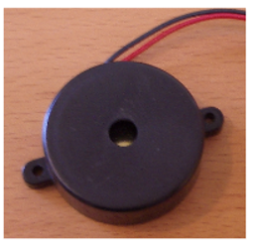

**Figure 2.8: Piezoelectric Buzzer**

Buzzer has two pins in it. One is positive and other is negative, when negative pin is grounded and the positive pin is given voltage of around 5-6 V the buzzer makes a beep sound continuously.

**Buzzer Specifications:**

* Rated Voltage: 6V
* Operating Voltage: 4V to 8V
* Rated Current ~< 30mA
* Resonant Frequency ~= 2300 Hz
  + 1. **LM 7805**

In this project we are providing the battery-operated power supply using a 12V DC battery. So, to regulate this 12V dc supply we are using a voltage regulator LM7805 IC to regulate this voltage to constant 5V supply.

This range of fixed-voltage integrated circuit voltage regulator is designed for a wide range of applications. These applications include on-card regulation for elimination of noise and distribution problems associated with single-point regulation. Each of these regulators can deliver up to 1.5 A of output current.

The internal current limiting and thermal shutdown features of these regulators essentially make them immune to overload.

In addition to using as fixed voltage regulators, these devices can be used with external components to obtain adjustable output voltages and currents, and also can be used as a power pass element in precision regulators.

* + 1. **LCD**

we are using a 16x2 LCD display to display the present time and also we display the medication schedule when the caretaker configures the device.



**Figure 2.9 16x2 LCD Display**

An LCD (Liquid Crystal Display) screen is an electronic display module and has a wide range of applications. A 16x2 LCD display is very basic module and is very commonly used in various devices and circuits. A 16x2 LCD means it can display 16 characters per line and there are 2 such lines. In this LCD each character is displayed in 5x7 pixel matrix. The 16 x 2 intelligent alphanumeric dot matrix display can display 224 different characters and symbols. This LCD has two registers, namely, Command and Data.

The LCD should also be instructed about the Position of the Pixels. Hence it will be a hectic task to handle everything with the help of MCU, hence an Interface IC like HD44780 is used, which is mounted on the backside of the LCD Module itself. The function of this IC is to get the Commands and Data from the MCU and process them to display meaningful information onto our LCD Screen.

**Pin Description of LCD:**

|  |  |  |
| --- | --- | --- |
| Pin No. | Pin Name | Description |
| 1 | Ground | Ground pin of the LCD |
| 2 | Vdd | Supply Voltage (4.7V to 5.3V) |
| 3 | Vee | Contrast setting voltage helps to set the contrast of display |
| 4 | RS (Register select) | Used to select the register LCD for Data or Command. When Low the Command register is selected and when high data register is selected. |
| 5 | Read/ Write | Used to indicate the LCD whether data is being read or written |
| 6 | Enable | Connected to Microcontroller Pin and toggled between 1 and 0 for data acknowledgement |
| 7 | DB0 | 8 bit Data Pins |
| 8 | DB1 |
| 9 | DB2 |
| 10 | DB3 |
| 11 | DB4 |
| 12 | DB5 |
| 13 | DB6 |
| 14 | DB7 |
| 15 | LED + | Backlight Vcc |
| 16 | LED - | Backlight GND |

**Table 2.4: Pin description of LCD**

**Features:**

* Operates at Voltage 4.7V to 5.3V
* Current consumption is 1mA without Backlight.
* Consists of an Alphanumeric Display
* Can work in 4-bit as well as 8-bit mode.
  + 1. **Relay**

In this project we are using a stepper motor. The relay is used to stop the supply of power to the stepper motor driver when it is not needed.

A relay is an electromagnetic switch that is used to turn on and turn off a circuit by a low power signal, or where several circuits must be controlled by one signal. We know that most of the high-end industrial application devices have relays for their effective working. The main operation of a relay comes in places where only a low-power signal can be used to control a circuit. It is also used in places where only one signal can be used to control a lot of circuits.

* + 1. **BC547 BJT**

We have used a buzzer in our project to alert the patient. This buzzer cannot be operated by directly connecting it to the controller pin as the controller cannot supply enough current. So we have used BC547 BJT which is a NPN transistor as a switch.

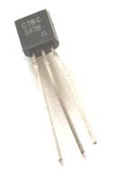

**Figure 2.10: BC547 NPN Transistor**

**Specifications:**

* Base Current is 5mA (max)
* DC current gain between 110 to 800
* Bipolar NPN Transistor
* Continuous Collector current (Ic) = 100mA (max)

**CHAPTER 3**

**Implementation Details**

* 1. **Schematic Diagram and its description**

`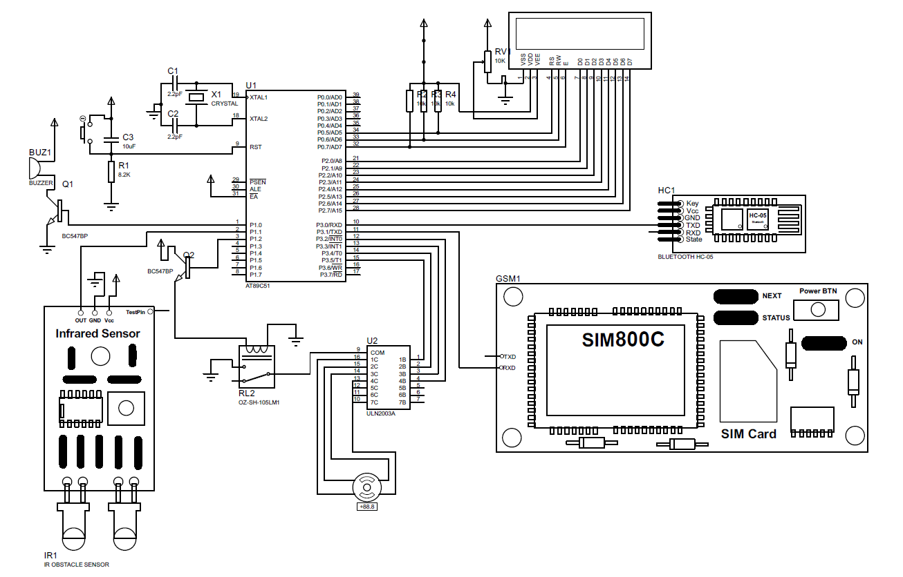

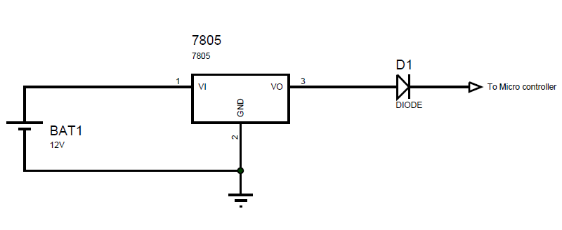

**Figure 3.1: Schematic Diagram**

* + 1. **Schematic Description**

5V DC adapter is used for the Power supply. This power supply supplies power to the controller, Stepper motor, IR sensor module, GSM module as well as the Bluetooth module.

Also as shown in schematic, there is a 12V battery connected in parallel with the adapter. The battery voltage is regulated using the LM7805 IC to give a constant output voltage of 5V as all the components in the circuit operate on 5V. There is a diode connected in series with the battery. This diode is used to prevent the flow of the reverse current in the battery. Also, this diode prevents the flow of current from the battery when the main power supply is ON as the it is reverse biased by the main power supply. When the main power supply is Cut-Off the reverse voltage across the diode is not there and then the power is supplied from the battery.

We are using the GSM module only for making the missed calls so we will be sending commands to the GSM module and are not interested to receive any data from it. So we have connected the Rx pin of GSM module to Tx pin of the controller and the Tx pin of GSM module is left open.

Similarly, we are using the HC-05 Bluetooth module to receive data from the user and we will not be sending any data via the Bluetooth module. So the Tx pin of HC-05 is connected to the controller and the Rx pin is left open.

* 1. **Software Description**
     1. **Proteus**

Proteus (PROcessor for TExt Easy to USe) is a fully functional, procedural programming language created in 1998 by Simone Zanella.

Proteus incorporates many functions derived from several other languages: C, BASIC,Assembly, Clipper/dBase; it is especially versatile in dealing with strings, having hundreds of dedicated functions; this makes it one of the richest languages for text manipulation.

Proteus owes its name to a Greek god of the sea (Proteus), who took care of Neptune's crowd and gave responses; he was renowned for being able to transform himself, assuming different shapes.

Transforming data from one form to another is the main use of this language.

* + 1. **Keil µVison-3**

To develop the code and for compiling our project C program we have used Keil µVison3 IDE.

**Keil µVision** is a free software which solves many of the pain points for an embedded program developer. This software is an integrated development environment (IDE), which integrated a text editor to write programs, a compiler and it will convert your source code to hex files too.

* 1. **Flow Chart**

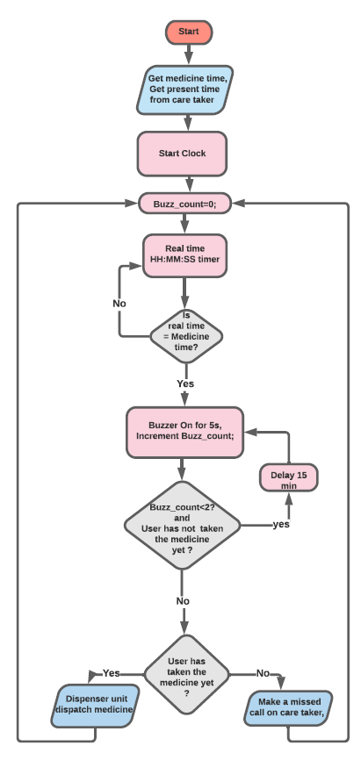

**Figure 3.2: Flow Chart of Program**

* + 1. **Flow Chart Description**

Take the medicine schedule and the present time from the caretaker. After taking the present time start the clock inside the microcontroller.

Initialize the variable buzz_count to 0 value. This variable indicates how many times the buzzer buzzed. The clock generated inside the microcontroller is displayed on the LCD connected to the microcontroller.

The controller is continuously checking if it is the time to take the medicine. If it is time to take the medicine has come then the buzzer makes a sound for 5 seconds to alert the patient to take the medicine. Also, then the buzz_count value is incremented as the buzzer has buzzed once.

If the patient comes to take the medicine, then the machine dispenses the medicine and then goes back to check the medicine time for next medication time.

But if. even after alerting the patient to take the medicine if he/she fails to take it, the device tries to alert the patient again by turning the buzzer on for 5 seconds. Even after alerting the patient twice if he/she fails to take the medicine then the device will make a missed call to the caretaker indicating him/her that the patient has failed to take the medicine even after alerting them twice.

**Chapter 4**

**Simulation and Testing**

* 1. **Work Plan**

The workflow followed will be to simulate LCD display and to check real time function tracker and testing will be done for components that cannot be simulated in software. During testing, modules will first be tested with Arduino to understand the commands and to configure module like HC-05 with password.

* 1. **Simulation**

The main objective for simulation was to check the function, that kept track on real time. The software that we used was Proteus 8 Professional. The main challenge that we faced during this was keeping the track on actual real time since the real time in controller was lagging with respect to actual real time. This problem was solved by making the timer faster than before. Finally real time function was able to track the real time properly. We also simulated LCD Display on Proteus to check for errors in LCD program. Two other major components namely GSM module and Stepper motor couldn’t be simulated so when directly went for hardware testing.

* 1. **Testing**

The testing was divided into various phases. The main objective for phase wise testing was to detect problem at component level.

* GSM Module Testing: We first tested GSM Module with Arduino Uno board. Here we found that the legend printed on board had some error. Power and Status light were wrongly printed and Tx, Rx were also wrongly printed. After detection of this error the GSM Module was working properly.
* Dispenser Box Testing: The main aim for this testing was to check whether the stepper motor is able to rotate the wheel.
* Bluetooth Module Testing: We first interfaced HC-05 with Arduino board to check for any errors in module. After testing we were able to conclude that HC-05 was working in the expected manner.
* LCD Testing: We tried to print some characters on LCD to check the program of LCD.

* Stepper Motor Testing: The stepper motor was working properly but the power dissipation in motor was much more than expected so to over come this we used a relay that would cut the power supply to driver when motor is not in use. This resulted in reduced power consumption.
* IR Sensor Testing: The concept behind testing IR sensor was to display ‘1’ on LCD when object is detected and print ‘0’ when no object is found.
* Battery Operated Power Supply Testing: The main objective was to provide the controller an uninterrupted power supply on mains failure. Thus in testing phase we used a led as load and intentionally turned off the mains power supply so that battery provides power to led.
* Overall Testing: When the circuit was powered then we connected our phone to HC-05 and entered the medicine time along with real time. When the medicine time was reached then the buzzer was enabled. If medicine was not taken in 2 minutes (just for testing), then a miss call was made to the care taker. If the person kept his hand in front of the dispenser, then the stepper motor was rotated to dispense medicine in the hand of people. We also tried to interrupt the mains power supply so that we can check whether the controller is getting uninterrupted power supply from battery.

**Chapter 5**

**Results and Conclusion**

* 1. **Results**

As we mentioned in our aim of this project, our device takes medicine time and actual time from Bluetooth module and then real time clock starts. When the medicine time is reached then a buzzer is activated for 1 minute to alert the elder person to take medicine. The buzzer is activated again after 15 minutes to remind the elder person. On failure to take medicine within 15 minutes the care taker is alerted by sending a miss call.

* 1. **Application**
* This device can be helpful to a family with elders who are alone the whole day, to remind them to take medicine on time.
* This can also be useful to person who have tendency to forget small things like taking medicine on time.
* This can also be used in hospitals where there are too many patients and care takers are less.
  1. **Limitation**

The device is designed to rule out maximum problems associated with it yet there are some limitations to it. Below mentioned are the limitations:

* The device needs a good cellular network since it has a GSM Module with sim card in it.
* The battery connected to it must be checked regularly since it may discharge itself when kept idle.
* While the data of medicine is to be entered the person, who is entering the data must be near the dispenser since it has Bluetooth module to receive data.
  1. **Scope of Improvement and Modification Possibilities**

The data reception from Bluetooth module can be substituted by data reception from GSM module so that medicine time can be entered from remote location also. A battery charger can be connected so that the regular check on battery can be avoided. The number of slots can be increased so that the person who needs to take medicine more frequently is also considered.

* 1. **Conclusion**

In accordance to the name “Smart Medicine Dispenser” this dispenser unit reminds person to take medicines on time and dispenses medicine into the hands of person. On failure to take medicine the care taker is alerted with a miss call.

During the testing phase we learned how to test a component at software and hardware level. During the testing of GSM module, we learned how to troubleshoot hardware level problem. We also learned the problems that may occur while loading a program into controller and then how to find the way out to it. We also learned how to connect all the standalone components together to achieve a particular aim.

On completion of the project we can say that this dispenser unit can be extremely helpful to old age people and to them who are alone at home the whole day and tend to forget to take medicine on time.

**Chapter 6**

**Pin Diagram and Description**

* 1. **LM 7805**

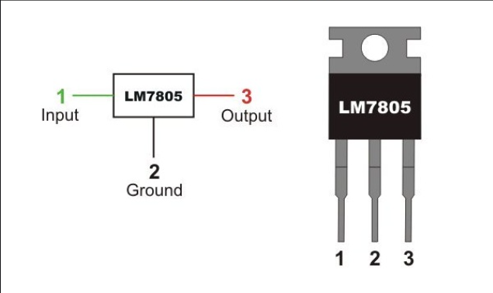

**Figure 6.1: LM 7805 Pin Diagram**

* 1. **Transistor BC547**

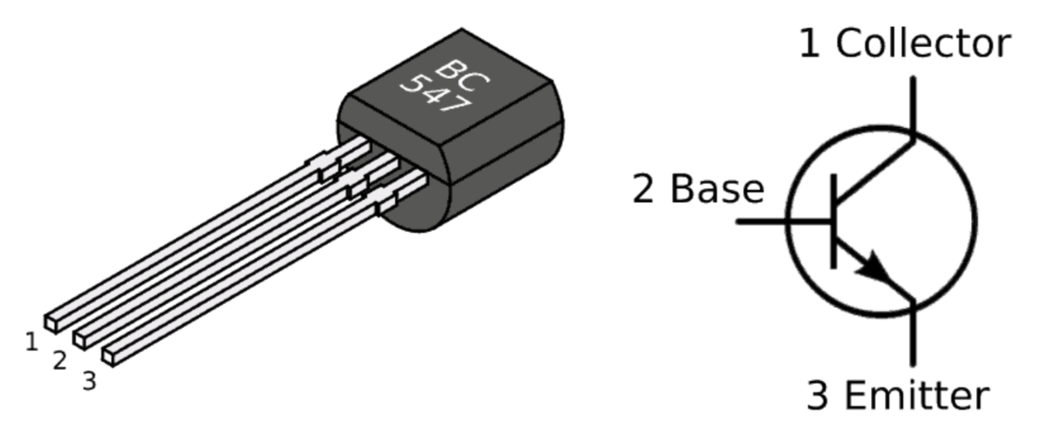

**Figure 6.2: BC547 Pin Diagram**

* 1. **ULN2003**

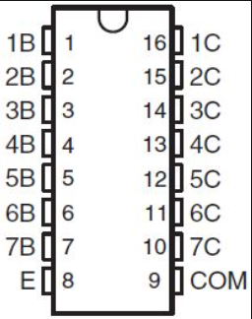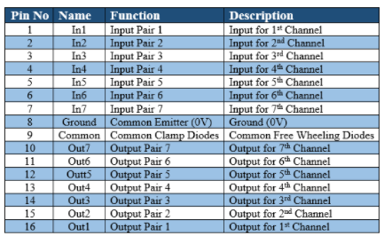

**Figure 6.3: ULN2003 Pin Diagram**

* 1. **HC-05**

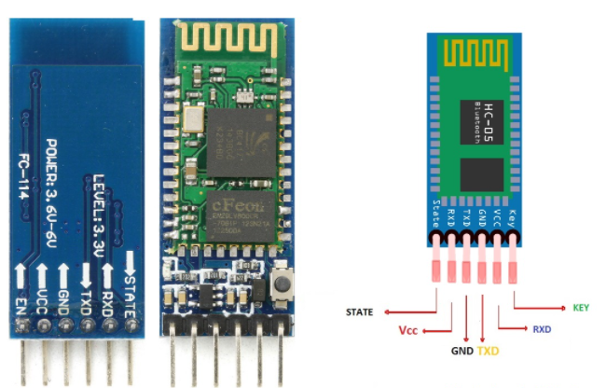

**Figure 6.4: HC-05 Pin Diagram**

* 1. **LCD**

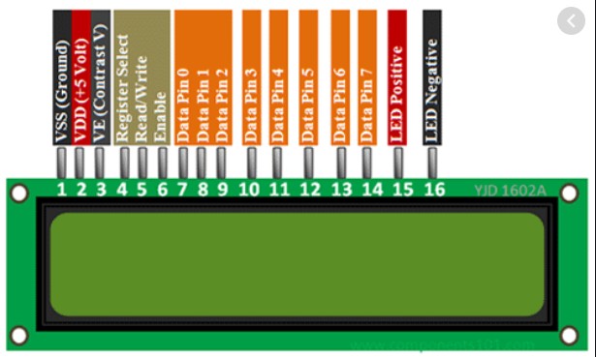

**Figure 6.5: LCD Pin Diagram**

* 1. **GSM Module**

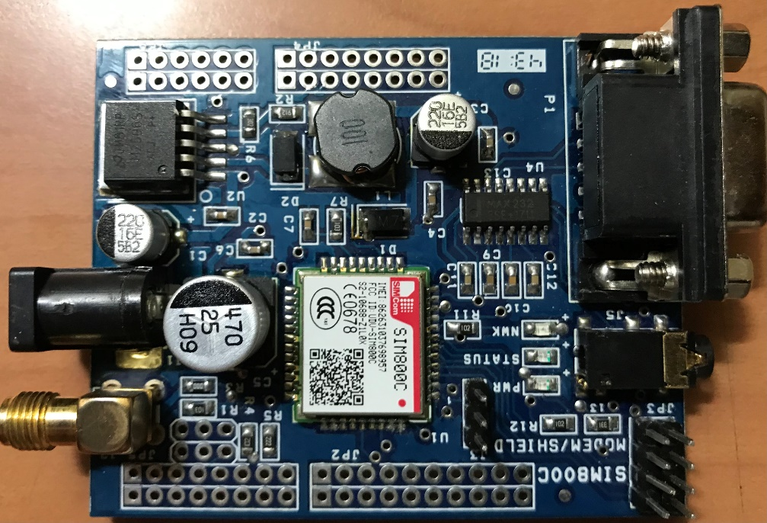

GND

RX

**Figure 6.6: GSM Module**

* 1. **IR Sensor**

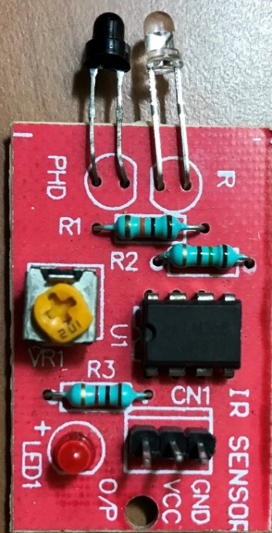

**Figure 6.7: IR Sensor Pin out**