
RV COLLEGE OF ENGINEERING
Bengaluru-560 059

REPORT ON
EXPERIENTIAL LEARNING / PROJECT BASED LEARNING
ACY 2024-25

THEME
Energy
Title of the Project
Portable Smart Chemical Cooling Unit
Students Group
SL. No. | USN | Name | Prog.
1 | 1RV24CI016 | Anika U Bhat | Artificial Intelligence and Machine Learning
2 | 1RV24CS194 | Pramath J | Computer Science and Engineering
3 | 1RV24CS243 | Samaraditya P H | Computer Science and Engineering
4 | 1RV24EC187 | Sanjana Aathreya | Electronics and Communication Engineering

Project Evaluators
SL. No. | Name of the Evaluators (Enter the Names in Capitals)
 | DR DILEEP MS
 | DR SUMAN N P
 | DR R CHANDRA KUMAR
 | DR AJAY K M

- Introduction
  - Reliable cooling is essential for safe transport and storage of temperature-sensitive medical items.
  - In rural or emergency settings, electricity-based refrigeration is often unavailable or unreliable.
  - Ice-based cooling methods are bulky, inconsistent, and have limited duration.
  - The project introduces a Portable Smart Chemical Cooling Unit (PCCS) that works without electricity.
  - It utilizes the endothermic reaction of ammonium chloride in water to achieve rapid cooling.
  - The system is safe, reusable, and environmentally friendly.
  - Temperature regulation is achieved using an ESP32 microcontroller and a DS18B20 temperature sensor.
  - It maintains cooling at 8°C for over an hour and enables salt regeneration using solar or thermal methods.

2. Problem Definition
2.1 Problem Statement:
Lack of refrigeration in rural or emergency areas compromises the storage of temperature-sensitive materials like vaccines and insulin. Ice-based coolers are unreliable, and grid-dependent fridges are infeasible.

2.2 Background Information: (literature review)
Recent literature highlights the practicality of salt-based cooling systems powered by renewable energy and regulated using embedded control systems. Several studies support the design choices made in this project:
- Jones et al. (2020): Proposed field-deployable endothermic cooling using salt–water mixtures, laying the foundation for portable chemical-based refrigeration.
- Smith & Lee (2021): Evaluated safety and thermal performance of ammonium chloride cooling packs, affirming its suitability as a safe and effective cooling agent.
- Park et al. (2023): Demonstrated a solar-powered salt-based cooling unit using potassium chloride, achieving temperature drops of 12.3°C. However, its efficiency was limited by high water use and regeneration energy needs.
- Kumar Raju & Jain (2015): Designed a low-cost, energy-efficient water cooling system using ammonium chloride and urea. Their system integrated insulation and heat exchangers, reinforcing scalability and simplicity.
- Desai et al. (2020): Highlighted the potential of endothermic reversible reactions of salts for thermochemical energy storage (TCES) and their renewable integration.
- Zhao et al. (2021): Demonstrated solar-thermal regeneration of ammonium chloride, confirming its sustainability for reuse.
- Gupta et al. (2023): Emphasized the feasibility of low-grade heat sources for salt regeneration, supporting our use of solar and mild heating.
- Ramesh Saha et al. (2021): Developed a temperature monitoring system using the DS18B20 sensor with Arduino, which directly informed our sensor choice.
- Ramos & Ortiz (2020): Implemented microcontroller-based temperature control in mobile health units, aligning with our use of ESP32 for thermal regulation.
- Patel et al. (2022): Discussed feedback-loop based temperature control systems for IoT-enabled cooling applications.
- Allen & Roberts (2019): Evaluated composite insulation effectiveness for mobile cold storage; supported our selection of layered foam and foil.
- Nguyen & Torres (2022): Analyzed vacuum insulation panels for mobile refrigeration. Though not used in our setup due to cost, their results helped benchmark performance.
These studies collectively guided our material selection, control system architecture, and sustainability practices while confirming the overall viability of a low-cost, portable, and reusable chemical cooling unit.

3. Objectives
3.1 Primary Objectives: To design and fabricate a self-contained chemical cooling system capable of maintaining temperatures below 10°C without electricity or ice.

3.2 Secondary Objectives:
- To automate the cooling process using sensors and a microcontroller for real-time temperature monitoring.
- To enable reusability by integrating a simple and effective salt regeneration process using solar or thermal heating.
- To ensure user-friendly operation with minimal intervention, making it suitable for remote or mobile applications.
- To test and validate performance parameters such as cooling time, hold time, and energy consumption.
- To achieve a compact, lightweight, and cost-effective design that can be easily transported.
4. Methodology
4.1 Approach:
- The project involved an iterative design approach, beginning with a literature survey and initial trials.
- Initial reactions with barium hydroxide were tested but discarded due to safety concerns, leading to the selection of ammonium chloride.
- The system was divided into functional blocks: reaction chamber, insulation, fluid transfer, mixing mechanism, and temperature control.
- Hardware and software were co-developed to ensure integration and synchronization between sensors, pumps, and display.

4.2 Procedures:
- The insulated chamber was prepared using a dual-container design with multilayered foam and aluminum insulation.
- 600g of ammonium chloride was placed in the inner chamber, and water was pumped from a side pouch using a DC water pump.
- Mixing was achieved using a geared motor to enhance salt dissolution and maximize the cooling effect.
- Real-time temperature was displayed via an LCD screen connected to the ESP32 microcontroller and DS18B20 sensor.
- After the cooling cycle, the used solution was transferred to a secondary pouch for regeneration.
- Regeneration of ammonium chloride was tested using both solar drying and low-heat methods..
5. Project Execution
5.1 Planning and Design:
- Defined the project objective: developing a portable, electricity-free refrigeration unit for storing temperature-sensitive medical supplies.
- Identified key users and use-cases including rural clinics, mobile medical camps, and emergency response situations.
- Reviewed and compared existing chemical cooling methods, ultimately selecting ammonium chloride for its safety, efficiency, and reusability.
- Finalized system features: rapid cooling using endothermic salt reaction, automated temperature monitoring, salt regeneration, and portability.
- Evaluated hardware feasibility: availability of DC pumps, mixing motors, insulation materials, ESP32 microcontroller, and temperature sensors.
- Analyzed software requirements for real-time monitoring, sensor control, and data display.
- Assessed constraints including safety, weight, budget, and ease of transport to guide material and component choices.
- Outlined a timeline and resources needed to ensure completion within the academic term.
5.2 Implementation:
- Assembled and integrated core components including ESP32 microcontroller, DS18B20 sensor, DC water pumps, and a geared motor.
- Programmed the ESP32 microcontroller to execute temperature-based logic and control water transfer and mixing operations.
- Set up a dual-container system for holding ammonium chloride and facilitating its dissolution via a controlled pumping and mixing mechanism.
- Calibrated the DS18B20 sensor for real-time temperature monitoring with ±0.5°C accuracy.
- Implemented a display system using an LCD to show live temperature data from the reaction chamber.
- Designed and tested the power system using a 14.8V lithium-ion battery pack to support at least 14 hours of usage.
- Conducted initial dry runs to validate water circulation between the primary chamber and the side pouches.
- Conducted wet tests with ammonium chloride and water to observe endothermic cooling behavior.
- Monitored and logged data to evaluate cooling rate and duration.
- Performed salt recovery experiments via solar drying and low-grade thermal evaporation.
- Re-tested the system with recovered salt to validate reusability and consistency of cooling.
- Optimized wiring layout and component housing for compact and safe transport of the assembled prototype.
- Collected thermal performance metrics such as temperature drop speed, hold time, and system responsiveness.

6. Tools and Techniques Used
6.1 Tools:
- ESP32 Microcontroller: Used for system control and integration of temperature sensing, display, and actuation logic.
- DS18B20 Temperature Sensor: Provides precise temperature readings inside the reaction chamber.
- DC Water Pump: Transfers water between compartments and initiates the cooling reaction.
- Geared DC Motor: Facilitates efficient mixing of salt and water.
- Battery Pack (14.8V, 2Ah): Supplies portable power, supporting over 14 hours of operation.
- Containers & Tubes: Hold salt, water, and waste solution; facilitate fluid routing.
- Insulation Materials: Foam , aluminum foil, plastic wrap for thermal efficiency.
6.2 Techniques:
- Chemical Cooling: Endothermic dissolution of ammonium chloride in water to reduce temperature.
- Thermal Insulation: Multi Layer insulation to minimize external heat transfer and maintain cooling.
- Sensor Feedback Loop: Closed-loop control using ESP32 and DS18B20 to monitor and adjust system operation.
- Salt Recovery: Recovered ammonium chloride using evaporation through sunlight or low-grade heating.
- Data Logging: Real-time monitoring and performance tracking for optimization and validation.
- Modular Assembly: Ensured system was easy to assemble/disassemble for testing and transport.

7. Results and Discussion
7.1 Final Results:
- Temperature dropped from 27°C to 8°C within 30 seconds, highlighting the rapid cooling effect of the endothermic ammonium chloride-water reaction and confirming its suitability for medical-grade refrigeration needs.
- The system was able to maintain a temperature below 10°C for up to 2 hours under insulated conditions, providing sufficient time for the transportation or temporary storage of temperature-sensitive medical supplies.
- The regeneration process was successfully demonstrated using both solar drying and gentle heating techniques, with over 90% of the ammonium chloride salt recovered in solid form, validating the system's sustainability and low operational cost.
- Power testing confirmed that the battery-powered system can operate continuously for up to 14 hours on a full charge, enabling reliable use in remote or off-grid environments without requiring external electricity..
7.2 Discussion: The project successfully achieved its primary and secondary goals. It demonstrated the feasibility of using an endothermic salt-water reaction for refrigeration, supported by a simple and efficient hardware setup.
Significance:
- The PCCS proves that sustainable, reusable, and electricity-free refrigeration is achievable using safe chemicals and minimal resources.
- It has the potential to transform vaccine and medicine logistics in rural or disaster-stricken areas where power is unreliable.
Unexpected Outcomes:
- The salt recovery process performed better than anticipated, especially under sunlight.
- Passive insulation retained cooling longer than expected, even without continuous pumping.
- The ESP32 and sensor system operated stably across all test conditions without requiring calibration beyond initial setup.
Overall, the project met its core objectives while also offering insights into further improvements and real-world viability. It highlights a promising direction for sustainable cooling technologies.
8. Prototype (Hardware/Software)

8.1 Prototype Description:
- Dual-pouch water routing system.
- Insulated dual-container for cooling.
- ESP32-based automated control.

8.2 Development Process:
- Initial trials with barium hydroxide discarded.
- Final system validated for thermal, mechanical, and electrical integration.

8.3 Testing and Validation:
- Verified using temperature logs, power consumption calculations, and regeneration yield.
- Temperature–Time graph shows clear drop to 8°C with 1°C/hour increase post-cooling.
9. Conclusion
9.1 Summary:
The project validated a sustainable, portable cooling solution suitable for the medical cold chain in low-resource settings. It successfully demonstrated rapid, electricity-free cooling through an endothermic salt-water reaction and maintained sub-ambient temperatures for extended periods using optimized insulation. Real-time temperature monitoring using the ESP32 and DS18B20 sensor ensured precision and control throughout the process. The regeneration of ammonium chloride using solar or thermal heat also highlighted the reusability and cost-effectiveness of the system.
The prototype met all the core objectives set out at the start, including energy independence, safety, and portability. It also revealed key areas for future improvement, such as enhanced automation, app-based control systems, and integration of renewable energy for battery recharging. With its low-cost components and eco-friendly operation, the PCCS offers a viable and impactful solution for healthcare logistics in rural or emergency environments. It stands as a strong proof-of-concept for sustainable refrigeration technology.
9.2 Personal Reflection:
- Anika U Bhat : Working on this project has been a highly enriching experience, allowing me to apply theoretical knowledge to solve a real-world problem. I gained hands-on skills in prototyping, chemical thermodynamics, and embedded systems. Overcoming design challenges and optimizing the system for reusability deepened my understanding of sustainable engineering. Overall, the project enhanced my technical confidence and strengthened my motivation to pursue impactful innovations in healthcare and energy-efficient technologies.
- Pramath J : This project was a deep dive into hardware design and testing, which is something I genuinely enjoy. Figuring out the wiring, pump system, motor integration, and how to power everything from a portable battery pack was both challenging and rewarding. There were plenty of trial-and-error moments—especially with mixing and water flow—but they taught me a lot about practical engineering and patience. Getting all the components to work together smoothly felt like solving a puzzle in real time. I also learned the importance of efficient layout and insulation, which are often overlooked. This was easily one of the most hands-on learning experiences I’ve had so far.
- Samaraditya P H : This experience allowed me to discover my personal strengths and weaknesses. I realized I am good at organizing tasks and staying on track, but I also learned that I need to become more confident when sharing my ideas with others. Knowing this will help me focus on improving these areas in the future.
- Sanjana Aathreya : Working on this project has been a highly enriching experience, allowing me to bridge theoretical knowledge with practical implementation. I actively contributed to the system design, thermal insulation strategy, and the regeneration process, which gave me hands-on exposure to both hardware and chemical integration. Tackling real-world constraints such as safety, portability, and efficiency helped me think critically and make informed design choices. The experience not only improved my technical and problem-solving skills but also deepened my interest in sustainable technology and interdisciplinary innovation.

10. Visuals:
Fig 1.1 Fig 1.2
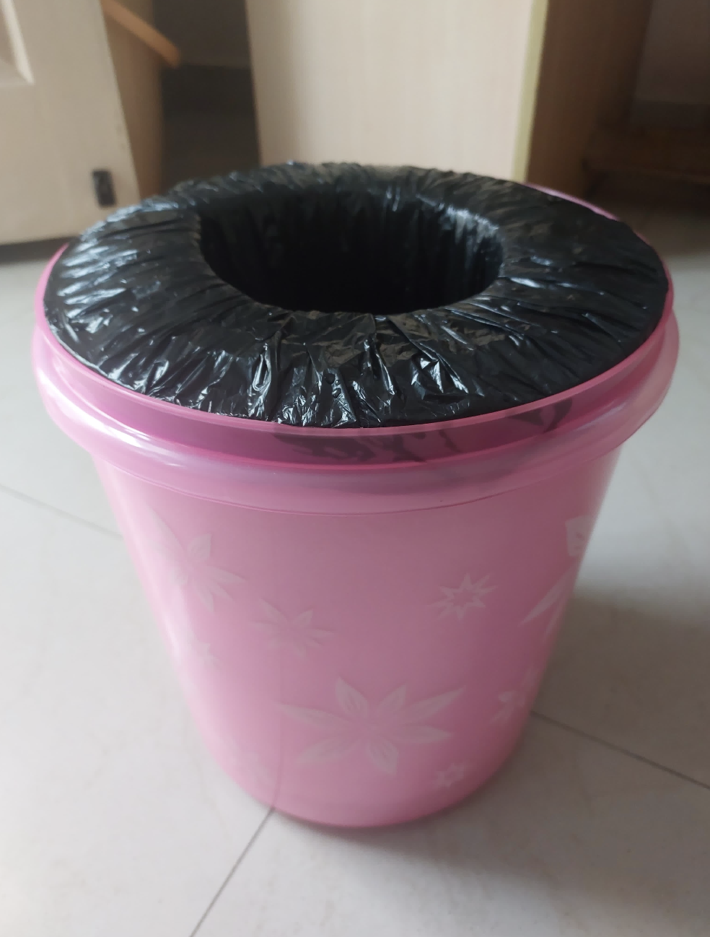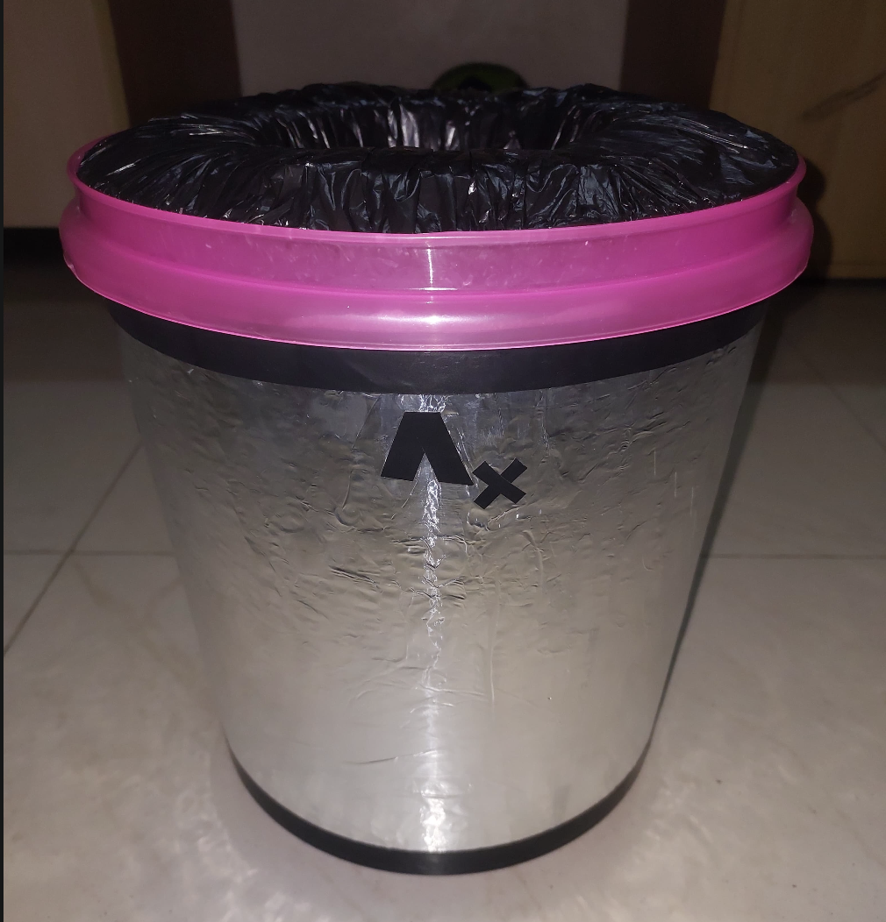
Fig 1.1 and Fig 1.2 show the insulation inside and aluminium coating outside the unit

Fig 2.1 Fig 2.2
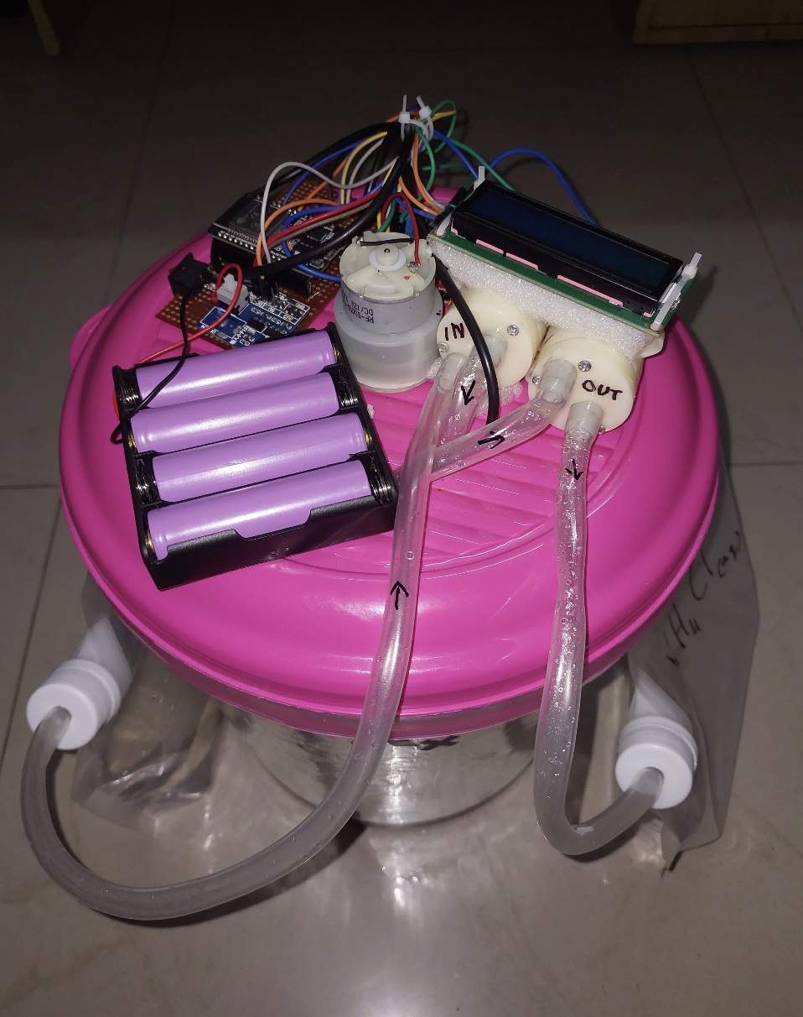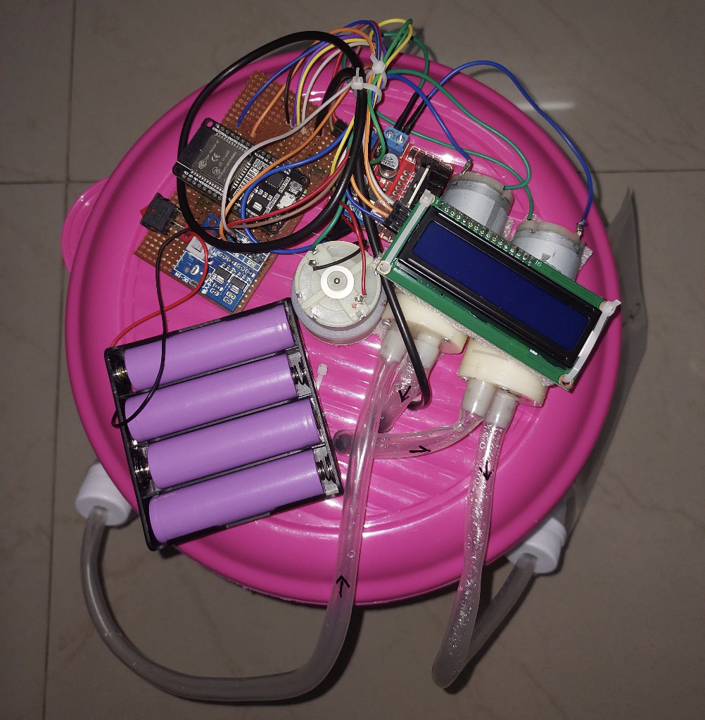
Fig 1.1 and Fig 1.2 show the ESP32 and LCD along with motors and battery pack

Fig 3.1
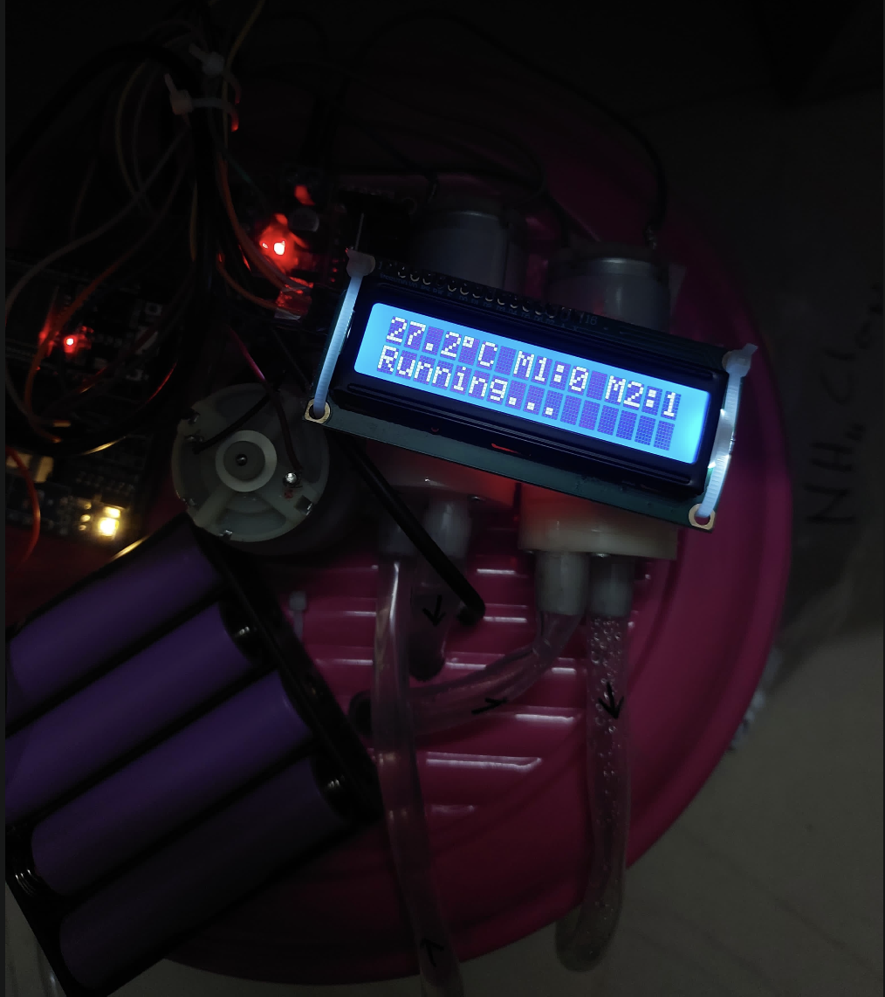 Fig 3.1 shows the data displayed on LCD screen

Fig 4.1
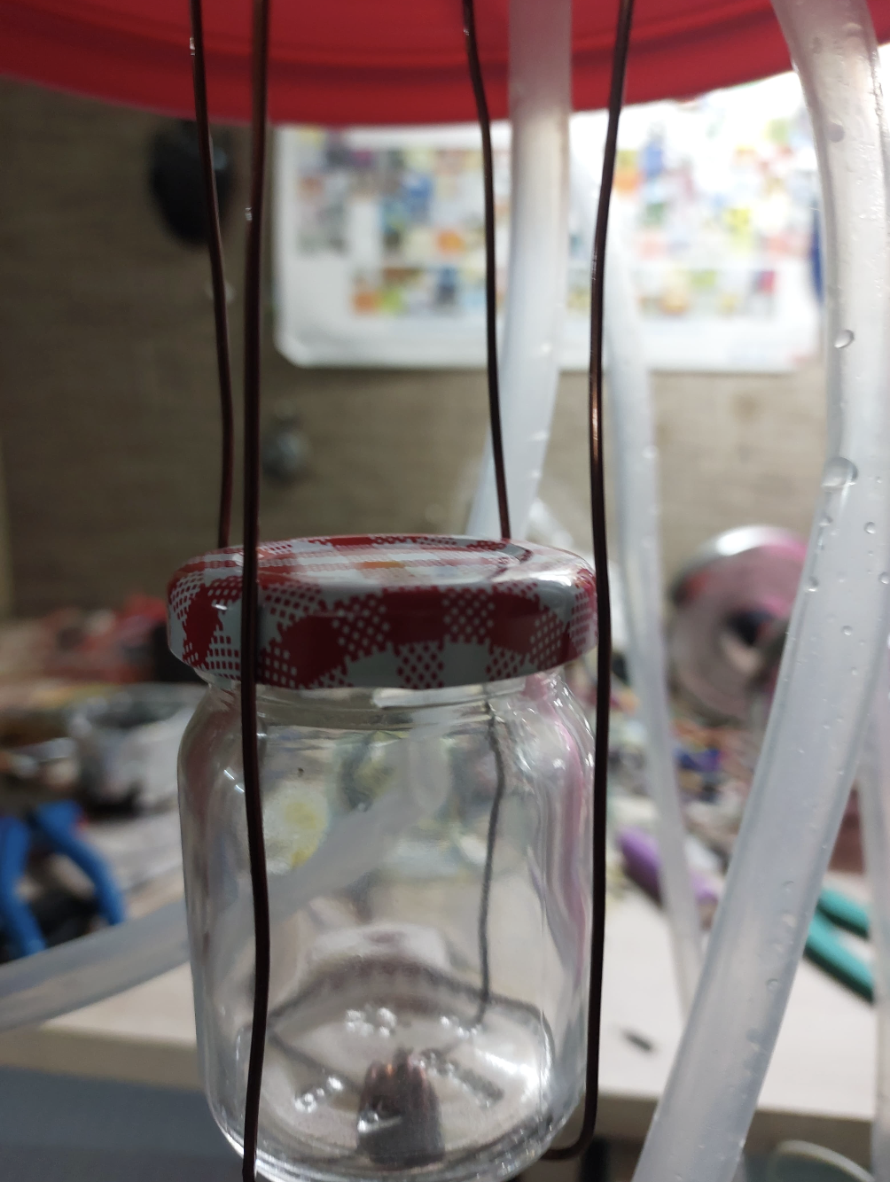
Fig 4.1 shows the salt mixing structure with the chamber for medical items to be kept cool

Fig 5
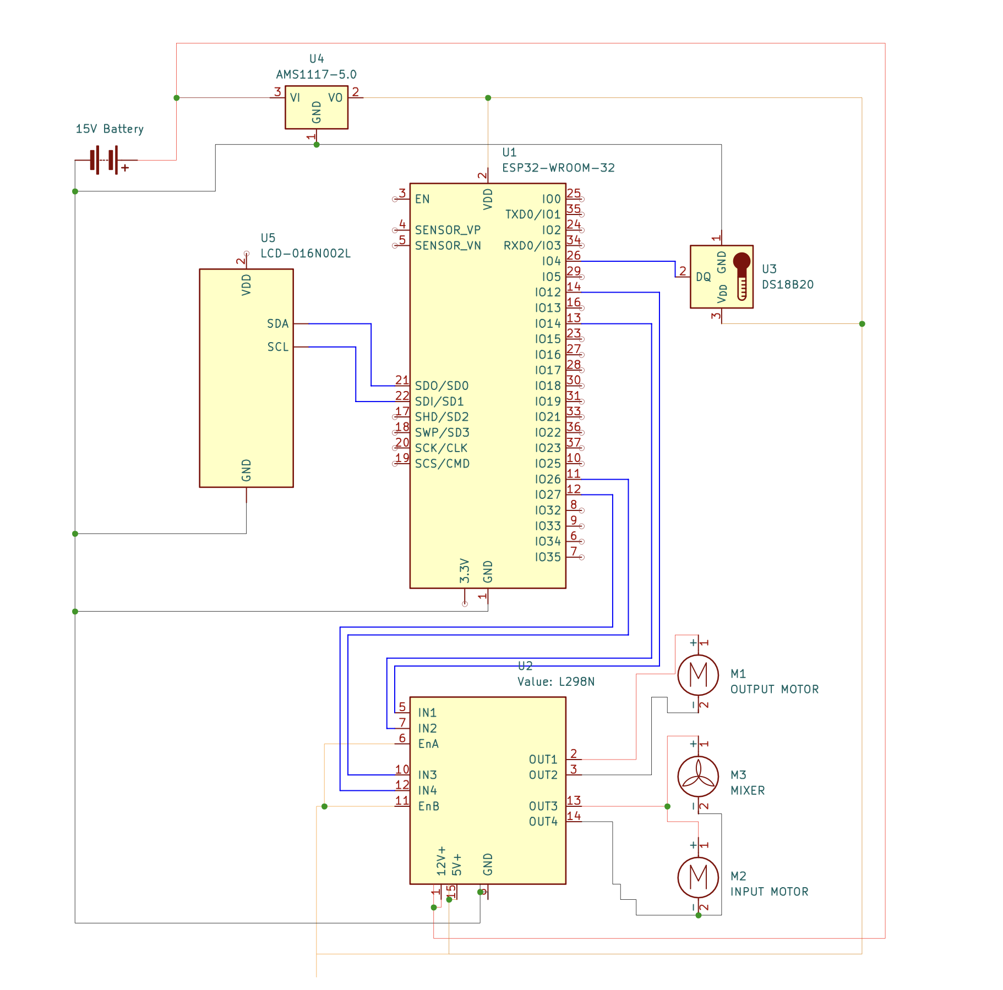
Fig 5 shows the electric circuit of microcontroller , temperature sensor , motor driver and LCD screen

Fig 6.1 Fig 6.2
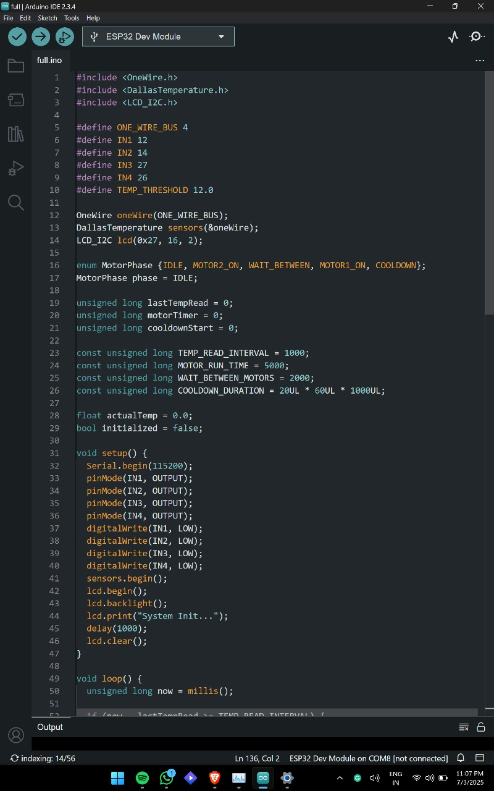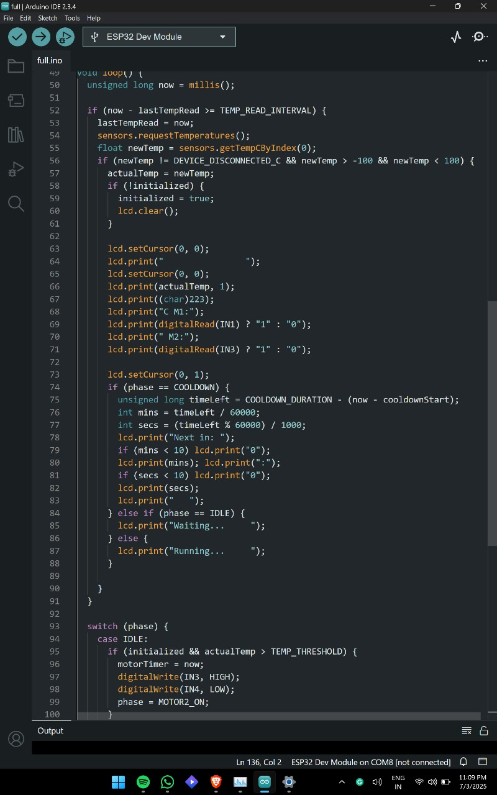
Fig 6.3 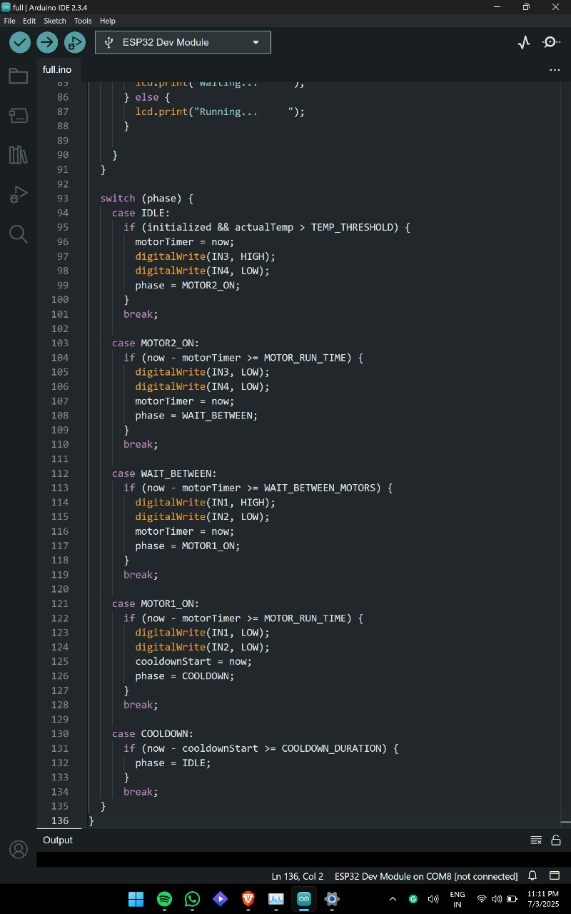
Fig 6.1,6.2 and 6.3 show the code and logic used in microcontroller

11. QR Code of Demonstration Video
`

