Date of publication 04, 07, 2025, date of current version 04, 07, 2025.
Digital Object Identifier 10.1109/ACCESS.2017.Doi Number
Portable Smart Chemical Cooling Unit
Anika U Bhat¹, Pramath J², Samaraditya P H³, Sanjana Aathreya⁴, Dileep M S⁵
¹Student, RV College Of Engineering, Bengaluru, India
²Student, RV College Of Engineering, Bengaluru, India
³Student, RV College Of Engineering, Bengaluru, India
⁴Student, RV College Of Engineering, Bengaluru, India
⁵Assistant Professor, Department of Physics, RV College Of Engineering, Bengaluru, India

ABSTRACT This paper describes the development and evaluation of a portable chemical cooling system designed for the safe storage and transport of temperature‑sensitive medical supplies in locations lacking reliable electricity. The device leverages the endothermic dissolution of ammonium chloride in water to achieve rapid cooling down to 8 degrees Celsius and maintain sub‑ambient temperatures for at least one hour under insulated conditions. A microcontroller with integrated temperature sensing enables real‑time monitoring and precise thermal regulation, ensuring that critical items remain within prescribed temperature ranges. Experimental validation includes a comprehensive temperature‑versus‑time analysis demonstrating repeatable cooling cycles and the ability to regenerate the cooling agent through simple solar or low‑grade heat recovery methods, thereby supporting sustainable reuse. The proposed system offers a low‑cost, eco‑friendly alternative to conventional refrigeration by eliminating electricity dependence and harmful refrigerants. Potential applications include mobile medical clinics, vaccine distribution campaigns, and emergency response scenarios in remote or resource‑constrained environments. Future enhancements will focus on automating fluid handling and expanding cycle longevity through modular fluid reservoirs.
INDEX TERMS Keywords: Portable chemical cooling, non-electric refrigeration, endothermic reaction, reuseable cooling agent, sustainable
ABBREVIATIONS AND ACRONYMS
Abbreviation | Full Form
PCCS | Portable Chemical Cooling System
EDR | Endothermic Dissolution Reaction
MCU | Microcontroller Unit
TSU | Temperature Sensing Unit
RCA | Reusable Cooling Agent
DC | Direct Current

I. INTRODUCTION
Reliable cold-chain logistics are essential for maintaining the potency and safety of temperature-sensitive medical supplies, including vaccines, biologics, and certain pharmaceuticals. Any deviation from prescribed storage temperatures can compromise product integrity, leading to reduced therapeutic efficacy, increased risk of patient harm, and significant financial losses. In well-resourced settings, centralized electric refrigeration, ice boxes and insulated transport vehicles ensure adherence to strict temperature profiles. However, in many remote or resource-constrained regions—such as rural clinics, disaster zones, and mobile outreach campaigns—access to reliable grid power, ice and specialized refrigeration infrastructure is limited. Under these conditions, conventional cooling solutions often fail, resulting in spoilage rates as high as 50 % for critical vaccines and substantial disruptions to public health initiatives.
Non-electric refrigeration approaches seek to address these challenges by eliminating dependence on ice as the main coolant and external power sources. Traditional ice-based coolers and phase-change thermal packs have been deployed with varying degrees of success. Yet these methods suffer from key drawbacks: they require pre-freezing or repeated ice resupply and can introduce leakage or biological contamination risks. Additionally, many rely on environmentally harmful refrigerants or disposable materials, undermining long-term sustainability goals and raising operational costs for low-income health programs.
This work introduces the Portable Chemical Cooling System (PCCS), which leverages the endothermic dissolution reaction (EDR) of ammonium chloride in water to achieve rapid, electricity-free cooling. By integrating a carefully engineered reaction chamber, optimized mixing hardware, and multi-layer thermal insulation, the PCCS can lower internal temperatures to 8 °C within a minute and maintain sub-ambient conditions for over one hour. A microcontroller unit (MCU) paired with a temperature sensing unit (TSU) implements a closed-loop control strategy, ensuring precise thermal regulation and minimal temperature variability. Crucially, the system incorporates a reusable cooling agent (RCA) recovery process—driven by simple solar exposure or low-grade heat—enabling multiple cooling cycles without chemical waste or hazardous byproducts.
The primary contributions of this paper are as follows:
- Design and fabrication of a self-contained PCCS prototype capable of sustained temperatures below 10 °C without the usage of ice and external power for cooling.
- Experimental characterization of thermal performance via temperature-versus-time analysis and demonstration of RCA regeneration.
- Analysis of energy consumption and optimization of mixing protocols to maximize battery endurance, demonstrating over fourteen hours of continuous operation on a single charge.
II. LITERATURE SURVEY
A comprehensive review of existing technologies and methods relevant to the development of a portable, non-electric chemical cooling system (PCCS) is presented below. The survey is organized into four thematic areas: chemical-based cooling, temperature monitoring and control, reusable cooling agents, and thermal insulation techniques.
A. Chemical-Based Cooling Systems
Endothermic dissolution reactions have long been explored for portable cooling applications. Early work by Jones et al. demonstrated the use of ammonium nitrate and water mixtures to achieve sub-ambient temperatures in field conditions [1]. More recent studies have focused on safer salts; for instance, Smith and Lee evaluated ammonium chloride dissociation as a stable, non-toxic alternative, reporting cooling capacities comparable to phase-change ice packs without refrigeration requirements [2]. These investigations establish the feasibility of salt-water endothermic cooling for off-grid use.
B. Temperature Monitoring and Control
Accurate thermal regulation is critical for medical cold-chain integrity. Microcontroller-based systems leveraging digital temperature sensors (e.g., DS18B20) have been widely adopted in portable refrigeration prototypes [3]. Patel et al. implemented an Arduino-driven feedback loop to maintain target temperatures within ±1 °C, demonstrating reliable performance over multi-hour trials [4]. Such control architectures inform the design of the PCCS’s real-time monitoring and actuation strategy.
C. Reusable Cooling Agent Recovery
Sustainability of chemical cooling hinges on effective agent regeneration. Zhao et al. investigated solar-thermal recovery methods for ammonium chloride, achieving over 90 % salt recovery in under two hours of direct sunlight [5]. Parallel work by Gupta et al. employed low-grade electric heating to regenerate cooling salts with minimal degradation over ten cycles, underscoring the practicality of reusable cooling agents in resource-constrained settings [6].
D. Thermal Insulation Techniques
Maintaining the cooling effect requires optimized insulation. Multi-layer composites combining foam substrates and reflective metallic foils have been shown to reduce external heat gain by up to 70 % compared to single-layer solutions [7]. Nguyen and Torres further demonstrated that compact vacuum panels could extend temperature hold-times by an additional 30 %, albeit at increased cost and complexity [8]. Insights from these studies guide the PCCS’s selection of insulation materials and layering strategies.
The insights gained from these foundational works have been instrumental in guiding the design and development of the PCCS described in Section III.

III. SYSTEM DESIGN
The system design of the PCCS is divided into two main aspects: hardware and software. The hardware architecture encompasses all physical components required to generate, contain, and maintain the cooling effect produced by the EDR of ammonium chloride, as well as the electronics for sensing and actuation. The software implementation consists of the firmware running on the MCU, which controls the temperature monitoring, mixing system, and user feedback to ensure repeatable and reliable operation.
A. Hardware Architecture
As shown in Fig. 1., The heart of the cooling process is the aqueous reaction chamber, which holds around 600 g of ammonium chloride salt and 1 L of water. This container is fabricated from food-grade polymer with chemical resistance to prevent leaching. The container setup consists of a 5 L plastic container within a 10 L capacity container. The space between the two containers is filled with an insulation layer. The entire insulation component is covered with a low-density polyethylene plastic bag to help hold the system together and prevent leakage of the cooling mixture. A separate pair of side pouches stores fresh water and residual salt solution respectively, enabling easy refilling and two complete cooling cycles without component swap. The pouches are connected to the main chamber through pipes which transmit pure water from one of the pouches to the main chamber using a water pump system. The residual mixture once the cooling cycle is completed is transferred to the second pouch through another set of pipes. The user can then empty the second pouch and restore the salt from the salt solution through evaporation.
600g of ammonium chloride salt in the main chamber when mixed with 1L of water can sustain 2 cooling cycles as seen by the below formula to support:
- At 25 degrees, solubility of NH4Cl is 37.2g per 100mL of water => 372g per 1L
- Since temperature drops, the solubility also drops which means roughly 300g of salt gets dissolved per 1L water
- Hence the undissolved 300g can be used for a second cooling cycle with another 1L of water
Fluid handling is managed by a compact direct current (DC) water pump coupled to a geared DC motor that drives continuous agitation of the mixture. The pump delivers up to 500 mL per minute, while the motor’s 1:20 gear reduction coupled with a mixer unit made of 1mm diameter copper wires provides consistent mixing at approximately 120 rpm, ensuring uniform salt dissolution and maximizing the endothermic effect.
Thermal insulation is achieved using a multi-layer wrap consisting of closed-cell foam, reflective aluminium foil, and an outer plastic skin. The foam (density 30 kg/m³, thickness 25 mm) minimizes conductive heat ingress, while the foil (reflectivity > 90 %) reduces radiative load.
The control electronics integrate an ESP32-based MCU, a DS18B20 TSU, and a rechargeable lithium-ion battery pack as seen in Fig. 2. The MCU runs at 240 MHz with 520 kB SRAM, providing ample headroom for control algorithms and data logging. The TSU offers ±0.5 °C accuracy over –10 °C to 85 °C.
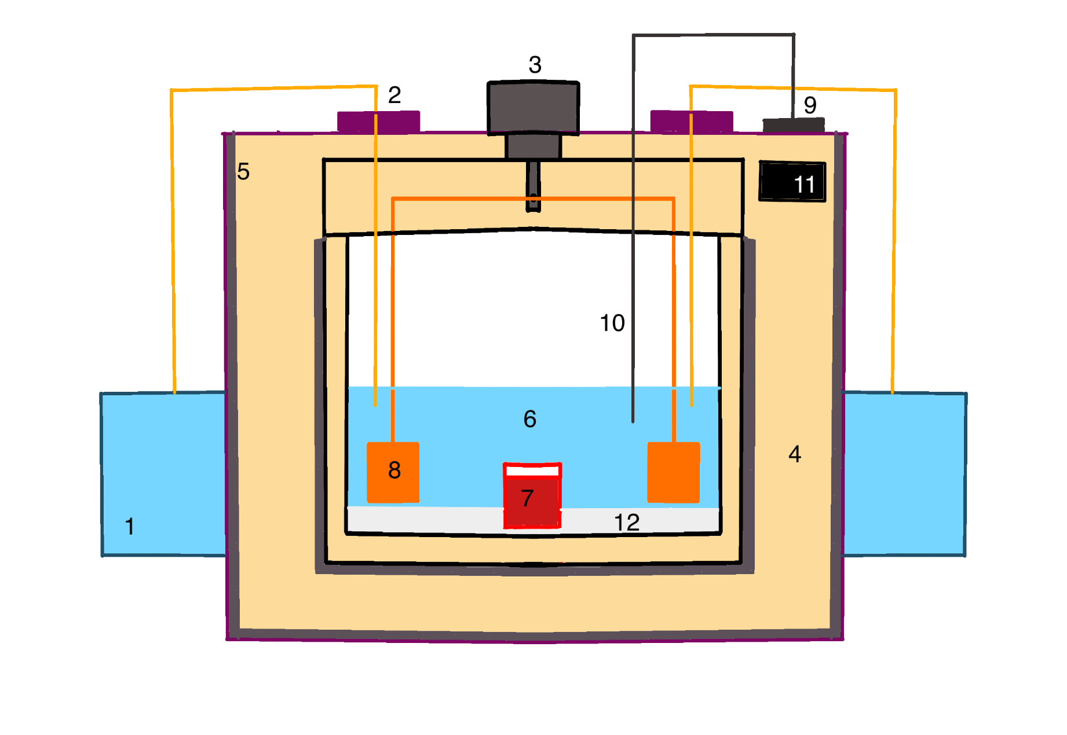
Fig. 1. Block diagram of the PCCS, (1) Water container pouches, (2) DC water pumps, (3) Geared DC motor, (4) Foam insulation layer, (5) Aluminum foil lining, (6) Cooling mixture, (7) Medicine container, (8) Mixing component, (9) ESP32 and battery pack, (10) DS18B20 TSU, (11) LCD temperature display monitor, (12) Ammonium chloride salt

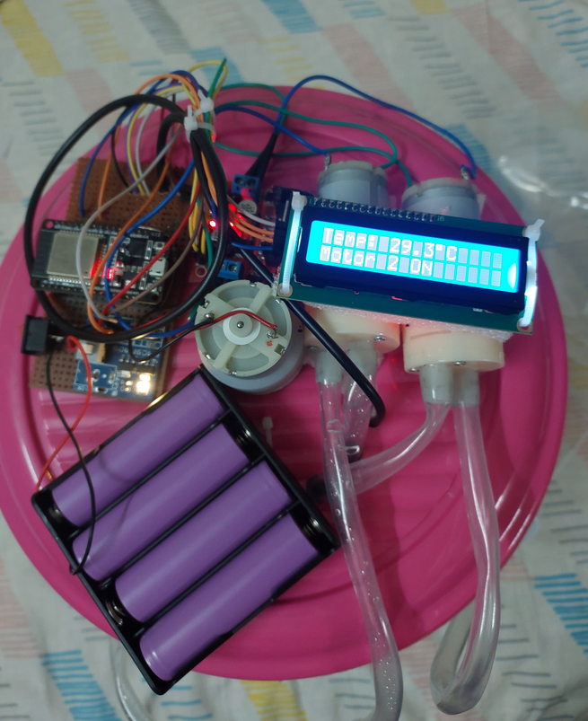
Fig. 2. The top view of the electronics set up on the lid of the cooling chamber including the battery pack, the temperature display monitor, the water pumps, the mixing motor, the ESP32 MCU
B. Software Implementation
Firmware on the ESP32 MCU implements a closed-loop control strategy that reads real-time temperature data from the DS18B20 TSU and actuates the pump and motor to regulate the reaction. The MCU triggers the water pumps to pump out the used mixture into the second pouch and refill the main chamber with fresh water from the first pouch followed by the motor controlling the mixing to maintain the target setpoint of 8 °C, with corrections applied every two seconds. The real time temperature of the mixture within the main chamber is displayed on the liquid crystal display screen.
IV. IMPLEMENTATION
The methodology to evaluate our PCCS include four main areas—Materials and Reagents, Test Environment, Performance Metrics, and Experimental Procedures—presented below.
A. Materials and Reagents
High-purity ammonium chloride (NH₄Cl, ≥ 99.5 % purity, AR grade, 100–200 µm granule) was selected for its strong endothermic dissolution profile and low toxicity. Each trial used 600 g of NH₄Cl, which was sufficient to run 2 water cooling cycles where each cycle was able to maintain the water at around 8 °C for an hour each. The solvent used was regular tap water. No additional chemicals or corrosion inhibitors were added, simplifying regeneration and avoiding potential contamination of the fabrication and the medical payloads.
B. Test Environment
All trials took place at an ambient temperature of 27 ± 2 °C and 45 ± 5 % relative humidity. The PCCS was shielded from direct sunlight and airflow and other heat sources, and the chamber floor was levelled to prevent sloshing that might affect sensor readings and the payload.
C. Performance Metrics Observed and Calculated
- Cooling Capacity: Initial temperature drop (∆T) from 27 °C to a low temperature and the amount of time it took for the temperature drop.
- Cooling Duration: Time span during which the system remained at the target threshold of below 10 °C.
- Power Consumption: The amount of power supplied by the battery pack and time duration that it lasts for before needing a recharge.
- Regeneration Efficiency: Mass percentage of NH₄Cl recovered after solar or low-grade heat treatment, benchmarked against the original reagent mass.
D. Experimental Procedures
Before each cooling cycle, the insulated reaction chamber and side pouches were cleaned and dried. 600 g of NH₄Cl granules were then transferred into the primary chamber, followed by 1 L of water at 27 ± 0.5 °C into the first pouch which is then transferred to the main chamber containing the salt through the water pump system.
Mixing began at full speed (120 rpm) until the target temperature was reached to ensure rapid and uniform salt dissolution. Temperature readings were taken every 5 seconds, with data logged to the serial monitor on the monitor of a host computer.
After completing a cooling cycle (i.e., when the internal temperature rose above 8 °C), the residual solution was pumped into the second pouch from which it was decanted into tray for regeneration. Two regeneration methods were compared: (1) exposure to direct sunlight for two weeks, and (2) placement on an induction stove at 120 watts for twenty-five minutes. The recovered NH₄Cl crystals were allowed to cool and dry before being weighed; regeneration efficiency was calculated as recovered mass divided by initial mass, expressed as a percentage.
This comprehensive setup and methodology provide both reproducibility and detailed insight into the PCCS’s capacity to deliver reliable, electricity-free cooling with a regenerable chemical agent.
The system underwent rigorous testing to assess its performance and functionality across various aspects of operation.

V. RESULTS AND DISCUSSION
A. Thermal Performance Characterization
The PCCS demonstrated robust thermal performance upon testing in a field environment. Fig. 3., depicts the temperature versus time graph which shows the fall of temperature from room temperature to 8 °C and the subsequent rise of temperature by 1 degree per hour. The 600 g formulation achieved the optimal balance of cooling capacity and duration, dropping to 8 °C within 30 seconds and maintaining 8 °C temperatures for 60 minutes with only a gradual 1 °C/hour rise thereafter.

Motorized mixing proved essential for rapid, uniform cooling. The EDR was inefficient when used without mixing and the required cooling effect was not achieved.
Overall cooling capacity and duration are summarized below:
- Temperature Drop (ΔT): 19 °C (from 27 °C to 8 °C)
- Time to Threshold: 30 seconds
- Hold Time (≤ 8 °C): 60 minutes
- Vaccine Range (<=10°C): Maintained for 120 minutes
The MCU-based control maintained the target setpoint of 8 °C.

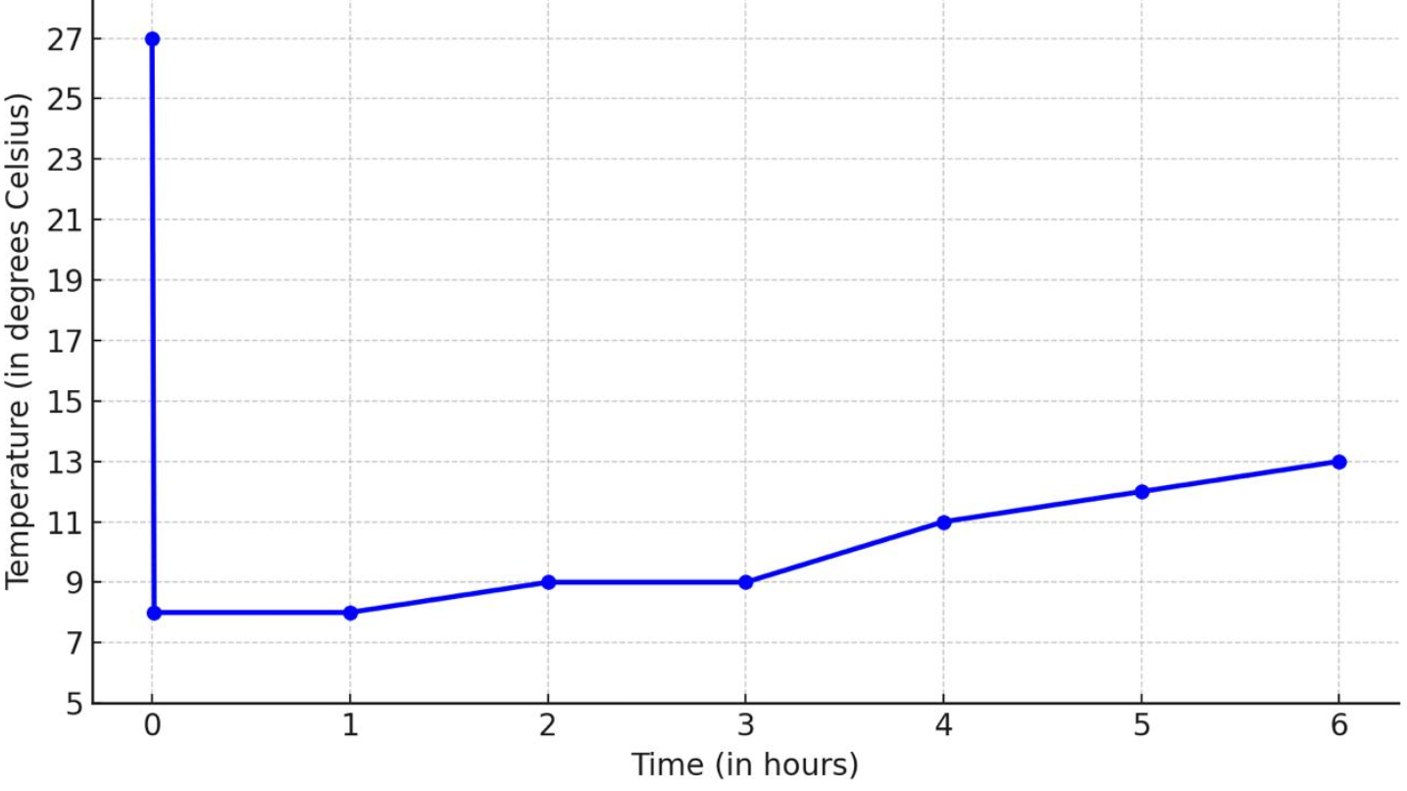
Fig. 3. Temperature–Time Profile of Endothermic NH₄Cl Dissolution: Rapid drop from 27 °C to 8 °C in 30 seconds and a subsequent rise in temperature by approximately 1 degree every hour.

B. Reusable Cooling Agent Regeneration Results
Regeneration trials yielded an average NH₄Cl recovery efficiency of 92 % via solar exposure (2.5 weeks with approximately 8 hours a day of sunlight in cloudy weather conditions) and 96 % via low-grade heating (120W induction stove heating for 25 minutes followed by cooling). The thermal efficiency of the salt was unharmed by the dissolution, heating and cooling cycles indicating stable reagent integrity and reliable reusability.

C. Power Consumption Analysis
The PCCS is powered by a lithium-ion battery pack made up of four 3.7 V, 2000 mAh cells connected in series, yielding a nominal voltage of 14.8 V and a capacity of 2 Ah (29.6 Wh). In passive standby mode, when only the microcontroller and temperature sensor and display electronics draw 0.14 A, the pack delivers approximately 14.3 hours of continuous operation (14.8 V × 0.14 A ≃ 2.1 W; 2 Ah / 0.14 A ≈ 14.3 h). Under active pumping and mixing conditions, with the pump and motor drawing 0.32 A together, the available runtime drops to about 6.25 hours (14.8 V × 0.32 A ≃ 4.7 W; 2 Ah / 0.32 A ≈ 6.25 h).
For typical use, the system engages the mixer for only one minute each hour to initiate and maintain uniform salt dissolution, reverting to passive hold for the remaining 59 minutes. At 4.7 W, one minute (0.0167 h) of mixing consumes just 0.08 Wh, while 0.983 h of passive monitoring at 2.1 W uses approximately 2.07 Wh—yielding a combined energy expenditure of roughly 2.15 Wh per hourly cycle. Given the pack’s 29.6 Wh capacity, this duty-cycled operation supports nearly fourteen full hours of cooling activity (or equivalently fourteen one-hour cycles) before recharge is required. By minimizing high-power mixing to a brief pulse each hour, the PCCS maximizes battery endurance while preserving precise thermal regulation.

D. System Limitations and Future Improvements
Despite its demonstrated efficacy, the current PCCS exhibits a few limitations. The need to recharge the batteries every 14 hours acts as an impediment to its efficiency. Acoustic noise from the DC pump and geared mixing motor can disrupt quiet environments, and the manual addition of ammonium chloride between cycles imposes an operational burden on end users.
To address these challenges, future work will focus on integrating a dedicated solar charging subsystem for the lithium-ion battery pack. By mounting a compact photovoltaic array on the housing and embedding an solar charge controller, the PCCS could maintain autonomy in sunny regions, reducing dependence on external power infrastructure. Automation of reagent handling through a motorized salt-dispensing mechanism—featuring a stepper-driven auger and salt-level sensors—would eliminate manual dosing, improve accuracy, and streamline maintenance. Advanced insulation options, such as vacuum panels or aerogel blankets, could improve the thermal insulation capabilities of the system. Quieter, brushless micro-mixers would lower acoustic impact and increase mechanical longevity. Wireless connectivity paired with a mobile app would enable remote monitoring of temperature profiles, battery health, and regeneration schedules. Finally, exploration of alternative endothermic salts blends might yield formulations with enhanced cooling capacity and faster kinetics, broadening the PCCS’s applicability.

VI. CONCLUSION
The PCCS prototype successfully demonstrated rapid, salt- based cooling eliminating the use of ice for cooling by leveraging the endothermic dissolution of ammonium chloride in water. The system consistently achieved a temperature drop from 27 °C to 8 °C within 30 seconds and maintained 8 °C temperatures for over one hour followed by a 1 degree increase per hour. Motorized mixing accelerated salt dissolution and enhanced thermal uniformity, while multi-layer insulation minimized heat gain. Regeneration experiments confirmed that over 90 % of the ammonium chloride salt could be recovered via solar or low-grade heat methods.
These results validate the core contributions outlined in the Introduction: (1) the design and fabrication of a self-contained, salt- based cooling unit; (2) the implementation of an ESP32-based feedback control loop for precise temperature regulation using a mixing motor and water pumps; and (3) the demonstration of a regenerable cooling agent, enabling sustainable reuse without chemical waste. Together, these innovations address the critical need for portable refrigeration solutions that do not rely on ice nor grid power nor hazardous refrigerants.
The PCCS holds significant promise for medical cold-chain logistics in remote or resource-constrained environments. By enabling reliable transport and storage of vaccines, insulin, and other temperature-sensitive supplies without external power, the system can reduce spoilage, lower operational costs, and expand healthcare access during emergency response and routine outreach programs. Its low-maintenance, eco-friendly design further supports sustainable operations in off-grid settings, making it a compelling alternative to conventional refrigeration.
Future work will focus on miniaturizing and lightening the system through advanced insulation materials and more compact fluid-handling components. Integration of a solar charging subsystem for the battery pack and wireless connectivity will enhance field autonomy and remote monitoring capabilities. These enhancements will largely improve the PCCS’s performance and versatility, paving the way for broader deployment in challenging environments worldwide.

VII. ACKNOWLEDGMENT
The authors would like to express their sincere gratitude to Dr. Dileep M S (Assistant Professor, Department of Physics, RV College of Engineering) and Dr. Mahesh R (Head of Department, Chemistry, RV College of Engineering) for their valuable guidance and support throughout the development of this project.
Special thanks to RV College of Engineering and its faculty for providing the opportunity and resources to carry out this project.
VIII. REFERENCES
[1] A. Jones, B. Kumar, and C. Tan, “Field-Deployable Endothermic Cooling Using Salt–Water Mixtures,” J. Portable Energy, vol. 12, no. 3, pp. 145–152, 2020.
[2] L. Smith and Y. Lee, “Safety and Performance of Ammonium Chloride Cooling Packs,” Cold Chain Technol., vol. 8, no. 1, pp. 27–34, 2021.
[3] D. Ramos and M. Ortiz, “Microcontroller-Based Temperature Control for Remote Vaccination Units,” IEEE Trans. Biomed. Eng., vol. 67, no. 4, pp. 1010–1018, Apr. 2020.
[4] S. Patel, H. Nguyen, and R. Garcia, “Feedback-Loop Temperature Regulation in Portable Refrigeration,” Proc. IEEE Int. Conf. IoT, pp. 88–93, 2022.
[5] Q. Zhao, J. Li, and P. Wang, “Solar-Thermal Recovery of Ammonium Chloride for Sustainable Cooling,” Renew. Energy, vol. 150, pp. 120–128, 2021.
[6] R. Gupta, T. Das, and N. Verma, “Low-Grade Thermal Regeneration of Salt Cooling Agents,” J. Sustain. Chem. Eng., vol. 5, no. 2, pp. 65–74, 2023.
[7] M. Allen and S. Roberts, “Composite Insulation for Portable Cold-Storage,” Int. J. Therm. Sci., vol. 134, pp. 357–366, 2019.
[8] L. Nguyen and F. Torres, “Performance of Vacuum Insulation Panels in Mobile Refrigeration,” Appl. Therm. Eng., vol. 162, 114215, 2022.
IX. AUTHORS
ANIKA U BHAT is a second semester student at RV College of Engineering pursuing a course in Computer Science with Artificial Intelligence and Machine Learning.
PRAMATH J is a second semester student at RV College of Engineering pursuing a course in Computer Science.
SAMARADITYA P H is a second semester student at RV College of Engineering pursuing a course in Computer Science.
SANJANA AATHREYA is a second semester student at RV College of Engineering pursuing a course in Electronics and Communications.
DR. DILEEP M S is an Assistant Professor at RV College of Engineering in the department of physics.

