DEPARTMENT OF MECHANICAL ENGINEERING

RV COLLEGE OF ENGINEERING®

(Autonomous Institution affiliated to VTU, Belagavi)


PROJECT REPORT

On

IoT-Based Environmental Data Logger for Laboratory Research and Equipment Longevity Studies

Submitted in partial fulfilment of First year IDEA Lab

Submitted by
- P R Hari Hara Sai Pratham [1RV24CS180]]
- Pramarth J[1RV24CS194]
- Poojith Khanapur [1RV24CS189]
4. Patel Ansh[1RV24CS185]

Under the guidance of
Dr. Mahantesh Math
2024-2025

RV COLLEGE OF ENGINEERING®, BENGALURU–560059
(Autonomous Institution Affiliated to VTU, Belagavi)
DEPARTMENT OF MECHANICAL ENGINEERING



CERTIFICATE
This is to certify that the project work titled “IoT-Based Environmental Data Logger for Laboratory Research and Equipment Longevity Studies” carried out P R Hari Hara Sai Pratham [1RV24CS180], Pramath J [1RV24CS194], Ansh Patel [1RV24CS185], and Poojith Khanapur [1RV24CS189], in partial fulfilment of the IDEA Lab (ME121DL) course introduced in the first year for all branches, during the academic year 2024-2025. It is certified that all necessary corrections/suggestions indicated during internal assessment have been duly incorporated in the final report. The project work has been approved as it satisfies the academic requirements in respect of the IDEA Lab Experiential Learning Project as prescribed by the institution.
Dr. Mahantesh M Math  Assistant Professor  Department of Mechanical Engineering | Dr. Sridhar R  Associative Professor  Department of Mechanical Engineering | Dr. Shanmukha N  Prof. & Head  Department of Mechanical Engineering

External Examiners
Name of Examiners | Signature with Date
- __________________ _______________________
- __________________ _______________________
Abstract
This project presents the design and implementation of an IoT-based environmental data logger tailored for laboratory research and equipment longevity monitoring. Laboratories often require tightly controlled environmental conditions to ensure the accuracy of experiments and the durability of sensitive equipment. Even minor fluctuations in temperature, humidity, gas concentration, or light intensity can significantly impact experimental outcomes. To address this, we developed a compact, low-cost, and modular device capable of real-time sensing, display, and data logging of critical environmental parameters.

The system is built around an ESP32 microcontroller integrated with a DHT11 sensor for temperature and humidity, an LDR for light intensity, and an MQ gas sensor for detecting air quality. Data is displayed locally using an I2C-based LCD and logged continuously to a microSD card with timestamping via Network Time Protocol (NTP). Additionally, the ESP32 hosts a live web server to broadcast sensor readings over a Wi-Fi network, enabling remote monitoring.

The prototype was tested in controlled laboratory conditions and demonstrated stable and reliable performance across multiple sessions. The device effectively captured trends and anomalies, offering valuable insights for research teams aiming to maintain consistent experimental setups. Its standalone operation, ease of use, and accurate data logging make it suitable for academic, research, and industrial environments.

Future iterations may incorporate advanced sensors, cloud integration, and mobile-based dashboards, making the system scalable for broader IoT applications. Overall, this project showcases the potential of embedded systems in enhancing environmental awareness and control within precision-focused workspaces.

Contents
- Chapter 1 – Introduction
  - Background
  - Problem Statement
  - Motivation
  - Objectives
  - Scope

- Chapter 2 – Literature Review
  - Introduction
  - Existing Systems
  - Prior Work and Technologies
  - Gaps Identified
  - Our Approach

- Chapter 3 – System Design and Architecture
  - Block Diagram
  - Functional Blocks
  - Working Principle

- Chapter 4 – Hardware and Software Implementation
  - Components Used
  - Circuit Diagrams
  - Functionality

- Chapter 5 – Experimental Setup
  - Setup Description
  - Calibration
  - Testing
  - Observations

- Chapter 6 – Results and Discussion
  - System Performance
  - Limitation
  - Improvements and Challenges
  - Key Findings

- Chapter 7 – Conclusion and Future Work
  - Conclusion
  - Future Enhancements

- References
- Appendices – Code Snippets

Chapter 1 – Introduction
  - Background
In modern laboratory environments, maintaining consistent environmental conditions is critical for accurate experimental outcomes and for protecting sensitive equipment. Variations in temperature, humidity, light intensity, and gas concentration can introduce inconsistencies in research, leading to unreliable results and degraded apparatus performance. Conventional methods of manually monitoring these parameters are not only labor-intensive but also prone to human error and lack real-time precision.
The emergence of IoT (Internet of Things) has transformed environmental monitoring by introducing automation, remote accessibility, and continuous data logging. With microcontrollers like the ESP32, it is now possible to build compact, energy-efficient, and cost-effective data loggers that collect, store, and broadcast environmental data in real time. This project leverages such capabilities to develop a laboratory-grade environmental logger that enhances research reliability and equipment longevity.

1.2 Problem Statement
Laboratories often rely on manual readings or outdated devices to track critical environmental parameters. This creates several challenges:
- Lack of continuous monitoring
- No real-time alert or visualization mechanism
- Poor data logging for long-term trend analysis
As a result, labs risk inconsistent environmental conditions, which can lead to flawed experiments or shortened equipment lifespan. A smart, self-contained data logging solution is required to address these gaps.

1.3 Motivation
We were motivated by the need to build a system that empowers laboratories to monitor and analyze their environments continuously and reliably. The idea was to make a tool that any lab—educational or industrial—could deploy without complex setup or infrastructure. Using an ESP32-based platform allowed us to incorporate Wi-Fi, display interfaces, and storage in a single affordable unit.

1.4 Objectives
The main objectives of this project are:
- To design and develop an IoT-based system for monitoring temperature, humidity, gas levels, and light intensity.
- To interface sensors with an ESP32 microcontroller and implement real-time data display on an LCD.
- To log timestamped data locally on an SD card for offline analysis.
- To serve sensor data via a simple local web server for remote viewing within the lab.
- To create a modular and scalable prototype suitable for future enhancements.

1.5 Scope
The project is limited to monitoring four parameters: temperature, humidity, light intensity, and gas concentration. The current version logs data locally and displays it via both LCD and browser-based UI. It is not cloud-connected but is structured to allow future expansion to cloud platforms, mobile dashboards, and additional sensors such as CO₂, motion, or noise. The intended deployment is within controlled lab environments, though the system can be adapted for broader applications such as greenhouses, data centers, or cleanrooms.

Chapter 2 – Literature review

2.1 Introduction
Environmental monitoring has become a critical area of focus across research laboratories, industrial setups, and educational institutions. Traditional approaches relied on manual readings or single-purpose instruments, which lack the flexibility, accuracy, and real-time capabilities needed for modern research. With the rise of IoT and embedded systems, low-cost microcontroller-based solutions have become more accessible, enabling precise environmental logging and analytics.

2.2 Prior Work and Technologies
Several recent projects and academic publications have explored environmental monitoring using microcontrollers and sensors:
- Kumar et al. (2022) developed an ESP32-based data logger using DHT11 and MQ135 sensors for temperature and gas tracking. Their work proved the feasibility of low-power wireless logging for lab environments.
- Patel & Sharma (2021) designed a lightweight environmental tracking system using SD card storage and LCD interfaces. Their project demonstrated local-only storage with no remote access features.
- Ramesh et al. (2023) compared manual monitoring to IoT-based solutions in chemical labs. They concluded that digital systems offered higher reliability and consistency, especially when environmental fluctuations were subtle.
- Liu et al. (2020) reviewed sensor calibration methods, emphasizing the need for continuous logging to reduce drift and noise in sensitive experiments.

2.3 Identified Gaps
Despite advancements, existing solutions still show several gaps:
- Many designs focus on only one or two parameters, such as temperature or gas.
- Cloud or web integration is often missing in SD-based loggers.
- Data visualization is limited to serial output or unformatted CSVs.
- Calibration efforts are rarely integrated into system design.
- Few systems offer both local display + remote access in real time.

2.4 Our Approach
To address these gaps, our project:
- Integrates four sensors (temperature, humidity, gas, light) with timestamp logging.
- Combines local storage (SD card) with real-time web server broadcasting.
- Uses LCD feedback for onsite observation.
- Adds NTP-based timestamping for structured and synchronized data.
- Emphasizes low cost, scalability, and modularity for future upgrades.

Chapter 3 – System Design and Architecture
3.1 Block Diagram
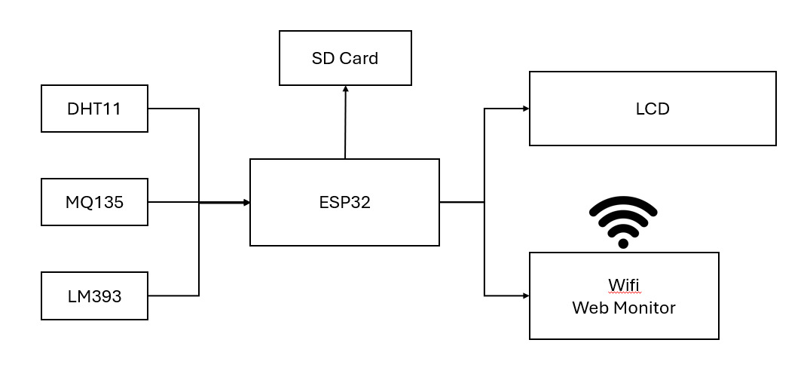3.2 Functional Blocks
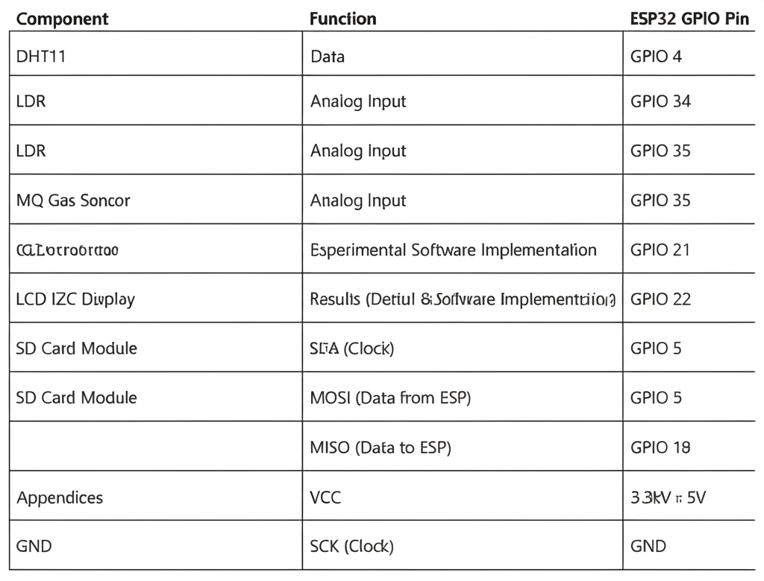
Figure 1: Hardware prototype showing breadboard setup with sensors and ESP32

The system architecture is centered around an ESP32 microcontroller, which collects data from four sensors: DHT11 (temperature and humidity), LDR (light intensity), and MQ Gas Sensor (air quality). The data is displayed locally on an LCD and logged to an SD card. Additionally, the ESP32 hosts a Wi-Fi web server to display live readings on a browser.

3.3 Working Principle
Once powered, the ESP32 initializes the connected sensors and modules. The DHT11 collects temperature and humidity, while the LDR and MQ sensors provide analog values for light intensity and air quality respectively. The LCD displays live values, and the ESP32 logs them into an SD card file with a timestamp from the NTP server. Simultaneously, the microcontroller hosts a local web server over Wi-Fi that serves an HTML page updating every 5 seconds with the latest readings.
This multi-channel system enables:
- Local display for immediate viewing
- Data logging for offline analysis
- Remote access within the same Wi-Fi network
The setup ensures redundancy (local + web) and flexibility for further upgrades like cloud integration or mobile app interfacing.
Chapter 4 – Hardware and Software Implementation

4.1 Component Used
The hardware circuit was assembled on a breadboard using jumper wires and regulated power through USB. Each sensor and module was directly interfaced with the ESP32 using GPIO pins as detailed in Chapter 3.
Key circuit highlights:
- The DHT11 sensor provides digital temperature and humidity data to GPIO 4.
- The LDR and MQ Gas Sensor feed analog data to GPIO 34 and GPIO 35 respectively.
- The LCD is connected via I2C using GPIO 21 (SDA) and GPIO 22 (SCL).
- The SD card module uses SPI protocol with connections on GPIO 5 (CS), GPIO 23 (MOSI), GPIO 19 (MISO), and GPIO 18 (SCK).
- Power is supplied using 3.3V or 5V depending on module specification.
4.2 Circuit Diagrams
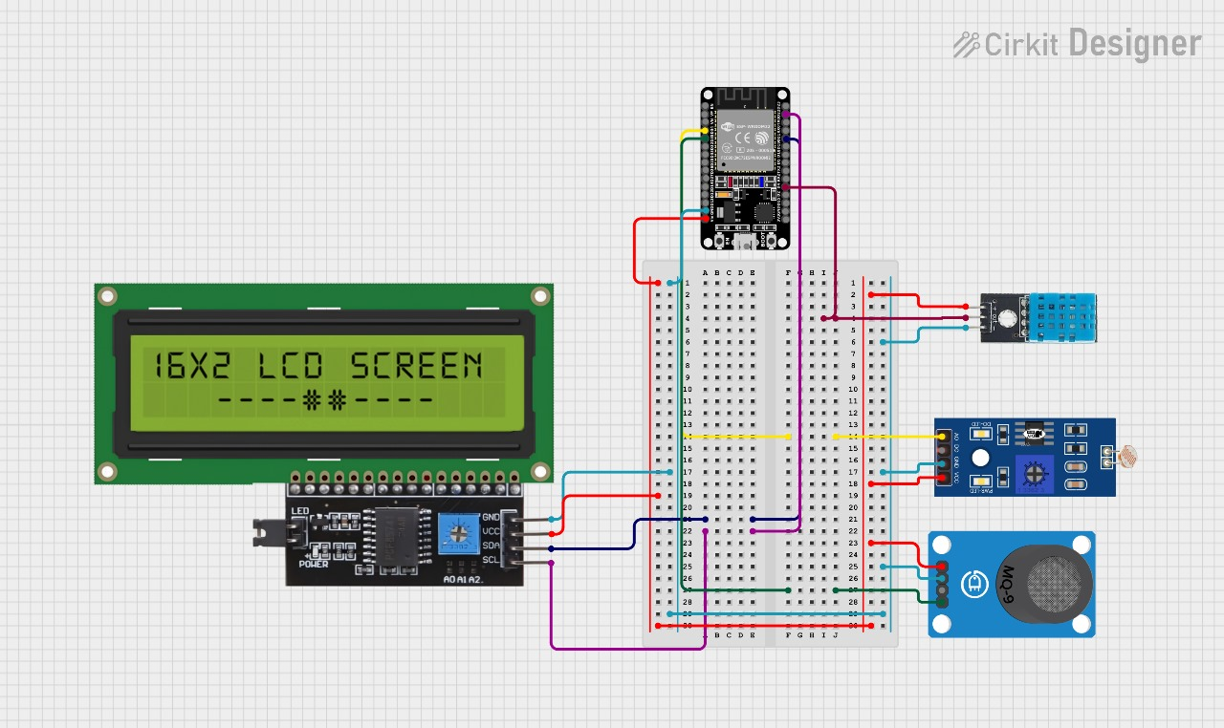
4.3 Functioning
Wifi Setup
- The ESP32 connects to a local Wi-Fi network using the specified SSID and password.
- Once connected, the module prints its assigned IP address to the Serial Monitor.
- This connection is required to host the onboard web server and sync time using NTP.
Web Server Setup
- A web server runs on port 80 of the ESP32.
- The handleRoot() function serves the root URL ("/"), generating a basic HTML page.
- This page displays live sensor readings and auto-refreshes every 5 seconds.
- UTF-8 encoding is used to correctly render special characters like the degree symbol (°).
LCD Display Initialization
- The I2C LCD (address 0x27) is initialized with 16 columns and 2 rows.
- A startup message is briefly shown during system boot.
- In the main loop, the LCD displays live readings of:
  - Temperature (°C)
  - Humidity (%)
  - Light Intensity (%)
  - Gas Concentration (%)
SD Card Initialization
- The SD card is initialized over SPI, with Chip Select on GPIO 5.
- If detected, the device opens or creates a file named data.csv.
Main Loop – Sensor Readings
- Analog values from the LDR and MQ gas sensor are read and converted to percentages.
- Temperature and humidity are read from the DHT11 using digital input.
- The values are printed to the LCD in two lines for clarity.
Logging to SD Card
- The current time is fetched using time_t and formatted in HH:MM:SS format.
- If sensor values are valid (non-NaN), a new row is appended to data.csv:
Handling Web Requests
- The server.handleClient() function is called in the loop.
- This ensures the ESP32 remains responsive to any browser requests to the IP address.
- The live data web page remains updated every second.

Chapter 5 – Experimental Setup
5.1 Setup Description
The IoT-based environmental data logger prototype was tested in a controlled lab environment within RV College of Engineering. All components were assembled on a breadboard and powered via USB. The system was connected to a secure Wi-Fi network for time synchronization and web-based monitoring.
The logger consisted of:
- ESP32 Microcontroller (central controller)
- DHT11 Sensor – temperature and humidity monitoring
- LDR Sensor – light intensity measurement
- MQ Gas Sensor – volatile gas (e.g., NH₃) detection
- I2C LCD – local display
- MicroSD Card – timestamped data logging
The device was placed on a lab bench, surrounded by equipment, with the sensors exposed to ambient air to mimic realistic lab usage.
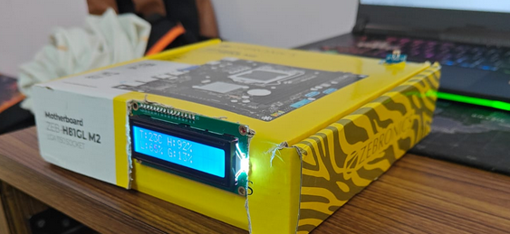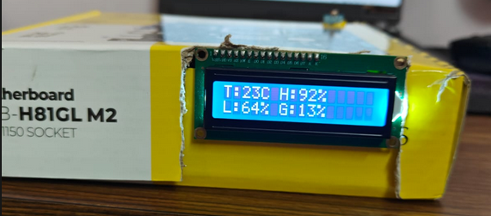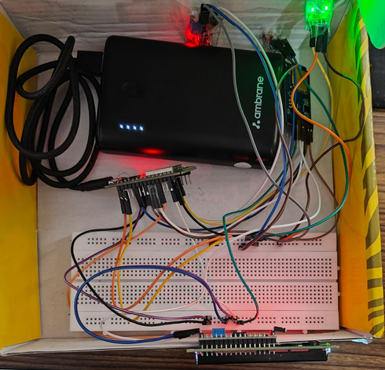
5.2 Testing/Procedure
To validate the MQ gas sensor’s effectiveness in detecting ammonia, a simple laboratory chemical reaction was performed:
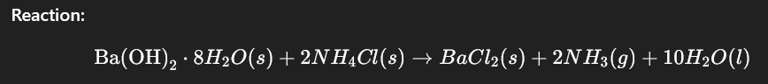
This reaction releases ammonia gas (NH₃), which is volatile and detectable by the MQ gas sensor.
Steps:
- The data logger was powered on and initialized successfully.
- The MQ gas sensor was placed in a small chamber (open beaker) near the site of reaction.
- Ba(OH)₂·8H₂O and NH₄Cl were mixed in a dry container at room temperature.
- The reaction commenced, releasing NH₃ gas, which diffused into the sensor’s surroundings.
- Data was recorded every second for ~30 minutes, including the reaction window and post-reaction stabilization.
- All readings (Temperature, Humidity, Light, Gas concentration) were logged to SD and served on the local web dashboard.

5.3 Data Collection
The logger was allowed to run for extended periods (~30 minutes per session), capturing sensor values every second. The system performed the following steps automatically:
  - Read temperature and humidity frwom DHT11
  - Read analog values from LDR and MQ gas sensor
  - Display on LCD
  - Log to SD card (data.csv) with NTP timestamp
  - Update live web page

5.4 Observations
Parameter | Observation
Temperature | Minor increase (~1–2°C) due to slight exothermic nature of the reaction.
Humidity | Rose slightly (~5%) due to water formation during the reaction.
Light Intensity | Remained constant, confirming consistent ambient lighting.
Gas Concentration | Spiked rapidly from ~5% to over 50% during ammonia release. Clear, sharp response observed on both LCD and web dashboard.
The MQ sensor effectively captured the NH₃ spike, validating the logger’s suitability for detecting real gas events in lab settings. The SD card logged each spike accurately with correct timestamps. No missed logs or data corruption occurred.
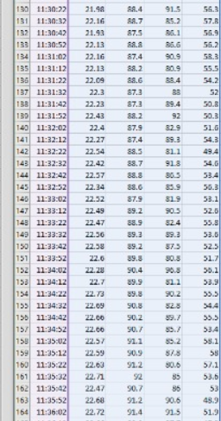
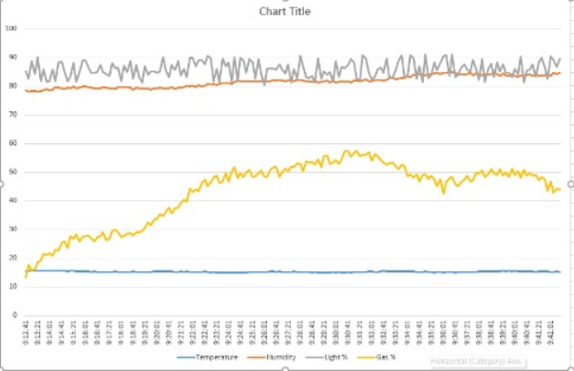
Chapter 6 – Results and Discussions
6.1 System Performance
The IoT-based environmental data logger performed reliably during all lab tests. It successfully monitored and recorded four environmental parameters: temperature, humidity, light intensity, and gas concentration.
Key performance outcomes:
- Accurate data capture with <1 second lag on both LCD and the live web dashboard.
- Reliable data logging to the SD card with synchronized timestamps via NTP.
- Quick sensor response, especially the MQ gas sensor detecting NH₃ during the Ba(OH)₂ + NH₄Cl reaction.
- Stable local Wi-Fi connectivity, allowing smooth web monitoring from any device on the same network.
- Uninterrupted operation using a power bank, which provided consistent power for extended sessions and added portability and protection against power cuts.
Overall, the system met its objectives as a modular, real-time monitoring tool suited for research and lab environments.
6.2 Limitations
Despite strong performance, the system had some limitations:
- Sensor Resolution: The DHT11 offers basic accuracy, and the MQ sensor reports relative gas levels, not exact ppm.
- Local-Only Access: The web server can only be accessed on the same Wi-Fi network — no remote/cloud access in current version.
- No Automatic Data Export: Users need to manually remove the SD card to retrieve logged data. There’s no real-time push to external storage or email.
- Gas Selectivity: The MQ sensor detects a range of gases but lacks selectivity for individual gases without calibration or filtering.

6.3 Improvements and Challenges
- Challenges Faced:
- Sensor Stability: Early tests on a breadboard suffered from noise and inconsistent readings due to ground loops and loose connections.
- NTP Time Sync: Occasional delays in acquiring time when Wi-Fi was weak.
- Real-World Gas Testing: Controlled release of ammonia was required to safely validate the gas sensor in a lab setting.

- Future Improvements:
- Replace DHT11 with BME280 or DHT22 for better accuracy and additional environmental metrics.
- Use MQ-135 or calibrated sensors for more specific gas measurements (e.g., CO₂, NH₃, VOCs).
- Add Bluetooth or USB data export options for easier log retrieval.
- Integrate cloud services (Firebase, ThingSpeak) for remote data access.
- Add a basic mobile dashboard or companion app for visualization and alerting.
- Improve packaging with enclosures and permanently soldered connections for durability.

6.4 Key Findings
- The logger is capable of real-time environmental monitoring with reliable logging and visualization.
- The MQ gas sensor effectively detected NH₃ gas during a chemical reaction, confirming its practical sensitivity.
- The power bank-based power supply makes the system portable and immune to short-term power failures.
- The web interface and LCD provide redundant viewing options — local and remote.
- The system is affordable, modular, and scalable, ideal for educational, lab-scale, and even small industrial monitoring tasks
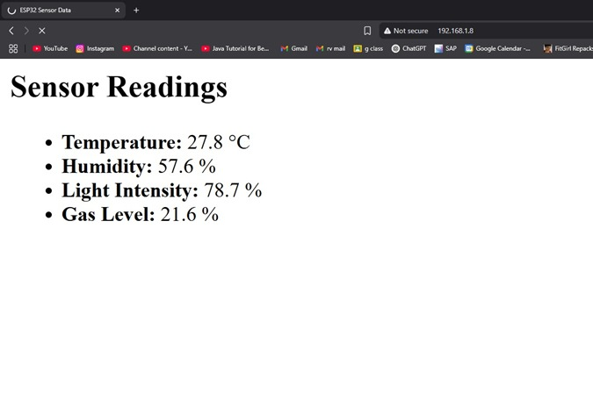
Figure 2 : Screenshot of live sensor readings displayed on local server

Chapter 7 – Conclusions and Future Work
7.1 Conclusion
The IoT-based environmental data logger developed in this project successfully achieved its core objectives. It was able to monitor temperature, humidity, light intensity, and gas concentration in real time using cost-effective sensors and log this data with accurate timestamps. The ESP32 microcontroller handled all tasks reliably — from interfacing sensors to serving a live web page and storing data on an SD card.
The LCD interface provided immediate on-site visibility, while the web server enabled remote access on devices within the local network. Experimental results confirmed stable performance, sensor responsiveness, and data consistency. The modular design, local logging capability, and low power consumption make it suitable for research labs, classrooms, and other controlled environments.

7.2 Future Enhancements
Several enhancements can be implemented in future versions of this system to improve performance, scalability, and usability:
- Advanced Sensors: Replace DHT11 and MQ with more accurate sensors like DHT22, BME280 (temperature/pressure/humidity), or MQ-7 (carbon monoxide).
- Cloud Integration: Enable real-time upload to platforms like Firebase, ThingSpeak, or AWS IoT for remote access and storage.
- Mobile App Dashboard: Develop a mobile/web app to visualize trends, send alerts, or download logs.
- AI/ML for Anomaly Detection: Use machine learning models to predict unusual conditions, send alerts, or optimize lab environments automatically.
- Battery/UPS Backup: Add a rechargeable battery or UPS to avoid data loss during power cuts.
- Data Export via USB/Bluetooth: Add alternative ways to extract logs directly from the system without removing the SD card.
- Auto Calibration: Include self-calibration routines for sensors using baseline/environmental thresholds.
These improvements would transform the project from a basic logger to a fully connected smart lab assistant, suitable for large-scale, industry-grade applications.

References

[1] K. Chenchireddy, D. Sandhya, M. Praveen, G. Karthik and G. Maruthi, "Air Quality Monitoring and Alert System Using MQ 135 Gas Sensor with Arduino Controller," *International Journal of Research Publication and Reviews*, vol. 3, no. 10, pp. 2020-2026, October 2022.
[2] A. K. Saha *et al.*, "A raspberry Pi controlled cloud based air and sound pollution monitoring system with temperature and humidity sensing," in *2018 IEEE 8th Annual Computing and Communication Workshop and Conference (CCWC)*, 2018.
[3] A. Choiri *et al.*, "Real Time Monitoring Approach for Underground Mine Air Quality Pollution Monitoring System Based on IoT Technology," in *2021 IEEE International Conference on Automatic Control & Intelligent Systems (I2CACIS)*, 2021.
[4] H. N. Shah, Z. Khan, A. A. Merchant, M. Moghal, A. Shaikh and P. Rane, "IOT based air pollution monitoring system," *International Journal of Scientific & Engineering Research*, vol. 9, no. 2, pp. 62-66, 2018.
[5] B. Perumal, J. Deny, K. Alekhya, V. Maneesha and M. Vaishnavi, "Air Pollution Monitoring System by using Arduino IDE," in *2021 Second International Conference on Electronics and Sustainable Communication Systems (ICESC)*, 2021, pp. 797-802.
[6] B. K. Moharana, P. Anand, S. Kumar and P. Kodali, "Development of an IoT - based real - time air quality monitoring device," in *2020 International conference on communication and signal processing (ICCSP)*, 2020, pp. 191-194.
[7] D. W. DARA, A. MADE and K. R. T. P. Sari, "Monitoring and notification system air quality against carbon monoxide in the study room IoT based," *Jurnal Intensif*, vol. 5, no. 1, pp. 121-133, 2021.
[8] K. Okokpujie, E. Noma-Osaghae, O. Modupe, S. John and O. Oluwatosin, "A smart air pollution monitoring system," *International Journal of Civil Engineering and Technology (IJCIET)*, vol. 9, no. 9, pp. 799-809, 2018.
[9] R. Golwalkar, K. Shivgan and P. Sindhwad, "Pollution Monitoring System Using IoT and LabVIEW," *International Journal for Research in Engineering Application & Management*, vol. 6, pp. 184-188, 2020.
[10] S. I. Conea and G. C. Crişan, "Green air quality monitoring system based on Arduino," in *2022 14th International Conference on Electronics, Computers and Artificial Intelligence (ECAI)*, 2022, pp. 1-4.
[11] V. Laijawala, M. Masurkar and R. Khandekar, "Air Quality Monitoring System," 2019.
[12] N. Omkar, S. Rahul, R. Vijaykrishna, N. Swapna and M. Reddy Sura, "Smart Environmental Monitoring Using Esp32 Microcontroller," IOSR Journal of Electronics and Communication Engineering (IOSR - JECE), vol. 19, no. 3, pp. 07-12, 2024.
[13] M. I. Ash Shiddiqy and Sunardi, "Performance Analysis of LDR, Photodiode, and BH1750 Sensors for Sunlight Intensity Measurement in Open Areas," Signal and Image Processing Letters, vol. 6, no. 1, pp. 11-26, 2024.

Appendices – Code Snippets
#include <DHT.h>
#include <Wire.h>
#include <LCD_I2C.h>
#include <SD.h>
#include <WiFi.h>
#include <WebServer.h>
#include <time.h>
#include <WiFiUdp.h>

const char* ssid = "idea";
const char* password = "9901110972";

#define SD_CS 5

#define DHTPIN 4
#define DHTTYPE DHT11
#define LDR_PIN 34
#define MQ_PIN 35

DHT dht(DHTPIN, DHTTYPE);
LCD_I2C lcd(0x27, 16, 2);

WebServer server(80);

float temp = 0.0, humidity = 0.0, ldrPercent = 0.0, gasPercent = 0.0;

// ✅ Global file name for SD logging
String filename = "/default.csv";

void handleRoot() {
String html = "<html><head><meta http-equiv='refresh' content='5'>";
html += "<title>Sensor Data</title></head><body>";
html += "<h2>Live Sensor Data</h2>";
html += "<p>Temperature: " + String(temp, 1) + " °C</p>";
html += "<p>Humidity: " + String(humidity, 1) + " %</p>";
html += "<p>Light Intensity: " + String(ldrPercent, 1) + " %</p>";
html += "<p>Gas Level: " + String(gasPercent, 1) + " %</p>";
html += "</body></html>";
server.send(200, "text/html", html);
}

void setup() {
Serial.begin(115200);
delay(1000);

// WiFi setup
WiFi.mode(WIFI_STA);
WiFi.setAutoReconnect(true);
WiFi.persistent(true);
WiFi.begin(ssid, password);

Serial.print("Connecting to WiFi");
while (WiFi.status() != WL_CONNECTED) {
delay(500);
Serial.print(".");
}
Serial.println("\nConnected. IP: " + WiFi.localIP().toString());

// Web server setup
server.on("/", handleRoot);
server.begin();
Serial.println("Web server started.");

// Time sync with NTP (IST = GMT+5:30 = 19800 seconds)
configTime(19800, 0, "pool.ntp.org");
Serial.print("Waiting for time sync");
while (time(nullptr) < 100000) {
Serial.print(".");
delay(500);
}
Serial.println(" Time synced.");

// Create filename based on date and time
time_t now = time(nullptr);
struct tm* timeinfo = localtime(&now);
char fname[32];
strftime(fname, sizeof(fname), "/%Y_%m_%d_%H_%M.csv", timeinfo);
filename = String(fname);
Serial.println("Log filename: " + filename);

// Sensors and LCD init
dht.begin();
Wire.begin();
lcd.begin();
lcd.backlight();
lcd.clear();
lcd.setCursor(0, 0);
lcd.print("System Starting...");
delay(2000);
lcd.clear();

// SD Card setup
if (!SD.begin(SD_CS)) {
Serial.println("❌ SD Card init failed!");
} else {
Serial.println("✅ SD Card initialized.");
File file = SD.open(filename, FILE_WRITE);
if (file) {
file.println("Timestamp,Temperature,Humidity,Light %,Gas %");
file.close();
Serial.println("✔️ Log file created: " + filename);
} else {
Serial.println("❌ Could not create log file.");
}
}
}

void loop() {
// Read sensors
int ldrRaw = analogRead(LDR_PIN);
ldrPercent = 100.0 - ((ldrRaw / 4095.0) * 100.0);

int mqRaw = analogRead(MQ_PIN);
gasPercent = (mqRaw / 4095.0) * 100.0;

temp = dht.readTemperature();
humidity = dht.readHumidity();

// LCD output
lcd.clear();
lcd.setCursor(0, 0);
if (!isnan(temp) && !isnan(humidity)) {
lcd.print("T:");
lcd.print(temp, 0);
lcd.print("C H:");
lcd.print(humidity, 0);
lcd.print("%");
} else {
lcd.print("DHT Read Error");
}

lcd.setCursor(0, 1);
lcd.print("L:");
lcd.print(ldrPercent, 0);
lcd.print("% G:");
lcd.print(gasPercent, 0);
lcd.print("%");

// Timestamp
time_t now = time(nullptr);
struct tm* timeinfo = localtime(&now);
char timeStr[16];
strftime(timeStr, sizeof(timeStr), "%H:%M:%S", timeinfo);

// Write to SD card
File file = SD.open(filename, FILE_APPEND);
if (!file) {
Serial.println("❌ Failed to open file for appending.");
} else if (isnan(temp) || isnan(humidity)) {
Serial.println("❌ Sensor read returned NaN.");
file.close();
} else {
file.print(timeStr);
file.print(",");
file.print(temp, 1);
file.print(",");
file.print(humidity, 1);
file.print(",");
file.print(ldrPercent, 1);
file.print(",");
file.println(gasPercent, 1);
file.close();
}

// Handle web client
server.handleClient();
delay(1000);
}

