Prameela Nannapaneni

AP20110010120

CSE – B

Lab Experiment - 1

Numpy:

1. Code for initializing NumPy array

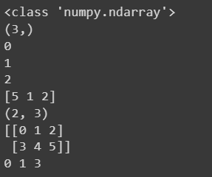

1. Creating NumPy array

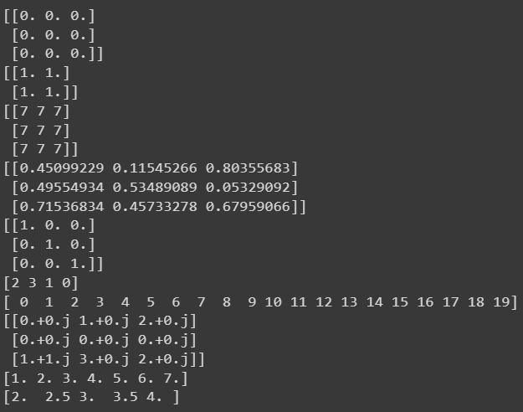

1. NumPy data types



1. Python program to demonstrate indexing in numpy

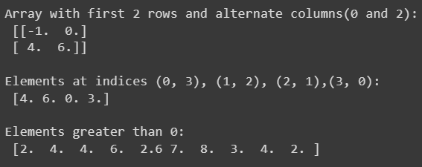

1. Python program to demonstrate basic operations on single array

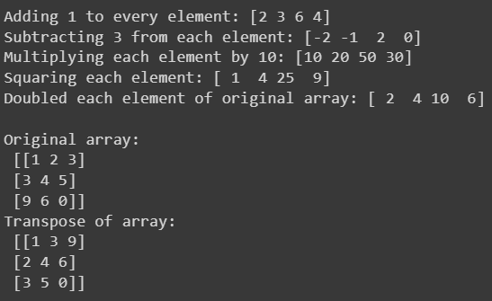

1. Python program to demonstrate unary operators in numpy

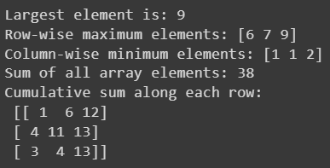

1. Python program to demonstrate binary operators in Numpy

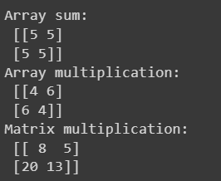

1. Python program to demonstrate universal functions in numpy

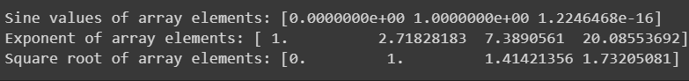

1. Python program to find the inverse of an array (without exception handling)

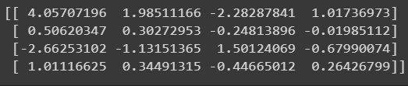

Matplotlib:

1. Creating plot on variables

