DAA GROUP – 11

Accessory Collection

Done by:

AP20110010120 – Prameela Nannapaneni

AP20110010121 – Hajarath Sriram Virigineni

AP20110010122 –Rakesh Gangula

AP20110010123 – Sai Prakash Gonugunta

CODE:

#include <bits/stdc++.h>

#define ll long long int

using namespace std;

void accessoryCollection(ll l,ll a,ll n,ll d)

{

if(d>a)

cout<<"SAD\n";

else if(d==1)

cout<<l\*a<<endl;

else

{

ll sum=-1,x,j,y,z;

for(int i=(n-1)/(d-1);i>=1;i--)

{

x=n-1-(d-1)\*i;

if(x+a\*i<l)

continue;

y=(l-x)/i;

z=(l-x)%i;

j= a\*x + (a+a-y+1)\*y/2\*i + (a-y)\*z;

if(j>sum)

sum=j;

}

if(sum<0)

cout<<"SAD\n";

else

cout<<sum<<endl;

}

}

int main()

{

int T;

cin >> T;

while (T--)

{

ll L,A,N,D;

cin>>L>>A>>N>>D;

accessoryCollection(L,A,N,D);

}

return 0;

}

OUTPUT WITH DIFFERENT DATA SETS:

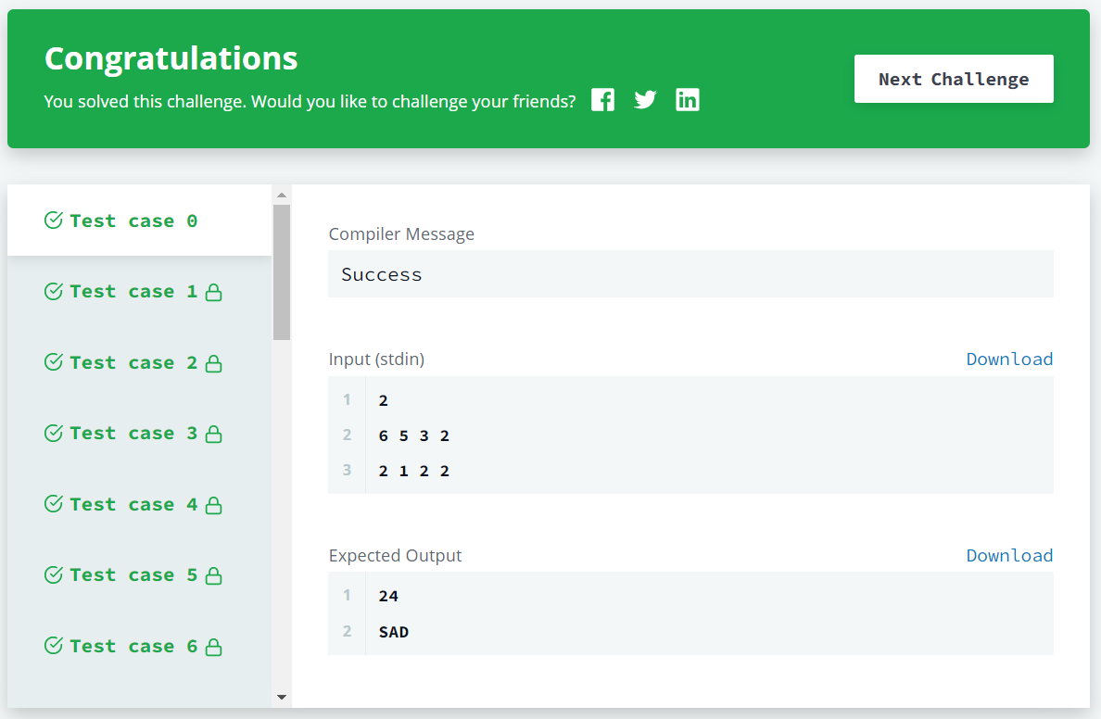

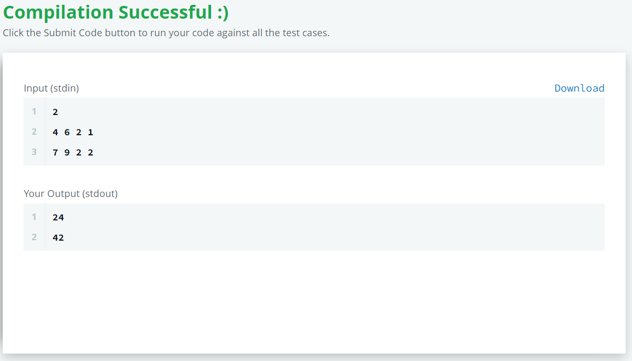

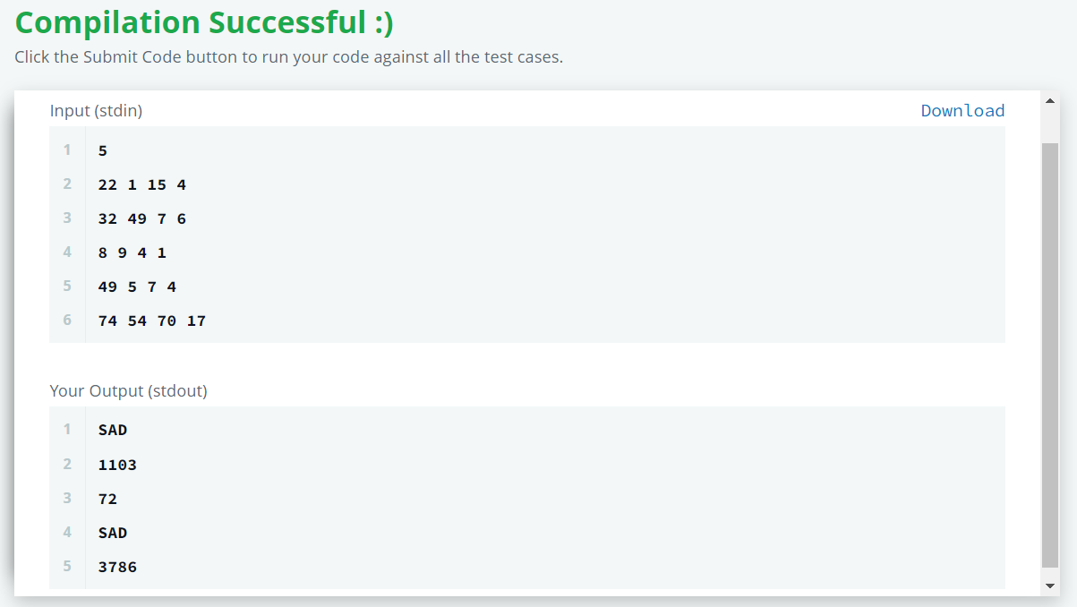

EXPLANATION OF OUTPUT:

l is the number of accessories to be bought, a is the number of types available at the store, n is the number of accessories any selected subset should contain, d is the minimum number of distinct types a subset should contain.

If d<a, it means we do not have sufficient types of accessories at the store. So, this condition prints “SAD”. If d=1, there is no need to show distinct types for any subset n. hence, only 1 type of accessory(a) is bought. This prints l\*a(all l accessories of same type).

For every other condition, we change the number of times any accessory is bought through a for loop which can maximum run for (n-1)/(d-1) times. If there are no sufficient types of accessories, skip calculating the cost. If the cost<0, prints “SAD”(accessories cannot be bought by given conditions else prints the maximum cost of l accessories.

TIME COMPLEXITY:

In the best case, either if block(d>a) or if else block(d=1) is executed. Hence, the best-case time complexity is constant (O (1)).

In the worst case, for loop in the else block is executed when d=2(it runs for n-1 times). Hence, the worst-case time complexity is O(n) where n is the number of elements in the subset.

In the average case, for loop in the else block is executed for (n-1)/(d-1) times when d>2. Hence, the time complexity is O(k) where k=(n-1)/(d-1) (n is the number of elements in subset, d is the least possible distinct types in the subset).