VULNERABILITY LABS

1. AUTHENTICATION
2. DOCUMENT OBJECT MODEL (DOM)
3. HTTP REQUEST SMUGGLING
4. CROSS – ORIGIN RESOURCE SHARING (CORS)
5. SQL INJECTION
6. CROSS – SITE SCRIPTING (XSS)
7. CROSS – SITE REQUEST FORGERY
8. SERVER – SIDE TEMPLATE INJECTION
9. COMMAND INJECTION
10. SERVER – SIDE REQUEST FORGERY (SSRF)

1. AUTHENTICATION
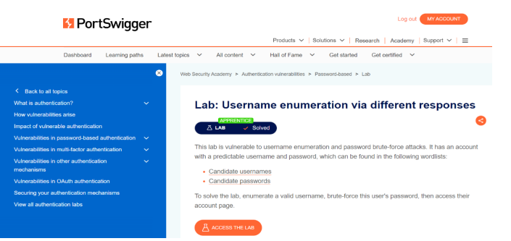

2. DOCUMENT OBJECT MODEL (DOM)
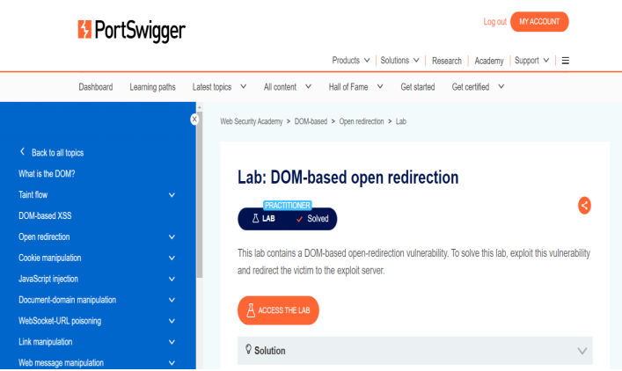

3. HTTP REQUEST SMUGGLING

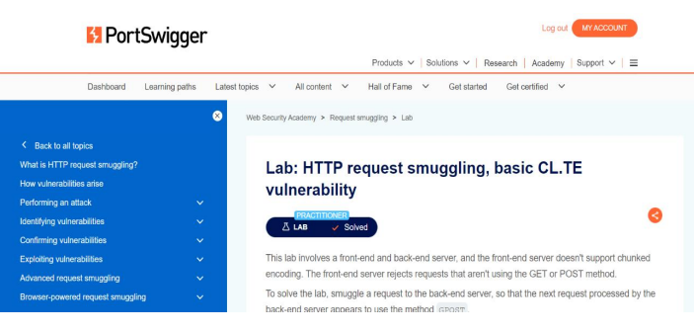

4. CROSS – ORIGIN RESOURCE SHARING (CORS)
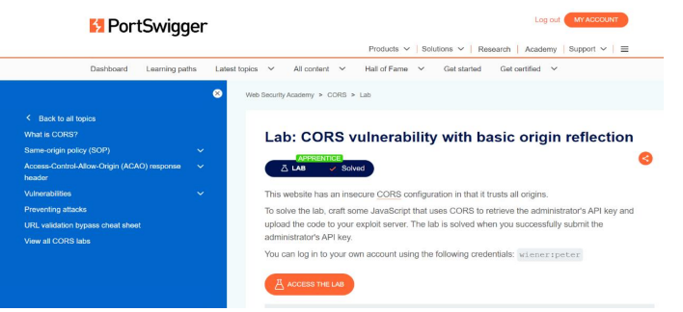

5. SQL INJECTION

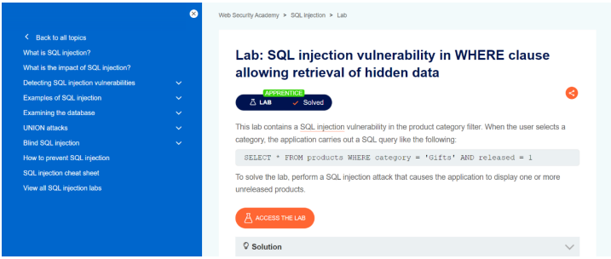

6. CROSS – SITE SCRIPTING (XSS)

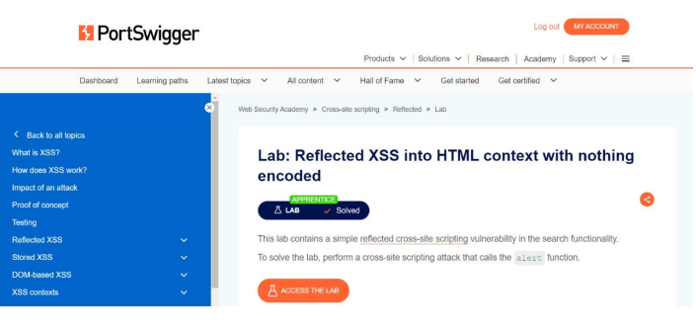

7. CROSS – SITE REQUEST FORGERY
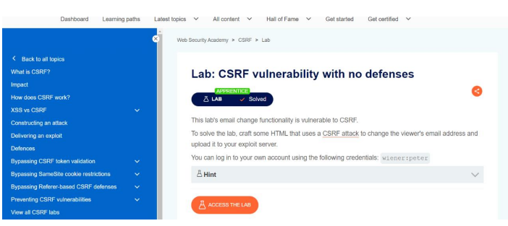

8. SERVER – SIDE TEMPLATE INJECTION

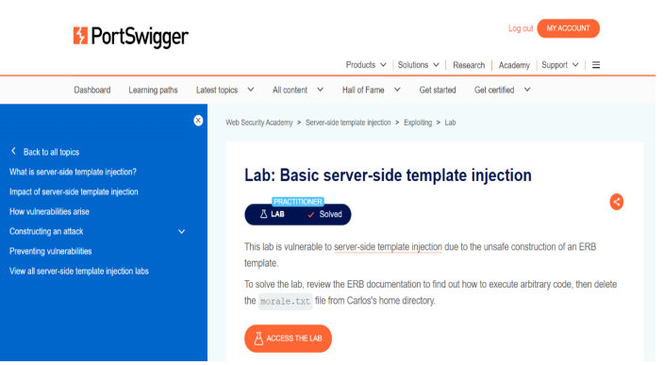

9. COMMAND INJECTION
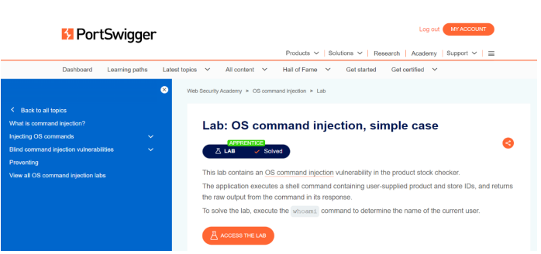

10. SERVER – SIDE REQUEST FORGERY (SSRF)
