TONHE MODULE:

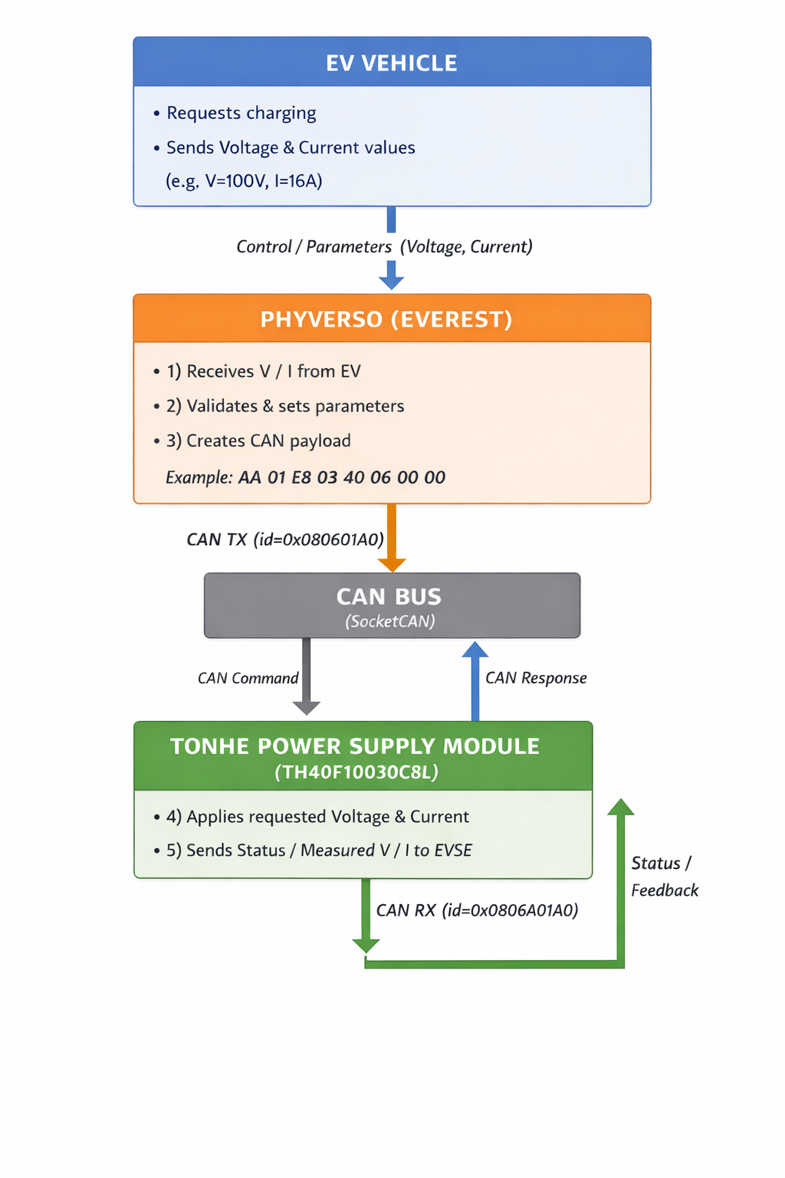

Functional Flow

Step 1: EV → Phyverso
- EV sends requested:
  - Voltage (V)
  - Current (A)
- Transport: internal control interface (EVerest control logic)

Step 2: Phyverso Processing
- Validates EV request
- Converts values into Tonhe CAN format
- Scales parameters:
  - Voltage ×10
  - Current ×100

Step 3: Phyverso → Tonhe (CAN Command)
- Phyverso sends extended CAN frame
- Command: Set Voltage & Current

Step 4: Tonhe → Phyverso (CAN Response)
- Tonhe responds with:
  - Applied voltage
  - Applied current
  - Module status

Packet format:

Everest to tonhe pakcet:
CAN TX -> id=0x080601A0 dlc=8 data=AA 01 E8 03 40 06 00 00
Tonhe to Everest response packet:
CAN RX -> id=0x1806A001 dlc=8 data=AA 01 E8 03 40 06 00 00
ID:
08 -> Tonhe protocol identifier
06 -> DC Power Module
01 -> Source Address
A0 ->Destination Address

Data:
AA -> start byte
01 ->module address
E8 -> Voltage LSB
03 -> Voltage MSB
40 -> Current LSB
06 -> Current MSB
00 00 -> Reserved bytes.

Tonhe CAN IDs

Downlink (Controller → Module)
Commands sent from the master controller (SA = 0xA0) to the rectifier modules.
CAN ID | PGN | Purpose
0x080601A0 | 000600H | Specific module start/stop & voltage/current setting (target one module).
0x0803FFA0 | 000300H | Broadcast start/stop (to multiple modules).
0x1004FFA0 | 000400H | Broadcast parameter setting (voltage/current for a group).
0x1805FFA0 | 000500H | Timing command (keep-alive).
0x1809FFA0 | 000900H | Module address setting (assign new addresses).
0x1C90FFA0 | 009000H | Address mode selection (automatic/manual).
0x18AAFFA0 | 00AA00H | Input mode configuration (AC/DC).

Uplink (Module → Controller)
Responses/status messages sent from modules (SA = module address) back to the controller.
CAN ID | PGN | Purpose
0x0802A0XX | 000200H | Confirmation of command reception (acknowledge start/stop or parameter set).
0x1801A0XX | 000100H | Module state upload (ON/OFF, voltage, current, fault bits).
0x180BA0XX | 000B00H | AC information upload (phase voltages, ambient temperature).
0x009100H | 009100H | Extended fault info upload (detailed fault/warning bits).

LOG :
root@phyboard-lyra-am62xx-3:~# manager --conf sample.yaml
2026-01-09 10:51:42.231480 [INFO] manager :: ________ __ _
2026-01-09 10:51:42.231734 [INFO] manager :: | ____\ \ / / | |
2026-01-09 10:51:42.231776 [INFO] manager :: | |__ \ \ / /__ _ __ ___ ___| |_
2026-01-09 10:51:42.231810 [INFO] manager :: | __| \ \/ / _ \ '__/ _ \/ __| __|
2026-01-09 10:51:42.231845 [INFO] manager :: | |____ \ / __/ | | __/\__ \ |_
2026-01-09 10:51:42.231954 [INFO] manager :: |______| \/ \___|_| \___||___/\__|
2026-01-09 10:51:42.231991 [INFO] manager ::
2026-01-09 10:51:42.232020 [INFO] manager :: everest-framework 0.23.0 main@v0.23.0
2026-01-09 10:51:42.232051 [INFO] manager :: everest-core 2025.8.0 main@2025.8.0-dirty
2026-01-09 10:51:42.232078 [INFO] manager ::
2026-01-09 10:51:42.232107 [INFO] manager :: Using MQTT broker localhost:1883
2026-01-09 10:51:42.232145 [INFO] manager :: Telemetry enabled
2026-01-09 10:51:42.259178 [INFO] everest_ctrl :: Launching controller service on port 8849
2026-01-09 10:51:42.270648 [INFO] manager :: Boot mode is set to YamlFile, loading module configs from YAML file
2026-01-09 10:51:42.270856 [INFO] manager :: Loading config file at: /root/sample.yaml
2026-01-09 10:51:42.279835 [INFO] manager :: Config loading completed in 44ms
2026-01-09 10:51:42.285739 [INFO] manager :: Starting 1 modules
2026-01-09 10:51:42.679554 [INFO] powersupply_dc: :: Initializing Tonhe power supply
2026-01-09 10:51:42.680912 [INFO] powersupply_dc: :: Tonhe CAN addr: master=160 module=1
2026-01-09 10:51:42.681247 [INFO] powersupply_dc: :: Module powersupply_dc initialized [365ms]
2026-01-09 10:51:42.725472 [INFO] manager :: Clearing retained topics published by manager during startup
2026-01-09 10:51:42.726408 [INFO] manager :: 🚙🚙🚙 All modules are initialized. EVerest up and running [496ms] 🚙🚙🚙
2026-01-09 10:51:42.768628 [INFO] powersupply_dc: :: TH40F10030C8L ready
2026-01-09 10:51:42.769301 [INFO] powersupply_dc: :: Controller requested V=100 I=16
2026-01-09 10:51:42.769751 [INFO] powersupply_dc: :: CAN TX -> id=0x080601A0 dlc=8 data=AA 01 E8 03 40 06 00 00
2026-01-09 10:51:55.166310 [INFO] powersupply_dc: :: RX ACCEPTED | SRC=0xa0 DST=0x1
2026-01-09 10:51:55.166672 [INFO] powersupply_dc: :: CAN RX -> id=0x1806A001 dlc=8 data=AA 01 A0 0F 10 27 00 00
2026-01-09 10:53:17.105485 [INFO] powersupply_dc: :: RX ACCEPTED | SRC=0xa0 DST=0x1
2026-01-09 10:53:17.106144 [INFO] powersupply_dc: :: CAN RX -> id=0x1806A001 dlc=8 data=AA 01 E8 03 40 06 00 00
2026-01-09 10:53:33.339407 [INFO] powersupply_dc: :: RX ACCEPTED | SRC=0xa0 DST=0x1
2026-01-09 10:53:33.340244 [INFO] powersupply_dc: :: CAN RX -> id=0x1806A001 dlc=8 data=AA 01 E8 03 40 06 00 00
2026-01-09 10:53:33.959180 [INFO] powersupply_dc: :: RX ACCEPTED | SRC=0xa0 DST=0x1
2026-01-09 10:53:33.959669 [INFO] powersupply_dc: :: CAN RX -> id=0x1806A001 dlc=8 data=AA 01 E8 03 40 06 00 00
2026-01-09 10:53:34.969296 [INFO] powersupply_dc: :: RX ACCEPTED | SRC=0xa0 DST=0x1
2026-01-09 10:53:34.969854 [INFO] powersupply_dc: :: CAN RX -> id=0x1806A001 dlc=8 data=AA 01 E8 03 40 06 00 00
root@ruggedboard-imx6ul:~# candump can0
can0 1A0 [8] AA 01 E8 03 40 06 00 00
^Croot@ruggedboard-imx6ul:~# cansend can0 1806A001#AA01A00F10270000
root@ruggedboard-imx6ul:~# cansend can0 180601A0#AA01A00F10270000
root@ruggedboard-imx6ul:~# cansend can0 180601A0#AA01A00F10270000
root@ruggedboard-imx6ul:~# cansend can0 180601A0#AA01A00F10270000
root@ruggedboard-imx6ul:~# cansend can0 180601A0#AA01E80340060000
root@ruggedboard-imx6ul:~# cansend can0 180601A0#AA01E80340060000

