Relay Module
-------------
Overview
This Module is part of the Everest module named relay_modbusImpl, designed to control relays using the Modbus RTU protocol over RS485 (UART).

Flow chart
----------------

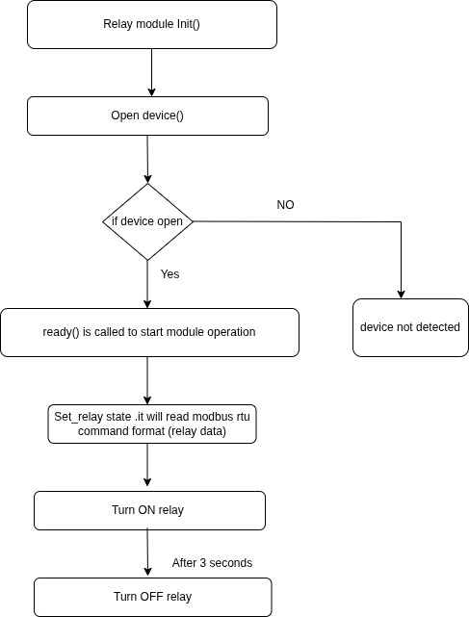

RelayModbus Module Components

1. Constructor: relay_modbusImpl()
- Automatically generated or default.
- Sets up internal variables like uart_fd for UART communication.

2. init() Method
- Opens the UART port (/dev/ttyUSB2) for Modbus communication.
- Prepares the module for sending commands to the relay.

3. ready() Method
- Called when the module is fully initialized and ready.
- Turns ON all relays one by one with 5-second delays.
- Waits 10 seconds.
- Then turns OFF all relays one by one, again with delays.

4. set_relay() Method
- Sends a Modbus RTU command to turn ON or OFF a specific relay.
- Uses UART to transmit the command.

5. build_modbus_command() Method
- Constructs a valid Modbus frame (8 bytes) to control one relay.
- Includes function code, coil address, desired state, and CRC16 checksum.

6. modbus_crc16() Method
- Calculates the CRC16 checksum required by the Modbus RTU protocol.

7. open_uart() Method
- Opens and configures the serial port for communication with the relay module.
- Sets baud rate, data format, and disables flow control.

Relay Controller Interface Implementation

Class: relay_modbusImpl
- Directly handles communication with the relay module.
- Provides control functions such as:
  - set_relay() – Turns individual relay ON/OFF
  - handle_set_state() – Called externally to set relay state
  - handle_get_state() – (Not implemented) Stub to read state
  - handle_get_num_relays() – Returns the number of relays (8)

Configuration
- UART port is currently hardcoded to /dev/ttyUSB2 (in init()).
- Number of relays is fixed to 8.
- Baud rate is 9600.
- Modbus slave ID is 1.

Code Flow Summary
- Everest Framework starts and loads the module.
- relay_modbusImpl::init() opens UART and prepares communication.
- ready() is called to begin operations.
- Relays are turned ON and OFF sequentially using Modbus commands.
- External modules can call handle_set_state() to control individual relays.

