Use Case –

There is a table in database by name POST_DETAILS, it contains the user specific blog posts. Each post has a unique id, title and body. We have to design crud operations on the given table.

Database Table Structure –

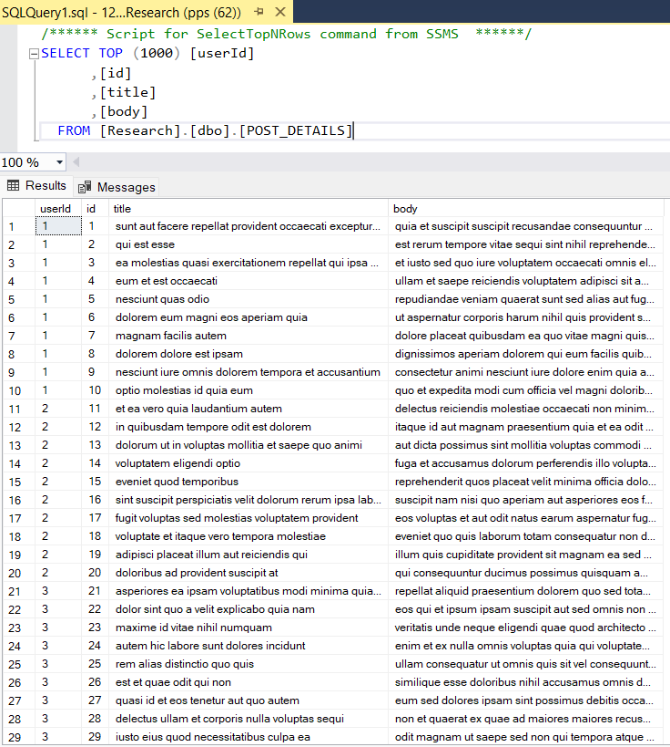

Get End Points

<http://localhost:8082/db-demo/posts/1/10>

<http://localhost:8082/db-demo/posts/1>

Template posts/{userId}/{postId}

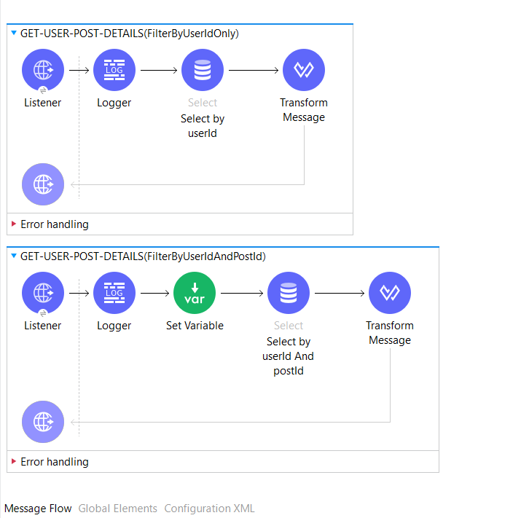

Http Listener Configurations –

**How to design uri & query string parameters?**

Example - http://localhost:8082/db-demo/posts/100/1

Set path as posts/{userId} OR posts/{userId}/{postId}

|  |  |
| --- | --- |
| Design Uri Parameter | Design Query String Parameters |
|  | <http://localhost:8082/db-demo/posts?userId=100&postId=1> |
| Retrieve Uri Parameters | Retrieve Query Parameters |
| attributes.uriParams.userId  attributes.uriParams.postId | attributes.queryParams.userId  attributes.queryParams.postId |

Database Select Configuration –

|  |  |
| --- | --- |
| Select Query Text:- | Input Parameters (fx) |
| **SELECT [userId]**  **,[id]**  **,[title]**  **,[body]**  **FROM [Research].[dbo].[POST_DETAILS]**  **WHERE [userId]=:userId**  AND [id]=:**postId** | **Single Parameter Example**  **{'userId':attributes.uriParams.userId}**  Another example  **Multiple Parameter Example**  **{'userId':attributes.uriParams.userId**  **,'postId':attributes.uriParams.postId**  **}** |
|  | |