**Aim –** To create a simple web service and write any distributed application to consume the web service.

**Name –** Yogita Sunil Girigosavi

**GCDWS**

**GCD.java**

/*

* To change this license header, choose License Headers in Project Properties.

* To change this template file, choose Tools | Templates

* and open the template in the editor.

*/

package com.unique;

import javax.jws.WebService;

import javax.jws.WebMethod;

import javax.jws.WebParam;

/**

*

* @author 390

*/

@WebService(serviceName = "GCD")

public class GCD {

/**

* Web service operation

*/

@WebMethod(operationName = "getNumbers")

public int getNumbers(@WebParam(name = "num1") int num1, @WebParam(name = "num2") int num2) {

int gcd=1;

for(int i = 1; i <= num1 && i <= num2; i++)

{

//returns true if both conditions are satisfied

if(num1%i==0 && num2%i==0)

{

//storing the variable i in the variable gcd

gcd = i;

}

}

return gcd;

}

/**

* This is a sample web service operation

*/

}

**GCDWSClient**

**index.html**

<!DOCTYPE html>

<!--

To change this license header, choose License Headers in Project Properties.

To change this template file, choose Tools | Templates

and open the template in the editor.

-->

<html>

<head>

<title>TODO supply a title</title>

<meta charset="UTF-8">

<meta name="viewport" content="width=device-width">

</head>

<body>

<form action="GCDCalc">

Enter First Number : <input type="text" name="txt1" value=""/><br>

Enter Second Number : <input type="text" name="txt2" value=""/><br>

<input type="submit" value="Submit"/>

</form>

</body>

</html>

**GCDCalc.java**

/*

* To change this license header, choose License Headers in Project Properties.

* To change this template file, choose Tools | Templates

* and open the template in the editor.

*/

import com.unique.GCD_Service;

import java.io.IOException;

import java.io.PrintWriter;

import javax.servlet.ServletException;

import javax.servlet.http.HttpServlet;

import javax.servlet.http.HttpServletRequest;

import javax.servlet.http.HttpServletResponse;

import javax.xml.ws.WebServiceRef;

/**

*

* @author 390

*/

public class GCDCalc extends HttpServlet {

@WebServiceRef(wsdlLocation = "WEB-INF/wsdl/localhost_8080/GCDWS/GCD.wsdl")

private GCD_Service service;

/**

* Processes requests for both HTTP <code>GET</code> and <code>POST</code>

* methods.

*

* @param request servlet request

* @param response servlet response

* @throws ServletException if a servlet-specific error occurs

* @throws IOException if an I/O error occurs

*/

protected void processRequest(HttpServletRequest request, HttpServletResponse response)

throws ServletException, IOException {

response.setContentType("text/html;charset=UTF-8");

try (PrintWriter out = response.getWriter()) {

int num1,num2;

num1=Integer.parseInt(request.getParameter("txt1"));

num2=Integer.parseInt(request.getParameter("txt2"));

out.println("<!DOCTYPE html>");

out.println("<html>");

out.println("<head>");

out.println("<title>Servlet GCDCalc</title>");

out.println("</head>");

out.println("<body>");

out.println("<h1>GCD of "+num1+" and "+num2+" is "+getNumbers(num1,num2)+"</h1>");

out.println("</body>");

out.println("</html>");

}

}

// <editor-fold defaultstate="collapsed" desc="HttpServlet methods. Click on the + sign on the left to edit the code.">

/**

* Handles the HTTP <code>GET</code> method.

*

* @param request servlet request

* @param response servlet response

* @throws ServletException if a servlet-specific error occurs

* @throws IOException if an I/O error occurs

*/

@Override

protected void doGet(HttpServletRequest request, HttpServletResponse response)

throws ServletException, IOException {

processRequest(request, response);

}

/**

* Handles the HTTP <code>POST</code> method.

*

* @param request servlet request

* @param response servlet response

* @throws ServletException if a servlet-specific error occurs

* @throws IOException if an I/O error occurs

*/

@Override

protected void doPost(HttpServletRequest request, HttpServletResponse response)

throws ServletException, IOException {

processRequest(request, response);

}

/**

* Returns a short description of the servlet.

*

* @return a String containing servlet description

*/

@Override

public String getServletInfo() {

return "Short description";

}// </editor-fold>

private int getNumbers(int num1, int num2) {

// Note that the injected javax.xml.ws.Service reference as well as port objects are not thread safe.

// If the calling of port operations may lead to race condition some synchronization is required.

com.unique.GCD port = service.getGCDPort();

return port.getNumbers(num1, num2);

}

}

**File Structure**

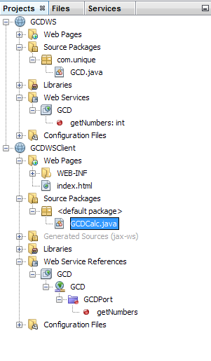

**Output**

