# Spatial Queries

*Suggested by Soo

Depending on the query performed, we may be able to pull all objects that lie within a query window [[Source](https://docs.oracle.com/database/121/SPATL/querying-spatial-data.htm#SPATL593)].

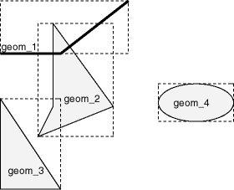

This is an example where we get all buildings in a region:

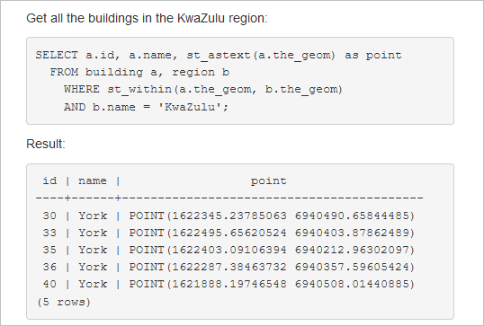

We can also get items that are closest to the given GPS coordinate: [[Source](https://docs.qgis.org/2.8/en/docs/training_manual/spatial_databases/spatial_queries.html)]

Ex: Select * from people where distance({gps_coordinates}) < 2;

Requires PostGIS functions in a database

Using the results from the queries, we can leverage software to build our maps for us.

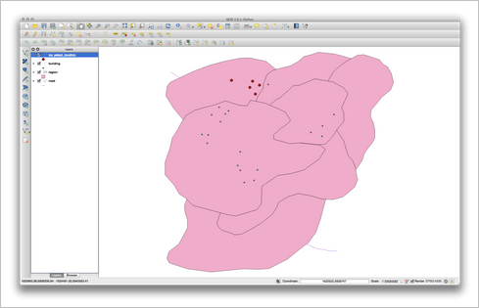

# Mapping Data

From the data that we collect in our queries, we would need to have a script that builds a view of that in a map form. The user could select the dot and each dot already has an ID for the images taken at that spot.

For example: The user might enter the GPS coordinates of a particular part of the city. Our query would find the closest points to that location and display the image at that spot using our website. In the site, we might need to add a map feature like the image below. It would display the location at where there are images of the sidewalk taken by the rover. 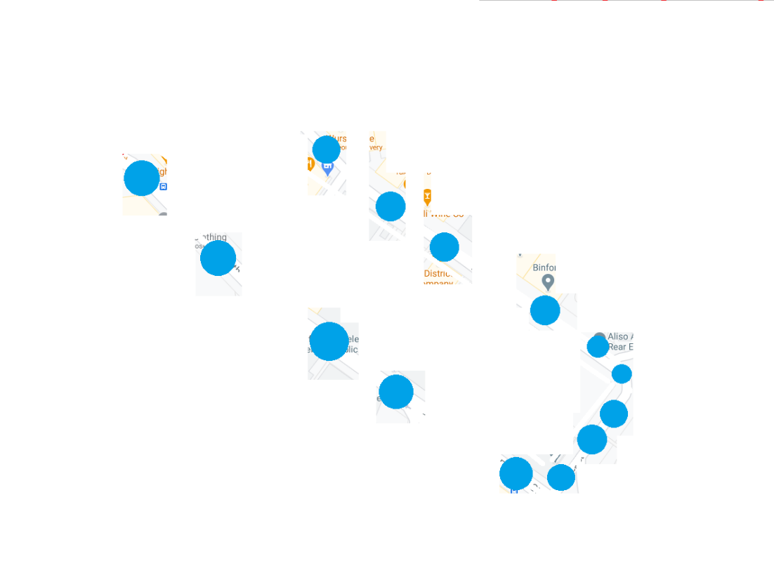

It may be necessary to display the actual streets. In this case, we can use existing mapping programs (like ArcGIS, QGIS, MapInfo) and embed them to our site. We would just need to adjust any necessary HTML to display the blue points. [[Example](https://doc.arcgis.com/en/arcgis-online/share-maps/embed-maps-groups.htm)] [[Example](https://doc.arcgis.com/en/arcgis-online/create-maps/choose-configurable-app.htm)]

We can also query Google Map’s API and use their map customization [[Example](https://cloud.google.com/maps-platform)] or as recommended by Alexis, Microsoft’s Azure Maps [[Example](https://azure.microsoft.com/en-us/services/azure-maps/)].

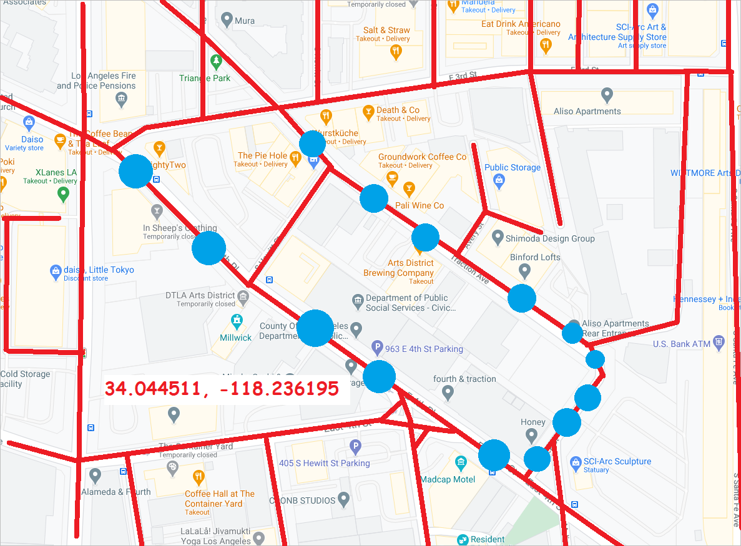

# Basic Components

These basic components were outlined in the scholarly journal, “Usage of Web Mapping Systems and Services for Information Support of Regional Management” [[Source](http://www.matec-conferences.org/10.1051/matecconf/20167901081)]. Only the components that can apply to our system are listed

1. Database system with geospatial data [WIP, database team already has some data in it]
2. Spatial metadata management subsystem aka spatial query functions in the database [implementation needs to be looked into]
3. Web application [Already have most of frontend, backend still needs to be developed which is pretty much this whole thing]
4. Auxiliary services subsystem [all our systems must talk to eachother smoothly and have a standard form of passing data aka JSON, which we’ve already started doing with our web requests to the database]

## Implementation

Now that we’ve looked into spatial queries and explored possible methods of mapping our data, we will start to see how we can integrate spatial queries with the database and how to start displaying that data in our site.