

Tribhuvan University
Faculty of Humanities and Social Sciences

Crochet Ecommerce system
A PROJECT REPORT

Submitted to
Department of Bachelor of Computer Application
Bhaktapur Multiple Campus

In partial fulfillment of the requirements for the degree of Bachelor of Computer Applications

Submitted by:
Pramisha Paudel(6-2-20-19-2022)
Roll no: 18

Under the Supervision of:
Mr.Diwas Adhikari



Tribhuvan University
Faculty of Humanities and Social Sciences
Bhaktapur Multiple Campus

SUPERVISOR’S RECOMMENDATION

I hereby recommend that this project prepared under my supervision by Pramisha Paudel entitled “CROCHET ECOMMERCE SYSTEM” in partial fulfillment of the requirements for the degree of Bachelor of Computer Application is recommended for final evaluation.

-----------------
Mr. Diwash Adhikari
SUPERVISOR
Faculty of Humanities and Social Sciences
Bhaktapur Multiple Campus


Tribhuvan University
Faculty of Humanities and Social Sciences
Bhaktapur Multiple Campus
LETTER OF APPROVAL
This is to certify that this project prepared by Pramisha Paudel entitled " CROCHET ECOMMERCE SYSTEM" in partial fulfillment of the requirements for the degree of bachelor’s in computer application has been evaluated. In our opinion it is satisfactory in scope and quality as a project for the required degree.
Mr. Diwash Adhikari
Supervisor
Bhaktapur Multiple Campus
Dudhpati Bhaktapur,Nepal
Internal Examiner | External Examiner

ABSTRACT
The Crochet Ecommerce System is a web-based platform developed to empower crochet artisans in Nepal by providing a digital marketplace for their handmade products. The system enables users to register, log in, browse a catalog of crochet items, manage a shopping cart, and place orders using either Cash on Delivery or the Khalti digital wallet. The backend, built with PHP and MySQL, ensures secure handling of user data and transaction records, while the frontend leverages HTML, CSS, and JavaScript for a responsive and user-friendly experience. An integrated admin panel allows administrators to manage products, monitor inventory, and oversee customer orders efficiently. The system features real-time inventory tracking, robust authentication using PHP’s password hashing, and error handling for payment processes, ensuring that orders are only finalized upon successful payment. Comprehensive testing confirmed the reliability of cart operations, order processing, and payment integration. The results demonstrate that the system streamlines online sales for artisans, enhances customer accessibility, and supports the growth of Nepal’s crochet community.
Keywords: Crochet System, Online Store, Handmade Products, Inventory Tracking, Simple Web Application

ACKNOWLEDGEMENT
I would like to express my sincere gratitude to my faculty teacher, Mr. Diwash Adhikari, for his invaluable inspiration, support, and guidance throughout the semester in both the theoretical and practical aspects of the course CACS 301: MIS and E-Business. His insightful advice and encouragement have been instrumental in the successful completion of my lab work. I am also deeply thankful to Bhaktapur Multiple Campus for providing the resources and academic environment necessary for the successful completion of this project.

With Regards:
Pramisha Paudel

LIST OF ABBREVIATIONS
BCA : Bachelor’s in Computer Applications
CASE : Computer Aided Software Engineering
CSS : Cascading Stylesheet
DFD : Data Flow Diagram
ERD : Entity Relation Diagram
HTML : Hypertext Markup Language
JS : Java Script
MYSQL : My Structured Query Language
PHP : Hypertext Preprocessor
UI : User Interface

List of Figures
Figure 2.1 Gantt Chart 6
Figure 4.1: Use Case Diagram 11
Figure 4.2: E-R Diagram 12
Figure 4.3: Context Level-DFD 12
Figure 4.4: DFD LEVEL 1 13

Table of Contents
ABSTRACT iii
ACKNOWLEDGEMENT iv
LIST OF ABBREVIATIONS v
List of Figures vi
Chapter 1: Introduction 1
1.1 Introduction to E-Commerce 1
1.2 Introduction to MIS 1
1.2.1 Management 2
1.2.2 Information 2
1.2.3 System 2
1.3 Introduction to Store 2
Chapter 2: Planning 4
2.1 Introduction 4
2.2 The e-Commerce planning process 4
2.3 Budget 5
2.3 Gantt chart 6
2.4 Feasibility Analysis 6
Chapter 3: Network Infrastructure 8
3.1 Network Infrastructure 8
3.1.1 Connecting to the Internet 9
3.1.2 Components of I-Way 9
CHAPTER 4: System Analysis and Design 11
4.1 System Analysis 11
4.2 Use Case Diagram 11
4.3 E-R Diagram 12
4.4 Context Level - DFD 12
4.5 DFD Level 1 13
5.1 Process of Building Website 14
5.1.1 To Make Live on Domain 14
5.1.2 Customer Account 15
5.1.3 Admin Dashboard Login 15
Chapter 6: Payment Gateway 16
6.1 Payment Gateway 16
6.2 Khalti Integration 16
Chapter 7: Handling Security Issue 19
7.1 Handle Security Issue 19
Chapter 8: Screens of the Website Design 21
8.1 Consumer Account Register and Login: 21
8.2 Public Pages for Visitors 22
8.3 Checkout Pages 22
8.4 Admin Section 24
8.4.1 Order Management 25
8.4.2 Product Management 26
Chapter 9: Conclusion 28
9.1 Conclusion 28

Chapter 1: Introduction

Introduction to E-Commerce
E-commerce means using the Internet and the web for business transactions and/or commercial transactions, which typically involve the exchange of value (e.g., money) across organizational or individual boundaries in return for products and services. Here we focus on digitally enabled commercial transactions among organizations and individuals.
E-business applications turn into e-commerce precisely, when an exchange of value occurs. Digitally enabled transactions include all transactions mediated by digital technology and platform; that is, transactions that occur over the Internet and the web.
An e-Commerce website is an information technology method in which traders, businesses/distributors/marketers can sell products/services and the customer can purchase on that website electronically by using the internet on the mobile and computer. It means an e-commerce website is an online shop. e means electronic. Commerce means business. Website means the group of HTML web pages and that is created to market/sell information/product/services.

Some basics types of E-commerce are listed below:
- Business-to-Business. (B2B)
- Business-to-Consumer. (B2C)
- Consumer-to-Business. (C2B)
- Consumer-to-Consumer. (C2C)

Introduction to MIS
Management Information System or 'MIS' is a planned system of collecting, storing, and disseminating data in the form of information needed to carry out the functions of management.
The three components of MIS provide a more complete and focused definition, where System suggests integration and holistic view, Information stands for processed data, and Management is the ultimate user, the decision makers.

Management information system can thus be analyzed as follows:

Management
Management covers the planning, control, and administration of the operations of a concern. The top management handles planning; the middle management concentrates on controlling; and the lower management is concerned with actual administration.

1.2.2 Information
Information, in MIS, means the processed data that helps the management in planning, controlling and operations. Data means all the facts arising out of the operations of the concern. Data is processed i.e. recorded, summarized, compared and finally presented to the management in the form of MIS report.

1.2.3 System
Data is processed into information with the help of a system. A system is made up of inputs, processing, output and feedback or control.
Thus MIS means a system for processing data in order to give proper information to the management for performing its functions.

The major components of a typical MIS long-form (Management Information System)
People - people who use the information system.
Data - the data that the information system records.
Business Procedures – procedures put in place on how to record, store and analyze data.
Hardware - these include servers, workstations, networking equipment, printers,
Software - these are programs used to handle the data. These include programs such as spreadsheet programs, database software, etc.

Introduction to Store
The Crochet Ecommerce System is a web-based platform designed to manage and promote a variety of crochet products. The platform offers an intuitive and user-friendly interface that enables the shop owner to upload and showcase crochet items, efficiently manage inventory, and process customer orders. Customers are provided with a seamless browsing and purchasing experience, allowing them to explore available products and place orders with ease. The system also incorporates features for tracking sales and managing customer interactions, thereby simplifying the day-to-day operations of the business. The store offers:
- Crochet bags
- Tote bags
- CrochetFlowers
- Decorative pieces
- Accessories (keychains, coasters, etc.)
While the system automates inventory management, order processing, and customer interactions—addressing many issues of traditional paper-based methods—it still has some limitations. For example:
- The system does not currently support product reviews or customer feedback.
- There is no automated email notification for orders or deliveries.

Chapter 2: Planning

2.1 Introduction
The Crochet Ecommerce System is a web-based platform designed to streamline the E-Commerce of crochet products and enhance the customer experience. Similar to other e-commerce solutions, this system offers a customer-friendly interface that allows shop owners to manage inventory, process orders, and track sales. For customers, it simplifies the process of browsing products, placing orders, and tracking purchases, ensuring a seamless shopping experience. By integrating order management and real-time inventory updates, the system aims to overcome the inefficiencies associated with manual management, improve customer satisfaction, and facilitate business growth for Crochet items. This approach not only enhances operational efficiency but also provides a practical solution for small businesses in the crochet industry.

2.2 The e-Commerce planning process
The e-Commerce planning process must have a six key steps that'll get you up and running with e-Commerce.
It covers the key skills, systems and sales know-how you need to drive e- Commerce success.
- Identify the opportunity
- Validate the opportunity
- Channel planning
- Develop experiences
- Sell
- Evaluate and optimize
- Identify the opportunity:
The first step of the e-Commerce planning process is to identity the opportunity. What benefit is e-Commerce actually going to have for your target audience and your brand? What e-Commerce insights do you have that make you confident you'll make money selling online?
You need to spend time defining the opportunity more specifically than just “sell online". That's too broad. The move to sell online is similar to the decision to launch a new product.
- Validate the opportunity:
So, once you've identified the opportunity, you need to test out if it is big enough to be worth pursuing. There's no single best way to do this. It very much depends on the size and nature of the opportunity. And your approach to opportunities and risks.
- Channel planning:
Once you've identified and validated the overall e-Commerce planning opportunity for your business, it's now time to think about where you will sell online.
- Develop experiences:
This is where there are a series of steps consumers go through before they become loyal and regular purchasers. So, they need to trust your brand, be aware of your brand, and be persuaded to consider it and so on.
- Sell:
Once you have all these elements of the e-Commerce planning process lined up, then your focus moves on to how to continue to sell your products online.
- Evaluate and optimize:
To setting up an online store and online retailers, we expand more on the day to day operations of online selling once you've gone through the e-Commerce planning process.
On-going, it's important to think like a retailer.

2.3 Budget
All free tools were used so budget wasn’t required. However, Administrator owner can choose the any domain free and top-level domain as own requirement. For Nepal user (.com.np) domain has free for business.

2.3 Gantt chart
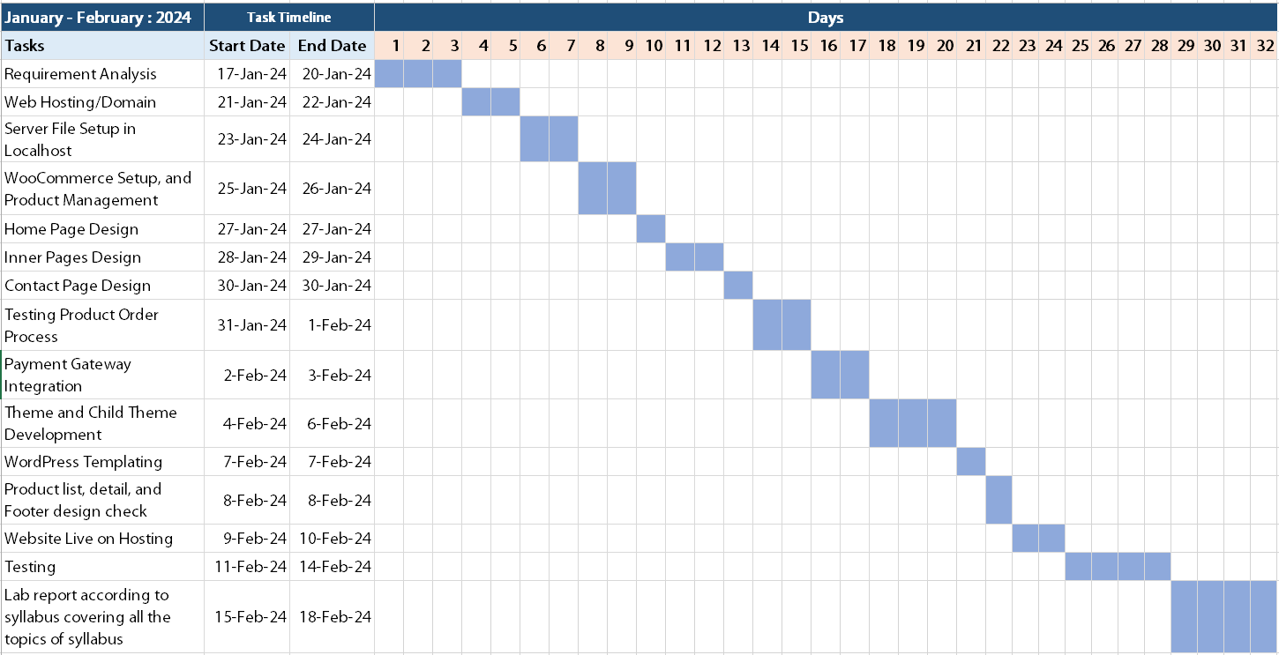
Figure 2.1: Gantt Chart

2.4 Feasibility Analysis
A feasibility study is an evaluation and analysis of a project or system that somebody has proposed.

Technical Feasibility
The system is designed to manage orders, inventory, and customer records easily. It uses PHP for backend processing, MySQL for secure data storage, and HTML, CSS, and JavaScript for an interactive and customer-friendly interface. The technology stack is robust and scalable, ensuring smooth operations and easy maintenance.

Operational Feasibility
The system offers a simple, intuitive interface for both shop owners and customers, requiring minimal technical expertise to operate. It is accessible on devices with basic hardware and software configurations, making it feasible for widespread use. The design ensures it effectively meets the objectives of order placement, tracking, and inventory management.

Economic Feasibility
The project utilizes open-source tools, keeping development costs minimal. No additional software or hardware purchases are necessary, making it highly cost-effective while delivering essential features to meet business needs efficiently.

Schedule Analysis
The project had followed a well-structured timeline, ensuring its completion within 12 weeks. It had begun with planning and analysis, followed by system design and development. Testing had run parallel to later development stages to ensure quality, while documentation had been prepared after the project's completion. The schedule had been realistic, allowing sufficient time for each phase, making the project feasible within the given timeframe.

Chapter 3: Network Infrastructure

3.1 Network Infrastructure

The network infrastructure of E-commerce: Network infrastructure is required for e- commerce to transport content. I-way is a high-capacity, interactive electronic pipeline used to transfer content in case of ecommerce.
I-way can transfer any type of context like, text, graphics, audio, and video. In other words, multimedia contents are easily transported through I-way.

A network can be defined as:
- Building block of E-commerce.
- Technologies to integrate Business Process
- Mediator for Digital transmission of Digital
- Content/Message/File/DATA
- The interaction between Entities of business
- Like Supplier/Distributor/partner etc...
- A framework with security & ease.

World Wide hypermedia distribution
Motivation: Developing a global distributed hypermedia system.
- Started 1989 by a research paper issued by Tim Berners-Lee who worked at the CERN.
- 1993: First usable browser (MOSAIC) issued.
- 1994: Foundation of World Wide Web Consortium (W3C). W3C then started developing HTML, HTTP and Style Sheets.

Internet
The Internet is the entirety of all connected computers that use the package of internet protocols at their network systems' topmost layer. The collection of internet protocols implements a packet-oriented Wide Area Network for connecting networks of diverse protocols and different connection characteristics.

WWW
The World Wide Web is a distributed hypermedia system that relies on some of the internet's services. Most important are the naming service provided by the Domain Name Service (DNS) and the - quite - reliable connection-oriented transmission service provided by the Transmission Control Protocol (TCP).

3.1.1 Connecting to the Internet
- Dial-up Connection: Computers connected to the internet via a dial-up connection usually are assigned a dynamic IP address by their ISP (Internet Service Provider).
- Leased Line Connection: Servers must always be connected to the internet. No dial-up connection via modem is used, but a leased line. Costs vary depending on bandwidth, distance and supplementary services.
In these Given Network of Internet to use.
  - WPA
  - 3G
  - 4G
  - 5G

Components of I-Way
- Consumer access equipment.
- Local on-ramps,
- Global information distribution networks.

Consumer access equipment are devices used by consumers to access the multimedia interactive contents of e-commerce. In this segment, hardware and software vendors are also included.

Local or access road, or on-ramps: This segment of I-way simplify linkages between businesses, universities, and homes to the communications backbone.

There are four different types of provider of access ramps: telecom-based, cable TV-based, wireless-based, and computer-based online information services. These providers link users and e-commerce application providers.
Global information distribution networks are the infrastructure that is connecting countries and continents.

CHAPTER 4: System Analysis and Design

4.1 System Analysis
The Crochet Ecommerce System is designed to simplify order placement, tracking, and inventory management for both customers and the shop owner. Customers can browse and select from a list of pre-listed crochet products, view their details, and place orders through a simple and secure process. The system focuses on providing an easy, fast, and reliable experience without the ability for customers to generate content or add new products, adhering to the project’s limitations. For the shop owner, the system tracks inventory and orders, offering a streamlined way to manage stock and sales. The system is dependent on a stable internet connection and focuses solely on basic order and inventory management, without additional features like tutorials or advanced product categorization.

4.2 Use Case Diagram
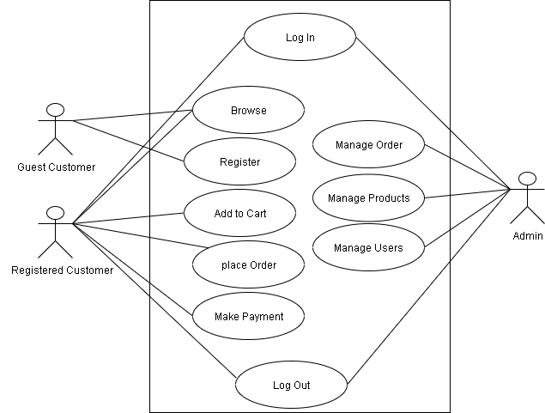
Figure 4.1: Use Case Diagram

4.3 E-R Diagram
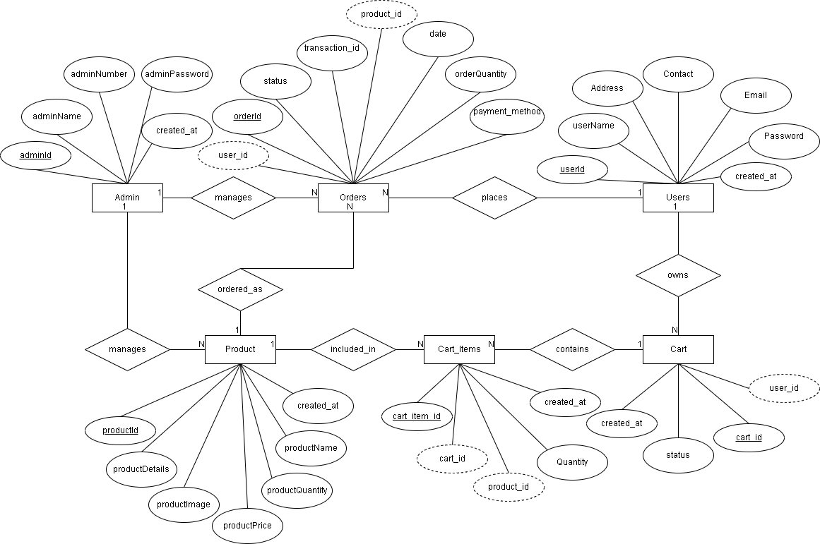
Figure 4.2: E-R Diagram

4.4 Context Level - DFD
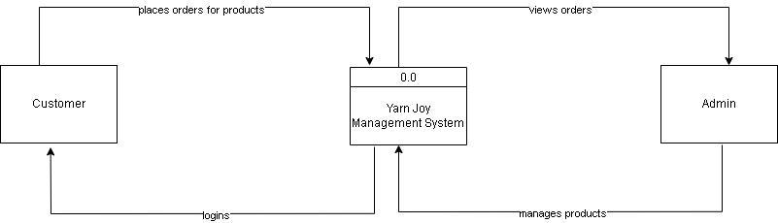
Figure 4.3: Context Level-DFD

4.5 DFD Level 1
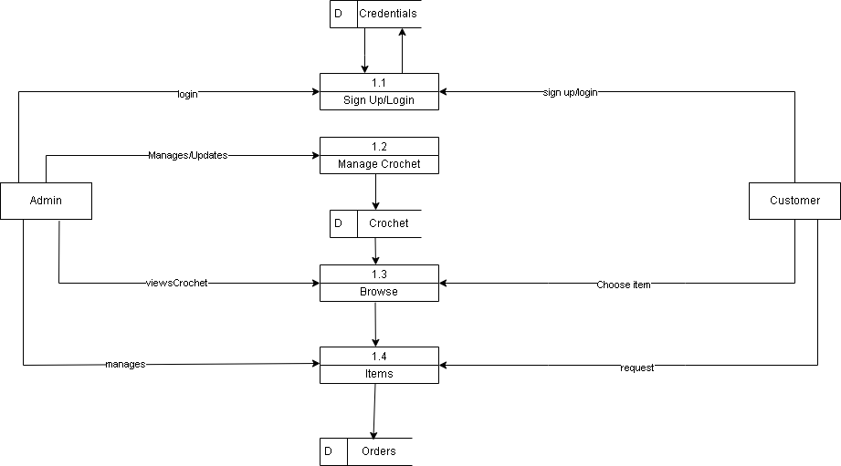
Figure 4.4: DFD LEVEL 1

CHAPTER 5: Process of Building Website

5.1 Process of Building Website
- This Online Shopping Website is a Single Vendor system developed using HTML, CSS, JavaScript, PHP, and MySQL. It was built from scratch without using any Content Management System (CMS) like WordPress.
- Here are the steps followed during the website development process:
- First, XAMPP was installed on the development machine to create a local server environment.
- Apache and MySQL services were started to enable local hosting and database support.
- A new MySQL database was created using phpMyAdmin, which is bundled with XAMPP.
- The folder structure of the website was created inside the htdocs directory of XAMPP.
- Using HTML and CSS, the layout and design of the website's front-end (Home page, Product list, About, Contact, etc.) were developed.
- JavaScript was used to add interactivity, such as form validation, hiding/showing product sections, or updating cart quantity dynamically.
- PHP was used for server-side logic such as:
  - Connecting to the database.
  - Handling user login and registration.
  - Managing cart sessions and order processing.
  - Fetching and displaying products dynamically.
- A basic payment module structure was created using dummy methods (or third-party sandbox setups like eSewa/Khalti if integrated).
- All pages were tested on localhost to ensure functionality and responsiveness.
Finally, the entire website was completed and fully functional in the local development environment

5.1.1 To Make Live on Domain
Note: The website is currently not live on a domain and is only being run in a local development environment (localhost).
However, the following steps outline how the website can be made live in the future:
- A domain name can be registered from services like register.com.np.
- A web hosting plan with cPanel access needs to be purchased.
- All local project files (HTML, CSS, JS, PHP, and MySQL database) should be uploaded to the public_html directory using cPanel File Manager or tools like FileZilla (FTP).
- The local database must be exported from phpMyAdmin and then imported into the hosting provider’s database system.
- Database connection details (host, username, password, database name) must be updated in the PHP configuration files accordingly.
Once everything is uploaded and properly configured, the website will be live and accessible through the registered domain

5.1.2 Customer Account
- Customers can create an account by visiting:
https://yourdomain.com/register.php
- They can log in via:
https://yourdomain.com/login.php
- From their account dashboard, users can view their orders, edit profile information, and manage their cart.

5.1.3 Admin Dashboard Login
- The website includes an admin panel that allows administrators to manage product listings, view orders, and control user accounts.
- The admin can log in using the following URL:
https://yourdomain.com/admin/login.php
- After logging in, the admin has access to features like:
- Adding/editing/deleting products
- Viewing and managing customer orders.
- Checking payment status and inventory.

Chapter 6: Payment Gateway

6.1 Payment Gateway
A payment gateway is an e-commerce application service which facilitates the sharing of relevant information between banks during an attempted credit or debit card transaction. It allows the appropriate information to be sent to the acquiring bank, and then collects a response from the issuing bank (whether the exchange has been approved or declined). Generally, the service is needed by any business that wants to trade online and accept card payments from its customers. With the total value of B2C e-commerce sales currently standing at almost RS1.5 trillion per year - and major growth expected in the coming years - this group is likely to include the majority of commercial organizations.
In our e-commerce application we have many different modes of payment. Some of the popular modes of payments system are as:
- Khalti
- Cash on delivery
In our system we are included all types of payment method above and it is client user friendly for payment complete process.

6.2 Khalti Integration
In this Bookshop website, Khalti is integrated as the payment gateway, enabling users to make secure digital payments for their orders. Khalti is one of Nepal’s leading digital wallets and payment service providers, offering a well-documented API and SDK for developers. It supports both test and live environments, ensuring smooth integration and secure transactions.
This project integrates Khalti (https://khalti.com/) as a payment gateway for handling online payments. The integration follows a secure verification process where the transaction token received from the frontend is verified by the backend using Khalti’s API.
Payment Flow Implemented in the Application
- User Checkout
  - The user selects books, adds them to the shopping cart, and proceeds to checkout.
  - On the checkout page, the user fills in shipping details and selects Khalti as the payment method.
2. Payment Initiation (Backend)
- When the order is confirmed, the backend fetches order details such as order ID, user information, and total amount.
- A payment initiation request is then sent to Khalti’s API (/epayment/initiate/) with required parameters, including:
  - Return URL → the page where Khalti redirects the user after payment.
  - Website URL → the base URL of the Bookshop website.
  - Amount → total order amount in paisa.
  - Purchase Order ID → unique order reference.
  - Purchase Order Name → a descriptive name for the order.
  - Customer Information → name, email, and phone number of the buyer.
- Khalti responds with a payment URL, and the user is redirected to Khalti’s secure payment page.
3. Payment Processing (Khalti Gateway)
- On the Khalti Payment Gateway, the customer completes the payment using wallet balance, bank transfer, or card.
- After completion, Khalti redirects the user back to the return URL defined earlier, along with a unique transaction identifier (pidx).
4. Payment Verification (Backend)
- Once redirected, the backend receives the pidx and sends a lookup request to Khalti’s API (/epayment/lookup/) to verify the payment status.
- Khalti responds with the transaction details and current status.
- If the status is Completed:
  - The order is marked as Paid in the database.
  - Stock quantities of purchased books are reduced.
  - The customer’s shopping cart is cleared.
  - The user is shown an Order Success page with confirmation details.
- If the status is not successful, the order remains Pending or is marked as Failed, and the user is informed accordingly.
5. Order Completion
- For successful payments:
  - The order status is finalized as Paid.
  - Inventory is updated to reflect the purchase.
  - The user’s cart is emptied.
  - A styled confirmation page is displayed to assure the customer that the purchase was successful.
- For failed or pending transactions:
  - The order is not finalized.

Chapter 7: Handling Security Issue

7.1 Handle Security Issue
Security is a key aspect of our website to protect user data, transactions, and ensure system integrity. The following measures have been implemented:
- Authentication and Authorization
  - Session-based Authentication: User and admin login sessions are managed securely using PHP sessions.
  - Role-based Access: Admin panel functions (e.g., inventory management, order tracking) are only accessible to authorized admins.
- Password Security
  - Hashing: All user passwords are hashed (e.g., using password_hash() in PHP) before being stored in the database to prevent exposure of plain-text credentials.
  - Validation: Users are encouraged to use strong passwords during registration.
- API & Form Security
  - Input Validation: User inputs (login, registration, contact form, order details) are validated to prevent malicious entries.
  - SQL Injection Prevention: Prepared statements and parameterized queries are used with MySQL to prevent SQL injection.
  - XSS Protection: Output encoding is used when displaying user data to prevent Cross-Site Scripting (XSS).
- Secure File Uploads
  - File Restrictions: If the system supports image uploads (e.g., book covers), restrictions on file type and size are applied.
  - Storage: Uploaded files are stored in a secure directory with controlled access.
- Payment Security
  - Khalti Integration: Payments are processed through the secure Khalti gateway, where signature verification ensures transaction authenticity.
  - HTTPS: Payment-related communication with Khalti is protected using HTTPS.
- Environment Variables
  - Sensitive Data Protection: API keys, database credentials, and Khalti secrets are stored in environment configuration files, not directly in the code.
- Error Handling & Logging
  - Error Messages: Sensitive system errors are not shown to end users, only general error messages are displayed.
  - Logging: Errors and failed payment attempts are logged for monitoring and debugging, without exposing sensitive data.

Chapter 8: Screens of the Website Design

8.1 Consumer Account Register and Login:
To register an account: while registering an account required username, e-mail, Phone address, password.
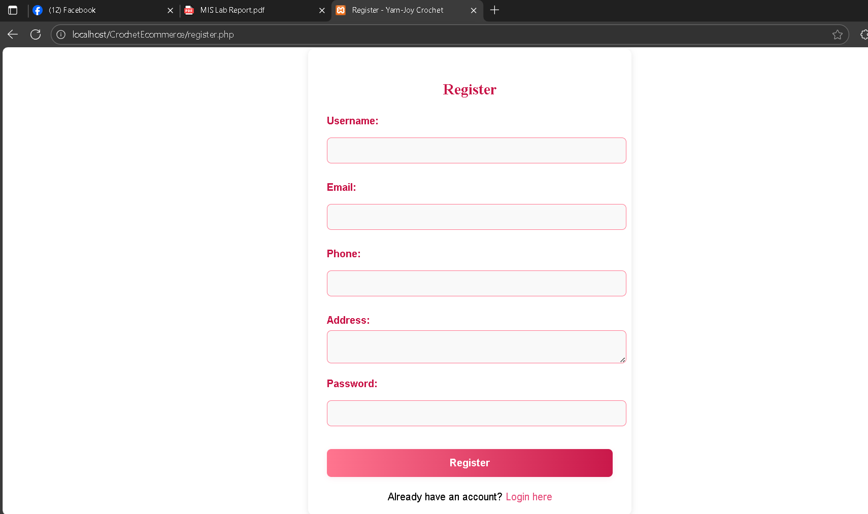
To Login an account: consumer can login own dashboard using username/e-mail and password.
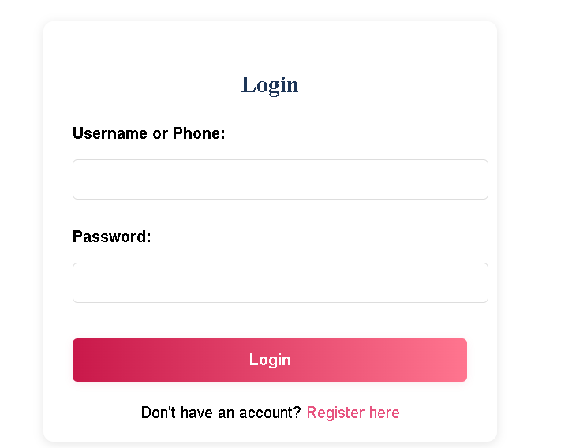

8.2 Public Pages for Visitors
Consumer can choose the products as own choice and add products on "Add to Cart" section
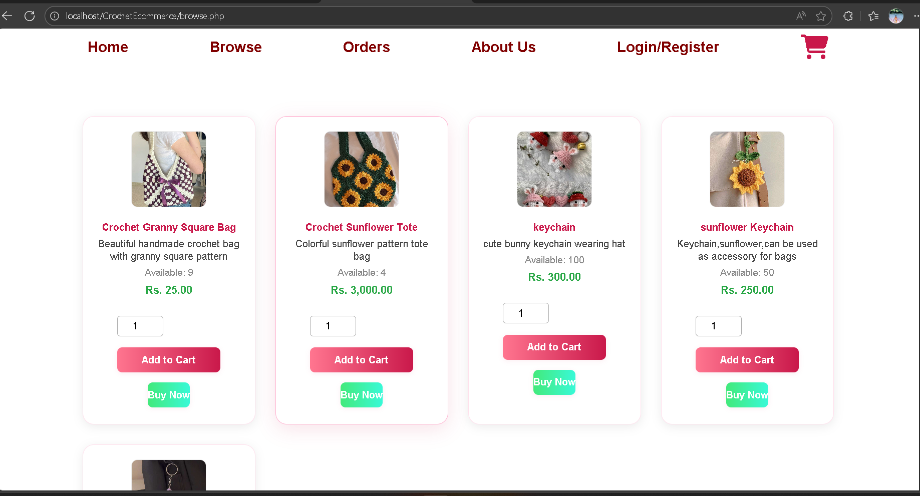

Click on Checkout
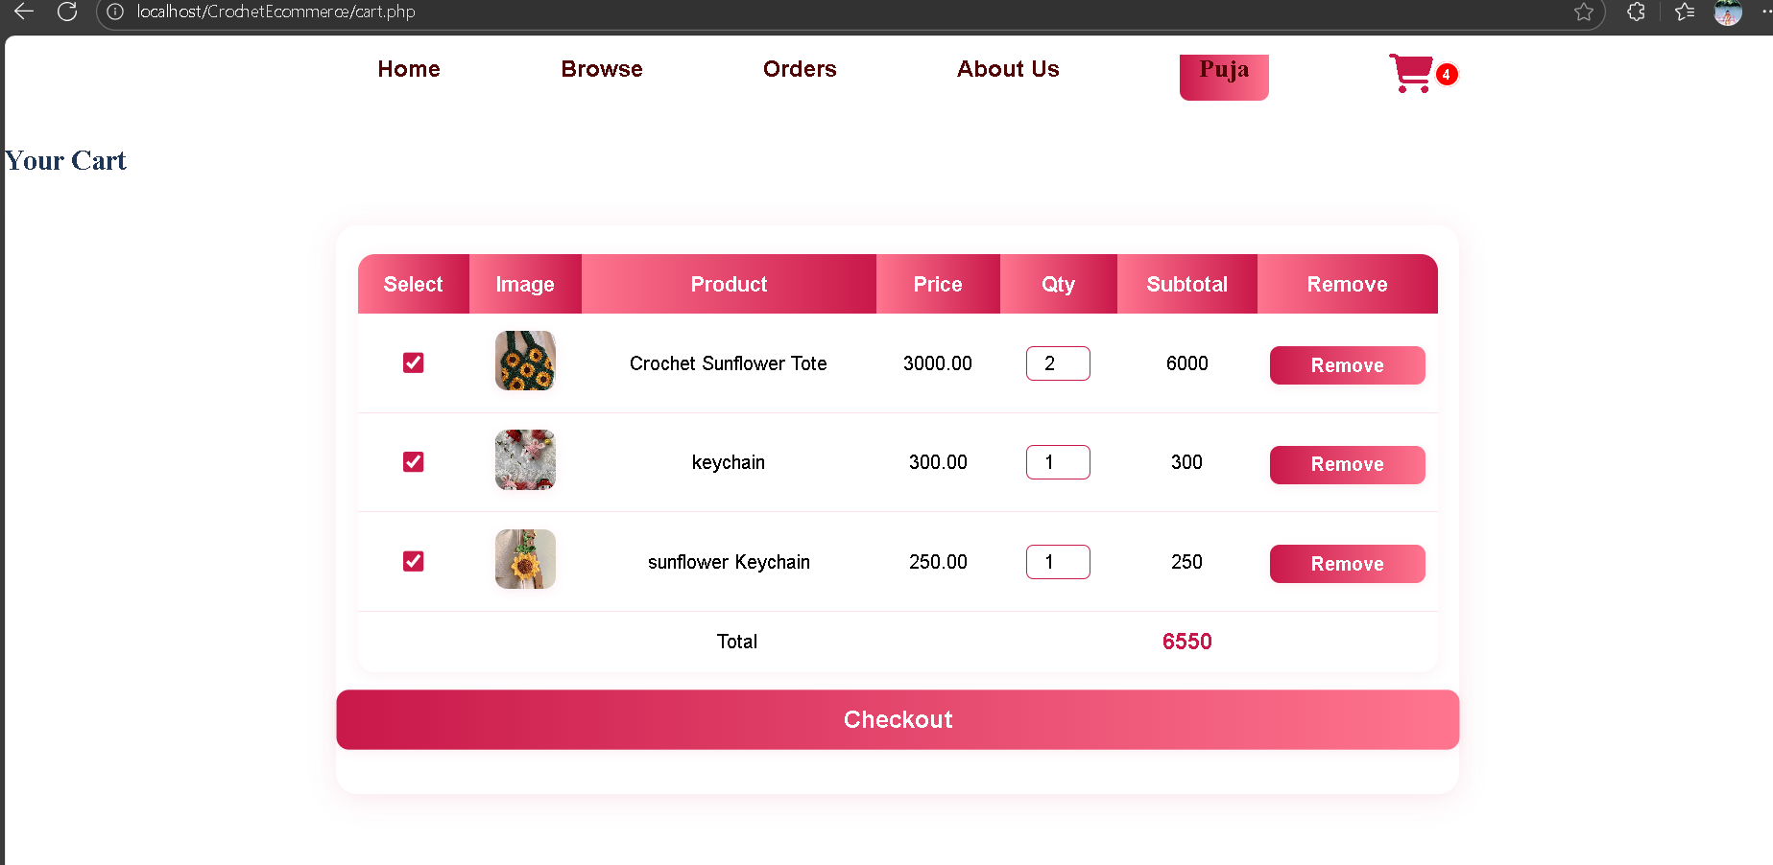

8.3 Checkout Pages
Consumer must fill up the correct details in form before complete the order.
You can see the ordered product details and choose the payment gateway
or cash on delivery payment option.
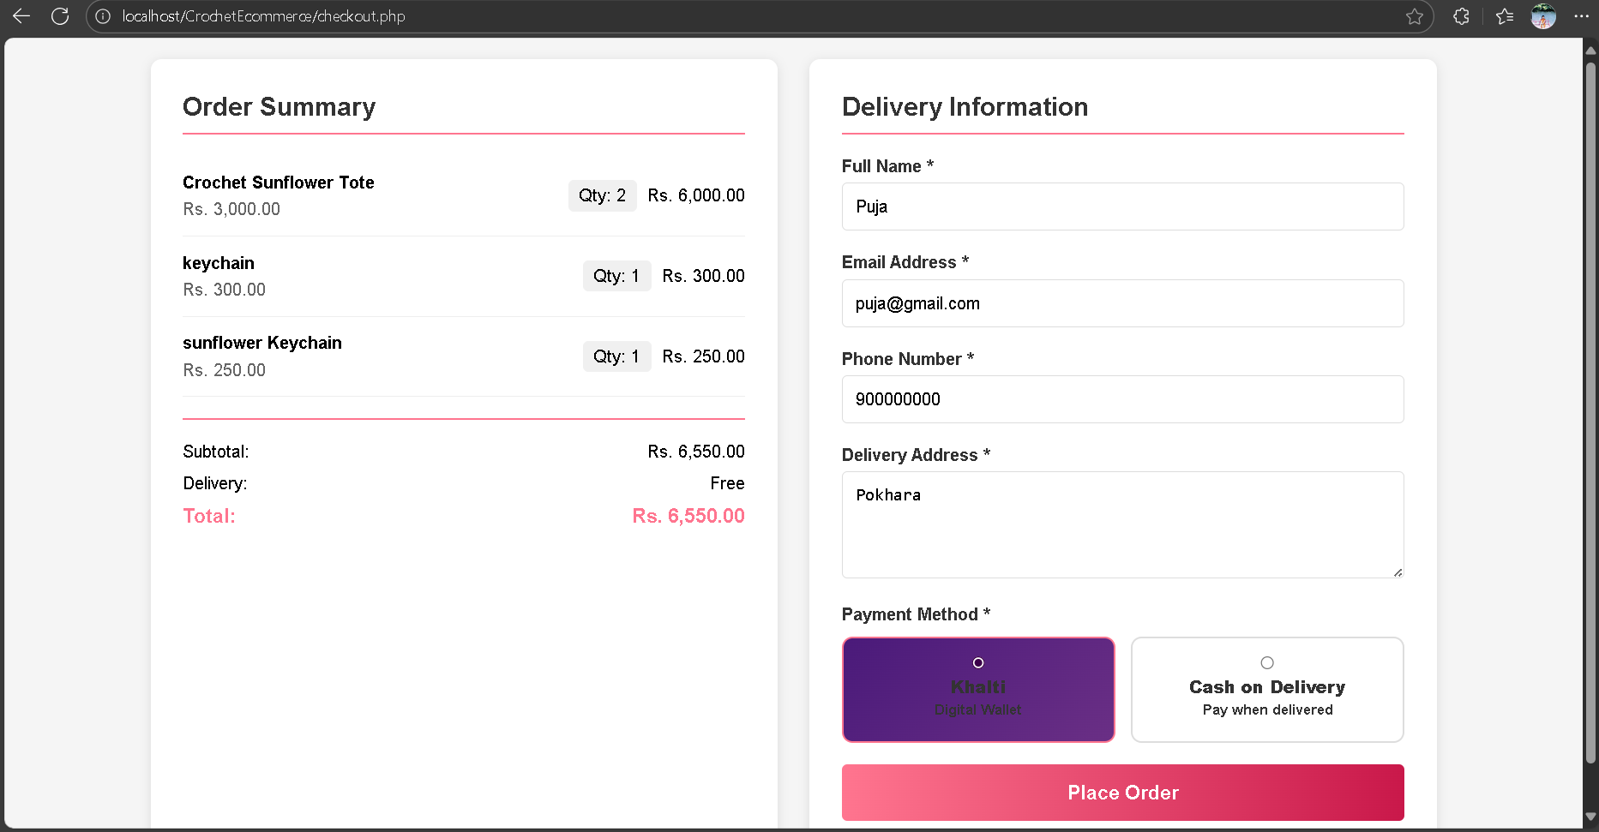
If you choose Payment Gateway (i.e.: Khalti): For payment gateway must have the merchant API integrated to work, otherwise the payment process will be failed.
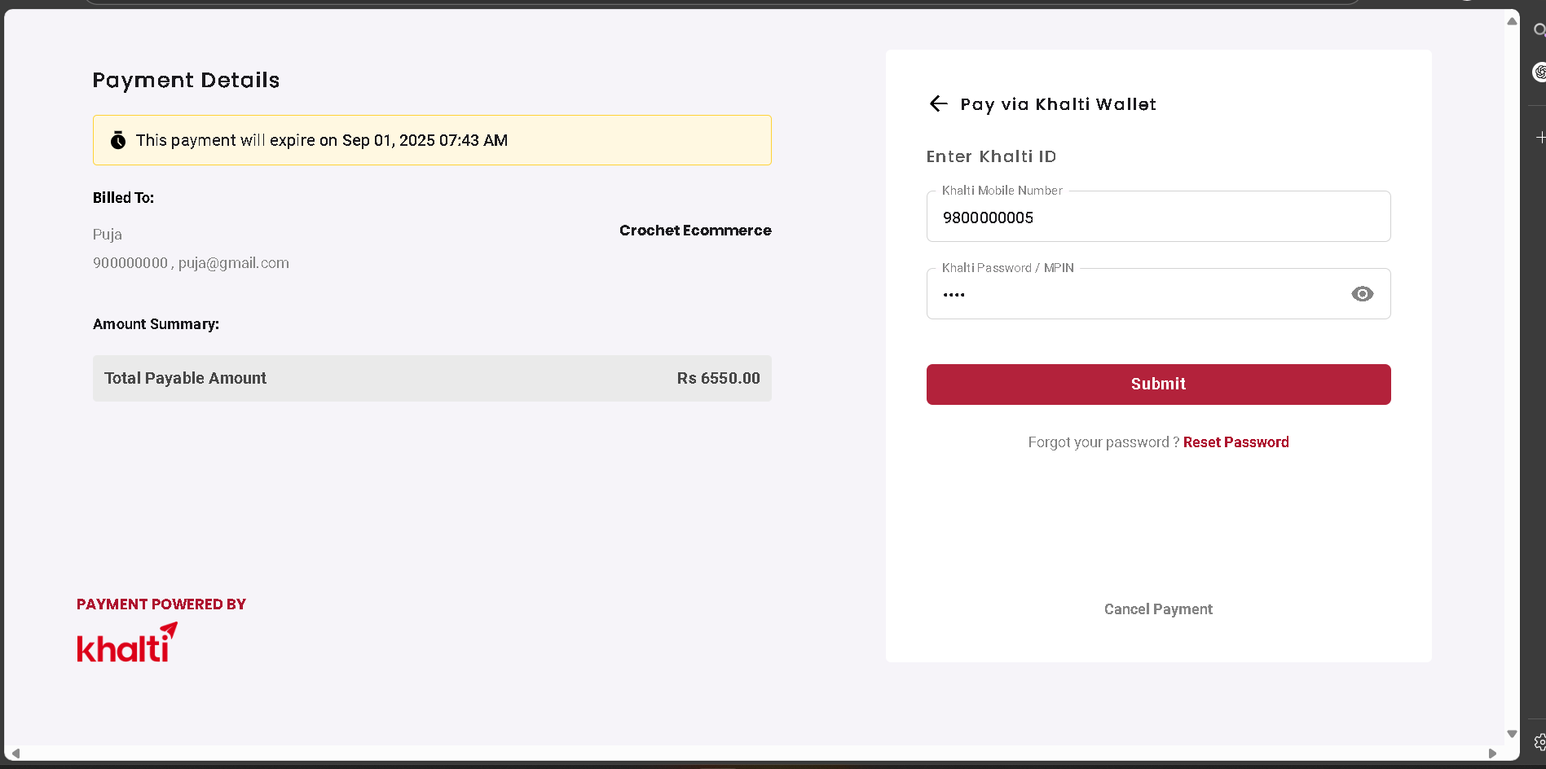
After completing the order, we get the order received notification/response.
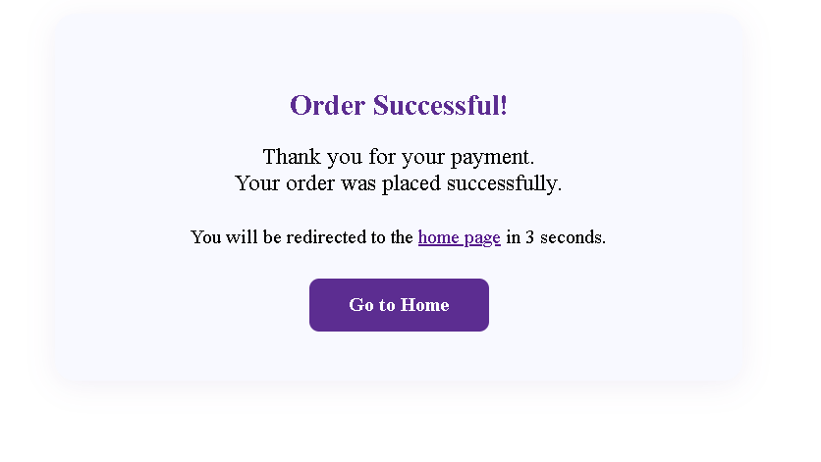
Consumer can also check the ordered product from dashboard.
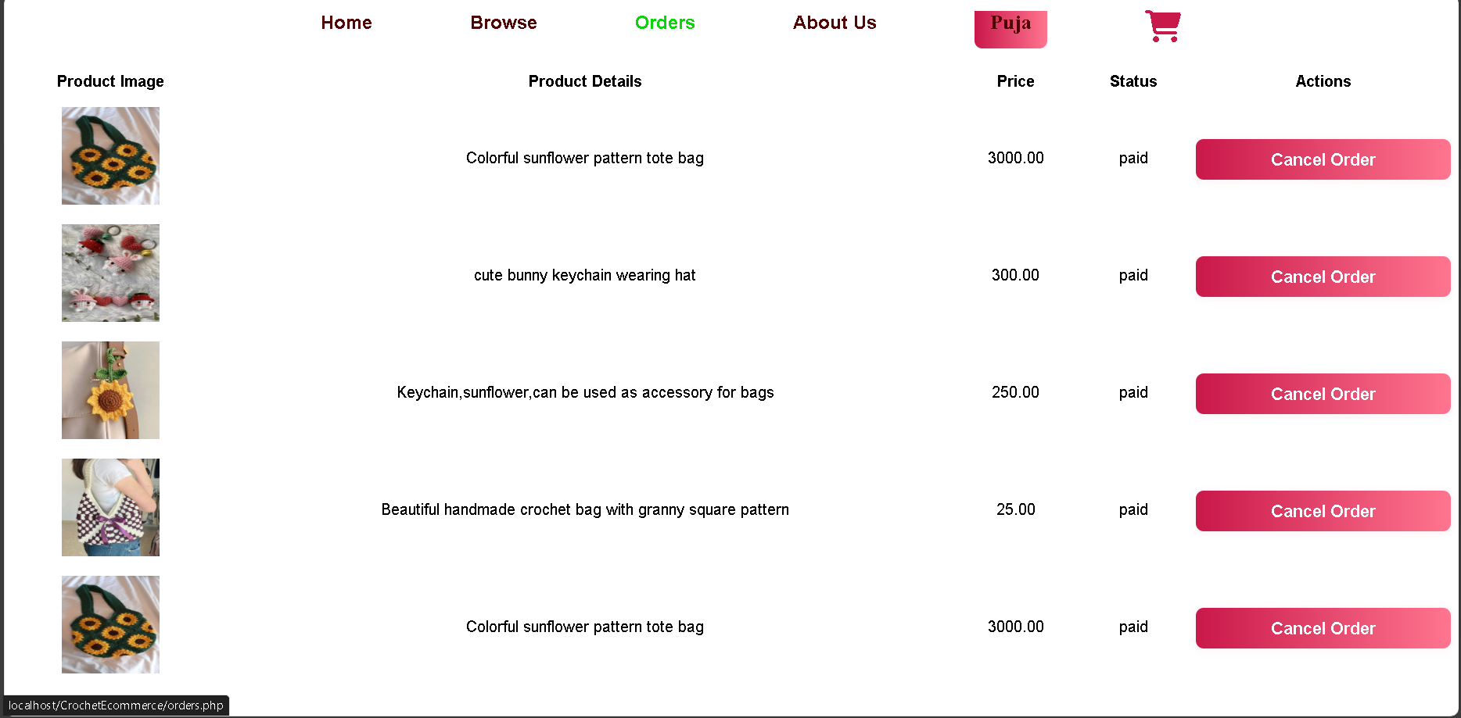

8.4 Admin Section
Admin login section
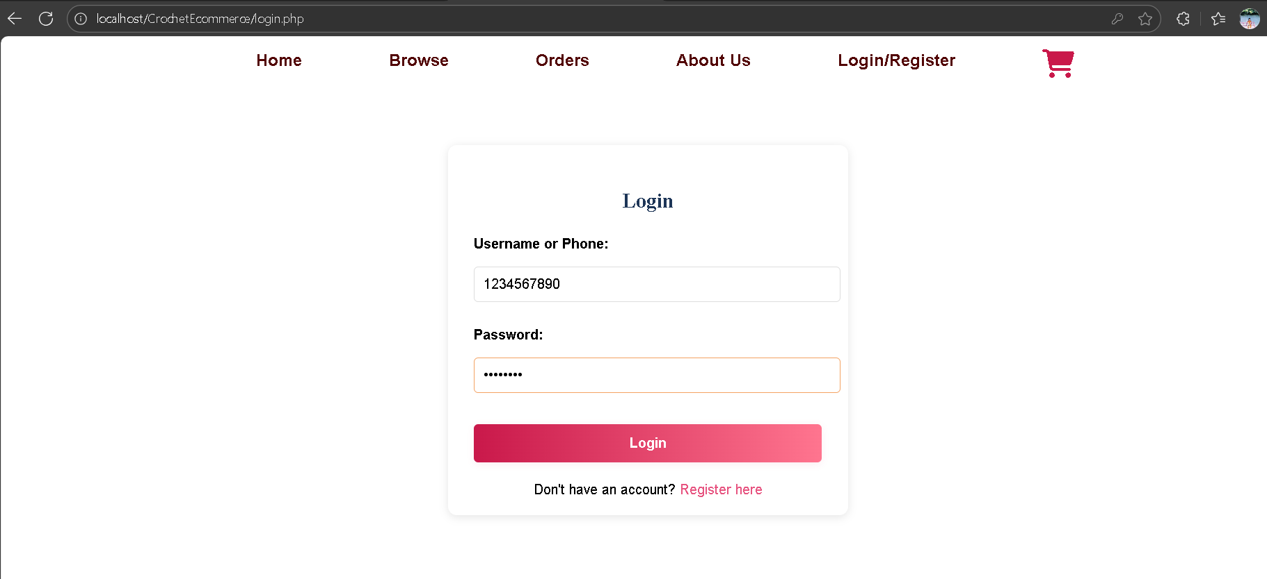

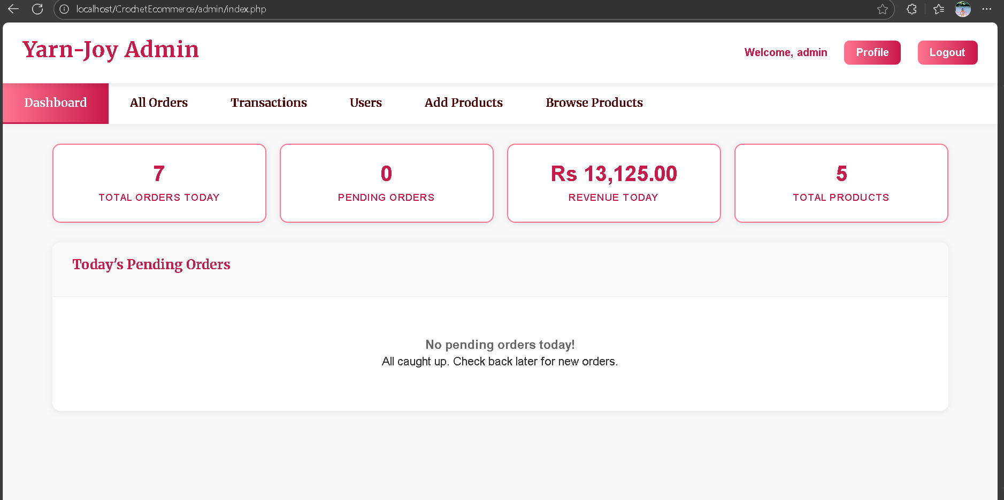

8.4.1 Order Management
Store staff can check ordered products from here.
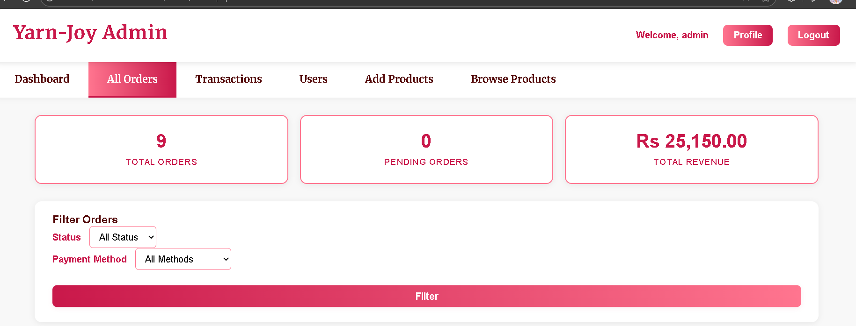
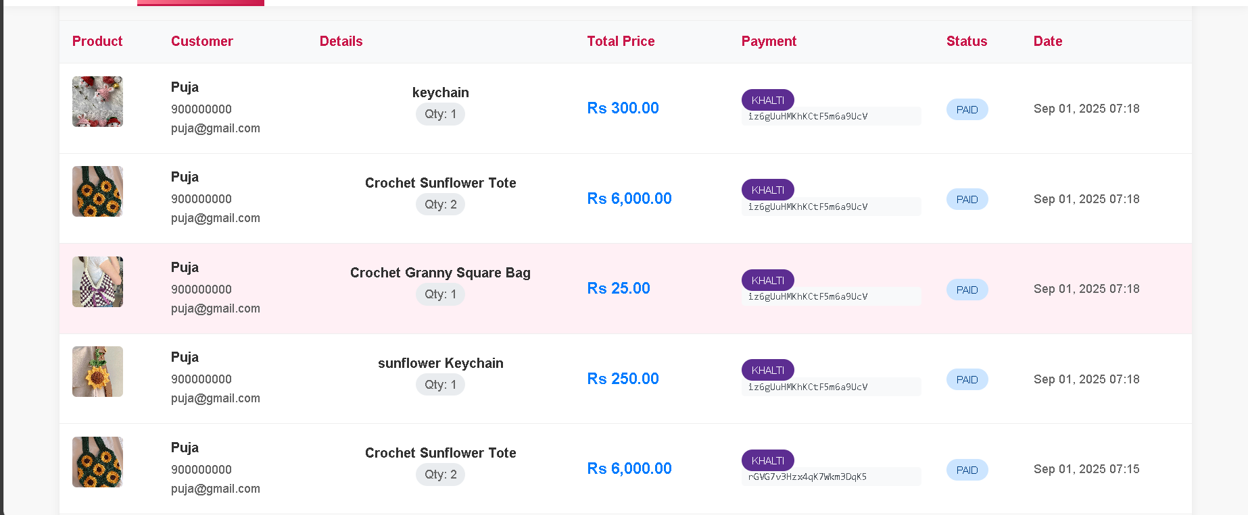

8.4.2 Product Management
Added product list and new product option.
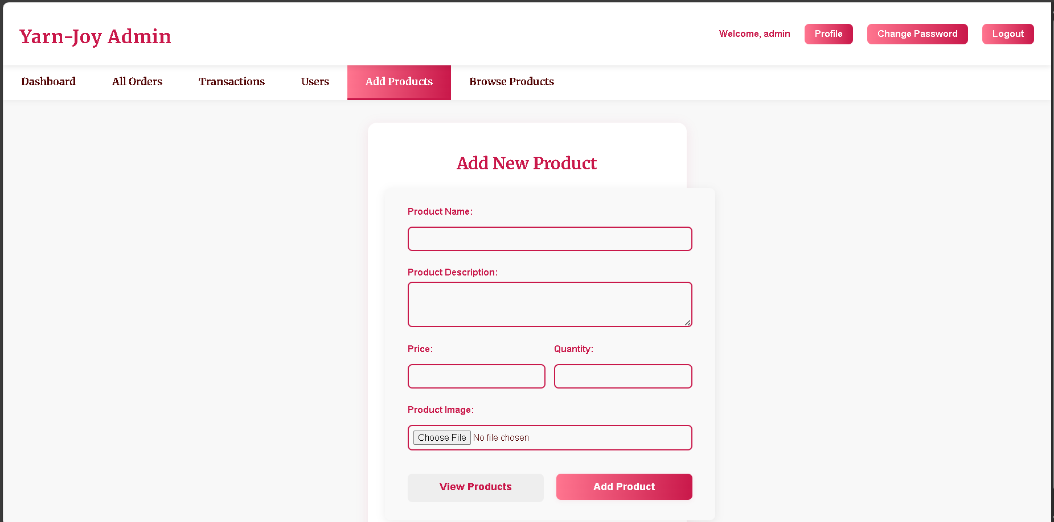

To edit existing product, browse product can be used then after clicking the edit button
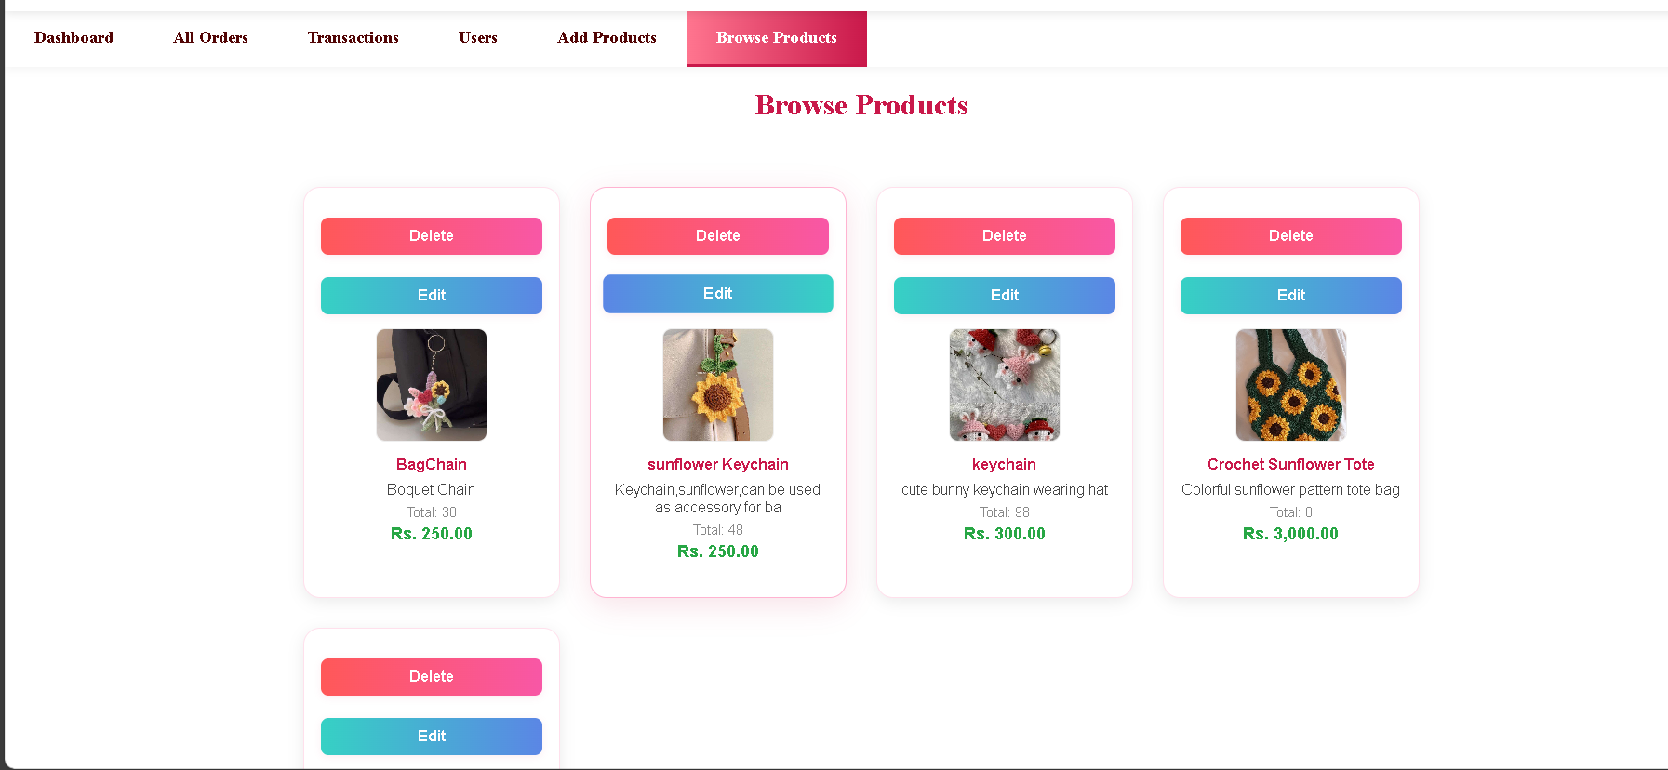

Chapter 9: Conclusion

9.1 Conclusion
The developed e-commerce website successfully provides a complete online shopping platform where consumers can easily browse products, add them to the cart, and place orders with flexible payment options, including cash on delivery. Designed with HTML, CSS, JavaScript, PHP, and MySQL, the system ensures both functionality and a smooth user experience.
On the user side, the website offers simple navigation, category-wise product display, and the ability to leave feedback, making the platform interactive and customer-friendly. On the admin side, the system provides essential features such as product and category management, order tracking, and user monitoring through a clean and user-friendly interface.
Overall, the project fulfills the requirements of an effective e-commerce system by bridging the gap between consumers and sellers. It enhances convenience for customers while giving administrators the necessary tools to manage the website efficiently. With its scalable design, this project lays a strong foundation for future improvements and integration of advanced features such as multiple payment gateways, enhanced security, and personalized recommendations.

