* **Title** : ShopNest Store Power BI Capstone – Dashboard Report
* **Submitted by** : Pramitha Sethu
* **Date** : July 18, 2025
* **Course** : Business Analytics

**Tasks to do:**

**1) Top Categories by Total Price :**

* **Identify and visually represent the Top 10 Product Categories by Total Sales**.

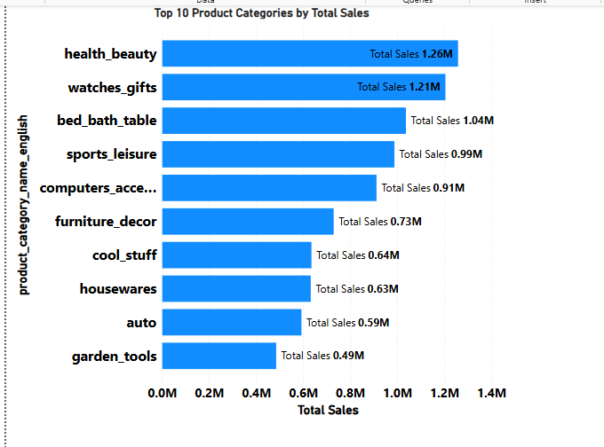

* **Explanation :**

This bar chart highlights the **Top 10 Product** categories based on total sales value ( **Total Price**), helping us understand which categories are generating the most revenue.

* The **Health and Beauty Category** leads with **₹ 1.26 M** in Total Sales.
* This is followed closely by **Watches & gifts (₹ 1.21M), and Bed, Bath & table (₹1.04M).**
* Other strong performers include **Sports & Leisure (₹0.99M), Computers & Accessories ( ₹0.91M), and Furniture & Décor (₹0.73M).**
* Categories like **Garden Tools** and **Auto** have relatively lower total sales but still make the top 10.

**This analysis provides clear direction for the business**:

* Focus on maintaining inventory and promotions for the top-selling categories.
* Investigate growth opportunities for mid-performing categories.
* These insights support strategic planning in merchandising, marketing, and supply chain alignment.

**2. Delayed Orders analysis**:

* **Determine the number of delayed orders in each category.**

(An order is considered delayed if the actual delivery date is later than the estimated delivery date)

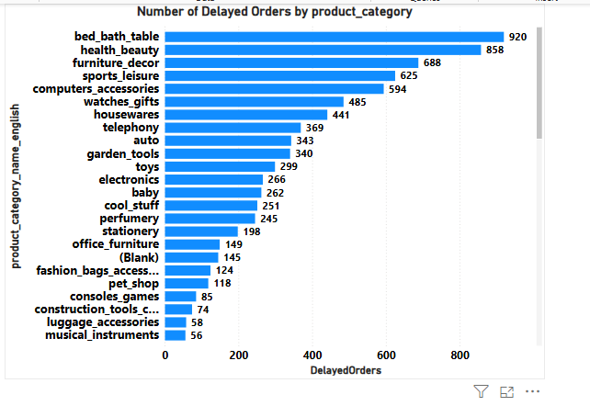

* **Explanation:**

This bar chart shows the total number of **delayed orders** for each product category based on the condition where actual_delivery_date > estimated_delivery_date.

**Key observations**:

* The **Bed, Bath, and Table** category has the highest number of delayed orders (920), followed by **Health & Beauty** (858) and **Furniture & Decor** (688).
* Categories like **Sports & Leisure**, **Computers & Accessories**, and **Watches & Gifts** also show significant delays, with over 400 orders each.
* On the lower end, categories such as **Musical Instruments**, **Luggage & Accessories**, and **Construction Tools** have fewer than 75 delayed orders.

These findings indicate that **home-related categories** tend to face more delays, possibly due to their size, fragility, or supply chain complexity. Improving logistics or setting more realistic estimated delivery times in these categories could enhance customer satisfaction and reduce negative reviews.

**3)** **Monthly comparison of Delayed and On-time orders**

* **Create a dynamic visual that compares the number of delayed orders to the number of orders received earlier for each month. Utilize the drill through cross-report feature to provide a detailed analysis of late and on-time deliveries**.

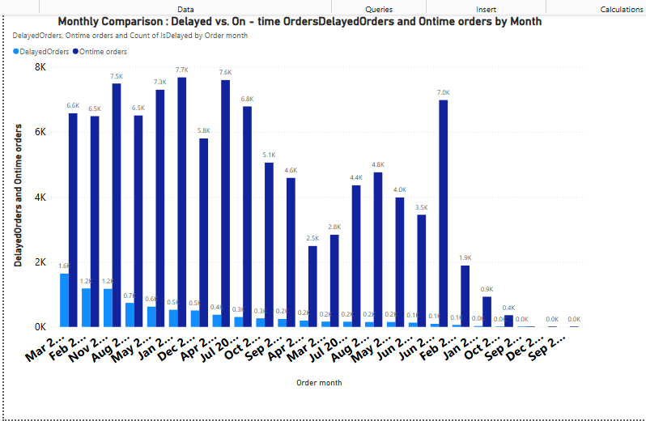

### ****Visualization 1: Clustered Column Chart of Delayed vs On-time Orders****

This visual presents a **month-wise comparison** of two key delivery metrics:

* **On-time Orders**
* **Delayed Orders**

The chart dynamically compares order counts across all months, highlighting periods where delivery performance improved or worsened.

* **Key Observations:**
* The highest number of **delayed orders** occurred in **March 2022**, indicating potential supply chain or operational challenges during that period.
* Conversely, **July 2022** recorded the highest number of **on-time deliveries**, showing an improvement in logistics or delivery service efficiency.
* There is a visible fluctuation in delivery performance across months, reflecting seasonality or promotional campaign effects.

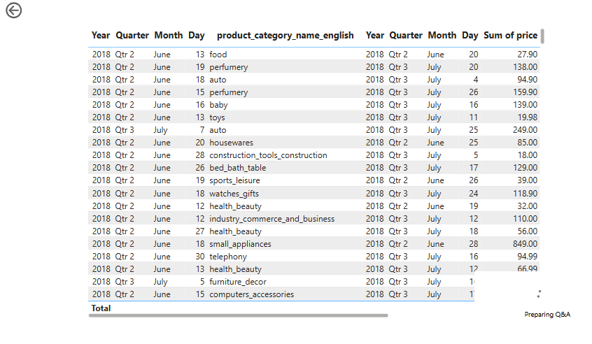

### ****Visualization 2: Drill-Through Revenue Analysis by Product Category & Month****

To complement the delay analysis, a detailed **matrix table** was created that shows:

* **Total revenue generated** per **product category**
* Organized by **year**, **quarter**, and **month**

This view helps us drill deeper to understand which product categories were most affected by delays and how they contributed to overall revenue.

* **Key Observations:**
* Categories like **health_beauty**, **telephony**, and **sports_leisure** generated high revenue during months with both high delays and high delivery volume.
* Certain months (e.g., **June–August**) show increased revenue and timely deliveries, possibly due to improved order processing systems.
* This analysis aids in pinpointing which categories may need better inventory or logistics planning during peak seasons.

### ****Conclusion:****

The dynamic visuals provide a clear understanding of delivery trends over time. Combined with the drill-through revenue breakdown, this analysis enables stakeholders to make **informed decisions** around:

* Inventory planning
* Delivery resource allocation
* Targeted category performance monitoring

This holistic approach helps in identifying **bottlenecks**, improving **customer satisfaction**, and boosting **overall operational efficiency**.

**4) Payment Method Analysis**:

* **Analyse the most frequently used payment methods by customers using a visually appealing representation such as a pie-chart or other suitable visuals.**

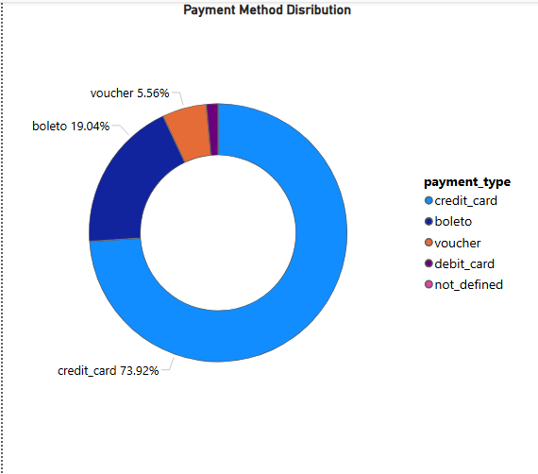

### ****Visualization Used: Donut Chart****

The donut chart displays the **distribution of payment types** across all transactions made by customers. This visualization allows for an **intuitive comparison** of various modes of payment, highlighting the **dominant payment method** and the **relative popularity** of others.

### ****Key Observations:****

* **Credit Card** is the most widely used payment method, accounting for **73.92%** of all transactions.  
  This shows a strong customer preference for using credit cards, likely due to benefits like reward points, EMI options, and ease of use.
* **Boleto** (a popular payment slip system in Brazil) is the second most used method, contributing to **19.04%** of transactions.  
  This indicates a significant portion of customers prefers offline or bank-based payment options.
* **Voucher** makes up **5.56%**, representing loyalty rewards or promotional redemptions.
* **Debit Card** and **Not Defined** together contribute marginally to the remaining share, suggesting either data entry gaps or minimal usage.

### ****Conclusion:****

The analysis highlights a clear dominance of **digital payment methods**, especially **credit cards**, among customers. Businesses can leverage this insight to:

* Offer more credit card-related promotions.
* Improve integration and support for boleto and voucher payments.
* Investigate the "not_defined" category to ensure cleaner data collection.

This visualization helps stakeholders better understand **customer payment behaviour**, allowing for more **informed marketing**, **customer experience enhancements**, and **payment infrastructure improvements**.

**5) Product Rating Analysis** :

* **Determine the Top – 10 highest rated products and the bottom 10 lowest – rated products using a bar or column chart.**

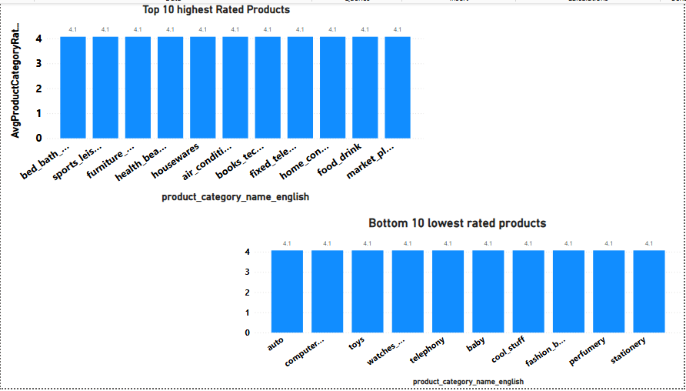

#### **Visualization Used:**

A **clustered column chart** has been used to visually represent:

* The **Top 10 highest-rated** product categories.
* The **Bottom 10 lowest-rated** product categories.

The Y-axis represents the **average product rating**, and the X-axis lists the **product category names**.

#### **Key Observations:**

* **Top 10 Highest Rated Categories** (all having an average rating of **4.1**):
  + bed_bath_table, sports_leisure, furniture_decor, health_beauty, housewares, air_conditioning, books_technical, fixed_telephony, home_construction, food_drink

These consistently high ratings suggest strong product quality and customer satisfaction in these categories. They can be considered as flagship categories for customer loyalty and positive brand perception.

* **Bottom 10 Lowest Rated Categories** (average rating just around **4.0**):
  + auto, computers_accessories, toys, watches_gifts, telephony, baby, cool_stuff, fashion_bags_accessories, perfumery, stationery

Although the ratings are still relatively high (hovering around 4.0), these categories show slightly lower satisfaction. Possible reasons could include quality inconsistencies, delivery issues, or customer expectations not being met.

* The **difference between the top and bottom categories** is subtle (4.1 vs. 4.0), indicating overall good customer feedback across the platform.
* However, even a **0.1 variation in average rating** can impact purchase decisions, especially in competitive markets.
* Categories like **baby, fashion, and telephony** may require further investigation into reviews to improve customer experience.

#### **Recommendations:**

* Deep-dive into **lowest-rated categories** to identify frequent complaints or issues mentioned in reviews.
* Promote the **highest-rated categories** more prominently on the platform to boost trust and conversions.
* Implement **customer feedback loops** or surveys for low-rated categories to gather more specific improvement points.

#### **Conclusion:**

This rating analysis provides a quick snapshot of customer satisfaction by product category. It enables the business to take focused action—celebrating and promoting what works, while improving what doesn't.

**6) State –wise sales Analysis**

* **Identify and visually represent sales with high and low sales providing a clear understanding of regional sales performance.**

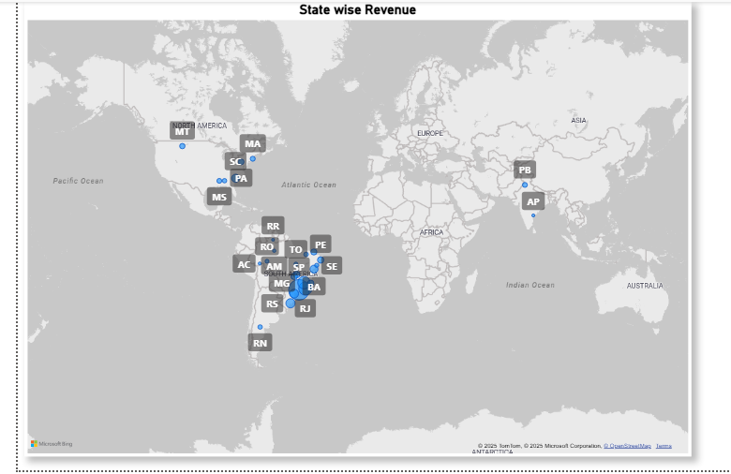

#### **Visualization Used:**

A **Map visual** (Bubble Map) has been used to display state-wise revenue across different regions.

* Each **bubble** on the map represents a state.
* The **size or intensity** of the bubble indicates the **total revenue** from that state.
* States are labeled using their **state codes** (e.g., SP, RJ, MG, etc.).

#### **Key Observations:**

* **Top Revenue-Contributing States:**
  + **SP (São Paulo)**: Clearly has one of the largest bubble sizes, indicating the **highest sales** contribution.
  + **RJ**  and **MG**  also show high revenue, representing strong customer bases.
  + These states are likely major urban centers with high population and purchasing power.
* **Moderate Revenue States:**
  + States like **BA**, **RS**, and **PR**  have moderate bubble sizes, indicating mid-level performance.
  + These can be targeted for growth strategies or localized marketing.
* **Low Revenue-Contributing States:**
  + States such as **RR, RO, AC, AM, PB, AP, RN**, etc., have very small or minimal bubble sizes, indicating **low sales** volume.
  + These could be due to lower population, weaker distribution channels, or low brand awareness.

#### **Recommendations:**

1. **Focus on high-performing states** like SP, RJ, and MG for maintaining momentum through loyalty campaigns and premium offerings.
2. **Boost mid-performing states** through targeted promotions or regional influencers.
3. Investigate **low-performing regions** for logistics issues, low internet penetration, or lack of marketing presence.

#### **Conclusion:**

The state-wise sales analysis provides **clear geographic insights** into business performance. Understanding which regions are performing well helps allocate resources effectively and opens up opportunities for expansion or correction in weaker markets.

**7) Seasonal Sales Patterns:**

* **Investigate and visualize any seasonal patterns (Quarterly) or trends in sales data over the course of the year.**

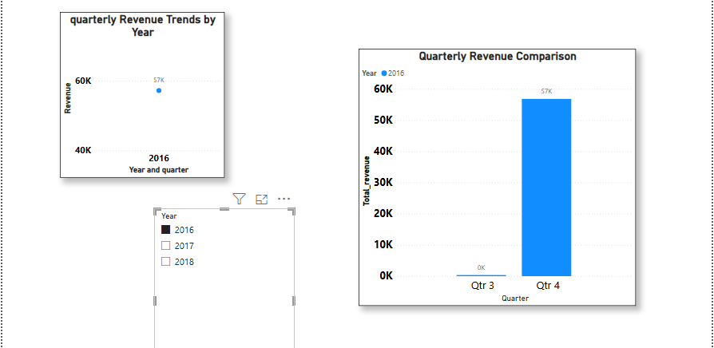

* **Explanation:**  
  To uncover seasonal trends in revenue performance, quarterly sales data from **2016 to 2018** was analysed and visualized separately for each year. This helped us identify how customer purchasing behaviour varied throughout the calendar year and whether any recurring seasonal patterns existed.
* **Key Observations:**
* **2016:**  
  Revenue was significantly skewed towards **Q4 (₹57,000)**, while **Q3** recorded the lowest

revenue, barely crossing ₹10,000. This indicates a strong end-of-year buying pattern possibly due to holiday shopping or year-end discounts.

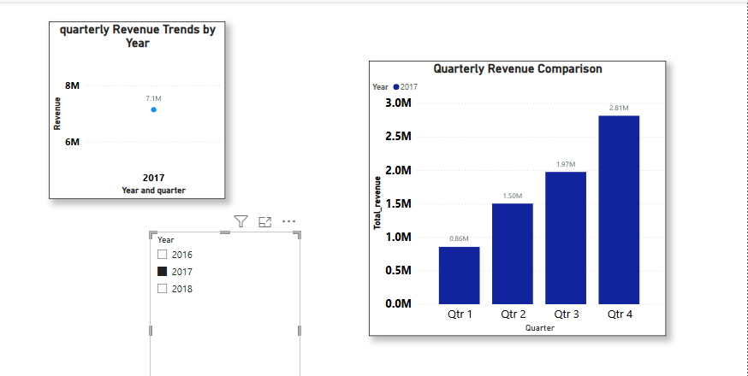

* **2017:**  
  There was a **steady upward trend across all quarters**:
  + Q1: ₹0.86 lakh
  + Q2: ₹1.50 lakh
  + Q3: ₹1.97 lakh
  + Q4: ₹2.81 lakh  
    this consistent growth suggests expanding business operations and customer base throughout the year.

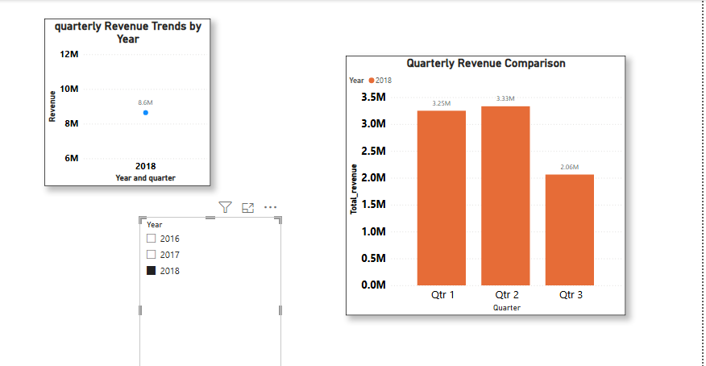

* **2018:**  
  The business continued to grow with revenue peaking in the **first two quarters**:
  + Q1: ₹3.25 million
  + Q2: ₹3.33 million
  + Q3: ₹2.06 million  
    The dip in Q3 suggests a seasonal slowdown possibly due to off-peak buying behavior or fewer marketing activities.
* **Conclusion:**  
  From the trend, it’s evident that:
* The business gained strong momentum from 2016 to 2018.
* **Q4 of 2016 and Q4 of 2017** performed exceptionally well, pointing to year-end seasonality.
* **Q2 of 2018** was the highest performing quarter, indicating a shift or change in promotional or customer activity patterns.

These insights can guide the business in better inventory planning, marketing campaigns, and resource allocation throughout the year.

**8) Revenue Analysis:**

* **Determine the total revenue generated by Shop Nest Store and Analyze how it changes overtime (Yearly).Represent this information through suitable visuals to highlight trends and patterns.**

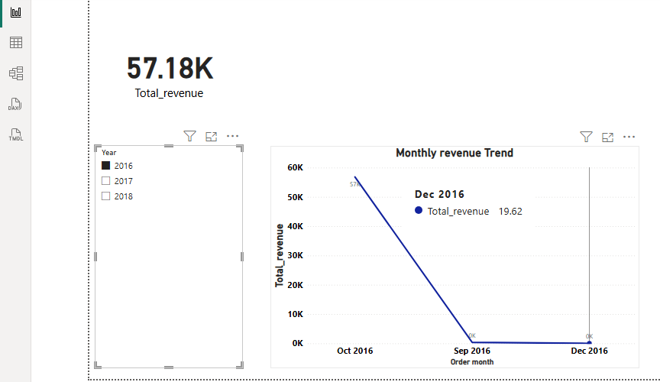

* **Year- Overview wise Total Revenue:**

| **Year** | **Total Revenue** |
| --- | --- |
| **2016** | **₹57.18 K** |
| **2017** | **₹7.14 Million** |
| **2018** | **₹8.64 Million** |

* **2016 – Initial Revenue Phase**
* **Total Revenue:** ₹57.18K
* This year appears to mark the stores early or launch phase, with limited order activity.
* **Monthly Highlights:**
  + **October:** ₹57K — the only month with significant revenue.
  + **September & December:** ₹0K — No revenue generated.
* **Key Observations:** Revenue was mostly generated in a single month, suggesting either a pilot launch or limited operations in 2016.

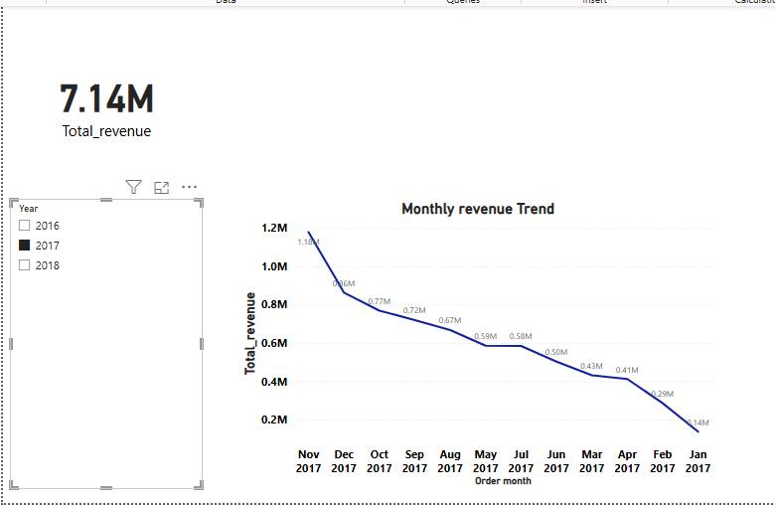

### ****2017 – Major Growth Year****

* **Total Revenue:** ₹7.14 Million
* This year shows **massive growth** compared to 2016, with steady revenue generation across all months.
* **Monthly Revenue Trend:**
  + **Top Months:**
    - **November:** ₹1.18M
    - **December:** ₹0.86M
    - **October:** ₹0.77M
  + **Mid-range Months:**
    - **September:** ₹0.72M
    - **August:** ₹0.67M
    - **May:** ₹0.59M
    - **July:** ₹0.58M
    - **June:** ₹0.50M
  + **Low Months:**
    - **March:** ₹0.43M
    - **April:** ₹0.41M
    - **February:** ₹0.29M
    - **January:** ₹0.14M
* **Key Observations:** Strong performance in Q4, especially during the festive season (Oct–Dec). A noticeable upward trend throughout the year shows successful expansion and sales efforts.

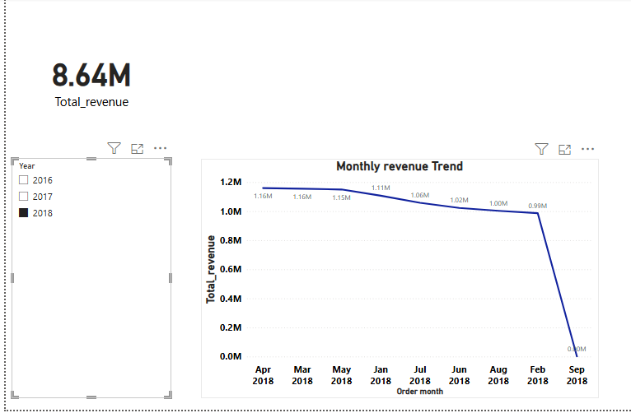

* **2018 – Peak Revenue Year**
* **Total Revenue:** ₹8.64 Million
* Slight increase compared to 2017, maintaining strong monthly performance.
* **Monthly Revenue Trend:**
  + **High Revenue Months:**
    - **March & April:** ₹1.16M each
    - **May:** ₹1.15M
    - **January:** ₹1.11M
    - **July:** ₹1.06M
    - **June:** ₹1.02M
    - **August:** ₹1.00M
    - **February:** ₹0.99M
  + **Drop in September:** ₹0M — No revenue recorded.
* **Key Observations:** 2018 sustained strong monthly revenue throughout Q1 and Q2. However, **September saw a complete drop**, which could indicate operational downtime, supply chain issues, or seasonal off-period.
* **Overall Insights and Patterns:**
* **Exponential growth** from ₹57K (2016) to ₹8.64M (2018) in just two years.
* **Peak revenue periods:**
  + 2017: October to December
  + 2018: January to May
* **Red flags:**
  + **September 2018:** ₹0 revenue — worth investigating.
* The **visuals effectively depict trends and seasonality**, making it easier to identify peak business cycles and dips.
* **Business Implication:**
* The strong Q4 in 2017 and Q1–Q2 in 2018 suggest successful promotional campaigns or product launches during those periods.
* September drop in 2018 requires a closer look to prevent future revenue losses.
* Planning marketing pushes during slow months like Jan (2017) and Sept (2018) could balance revenue flow better.