Web Search Engine

Search Engine Using Page Rank

Pramodh Acharya  
Computer Science  
University of Illinois at Chicago Chicago, IL, USA  
pachar7@uic.edu

ABSTRACT

This Report is the description of components, architecture, and the functionality of the final term project for the course CS-582. The project implements a web crawler to create a search engine for the “uic.edu” domain. The search incorporates the page rank algorithm along with a cosine similarity measure to rank search results for a query. The search provides a basic user-friendly UI to input their search query and obtains results.

KEYWORDS

Search Engine, Cosine Similarity, Page Rank, Information Retrieval

1 SOFTWARE

1.1 Introduction

This Search engine is composed of 4 components, namely crawler, preprocessor, retrieval system, and the website. The application uses Pytho3 and uses object-oriented style programming leaving room for a considerable extension of components or minor/major changes in the style of processing or implementing the algorithms.

1.1 Crawler

The crawler is implemented using the “scrapy” [1] library. A custom Spider is built on top of the vanilla Spider provided by scrapy. The spider is initiated to scrape the web pages via a Custom Crawler again built on top of the vanilla Crawler provided by scrapy. The crawling uses a Breadth-First Strategy for traversing the web pages. The crawler starts at the webpage “cs.uic.edu” and is forced to stay in the “uic.edu” domain throughout. Some of the primary points related to crawling are as follows:

* The fetched documents are maintained in a HashTable data structure. The key is the URL and the value being a Document object having attributes URL, outgoing URLs, and Id and the unprocessed html text.
* The visited URLs are stored in a HashSet. A site is visited as marked once scrapy spider can crawl it.
* Once a URL is scraped and the corresponding content is downloaded, the first check is whether it is of text/html content type. Only those ages are parsed and added to the HashTable.
* Then the downloaded HTML is parsed using Beautiful Soup[3].
* The text from the relevant tags is fetched and becomes the document’s text.
* Using Beautiful Soup all the links are obtained and filtered to fetch valid ones which will be traversed next. As the href tags contain relative URL’s we ignore the #url’s as they are fragments of the same page. The valid URLs are the ones that start with http and don’t end with extensions like xlsx, docx, gif, doc, xls, jpeg, mp3, png, jpg, pdf. I also used regex to match “uic.edu” here. If a href link starts with “/” then this url part was added to the parent url. Finally, the url is canonicalized and checked if it is already visited or not.
* In canonicalization of URLs, the trailing “/” is removed, and “[www.](http://www.)” Part of the url is removed and all “http” is changed to “https”.
* At this stage after all the valid URLs from a page are fetched, these make the outgoing URLs for the parent page which is necessary for calculating page rank.
* Only valid responses like 20 and 301(redirects) are considered valid and the rest are discarded.

Once the crawl limit which is an input indicating the number of pages to be crawled has been reached then the crawler stops and returns the HashTable of the Document objects to the Retrieval system. This HashTable is stored in a pickle file for easy storage and retrieval. The main classes of the module are ‘WebScraper.py’ extending from scrapy framework and the ‘Parser.py’ implementing html parsing using beautiful soup.

1.2 Retrieval System

The retrieval system is the orchestrator and links the Crawler, PreProcessor, and the UI. This module contains the Vector Model as well as the Page rank generator. On the initial run, if the crawled documents are available at the input file location, then those are read using pickle else the Crawler is run and the documents are fetched. Then this System generates the page rank for the set of documents using the out links available for each document. After this, the vector model containing an inverted index is generated for the set of documents. This Model also exposes a method to retrieve relevant documents from the corpus for any given query. This module contains the ‘RetrievalSystem.py’ and the ‘VectorModel.py’ which is used to create the inverted index and retrieve relevant documents.

1.3 Text Processor

The same PreProcessor from the previous assignment has been used here. It is a well-maintained Processor enabling a stemming as well as lemmatizing strategy along with the basic processing like discarding white spaces, numbers, and special characters. As usual, the stopwords and characters lower than 2 digits or greater than 20 digits are discarded. To remove stopwords nltk library corpus is used. The processor module implements this functionality and the main classes are ‘Tokenizer.py’ to tokenize and the ‘PreProcessor.py’ contains various processing techniques like ‘StemmingTextProcessor’ and ‘LemmatizerTextProcessor’.

1.4 User Interface

The user interface is a simple user-friendly single page with a search bar and a navigation pane at the top. The top 10 results are shown initially with an option to see more. The interface is built using the python flask framework along with html, css and bootstrap for decorating.

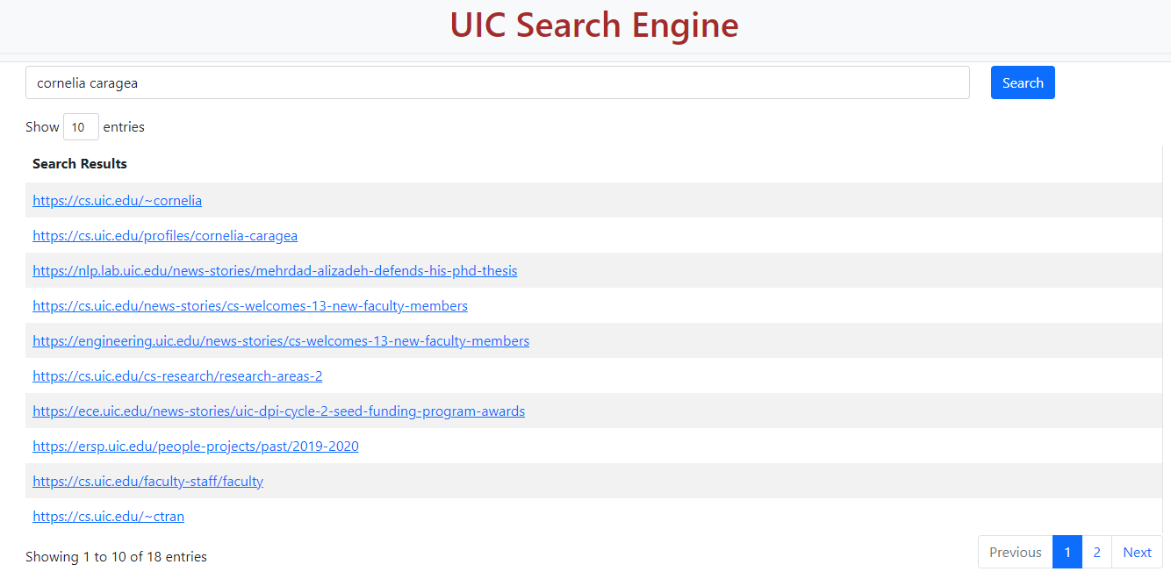

‘Search.py’ is the major file in this module and the entry point of the search engine for an interface experience.

1.5 Intelligent Component (Page Rank)

The page rank algorithm is used as the intelligent component. Initially, a manual implementation was used to calculate the page rank scores for each of the pages. For this, an adjacency matrix was created and the following formulae were used

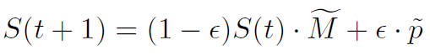

This module worked fine for up to 3000 documents but had performance issues for pages greater than 5000. So the module was replaced by a python module called network[2]. For this, a directed graph is created using all the edges whose information is stored in the HashTable of Document objects where the object contains a list of outgoing links. If any outgoing links are not a key in the HashTable (Dangling links) then it is discarded, hence ending up with a graph that has nodes that are present in the HashTable. Each edge is created in the graph by iterating through the HashTable of documents and an inner loop of the outgoing links. Then the pagerank() method exposed by the network is used to generate page rank scores for the graph. The eigenvector calculation is done by power iteration till convergence (set using a threshold). The damping factor used is 0.85 and the tolerance is 1.0e-6. The top 10-page rank scores and their links are as follows.

|  |  |
| --- | --- |
| **PageRank** | **Value** |
| https://today.uic.edu | 0.01131 |
| https://today.uic.edu/events | 0.01130 |
| https://maps.uic.edu | 0.00854 |
| https://uihealth.uic.edu | 0.00831 |
| https://catalog.uic.edu/ucat/academic-calendar | 0.00807 |
| https://uic.edu | 0.00793 |
| https://emergency.uic.edu | 0.00781 |
| https://uic.edu/about/job-opportunities | 0.00754 |
| https://library.uic.edu | 0.00710 |
| https://uic.edu/apps/departments-az/search | 0.00675 |

Table 1: PageRank value of the top-10 pages in the uic.edu domain. The document corpus contains 30,000 pages.

A manual inspection of the pages vaguely shows that there are a lot of incoming links to these pages and have outgoing links to some high authority pages which indicates the page rank scores are reasonable. This module is a submodule in ‘RetrievalSystem.py’ class

2 CHALLENGES

1. One of the issues faced in the scrapy crawler was that it does not obey the allowed domains rule on page redirects. Many pages from the uic.edu domain redirect to other domains. It was unavoidable to stop retrieving those pages, but once retrieved they could be discarded. Hence a check is provided once a URL document is downloaded to check if it is of “uic.edu” and only then proceed else discard.
2. Another redirecting-related issue was that of many pages redirected to login pages inside the “uic.edu” domain which were not useful and had bad repercussions in the inverted index. This was handled to some extent by catching the login URLs like “login.uic.edu” and discarding them after downloading the pages. Handling redirects was a bit difficult with scrapy but can be handled well with a little more research barring some code issues in scrapy itself.
3. Crawling takes a long time and the decision on how and where to store the crawled documents to avoid multiple crawls was a difficult one. There were two ways to do this. One was to store each document as one pickle file in a directory. In this scenario, the outgoing links for each page had to be extracted later to calculate page rank which was less efficient w.r.t time. If the page rank module is not included this is a better approach. The files can be parsed for text later when created inverted index. As our system included page rank, the second approach was taken which involved creating a HashTable in memory that stores the extracted html text, all outgoing links from a document along with its url, and after the crawling stops, this HashTable is stored in a file. This process is more memory intensive, but processing page rank becomes easier. This seemed reasonable as the pages crawled were small compared to enterprise-level retrieval systems.
4. Evaluating the system automatically is difficult to implement. The first step of this is to manually fetch relevant documents which seems difficult and laborious as well. Evaluating the system manually can be crude and is almost impossible for high thresholds. In general, evaluating the system quantitatively is difficult and currently has been done vaguely.

3 WEIGHTING AND MEASURES

3.1 Weighting Scheme

The weighting scheme used in the search engine is TF-IDF. The term weights are calculated as follows.



wij is the weight of the candidate term in i in web page j. tf is the term frequency and df is the document frequency. The part log2N/dfi) is the inversed document frequency where N is the total number of documents in the corpus. TF-IDF decreases the impact of the frequency of occurrence of a particular word. The same module submitted in the previous modules was used. A slight modification is made to use page rank to the weighting of the documents. An 85:15 ration weight is given to cosine similarity and page rank. Other ratios were used to test the results, but this ratio seemed to give the same or better precision.

3.1 Similarity Measure

The similarity measuring schema used is the cosine similarity. The measure seemed the best one to use given the constraints and given that the query is of smaller size than the documents to be compared with a and retrieved.

3.1 Possible Alternatives

Dice and Inner Product similarity measures were used on a trial set of documents for a few queries. The Cosine similarity either equally or better in terms of precision and recall for most of the queries. Bag of words was tried out as weighting scheme but as the. TF only was never tried as this will be impacted by the high-frequency words occurring in each document majorly like “UIC” etc.

4 EVALUATION

For evaluating the system, a corpus of 30,000 documents was scraped. Initially, only the cosine similarity (without page rank) was measured, and then along with page rank with an 85:15 weighting factor was evaluated. Both the systems gave similar results with one or two top 10 documents being different, but the precision remained similar.

|  |  |  |
| --- | --- | --- |
| Query | Cosine Similarity | Cosine Similarity with Page Rank |
| Cornelia | 0.9 | 0.9 |
| Computer Research | 0.5 | 0.4 |
| Career Services | 0.9 | 0.9 |
| Research Grants | 0.6 | 0.5 |
| UIC jobs | 0.9 | 0.9 |

**Table 3: Precision@10 for the search queries**

Following are the manual evaluation thoughts on the five queries:

1. ‘Cornelia’: The first query was a simple name-based query and returned all relevant documents. The first was the home page and the 2nd was the profile page which seemed accurate. The others were pages where the name was mentioned. Both the plain and page rank incorporated model gave the same results for this query.
2. ‘Computer Research’: This query expected any documents related to computer (science) research. The results were not as expected. Most of the documents were related to the computer science department like faculty, major/minor in computer science, or graduate/undergraduate in computer science pages. This shows the shortcomings of not using query expansion using relevance feedback. This probably could be made better by placing more emphasis on the word research.
3. ‘Career Services’: This query showed positive results. All except one pointed to career services-related pages. Most of them lead to their home, about, or their different services page.
4. ‘Research Grants’: This query should have pointed to pages discussing research grants in UIC. Half the results showed pages that are talking about some of the grants received by UIC for some research. The other half showed results only about research being done at UIC but nothing related to grants. This query worked similarly to the ‘Computer Research’ query.
5. ‘UIC Jobs’: This query returned all relevant results. Most of the pages are linked to directly job postings pages or to pages that point to help in acquiring a job at UIC. One of the pages pointed to jobs/internships outside UIC which is only partially relevant. This query gave different results from ‘Career Services’. Both the queries are distinct and should return different results which they did. Using query expansion in the form of using a broad synonym may give deteriorated results in this case.

5 RESULTS

The system performed well w.r.t to relevant documents retrieved. The ranking of documents did not seem very effective for some queries. The query “UIC” ranked the home page “<https://uic.edu>” 60 + when used with page rank. Without page rank, it ranked 100+. This shows that page rank is better when looked at in a holistic view.

The following worked well in the system:

* Using scrapy, an already built crawling module made the scraping part easier. Scraping of 30,000 pages in a FIFO order took around 1-2 hours. Scraping the minimum 3000 pages took just 10 minutes.
* Using pickle to store the scraped documents as well as the vector model and page rank ensures the system boots and is ready for query in less than a minute any time after the first run. This is due to the fact from the 2nd run onwards the existing files are used over scraping the web again and creating the vector model.

5.1 Error Analysis

The following components had errors or need major improvements:

* It was observed the as the scraped pages increased the number of pages scraped per time decreased. Scaling does seem like an issue. Scrapy and its options should be explored more to build a scalable crawler.
* Using scrapy limited ability to make customizations and had to do crude workarounds. Scrapy had some open issues which again had to be handled separately.
* Feature weight assessment needed more evaluations and modifications. Should have explored more options like placing differential weights to query terms.
* Should have implemented query expansion of some sort. Should have explored different ways of implementing it.

6 RELATED WORK

Code Snippets on examples of using scrapy were referenced while coding the crawler. Articles on how page rank is used in retrieval systems were read in the process and tried testing some of them.

7 FUTURE WORK

The algorithm can include pseudo relevance feedback using Rocchio’s Algorithm which might improve the query results. The search query can be expanded to use synonyms using some well-maintained corpus. For a better comparison of the ranking of the relevant documents, the system results should be compared with the results from either UIC or Google search engines for multiple top-K thresholds. A more effective way to use Page Rank needs to be determined to allow for a better ranking. Variable weight to query terms can be incorporated for better results. Features like query word correction could be a good extension.

REFERENCES

[1] <https://scrapy.org/>

[2] <https://networkx.org/documentation/stable/reference/algorithms/generated/networkx.algorithms.link_analysis.pagerank_alg.pagerank.html>

[3] <https://www.crummy.com/software/BeautifulSoup/bs4/doc/>

[4] <https://github.com/scrapy/scrapy/issues/1042>

[5] <http://www.cis.drexel.edu/faculty/cyang/papers/yang2005c.pdf>

Conference Name:ACM Woodstock conference

Conference Short Name:WOODSTOCK’18

Conference Location:El Paso, Texas USA

ISBN:978-1-4503-0000-0/18/06

Year:2018

Date:June

Copyright Year:2018

Copyright Statement:rightsretained

DOI:10.1145/1234567890

RRH: F. Surname et al.

Price:$15.00