**Screens**

**SREENSHOTS:**

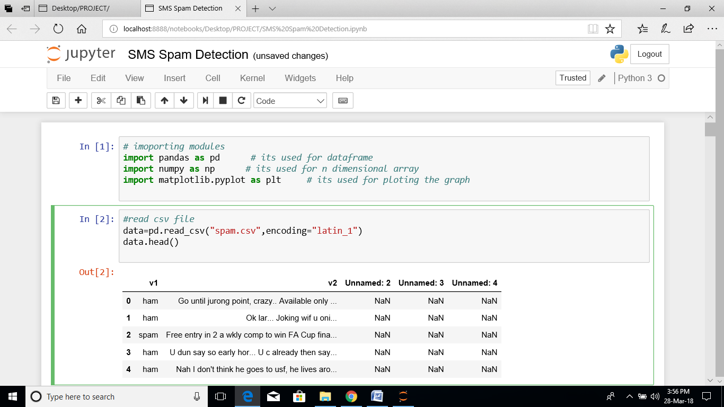

**Fig 9.1. Reading the Data**

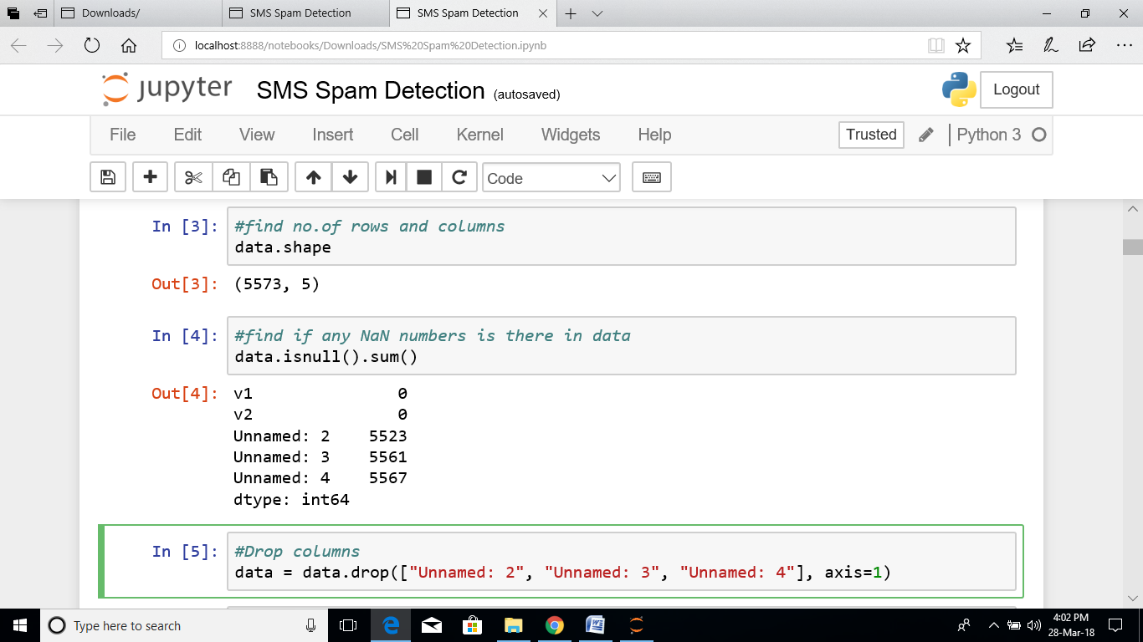

**Fig 9.2. Checking the Empty Data and Drop the columns**

**(Data preprocessing)**

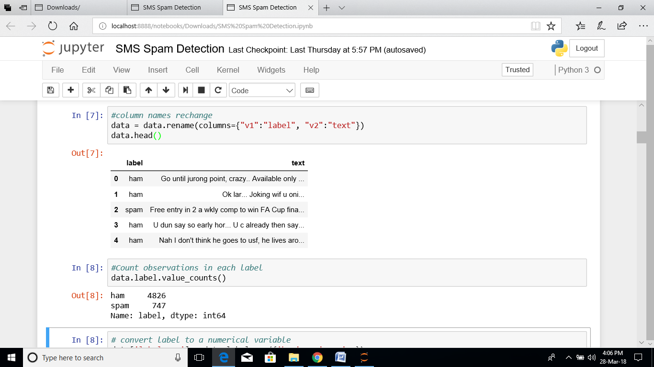

**Fig 9.3. After data preprocessing view the data**

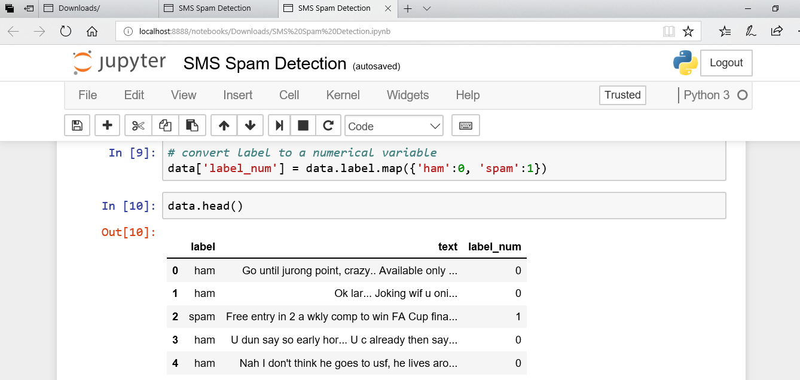

**Fig 9.4.the label can be rename as 0, 1 using .map function**

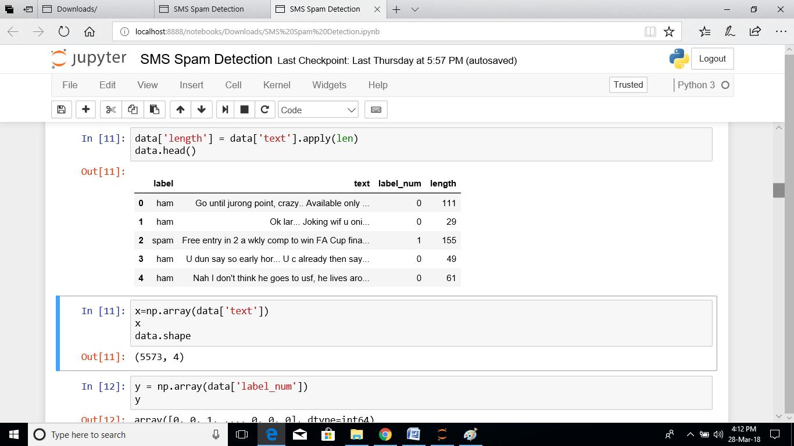

**Fig 9.5. Finding the lenth of messages and assiging x,y values**

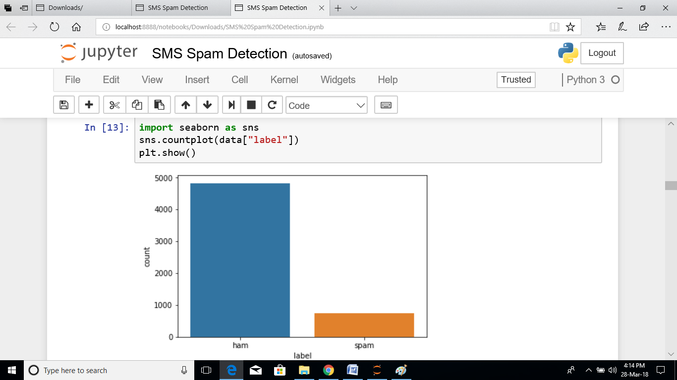

**Fig 9.6. Plotting the bar graph**

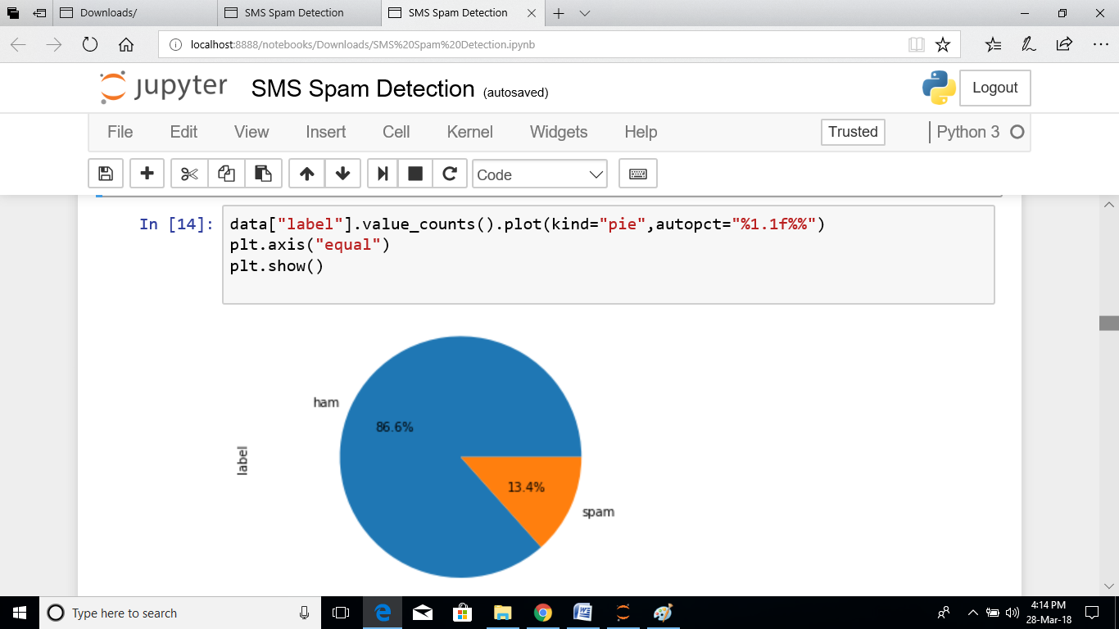

**Fig 9.7. Plotting the pie chart**

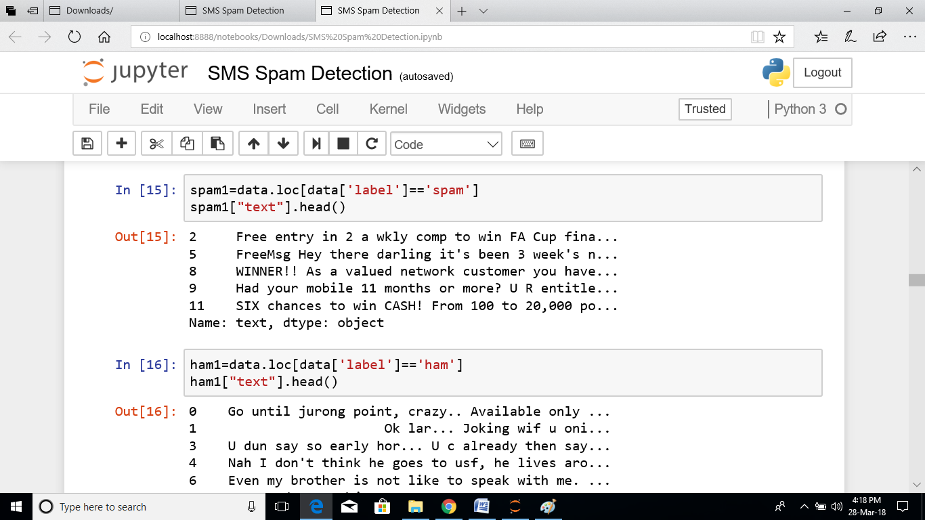

**Fig 9.8. Checking the spam and ham messages**

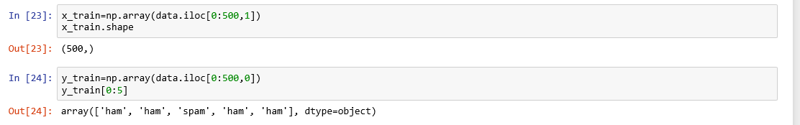

**Fig 9.9. Assign the x, y values**

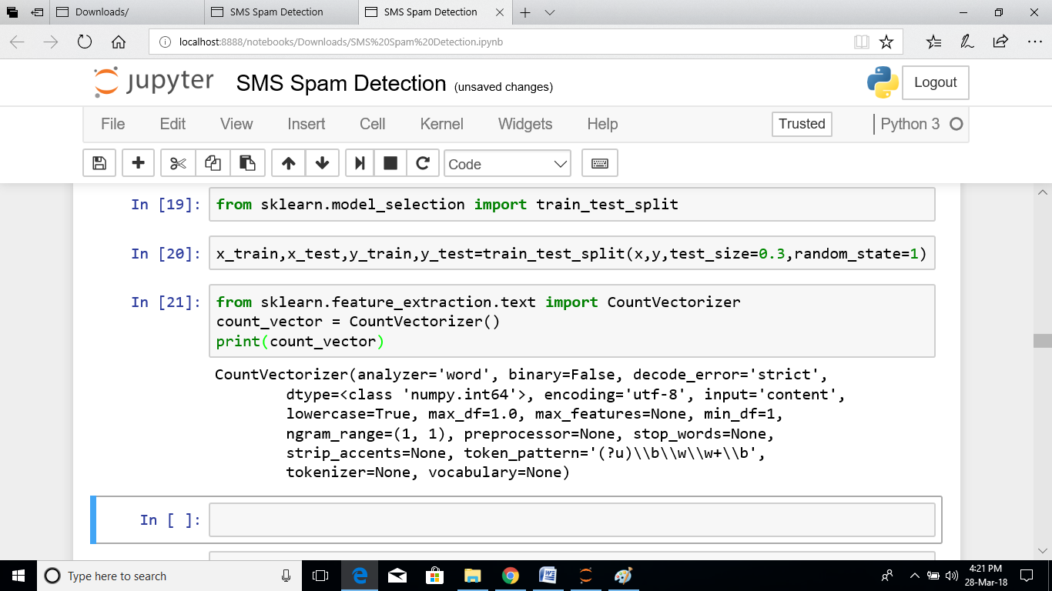

**Fig 9.10. Importing module and count vector split the data**

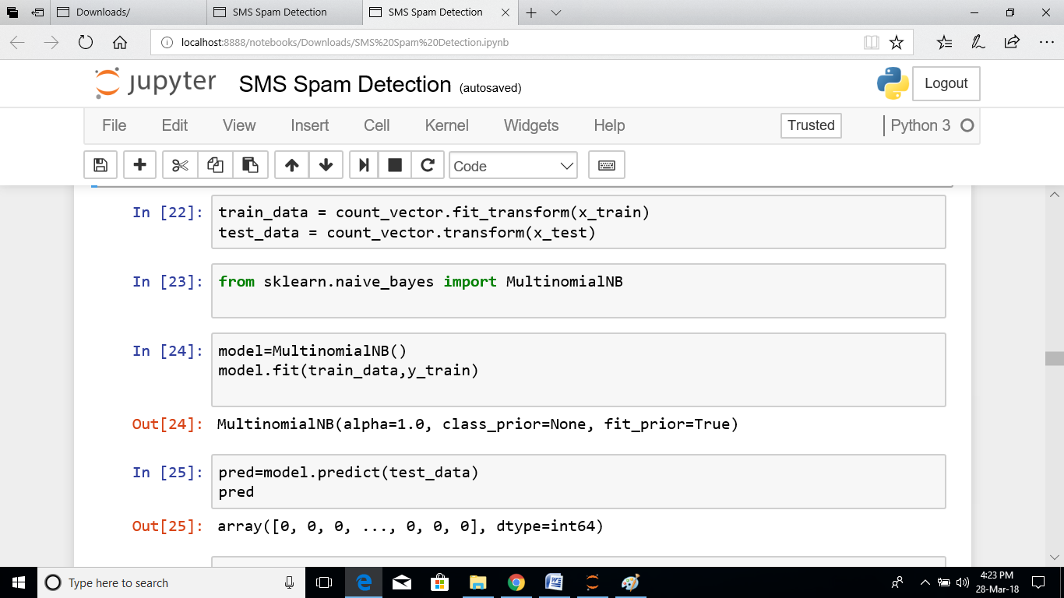

**Fig 9.11. Importing Naïve Bayes algorithm from sklearn**

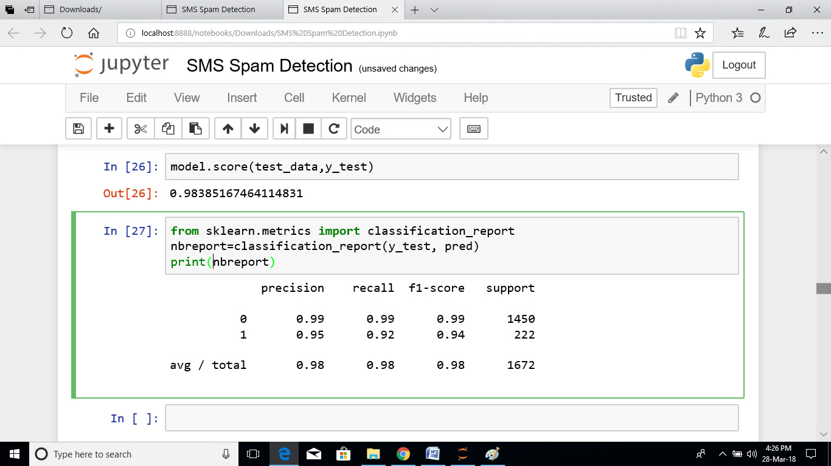

**Fig 9.12. Testing finding the accuracy**

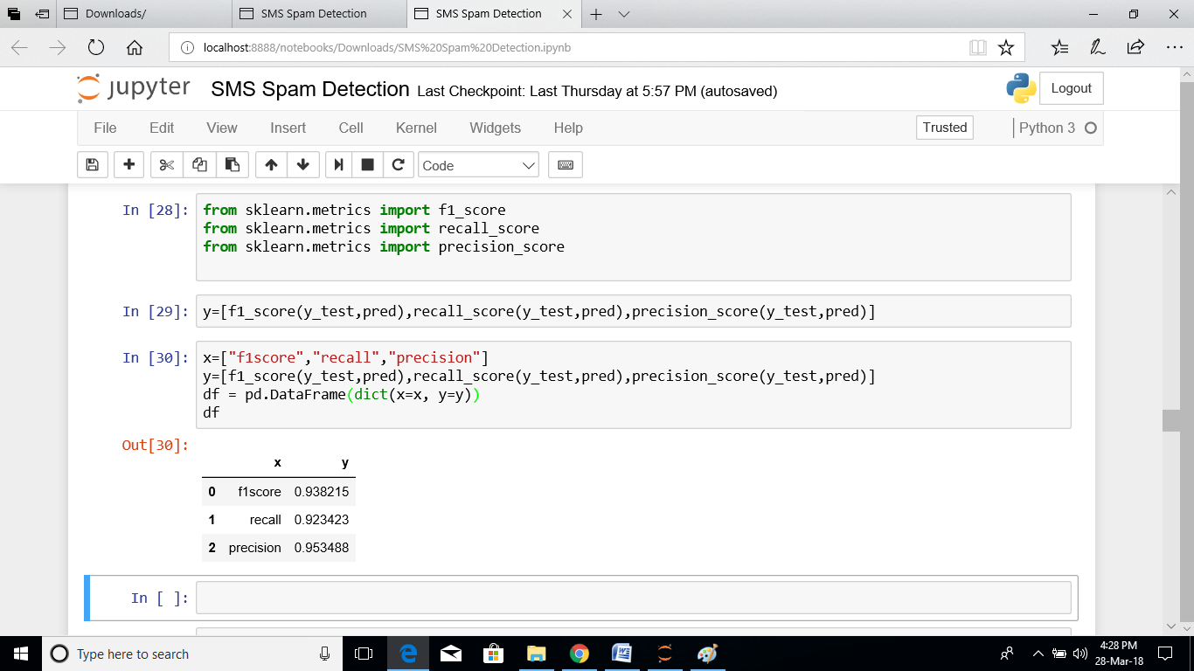

**Fig 9.13. Importing precision, recall, f1-score from sklearn**

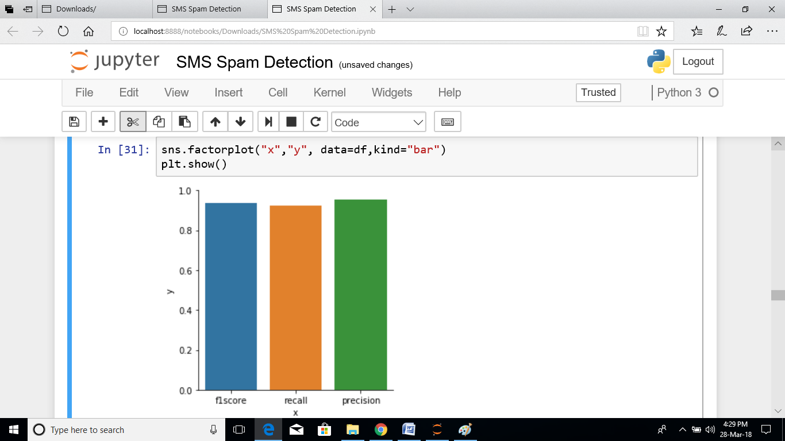

**Fig 9.14. Plotting the testing bar graph**

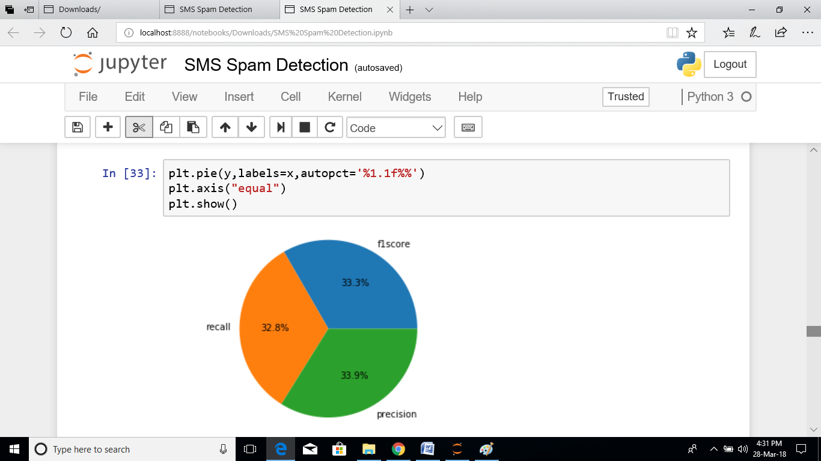

**Fig 9.15. Plotting the pie chart for testing**

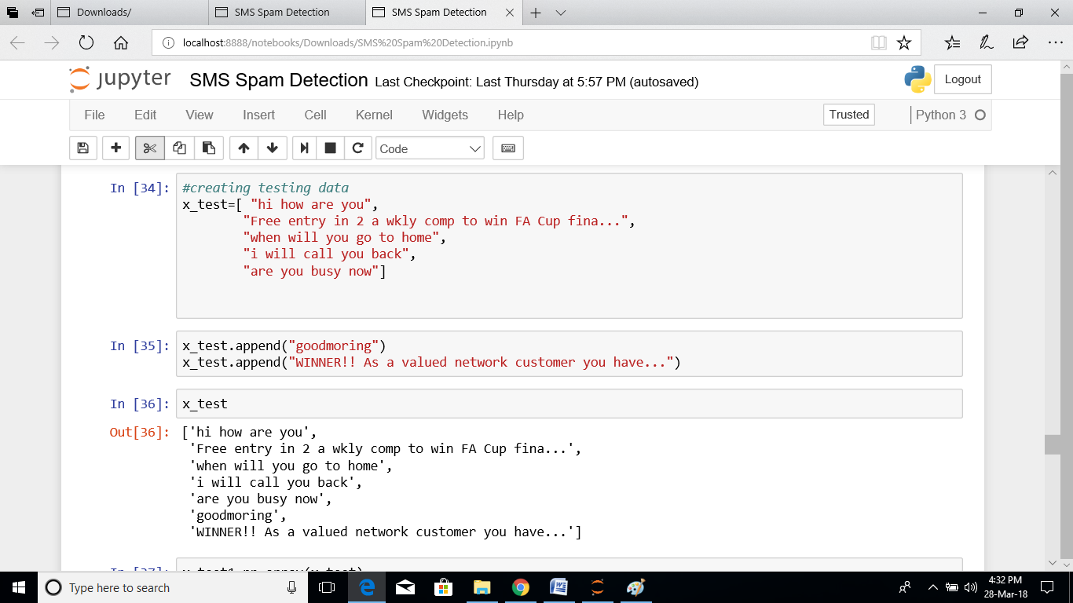

**Fig 9.16. System reading the new data from user**

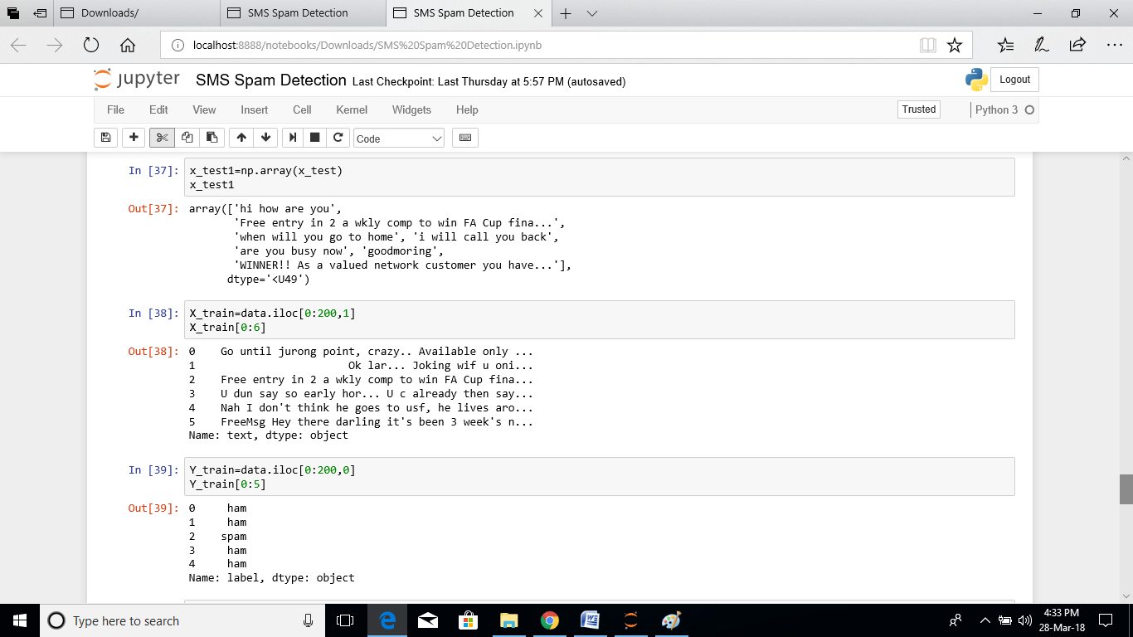

**Fig 9.17. New data converting into array and comparing with train data**

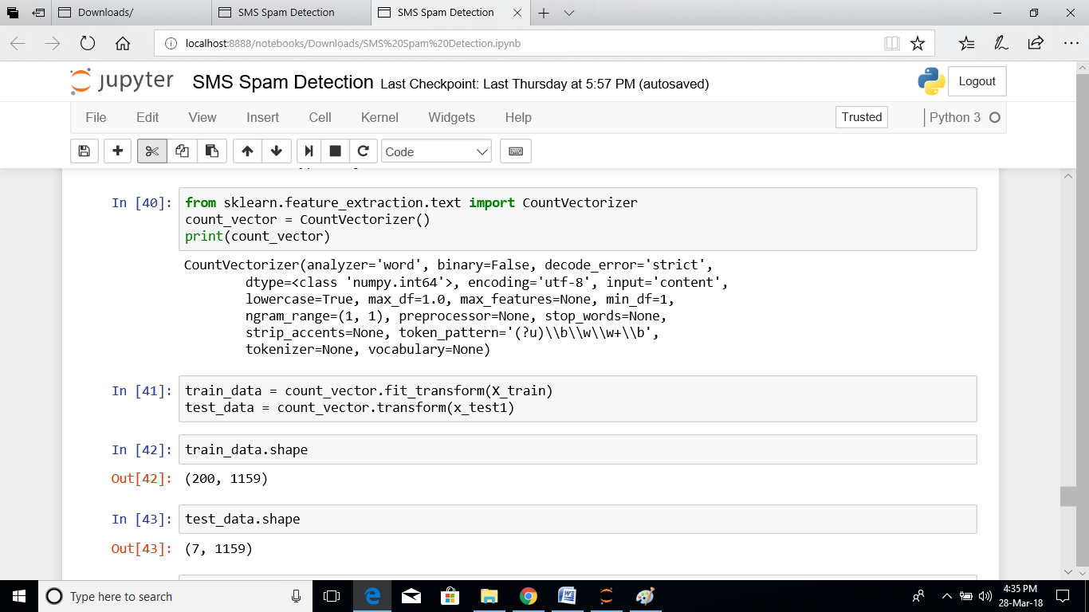

**Fig 9.18. Using fp-growth algorithm with use of feature extraction**

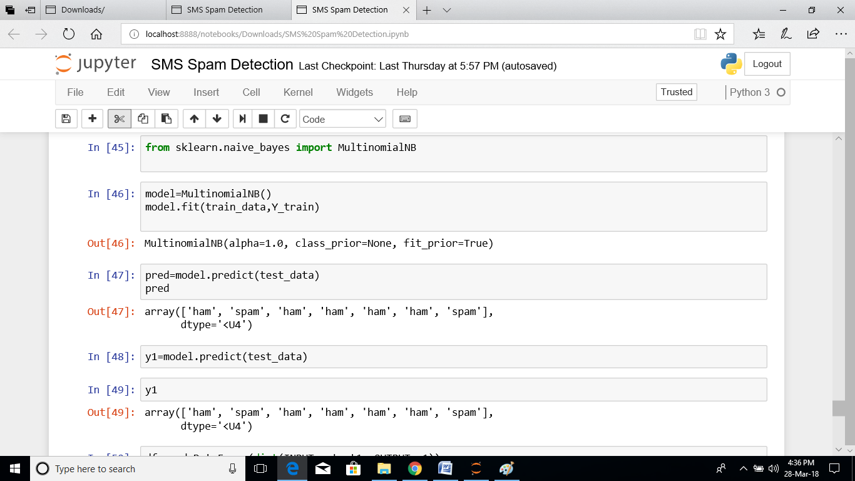

**Fig 9.19. Applying Naïve Bayes algorithm to predict the data**

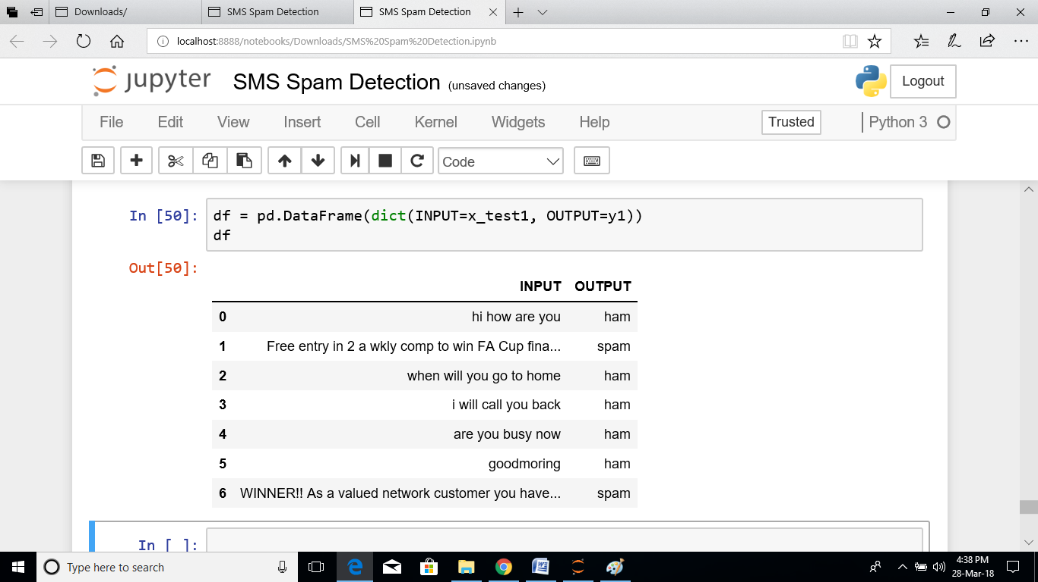

**Fig 9.20. Output of our project**

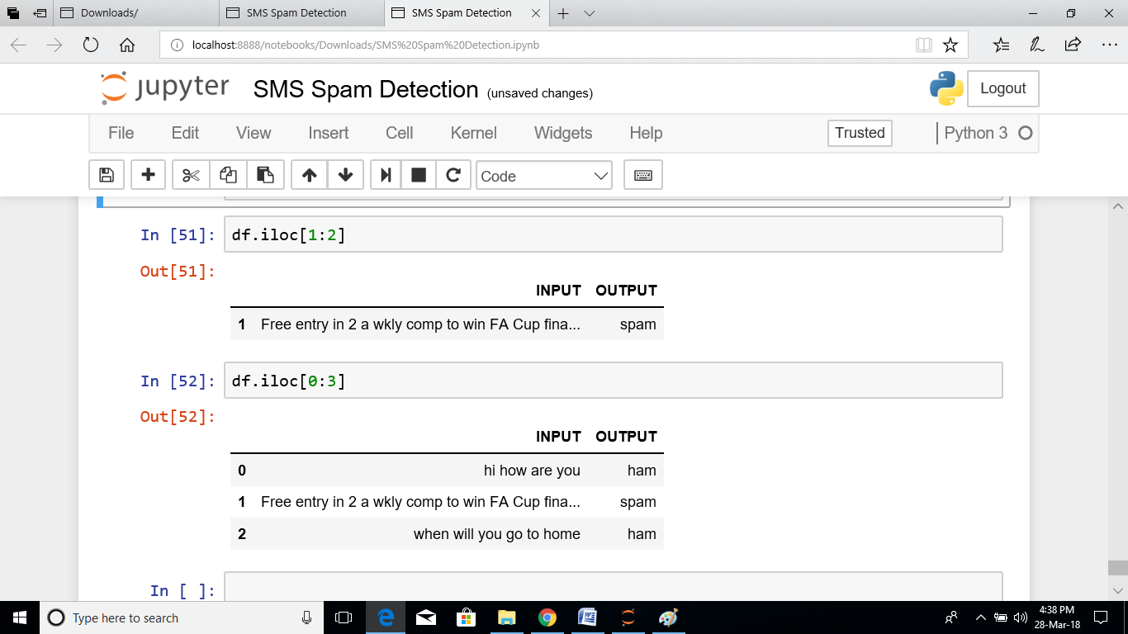

**Fig 9.21. to view the particular data**