Topsoe Ammonia Process

Report submitted to

Applied Process Engineering - CH203G

By

Chilaka Anand Sunhith, CH23B005

Chithirala Gargeya, CH23B006

Dharmesh S, CH23B008

Dharshan N K, CH23B009

M Pramod, CH23B022

Submitted on 22 September 2024

# Table of Contents

Table of Contents 1

1. Introduction 2

1.A. What is NH3: 2

1.B. What is Topsoe: 2

1.B.a. History: 3

1.B.b. Infrastructure: 3

1.B.c. Types of Ammonia Produced: 4

2. Salient Features 4

2.A. Advanced Catalyst Tech: 5

2.B. Integrated Production: 5

2.C. Modular Design Plant: 5

2.D. Heat Recovery System: 5

2.E. Technology and Procedures: 5

3. What happens in the Process? 6

3.A. Breakdown of Process Flow sheet 7

3.A.a. Feedstock Pre-Heater: 7

3.A.b. Hydrogenator: 7

3.A.c. H2S Absorber: 7

3.A.d. Adiabatic Reformer: 8

3.A.e. 1° Reformer: 8

3.A.f. 2° Reformer: 9

3.A.f. CO Shift Converter: 10

3.A.g. CO2 Absorber: 11

3.A.h. Methanator: 11

3.A.i. Ammonia Synthetic Converter (Haber-Bosch): 12

4. Statistics: 13

5. TABLE OF PROCESSES AND THEIR PARAMETERS 16

6. Advantages of the Topsoe Process: 18

7. Disadvantages of the Topsoe Process: 19

6. Abbreviation 20

# 1. Introduction

## 1.A. What is NH3:

* Ammonia is a versatile chemical compound that has primarily been used as a fertilizer in agriculture to feed the world's growing population, as well as in the production of numerous other chemicals, such as plastics, pharmaceuticals, and explosives.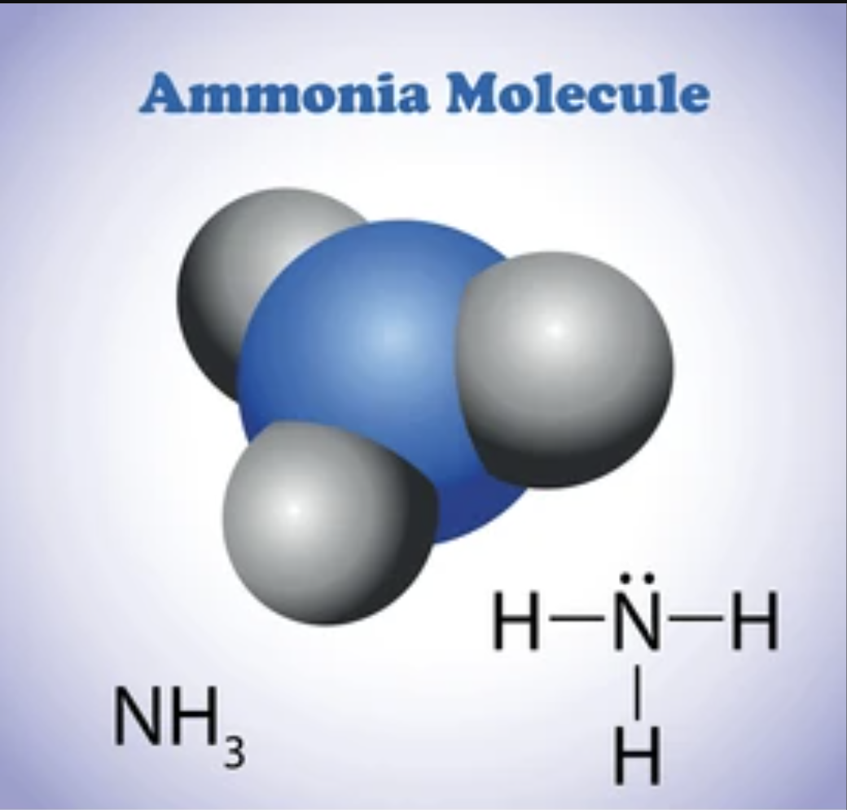
* Ammonia as a low-carbon energy carrier is receiving significant attention. Its high-energy density makes it an attractive fuel source, and when produced through a sustainable production method (low-carbon or green ammonia), ammonia is considered a game changer in decarbonizing the maritime industry and other energy-intensive industries where direct electrification is not an option. This will create a need for larger-than-ever built capacities.
* Being easy to store and transport, ammonia can be distributed worldwide by means of trucks, trains, ships, and pipelines. Ammonia is often discussed as the energy carrier and storage medium of the future and is considered an important transportation method for hydrogen.
* With the Haber-Bosch Process being one of the first to start the industrial production of ammonia, there have been significant advances in the field of ammonia production. One such advanced process/producer of ammonia is **Topsoe Process.**

## 1.B. What is Topsoe:

* The Topsoe process, developed by Haldor Topsoe, primarily refers to an advanced method for producing ammonia, leveraging steam reforming and various catalytic processes.
* The Topsoe process refers to a series of technologies and catalysts developed by Haldor Topsoe, a company known for its innovations in chemical engineering. One of their most notable contributions is in ammonia synthesis, particularly through the Haber-Bosch process.

### 1.B.a. History:

**“*Dr. Haldor Topsøe*** *founded the company in 1940 (Denmark), based on two things: A passion for science and a determination to make a positive difference in the world.***”**

* When growing up as a young man in the 1920s and 1930s, Dr. Haldor Topsøe saw many challenges. As a young scientist, he felt he needed to do something. Because he could. This led him to establish the company Haldor Topsøe.
* Dr. Haldor Topsøe’s **interest in chemistry and catalysis** was sparked during his study of physics with the prominent professor, **Niels Bohr**, at the Niels Bohr Institute in Copenhagen. That is where Dr. Haldor Topsøe first saw the potential of catalysis, which would become the basis of the company.
* Though catalysis was not prominent back then, Dr. Topsoe believed that one day it could serve a huge, unmet industrial need.
* Topsoe’s ammonia solutions have supported **fertilizer** **production** that has secured food for growing populations.
* Already in 1988, Dr. Haldor Topsøe predicted the climate challenges faced today:

**“*I wish*** *you would understand that the greenhouse effect will reach a point of no return, but we can postpone this through a more efficient use of fossil fuels and continued expansion of renewable energy*.**”**

* Dr. Haldor Topsøe’s contributions were recognized with many honors. These included the **Eminent Chemical Engineer Award** in Delhi in 1997. In 1999, he was awarded the **Engineer of the century** in Denmark for his devotion to chemical engineering and his determination to make science serve humanity and our planet.

### 1.B.b. Infrastructure:

1. **Raw Materials:** 
   1. Natural Gas – It serves as the primary feedstock. It provides the necessary Hydrogen needed for the process.
   2. Water – It is an important raw material, as it is used to produce syn gas.
   3. Air - It provides the necessary N2 required for the process.
   4. Catalysts - The process uses Fe and Ni – based catalyst, typically used for reforming, and synthesis processes to enhance reaction rates and efficiency.
2. **Storage of Raw Materials:**
   1. Natural Gas Storage – They are often stored in facilities with pressurized tanks, or underground tanks.
   2. Water Storage – Tanks are utilized for demineralized or treated water.
   3. Syn Gas Storage – Syn gas is stored in temporary containers, produced during reforming.
   4. Liquid Ammonia Tanks – Large, insulated tanks to store ammonia, typically under pressure to keep it in liquid form. Areas to facilitate tanks, trucks, and other transportation.
3. **Geographical Conditions of the Storage Location:**
   1. Climate – Oceanic climate/temperature is preferred.
   2. Location – Headquartered at Denmark. It has branches in various countries, including India. (Combination of favorable climate conditions, and strategic global presence are considered).
4. **Reaction Conditions:**
   1. Temperature – Different equipment is kept at a different temperature, typically ranging from *200 – 1000 °C.*
   2. Pressure – Similarly, the process is carried out at high pressures, typically at either 20-30 bar or 150-200 bar.

### 1.B.c. Types of Ammonia Produced:

Topsoe produces ammonia in 3 methods:

* Green Ammonia:
  + - It is projected for green ammonia to account for two-thirds of the total ammonia production by 2050.
    - It is produced from green hydrogen and nitrogen.
    - Uses S-300 Converter and KM1 catalyst.
* Blue Ammonia [Low-Carbon Ammonia]:
  + - Blue ammonia is a responsible way of producing ammonia that integrates carbon capture to minimize GHG emissions.
    - It is projected to have an increase of 688 MT in production and a market value of 400 billion by 2050.
    - It uses SynCOR™ Ammonia technology.
* Grey Ammonia [Conventional Ammonia]:
  + - It uses SynCOR Ammonia technology.

# 2. Salient Features

### 2.A. Advanced Catalyst Tech:

* Their proprietary catalyst technology ensures a high conversion rate for ammonia production, from raw materials. These catalysts withstand elevated temperature and pressure, ensuring lifespan, and reducing costs.
* Ni and Fe based catalysts are prominently used.

### 2.B. Integrated Production:

* Topsoe has an integrated Hydrogen production system, through SMR or other methods.
* This provides a steady supply of high-purity Hydrogen.

### 2.C. Modular Design Plant:

* It provides modular plants for easy scaling.
* ModuLite™ Green Ammonia Plant makes this possible and is available in 300 and 600 MTPD versions.

### 2.D. Heat Recovery System:

* It uses advanced heat recovery systems to reuse waste energy/heat. This increases plant efficiency, as input energy is less.

### 2.E. Technology and Procedures:

* It works on the principle of recycling (CO2 or heat or others), increasing efficiency.
* It also uses advanced technology ensuring safety and efficiency of production.
* S – 300 Converter**:**
  + The converter’s three catalyst beds with radial flow allow for higher conversion rates using small catalyst particles. This results in higher overall catalyst activity, meaning greater overall efﬁciency and higher proﬁt margins.
  + Advantages for green ammonia production include the ability to ramp up and down with ﬂuctuating feedstock loads, as well as sustained reliable operation at loads down to 10% of nameplate capacity.
* SynCOR Ammonia Technology**:**
  + The technology brings significant benefits in large-scale applications, most notably an extremely low steam-to-carbon ratio of 0.6 and potential for single-train capacities exceeding 6,000 MTPD. This enables ammonia and urea producers to gain unprecedented economies of scale that cannot be achieved with conventional technology.
  + Some advantages:
    - Low steam-to-carbon ratio
    - Exceptionally low water consumption
    - Reduced environmental impact
    - Great economy of scale
    - High safety
    - Technology for generous size plants
* With Catalyst:
  + Maximize plant’s design efficiency and sustain its performance
  + Minimize supply-chain risks with catalysts developed using non-exotic materials
  + Enjoy comprehensive support based on out of eight decades of ammonia-industry experience.
  + KM1 - Promoters that ensure high and stable activity.
    - Advantages:
      * Long-term reliability
      * Superior and stable activity
      * Outstanding poison resistance
      * Pre-reduced option for fast startup

# 3. What happens in the Process?

## 3.A. Breakdown of Process Flow sheet

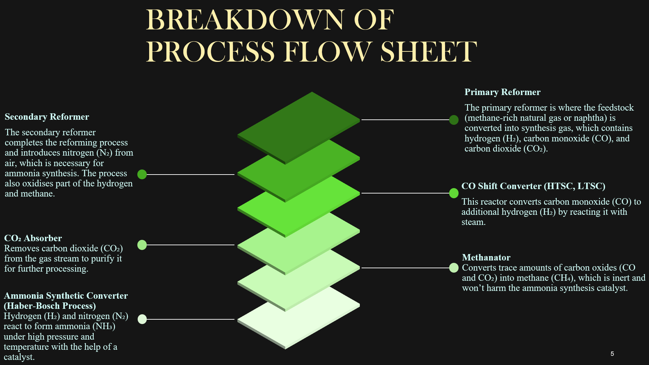

### 3.A.a. Feedstock Pre-Heater:

* NAPHTHA is taken as feed, along with FG, and is heated to a certain desired temperature. Temperature range is typically ~ 800 – 950 °C.

### 3.A.b. Hydrogenator:

* Naphtha containing impurities like sulfur, when processed in a hydrogenation unit, reacts with hydrogen to produce alkanes and H₂S. During this process, the sulfur impurities are removed as H₂S gas, while the unsaturated hydrocarbons in naphtha are converted to alkanes.

**R-S + H2 → R-H + H2S**

### 3.A.c. H2S Absorber:

* When the mixture of alkanes and H₂S is fed into an H₂S absorber, the absorber selectively removes the H₂S from the mixture, leaving behind only alkanes. Typically, the absorber contains a solvent or chemical agent, such as an amine solution, that reacts with or absorbs the H₂S, resulting in purified alkanes in the output stream.

### 3.A.d. Adiabatic Reformer:

* When alkanes are fed into an adiabatic reformer, they undergo a steam reforming reaction with water (steam), producing CO and H₂ as the primary products. This reaction typically occurs at elevated temperatures and is endothermic, but in an adiabatic reformer, no external heat is supplied, so the reaction relies on the heat generated from the previous reactors.

**CnH2n+2 + nH₂O → nCO + (2n+1) H₂**

### 3.A.e. 1° Reformer:

* The primary reformer is where the feedstock (CH4-rich natural gas or naphtha) is converted into synthesis gas, which contains H₂, CO, and CO₂.

#### Inputs**:**

* + **Hydrocarbon feedstock:** Natural gas (CH₄) or NAPHTHA (complex hydrocarbons)
  + **FG:** High-pressure steam is added for the steam reforming reaction.
  + **Catalyst:** Typically, a nickel-based catalyst is used to facilitate the reforming reaction.
  + **Reaction:**

**CH4 + H2O → CO + 3H2**

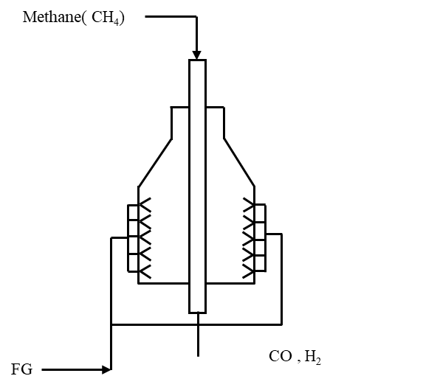

#### Outputs**:**

* + **H₂:** Main component needed for ammonia synthesis.
  + **CO:** A byproduct that will be converted into a 2° reformer or later processed.
  + **CO₂:** Produced in small quantities.
  + **CH₄:** A portion of methane remains unreacted.

### 3.A.f. 2° Reformer:

* The secondary reformer completes the reforming process and introduces N₂ from air, which is necessary for ammonia synthesis. The process also oxidizes parts of H and CH₄.

#### **Inputs:**

* + **Output gas from the primary reformer:** Contains H₂, CO, CO₂, and unreacted CH₄.
  + **Air:** Provides N₂ and O₂.
  + **Catalyst:** Ni-based or other reforming catalysts.

#### **Reactions:**

* + **Partial Combustion:**

**CH4 + 1.5O2 → CO + 2H2 O (**exothermic)

**H2 + 0.5O2 → H2 O (**exothermic)

* + **Further Steam Reforming:**

**CH4 + H2O → CO + 3H2** (endothermic)

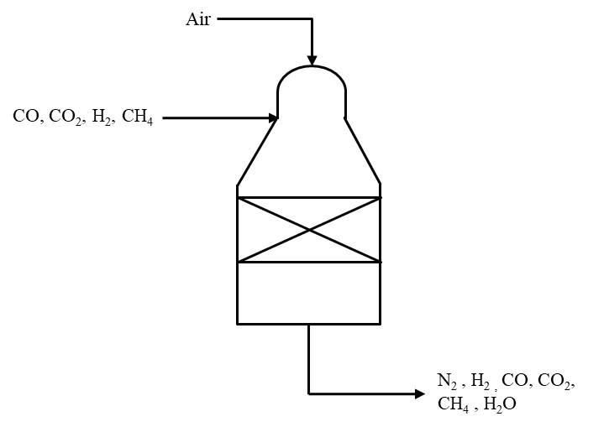

#### **Outputs:**

* + **H₂:** In larger quantities.
  + **N₂:** Introduced from the air, needed for ammonia synthesis.
  + **CO:** Residual amounts.
  + **CO₂:** Increases due to reforming and partial combustion.
  + **H₂O:** Produced from combustion.
  + **CH₄:** Trace amounts remain unreacted.

### 3.A.f. CO Shift Converter:

* This reactor converts CO to additional hydrogen H₂ by reacting it with steam.
* **Inputs:**
  + **Syn gas from the secondary reformer:** Contains CO, H₂, CO₂, and H₂O (g).
  + **H₂O (g):** Used in the water-gas shift reaction.
  + **Catalyst:** Typically, iron-based, or copper-based catalyst.

#### **Reactions:**

* + **Water-Gas Shift Reaction:**

**CO + H2O → CO2 + H2** (exothermic)

#### **Outputs:**

* + **H₂:** More hydrogen is produced.
  + **CO₂:** Byproduct of the shift reaction.
  + **Residual CO:** Exceedingly less amounts remain.
  + **H₂O:** Present as vapor or liquid, depending on the system.

### 3.A.g. CO2 Absorber:

* Removes CO₂ from the gas stream to purify it for further processing.

#### **Inputs:**

* + **Shifted synthesis gas**: Contains H₂, N₂, CO₂, and traces of CO.
  + **Solvent/Absorbent**: A chemical like monoethanolamide (MEA) or potassium carbonate, used to absorb CO₂

#### **Reactions:**

* + **CO₂ Absorption**: The solvent captures CO₂ from the gas stream, leaving a CO₂-free mixture behind.

#### **Outputs:**

* + **H2 and N2-rich gas**: Clean gas mixture (H₂ and N₂) ready for further use.
  + **Absorbed CO₂**: Collected by the solvent and can be stripped out for venting or reuse.

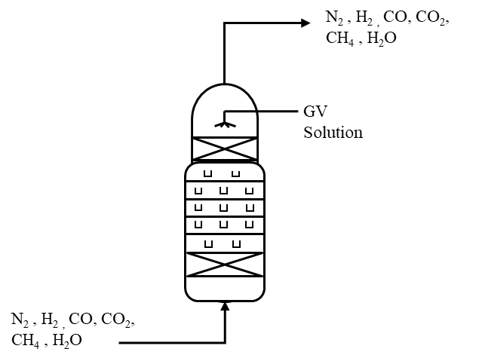

### 3.A.h. Methanator:

* Converts trace amounts of carbon oxides (CO and CO₂) into methane (CH₄), which is inert and will not harm the ammonia synthesis catalyst.

#### **Inputs:**

* + **CO₂-removed synthesis gas**: Contains H₂, N₂, and trace CO and CO₂.
  + **H₂**: Reacts with CO and CO₂.
  + **Catalyst**: Nickel-based.

#### **Reactions:**

* + **CO Methanation**:

**CO Methanation: CO + 3H2 → CH4 + H2O** (exothermic)

* + **CO₂ Methanation**:

**CO2 + 4H2 → CH4 + 2H2O (**exothermic)

#### **Outputs:**

* **CH₄**: Inert gas.
* **H₂O**: Byproduct.
* **H₂ and N₂-rich gas**: Cleaned and ready for ammonia synthesis.

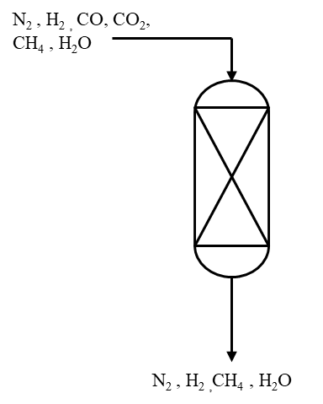

### 3.A.i. Ammonia Synthetic Converter (Haber-Bosch):

* H₂ and N₂ react to form NH₃ under high pressure and temperature with the help of a catalyst.

#### **Inputs:**

* + **H₂**: From the methanation reactor.
  + **N₂**: From air added in the secondary reformer.
  + **Catalyst**: Iron-based.

#### **Reaction:**

* + **Ammonia Synthesis**: N2 + 3H2 → 2NH3 (exothermic)
* **Outputs:**
  + **Ammonia (NH₃)**: Can be in gas or liquid form after cooling.
  + **Unreacted H₂ and N₂**: Recycled back into the reactor for efficiency.

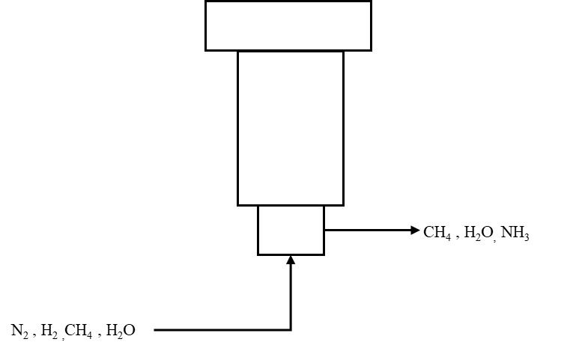

# 4. Statistics:

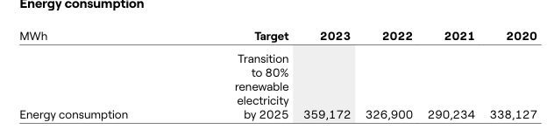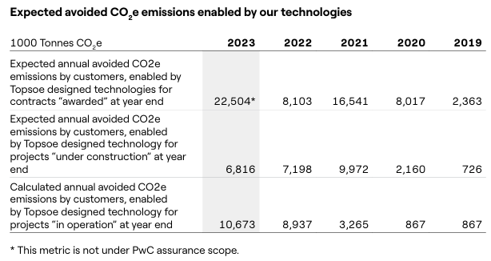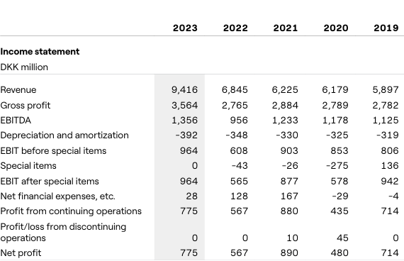

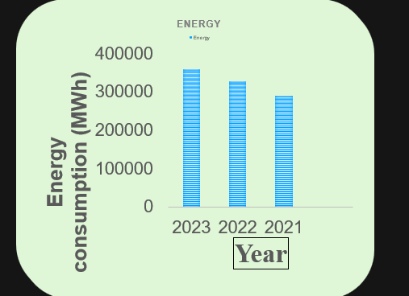

Fig. Energy consumption per year (2021 – 2023)

# 5. TABLE OF PROCESSES AND THEIR PARAMETERS

|  |  |  |  |  |
| --- | --- | --- | --- | --- |
| Process -> | **Haber - Bosch** | **Topsoe process** | **Linde** | **Krupp Uhde** |
| Parameters |  |  |  |  |
| Temperature | 300-500 ℃ | 370-460 ℃ | 400-500℃ | 740 - 950 ℃ |
| Pressure | 60 – 180 bars | 50-100 bars | 150-300 bar | 50 - 70 bars |
| Reactor type | Fixed-bed reactor | Gibbs and water boiling reactor | Steam reformer | Multi-bed catalytic reactor |
| Catalyst | Iron-based (magnetite, wustite) | Iron based synthesis catalyst | Nickel based | Platinum-rhodium gauze catalyst |
| Feed/Reactant Conditions | Pure N2, H2 | Pure N2, H2 | Natural gas and air | Mixture of NH₃ and O2 |
| Yield per day | >3000 tons | 1,650 metric tons | 1500 tons | 3,300 metric tons |
| Yield per year | 2,721 metric tons | 6,02,250 metric tons | 5,00,000 tons | 1204500 metric tons |
| Set of Chemical reactions (Raw material to ammonia) | **Steam Reforming:** CH₄(g) + H₂O(g) → CO(g) + 3H₂(g)  **Water-Gas Shift Reaction:**  CO(g) + H₂O(g) → CO₂(g) + H₂(g)  **Electrolysis:** 2H₂O(l) → 2H₂(g) + O₂(g)  **Main Reaction:**  N₂(g) + 3H₂(g) ⇌ 2NH₃(g)  This produce required raw materials. | 3 Hydrogen gas molecules with 1 N2 gas molecules over a catalyst bed | CH₄(g) + H₂O(g) → CO(g) + 3H₂(g)  N₂(g) + 3H₂(g) ⇌ 2NH₃(g) | **Ammonia Oxidation**: 4 NH3(g) + 5 O2(g) → 4 NO(g) + 6 H2O(g)  **NO Oxidation to NO₂**:  2 NO(g) +O2(g) → 2 NO2(g)  **Absorption and Formation of HNO₃**: 3 NO2(g) +H2O(l) →2 HNO3(aq) + NO3(g)  **Overall Reaction**: NH3(g) + 2O2(g) → HNO3(aq) + H2O(l) |
| Plant shutdown/Maintenance days | Generally **1-3 years**, for major maintenance, depends on factors like: Size of plant, Equipment age, etc. Minor maintenance checks occur regularly, for safety. | Impact negatively on day by day operations. | 32 days | Typically, shutdowns for Krupp Uhde processes can range from **20 days** to **13 weeks** for Plant Size and Complexity, Regulatory Requirements, and Planned Improvements. |
| Indian Industry content | Fertilizers, refrigerants, explosives (mining, defense),  raw materials (dyes, etc) | Electrolysis and petrochemicals | Praxair | Fertilizers, petrochemicals and organic chemicals ,Metallurgy, Green chemicals |
| Global Industry content | Apart from the ones mentioned above, it is utilized to produce clean energy (from hydrogen, by product) | Electrolysis, petrochemicals fuels and oil natural gas | Linde provides technology, engineering services, and equipment to ammonia production plants around the world. | Fertilizers, petrochemicals and organic chemicals ,Metallurgy, Green chemicals , digits products. |
| Energy consumption | 2% of world consumption | 7.2 Mwh of energy per ton | 0.4078 Mwh of energy per ton | 6.6 - 7.2 Gcal per metric ton |
| BY Products | Unconverted reactants, water (sometimes), ammonium carbamate (side rxn), impurities (CO, CO2) | CO2, olefins, H2S, aromatics, Water, traces of CH4 or NOx | Carbon di-oxide | Slag, Fly ash , sulphuric acid , carbon dioxide , H2 and O2 |

# 6. Advantages of the Topsoe Process:

* **Lower Pressure Operation:**
  + The Topsoe process operates at relatively **moderate pressures (50-100 bars)** compared to the **Haber-Bosch process (60-180 bars)** and **Linde process (150-300 bars)**. This reduces the need for high-pressure equipment, improving **safety** and **reducing operational costs**.
* **Moderate Temperature:**
  + The Topsoe process uses a **temperature range of 370-460°C**, which is lower than the **Krupp Uhde process** (740-950°C). Lower operating temperatures improve **catalyst life** and reduce the energy required for the process.
* **Iron-Based Catalyst:**
  + The **iron-based catalyst** used in the Topsoe process is **cost-effective** and readily available, compared to more expensive catalysts such as the **platinum-rhodium** used in Krupp Uhde.
* **Adaptability:**
  + The Topsoe process is adaptable and can be integrated with various hydrogen production methods, including **steam reforming, electrolysis, and natural gas**.
* **Efficient Use of By-products:**
  + By-products such as **CO₂, olefins, and aromatics** can be separated and used in other chemical processes, adding value to the production chain.

# 7. Disadvantages of the Topsoe Process:

* **Lower Daily Yield:**
  + The Topsoe process has a daily yield of **1,650 metric tons**, which is significantly lower than other processes like **Krupp Uhde (3,300 metric tons)** and **Haber-Bosch (>3,000 metric tons)**. This may limit the scalability of the process for large-scale ammonia production.
* **Higher Energy Consumption:**
  + The Topsoe process consumes **7.2 MWh per ton of ammonia**, which is higher compared to the **Linde process (0.4078 MWh/ton)** and even slightly higher than the **Krupp Uhde process**. This makes it less energy-efficient in comparison to the alternatives.
* **More Complex By-product Handling:**
  + The Topsoe process produces several by-products, including **CO₂, H₂S, olefins, and aromatics**. This requires additional separation and handling processes, increasing the complexity and cost of the plant's operations.
* **Shorter Maintenance Interval:**
  + The Topsoe process requires a shutdown every **32 days**, which is more frequent than the **Haber-Bosch process** (which typically runs for **1-3 years** between major shutdowns). This can lead to more frequent downtime and potentially higher maintenance costs.
* **Lower Process Flexibility:**
  + Compared to processes like **Linde** and **Krupp Uhde**, which can handle a wider range of feedstocks (such as natural gas and air), the Topsoe process primarily uses **pure H₂ and N₂**, limiting its flexibility in terms of feedstock variability.

# 8. Abbreviation

1. NH3 – Ammonia
2. H2 – Hydrogen
3. N2 – Nitrogen
4. S – Sulphur
5. H2S – Hydrogen Sulphide
6. CH4 – Methane
7. H2O – Water
8. CO – Carbon monoxide
9. CO2 – Carbon Dioxide
10. Fe – Iron
11. Ni – Nickel
12. FG – Fuel Gas
13. GV – Gas absorbing solution
14. WHB – Waste Heat Boiler
15. BFW – Boiler Feed Water
16. Hot HE – Hot Heat Exchanger
17. HTSC – High Temperature Shift Converter
18. LTSC – Low Temperature Shift Converter
19. KM1 – a Catalyst
20. MT – Metric Tonne
21. MTPD – Metric Tonnes Per Day
22. Syn gas – Synthetic Gas
23. S-300: - A type of Reactor
24. SMR - Steam Methane Reforming
25. GHG – Greenhouse Gases
26. ™ - Trademark symbol

# 9. References

1. [Flow sheet reference](https://enggyd.blogspot.com/2010/09/haldor-topsoe-process-flow-sheet.html)
2. [Chemcial Plant Design - M Omotioma](https://www.researchgate.net/publication/337428668_Chemical_Plant_Design_for_the_Production_of_Ammonia_through_Haldor_Topsoe_Process_Route_Simulation_using_Plant_Design_Management_System?enrichId=rgreq-4493154df38fb3244b19d059c09812c8-XXX&enrichSource=Y292ZXJQYWdlOzMzNzQyODY2ODtBUzo4Mjc3OTAwODE0MDA4MzVAMTU3NDM3MTk0MzQ3NQ%3D%3D&el=1_x_2)
3. [Topsoe Website](http://topsoe.com)
4. [3D render Website](http://meshy.ai)