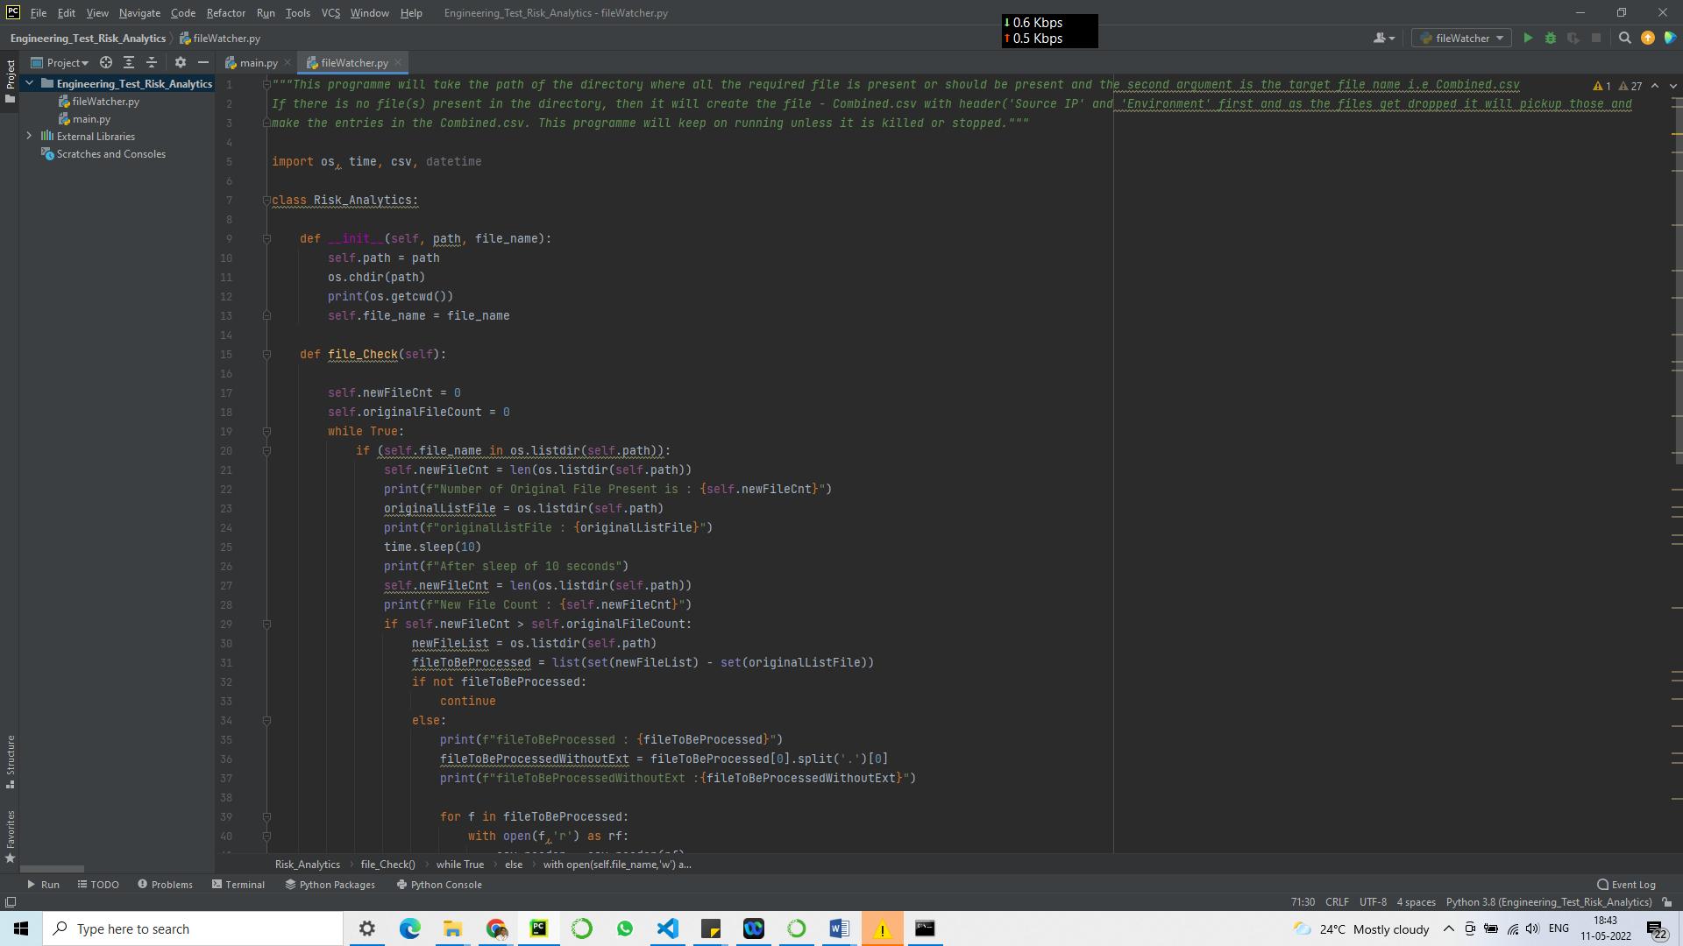

Source folder Path : C:\Users\91998\Documents\Pramod\Official\TCS\Engineering Test Risk Analytics\Engineering Test Risk Analytics\Engineering Test Files

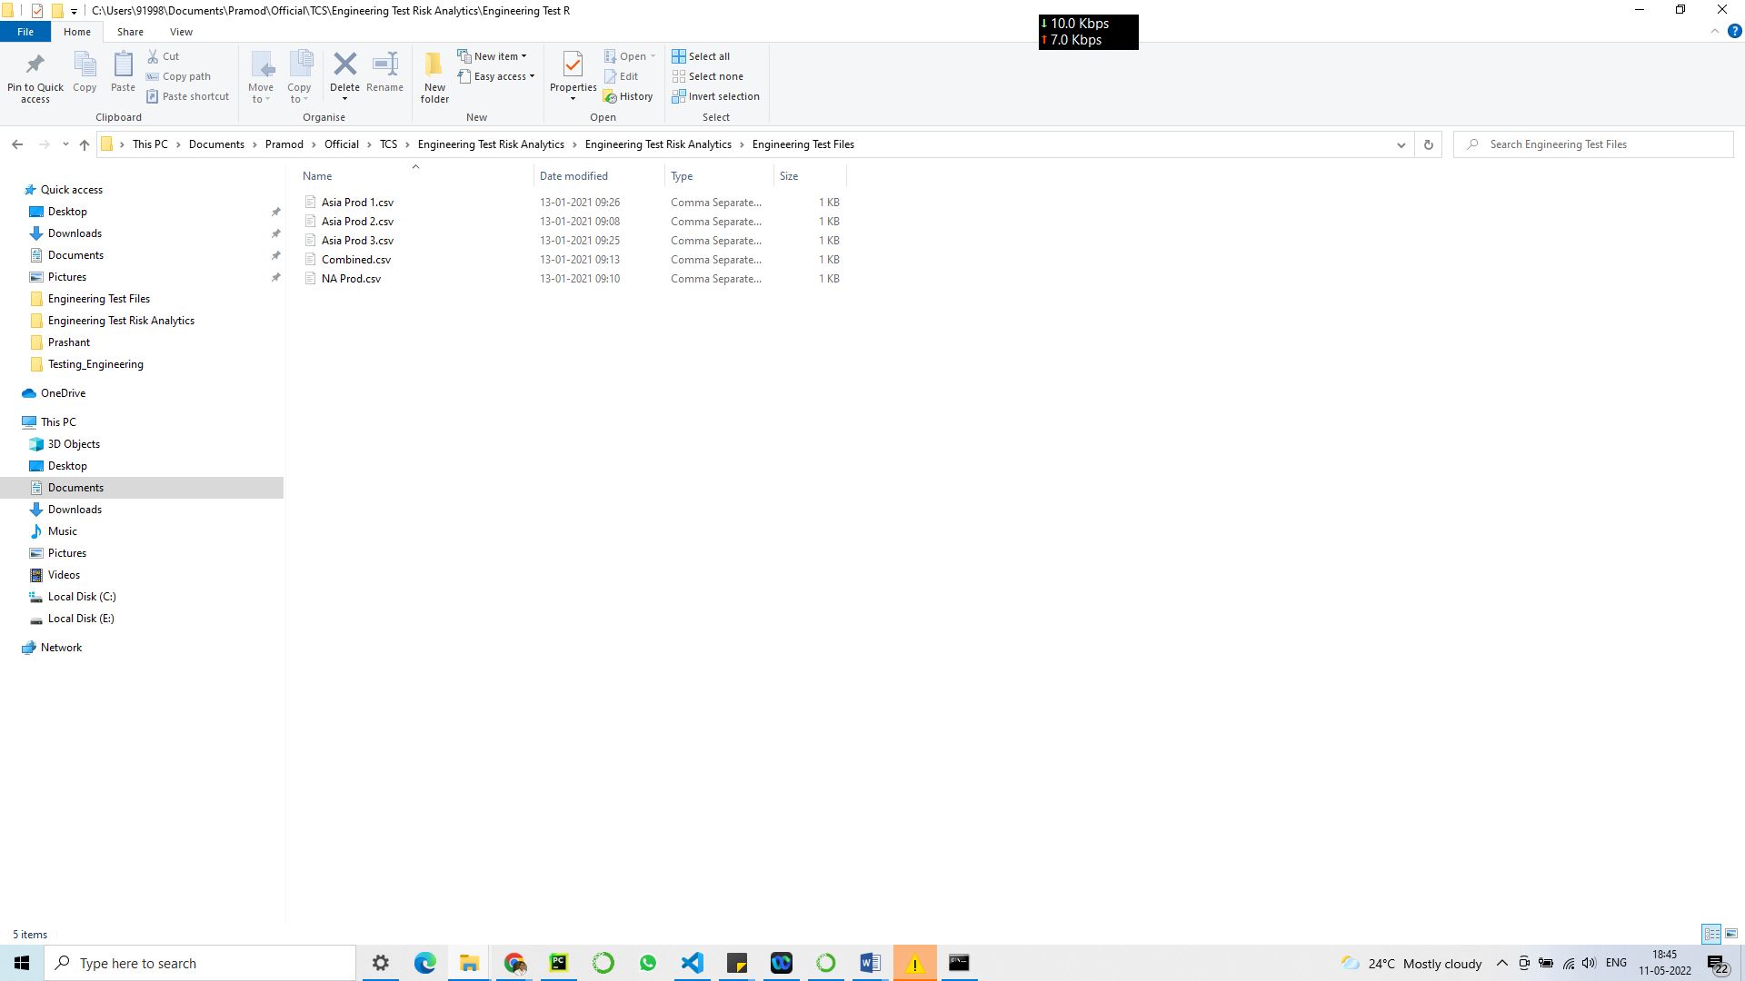

Target folder path : C:\Users\91998\Documents\Pramod\Official\TCS\Engineering Test Risk Analytics\Testing_Engineering

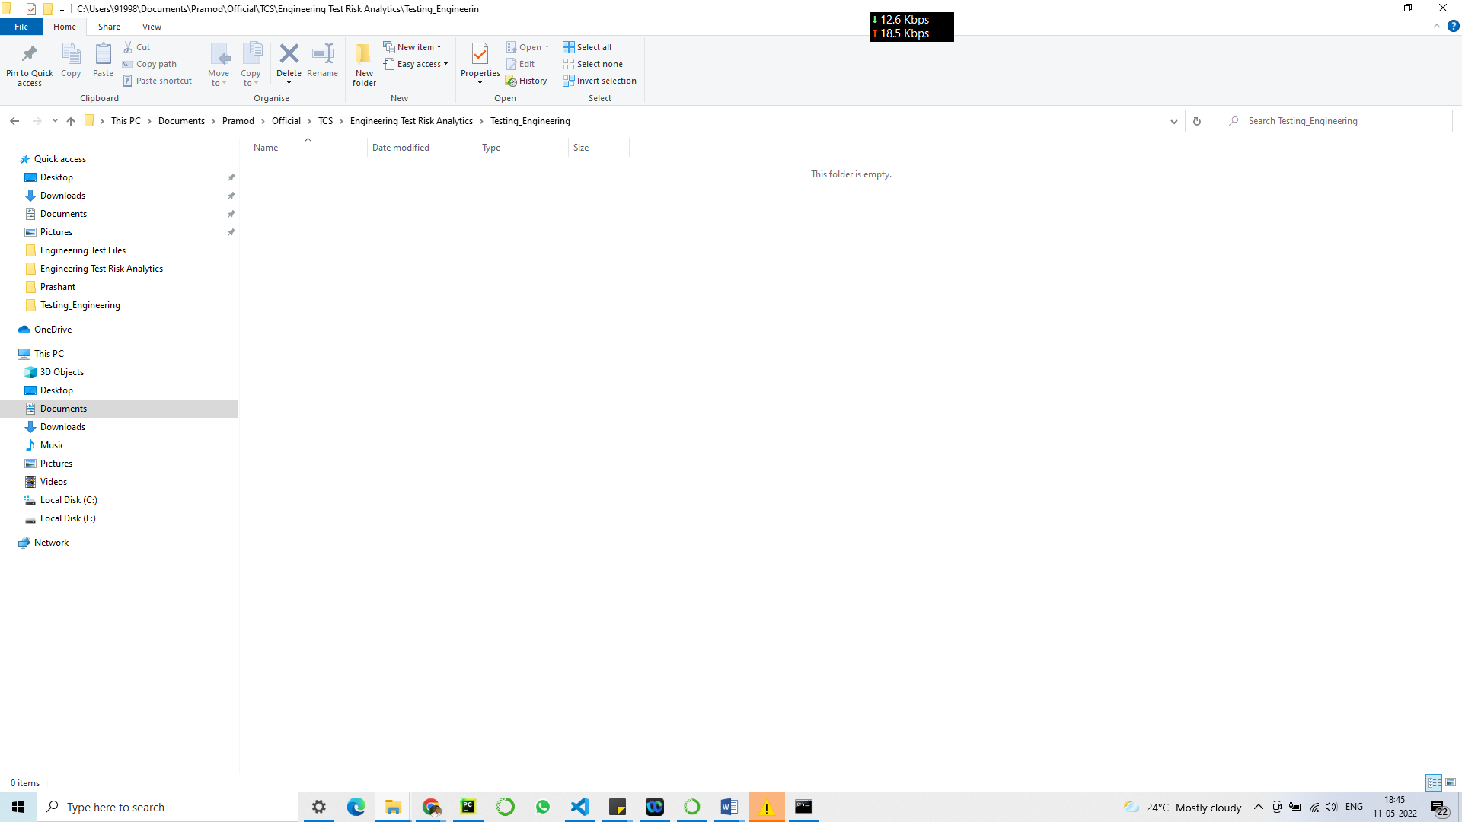

At the beginning there is no files in the target folder as shown above.

When the code starts executing as shown below, it does the below steps:

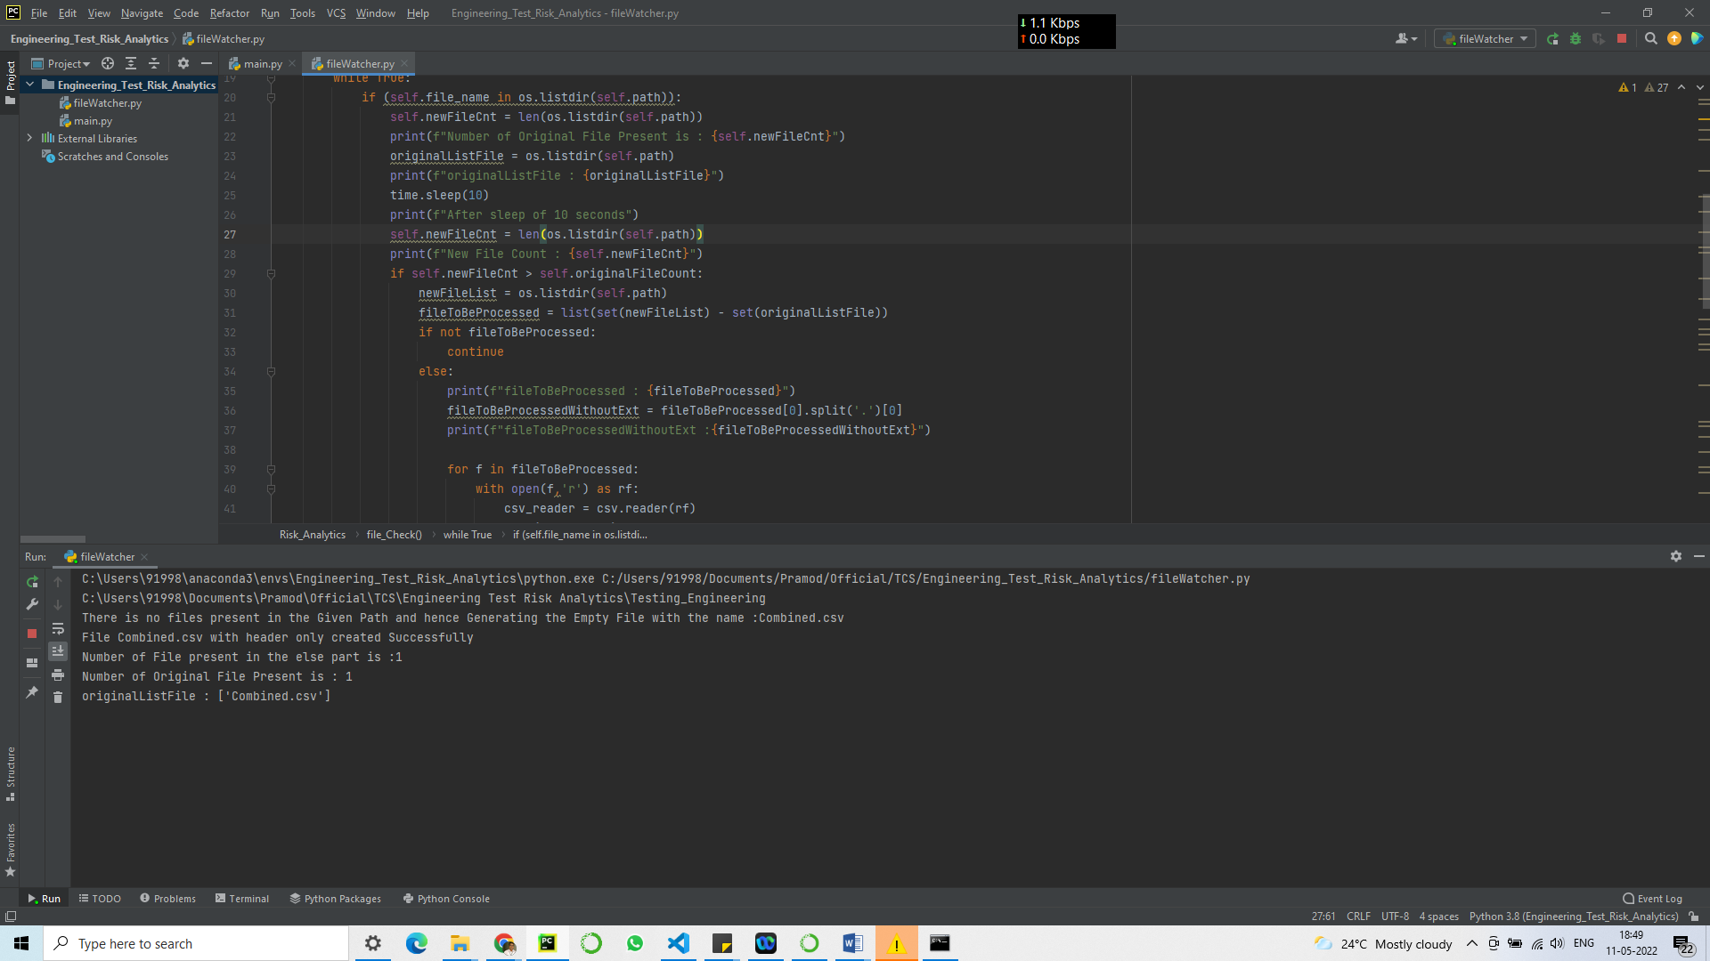

* Checks whether the file ‘Combined.csv’ is present or not, if not then it will generate it.

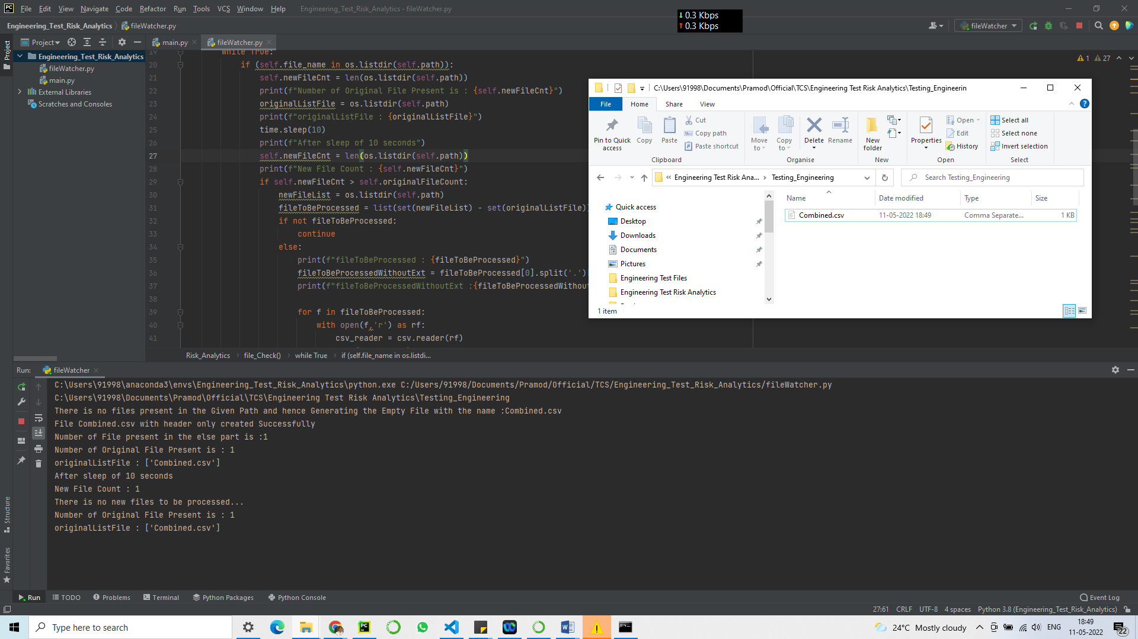

* And if Present, it will wait for the files to be dropped into the target folder with some custom messages as shown below:
  + 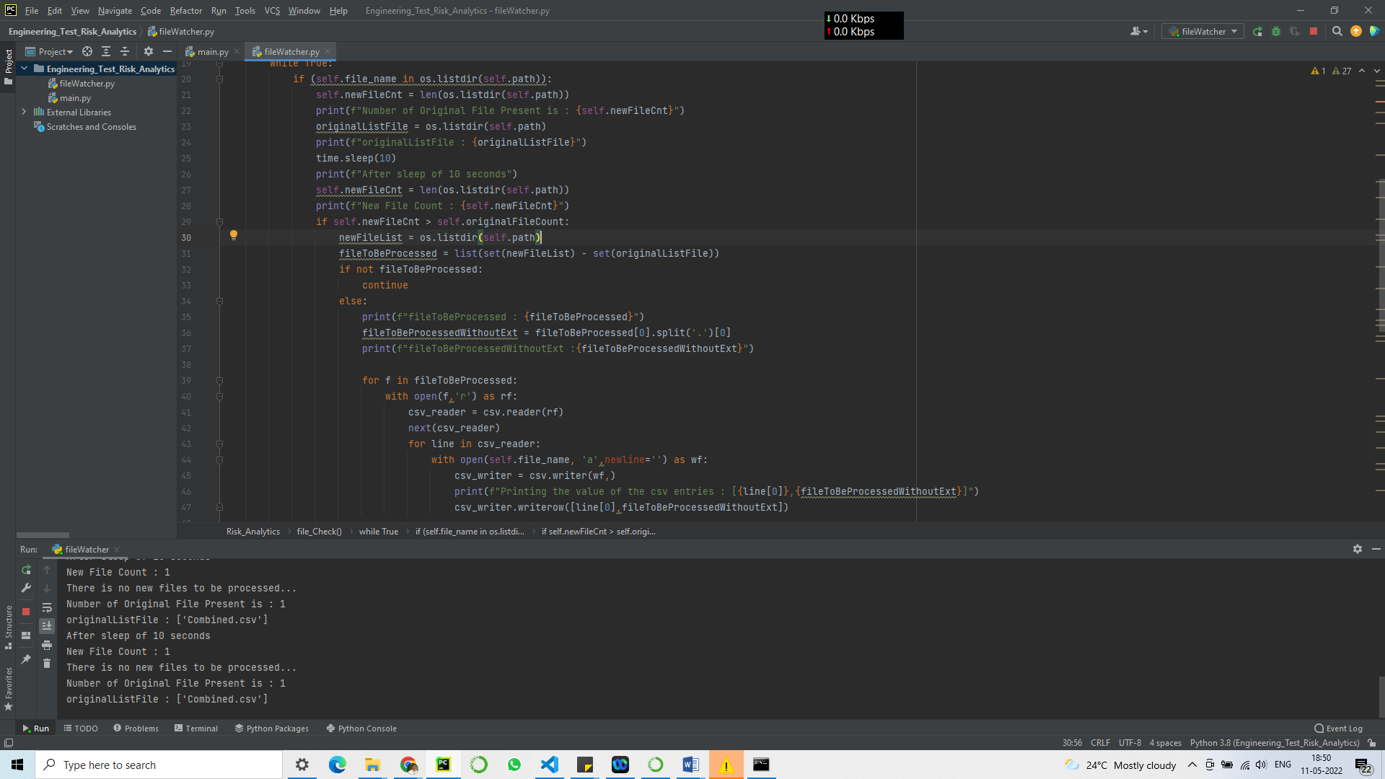

As the files get dropped, it will keep on updating the ‘Combine.csv’ file with the entries of the dropped file as per the requirement.

After updating all the files into the Combined.csv, the output is as shown below:

