Data Quality Check with a FAIR Dataset Using Tableau Prep
Pramodkumar Shivanna | M.Sc. Applied Data Science & AI | SRH University Heidelberg | April 2026
1. Dataset Description
Title: Life Expectancy (WHO) Dataset
Source: https://www.kaggle.com/datasets/kumarajarshi/life-expectancy-who (Original: WHO Global Health Observatory)
Contents: Health, economic, and demographic indicators for 193 countries from 2000–2015. Includes life expectancy, adult mortality, GDP, BMI, vaccination rates, schooling, and more. Original size: 2,938 rows × 22 columns.
Why selected: Freely available, FAIR-compliant (open CSV format, clear source, no login required), and contains realistic data quality issues including missing values, inconsistent column names, and data type mismatches — ideal for a Tableau Prep cleaning exercise.

2. Identified Data Quality Issues

Dimension | Issue | Detail | Affected Columns
Completeness | Missing values | 2,563 nulls in 14 of 22 columns (4.0% of data) | Population 22%, Hepatitis B 19%, GDP 15%
Consistency | Column name spaces | 8 columns had leading/trailing whitespace in names | 'Life expectancy ', ' BMI ', ' HIV/AIDS'
Validity | Wrong data type | Population stored as float instead of whole number | Population, Year
Uniqueness | Duplicate check | No duplicates found on Country + Year key (all Unique) | All 2,928 rows
Relevance | Redundant column | Thinness 5-9 yrs overlaps with Thinness 1-19 yrs | thinness 5-9 years
Integrity | Wide outlier range | GDP ranges from 1.68 to 119,173 — possible unit issue | GDP

3. Cleaning Workflow — Screenshots

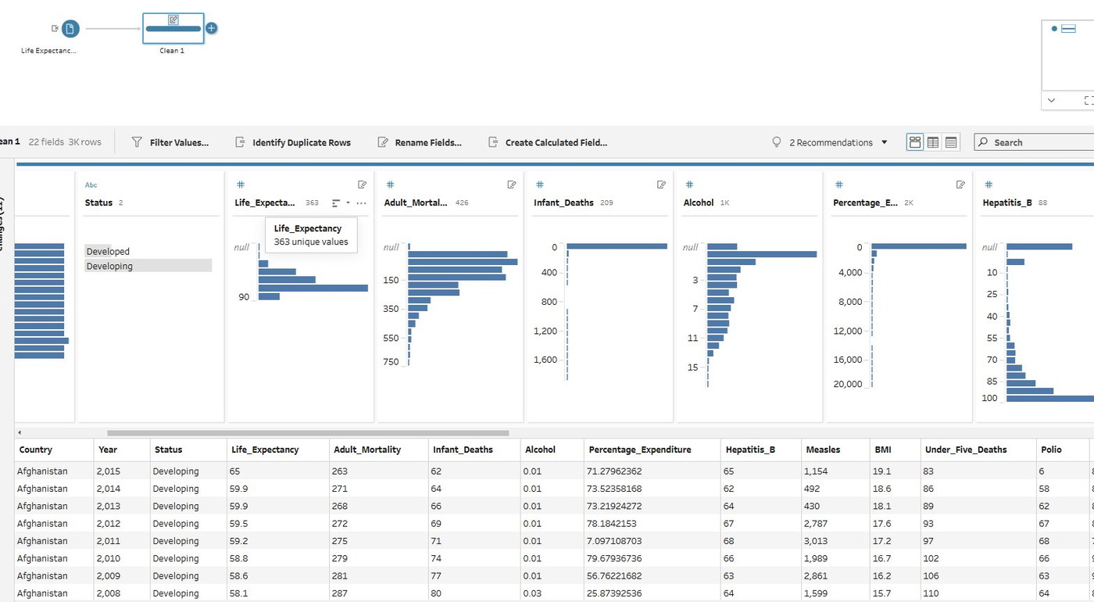  Fig 1 — Profile view after renaming columns | 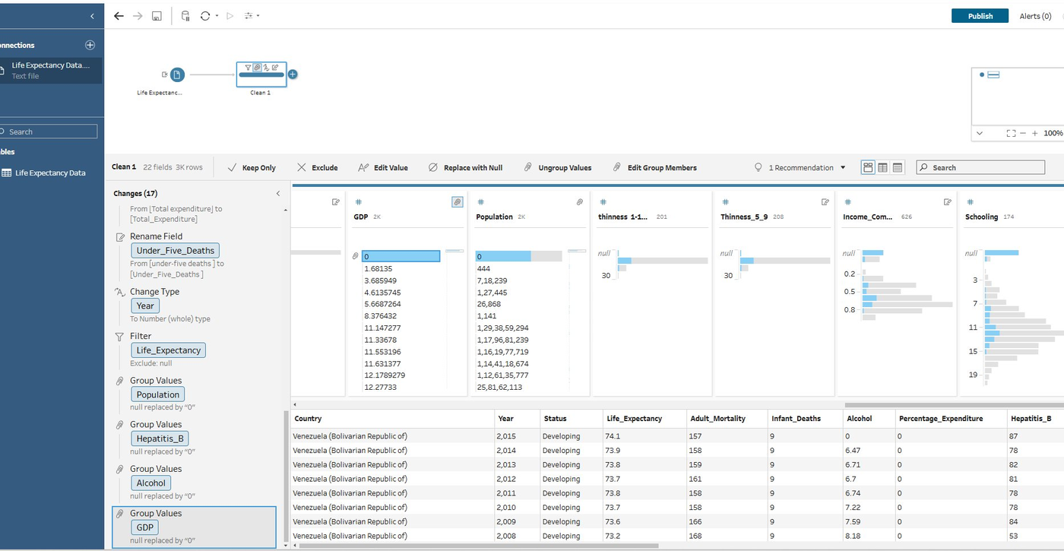  Fig 2 — Changes panel: null replacement & Title Case
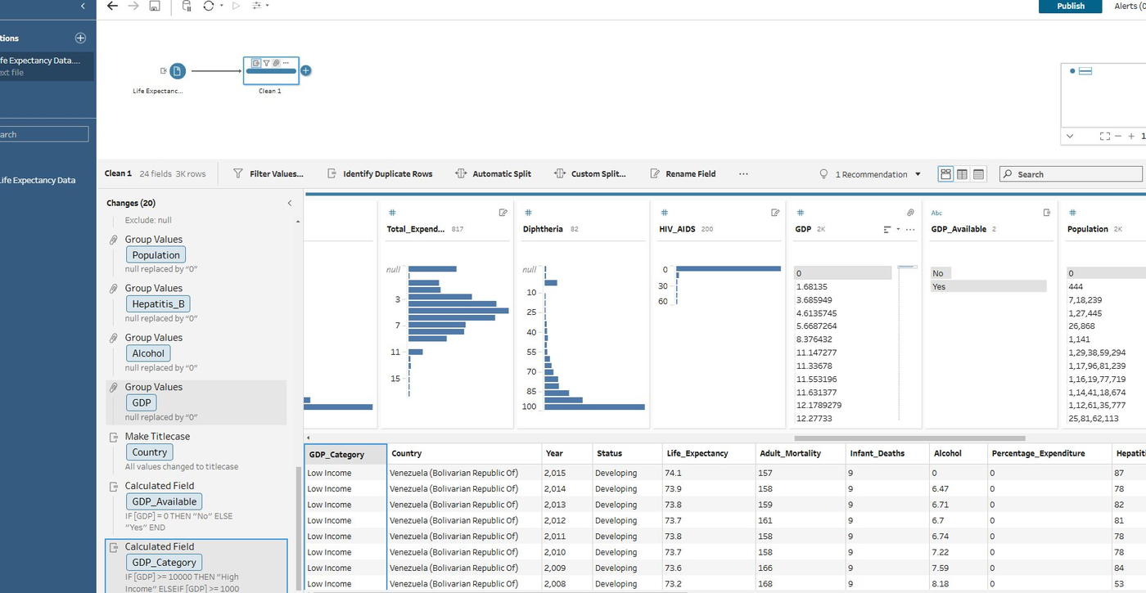  Fig 3 — Calculated fields: GDP_Available & GDP_Category | 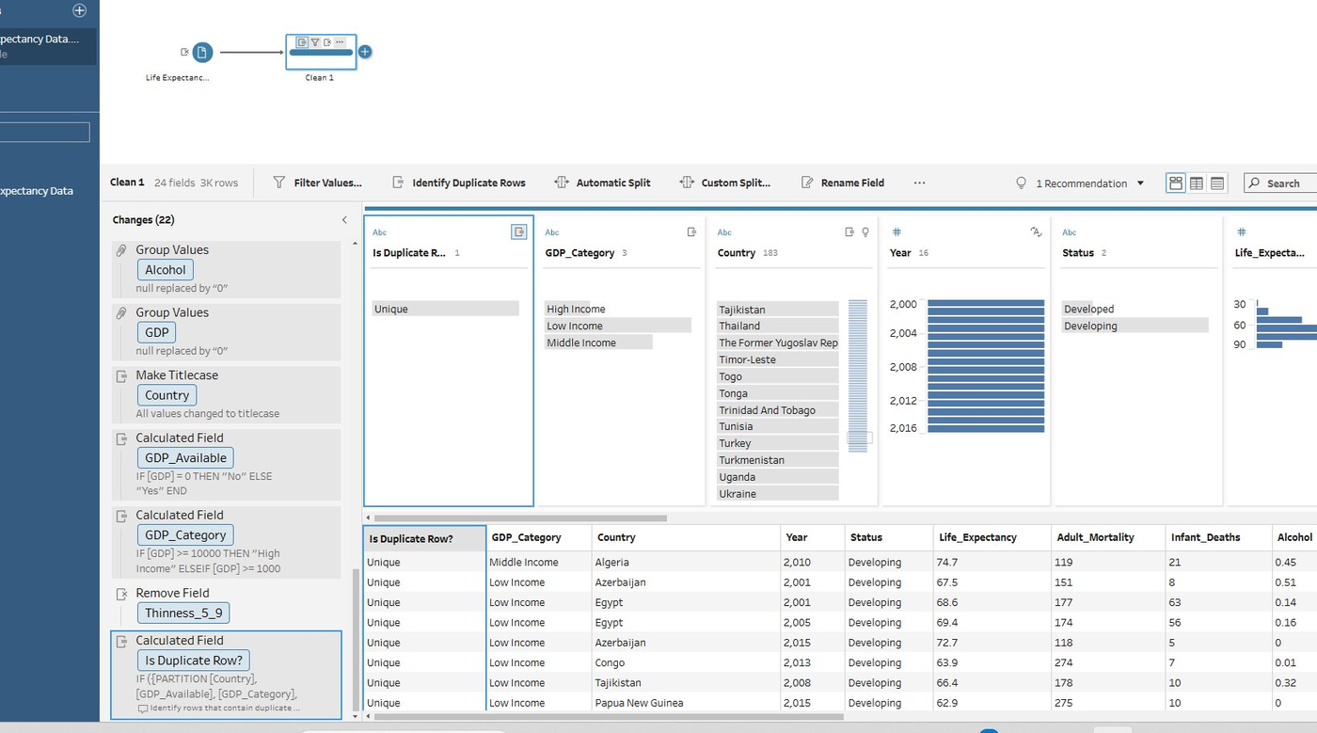  Fig 4 — Duplicate check: all rows labelled Unique

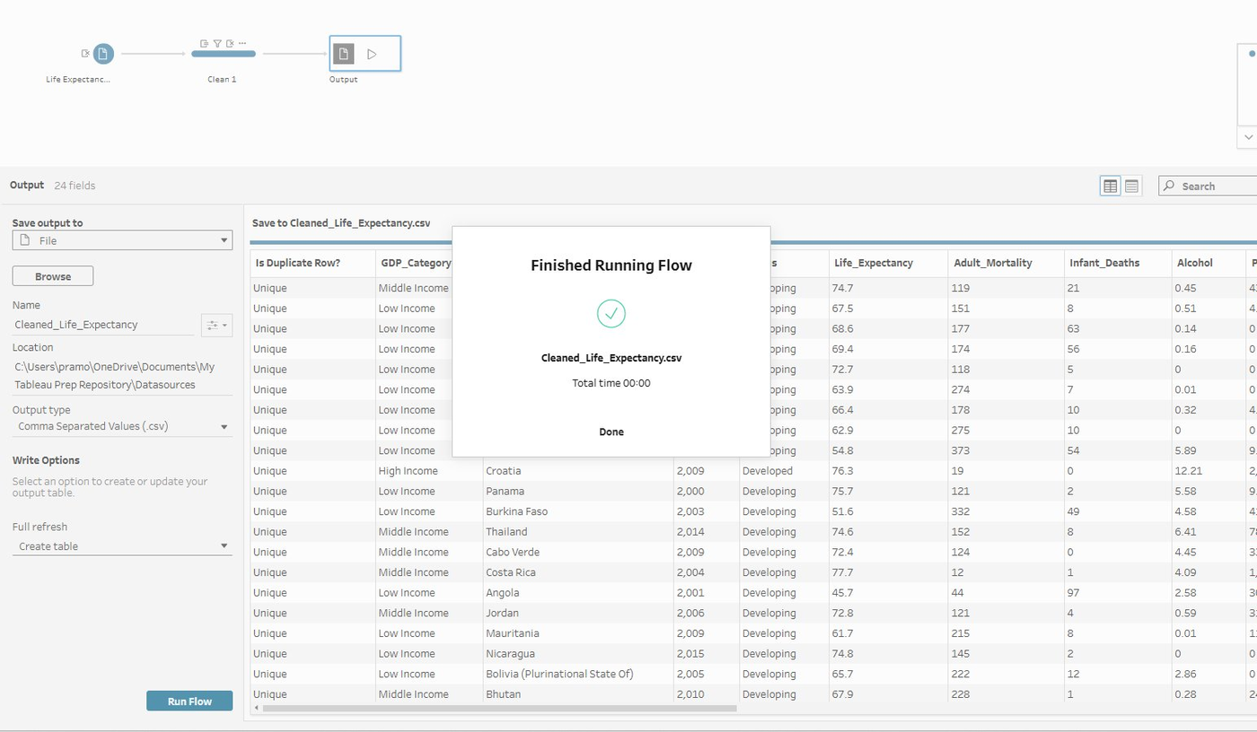
Fig 5 — Flow finished: Cleaned_Life_Expectancy.csv exported successfully (2,928 rows, 24 fields)

4. Cleaning Steps Explained
- Rename Fields: 14 columns renamed to remove extra spaces and standardise to snake_case (e.g. 'Life expectancy ' → 'Life_Expectancy'). Addresses the Consistency dimension.
- Fix Data Types: Year and Population changed to Number (Whole). Addresses the Validity dimension.
- Filter Nulls: 10 rows where Life_Expectancy was null were excluded — the target variable cannot be imputed. Addresses Completeness.
- Group Values (Replace Nulls): Null values in GDP, Population, Hepatitis_B, and Alcohol replaced with 0 using Group Values. Preserves row structure while making nulls explicit. Addresses Completeness.
- Title Case on Country: Applied built-in Title Case to standardise all 193 country names. Addresses Consistency.
- Calculated Fields: Created GDP_Available (Yes/No flag) and GDP_Category (High/Middle/Low Income) to support analysis and flag data gaps. Addresses Integrity.
- Remove Field: Removed 'thinness 5-9 years' as it is redundant with 'thinness 1-19 years'. Addresses Relevance.
- Identify Duplicates: Ran duplicate detection on Country + Year — all 2,928 rows confirmed Unique. Addresses Uniqueness.

5. Conclusion
The original dataset had 2,563 missing values, 8 inconsistently named columns, data type mismatches, and a redundant column. After applying 22 changes in a single Tableau Prep Clean Step, the dataset was reduced to 2,928 clean rows with 24 well-named columns, zero nulls in the target variable, and three new analytical fields. The main remaining limitation is that replacing missing GDP and Population values with 0 is a simplification — these should be treated as 'data unavailable' in any downstream analysis. The dataset now satisfies the Completeness, Consistency, Validity, Uniqueness, and Relevance data quality dimensions.

