EXPERIMENT 1
Simulation-Based Electromagnetic Analysis of TEM, TE and TM Propagation Modes in Microwave Transmission Structures
OBJECTIVE 1:
To develop electromagnetic simulation models for TEM, TE and TM propagation modes in suitable microwave transmission structures.
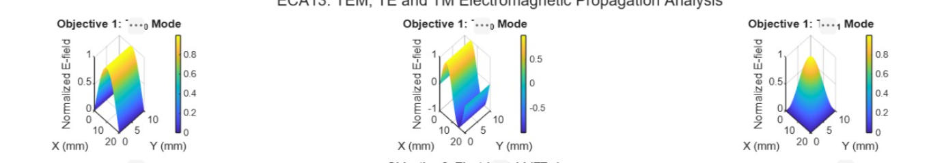
OBJECTIVE 2:
To visualize and analyze the electric-field and magnetic-field distributions associated with different propagation modes.
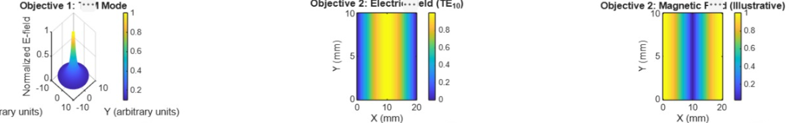
OBJECTIVE 3:
To determine the cutoff frequency, propagation constant and field characteristics of selected TE and TM modes.
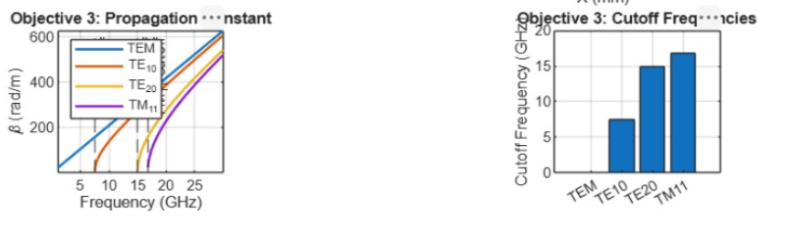
OBJECTIVE 4:
To compare the propagation behavior of different modes and identify their suitability for practical microwave transmission.
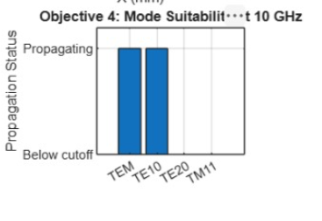
OUTPUT:
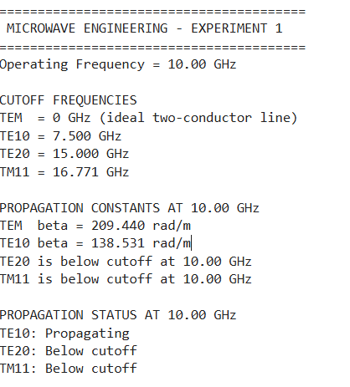
RESULT:
This experiment helped me understand the differences between TEM, TE, and TM modes. The MATLAB plots made it easier to visualize the electric fields and understand how frequency affects microwave propagation.

