1. To upload PDF document.

URL - <http://localhost:8181/upload>

Request parameter – file as key and attach document.

- result

a) As a sample application first, it will create directory "C:\documents"

Note – User can upload pdf documents from sample-docs folder under in project directory.

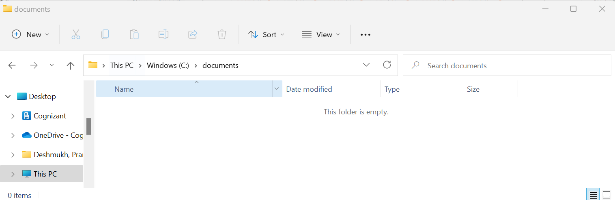

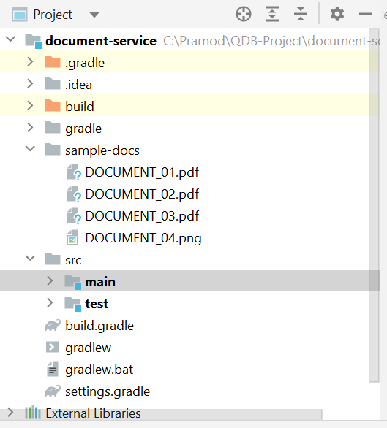

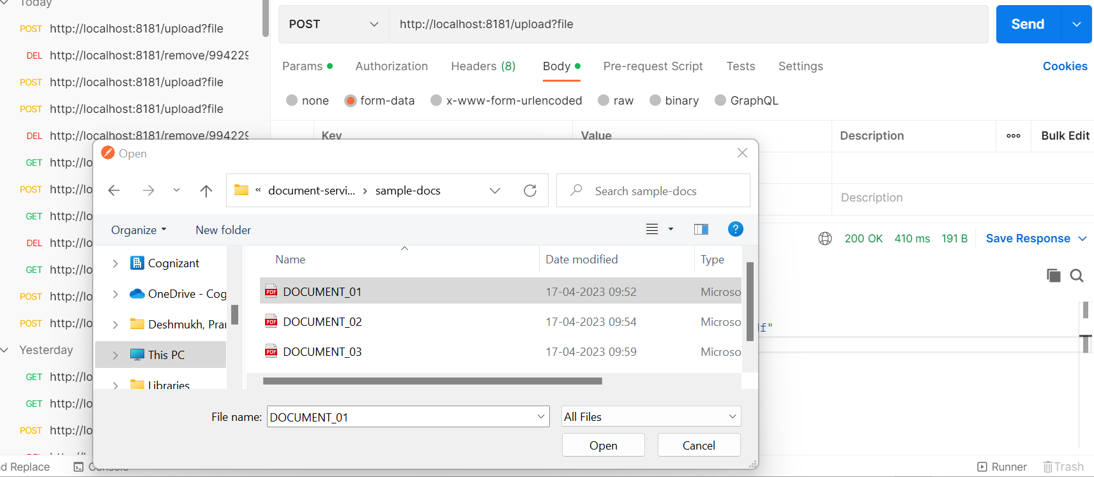

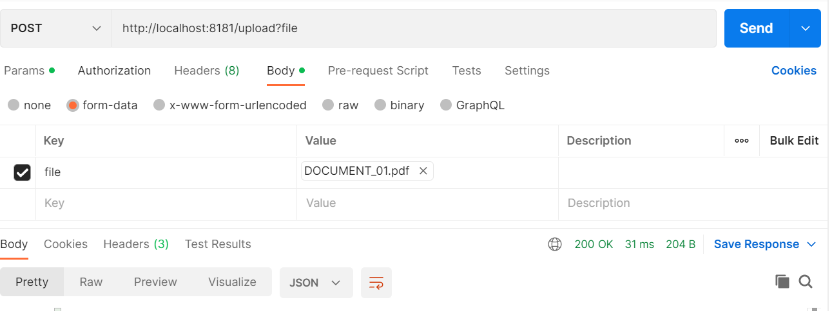

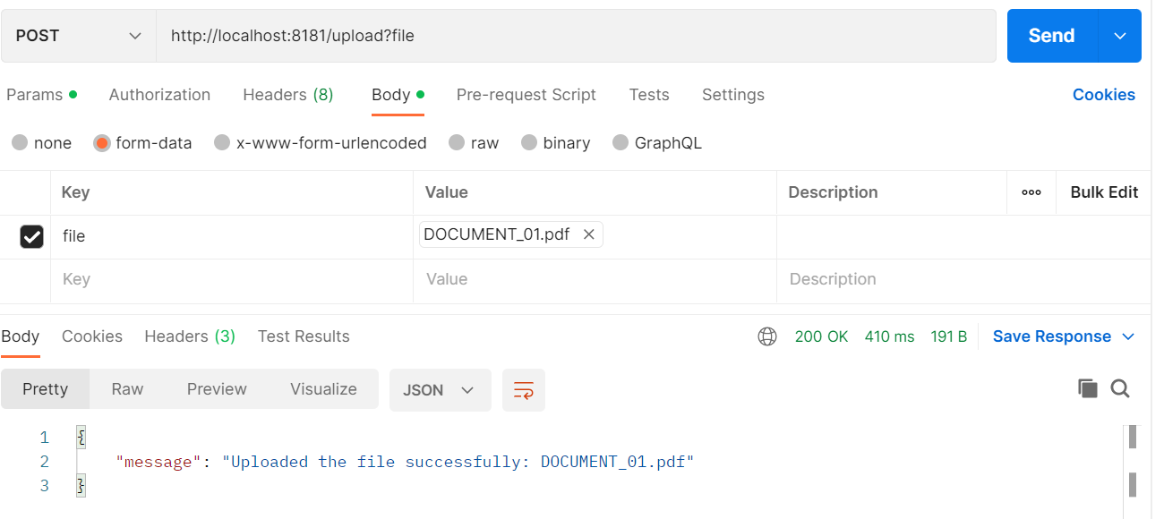

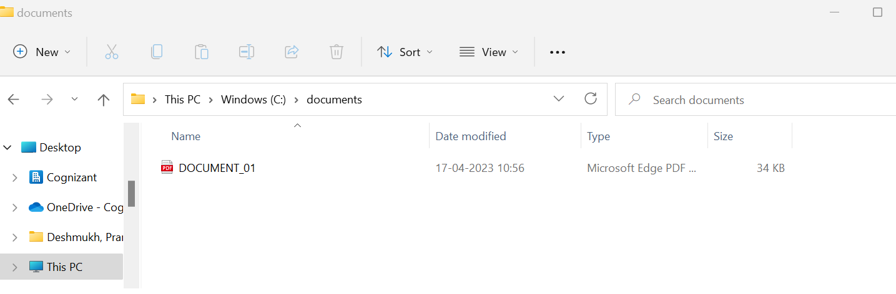

* PDF file successfully saved in location.

b) Upload PNG file. – It will not allowed png other than PDF and return error, only PDF files can be uploaded.

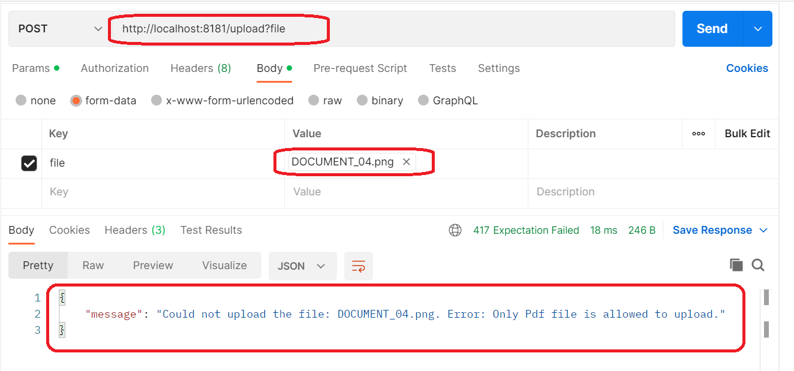

c) Add 2-3 more pdf files, will see below in documents folder.

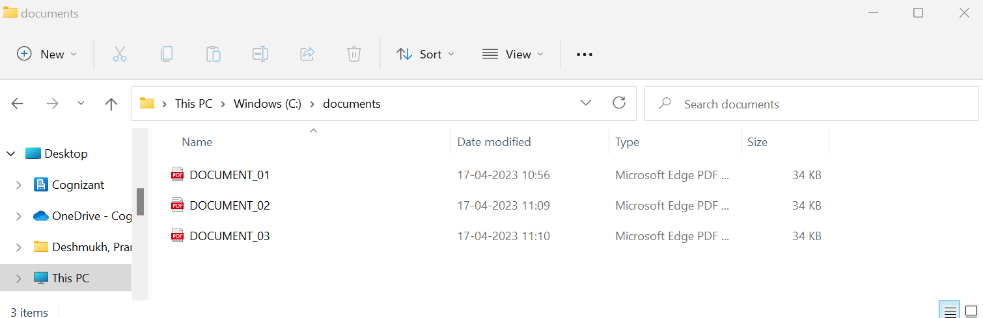

1. Uploaded document records entries inserted into h2 in memory DB.

* URL - <http://localhost:8181/h2-console>

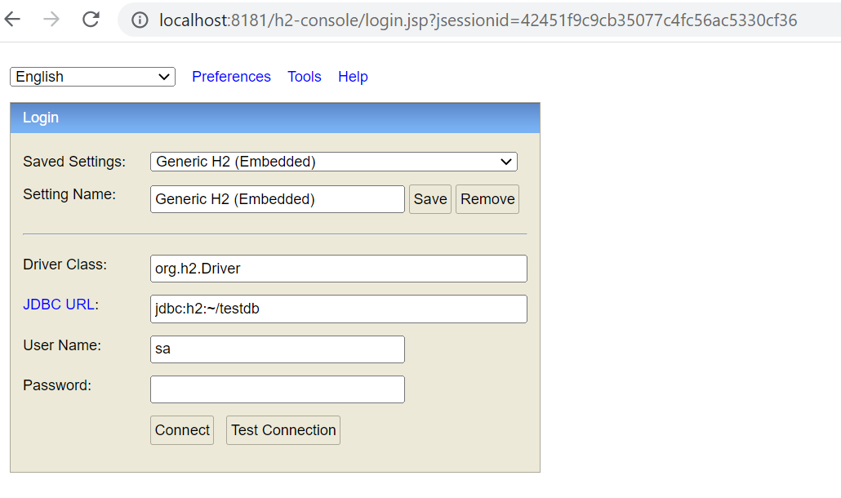

* User can see entries for all 3 uploaded documents as below :

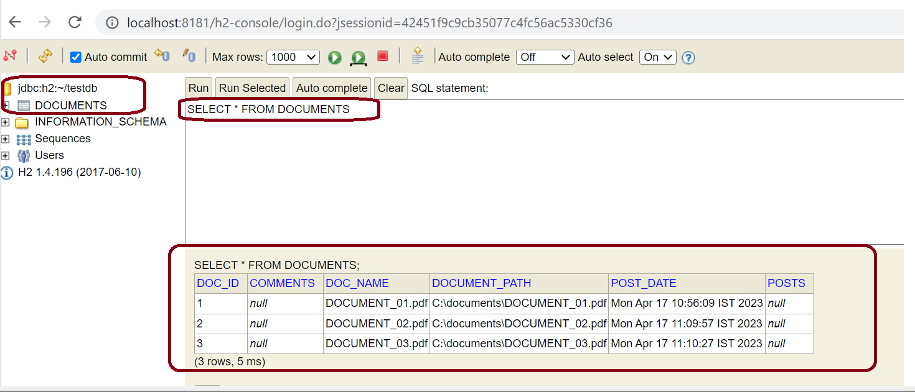

3) Delete PDF file

- URL : [http://localhost:8181/remove/<PDF-FileName](http://localhost:8181/remove/%3cPDF-FileName)>

e.g. - <http://localhost:8181/remove/DOCUMENT_01.pdf>

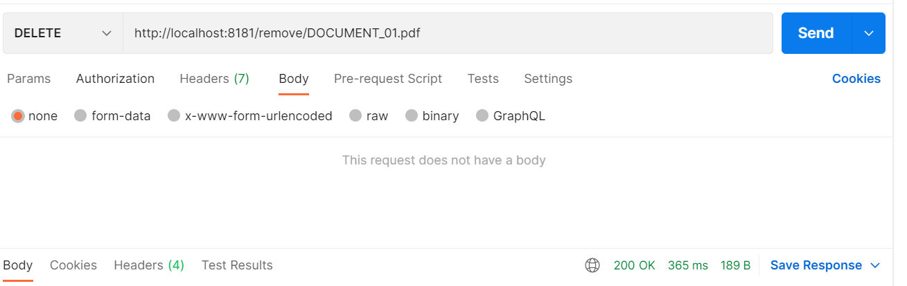

* PDF file deleted from documents folder

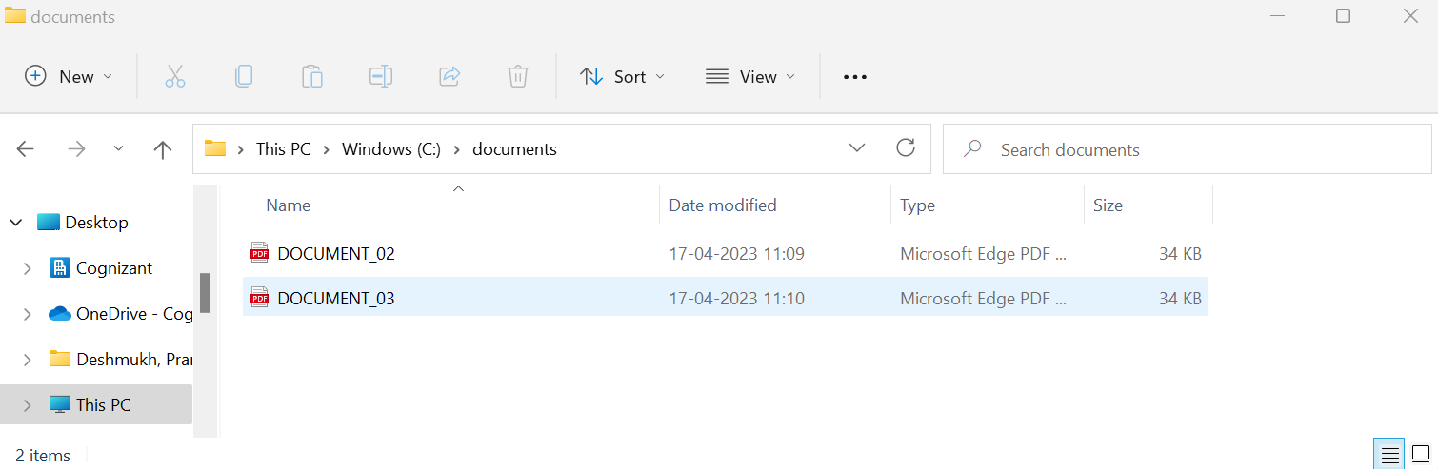

* Record deleted from h2 database

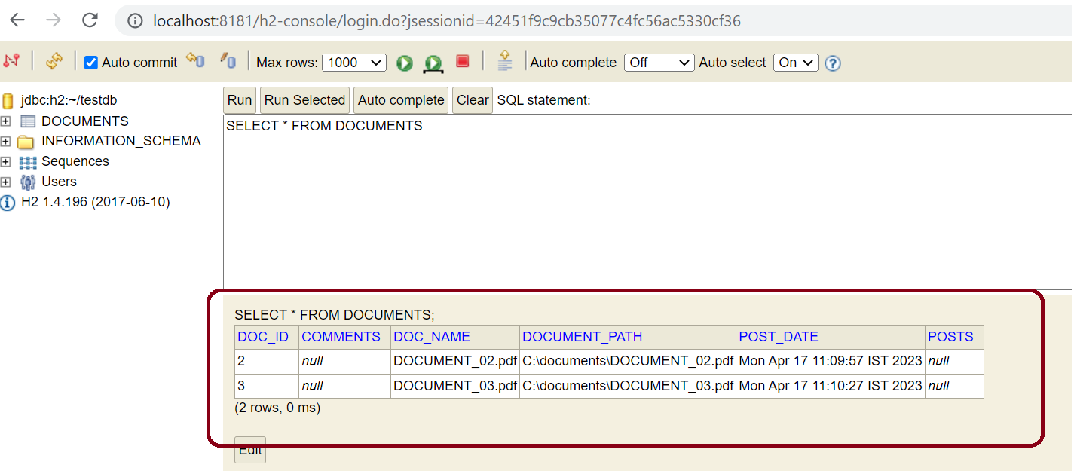

4) To view all uploaded documents

URL - <http://localhost:8181/view-all> - fetch data from DB.

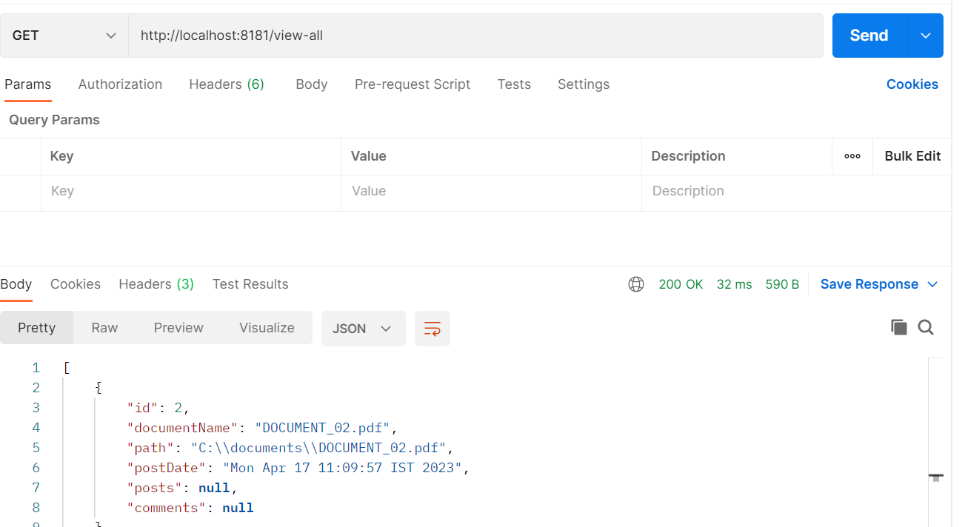

* Response JSON :
* [
* {
* "id": 2,
* "documentName": "DOCUMENT_02.pdf",
* "path": "C:\\documents\\DOCUMENT_02.pdf",
* "postDate": "Mon Apr 17 11:09:57 IST 2023",
* "posts": **null**,
* "comments": **null**
* },
* {
* "id": 3,
* "documentName": "DOCUMENT_03.pdf",
* "path": "C:\\documents\\DOCUMENT_03.pdf",
* "postDate": "Mon Apr 17 11:10:27 IST 2023",
* "posts": **null**,
* "comments": **null**
* },
* {
* "id": 4,
* "documentName": "DOCUMENT_01.pdf",
* "path": "C:\\documents\\DOCUMENT_01.pdf",
* "postDate": "Mon Apr 17 11:27:36 IST 2023",
* "posts": **null**,
* "comments": **null**
* }
* ]

1. create post for uploaded document

URL - [http://localhost:8181/post/{doc-id}/{post](http://localhost:8181/post/%7bdoc-id%7d/%7bpost)}

e.g. - <http://localhost:8181/post/2/firstpost>

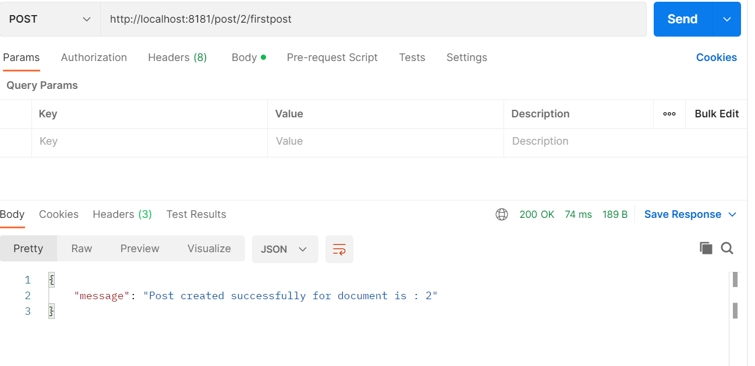

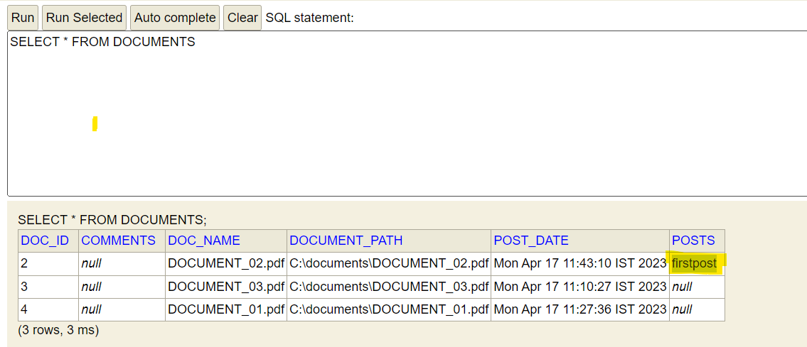

1. Create comments for uploaded document

URL [http://localhost:8181/comment/{doc-id}/{comment}](http://localhost:8181/comment/%7bdoc-id%7d/%7bcomment%7d)

e.g. <http://localhost:8181/comment/3/firstcomment>

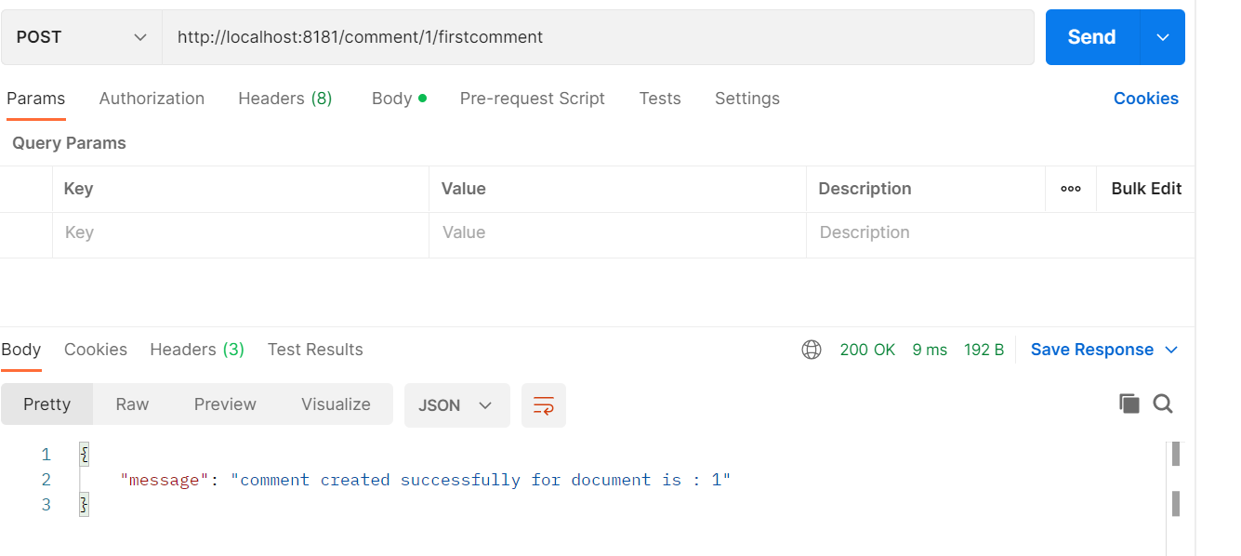

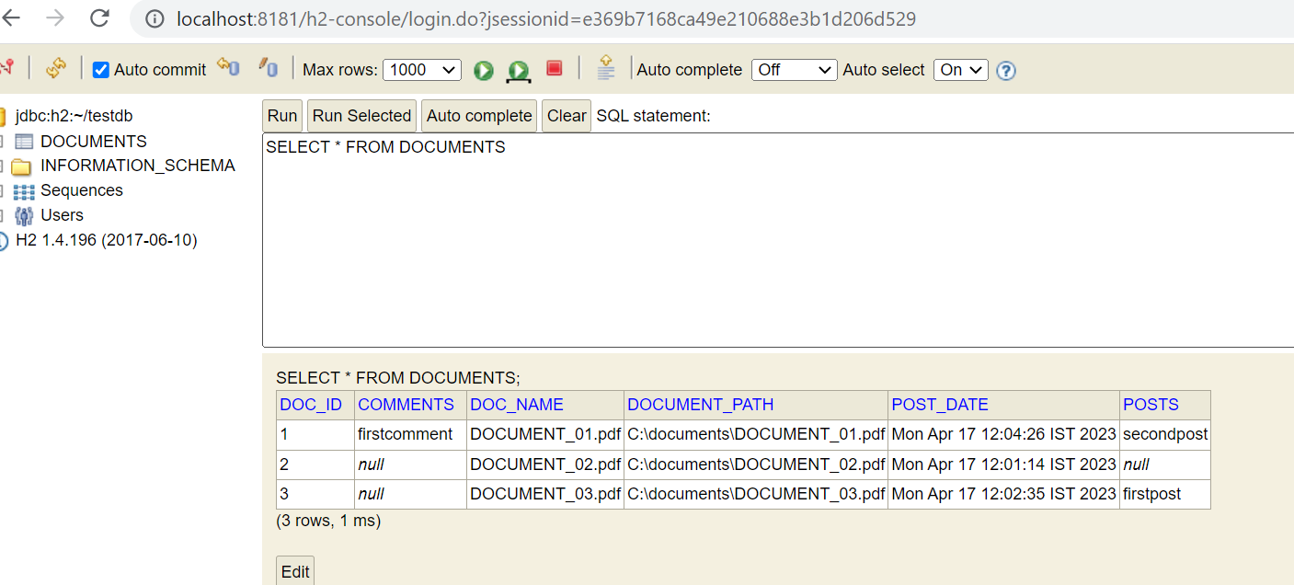

If there is no document uploaded, then user cannot perform post or comments. It will return error message as below:

