**E-Registration for online Course Registration**

### BITS ZG628T: Dissertation Outline

By

PRAKASH J KATUDIA

(2013HT12362)

# Dissertation work carried out at

## Cisco systems India PVT LTD, Bangalore



**BIRLA INSTITUTE OF TECHNOLOGY & SCIENCE**

**PILANI (RAJASTHAN)**

April 2015

**BIRLA INSTITUTE OF TECHNOLOGY & SCIENCE, PILANI**

**Project progress summary :**

|  |  |  |  |  |
| --- | --- | --- | --- | --- |
| SI.NO | Description of Work | Start date | End date | Work progrss |
| **1** | **Software Requirements & Analysis**   * Requirement analysis | 10-Jan-2015 | 22-Jan-2015 | Completed |
| **2** | **Software Design**   * Design the software Architecture , and prepare design * Test the design, by analyzing and trying out all possible upper level cases. | 24-Jan-2015 | 15-Feb-2015 | Design is completed.  Possible cases need to test. |
| **3** | **Software Construction-Coding**  Final level of software (make it best level)   * Add necessary codes to handle the Functionalities. | 16-Feb-2015 | 15-March-2015 | Pending |
| **4** | **Software Testing**  Build the basic code and Test   * Do testing of, functionalities of the Application | 16-March-2015 | 25-March-2015 | Pending |
| **5** | **Software Implementation-Deployment**   * Test all possible cases, and Deploy code | 26-March-2015 | 31-March-2015 | Pending |
| **6** | **Handover and Documentation**  Handover the project.   * Documentation of the project both for the client as well as for the purpose of Project work. | 01-April-2015 | 15-April-2015 | Pending |

**1. Software Requirements & Analysis**

**1.1 Organization Background:**

Cisco Systems was founded in December 1984 by two members of Stanford University computer support staff: Leonard Bosack who was in charge of the computer science department's computers, and Sandy Lerner, who managed the Graduate School of Business' computers. Although Cisco was not the first company to develop and sell dedicated network nodes, it was one of the first to sell commercially successful routers supporting multiple network protocols.

**1.2 About the product:**

Cisco Wide Area Application Services (WAAS) is technology developed by Cisco Systems that optimizes the performance of any TCP-based application operating in a wide area network (WAN) environment while preserving and strengthening branch security. WAAS combines WAN optimization, acceleration of TCP-based applications, and Cisco's Wide Area File Services (WAFS) in a single appliance or blade.



**2. Project Overview**

Here we are trying to leverage the advantage of being in between Client and Data center. WAAS when deployed looks at the SMB packet. It parses the packet and stores the relevant data is stored, both into the log file and to the data server. Once the data is stored in the data server, Central Manager [Device GUI] picks the data in regular intervals of time and displays the data for the customer in real time.

**Objectives:**

* Give the customer the granular level detail of their network
* Automate the policy decision based on traffic pattern
* Suggest network topology change or QoS based on the traffic pattern or usage.

**2.1 Project details and research:**

**SMB protocol:** SMB[1], which stands for Server Message Block, is a protocol for sharing files, printers,serial ports, and communications abstractions such as named pipes and mail slotsbetween computers.

The **Server Message Block** (**SMB**) protocol is a network file sharing protocol that allows applications on a computer to read and write to files and to request services from **server** programs in a computer network. The **SMB** protocol can be used on top of its TCP/IP protocol or other network protocols.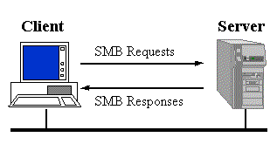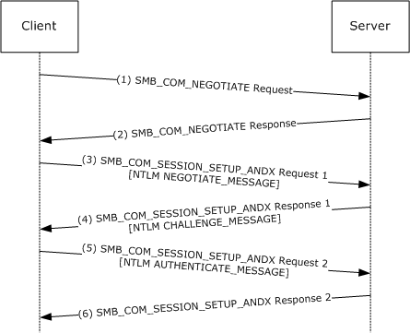

**2.2 Topology of network:**

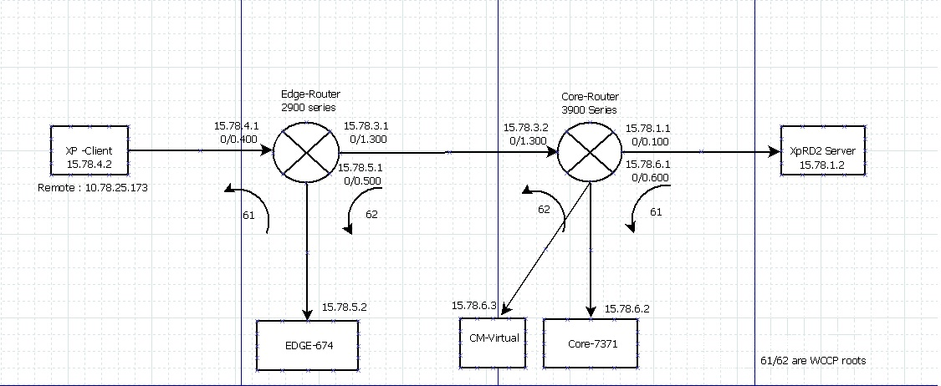

**2.3 SMB statistics view in device:**

**SMB statistics:**

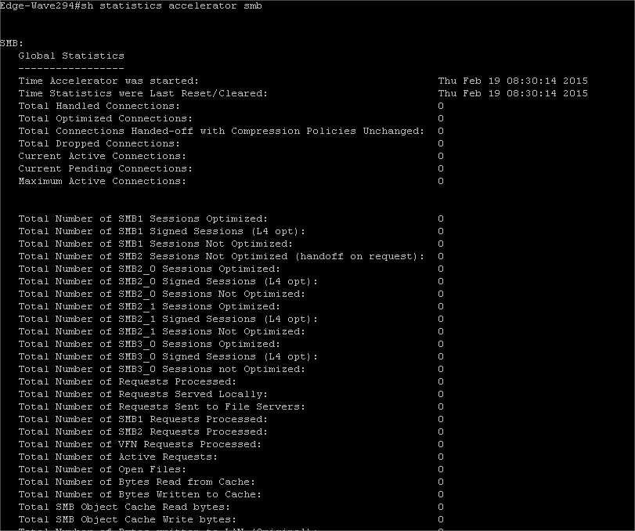

**Reference:**

[1] Details on what is SMB <https://www.samba.org/cifs/docs/what-is-smb.html>

[2]Server Message block explained in detail <http://en.wikipedia.org/wiki/Server_Message_Block>

[3] Cisco wiki doc on WAAS

<http://docwiki.cisco.com/wiki/Cisco_WAAS_Troubleshooting_Guide_for_Release_4.1.3_and_Later_--_Understanding_the_WAAS_Architecture_and_Traffic_Flow>

[4] Microsoft article on SMB <http://support.microsoft.com/support/kb/articles/Q163/4/09.asp>

[5] Microsoft CIFS RFC <http://msdn.microsoft.com/en-us/library/ee442092.aspx>

[6] Microsoft SMB RFC <http://msdn.microsoft.com/en-us/library/cc246482.aspx>