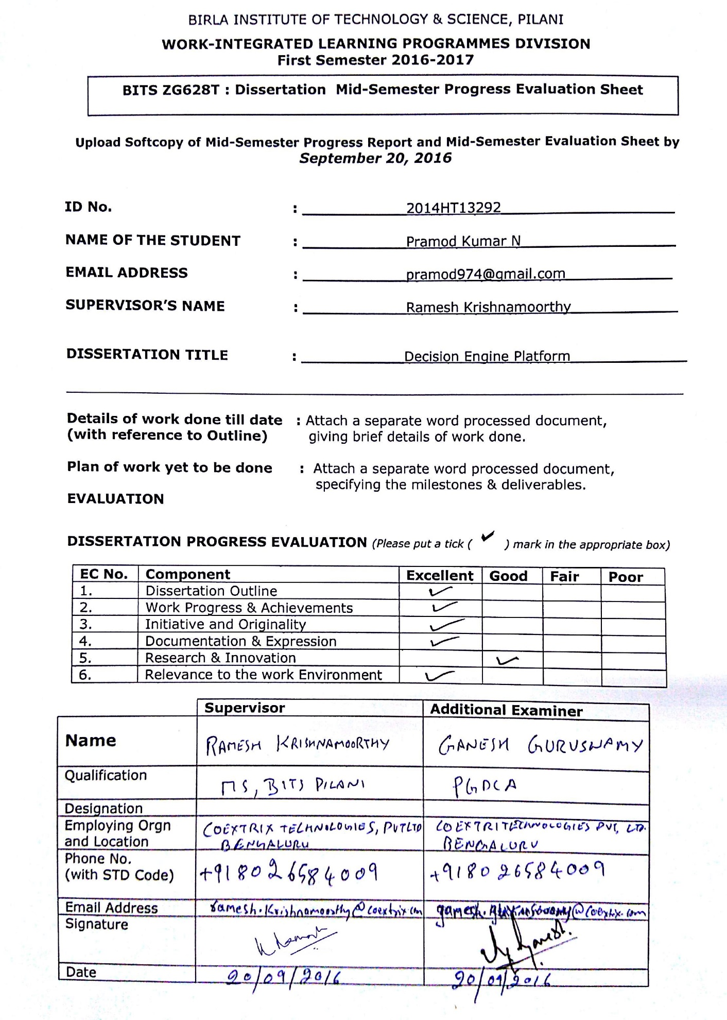

**Decision Engine Platform**

### BITS ZG628T: Dissertation Outline

By

PRAMOD KUMAR N

(2014HT13292)

# Dissertation work carried out at

## COEXTRIX TECHNOLOGIES PVT LTD, Bangalore



**BIRLA INSTITUTE OF TECHNOLOGY & SCIENCE**

**PILANI (RAJASTHAN)**

November 2016

**BIRLA INSTITUTE OF TECHNOLOGY & SCIENCE, PILANI**

**Project progress summary:**

|  |  |  |  |  |
| --- | --- | --- | --- | --- |
| **Sl.No** | **Description of Work** | **Start date** | **End date** | **Status** |
|  | **Literature Review and System Study**   * + Analysis on How a Decision System and Rules Engine is built   + Survey of existing models, tools and technology available | 1/08/2016 | 07/08/2016 | Completed |
|  | **Analysis and Design**   * + Identify the various components and architecture   + Design how the workflow needs to be handled | 08/08/2016 | 17/08/2016 | Completed |
|  | **Development** | 17/08/2016 | 02/10/2016 | In Progress |
|  | **System Integration and Testing Application** | 03/10/2016 | 6/10/2016 |  |
|  | Documentation Review and Submission | 6/10/2016 | 17/10/2016 |  |
|  | Documentation | 19/10/2016 | 25/10/2016 |  |

**Progress Summary:**

The development of Rule Repository and Rule Orchestration is completed, focus is now on developing a Decision engine which would leverage the rule repository and orchestration to give insight into the data.

**Milestones and Deliverables:**

The next milestone is to integrate all the three components i.e. Rule Repository, Rule Orchestration and Decision engine.

The deliverable is to provide an interface via command prompt and run a sample csv on the engine so as to get the decisions.

**Reference:**

1. Rules Design Pattern : <http://www.michael-whelan.net/rules-design-pattern/>
2. Single Responsibility Principle : <https://en.wikipedia.org/wiki/Single_responsibility_principle>
3. Strategy Pattern : <http://www.informit.com/articles/article.aspx?p=1398607&seqNum=2>
4. Web tasks… how to handle orchestration moving code to UI and HTTP request <https://webtask.io/docs/how>
5. Architecture cycle : <https://sites.google.com/site/softwarearchitectureinpractice/9-documenting-software-architecture/b-module-views>
6. Software Architectures <https://en.wikipedia.org/wiki/Software_architecture>
7. Reconciliation , https://help.sap.com/saphelp_erp60_sp/helpdata/en/43/714ae8b5263457e10000000a422035/content.htm