Guidelines to fetch data from .db file

import SQLite3: Import the sqlite3 module in your Jupyter Notebook.
Retrieve Table Names: Query to retrieve the names of all tables in the database:

import sqlite3

# Connect to the SQLite database file
conn = sqlite3.connect('regression.db')
# Replace ‘regression.db' with the path to your .db file if the file is in another directory.
# Replace regression.db with the classification.db or clustering,db if you are working on classification # or clustering projects

# Create a cursor object
cursor = conn.cursor()

# Query to retrieve table names
cursor.execute("SELECT name FROM sqlite_master WHERE type='table';")

# Fetch all table names
tables = cursor.fetchall()

# Print the table names
for table in tables:
print(table[0])

# Close the connection
conn.close()

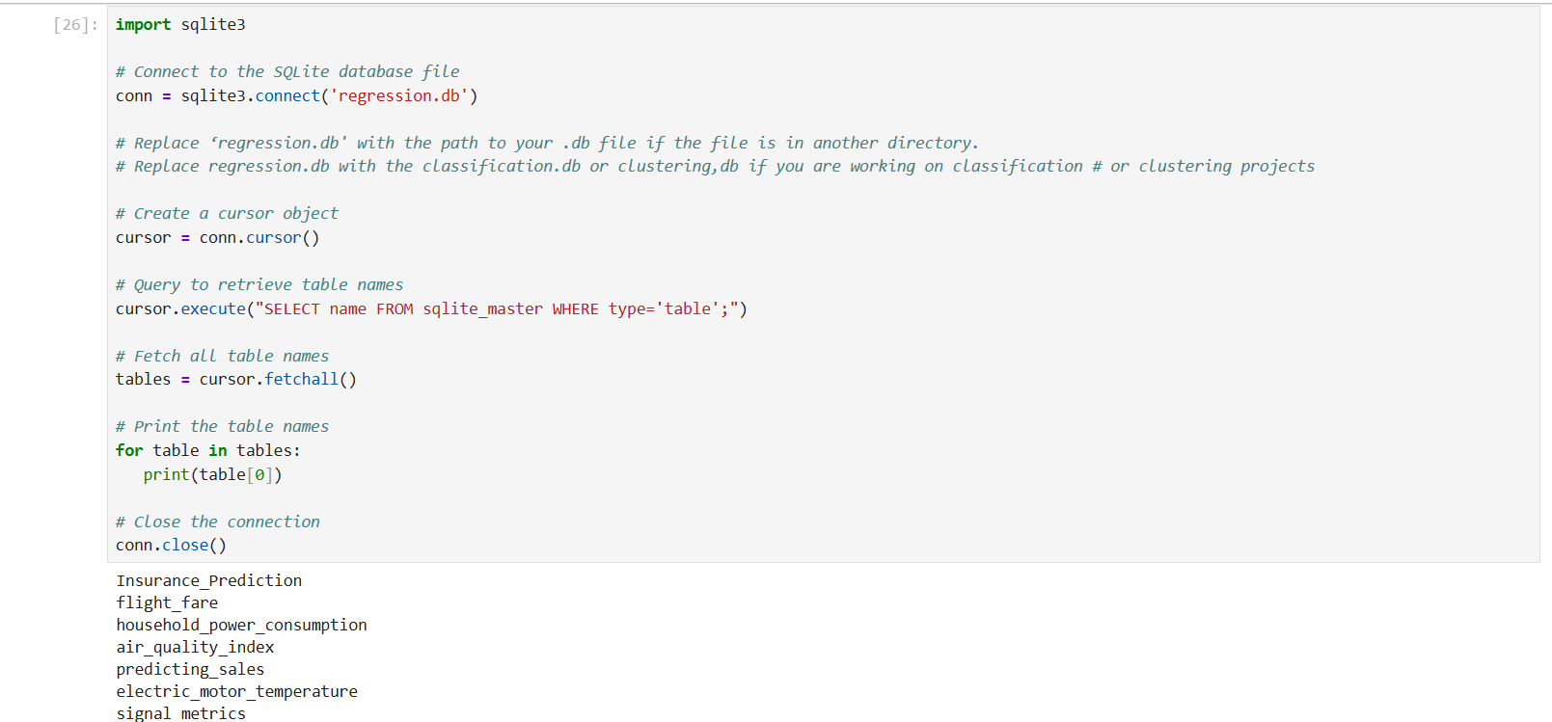

Refer above example image.
The Regression database contains the following datasets:
- Insurance_Prediction
- flight_fare
- household_power_consumption
- air_quality_index
- predicting_sales
- electric_motor_temperature
- signal_metrics
- mining_data
- life_science
- fuel_efficiency_automobile

Refer above example image.
The Classification database contains the following datasets:
- fraud_detection
- Heart_disease
- Metro_Train_Maintenance
- forest_cov_type
- fake_news_classification
- fault_detection_manufacturing
- drug_reviews_sentiment_analysis
- Telecom_microservices_loan
- malware_detection

Refer above example image.
The Clustering database contains the following datasets:
- tripadvisor_reviews
- supermarket_data
- ecommerce_behavior
- online_retail_customers
- amazon_book_reviews

Each project's problem statement specifies which dataset to use.

Code to create a Dataframe:

conn = sqlite3.connect('clustering.db')
df = pd.read_sql_query('Select * from tripadvisor_reviews' , conn)
df
(Make sure to replace 'Table_name' with the name of the table you want to read data from.)
