NETWORK TRAFFIC ANALYSIS
Using Wireshark

SOC Investigation Report

Name | Pramodh Prakash
Education | MSc Cybersecurity, NTU UK
Experience | 1 Year - Network Engineer, Cisco
Tool Used | Wireshark, Command Prompt, Browser

1. Introduction
This report documents a hands-on network traffic analysis exercise carried out using Wireshark from a SOC analyst perspective. The goal was to capture real network traffic on a live machine and analyze each protocol to understand what normal traffic looks like, and more importantly, what suspicious traffic looks like.

As a SOC analyst, understanding how each protocol behaves in normal conditions is the foundation of being able to spot anything unusual. This exercise covered seven core protocols that appear in almost every network investigation.

2. Objective
The objective of this lab was to:
- Capture live network traffic using Wireshark on a Windows machine
- Apply protocol-specific filters to isolate and study each traffic type
- Analyze the packets and understand what each one means in plain terms
- Relate each protocol to real SOC investigation scenarios
- Document findings in a structured report format as a SOC analyst would

3. Tools Used
Tool | Purpose
Wireshark | Capturing and analyzing network packets in real time
Command Prompt (CMD) | Generating ICMP, ARP and DHCP traffic using ping, arp -a, ipconfig commands
Web Browser (Brave) | Generating DNS, TCP, TLS, HTTP and UDP traffic by visiting websites

4. Lab Sections
Each protocol was isolated using a specific Wireshark display filter. The analysis below explains what was observed in each capture and how a SOC analyst would use this information during a real investigation.

4.1 DNS - Domain Name System
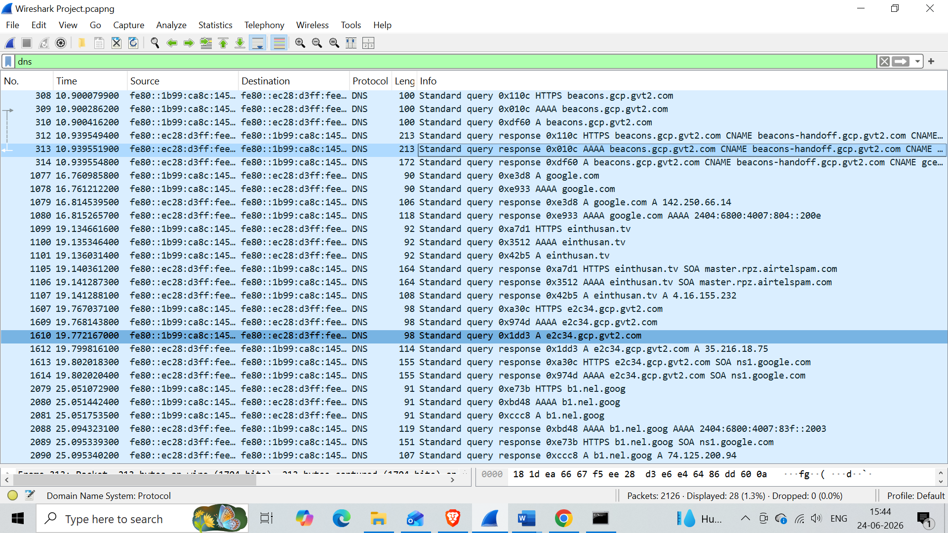

Filter Used: dns
What it Shows | DNS traffic shows all domain name lookup requests made by the machine and the replies from the DNS server. Every time you visit a website, a DNS query happens first.
Analysis | The machine sent DNS queries to resolve multiple domains including google.com, beacons.gcp.gvt2.com, einthusan.tv, and b1.nel.goog. Key observations:  - The machine sent HTTPS, AAAA (IPv6), and A (IPv4) query types showing a complete modern DNS resolution flow  - CNAME records were returned for some domains showing alias chains before the final IP is given  - google.com resolved to IPv4 142.250.66.14 and IPv6 2404:6800:4007:804::200e confirming dual-stack resolution  - einthusan.tv returned a response from master.rpz.airtelspam.com meaning Airtel is blocking this domain using Response Policy Zone - a real DNS filtering technique  - Background service domains like gcp.gvt2.com and b1.nel.goog appeared automatically showing the browser generates DNS traffic beyond what the user directly requests
SOC Use Case | SOC analysts look at DNS traffic closely because attackers frequently abuse it. Normal DNS looks exactly like what is captured here - known domains, clean responses, expected IPs.  - Malicious domains — checking if any queried domain matches known bad domains from threat intel feeds like VirusTotal or Cisco Talos.  - Suspicious server responses — if a DNS server returns an unexpected IP or routes through an unusual path like the Airtel RPZ block seen in this capture, it tells the analyst something about how the network is filtering or redirecting traffic  - Random or very long domain names like a1b2c3xyz.ru may indicate malware communicating with a C2 server using a Domain Generation Algorithm  - DNS tunneling — very high volume of DNS queries in a short time, especially with unusually long query names, can mean an attacker is secretly sending stolen data out of the network hidden inside DNS packets  - Newly registered domains being queried by internal machines are a strong indicator of phishing or malware activity since attackers register fresh domains specifically to avoid blacklists

4.2 ICMP - Internet Control Message Protocol

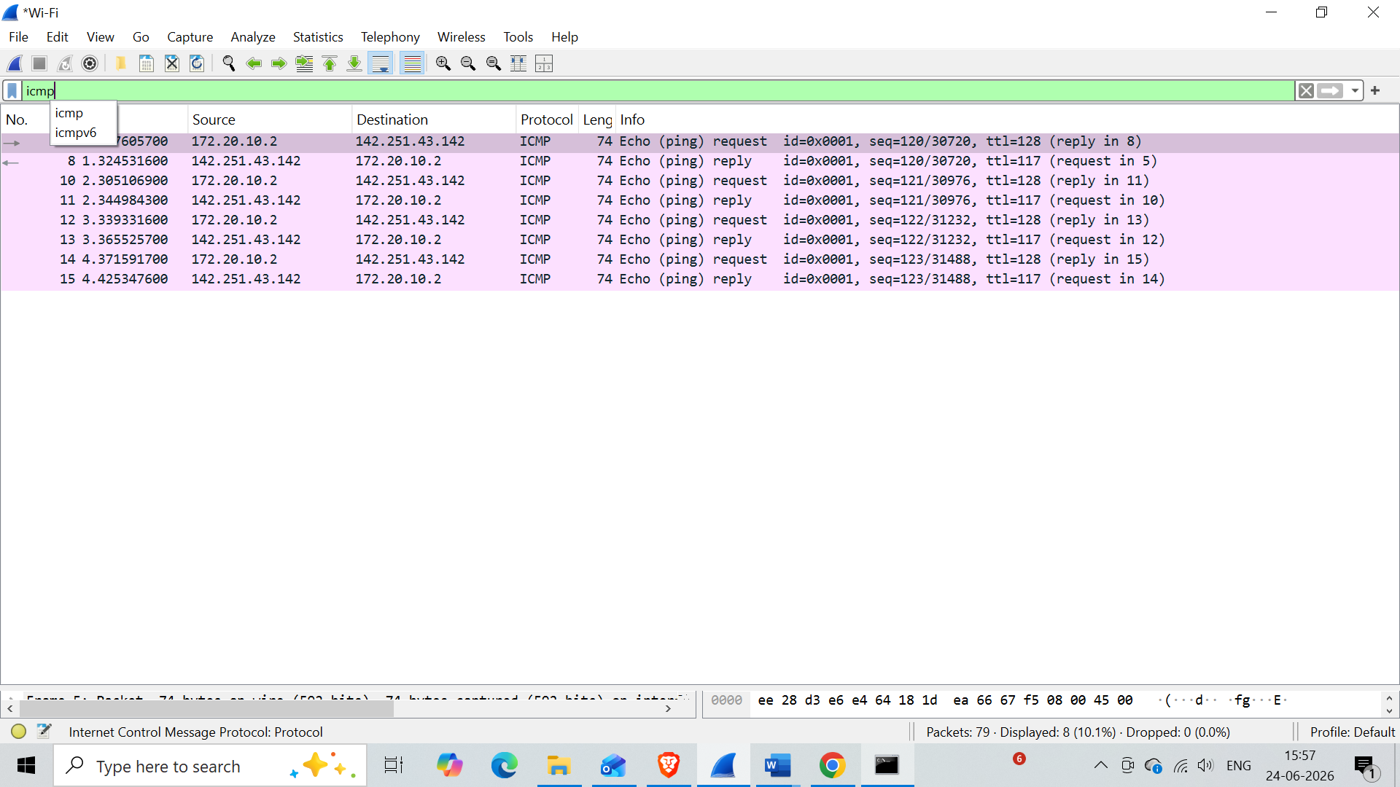

Filter Used: icmp
What it Shows | ICMP is used to test whether a device is reachable on the network. The most common use is the ping command which sends echo requests and waits for echo replies.
Analysis | The ping command was run targeting google.com. The machine at 172.20.10.2 sent 4 echo requests to Google at 142.251.43.142 and received 4 replies. Key observations:  - 4 requests sent and 4 replies received - 100% connectivity with zero packet loss  - TTL on outgoing requests is 128 (default Windows value), TTL on replies is 117 - the difference of 11 means the packet passed through 11 network hops to reach Google and return  - Sequence numbers increment cleanly - 120, 121, 122, 123 - showing packets are sent and matched in order with no gaps  - Each request is directly matched to its reply in the Info column confirming a clean request-response cycle with no dropped packets
SOC Use Case | ICMP by itself is harmless and is used every day for basic connectivity testing. But attackers misuse it in several ways that a SOC analyst must watch for.  - Ping sweep - sending ICMP requests to every IP in a subnet to find which devices are online, this is a common first step in network reconnaissance  - ICMP flood - sending thousands of pings to overwhelm a target, used in denial of service attacks  - ICMP tunneling - hiding malicious data inside ICMP packets to communicate with C2 servers while bypassing firewall rules  - Oversized or malformed ICMP packets are a red flag for packet crafting or old exploits like Ping of Death

4.3 TCP - Transmission Control Protocol

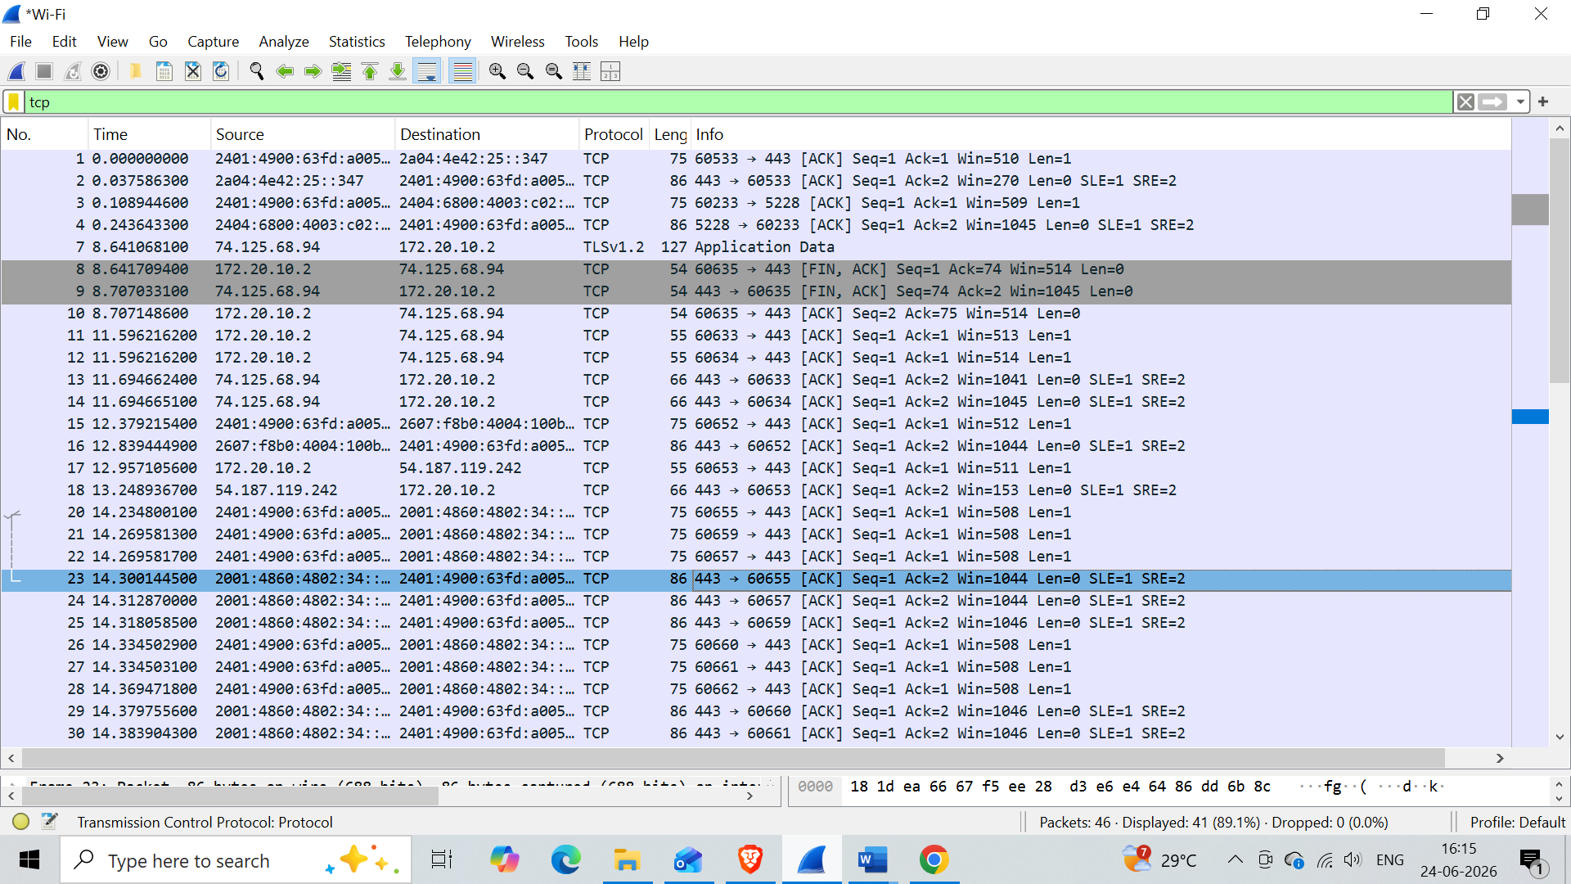

Filter Used: tcp
What it Shows | TCP is the most widely used transport protocol. It provides reliable, ordered delivery of data and uses a three-way handshake to establish connections before any data is sent.
Analysis | The TCP filter showed active connections between the local machine at 172.20.10.2 and multiple Google servers. Key observations:  - All traffic was going to and from port 443 confirming these are HTTPS encrypted web connections  - ACK packets were consistently present showing data is actively being exchanged and acknowledged  - FIN ACK packets were visible between 172.20.10.2 and 74.125.68.94 showing a clean and graceful connection termination where both sides agreed to close  - A TLSv1.2 Application Data packet confirmed that the TCP connection is carrying encrypted data  - SYN packets were not captured because the connections were already established before the capture started - this is completely normal  - Both IPv4 and IPv6 connections were active at the same time showing dual-stack operation
SOC Use Case | TCP analysis helps SOC analysts understand how connections are being made. Most attack traffic also uses TCP which makes it important to monitor closely.  - SYN flood - thousands of SYN packets sent without completing the handshake, used to exhaust server resources in a DDoS attack  - Port scanning - sequential SYN packets sent to many different ports from one source, indicating someone mapping what services are open  - Connections to unusual ports like 4444 or 1337 may indicate malware communicating with a C2 server  - Large data transfers over port 443 at unusual hours could be encrypted data exfiltration

4.4 HTTP - Hypertext Transfer Protocol

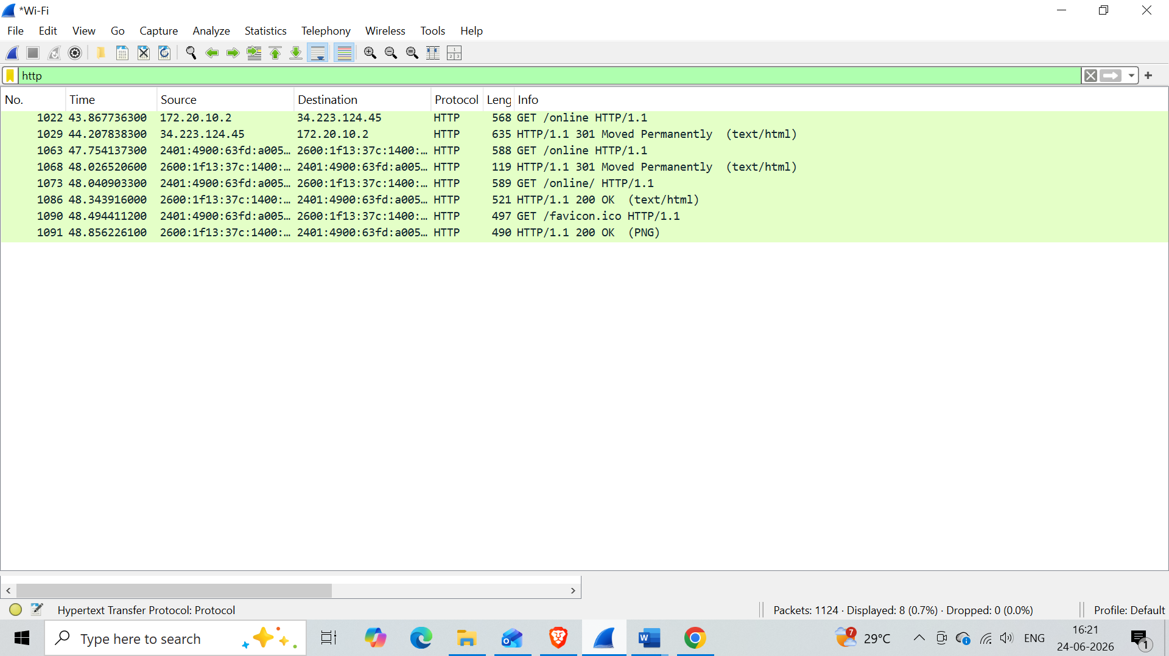

Filter Used: http
What it Shows | HTTP is the protocol used for web communication. Unlike HTTPS it sends everything in plain text with no encryption, meaning anyone on the same network can read the full content of requests and responses.
Analysis | The browser was directed to an HTTP website to generate plain HTTP traffic. The machine at 172.20.10.2 communicated with a web server at 34.223.124.45.  Key observations:  - The browser sent an HTTP GET /online request asking the server to send back a webpage  - The server replied with HTTP 301 Moved Permanently redirecting the browser to the HTTPS version of the site as a security measure  - After the redirect the server returned HTTP 200 OK with a text/html response confirming the page loaded successfully  - The browser also made a GET /favicon.ico request to fetch the small icon shown in the browser tab, which returned 200 OK with a PNG image  - All traffic is HTTP/1.1 and completely unencrypted - everything is readable in plain text by anyone capturing this traffic on the same network
SOC Use Case | HTTP is dangerous from a security perspective because of its lack of encryption. SOC analysts look at HTTP traffic for signs of both data theft and active attacks.  - Credentials in plain text — if a user submits a login form over HTTP instead of HTTPS, the username and password are fully visible in the packet. An attacker on the same network can steal them without doing anything complex  - Suspicious request paths — GET or POST requests to paths like /shell, /cmd.php, /upload, or /admin in HTTP traffic may indicate someone is accessing a web shell, exploiting a vulnerability, or trying to upload a malicious file to the server  - HTTP on non-standard ports — legitimate web traffic uses port 80. If an internal machine is making HTTP requests to ports like 8080, 8888, or other random high ports it could be malware communicating with a C2 server disguised as normal web traffic  - Downgrade attack — a machine that keeps using HTTP even after receiving a 301 redirect to HTTPS may have been intercepted by an attacker who is stripping the encryption, forcing the victim to stay on plain HTTP so the attacker can read everything

4.5 ARP - Address Resolution Protocol

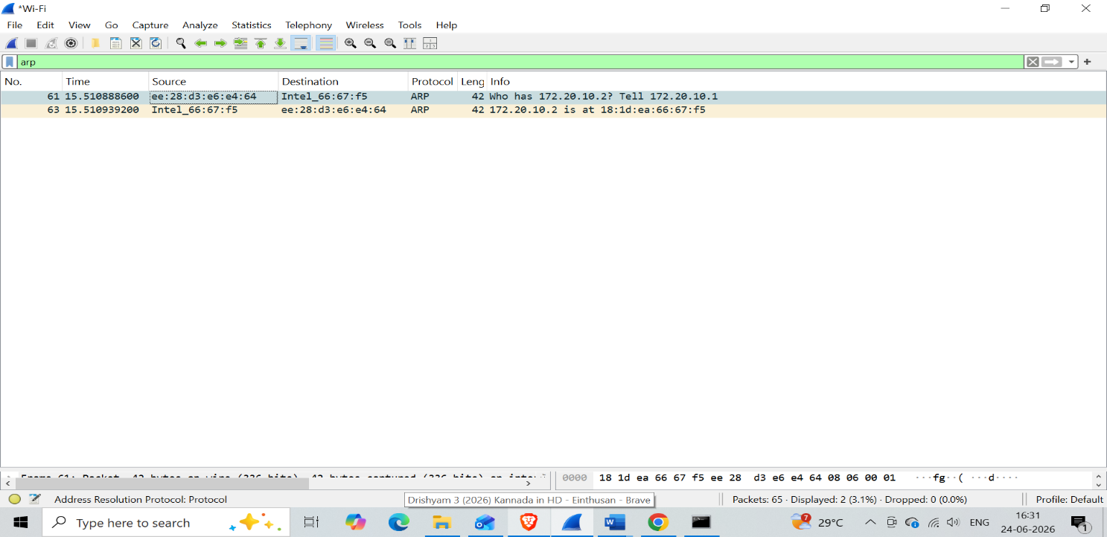

Filter Used: arp
What it Shows | ARP is used inside a local network to find out which MAC address belongs to a given IP address. Before any device can send data to another device on the same network it needs to know the MAC address, and ARP is how it finds that.
Analysis | Only 2 ARP packets were captured showing a clean and complete ARP exchange. The router needed to find the MAC address of the local machine. Key observations:  - Packet 61 shows an ARP Request from the router MAC ee:28:d3:e6:e4:64 asking Who has 172.20.10.2? Tell 172.20.10.1 - the router was looking for the local machine's MAC address before it could deliver traffic  - Packet 63 shows the ARP Reply from the local machine's Intel adapter 18:1d:ea:66:67:f5 confirming 172.20.10.2 is at 18:1d:ea:66:67:f5  - Both packets completed in under 1 millisecond showing an instant and clean ARP resolution  - Only 2 packets captured which is the most minimal possible ARP exchange - one request and one reply with no retransmissions or errors
SOC Use Case | ARP has no authentication built in. Any device on the network can send a fake ARP reply and other devices will blindly accept it. This makes ARP a common target for local network attacks.  - ARP Spoofing or ARP Poisoning - an attacker sends fake ARP replies claiming their MAC address belongs to the gateway IP. All traffic then flows through the attacker enabling a Man in the Middle attack  - Gratuitous ARP - an unsolicited ARP reply sent without a request, often used to overwrite ARP entries on other devices  - Duplicate IP detection - two ARP replies for the same IP with different MACs means someone is either misconfigured or actively spoofing  - High volume ARP requests to every IP in a subnet is a clear sign of network reconnaissance

4.6 UDP - User Datagram Protocol

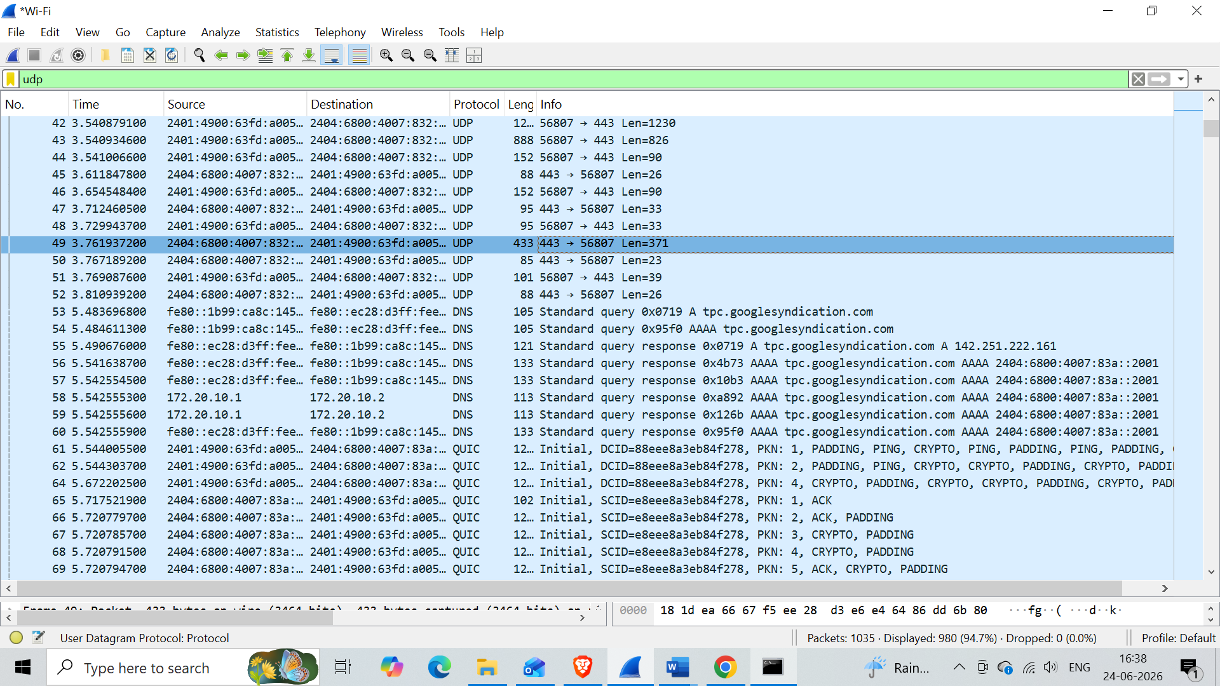

Filter Used: udp
What it Shows | UDP is a fast, connectionless transport protocol. It does not check if packets arrived or guarantee delivery. This makes it ideal for real-time applications like video streaming, DNS, and voice calls where speed matters more than perfect reliability.
Analysis | The UDP filter revealed three different types of traffic running simultaneously - raw UDP data, DNS queries, and QUIC protocol traffic. Key observations:  - Raw UDP packets were going between the local machine and Google servers on port 443 with varying sizes of 1230, 826, and 90 bytes showing live data exchange without waiting for acknowledgment  - DNS traffic appeared from packet 53 with the machine resolving tpc.googlesyndication.com - Google's advertising network. Both IPv4 and IPv6 addresses were returned  - QUIC protocol packets were visible from packet 61 - QUIC is Google's modern protocol that runs over UDP and is used by YouTube and Chrome. The initial handshake showed CRYPTO, PADDING, and PING packets followed by ACK confirmations  - Port 56807 was the local machine's temporary source port assigned for this specific session  - 980 out of 1035 total packets (94.7%) were UDP showing how dominant UDP traffic is during normal browser activity
SOC Use Case | UDP is fast and hard to track because there is no connection state. Attackers take advantage of this in several ways.  - DNS tunneling - attackers encode stolen data inside DNS query names and send it out over UDP port 53. Unusually long domain names or very high DNS query volumes are the main signs  - UDP flood DDoS - sending large volumes of UDP packets to random ports on a target to exhaust its bandwidth  - QUIC abuse - because QUIC is encrypted and uses UDP it is harder for security tools to inspect, making it useful for hiding C2 traffic  - UDP traffic on unexpected ports from internal machines may indicate malware activity or data exfiltration

4.7 DHCP - Dynamic Host Configuration Protocol

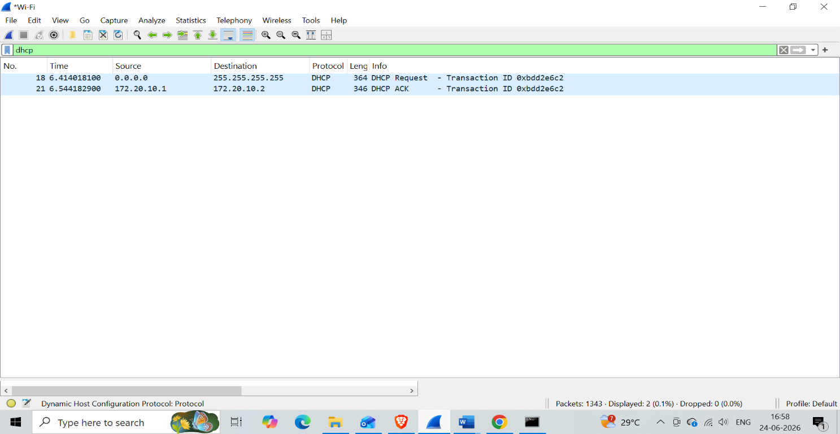

Filter Used: dhcp (bootp)
What it Shows | DHCP is the protocol that automatically assigns an IP address to a device when it connects to a network. It follows a four step process called DORA - Discover, Offer, Request, Acknowledge.
Analysis | The ipconfig /release and /renew commands were used to force a DHCP exchange. The machine requested to keep its previous IP address. Key observations:  - Packet 18 shows a DHCP Request sent from source 0.0.0.0 to broadcast 255.255.255.255 - the machine used 0.0.0.0 because it had no confirmed IP yet and broadcast because it did not know the router address  - The machine was asking the router - Can I keep using my previous IP address 172.20.10.2?  - Packet 21 shows a DHCP ACK from the router at 172.20.10.1 to the machine at 172.20.10.2 confirming - Yes, that IP is yours  - Both packets share the same Transaction ID 0xbdd2e6c2 which links the request and reply together  - Only 2 packets instead of the full 4 step DORA process because the machine already knew its previous IP and jumped straight to Request and Acknowledge - normal behaviour when reconnecting to a known network
SOC Use Case | DHCP has no authentication by default which means any device on the network can pretend to be a DHCP server. This makes it a target for both attackers and network misconfigurations.  - Rogue DHCP server - an attacker sets up their own DHCP server and responds faster than the real router, assigning themselves as the gateway. All traffic then routes through the attacker enabling a Man in the Middle attack  - DHCP starvation - an attacker sends thousands of DHCP requests with fake MAC addresses to use up all available IP addresses, kicking legitimate devices off the network  - Unauthorised device detection - DHCP logs show every device that joined the network with its MAC address and timestamp. Unknown devices stand out immediately in the SIEM  - IP conflict detection - two DHCP replies assigning the same IP to different MACs indicates a rogue server or misconfiguration

5. Investigation Summary
When you open a website, multiple protocols work together in a specific order. Here is the full flow from start to finish:

# | Protocol | What happens
1 | DHCP | When your machine connects to the network, DHCP assigns it an IP address automatically
2 | ARP | Your machine uses ARP to find the MAC address of the router so it can send traffic out
3 | DNS | When you type a website name, DNS converts it to an IP address your machine can connect to
4 | TCP | Your machine does a three-way handshake with the web server to establish a reliable connection
5 | TLS | Over that TCP connection, TLS negotiates encryption so all communication is secure
6 | HTTP/HTTPS | The actual web page data is transferred over the encrypted connection
7 | ICMP | Used separately to test connectivity - ping checks if a host is reachable
8 | UDP | Used by DNS, video streaming via QUIC, and any real-time data that needs speed over reliability

6. Conclusion
This project gave me a clear, hands-on understanding of how different network protocols behave in real traffic. By capturing live packets and applying filters one by one, I was able to see exactly what normal DNS lookups, ICMP pings, TCP connections, HTTP requests, ARP exchanges, UDP streams, and DHCP assignments look like from the inside.

More importantly, this exercise helped me understand what each of these protocols looks like when something is wrong. A SOC analyst spends a lot of time in tools like Wireshark looking for the things that do not fit - unusual domains, unexpected ports, abnormal packet volumes, or suspicious connection patterns.

Having this foundation of protocol knowledge makes it much easier to spot those anomalies quickly and confidently during a real investigation. This is directly applicable to day-to-day SOC work including alert triage, incident investigation, and threat hunting.
--- End of Report ---

