Index No: 249321V  
Name: HDPR Perera   
GitHub project link: <https://github.com/pramodiperera/IT5437>

Question 01

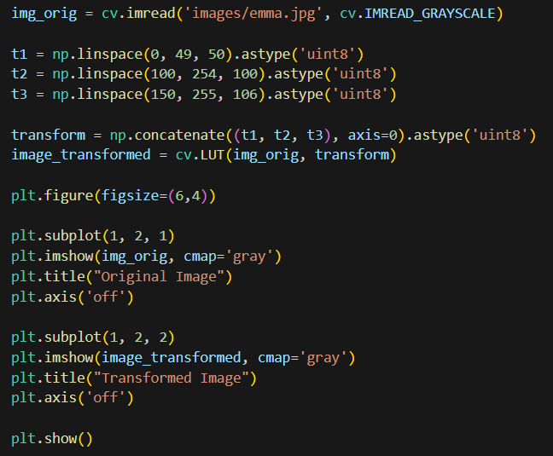Input intensity pixels are grouped as (0 – 49 , 50 – 149, 150 - 255)

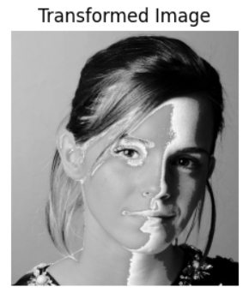

Question 02

1. White matter

(b) Gray matter

Question 08

1. Use grabCut to segment the image

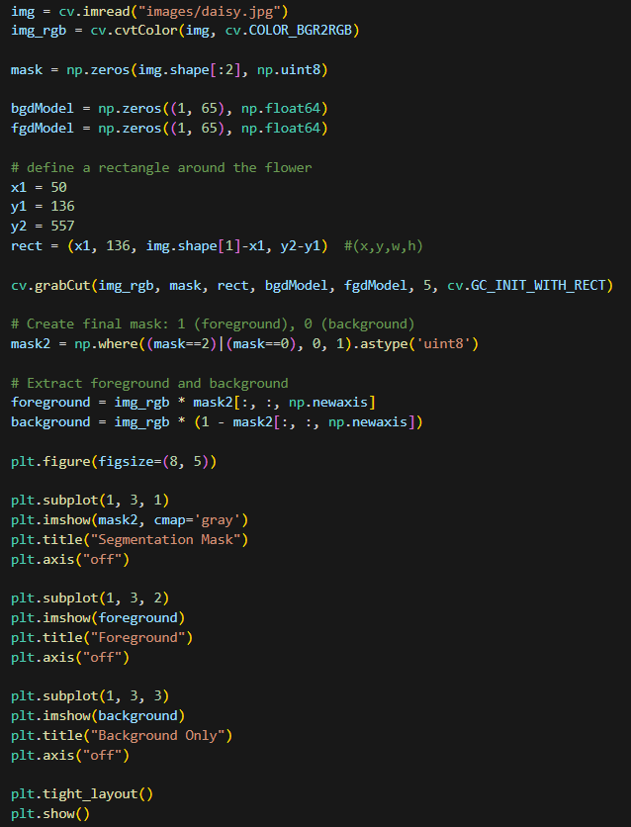The GrabCut algorithm was used with a bounding rectangle around the flower. Rectangle was defined approximately using the original image. This produced a segmentation mask, from which the foreground (flower) and background were extracted separately.

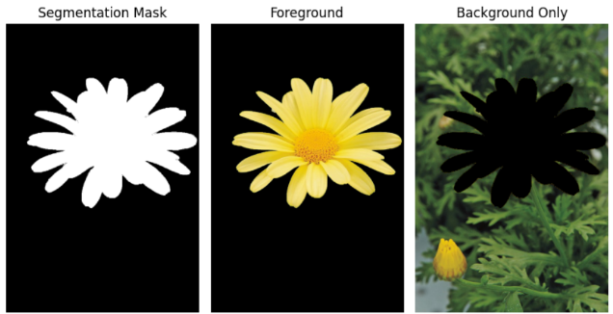

1. Produce an enhanced image with a blurred background

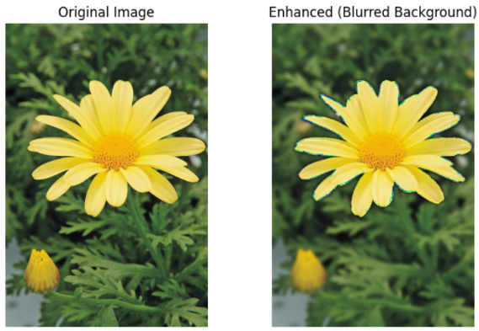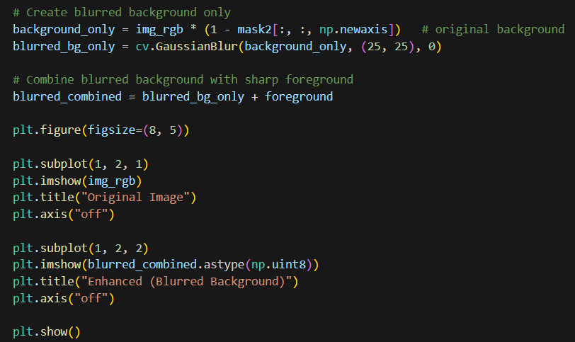To generate a blurred background, gaussian blur was applied. Then, combined blurred background and original foreground.

1. Why is the background just beyond the edge of the flower quite dark in the enhanced image?

Because Grabcut doesn’t perfectly segment the flower from its background. There can be misclassified boundary pixels. So after it combined with the blurred background , we can see a dark outline around the flower.

Question 10

1. Obtain a binary mask for the sapphires.

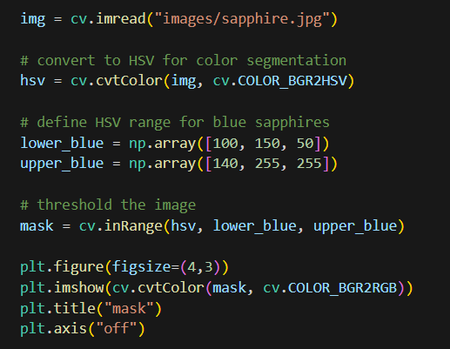A colour-based thresholding method was used to segment the image. The original image was converted to HSV color space. Then, the binary mask was created using a predefined HSV range for blue colour.

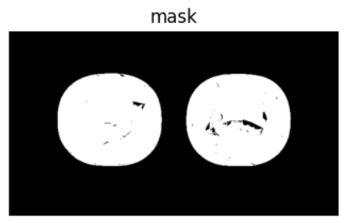

1. Apply a morphological operation to fill the holes

To remove holes inside the sapphires, a morphological operation was used with kernel size 8. Because small kernel sizes(< 8) resulted unfilled few holes.

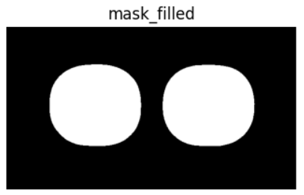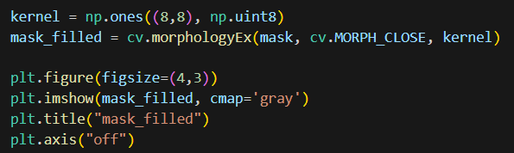

1. Run connectedComponentsWithStats to obtain the areas in pixels.

**Connected component labeling** was used to detect each sapphire separately. The **area in pixels** for each connected component (excluding background) was extracted from stats[:, cv.CC_STAT_AREA].

Areas in pixels: 30059 , 30042

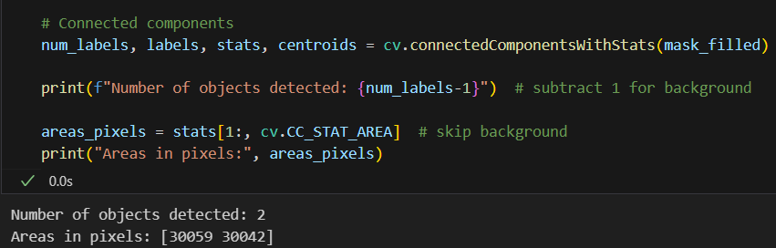

1. Compute the actual areas of the sapphires

The actual sapphire areas were computed using below equation.

Areas = 1.082124e+08 mm2, 1.081512e+08 mm2

= 108212400.00 mm2, 108151200.00 mm2

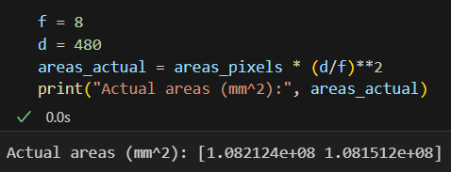 Area actual​ = Area pixels​ × (​)2