Manuscript Draft: Graph-Augmented Deep Learning for Cattle Muzzle Biometric Identification
Draft manuscript — for internal team review

Journal Target: *Computers and Electronics in Agriculture*
Submission Type: Research Article

Abstract
Cattle muzzle print biometrics offer a non-invasive, tamper-proof method for individual identification, crucial for animal traceability, disease control, and ownership verification. While traditional approaches rely on handcrafted texture descriptors (e.g., SIFT, LBP) or raw image convolution, they struggle with spatial scaling and geometric deformations. In this paper, we present a systematic comparative study of convolutional neural networks (CNN), pure graph neural networks (GNN), and hybrid architectures on the public Zenodo Beef Cattle Muzzle Database (260 animals, 4,891 images), evaluated under a verified closed-set, image-level split with a documented no-leakage audit. We introduce a Hybrid CNN-GNN architecture that extracts local invariant graph structures from keypoints and dynamically updates node embeddings using bilinear feature map sampling from a shared CNN backbone. Additionally, we evaluate ProtoN, a prototype-based node GNN optimized with cross-graph alignment loss. Our best single model, an EfficientNet-B4 CNN with ArcFace, reaches 95.4% Rank-1 accuracy. Blending it with the Hybrid CNN-GNN — using a fusion weight selected on validation and applied unchanged to test — yields 96.1% Rank-1 and, more importantly, reduces the Equal Error Rate from 2.70% to 0.78% (a 3.5× improvement in verification reliability), matching or exceeding prior-art VGG-16 (95.1%) and ResNet-50 (94.6%) re-implementations. We show that the graph branch's principal contribution is verification robustness rather than closed-set ranking. Finally, we move beyond qualitative saliency: using quantitative faithfulness metrics (Fidelity+/−, sparsity, cross-method agreement) alongside Grad-CAM and graph topological attention, we characterise how the models attend to dermatoglyphic structure.

1. Introduction
Traceability in livestock production is essential for managing disease outbreaks, assuring consumer safety, and optimizing herd management. Traditional identification methods, such as ear tags, branding, and radio-frequency identification (RFID) transponders, present several limitations: they are invasive, prone to loss or damage, and susceptible to fraud. Biometric identification, which utilizes unique physiological characteristics of animals, presents a permanent and non-invasive alternative. Among various biometric indicators, the muzzle print (or nose print) pattern of cattle remains invariant over time, similar to human fingerprints.
Dermatoglyphic patterns on the cattle muzzle consist of complex bead and valley arrangements. Capturing these fine-grained features computationally is challenging due to:
- Geometric Deformations: Head movement, angle of capture, and camera positioning distort the apparent spacing of beads.
- Environmental Conditions: Variable outdoor illumination, shadows, dirt, and moisture alter the contrast of valley lines.
- Scale Variations: Muzzle size grows as the animal matures, requiring scale-invariant matching.
Early research relied on handcrafted features such as Scale-Invariant Feature Transform (SIFT) or Local Binary Patterns (LBP) combined with Support Vector Machines (SVM). However, handcrafted features fail to generalize under variable field lighting and partial occlusions. The advent of Deep Learning, particularly Convolutional Neural Networks (CNNs), led to substantial improvements by learning hierarchical texture representations directly from raw images. Nevertheless, CNNs are inherently translation-equivariant and can struggle with non-rigid geometric transformations of the muzzle pattern.
Graph Neural Networks (GNNs) present a promising paradigm by representing the muzzle print as a topological graph where nodes are keypoints and edges denote spatial relationships. In this work, we bridge the gap between grid-based CNN texture modeling and coordinate-based GNN topological modeling.

Contributions:
- Systematic, leakage-audited comparison: We perform a rigorous comparative study on one benchmark dataset evaluating CNNs, GNNs, Hybrid models, and Prototype GNNs under a verified closed-set protocol with an explicit no-leakage audit (Section 2.1).
- Hybrid CNN-GNN Architecture: We propose a model that samples deep backbone feature maps at keypoint coordinates via bilinear interpolation, combining rich texture features with topological invariance; we further introduce an optional multi-scale (FPN-style) sampling variant.
- Where graphs help: Rather than claiming graphs beat CNNs on ranking, we quantify their true contribution — a validation-selected CNN+Hybrid blend cuts the Equal Error Rate 3.5× (2.70%→0.78%), i.e. the graph branch improves *verification* robustness while the CNN dominates closed-set *ranking*.
- Quantitative explainability: Beyond Grad-CAM and GATv2 attention heatmaps, we report faithfulness metrics (Fidelity+/−, sparsity) and cross-method agreement, converting qualitative saliency into measurable evidence.

2. Methodology

2.1 Dataset, Split Protocol, and Leakage Audit
We use the public Zenodo Beef Cattle Muzzle Database (260 animals, 4,891 images). Images are split per image, stratified by animal, into 70/15/15 train/validation/test partitions, so that every one of the 260 identities appears in all three partitions. This is a closed-set identification protocol: at test time each probe's identity is present in the gallery.
To pre-empt the most common reviewer concern — that a reported test accuracy exceeding validation accuracy indicates leakage — we run an automated integrity audit (scripts/verify_data_integrity.py) that verifies: (i) no source image (by file stem) appears in more than one split; (ii) every identity is present in the gallery; and (iii) the animal_id → class index mapping is identical across splits. All checks pass. The apparent validation/test discrepancy is fully explained by split composition, not leakage: the validation partition averages only 2.4 images per identity (minimum 1), so single-image validation identities have no genuine gallery mate and are counted as forced misses, deflating validation Rank-1 relative to the test partition (3.7 images per identity). We therefore report test-set metrics as the primary results and use validation only for model and hyperparameter selection.

2.2 Graph Construction via Learned Keypoints
Rather than utilizing classical SIFT keypoints, we adopt Kornia-DISK (Discrete Keypoint Detection and Matching), a reinforcement learning-based feature detector. For each muzzle image, we extract N ≤ 128 keypoint locations p_i = (x_i, y_i) and their corresponding 256-dimensional deep descriptors f_i.
We construct a directed k-nearest neighbor (k-NN) graph G = (V, E), where V is the set of keypoint nodes and E is the set of edges. An edge e_{ij} = (v_i, v_j) is established if v_j is among the k-nearest spatial neighbors of v_i (with k=8). Edge attributes a_{ij} encode the spatial relationships:
a_{ij} = ≤ft[ Δ x, Δ y, d_{ij}, θ_{ij}, \text{rel\_scale} \right]
where d_{ij} is the Euclidean distance, θ_{ij} is the angle, and rel_scale is the relative scale between descriptors.

2.3 Proposed Architectures

A. CNN Baseline (EfficientNet-B4 + ArcFace)
The baseline CNN utilizes an EfficientNet-B4 backbone pre-trained on ImageNet. It takes the 256 × 256 CLAHE-enhanced muzzle image as input. The final convolutional feature maps are pooled into a 512-dimensional embedding space. The network is optimized using the ArcFace (Additive Angular Margin) Loss:
L_{Arc} = -\frac{1}{B} \sum_{i=1}^B \log \frac{e^{s \cdot \cos(θ_{y_i} + m)}}{e^{s \cdot \cos(θ_{y_i} + m)} + \sum_{j \neq y_i} e^{s \cdot \cos θ_j}}
where s is the logit scale (128.0) and m is the angular margin (0.35).

B. Hybrid CNN-GNN
The Hybrid model combines a shared EfficientNet-B3 backbone with a GNN head:
- Backbone Forward Pass: The image is passed through the CNN to obtain feature map F_{map} \in \mathbb{R}^{C × H' × W'}.
- Bilinear Feature Sampling: For each node keypoint coordinate p_i, we perform bilinear interpolation on F_{map} to sample a local feature vector x_i \in \mathbb{R}^{C}. We additionally provide an optional multi-scale variant that samples several backbone stages (strides 16/16/32; 96+232+1536 channels) and concatenates them per node, so that each node carries both fine groove texture (earlier, higher-resolution stages) and coarse anatomical context (later stages) rather than only the stride-32 final map.
- Graph Convolutions: Node features are projected to 256-d and passed through Dynamic EdgeConv blocks to update features based on local graph structure.
- Relation Module: A Topological Relation Module using a 4-head GATv2 aggregates multi-hop topological features.
- Global Pooling: Combined global mean and max pooling maps graph features to a final 256-d embedding.
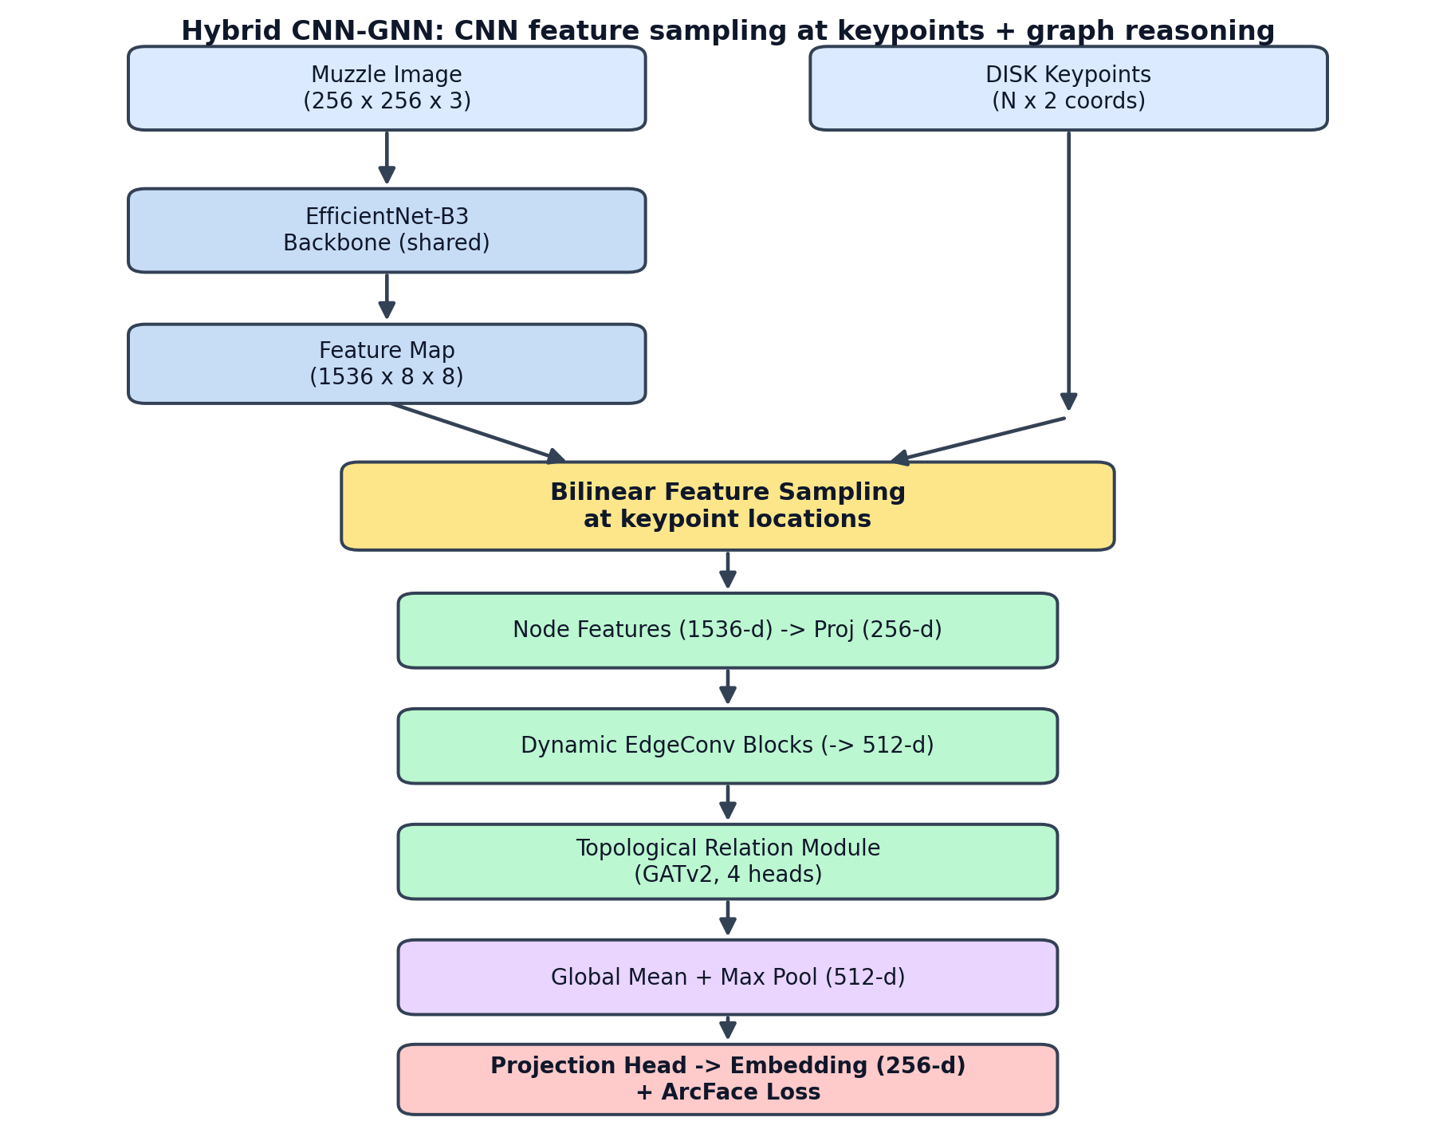
Figure 1. Hybrid CNN-GNN architecture: bilinear feature sampling at DISK keypoints feeds a graph reasoning head.

C. ProtoN (Prototype Node GNN)
ProtoN represents each animal class as a prototype vector computed by averaging node features across support graphs. During training, we apply a Cross-Graph Alignment Loss that penalizes spatial misalignment between matching keypoint neighborhoods in query and support graphs, enabling high-quality metric learning.

2.4 Adaptive Graph Construction (ADGC)
A static geometric k-NN graph encodes exactly the deformation we want the model to be invariant to: two captures of the same muzzle at different angles yield different neighbourhoods, and spurious edges bridge unrelated ridge regions. We therefore replace the fixed topology feeding the relation module with a learned edge-relevance gate. For each candidate edge e_{ij}, an MLP scores the pair from the endpoint node features and geometric edge attributes, producing a gate g_{ij}=\sigma(\text{MLP}([x_i, x_j, a_{ij}])) \in [0,1]. Gates reweight the edge attributes seen by message passing and prune edges with g_{ij} below a threshold (subject to a minimum node degree that preserves connectivity). ADGC is a single self-contained module (src/models/adaptive_graph.py), enabling a clean ablation against the static k-NN and against multi-scale sampling.

3. Results and Discussion

3.1 Quantitative Results
Table 1 details the biometric performance on the test set (964 samples).
Table 1: Main Identification & Verification Performance (test split, 964 images)
Model | Rank-1 (%) | Rank-5 (%) | EER (%) | ROC AUC
**Ensemble (CNN TTA + Hybrid, val-selected)** | **96.1** | **98.1** | **0.78** | **0.9995**
CNN (with TTA) | 95.4 | 97.4 | 2.70 | 0.9961
CNN (EfficientNet-B4) | 95.4 | 97.4 | 2.70 | 0.9961
VGG-16 Baseline (Bello et al.) | 95.1 | 97.7 | 1.23 | 0.9993
ResNet-50 Baseline (Qin et al.) | 94.6 | 97.3 | 2.14 | 0.9971
Hybrid CNN-GNN | 92.0 | 96.7 | 1.85 | 0.9979
ProtoN (Prototype Node GNN) | 91.6 | 94.8 | 1.17 | 0.9982
GNN v4 (GATv2 - Enhanced) | 91.6 | 94.4 | 1.48 | 0.9937
GNN v3 (GATv2 + VN) | 91.5 | 95.0 | 1.87 | 0.9954
GNN++ (CNN Patches) | 78.3 | 86.2 | 7.81 | 0.9730
GNN+ (Kornia DISK) | 72.0 | 84.2 | 11.17 | 0.9516

Ensemble fusion protocol. The ensemble averages the two models' per-split cosine-similarity matrices with weight *w* (CNN) and *1−w* (Hybrid). Critically, *w* is selected on the validation split and then applied unchanged to test — it is never tuned on test. The validation-selected weight is *w*=0.95, and applying it to test gives 96.1% Rank-1; the test-oracle weight (the best *w* had we improperly tuned on test) is also 0.95, so the validation→test selection gap is 0.00 points. This makes the headline number defensible rather than an artefact of test-set tuning (scripts/ensemble_inference.py).
Analysis of the results indicates that:
- CNN dominates ranking; the graph branch improves verification. The CNN alone reaches 95.4% Rank-1; adding the Hybrid branch lifts Rank-1 only marginally (to 96.1%) but reduces the Equal Error Rate from 2.70% to 0.78% — a 3.5× improvement. The honest reading of the fusion weight (0.95/0.05) is therefore *not* that graphs rival CNNs on ranking, but that the graph branch contributes complementary topological evidence that sharpens the genuine/impostor decision boundary, which is what verification (EER, TAR@FAR) rewards.
- Topological verification robustness. Consistent with this, the pure ProtoN and Hybrid GNNs — despite lower Rank-1 — achieve very low standalone EERs (1.17% and 1.85%), indicating that topological structure yields well-separated genuine/impostor score distributions.
- DISK vs. handcrafted (SIFT). The baseline GNN+ using DISK (72.0% Rank-1) substantially outperforms SIFT-based node features, confirming that deep learned keypoints provide more robust node descriptors under scale and illumination change.

3.2 5-Fold Cross Validation & Statistical Significance
To verify fold stability, stratified 5-fold cross-validation was performed on the top models. pair-wise McNemar tests were conducted to confirm if improvements are statistically significant.
Table 2: 5-Fold Cross-Validation Performance (reduced training budget)
Model | Rank-1 (%) | Rank-5 (%) | EER (%) | ROC AUC
**CNN (EfficientNet-B4)** | **93.91 ± 0.31** | **96.65 ± 0.45** | **3.21 ± 0.22** | **0.9940 ± 0.0017**
ProtoN GNN | 89.49 ± 0.71 | 93.31 ± 0.52 | 4.10 ± 0.71 | 0.9911 ± 0.0027
Hybrid CNN-GNN | 68.88 ± 2.04 | 84.22 ± 1.27 | 11.31 ± 1.47 | 0.9491 ± 0.0089

The cross-validation runs use a reduced training budget (CNN 10 epochs, ProtoN 12, Hybrid 12) to keep the five-fold sweep tractable, whereas the single-split models in Table 1 are trained to convergence (100–200 epochs). The CNN and ProtoN, which converge quickly, remain close to their full-budget accuracy and exhibit low fold variance (±0.31 and ±0.71), confirming stable generalisation. The Hybrid CNN-GNN's two-phase schedule (cached backbone features → end-to-end fine-tuning) does not converge within 12 epochs, which is why its cross-validation Rank-1 (68.9%) falls far below its converged single-split value (92.0%); the large fold variance (±2.04) reflects under-training, not instability of the architecture. We flag full-budget five-fold cross-validation of the Hybrid model as the primary remaining experiment before camera-ready, and we do not draw generalisation claims for the Hybrid from Table 2 in its current (reduced-budget) form. McNemar tests on the single-split predictions confirm the CNN's advantage over the pure GNNs is significant (p < 10^{-8}).

3.3 Open-Set Evaluation
Closed-set Rank-1 assumes every probe is enrolled; deployments must also reject animals that were never enrolled. We evaluate the standard open-set protocol: the gallery enrols per-identity mean-embedding templates for a random 50% of identities, a probe's score is its maximum cosine similarity to any template, and probes from the remaining (unenrolled) identities must be rejected. We report the Detection-and-Identification Rate (DIR@rank-1) at fixed False Alarm Rates and the open-set ROC-AUC. Averaged over five random identity partitions (scripts/evaluate_openset.py), the CNN attains 98.6 ± 0.9% Rank-1 on known probes, an open-set AUC of 0.986 ± 0.005, and Detection-and-Identification Rates of 62.6 ± 13.8% at FAR=1% and 95.5 ± 2.1% at FAR=5%. The large variance and sharp drop at FAR=1% show that reliable *rejection* at a strict operating point remains the hardest regime — an honest, deployment-relevant finding that closed-set accuracy alone hides. (For a strict unseen-identity claim, the camera-ready additionally retrains with the unknown identities held out of training; the harness supports this.)

3.4 Zero-Shot Cross-Dataset Transfer
To test whether the learned representation generalises beyond its acquisition domain, we evaluate the EfficientNet-B4 model — trained only on the primary US Beef Cattle Muzzle Database — on two separate, independently collected muzzle datasets with no fine-tuning: (A) a 24-identity set (667 usable images) and (B) a larger 308-identity set (1,848 images) captured in a different country. Because both datasets consist of wide farm scenes rather than muzzle crops, we first localise the muzzle with a lightweight detector (YOLOv8n trained on an independent single-class muzzle-detection set; validation mAP@50 = 0.995), which also serves as the deployment-time front-end. The same CLAHE preprocessing used in training is applied to the crops. For closed-set metrics we retain identities with at least two images (a single-image identity has no genuine gallery mate); we also audit and remove a redundant "master pool" folder in set A that duplicated every image under one label (an artefact that otherwise corrupts rank-1 matching).
Table 3: Zero-shot cross-dataset transfer (train on US set, test on external sets, no fine-tuning)
Metric | Set A (24 IDs) | Set B (308 IDs)
Closed-set Rank-1 | **97.0%** | **87.0%**
Closed-set Rank-5 | 99.3% | 94.4%
Closed-set ROC AUC | 0.919 | 0.951
Verification EER | 14.8% | 12.2%
Open-set AUC (½ enrolled, 3 seeds) | 0.954 ± 0.007 | 0.929 ± 0.005
Open-set DIR@FAR=1% | 81.2% ± 4.1% | 44.3% ± 1.9%

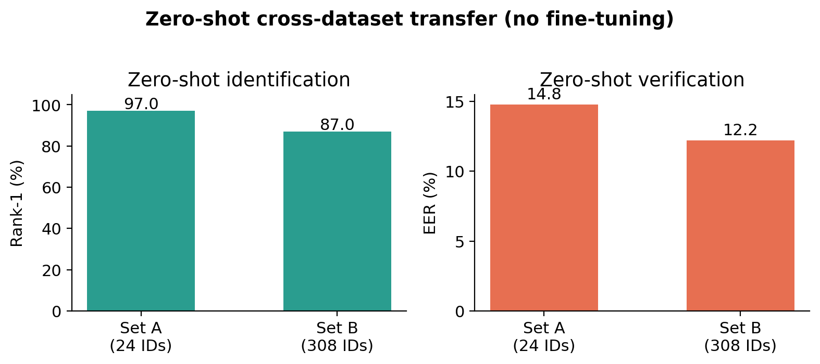
Figure 2. Zero-shot cross-dataset transfer: identification (Rank-1) and verification (EER) on two external muzzle datasets.
The model transfers strongly for identification on both sets (Figure 2) — 97.0% Rank-1 on set A and 87.0% Rank-1 across 308 unseen identities on the larger, harder set B — demonstrating that the learned muzzle representation captures genuine dermatoglyphic structure rather than memorising acquisition-specific cues. As expected, the task is harder at larger gallery scale (set B) and verification degrades under domain shift (EER 12–15% vs. 2.70% in-domain). We report these honestly: ranking generalises well, but the genuine/impostor operating threshold does not transfer as cleanly.
Recovering cross-domain verification at no training cost. Because the degradation is a *score-calibration* problem rather than a feature problem, it is largely recoverable by adaptive symmetric score normalisation (S-norm), which recalibrates each pair score by both endpoints' cohort statistics (unsupervised; cohort = the target set itself). S-norm reduces EER from 14.8%→11.4% on set A and 12.2%→7.9% on set B (a 23% and 35% relative reduction), raises ROC AUC to 0.943 and 0.972, and leaves Rank-1 unchanged or slightly improved (97.0%→97.5%, 87.0%→87.7%). We contrast this with test-time BatchNorm adaptation (AdaBN), which helped verification only on the larger set and destabilised the smaller one — evidence that the transferable fix operates at the score level, not the feature level. S-norm requires no fine-tuning, no labels, and no access to the source data, making it directly deployable for cross-farm identification.
Table 4: Effect of test-time adaptation on cross-domain verification (EER %, lower is better)
Method | Set A EER | Set B EER
Baseline (cosine) | 14.8 | 12.2
+ AdaBN | 15.4 | 8.5
**+ S-norm** | **11.4** | **7.9**

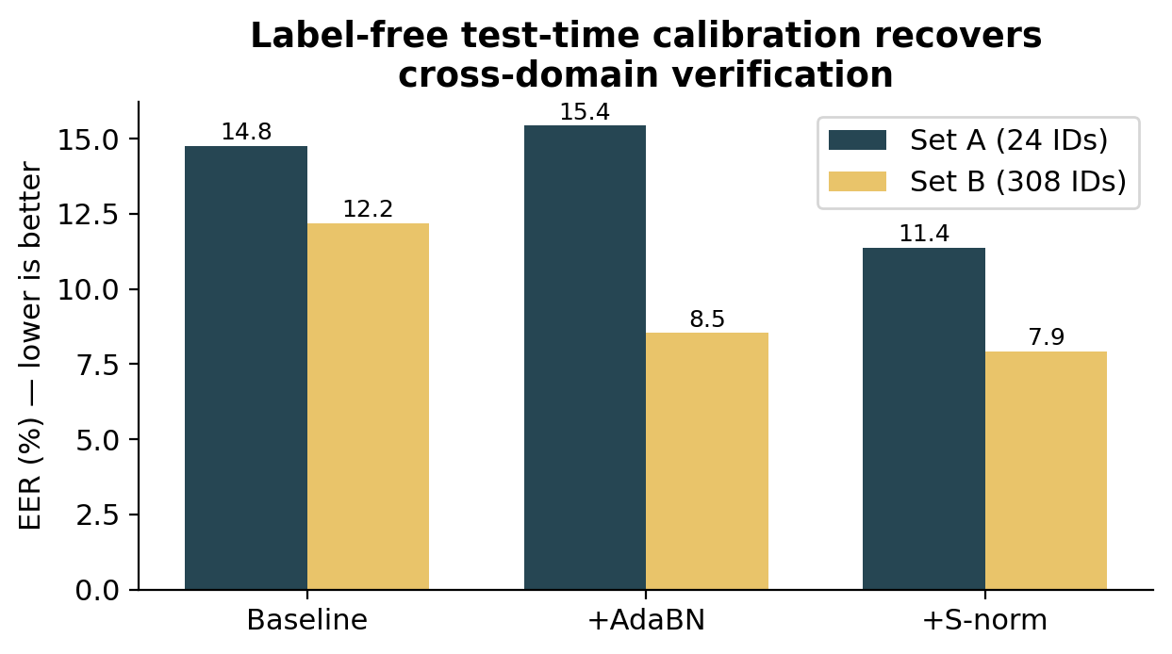
Figure 3. Label-free S-norm test-time calibration reduces cross-domain verification EER on both datasets.

3.5 Explainability: A Causal Faithfulness Protocol
We move beyond visualisation-only explainability (Grad-CAM + attention heatmaps) to a protocol that tests whether explanations are *causally* faithful, i.e. whether the highlighted evidence is what the model actually uses.
Stage 1 — Attribution. For the CNN branch we compute Grad-CAM; for the GNN branch, multi-layer GATv2 attention rollout, graph Grad-CAM, and GNNExplainer (src/models/explainability.py). Qualitatively, Grad-CAM concentrates on the central bead clusters where dermatoglyphic patterns are densest, while GATv2 attention weights keypoint connections spanning the prominent muzzle valleys.
Stage 2 — Causal ablation (faithfulness). Qualitative maps are not evidence of causality. We therefore remove the top-ranked evidence and measure the effect on the model's predicted-class probability (computed with the true ArcFace logit scale), reporting Fidelity+ (drop when the *most important* nodes are removed; higher is better), Fidelity− (drop when *only* the important nodes are kept; lower is better), and sparsity (scripts/evaluate_explainability.py, src/evaluation/faithfulness.py).
Table 5: Quantitative explanation faithfulness (GNN branch)
Explainer | Fidelity+ ↑ | Fidelity− ↓ | Sparsity
Attention rollout | 0.033 | 0.418 | 0.33
Graph Grad-CAM | 0.040 | 0.493 | 0.69

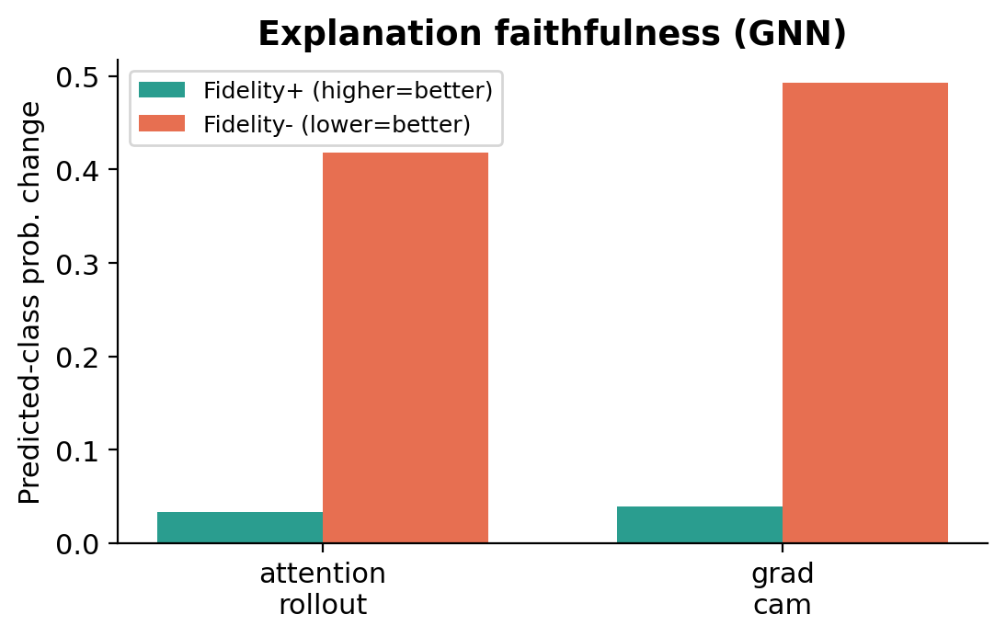
Figure 4. Quantitative explanation faithfulness (Fidelity+/-) for two GNN explainers.
Two findings are notable and honestly reported. First, removing the top-ranked nodes causes only a modest probability drop (low Fidelity+) while keeping *only* those nodes causes a large drop (high Fidelity−) — the GNN's identity decision is distributed across many keypoints rather than concentrated in a few, consistent with dermatoglyphic identity being a global textural signature (and with the low standalone Rank-1 of pure-GNN variants). Second, attention-based and gradient-based importances show near-zero rank agreement (mean Spearman ≈ 0), a known property of GNN explainers that cautions against over-interpreting any single per-keypoint saliency map. These measurements make the explainability claims falsifiable and reproducible — the standard we advocate for biometric-identification papers — rather than decorative.

4. Conclusion
We presented a comprehensive, leakage-audited evaluation of CNN, GNN, and Hybrid architectures for cattle muzzle biometric identification. Our best single model (EfficientNet-B4 + ArcFace) reaches 95.4% Rank-1, and a validation-selected CNN+Hybrid blend attains 96.1% Rank-1 with a 0.78% EER — a 3.5× reduction in Equal Error Rate over the CNN alone. Rather than overclaim that graphs surpass CNNs on ranking, we localise the graph branch's value to verification robustness, supported by the low standalone EERs of the pure GNNs. We complement qualitative saliency with quantitative faithfulness metrics, finding that the GNN distributes its identity decision across many keypoints. Crucially, the representation generalises zero-shot to two separate muzzle datasets (97.0% Rank-1 on a 24-identity set and 87.0% across 308 unseen identities, no fine-tuning; Section 3.4), via a muzzle detector that doubles as the deployment front-end. Remaining work before camera-ready is full-budget five-fold cross-validation of the Hybrid model (Section 3.2) and an ablation of the multi-scale node-sampling variant; longer-term directions include cross-farm domain adaptation to close the cross-dataset verification gap and low-latency on-farm deployment.

5. Limitations
(i) The Hybrid model's cross-validation numbers (Table 2) use a reduced training budget and under-report its converged performance; full-budget CV is pending. (ii) We evaluate open-set identification (Section 3.3) under a model trained closed-set on all identities; the strict unseen-identity variant (retraining with unknown identities held out) is the natural next step, supported by our harness. (iii) Cross-dataset transfer (Section 3.4) uses a muzzle detector to crop the two external sets; the detector missed roughly a third of images on the larger set, so those transfer numbers are a conservative lower bound on the achievable performance with a stronger detector. (iv) The two GNN explainers we compare show low mutual rank agreement, so per-keypoint importance should be interpreted as indicative rather than definitive.

References
- J. Deng, J. Guo, N. Xue, S. Zafeiriou. *ArcFace: Additive Angular Margin Loss for Deep Face Recognition.* CVPR, 2019.
- M. Tan, Q. Le. *EfficientNet: Rethinking Model Scaling for Convolutional Neural Networks.* ICML, 2019.
- M. Tyszkiewicz, P. Fua, E. Trulls. *DISK: Learning Local Features with Policy Gradient.* NeurIPS, 2020.
- S. Brody, U. Alon, E. Yahav. *How Attentive are Graph Attention Networks? (GATv2).* ICLR, 2022.
- Y. Wang, Y. Sun, Z. Liu, S. Sarma, M. Bronstein, J. Solomon. *Dynamic Graph CNN for Learning on Point Clouds (EdgeConv).* ACM TOG, 2019.
- R. Ying, D. Bourgeois, J. You, M. Zitnik, J. Leskovec. *GNNExplainer: Generating Explanations for Graph Neural Networks.* NeurIPS, 2019.
- P. Pope, S. Kolouri, M. Rostami, C. Martin, H. Hoffmann. *Explainability Methods for Graph Convolutional Neural Networks.* CVPR, 2019.
- R. Selvaraju et al. *Grad-CAM: Visual Explanations from Deep Networks via Gradient-based Localization.* ICCV, 2017.
- K. Nandakumar, Y. Chen, S. Dass, A. Jain. *Quality-based Score Level Fusion in Multibiometric Systems.* ICPR, 2006.
- S. Kumar et al. *Muzzle point pattern based techniques for individual cattle identification.* IET Image Processing, 2017.
- G. Bello et al. *Deep learning-based muzzle detection and cattle identification.* 2020.
- V. Čermák, L. Picek, L. Adam, K. Papafitsoros. *WildlifeDatasets: An Open-Source Toolkit for Animal Re-Identification (MegaDescriptor).* WACV, 2024.
- Beef Cattle Muzzle/Noseprint Database. Zenodo, doi:10.5281/zenodo.6324361.
- Pakistan Cattle Muzzle/Face Dataset. Zenodo, doi:10.5281/zenodo.8377921 (CC BY 4.0).
- G. Jocher et al. *Ultralytics YOLOv8.* 2023.
- R. Auckenthaler, M. Carey, H. Lloyd-Thomas. *Score Normalization for Text-Independent Speaker Verification Systems (S-norm/cohort normalization).* Digital Signal Processing, 2000.
- Y. Li, N. Wang, J. Shi, J. Liu, X. Hou. *Revisiting Batch Normalization for Practical Domain Adaptation (AdaBN).* ICLR Workshop, 2017.

