**Deploying Django application on Window:**

1. Installation of packages in python for Django

* Installing Virtual Environment
* Creating Virtual Environment 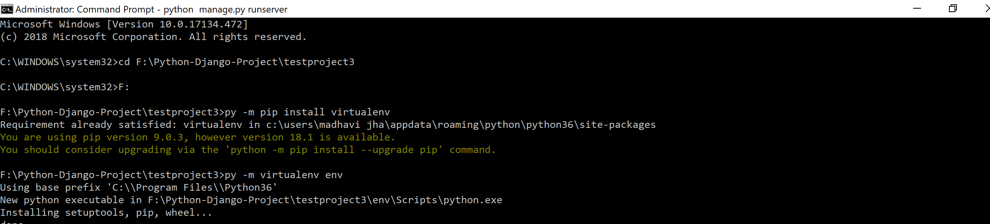
* Change directory to Scripts and activate virtual environment

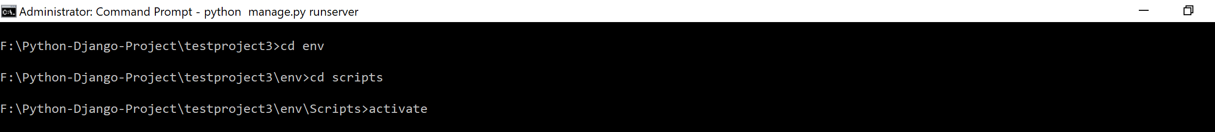

* Install wfastcgi
* Install Django
* enable wfastcgi

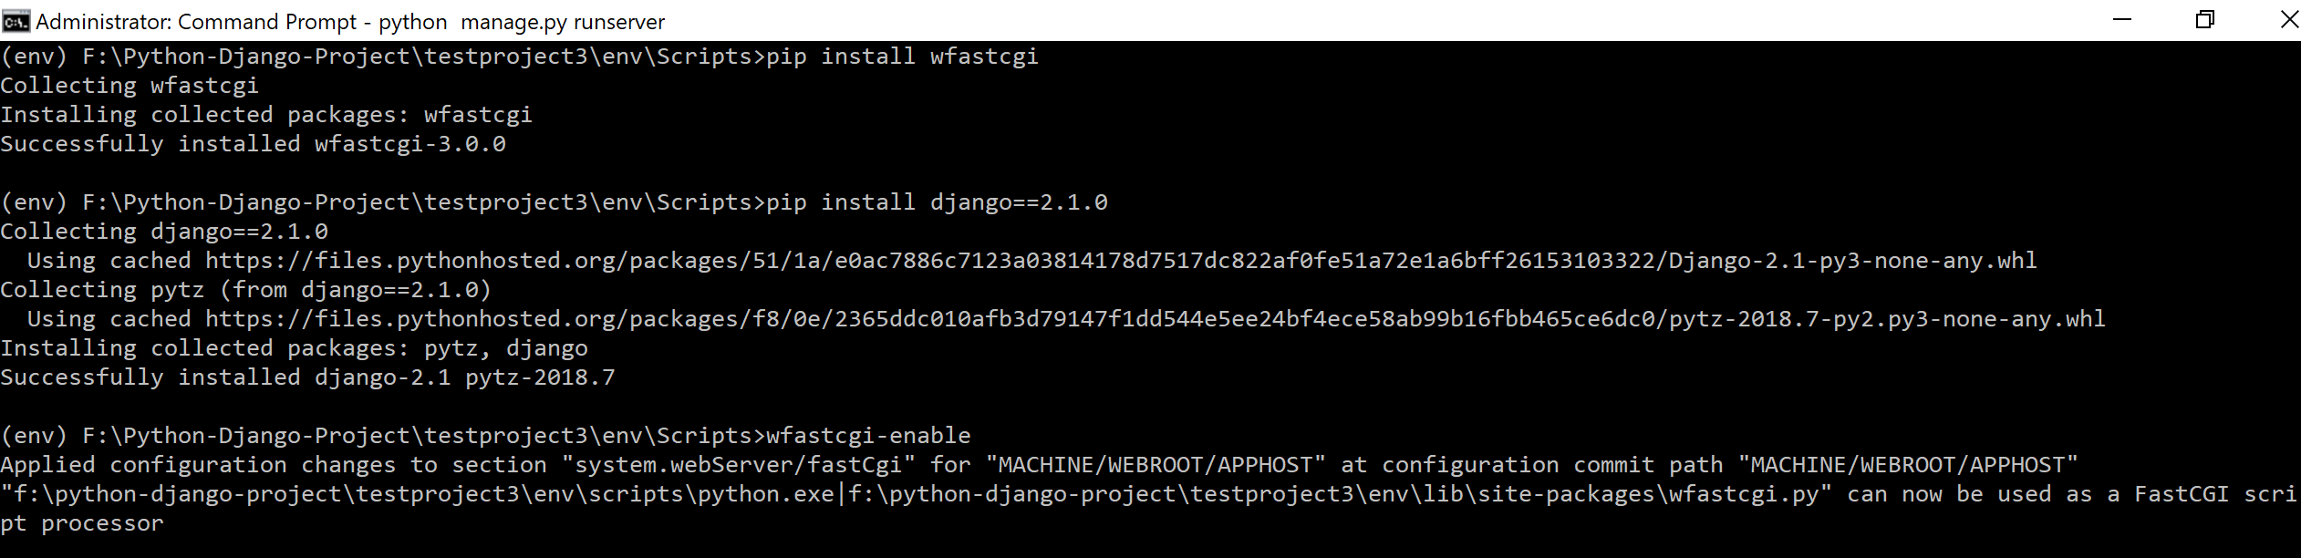

* Create Project
* Create App

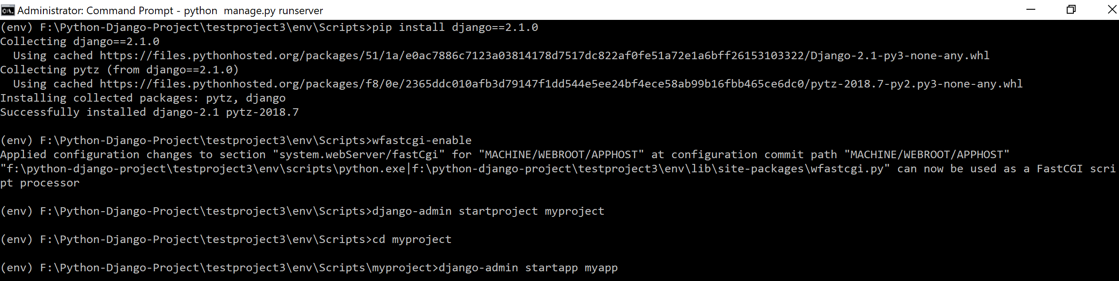

* Makemigrations
* Migrate
* Run server 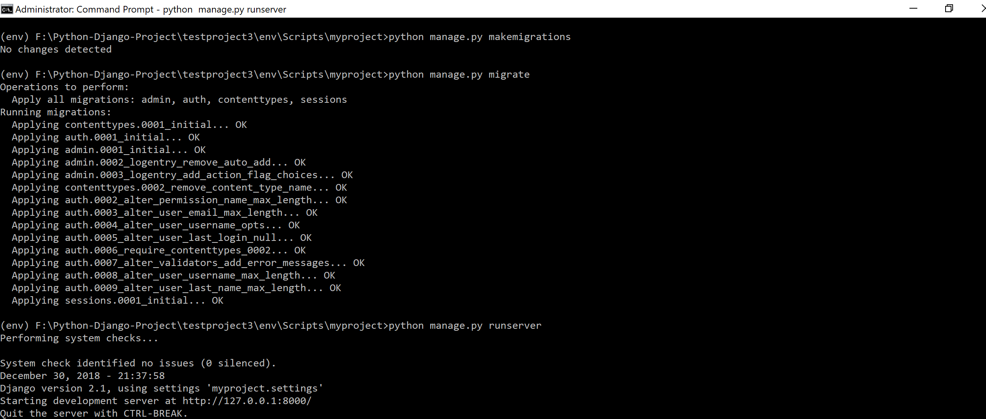

1. Installation of packages in python for Django
   1. Adding Website In IIS:

* Add Website in IIS as shown below:

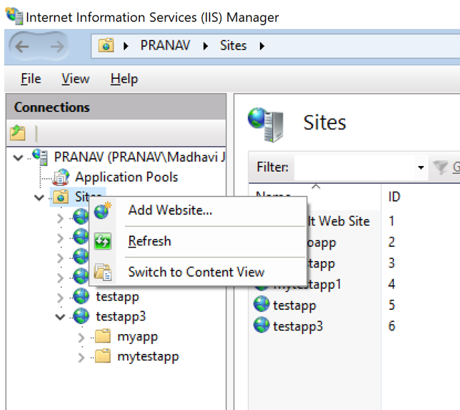

* Dialog box will appear as shown below:

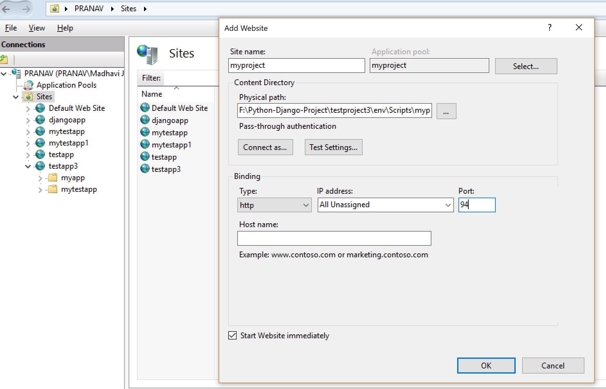

***Physical Path:*** *F:\Python-Django-Project\testproject3\env\Scripts\myproject*

* You can see the website created in below list:

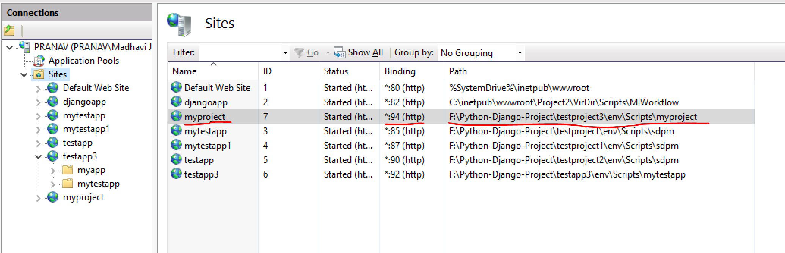

* 1. Add Handler Mapping in App:
* Select website and click on Handler mappings as shown below:

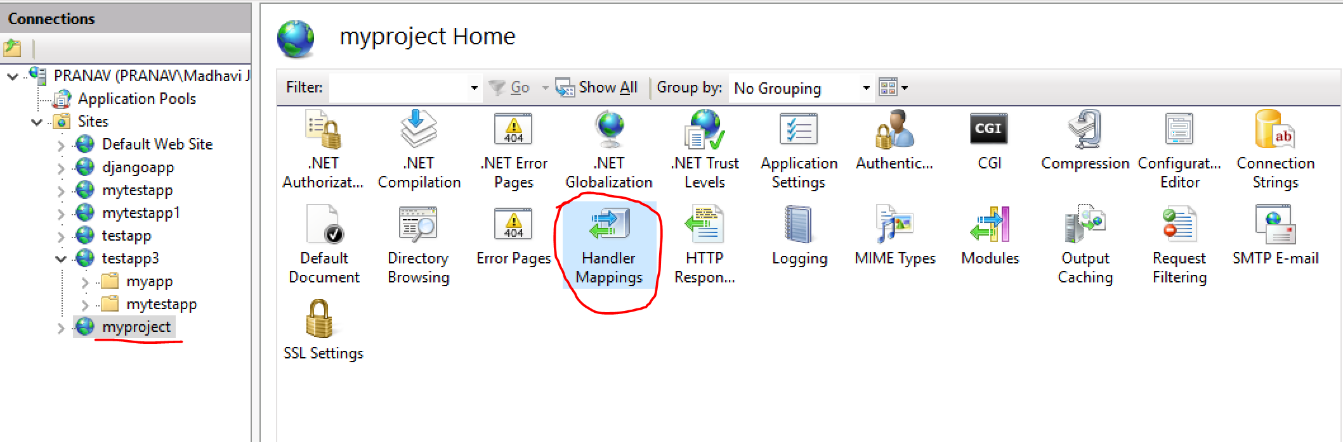

* On click ‘Handler Mappings’ Dialog box shown below will appear:

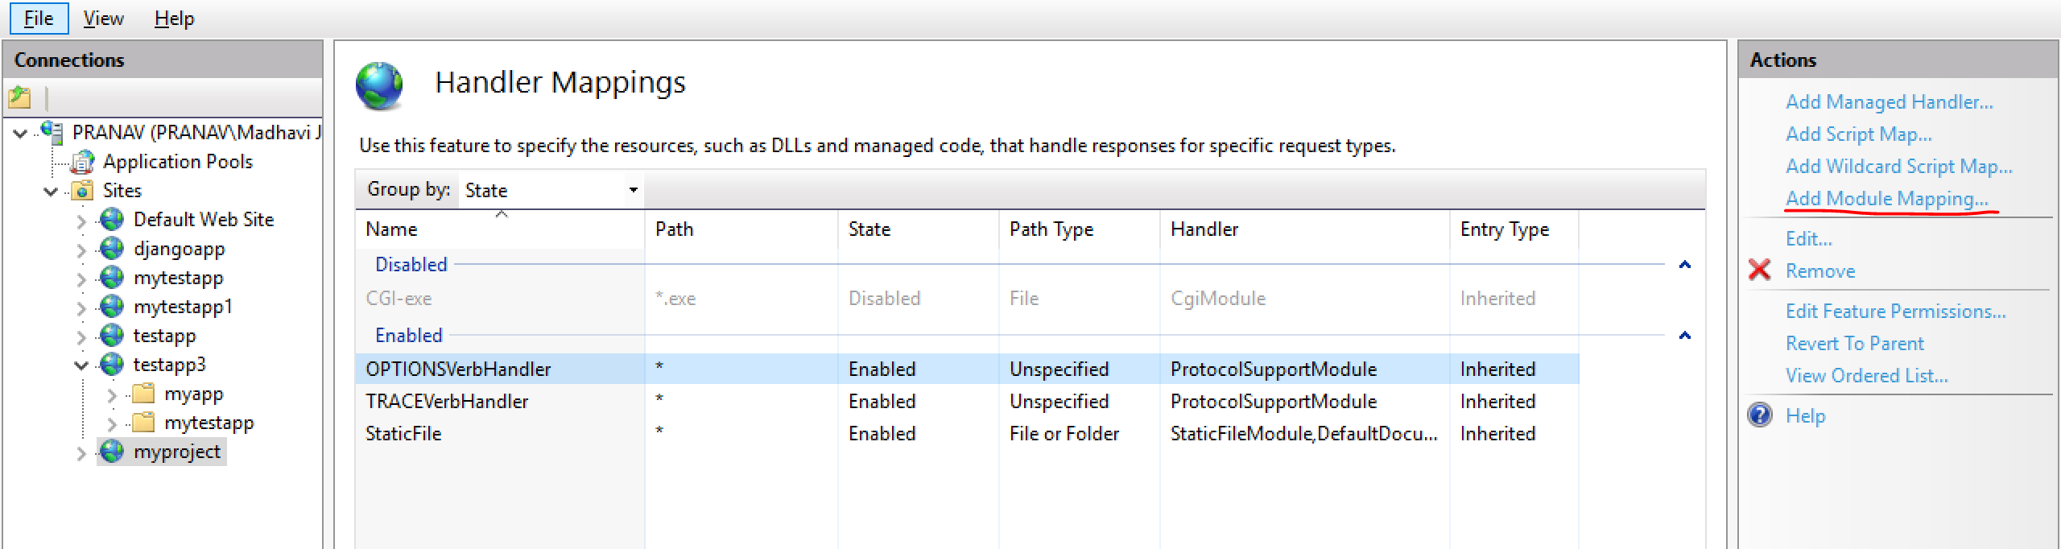

* Click on ‘Add Module Mapping’ highlighted in above dialog box, on click below dialog box will appear.

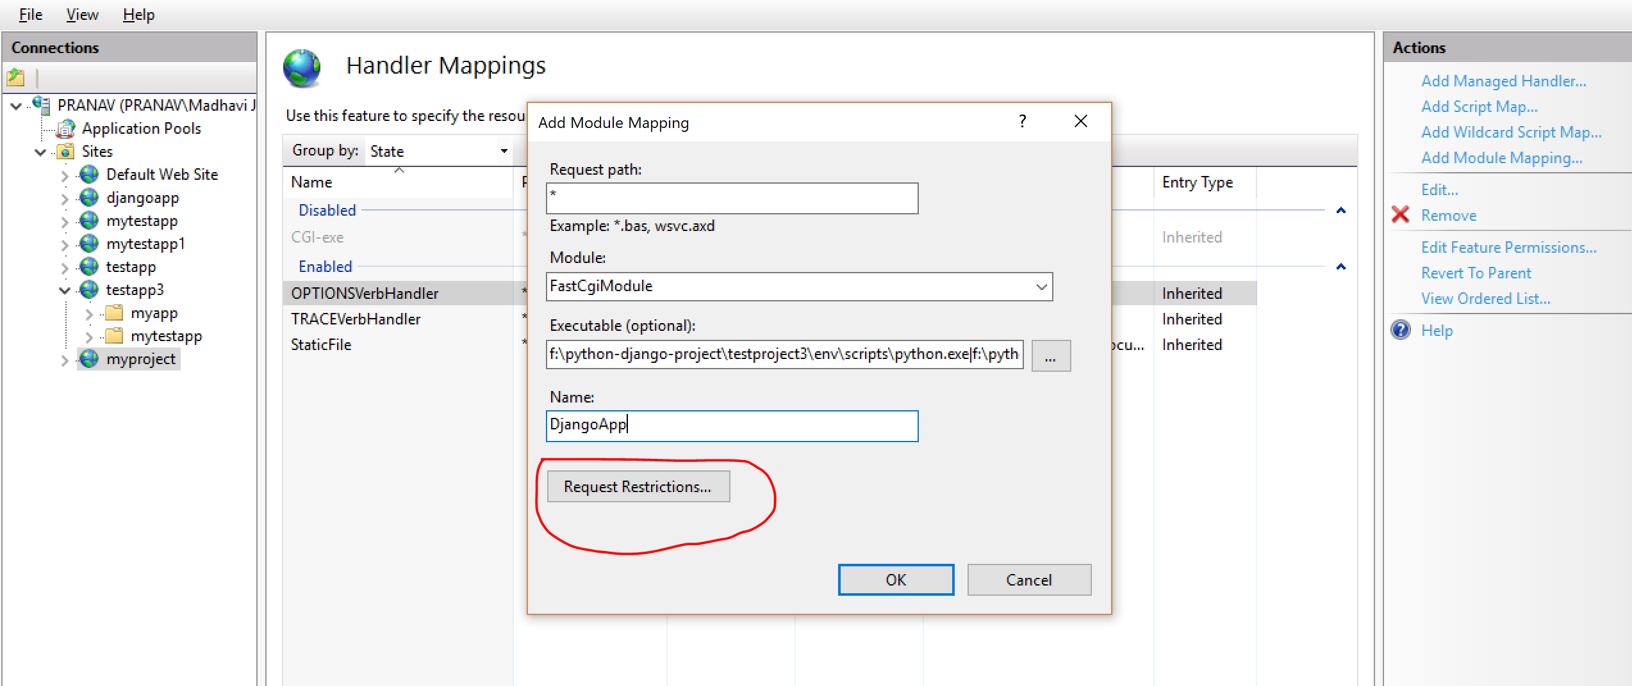

**On above enter the data as given below:**

Enter “*” in request path

Select ‘FastCgiModule’ in module

In Executable (Optional) add the path that was generated when we enabled wfastcgi in above step (Below is the screenshot of the same):

“f:\python-django-project\testproject3\env\scripts\python.exe|f:\python-django-project\testproject3\env\lib\site-packages\wfastcgi.py”

Now click on ‘Request Restrictions’ , below dialog box will appear, uncheck ‘Invoke handler only if request is mapped to’ and click ok:

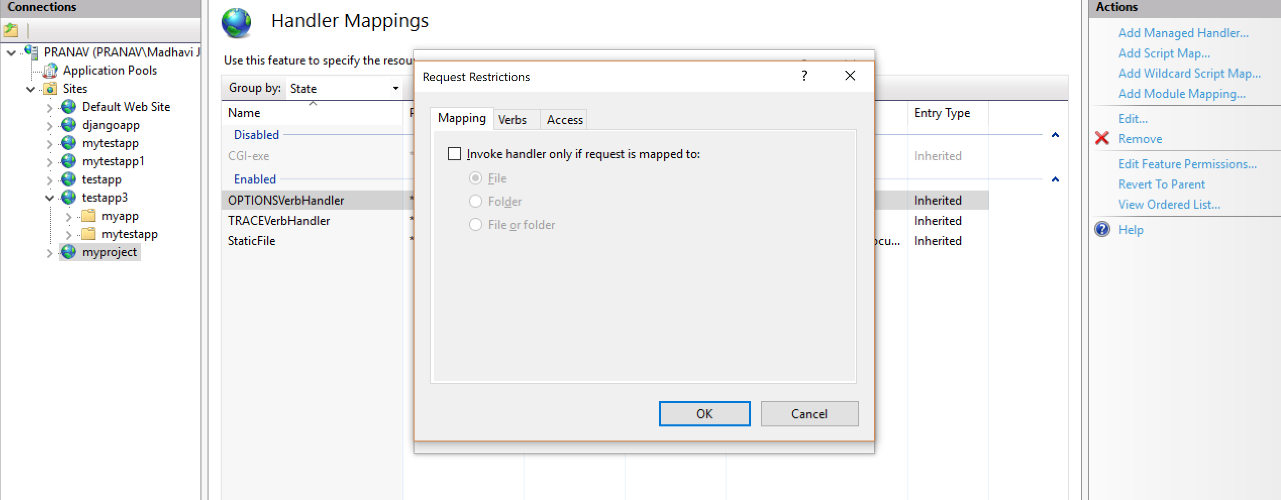

* On click of ‘ok’ below pop up will appear. Click ‘Yes’.

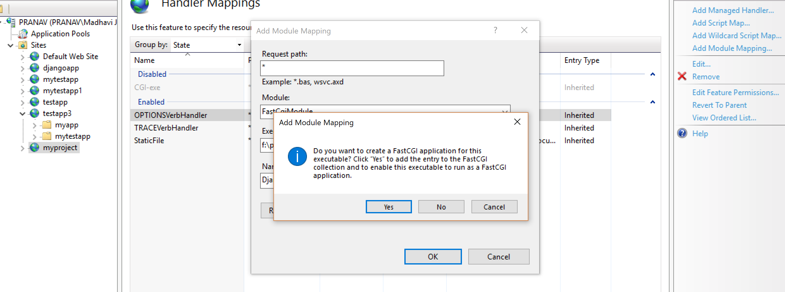

* Now you can find the handler below:

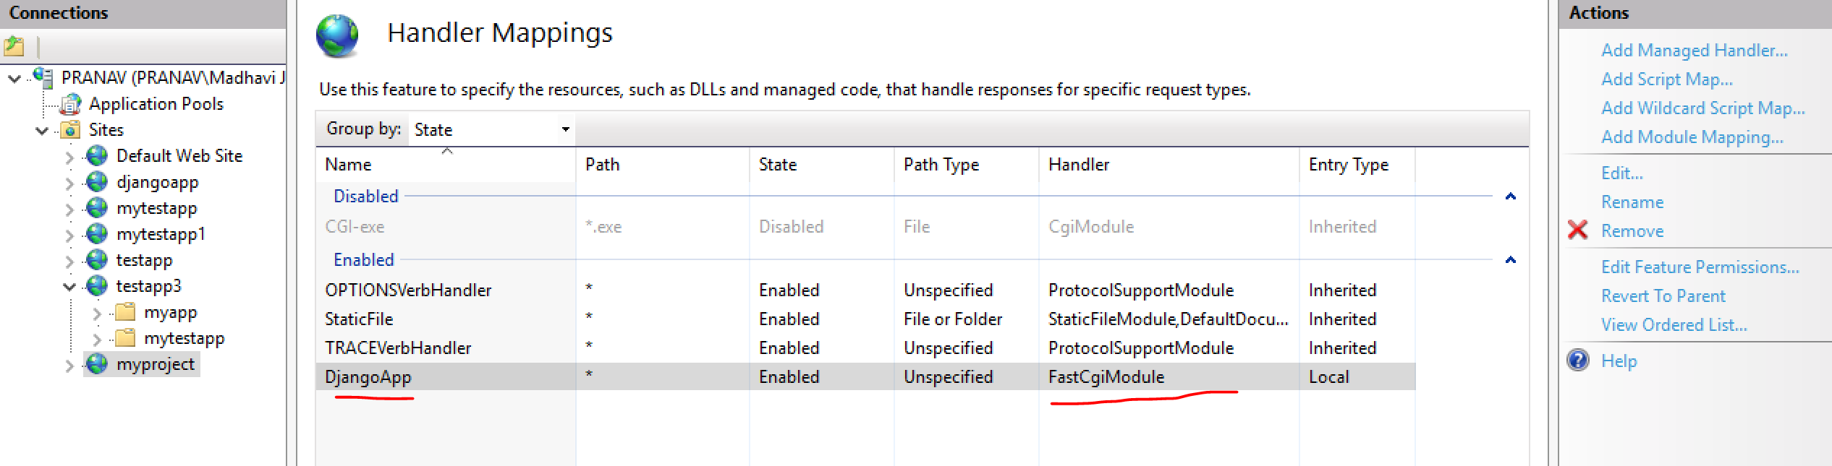

* 1. FastCGI Setting:
* Click on ‘FastCGI Settings’ on the icon shown below:

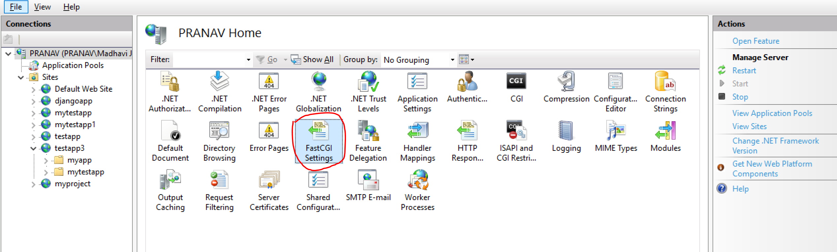

* On click you will find the arguments that was created using ‘wfastcgi-enable’. In previous stage.

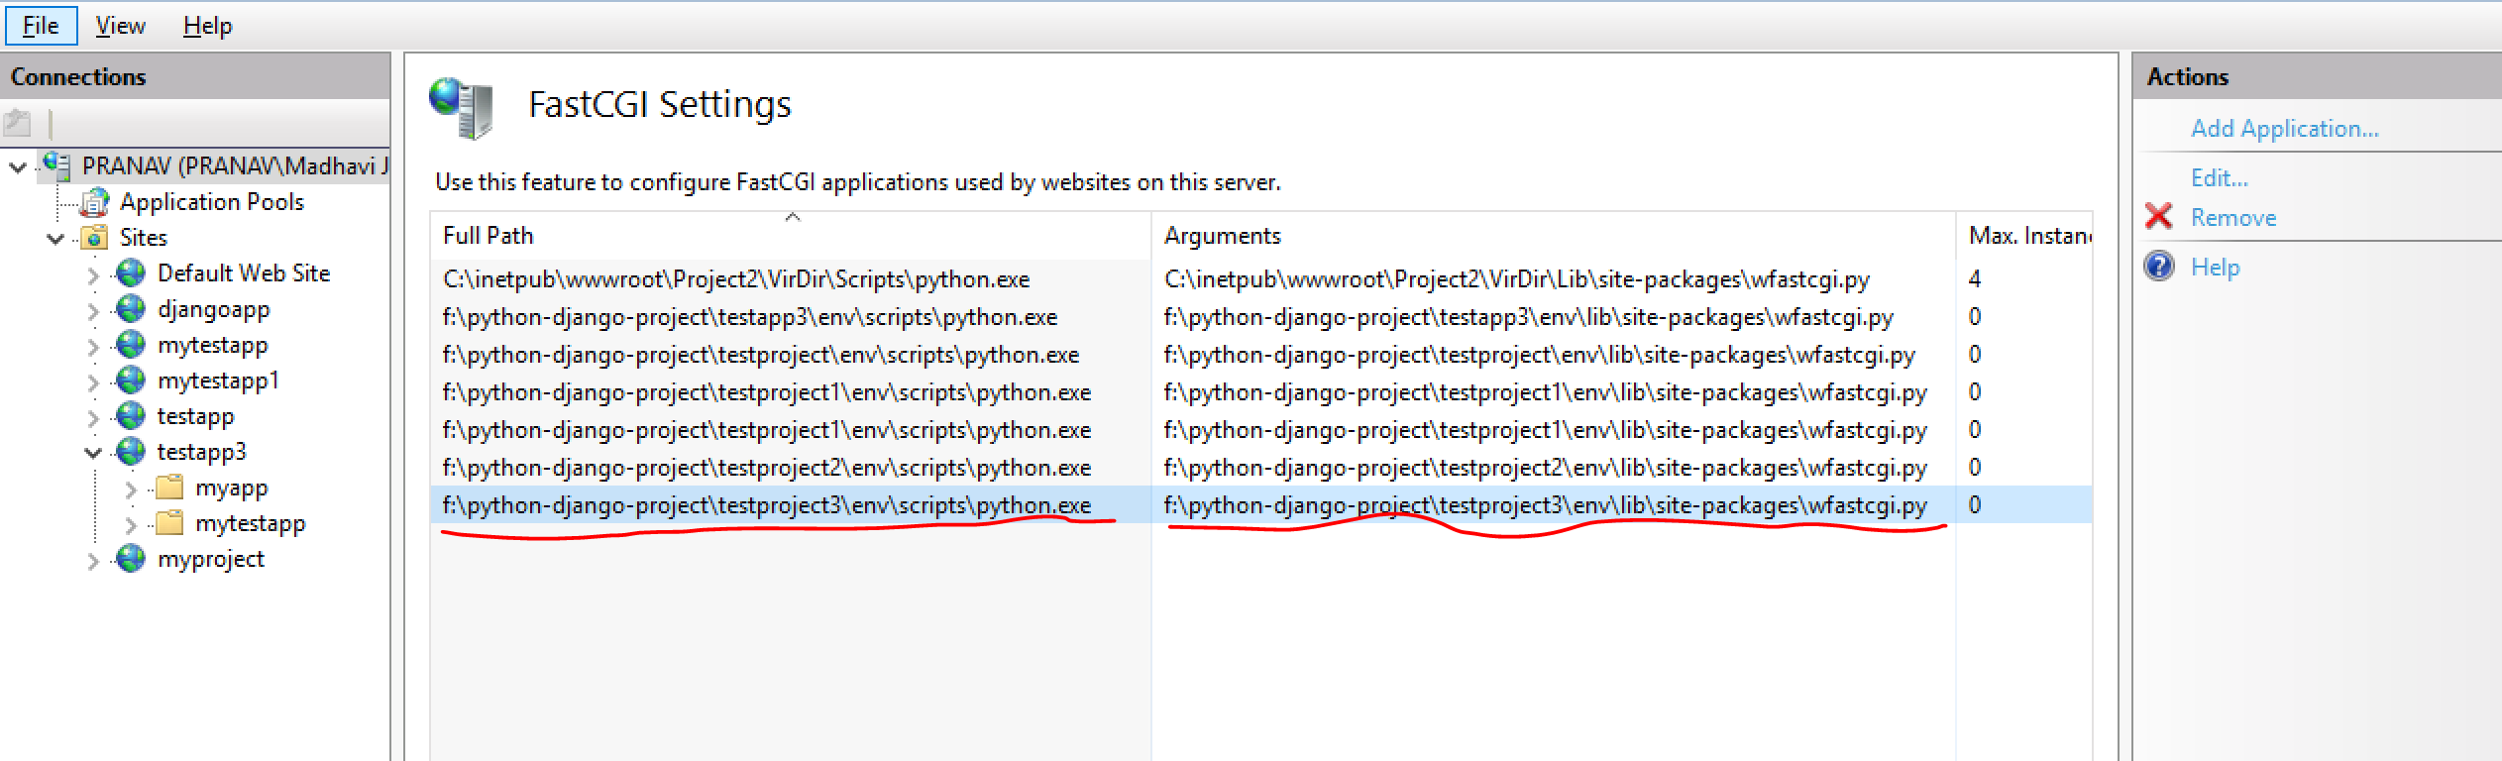

* Double click on argument or select argument and click edit, below dialog box will appear and then click on ‘collection’ highlighted below.

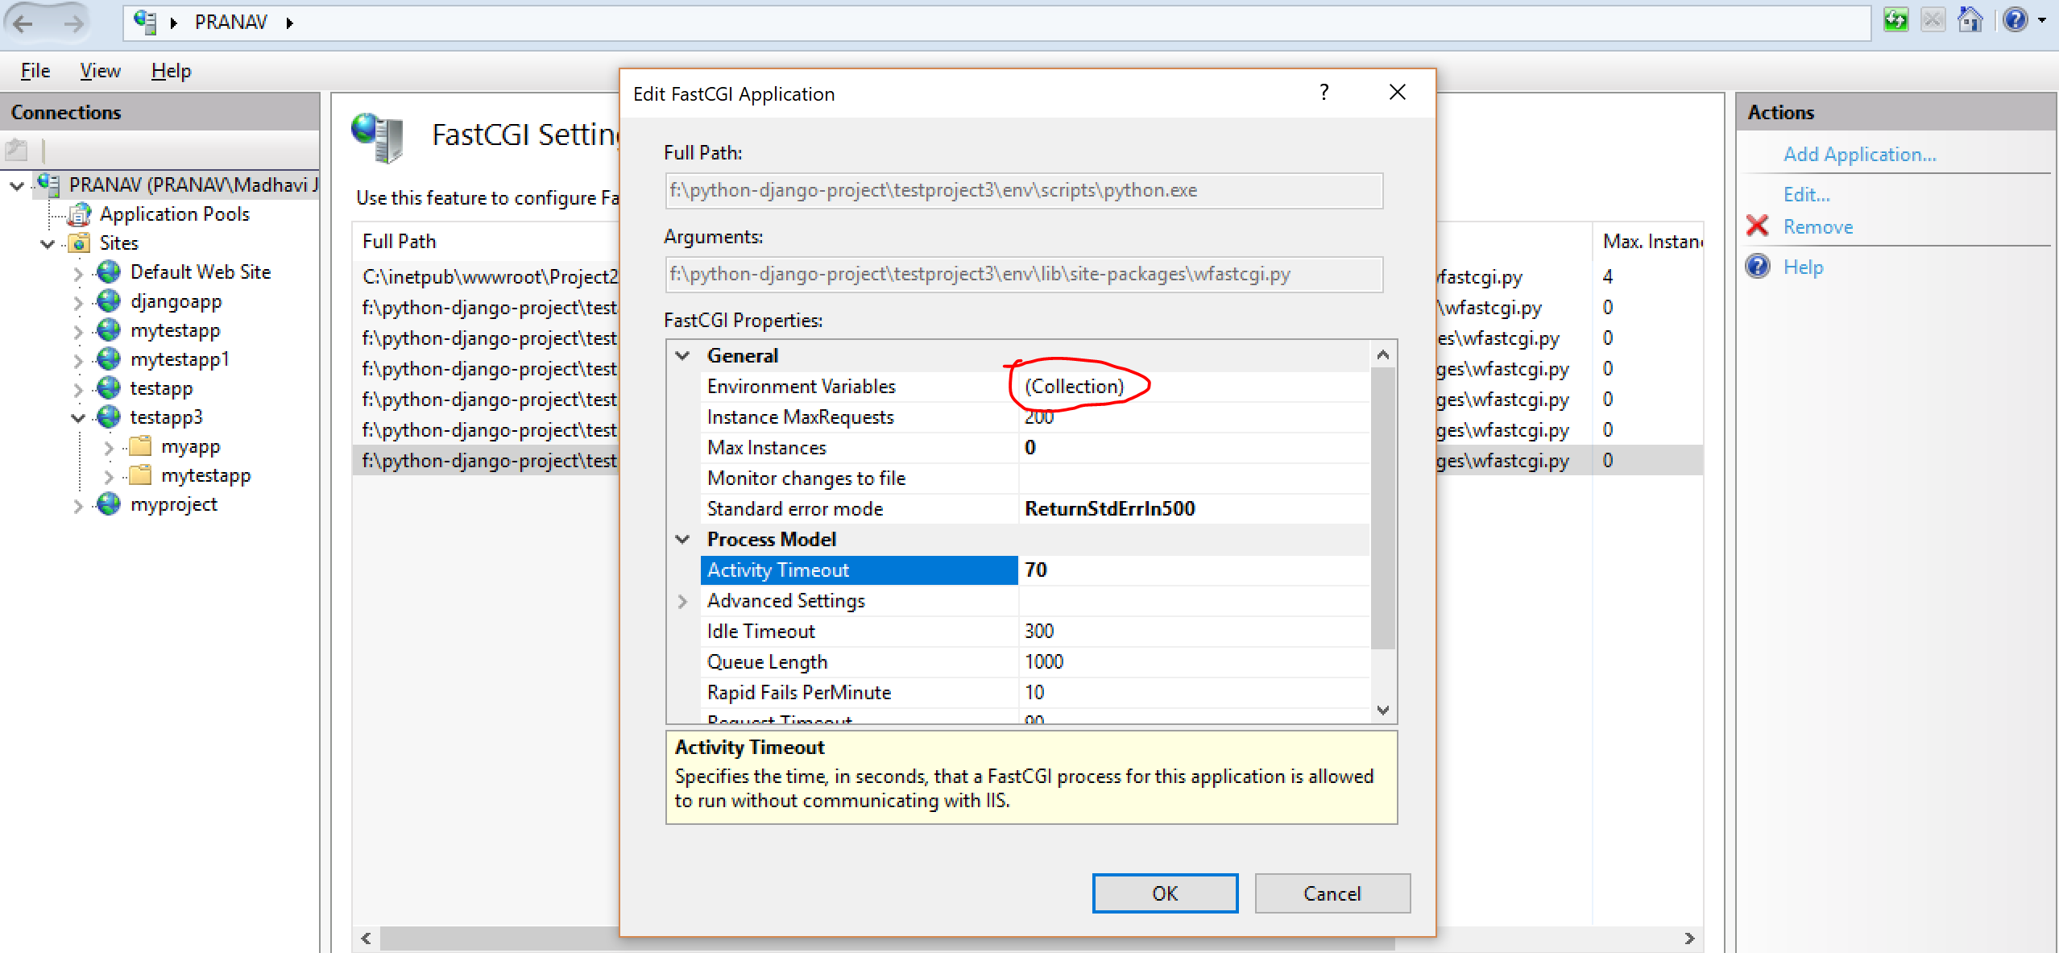

* On click of ‘Collection’ as mentioned above, below dialog box will appear add properties:

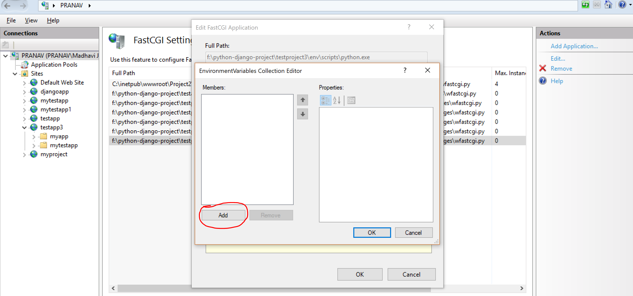

* Properties need to be added are given below:

DJANGO_SETTINGS_MODULE

myproject.settings

PYTHONPATH

F:\Python-Django-Project\testproject3\env\Scripts\myproject

WSGI_HANDLER

django.core.wsgi.get_wsgi_application()

* Once added dialog box will look like below

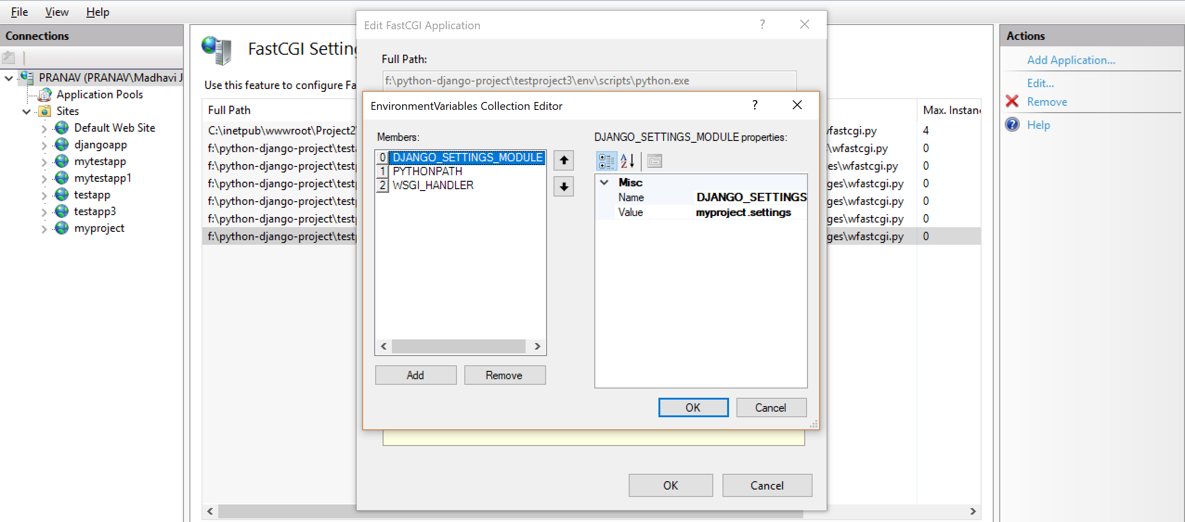

* Once Handler & FastCGI is configured: Click on Browser *94:

