**ISSUE: Remote_User**

Issue: Remote User was coming blank, ideally in the below screenshot the username of client computer should come but due to some reason it was not coming:

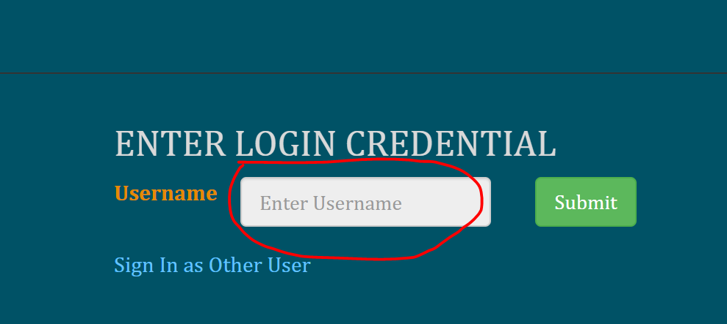

We were trying to get username though ‘remote_user’ however it was showing blank, we found that through debug, look at the highlighted below. Therefore username was empty.

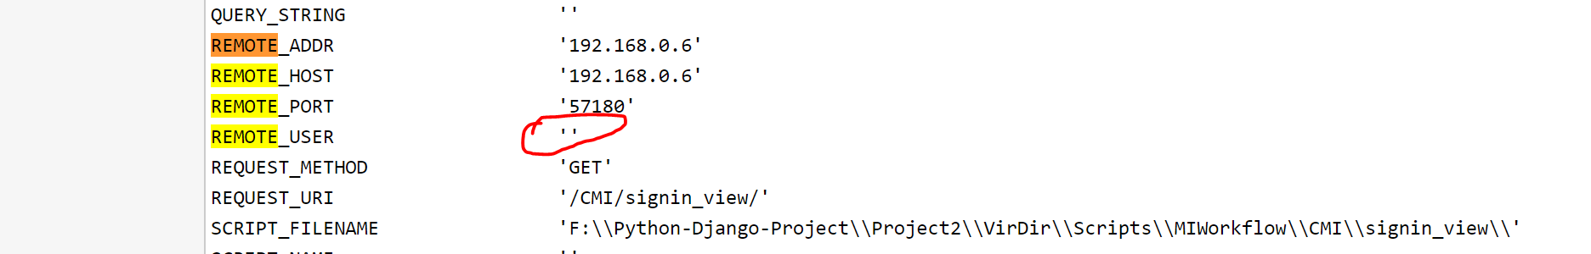

So tried to search for solution and we found that ‘Remote_User’ was blank because in IIS we were authentication was not on window. ‘Window Authentication was disable’ hence we need to enable the setting, as shown below:

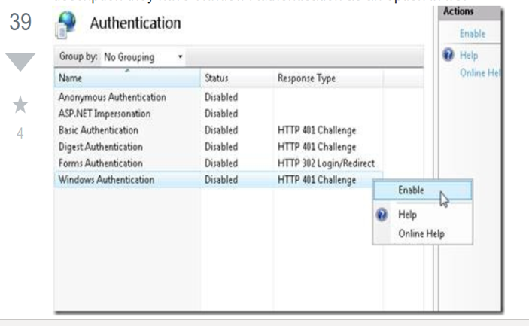

**Step to Enable Window Authentication:**

1. Go to control Panel and click on highlighted filed i.e. Uninstall a program

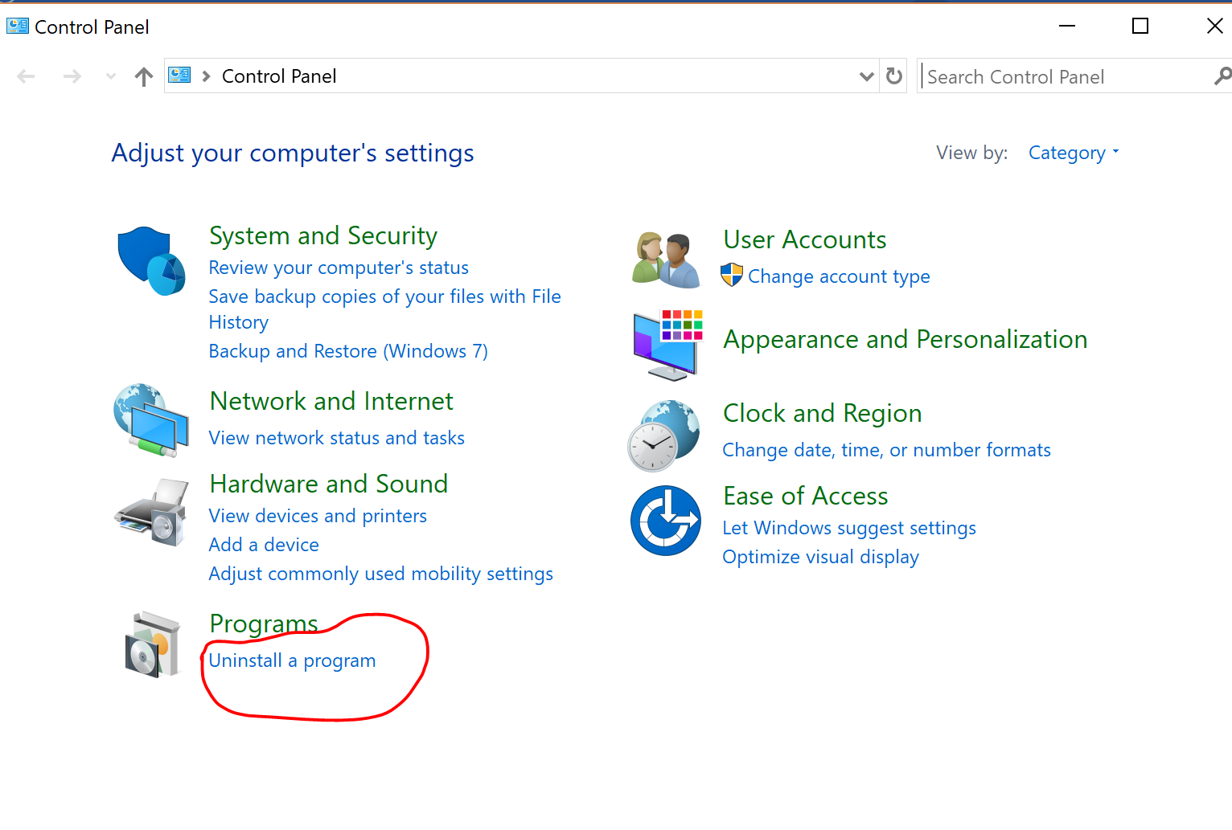

1. Now click on window feature show below:

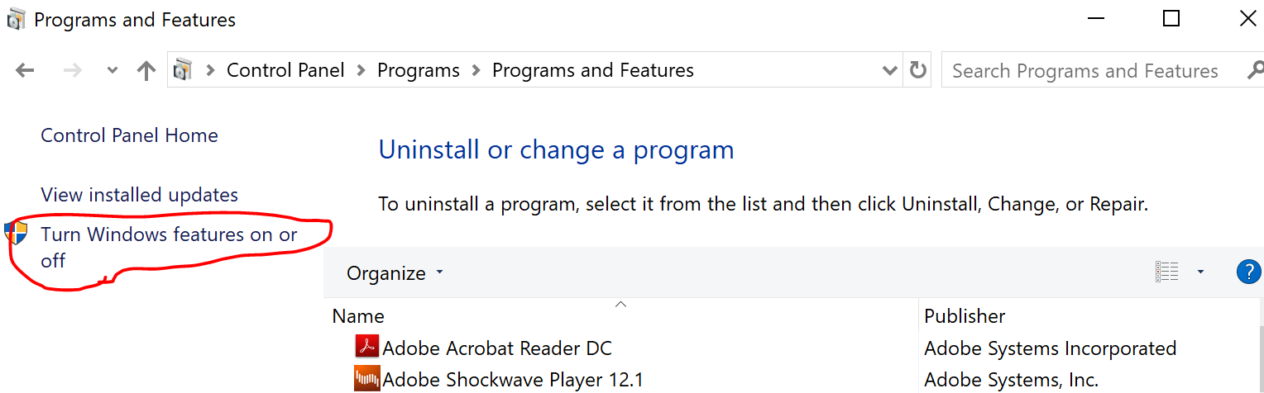

1. Dialog box will appear, Check ‘Window Authentication’ as shown below:

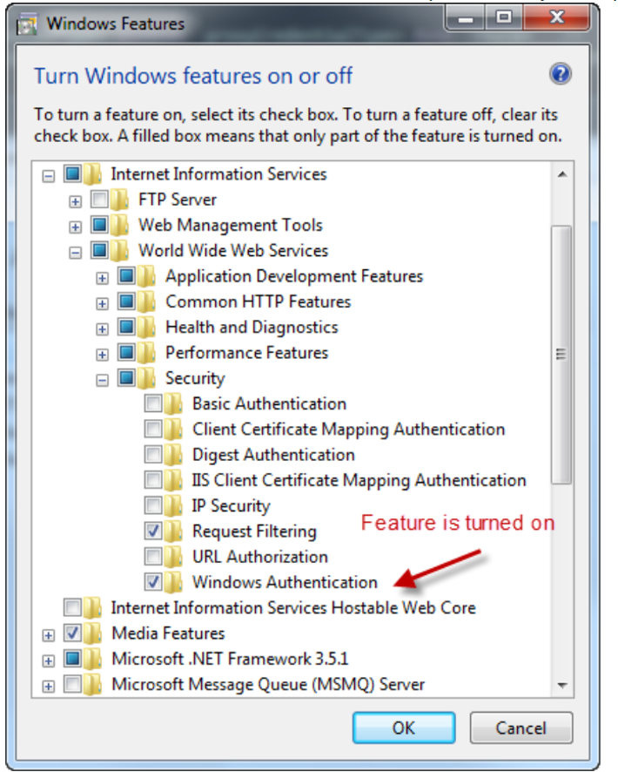

4) Now go to IIS , select you application (project) and then click on Authentication. 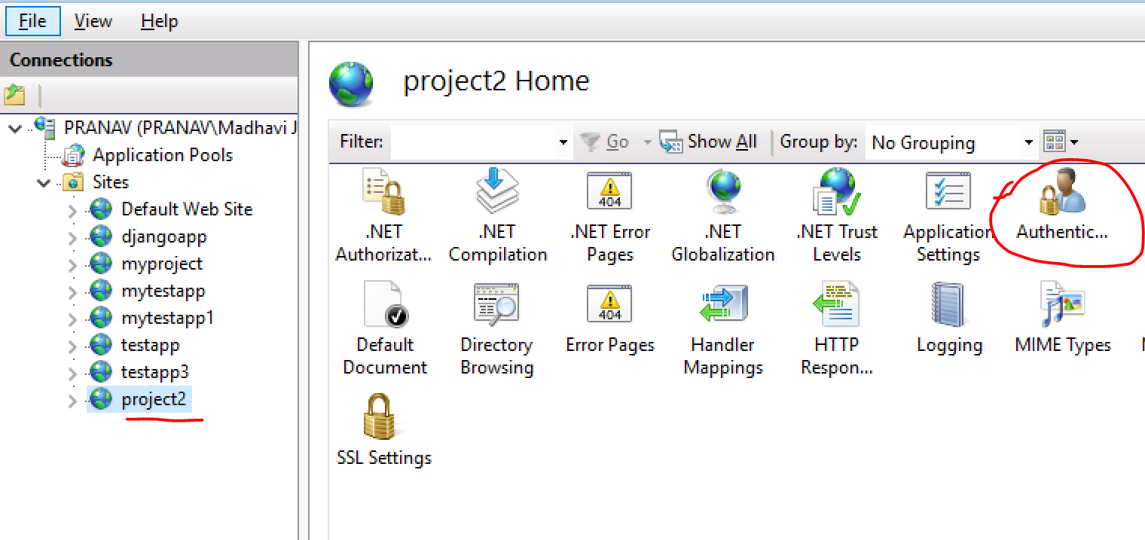

5) Now enable ‘Window Authetication’ and ‘Disable’ rest than restart the your application server