ASSIGNMENT -1

**Install Power BI Desktop and share the final screenshot of the report view page which appears when power desktop starts.**

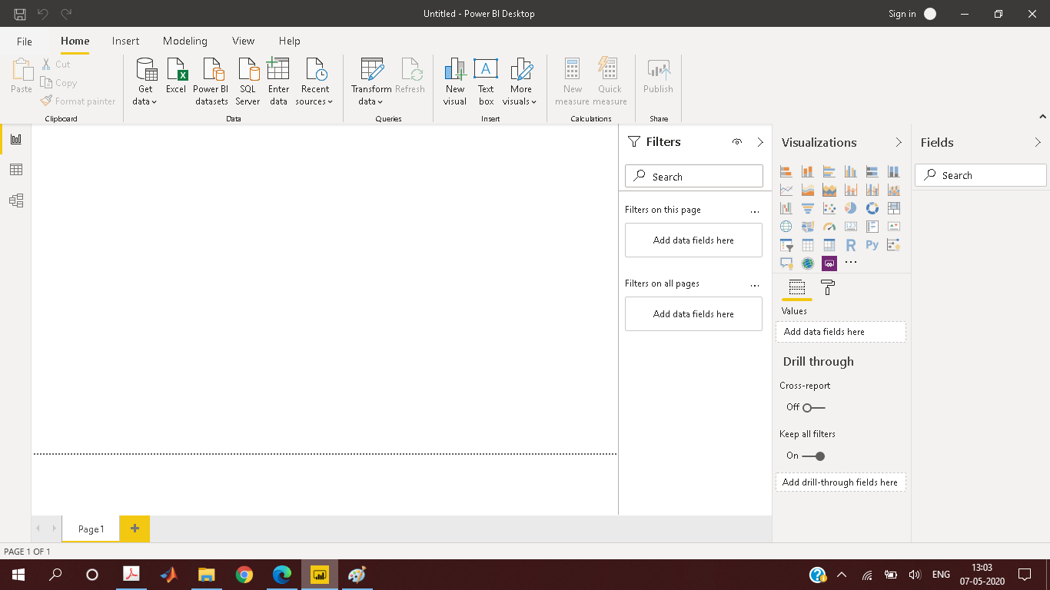

**Prepare a document and with the following screenshot**

* Report View

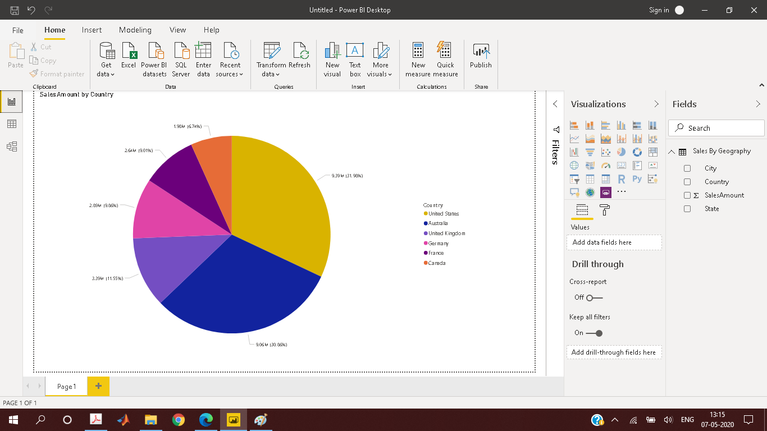

* Data View

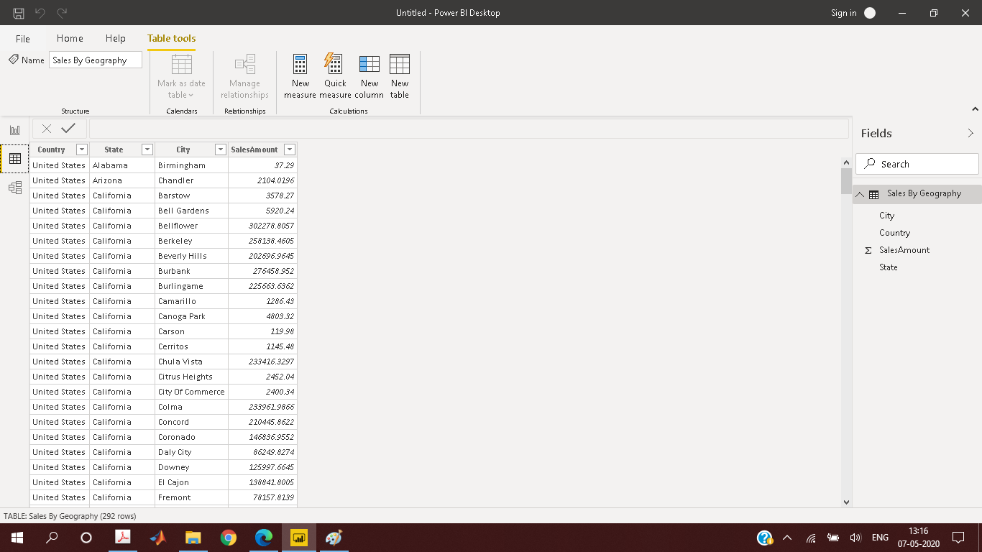

* Model View

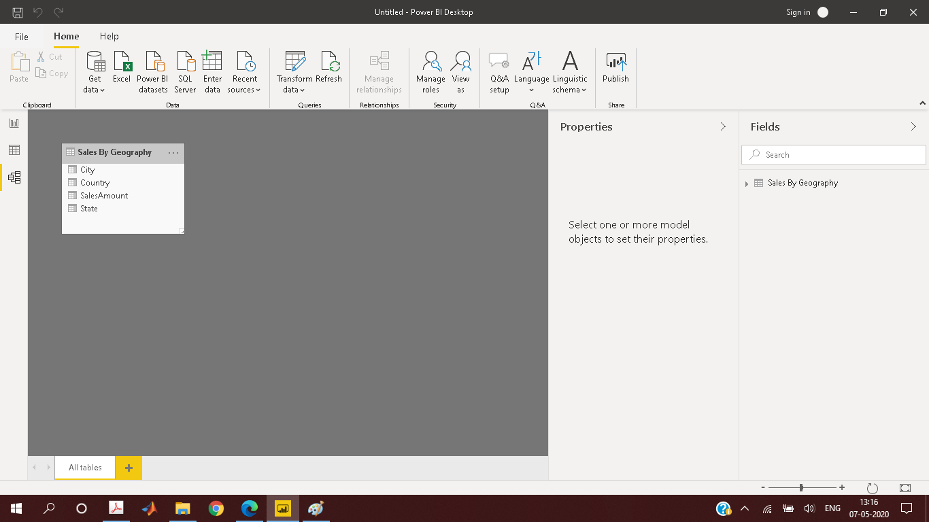

* Power Query Editor

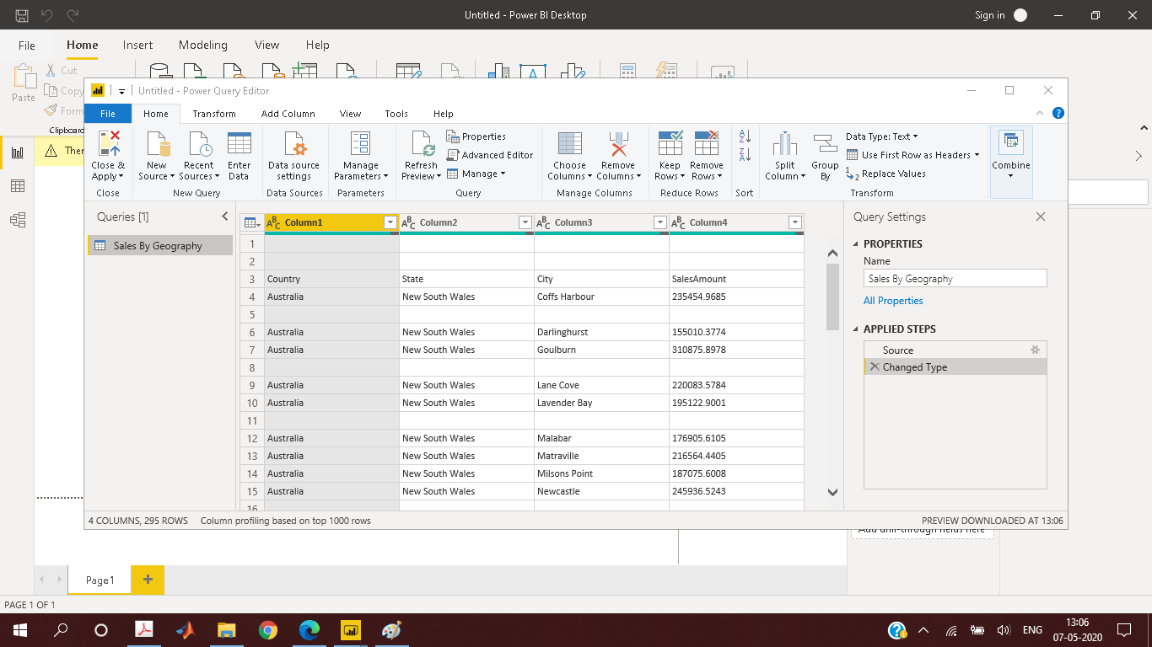

* Advanced Editor

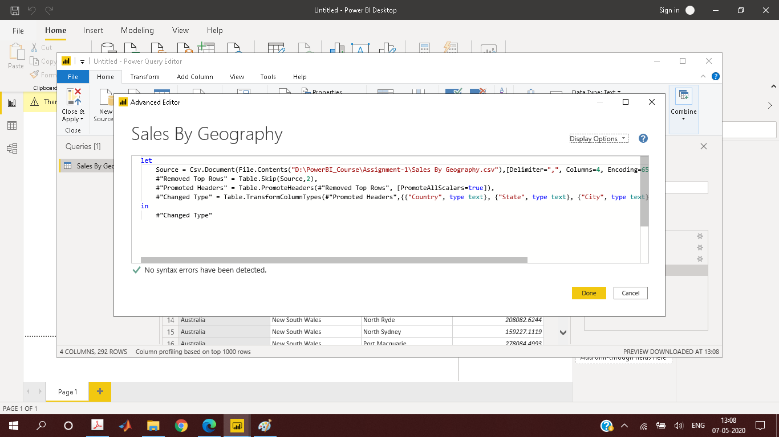

* PowerBI Dekstop (Free)

Power BI is a business analytics service by Microsoft. It aims to provide interactive visualizations and business intelligence capabilities with an interface simple enough for end users to create their own reports and dashboards.

* PowerBI Pro (₹660.00 Monthly price per user)
* Self-service and modern BI in the cloud
* Collaboration, publishing, sharing, and ad-hoc analysis
* Fully managed by Microsoft
* PowerBI pro (₹330,190 Monthly price per dedicated cloud compute and storage resource with annual subscription)
* Enterprise BI, big data analytics, cloud and on-premises reporting
* Advanced administration and deployment controls
* Dedicated cloud compute and storage resources
* Allows any user to consume Power BI content