Product Line Profitability & Margin
Performance Analysis
for Nassau Candy Distributor
Research Paper
Prepared by: Pramod Kale
Data Analyst Fellowship — Unified Mentor
August 2026

Abstract
This paper presents a product line profitability and margin performance analysis for Nassau Candy Distributor, a wholesale confectionery distributor. Using one year of order-level transaction data covering 15 products across three divisions (Chocolate, Sugar, Other), the analysis identifies which products genuinely drive profitability versus which merely generate sales volume. Key findings show the business is heavily concentrated: 5 of 15 products (33%) generate 80% of both revenue and profit, all belonging to the Chocolate division, while the Other division exhibits a structural margin problem driven by high manufacturing or acquisition costs relative to sales price. The paper recommends cost renegotiation for 7 flagged products and a discontinuation review for 5 low-performing items, alongside a broader recommendation to reduce dependency risk on the Chocolate line.

1. Background and Context
For distributors like Nassau Candy, sales volume alone is a misleading indicator of business health. Some products sell in high volume but generate low profit, consume disproportionate manufacturing or operational cost, or appear successful on a revenue basis while quietly weakening overall company margins. To remain competitive, the organization must understand not just what sells, but what sells profitably.
Nassau Candy sources its products from five factories — Lot's O' Nuts, Wicked Choccy's, Sugar Shack, Secret Factory, and The Other Factory — each responsible for a distinct subset of the product catalog. Products are grouped into three divisions: Chocolate, Sugar, and Other. This paper analyzes one year of transaction-level order data to build a clear, data-driven picture of profitability at the product and division level.

2. Problem Statement
Prior to this analysis, the organization lacked visibility into four key questions:
- Which product lines deliver the highest gross margin?
- Whether high-sales products are actually profitable.
- How profitability varies across product divisions.
- Which products represent margin risk.
Without this insight, decisions on pricing, promotions, and product portfolio management are made without a reliable basis in actual profitability.

3. Dataset and Methodology

3.1 Dataset Overview
The dataset consists of 10,194 order-line transactions covering the full 2025 calendar year, with fields including Order Date, Ship Date, Product Name, Division, Region, Sales, Units, Gross Profit, and Cost. The dataset required minimal cleaning: no missing values, no zero or negative sales/cost/unit entries, and no duplicate records were found. This is itself a notable finding — it suggests the source data is captured through a well-controlled order management system.

3.2 Methodology
The analysis followed five stages, consistent with standard profitability diagnostics:
- Data Cleaning & Validation — verifying cost/sales integrity and standardizing labels.
- Profitability Metric Calculation — Gross Margin %, Profit per Unit, Revenue/Profit Contribution % per product.
- Product- and Division-Level Analysis — ranking and quadrant classification.
- Profit Concentration (Pareto) Analysis — identifying dependency risk.
- Cost Structure Diagnostics — flagging pricing and cost inefficiencies.

4. Findings

4.1 Overall Company Performance
Across the full year, Nassau Candy generated $141,783.63 in total sales and $93,442.80 in gross profit, for an overall company gross margin of 65.91%. This is a healthy blended margin, but it masks significant variation at the product and division level, detailed below.

4.2 Product-Level Margin Performance
Figure 1 ranks all 15 products by Gross Margin %. The five Chocolate Wonka Bars form a clear top tier (65–71% margin), while the lowest-margin product, Kazookles, converts only 7.7% of its sales into profit — essentially breaking even after cost.
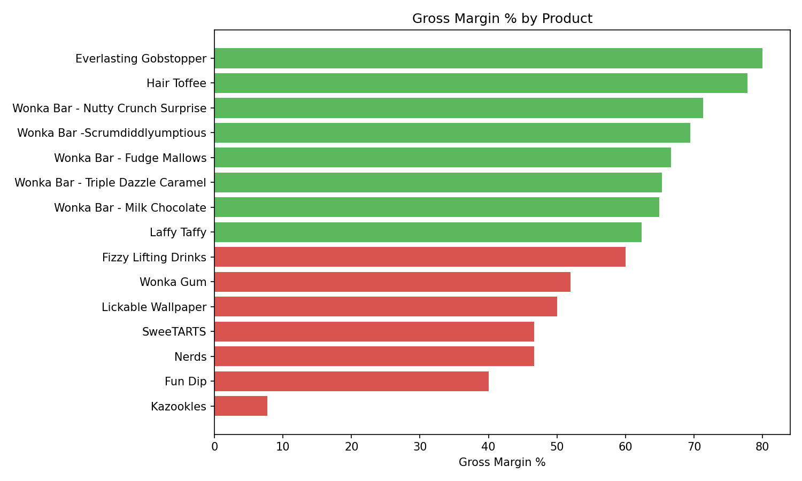
Figure 1: Gross Margin % by Product
Profit contribution tells a similar but sharper story: the five Chocolate products alone account for the overwhelming majority of total company profit, while several Sugar-division niche items (Everlasting Gobstopper, Hair Toffee) post high margins but contribute negligible dollar profit due to very low sales volume.
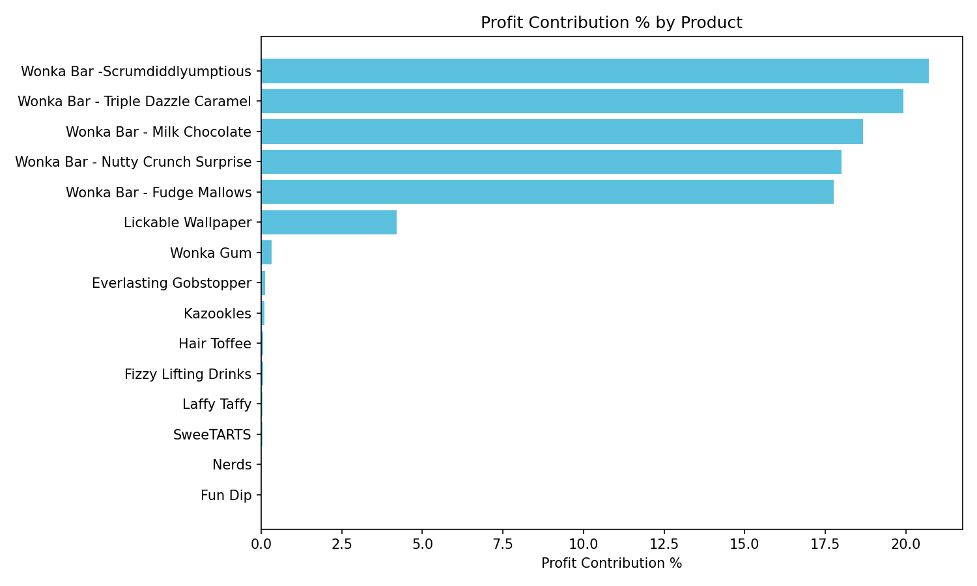
Figure 2: Profit Contribution % by Product

4.3 Product Quadrant Classification
Products were classified into four quadrants using the median Total Sales ($597.50) and median Gross Margin % (62.31%) as split points:
Quadrant | Products | Interpretation
High-Profit / High-Margin | 5 (all Chocolate) | Core business — protect and prioritize
High-Sales / Low-Margin (Margin Risk) | 3 (Lickable Wallpaper, Wonka Gum, Kazookles) | Volume without proportional profit — review pricing/cost
Low-Sales / High-Margin (Niche) | 3 (Everlasting Gobstopper, Hair Toffee, Laffy Taffy) | Profitable per unit but immaterial at current volume
Low-Sales / Low-Profit | 4 (Fizzy Lifting Drinks, Fun Dip, Nerds, SweeTARTS) | Candidates for discontinuation review

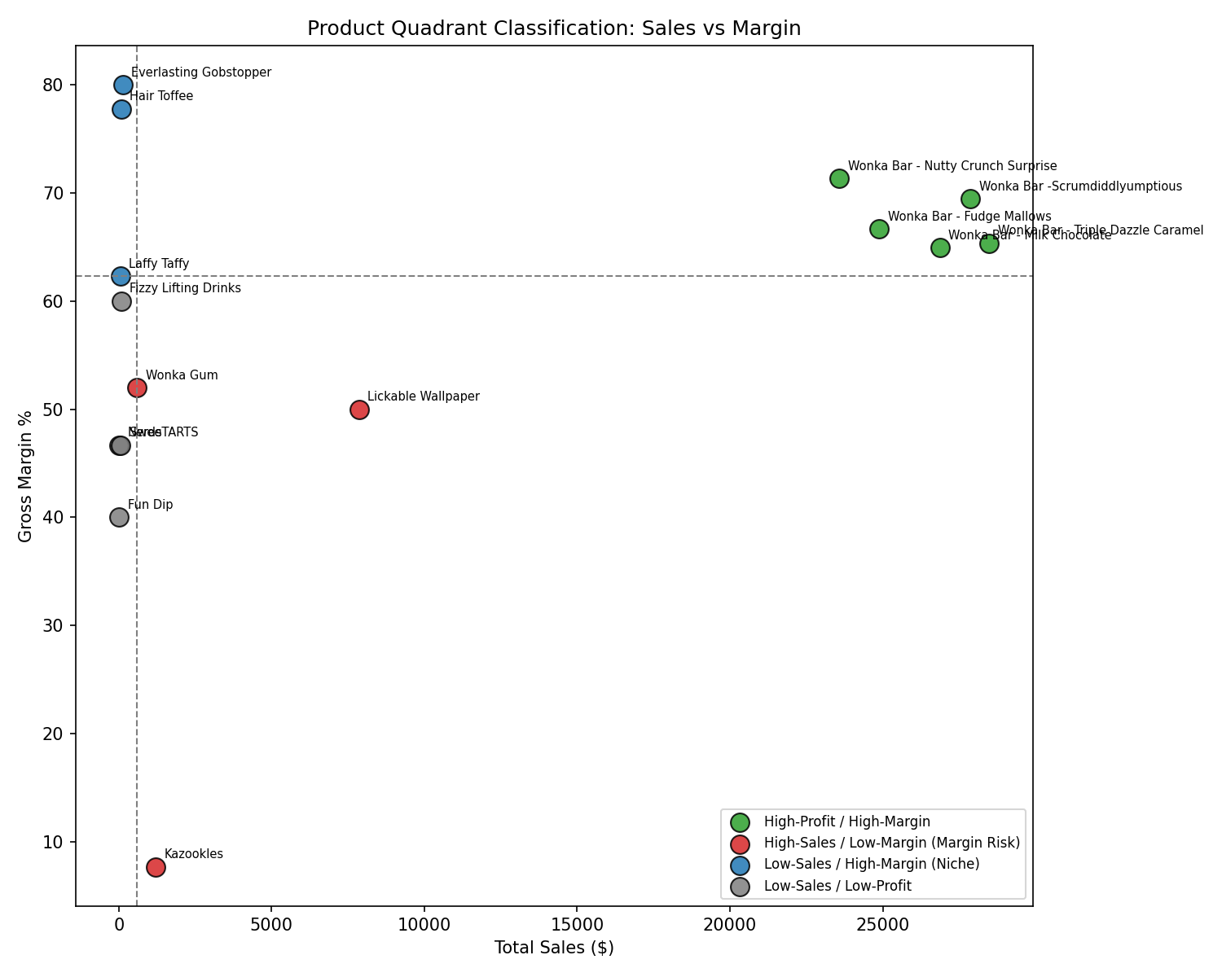
Figure 3: Product Quadrant Classification — Sales vs. Margin

4.4 Division-Level Performance
Aggregating to the division level reveals a stark imbalance. Chocolate accounts for 92.9% of company revenue and 95.1% of profit at a 67.4% margin — its profit share exceeds its revenue share, indicating strong financial efficiency. The Other division, by contrast, generates 6.8% of revenue but only 4.6% of profit at a 44.8% margin, a profit-to-revenue balance of 0.68 — flagged as a structural margin issue rather than a temporary dip. Sugar division revenue is negligible in dollar terms (0.3% of total) but margin-balanced.
Division | Revenue Share % | Profit Share % | Gross Margin % | Flag
Chocolate | 92.88% | 95.06% | 67.45% | Strong financial efficiency
Other | 6.82% | 4.64% | 44.84% | Structural margin issue
Sugar | 0.30% | 0.30% | 66.61% | Balanced

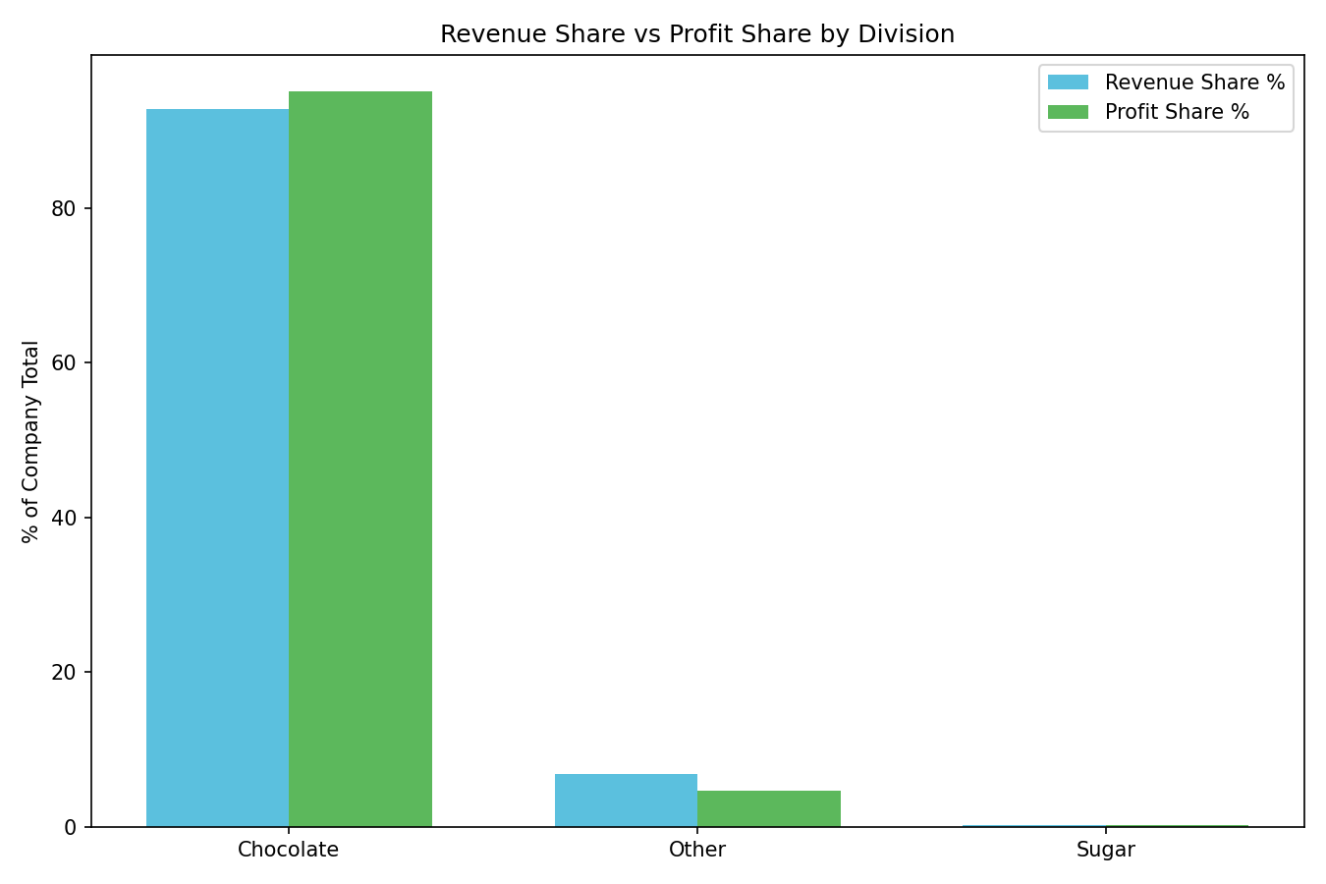
Figure 4: Revenue Share vs. Profit Share by Division
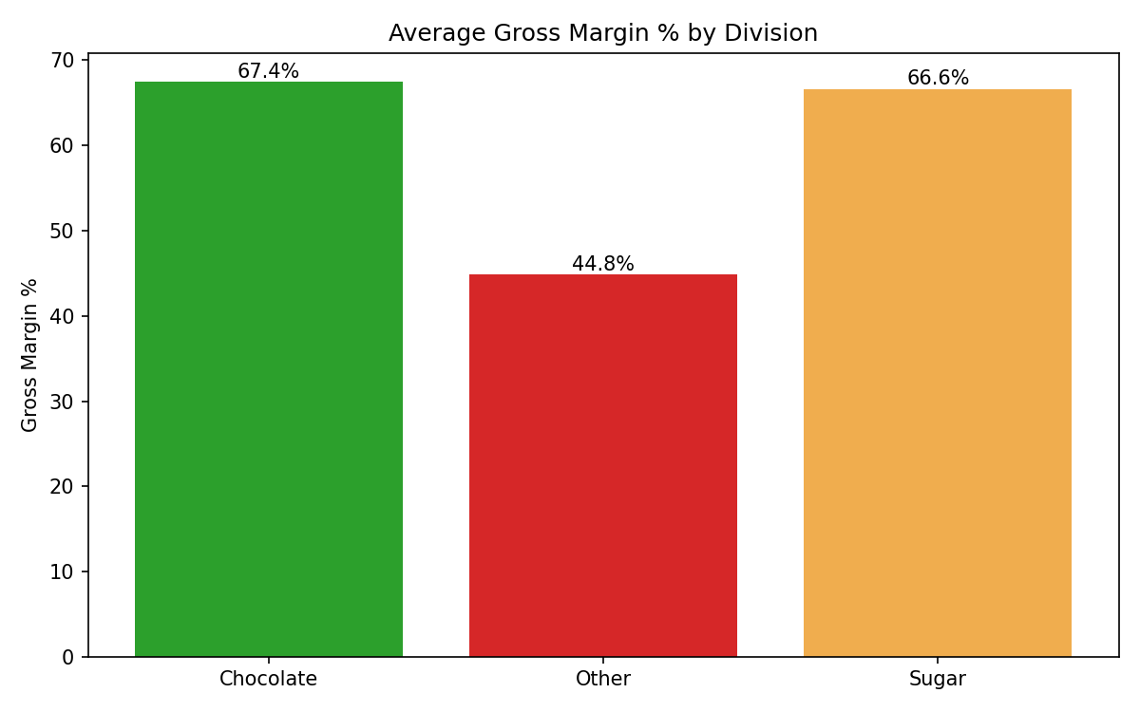
Figure 5: Average Gross Margin % by Division

4.5 Profit Concentration (Pareto Analysis)
A Pareto analysis confirms a high degree of dependency risk: just 5 of the 15 products (33% of the product lineup) generate 80% of both total revenue and total profit, and all five belong to the Chocolate division. Under the rule of thumb that 40% or fewer of products driving 80% of profit constitutes high concentration risk, Nassau Candy sits clearly in that category.
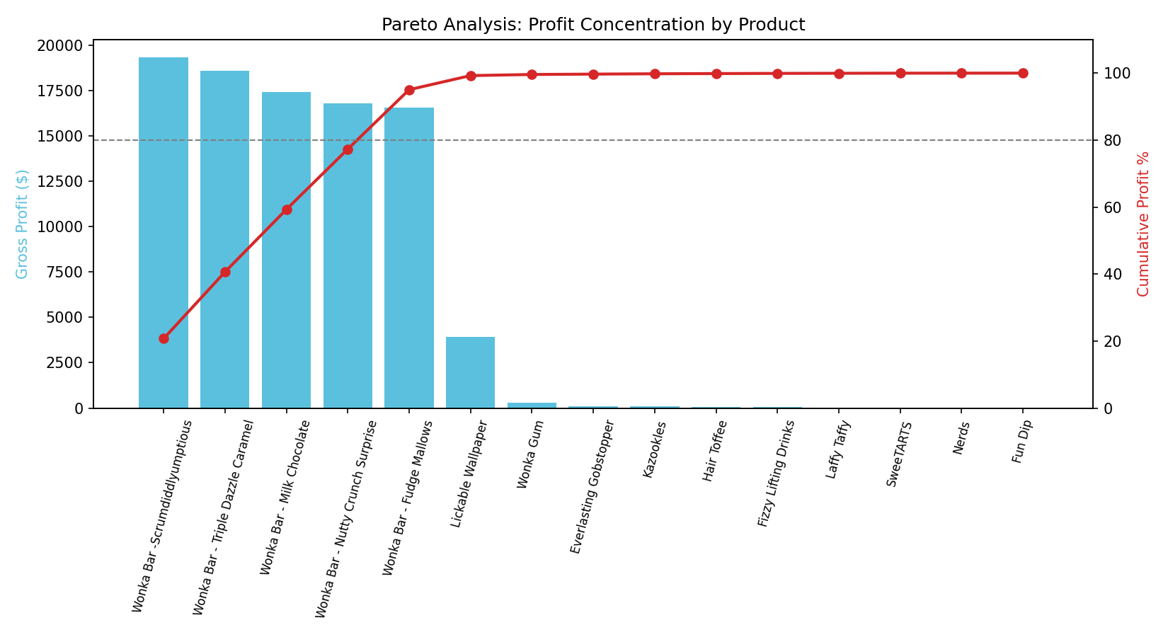
Figure 6: Pareto Chart — Profit Concentration by Product
This concentration means any disruption affecting the Chocolate division — a factory issue at Lot's O' Nuts or Wicked Choccy's, a raw material cost spike (e.g., cocoa pricing), or a shift in customer demand — would have an outsized impact on total company profitability.

4.6 Cost Structure Diagnostics
Comparing each product's cost-to-sales ratio against its gross margin identifies where margin problems originate. Seven products were flagged for cost renegotiation (high cost-to-sales ratio combined with below-median margin): Kazookles (92.3% cost ratio), Lickable Wallpaper, Wonka Gum, Fizzy Lifting Drinks, Fun Dip, Nerds, and SweeTARTS. Notably, no product was flagged purely for a pricing inefficiency (low cost but still low margin) — every margin problem in this dataset traces back to cost structure, not pricing strategy.
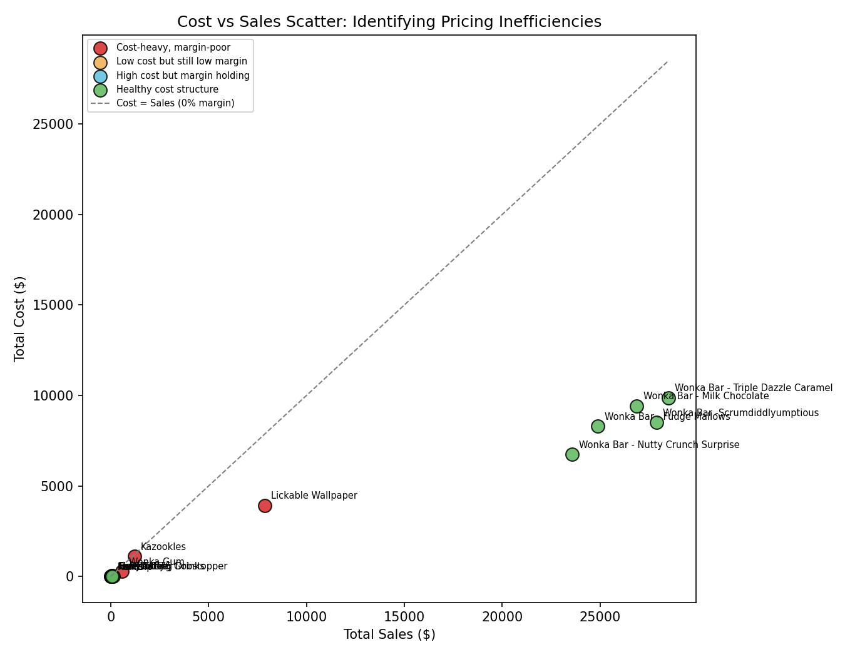
Figure 7: Cost vs. Sales Scatter — Identifying Pricing/Cost Inefficiencies
Product | Cost as % of Sales | Gross Margin %
Kazookles | 92.3% | 7.7%
Fun Dip | 60.0% | 40.0%
Nerds | 53.3% | 46.7%
SweeTARTS | 53.3% | 46.7%
Lickable Wallpaper | 50.0% | 50.0%
Wonka Gum | 48.0% | 52.0%
Fizzy Lifting Drinks | 40.0% | 60.0%

5. Recommendations

5.1 Cost Renegotiation (Priority: High)
Initiate cost review conversations for the 7 flagged products, starting with Kazookles, whose 92.3% cost-to-sales ratio leaves almost no margin buffer. This may involve renegotiating factory/supplier costs at Secret Factory and The Other Factory, or reassessing whether current unit pricing reflects true production cost.

5.2 Discontinuation Review (Priority: Medium)
Fizzy Lifting Drinks, Fun Dip, Nerds, and SweeTARTS combine low sales volume with low absolute profit. These four products contributed a combined $87.75 in gross profit across the full year — an amount unlikely to justify the operational overhead of maintaining them in the catalog. A discontinuation review is recommended, weighing any strategic value (e.g., catalog completeness, customer relationships) against the opportunity cost.

5.3 Reduce Chocolate Division Dependency Risk (Priority: Medium)
With 33% of the product lineup generating 80% of profit — entirely within one division — Nassau Candy carries meaningful concentration risk. Recommended mitigations include diversifying supply sources for Chocolate-division inputs, and evaluating whether underperforming Sugar/Other products can be repositioned or reformulated to close the profitability gap rather than simply discontinued.

5.4 Preserve and Monitor the Core Line (Priority: Ongoing)
The five Chocolate products should be protected as the core of the business — prioritized for inventory availability, marketing support, and supply chain reliability, given their outsized contribution to company profit.

6. Conclusion
This analysis establishes a clear, data-driven understanding of product line profitability for Nassau Candy Distributor. By moving beyond sales volume to examine gross margin, profit contribution, and cost structure at the product and division level, the organization now has actionable visibility into which products drive real profitability, which represent margin risk, and where cost — not pricing — is the primary lever for improvement. The concentration of profit within a small set of Chocolate products represents both the company's greatest strength and its most significant operational risk, and should inform decisions on sourcing diversification, portfolio rationalization, and pricing strategy going forward.

