**Content:**

* **Kafka Architecture**
* **Key terminologies**
* **Features**
* **Architecture of Kafka:**

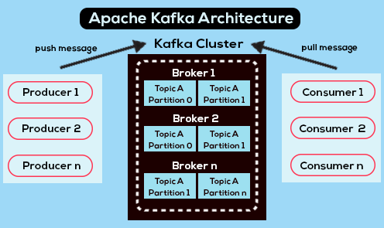

* The Kafka architecture is designed to handle large amounts of data streams in a distributed and fault-tolerant manner. At a high level, the Kafka architecture consists of four main components: producers, consumers, brokers, and ZooKeeper.
* We will see each point in detail:

1. **Topics:** A Kafka topic is a category or feed name to which records are published. Each topic consists of one or more partitions, which are distributed across multiple Kafka brokers in the Kafka cluster. A partition is an ordered, immutable sequence of records that can be stored in a Kafka broker.
2. **Producers:** A Kafka producer is an application that publishes data to Kafka topics. Producers are responsible for sending records to a Kafka cluster, which is then stored in one or more Kafka brokers. Producers can also specify the partition to which a record should be written.
3. **Consumers:** A Kafka consumer is an application that reads data from Kafka topics. Consumers can subscribe to one or more topics and read records from them. They can also specify the offset from which they want to start reading records, allowing them to read records from a specific point in time.
4. **Brokers:** Kafka brokers are the servers that manage the storage and replication of data in a Kafka cluster. Each broker can be thought of as a Kafka server that hosts one or more partitions. Kafka brokers are responsible for handling requests from producers and consumers, maintaining metadata about topics and partitions, and replicating data across multiple brokers for fault tolerance.
5. **Partitions:** A Kafka partition is an ordered, immutable sequence of records that can be stored in a Kafka broker. Partitions allow for parallel processing of data across multiple consumers, as each consumer can read records from a different partition. Kafka partitions are also replicated across multiple brokers for fault tolerance.
6. **Offsets:** A Kafka offset is a unique identifier that represents the position of a consumer in a partition. Consumers can specify the offset from which they want to start reading records, allowing them to read records from a specific point in time. Kafka offsets are stored in Kafka brokers and can be managed by consumers to ensure that they are reading the correct records.
7. **Consumer Groups:** A Kafka consumer group is a set of consumers that work together to consume data from Kafka topics. Each consumer in a consumer group reads from a unique partition, allowing for parallel processing of data across multiple consumers. Consumer groups also provide fault tolerance, as if one consumer fails, the remaining consumers in the group can continue to consume data from the topic.

These are the basic concepts of Kafka that are necessary to understand its architecture and how it can be used to process large amounts of data in real-time.

* **Features of Kafka:**

Kafka is a distributed streaming platform that is designed to handle large amounts of data streams in a fast, scalable, and fault-tolerant manner. Some of the key features of Kafka include:

1. **Pub/Sub messaging model:** Kafka provides a publish-subscribe messaging model that allows producers to publish messages to one or more topics, and consumers to subscribe to those topics and receive the messages.
2. **Distributed architecture:** Kafka is designed to be deployed in a distributed manner across multiple servers or nodes, providing high availability, scalability, and fault tolerance.
3. **High throughput and low latency:** Kafka is optimized for high throughput and low latency, allowing it to handle large amounts of data streams in real-time.
4. **Horizontal scalability:** Kafka allows for easy horizontal scalability by adding more brokers to the cluster, enabling it to handle increasing amounts of data traffic.
5. **Data retention:** Kafka provides configurable data retention policies, allowing users to retain data for a specified amount of time or based on storage constraints.
6. **Stream processing:** Kafka has built-in support for stream processing, allowing users to perform real-time data processing and analysis on the data streams.
7. **Message replay:** Kafka allows consumers to rewind and replay messages from a specified point in time, making it easy to recover from failures or reprocess data.
8. **Fault tolerance and replication:** Kafka provides fault-tolerance and replication features by replicating data across multiple brokers, ensuring that data is not lost in the event of a node failure.
9. **Connectors and APIs:** Kafka provides a range of connectors and APIs that enable integration with a wide range of systems and technologies, including Hadoop, Spark, and other databases.

Overall, Kafka's features make it a powerful tool for building real-time streaming applications, handling high volumes of data, and performing complex data processing and analysis.