**Content:**

Zookeeper cluster setup with 3 zK nodes.

**Zookeeper Architecture:**

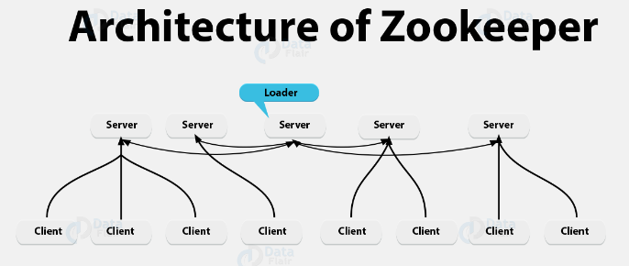

**Prerequisites:**

1. Java-8 or higher

Check using (java --version)

1. RAM size should be minimum 1 GB.

**Setup:**

* When we are setting up a zookeeper cluster with more than 1 node, then it is strongly recommended that nodes should be in odd numbers. (e.g. 1, 3, 5, 7)
* There will be one leader and others will be followers in multi node zK cluster.
* There is an election between all the nodes of zK. There are some algorithms based on which nodes are electing the leader.

**Zookeeper Setup(Node-1):**

* Untar zk binary:

tar -xzf apache-zookeeper-3.8.1-bin.tar.gz

* Create directory:

mkdir tmp/zookeeper-1

* Add myid file with unique identifier in tmp/zookeeper-1

echo 1 > tmp/zookeeper-1/myid

**(Note: 1. Every time we will restart the system myid file will get deleted as tmp is volatile memory.**

**2. Here 1 is unique server id for server 2 it will be 2 and for server 3 it will be 3 and so on.**

**Similarly create separate tmp/zookeeper-*/myid file for all nodes. In our case we’ll use 2 and 3 in place of *)**

* Create zoo.cfg file inside config directory

vim zoo.cfg

**Add below information in it:**

kafka1

tickTime=2000

initLimit=10

syncLimit=5

dataDir=/tmp/zookeeper-1

clientPort=2184

maxClientCnxns=60

admin.serverPort=8093

4lw.commands.whitelist=*

server.1=localhost:2788:3788

server.2=localhost:2888:3888

server.3=localhost:2988:3988

**Zoo.cfg file explaination:**

**tickTime=2000** (This is unit of time in miliseconds i.e. 2000 means 2 sec.)

**initLimit=10** (Whenever a zookeeper node is trying to connect to zookeeper cluster it has 10 unit of time to connect i.e. 10*2sec = 20sec)

**syncLimit=5** (When already connected node is getting disconnected from cluster it has 5 unit time to get conneted again. 5*2 = 10sec)

**dataDir=/tmp/zookeeper** (Here all info about clusters, clients etc. is stored.)

**clientPort=2181** (Where the clients can connect to the zookeeper server. This port should be unique in all the nodes.))

**maxClientCnxns=60** (Maximum clients which can connect to the zookeeper server.)

**admin.serverPort=8090** (admin server port, if it is same as other service's port it will throw error that port is already in use. Hence this port should be unique in all the nodes.)

**4lw.commands.whitelist=\*** (Enables 4 letter words. eg. stat, dump etc.)

Here server.1/2/3 are unique identifiers of zK nodes. Which we are setting inside tmp/zookeeper/myid file. The first port zK nodes are using to communicate between each other and second port is used for leader elections.

**server.1=localhost:2788:3788**

**server.2=localhost:2888:3888**

**server.3=localhost:2988:3988**

**Note: Do the same process for node 2 and node 3**

**Now start the nodes using below command:**

cd /home/vagrant/Kafka/apache-zookeeper-3.8.1-bin/bin

./zkServer.sh start-foreground

**Note: Do same for other nodes too.**

**Now if we want to check the properties of each node we can check using below command from different tab:**

**echo stat | nc localhost <server_port>**

**e.g. In our case we will check as given below:**

echo stat | nc localhost 2181 🡪 Node_1

echo stat | nc localhost 2182 🡪 Node_2

echo stat | nc localhost 2183 🡪 Node_3