**Content:**

Internals of Kafka consumers.

* **Internals when consumer pulls a message:**

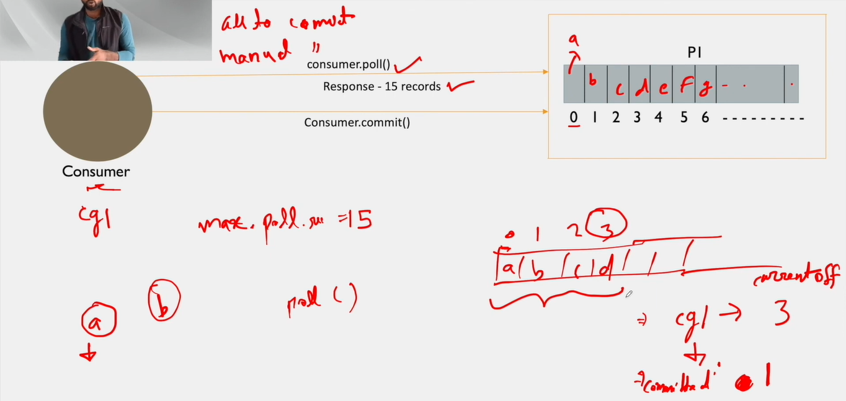

Figure 1 Consumer offset

* When consumer pulls a message, it uses ***consumer.poll()*** API.
* To get number of messages at one time we can configure using ***max.poll.record***
* When consumer requests messages from Kafka cluster, it gives the required number of messages (In above dig. 15 messages) i.e. ***response***.
* Once consumer receives messages from Kafka cluster it processes the messages, and once done it will send the acknowledgement to broker that it has completed the processing or consumed the message, it is called ***commit***.