**Content:**

* Consumer group.
* Consumer group Rebalancing.
* **What is Consumer group in Kafka?**

Consumer group is a logical entity in Kafka ecosystem which mainly provides parallel processing/Scalable message consumption to consumer client.

Each consumer should be associated with some consumer group.

Consumer group makes sure there is no duplication within consumers who are part of the same consumer group.

We will see concept of consumer group using below examples:

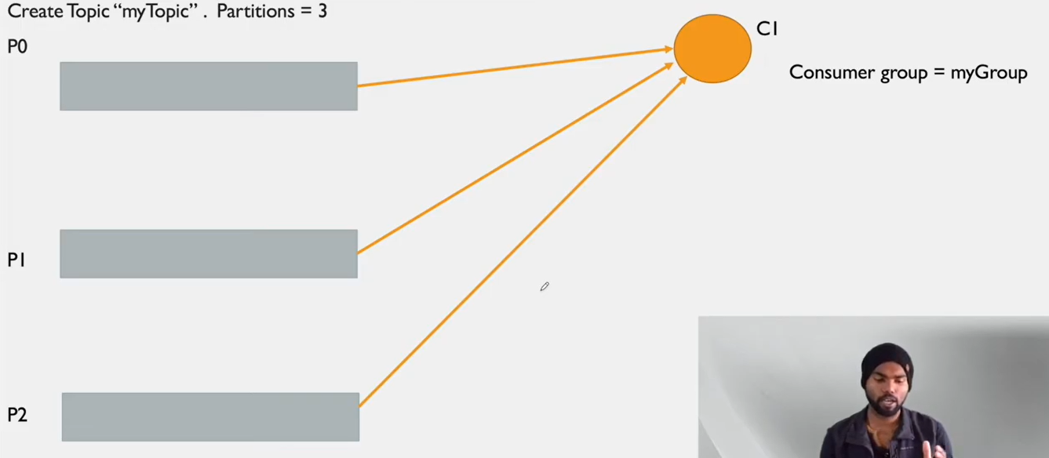

Figure Partitions with 1 consumer

In above example we have **three partitions** with **one** **consumer** which is associated to myGroup **consumer group**.

As there is only one consumer all the partitions are sending messages to that consumer.

In this example consumer (C1) subscribed our topic(myTopic) as this topic is associated with all 3 partitions consumer will subscribe all partitions internally.

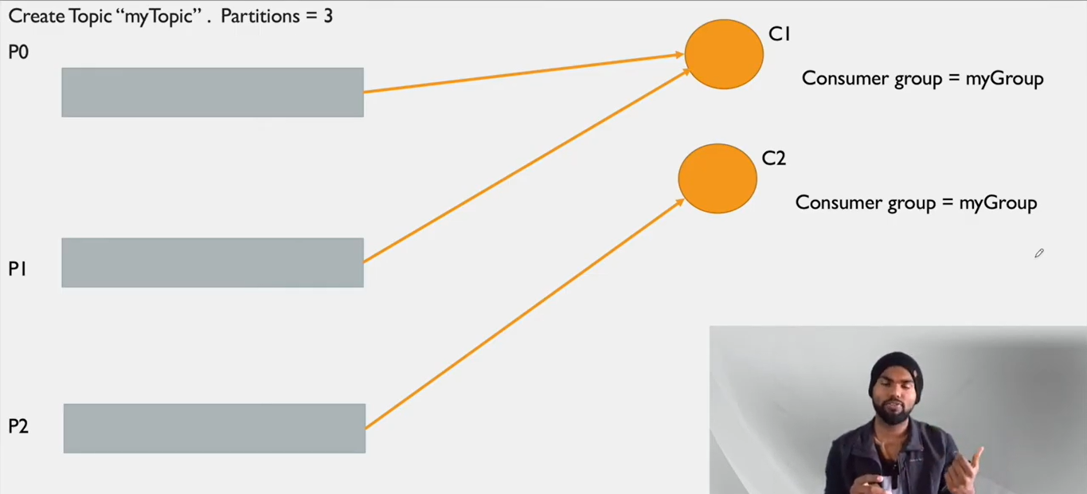

Figure Partitions with 2 consumers

Now in this example we have created one more consumer.

Here we can see one partition is assigned to C2 now and other two partitions are still with C1.

Here we can see parallel processing.

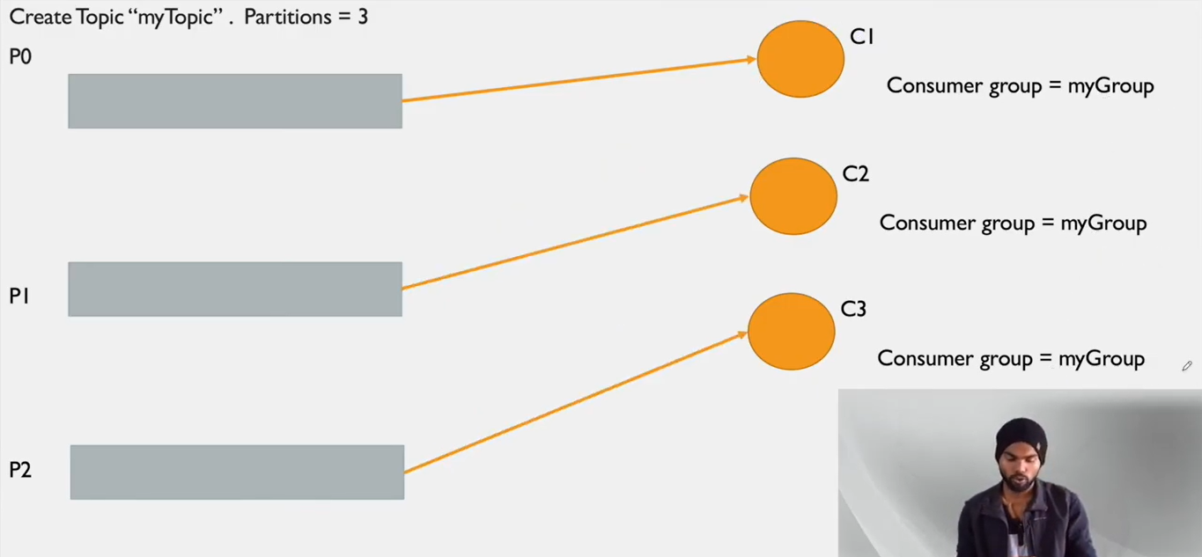

Figure Partitions with 3 consumers

In this example we have added one more consumer C3.

Now we can see partition p2 got assigned to C3, also C1 and C2 are reassigned.

C3 is also in **same** consumer group myGroup.

When C3 got created and it requested that it has to subscribe same topic, that time all partitions distributed again, and 1 partition got assigned to each consumer. This process is called consumer group rebalancing.

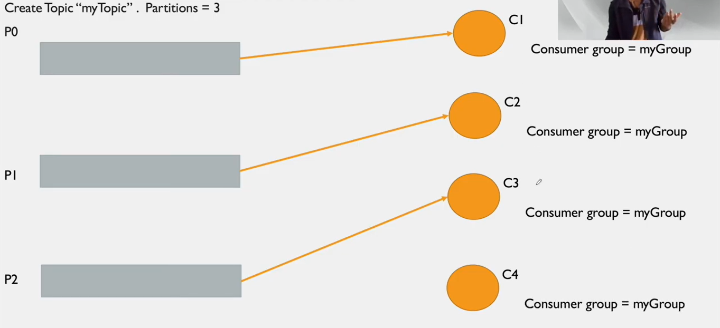

Figure Partitions with 4 consumers

Now in above example we have created one more consumer C4.

But if we have observed C4 is not assigned to any of the partition as there are only three partitions and four consumers.

Here we can note that one partition of a topic is not getting assigned to multiple consumers in same consumer group. It will prevent duplication of messages.

* **Consumer group Rebalancing:**

The process of redistributing partitions to the consumers within a same consumer group called as consumer group rebalancing.

Rebalancing of a consumer group can happen in below cases:

1. When a consumer joins the consumer group.
2. When a consumer leaving the consumer group.
3. If partitions are added to the topics in which these consumers are interested in.
4. If a partition goes in offline state.

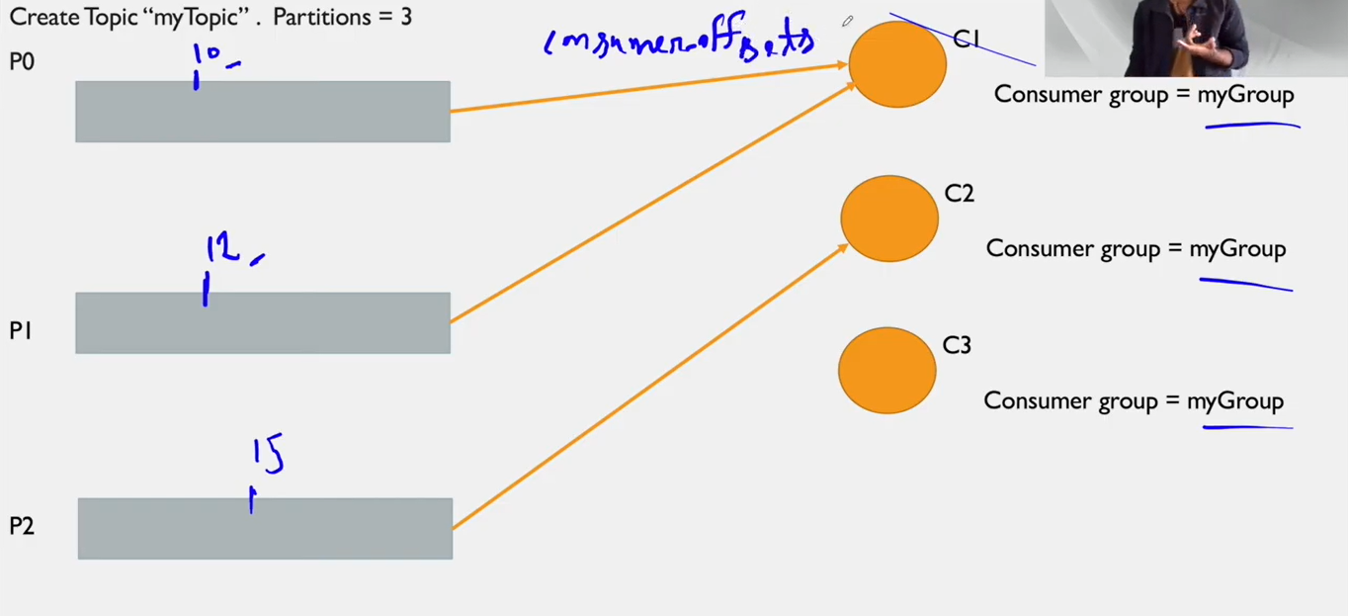

Figure Consumer group rebalancing

In this example, we will see consumer group rebalancing. Currently we have two consumers.

Consumer C1 is associated with partition P0 and P1.

Consumer C2 is associated with partition P2.

C1 consumed 10 and 12 messages from P0 and P1 respectively.

C2 consumed 15 messages from P2.

The information about how many messages are consumed by which consumer and from which partition is stored in ***__consumer_offsets.***

Now we will add one more consumer called C3, as given in below diagram:

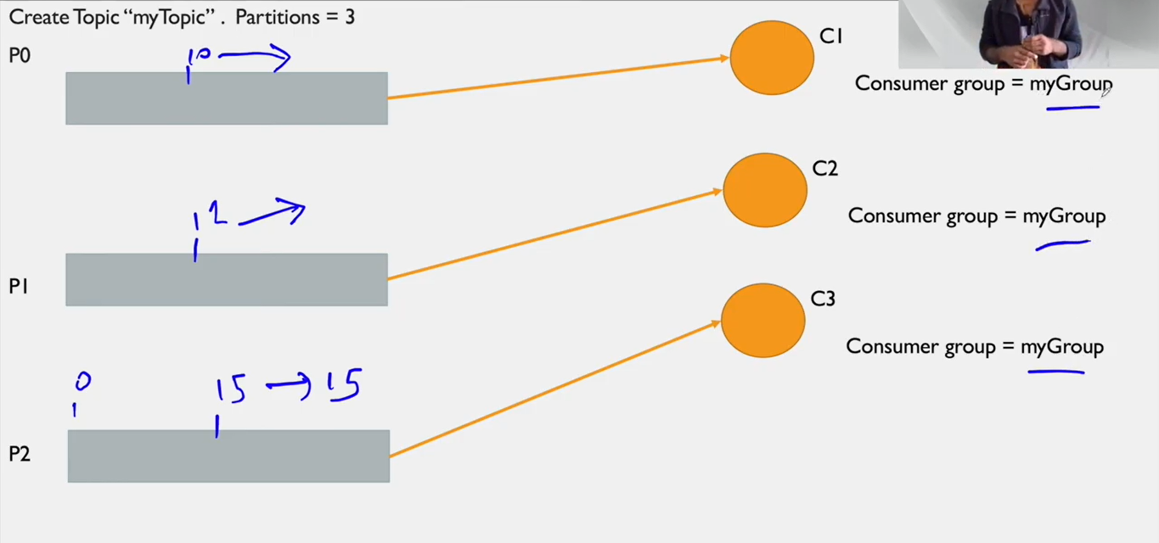

Figure Consumer rebalancing 3 consumers

We saw in previous diagram C1 and C2 consumed messages from all three partitions.

Now as C3 got added, consumer rebalancing happened.

Now P0 is assigned to C1, P1 assigned to C2 and P2 is assigned to C3.

Whatever messages are consumed by consumers are stored in consumer offset.

After consumer rebalancing the consumers will consume messages from offset point not from starting, this prevented duplication.