CICD:

1. Region=us-east-1
2. First take one system from aws .I am taking amazon linux and inside amazon linux I am configuring aws cli (that means I added acesskey,secret key)

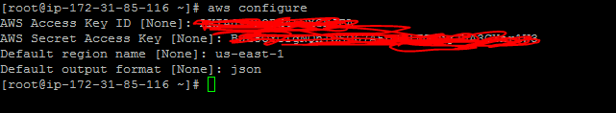

1. Now install git in that system by

yum install git –y



git --version

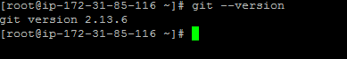

1. Now type git clone https://github.com/kellydemo7/hello-world

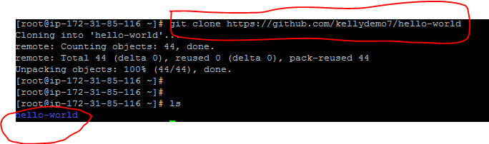

You will get a folder by name heelo-world as mentioned above.

1. Now we need to create a cluster by using aws cloudformation for this we will copy the below command in the system.

First transfer your pem key into hello world location by using winscp as mentioned below.

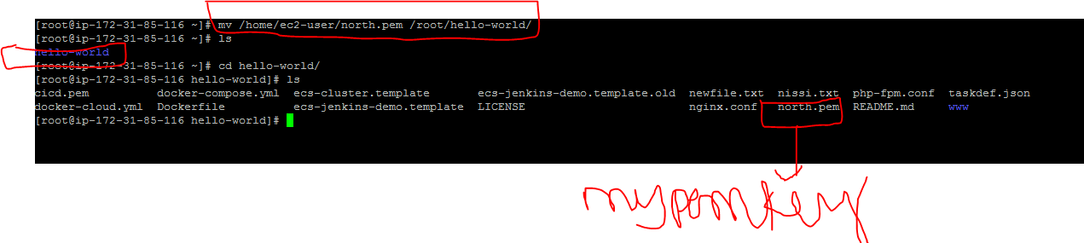

After this you need to run this entire command ,but you need to make two changes

1. Region name (my case it is us-east-1)
2. Pem key name( my case it is north ,no need of adding pem again)

Now go to hello-world folder and run the below command

aws cloudformation create-stack --template-body file://ecs-cluster.template --stack-name EcsClusterStack --capabilities CAPABILITY_IAM --tags Key=Name,Value=ECS --region us-east-1 --parameters ParameterKey=KeyName,ParameterValue=north ParameterKey=EcsCluster,ParameterValue=getting-started ParameterKey=AsgMaxSize,ParameterValue=2

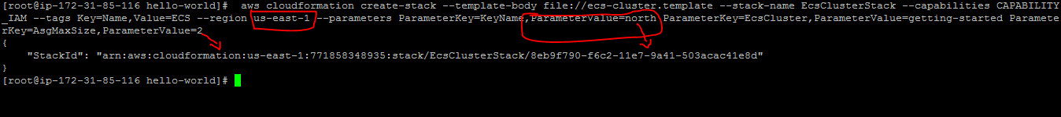

In the above screenshot I specified region as us-east-1 because I am launching in north Virginia.

Parametervalue=pem key name(north).

Parameter value=2 that means by using above command through cloud formation I am launching 2 ecs clusters.

Output I got a stack id that means if you open your cloud formation you can see one stack is created.

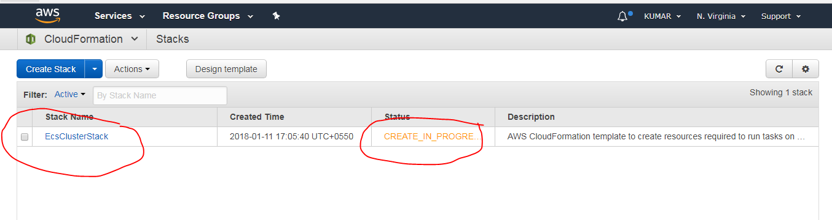

1. Now we need to create one jenkins server so copy the below command and execute in your system.

aws cloudformation create-stack --template-body file://ecs-jenkins-demo.template --stack-name JenkinsStack --capabilities CAPABILITY_IAM --tags Key=Name,Value=Jenkins --region us-east-1 --parameters ParameterKey=EcsStackName,ParameterValue=EcsClusterStack

In the above command my region is us-east-1



By this totally 2 ecs clusters and one jenkins server is created.

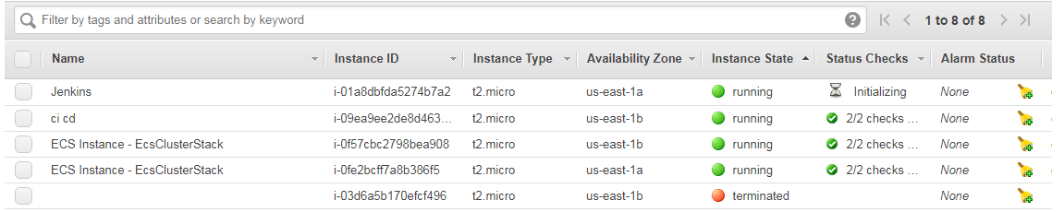

1. In jenkins server the java version is 1.7 so we login to jenkins server and install java 8 with help of tecadmin website

<https://tecadmin.net/install-java-8-on-centos-rhel-and-fedora/>

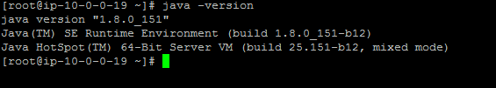

Now type service jenkins restart

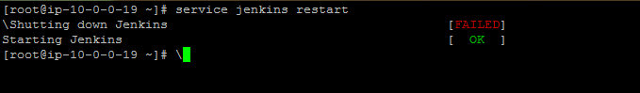

1. Now open the jenkins gui by taking the jenkins server ip and press enter

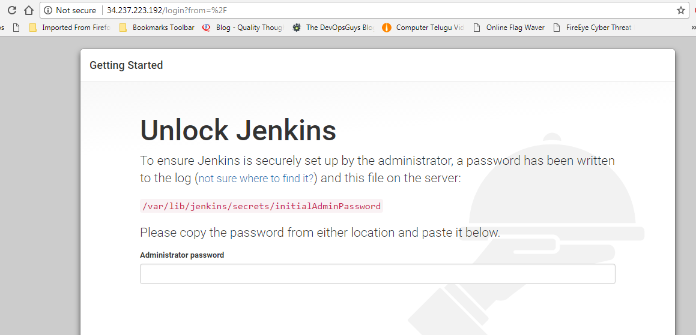

Unlock jenkins password and create one user and log into jenkins server.

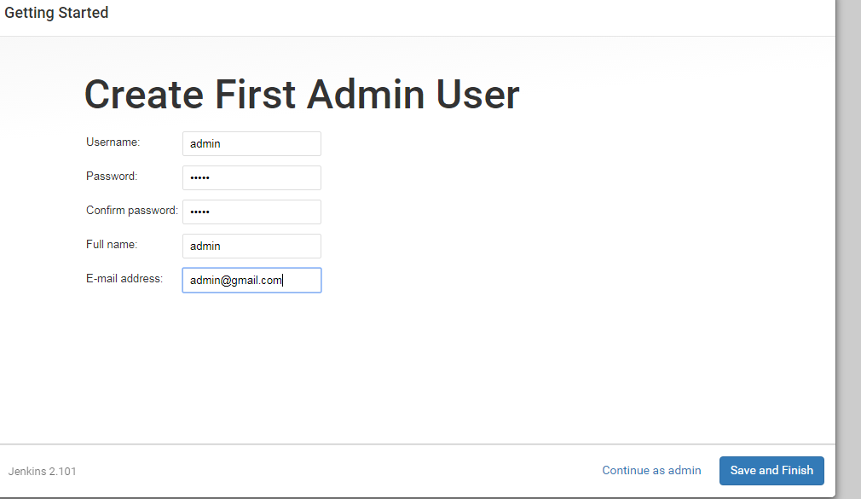

1. Now click on manage jenkins-->manageplugins🡪select available

Install two plugins

a) cloudbees docker build and publish

b) amazon ecr





Install two plugins .

1. Create a free style project with any name

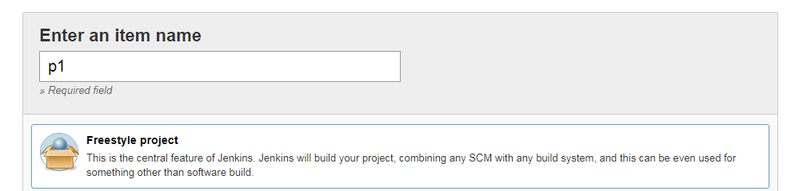

Now inside project in general select gitproject and paste the below url

https://github.com/kellydemo7/hello-world

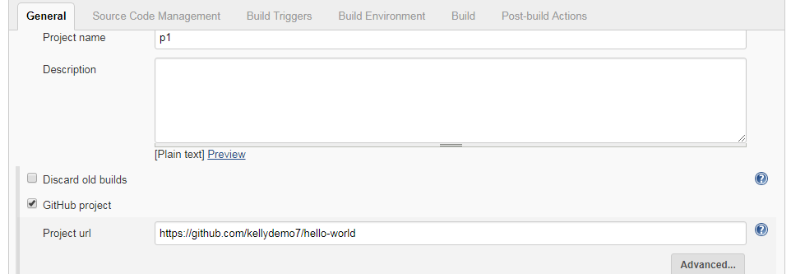

In source code management select git and paste the same url

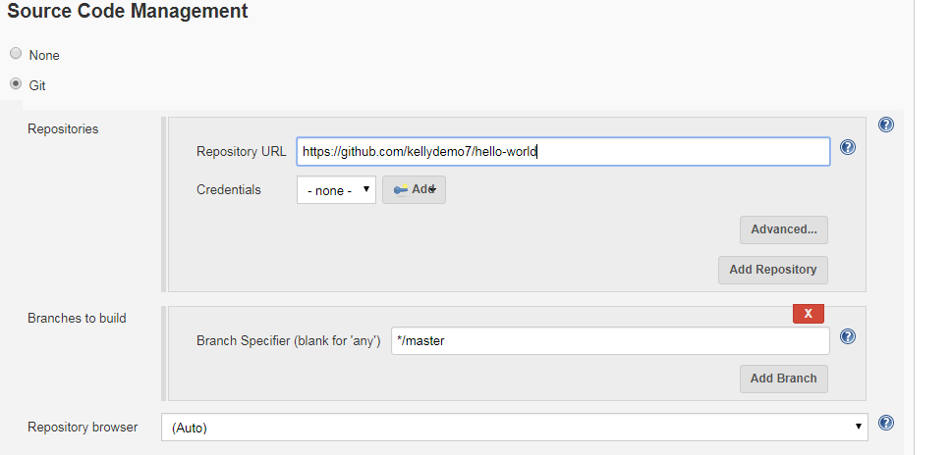

In the build step click on addbuildstep and select execute shell

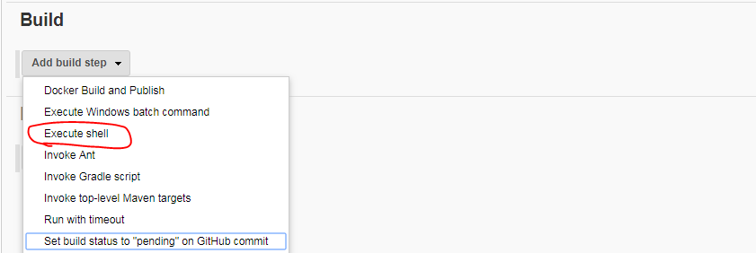

Now inside jenkins server run the below command

aws ecr get-login --region us-east-1

you will get output ,take that output from jenkins server and paste it in the execute shell

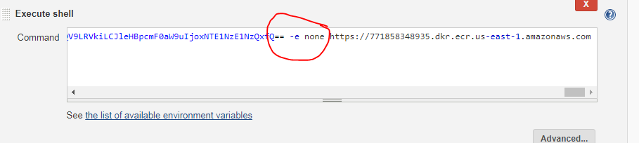

Remove –e and none it should be like this

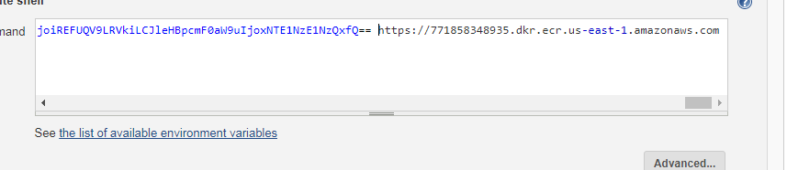

Just one space like this

Now again click on build step and select docker build and publish

In the build and publish

In tag copy this 🡪 v_$BUILD_NUMBER

Repository name🡪hello-world

Docker registry url for this u need to run below command in jenkins server

aws ecr create-repository --repository-name hello-world --region us-east-1

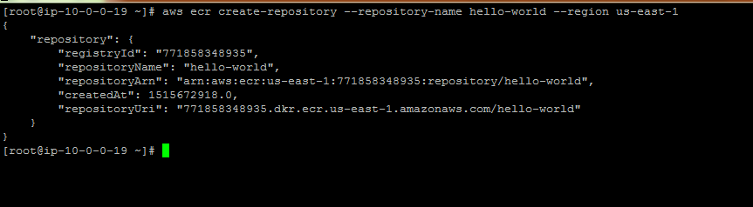

Now copy the uri from jenkins server

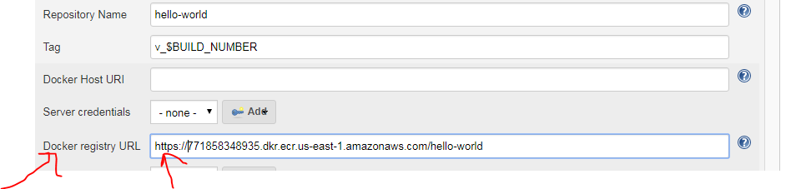

Please add https

Again click on execute shell and paste the below script

In below script you need to change region,repository name and clustername.

In my case I mentioned as below if ur working in northvirginia just copy below script

#!/bin/bash

#Constants

REGION=us-east-1

REPOSITORY_NAME=hello-world

CLUSTER=getting-started

FAMILY=`sed -n 's/.*"family": "\(.*\)",/\1/p' taskdef.json`

NAME=`sed -n 's/.*"name": "\(.*\)",/\1/p' taskdef.json`

SERVICE_NAME=${NAME}-service

#Store the repositoryUri as a variable

REPOSITORY_URI=`aws ecr describe-repositories --repository-names ${REPOSITORY_NAME} --region ${REGION} | jq .repositories[].repositoryUri | tr -d '"'`

#Replace the build number and respository URI placeholders with the constants above

sed -e "s;%BUILD_NUMBER%;${BUILD_NUMBER};g" -e "s;%REPOSITORY_URI%;${REPOSITORY_URI};g" taskdef.json > ${NAME}-v_${BUILD_NUMBER}.json

#Register the task definition in the repository

aws ecs register-task-definition --family ${FAMILY} --cli-input-json file://${WORKSPACE}/${NAME}-v_${BUILD_NUMBER}.json --region ${REGION}

SERVICES=`aws ecs describe-services --services ${SERVICE_NAME} --cluster ${CLUSTER} --region ${REGION} | jq .failures[]`

#Get latest revision

REVISION=`aws ecs describe-task-definition --task-definition ${NAME} --region ${REGION} | jq .taskDefinition.revision`

#Create or update service

if [ "$SERVICES" == "" ]; then

echo "entered existing service"

DESIRED_COUNT=`aws ecs describe-services --services ${SERVICE_NAME} --cluster ${CLUSTER} --region ${REGION} | jq .services[].desiredCount`

if [ ${DESIRED_COUNT} = "0" ]; then

DESIRED_COUNT="1"

fi

aws ecs update-service --cluster ${CLUSTER} --region ${REGION} --service ${SERVICE_NAME} --task-definition ${FAMILY}:${REVISION} --desired-count ${DESIRED_COUNT}

else

echo "entered new service"

aws ecs create-service --service-name ${SERVICE_NAME} --desired-count 1 --task-definition ${FAMILY} --cluster ${CLUSTER} --region ${REGION}

fi

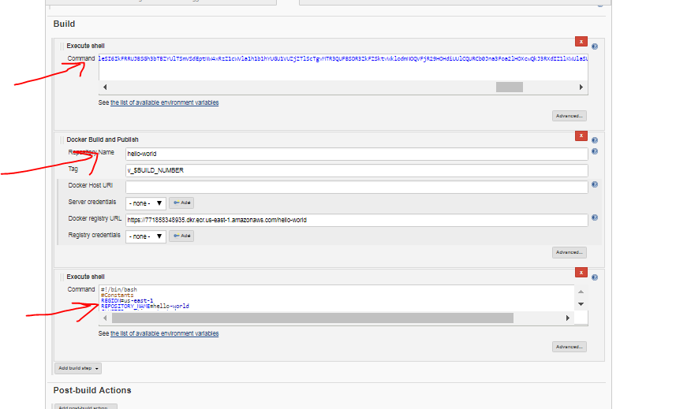

Now click on apply and save, build the project .

So successfully done. After build is done you can take the ip of one the ecs clusters that are running you will get the docker image as output

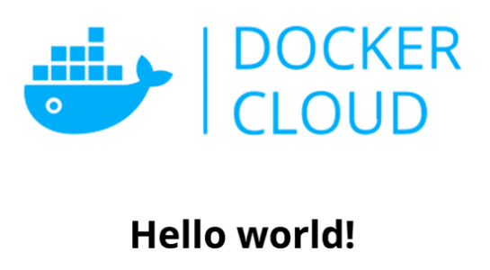

*****If you are doing 2nd time in same region update service error u will get.

Update service error ,in this scenario go to configure project and add zero as mentioned in blow screenshot.

By default it is empty.

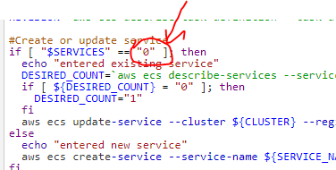

***Once it is done delete the stacks by going to cloudformation service

****go to ecs service and delete cluster and repo,for repo it will be deregister

For more info pls visit below site

https://docs.aws.amazon.com/AWSGettingStartedContinuousDeliveryPipeline/latest/GettingStarted/CICD_Jenkins_Pipeline.html