**8 Puzzle solver**  
I need a working code on VS 2019 of 8 puzzle problem using C++ along with document explaining what each class/structure/function does.

**fig. 1** The puzzle grid are labelled as below: (this is use for the output of move sequence that gets to the goal state)

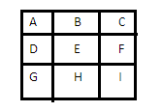

**fig. 2** The puzzle initial state would be like this: after taking input from command line: (the program can be run in command line (cmd) and takes input) e.g. projectname.exe 315027684   
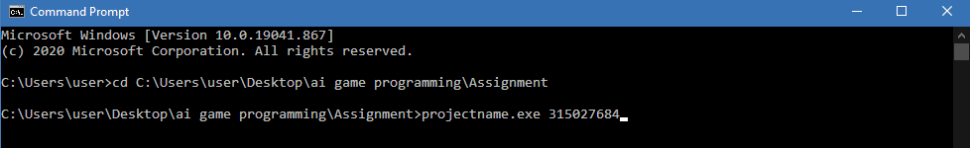

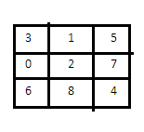

**fig. 3** The puzzle in goal state would be like this:

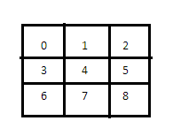  
The program needs to determine the moves to solve the puzzle to its goal state.

The output of the program should be the **move sequence** using the labels of the grids in **figure 1**. Below is the move sequence example to solve the **fig. 2 puzzle** problem as an example. This is the only one we need to show as output of the program.

ABEFIHEFCBA

(this is for reference of the process)

Initial state: (refer to fig. 1)

3 1 5

0 2 7

6 8 4

step 1: A (Move 0 which is in position of cell D to position cell of A which contains the number 3)

0 1 5

3 2 7

6 8 4

step 2: B

1 0 5

3 2 7

6 8 4

step 3: E

1 2 5

3 0 7

6 8 4

step 4: F

1 2 5

3 7 0

6 8 4

step 5: I

1 2 5

3 7 4

6 8 0

step 6: H

1 2 5

3 7 4

6 0 8

step 7: E

1 2 5

3 0 4

6 7 8

step 8: F

1 2 5

3 4 0

6 7 8

step 9: C

1 2 0

3 4 5

6 7 8

step 10: B

1 0 2

3 4 5

6 7 8

step 11: A

0 1 2

3 4 5

6 7 8