**GIT – Assignment  
1-6**

1. Create a directory ‘project_dir’ & cd to ‘project_dir’.

2. Initialize git version database. (git init)

3. Create a new file index.html.

4. Check the git status. You should find index.html as untracked file.

5. Stage the index.html file.

6. Commit index.html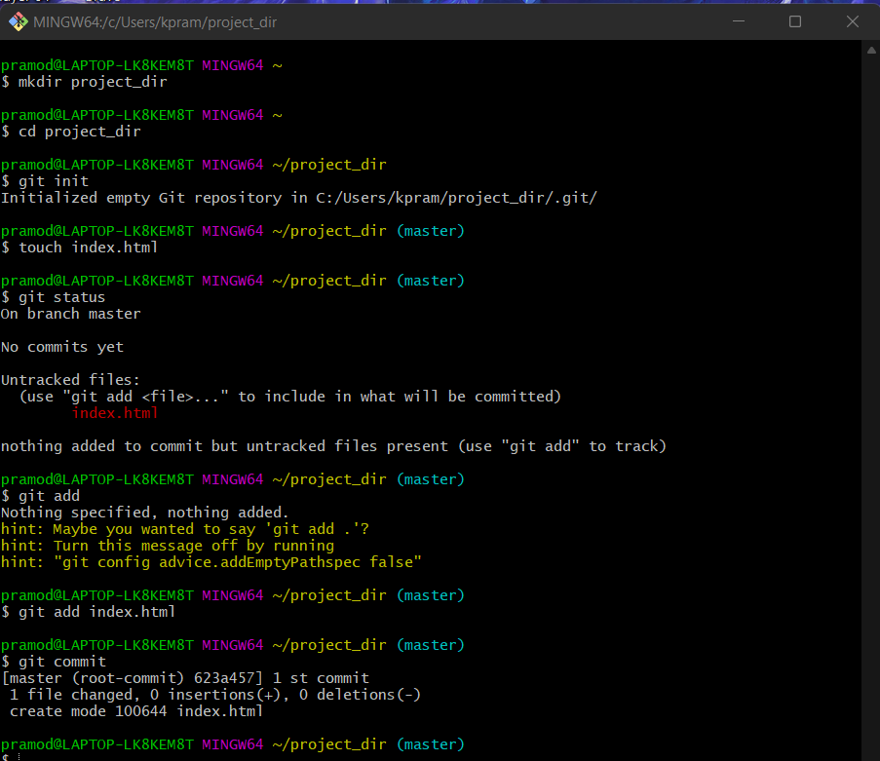

7. Make few changes in index.html & create a new file info.txt file

pramod@LAPTOP-LK8KEM8T MINGW64 ~/desktop/project_dir (master)

$ touch info.txt

8. Check git status. You should find index.html & info.txt as untracked files

pramod@LAPTOP-LK8KEM8T MINGW64 ~/desktop/project_dir (master)

$ git status

On branch master

Changes not staged for commit:

(use "git add <file>..." to update what will be committed)

(use "git restore <file>..." to discard changes in working directory)

modified: index.html

Untracked files:

(use "git add <file>..." to include in what will be committed)

info.txt

no changes added to commit (use "git add" and/or "git commit -a")

9. Configure GIT to ignore all txt files

pramod@LAPTOP-LK8KEM8T MINGW64 ~/desktop/project_dir (master)

$ touch .gitignore

9. Configure GIT to ignore all txt files.

10. Again check the git status. You should find only index.html as untracked file.

pramod@LAPTOP-LK8KEM8T MINGW64 ~/desktop/project_dir (master)

$ git status

On branch master

Changes not staged for commit:

(use "git add <file>..." to update what will be committed)

(use "git restore <file>..." to discard changes in working directory)

modified: index.html

Untracked files:

(use "git add <file>..." to include in what will be committed)

.gitignore

no changes added to commit (use "git add" and/or "git commit -a")

11. State & commit index.html

pramod@LAPTOP-LK8KEM8T MINGW64 ~/desktop/project_dir (master)

$ git commit index.html

[master f77d740] 2nd commit

1 file changed, 1 insertion(+)

12. Log all your comments so far.

pramod@LAPTOP-LK8KEM8T MINGW64 ~/desktop/project_dir (master)

$ git log

commit f77d740632bd15602fb52ffca10129125968b36f (HEAD -> master)

Author: pramod-kumar444 <k.pramodkumarchowdary@gmail.com>

Date: Thu Jan 20 17:40:39 2022 +0530

2nd commit

commit cf3f22cbe3a4d97641b6f30b76c8df65f1188b25

Author: pramod-kumar444 <k.pramodkumarchowdary@gmail.com>

Date: Thu Jan 20 17:26:01 2022 +0530

1st commit

13. Make some changes in index.html.

14. Revert the change made in the previous step using git command.

pramod@LAPTOP-LK8KEM8T MINGW64 ~/desktop/project_dir (master)

$ git revert

16. Stage index.html

17. Revert back the last stage

pramod@LAPTOP-LK8KEM8T MINGW64 ~/desktop/project_dir (master)

$ git add index.html

pramod@LAPTOP-LK8KEM8T MINGW64 ~/desktop/project_dir (master)

$ git revert HEAD

error: your local changes would be overwritten by revert.

hint: commit your changes or stash them to proceed.

fatal: revert failed

pramod@LAPTOP-LK8KEM8T MINGW64 ~/desktop/project_dir (master)

$

18. Rename ‘add’ command to ‘my-add’.

pramod@LAPTOP-LK8KEM8T MINGW64 ~/desktop/project_dir (master)

$ alias my-add="git add"

19. Using my_add command Stage index.html again & commit the changes.

pramod@LAPTOP-LK8KEM8T MINGW64 ~/desktop/project_dir (master)

$ my-add index.html

pramod@LAPTOP-LK8KEM8T MINGW64 ~/desktop/project_dir (master)

$ git commit

[master 1b1d13f] final commit

1 file changed, 2 insertions(+)

20. Revert the last commit.

pramod@LAPTOP-LK8KEM8T MINGW64 ~/desktop/project_dir (master)

$ git reset HEAD~

Unstaged changes after reset:

M index.html

**GIT-Branching**

22. Create an empty directory ‘Assignments’ & cd to ‘Assignments’

pramod@LAPTOP-LK8KEM8T MINGW64 ~/desktop

$ mkdir assignments

23. Create a file README.txt inside ‘Assignments’ & write few lines about the contents of ‘Assignments’ folder.

pramod@LAPTOP-LK8KEM8T MINGW64 ~/desktop

$ cd assignments

pramod@LAPTOP-LK8KEM8T MINGW64 ~/desktop/assignments

$ touch README.txt

pramod@LAPTOP-LK8KEM8T MINGW64 ~/desktop/assignments

$ git init

Initialized empty Git repository in C:/Users/kpram/Desktop/assignments/.git/

pramod@LAPTOP-LK8KEM8T MINGW64 ~/desktop/assignments (master)

$ git add README.txt

24. Commit README.txt file.

25. Now create a new branch ‘html-assignments’.

26. Switch to ‘html-assignments’ branch.

pramod@LAPTOP-LK8KEM8T MINGW64 ~/desktop/assignments (master)

$ git commit -m "Added multiple line in readme"

[master (root-commit) d99b3c8] Added multiple line in readme

1 file changed, 2 insertions(+)

create mode 100644 README.txt

pramod@LAPTOP-LK8KEM8T MINGW64 ~/desktop/assignments (master)

$ git branch html-assignments

pramod@LAPTOP-LK8KEM8T MINGW64 ~/desktop/assignments (master)

$ git checkout html-assignments

Switched to branch 'html-assignments'

27. Copy all HTML assignments inside ‘Assignments’ folder.

28. Commit HTML assignments into ‘html-assignments’ branch.

pramod@LAPTOP-LK8KEM8T MINGW64 ~/desktop/assignments (html-assignments)

$ git status

On branch html-assignments

Changes to be committed:

(use "git restore --staged <file>..." to unstage)

new file: about.html

new file: index.html

new file: secondpage.html

pramod@LAPTOP-LK8KEM8T MINGW64 ~/desktop/assignments (html-assignments)

$ git commit -m "commit of all html assignments into html-assignments"

[html-assignments b047cc9] commit of all html assignments into html-assignments

3 files changed, 0 insertions(+), 0 deletions(-)

create mode 100644 about.html

create mode 100644 index.html

create mode 100644 secondpage.html

29. Make minor changes into few files belonging to ‘html-assignments’ branch.

30. Commit those changed files

pramod@LAPTOP-LK8KEM8T MINGW64 ~/desktop/assignments (html-assignments)

$ git add .

pramod@LAPTOP-LK8KEM8T MINGW64 ~/desktop/assignments (html-assignments)

$ git add .

pramod@LAPTOP-LK8KEM8T MINGW64 ~/desktop/assignments (html-assignments)

$ git commit -m "commit of all changed files"

[html-assignments 7178e8f] commit of all changed files

3 files changed, 3 insertions(+)

31. Switch to master branch.

32. Make minor changes into README.txt file & commit those changes into master

pramod@LAPTOP-LK8KEM8T MINGW64 ~/desktop/assignments (html-assignments)

$ git checkout master

Switched to branch 'master'

pramod@LAPTOP-LK8KEM8T MINGW64 ~/desktop/assignments (master)

$ git add *.txt

pramod@LAPTOP-LK8KEM8T MINGW64 ~/desktop/assignments (master)

$ git commit -m "changes made in master readme file"

[master 5fd5c64] changes made in master readme file

1 file changed, 2 insertions(+)

33. Again switch to ‘html-assignments’ branch.

34. Make minor changes into few files belonging to ‘html-assignments’ branch.

pramod@LAPTOP-LK8KEM8T MINGW64 ~/desktop/assignments (master)

$ git checkout html-assignments

Switched to branch 'html-assignments'

pramod@LAPTOP-LK8KEM8T MINGW64 ~/desktop/assignments (html-assignments)

$ git add .

35. Commit those changes.

pramod@LAPTOP-LK8KEM8T MINGW64 ~/desktop/assignments (html-assignments)

$ git commit -m "Made some changes in html files in html-assignments branch"

[html-assignments 0e06e75] Made some changes in html files in html-assignments branch

3 files changed, 5 insertions(+), 2 deletions(-)

36. Switch to master.

pramod@LAPTOP-LK8KEM8T MINGW64 ~/desktop/assignments (html-assignments)

$ git checkout master

Switched to branch 'master'

37. Merge ‘html-assignments’ branch into master. Confirm all html assignments are shown in master.

pramod@LAPTOP-LK8KEM8T MINGW64 ~/desktop/assignments (master)

$ git merge html-assignments

Merge made by the 'ort' strategy.

about.html | 2 ++

index.html | 3 +++

secondpage.html | 1 +

3 files changed, 6 insertions(+)

create mode 100644 about.html

create mode 100644 index.html

create mode 100644 secondpage.html

38. Finally delete the ‘html-assignments’ branch.

pramod@LAPTOP-LK8KEM8T MINGW64 ~/desktop/assignments (master)

$ git branch -d html-assignments

Deleted branch html-assignments (was 0e06e75).

pramod@LAPTOP-LK8KEM8T MINGW64 ~/desktop/assignments (master)

$

**Section-2 (CSS-assignments)**

1. Create a new branch ‘css-assignments’.

pramod@LAPTOP-LK8KEM8T MINGW64 ~/desktop/assignments (master)

$ git branch css-assignments

2. Switch to ‘css-assignments’ branch.

pramod@LAPTOP-LK8KEM8T MINGW64 ~/desktop/assignments (master)

$ git checkout css-assignments

Switched to branch 'css-assignments'

3. Copy all CSS assignments inside ‘Assignments’ folder.

4. Commit CSS assignments into ‘css-assignments’ branch.

pramod@LAPTOP-LK8KEM8T MINGW64 ~/desktop/assignments (css-assignments)

$ git add .

pramod@LAPTOP-LK8KEM8T MINGW64 ~/desktop/assignments (css-assignments)

$ git commit -m "commiting all css files added new"

[css-assignments d4e4964] commiting all css files added new

3 files changed, 0 insertions(+), 0 deletions(-)

create mode 100644 about.css

create mode 100644 carrers.css

create mode 100644 contact.css

5. Make minor changes into README.txt file on line 1 belonging to ‘css-assignments’ branch.

6. Commit those changed files.

pramod@LAPTOP-LK8KEM8T MINGW64 ~/desktop/assignments (css-assignments)

$ git add .

pramod@LAPTOP-LK8KEM8T MINGW64 ~/desktop/assignments (css-assignments)

$ git commit -m "commit changes made in readme file for css"

[css-assignments 1c88f83] commit changes made in readme file for css

1 file changed, 2 insertions(+)

7. Switch to master branch

pramod@LAPTOP-LK8KEM8T MINGW64 ~/desktop/assignments (css-assignments)

$ git checkout master

Switched to branch 'master'

8. Make minor changes into README.txt file on line 3 & commit those changes into master

pramod@LAPTOP-LK8KEM8T MINGW64 ~/desktop/assignments (master)

$ git status

On branch master

Changes not staged for commit:

(use "git add <file>..." to update what will be committed)

(use "git restore <file>..." to discard changes in working directory)

modified: README.txt

no changes added to commit (use "git add" and/or "git commit -a")

pramod@LAPTOP-LK8KEM8T MINGW64 ~/desktop/assignments (master)

$ git add .

pramod@LAPTOP-LK8KEM8T MINGW64 ~/desktop/assignments (master)

$ git commit -m "changes made in readme in master branch"

[master 73385f2] changes made in readme in master branch

1 file changed, 1 insertion(+)

9. Again switch to ‘css-assignments’ branch

pramod@LAPTOP-LK8KEM8T MINGW64 ~/desktop/assignments (master)

$ git checkout css-assignments

Switched to branch 'css-assignments'

10. Make minor changes into few files belonging to ‘css-assignments’ branch.

11. Commit those changes.

pramod@LAPTOP-LK8KEM8T MINGW64 ~/desktop/assignments (css-assignments)

$ git add .

pramod@LAPTOP-LK8KEM8T MINGW64 ~/desktop/assignments (css-assignments)

$ git commit -m "made some changes in css files in css-assignments branch"

[css-assignments 11e4a4f] made some changes in css files in css-assignments branch

2 files changed, 2 insertions(+)

12. Switch to master.

pramod@LAPTOP-LK8KEM8T MINGW64 ~/desktop/assignments (css-assignments)

$ git checkout master

Switched to branch 'master'

13. Merge ‘css-assignments’ branch into master. Confirm all css assignments are shown in master. 14. Finally delete the ‘css-assignments’ branch.

pramod@LAPTOP-LK8KEM8T MINGW64 ~/desktop/assignments (master|MERGING)

$ git branch -D css-assignments

Deleted branch css-assignments (was 11e4a4f).

**Section-3 (Java script assignments)**

1. Create a new branch ‘js-assignments’.

pramod@LAPTOP-LK8KEM8T MINGW64 ~/desktop/assignments (master)

$ git init

Reinitialized existing Git repository in C:/Users/kpram/Desktop/assignments/.git/

2. Switch to ‘js-assignments’ branch.

pramod@LAPTOP-LK8KEM8T MINGW64 ~/desktop/assignments (master)

$ git branch js-assignments

3. Copy all JavaScript assignments inside ‘Assignments’ folder.

4. Commit JavaScript assignments into ‘js-assignments’ branch.

pramod@LAPTOP-LK8KEM8T MINGW64 ~/desktop/assignments (master)

$ git checkout js-assignments

Switched to branch 'js-assignments'

pramod@LAPTOP-LK8KEM8T MINGW64 ~/desktop/assignments (js-assignments)

$ git status

On branch js-assignments

Untracked files:

(use "git add <file>..." to include in what will be committed)

about.css

app.js

carrers.css

contact.css

head.js

nothing added to commit but untracked files present (use "git add" to track)

pramod@LAPTOP-LK8KEM8T MINGW64 ~/desktop/assignments (js-assignments)

$ git add .

pramod@LAPTOP-LK8KEM8T MINGW64 ~/desktop/assignments (js-assignments)

$ git commit -m "copied all javascript assignments"

[js-assignments 2f25540] copied all javascript assignments

5 files changed, 2 insertions(+)

create mode 100644 about.css

create mode 100644 app.js

create mode 100644 carrers.css

create mode 100644 contact.css

create mode 100644 head.js

5. Make minor changes into README.txt file on line 1 belonging to ‘js-assignments’ branch.

6. Commit those changed files.

pramod@LAPTOP-LK8KEM8T MINGW64 ~/desktop/assignments (js-assignments)

$ git add .

pramod@LAPTOP-LK8KEM8T MINGW64 ~/desktop/assignments (js-assignments)

$ git commit -m "changes made in readme file in js assignments"

[js-assignments cd35137] changes made in readme file in js assignments

1 file changed, 2 insertions(+), 1 deletion(-)

7. Switch to master branch.

pramod@LAPTOP-LK8KEM8T MINGW64 ~/desktop/assignments (js-assignments)

$ git checkout master

Switched to branch 'master'

8. Make minor changes into README.txt file on line 1 & commit those changes into master.

pramod@LAPTOP-LK8KEM8T MINGW64 ~/desktop/assignments (master)

$ git status

On branch master

Changes not staged for commit:

(use "git add <file>..." to update what will be committed)

(use "git restore <file>..." to discard changes in working directory)

modified: README.txt

no changes added to commit (use "git add" and/or "git commit -a")

pramod@LAPTOP-LK8KEM8T MINGW64 ~/desktop/assignments (master)

$ git add .

pramod@LAPTOP-LK8KEM8T MINGW64 ~/desktop/assignments (master)

$ git commit -m "changes made in readme file in master branch"

[master 06be288] changes made in readme file in master branch

1 file changed, 2 insertions(+), 1 deletion(-)

9. Again switch to ‘js-assignments’ branch

pramod@LAPTOP-LK8KEM8T MINGW64 ~/desktop/assignments (master)

$ git checkout js-assignments

Switched to branch 'js-assignments'

10. Make minor changes into few files belonging to ‘js-assignments’ branch.

11. Commit those changes.

pramod@LAPTOP-LK8KEM8T MINGW64 ~/desktop/assignments (js-assignments)

$ git add .

pramod@LAPTOP-LK8KEM8T MINGW64 ~/desktop/assignments (js-assignments)

$ git commit -m "changes made in app.js files"

[js-assignments 4ca4141] changes made in app.js files

2 files changed, 2 insertions(+)

12. Switch to master.

pramod@LAPTOP-LK8KEM8T MINGW64 ~/desktop/assignments (js-assignments)

$ git checkout master

Switched to branch 'master'

13. Merge ‘js-assignments’ branch into master. Confirm all JavaScript assignments are shown in master. 14. Finally delete the ‘js-assignments’ branch.

pramod@LAPTOP-LK8KEM8T MINGW64 ~/desktop/assignments (master)

$ git merge js-assignments

pramod@LAPTOP-LK8KEM8T MINGW64 ~/desktop/assignments (master)

$ git branch -D js-assignments

Deleted branch js-assignments (was 4ca4141).

**GIT-Remoting**

39. Create a github account if you do not have already.

40. Login on into github account.

41. Create new public repository ‘freshersbatch-oct16’

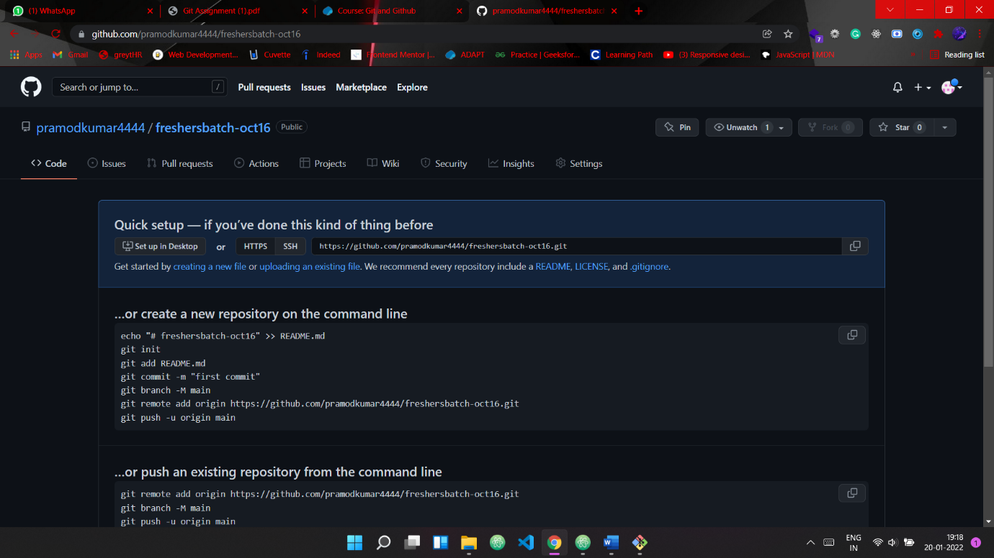

42. Commit & push any sample file to this repository under ‘Assignments’ directory.

pramod@LAPTOP-LK8KEM8T MINGW64 ~ (main)

$ git init

Reinitialized existing Git repository in C:/Users/kpram/.git/

pramod@LAPTOP-LK8KEM8T MINGW64 ~ (main)

$ git add README.md

warning: LF will be replaced by CRLF in README.md.

The file will have its original line endings in your working directory

pramod@LAPTOP-LK8KEM8T MINGW64 ~ (main)

$ git commit -m "first commit"

[main ce12ca6] first commit

1 file changed, 2 insertions(+)

pramod@LAPTOP-LK8KEM8T MINGW64 ~ (main)

$ git branch -M main

pramod@LAPTOP-LK8KEM8T MINGW64 ~ (main)

$ git remote add origin https://github.com/pramodkumar4444/freshersbatch-oct16.git

error: remote origin already exists.

pramod@LAPTOP-LK8KEM8T MINGW64 ~ (main)

$ git push -u origin main

Enumerating objects: 6, done.

Counting objects: 100% (6/6), done.

Delta compression using up to 8 threads

Compressing objects: 100% (3/3), done.

Writing objects: 100% (6/6), 484 bytes | 484.00 KiB/s, done.

Total 6 (delta 0), reused 0 (delta 0), pack-reused 0

To https://github.com/pramodkumar4444/freshersbatch-oct16.git

* [new branch] main -> main

Branch 'main' set up to track remote branch 'main' from 'origin'.