Super script

**I recommend making the line height 2px larger than the font size, and then for sup's making them 2 pixels less than surrounding font. Defining the line-height for the sup as 0 prevents the uneven space between each line of copy, and the vAlign moves the superscript up just enough in all of the diff clients (including Outlook 2007).**

<td style="font-family:Verdana, Geneva, sans-serif; font-size:10px; line-height:12px; mso-line-height-rule:exactly; color:#000000;">

Copy, Copy, Copy<sup style="font-size: 8px; line-height: 0; vertical-align: 3px">&reg;</sup></td>

Image tag:

<td style="line-height: 1px;">//to avoid white line in outlook 2013

<img style="display:block; outline:none; border:none; text-decoration:none; -ms-interpolation-mode:bicubic;" src=" images.jpg" width="320" height="300" alt=" ">

</td>

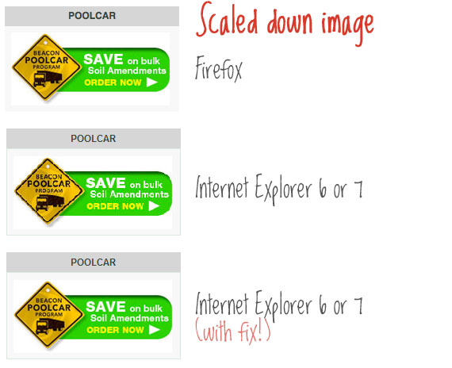CSS tips:

img { -ms-interpolation-mode: bicubic; }

If you use width or height tags to resize images in your markup, IE will ensure they look incredibly awful unless you use this little snippet. In general, resizing images in the browser isn't recommended, but of course there are always exceptions.

Line height Outlook 2013

<td height="1" bgcolor="#cccccc" style="font-size: 1px; line-height: 1px;">&nbsp;</td>

<td height="1" bgcolor="#cccccc" style="font-size: 1px; line-height: 1%; mso-line-height-rule: exactly;">&nbsp;</td>

<td colspan="2" class="banner" style="line-height: 1px;">

<img src="http://{*DATA(gsssite)*}/media/dynamic/id/{*DATA(tier3_id)*}zzzz5524d77b9ad3b557/sidebar-top-curve.jpg" width="195" height="10" style="display:block">

</td>

<Table style="border:1px solid #e6e7e9; border-collapse:collapse; mso-table-lspace:0pt; mso-table-rspace:0pt;">

<!--[if mso]></td><td><![endif]-->

Fix for line height ignored in Outlook 2010

< td style=“mso-line-height-rule:exactly; line-height:50px;>

This fix ONLY works on block elements.  So trying to achieve the same effect inside a font or span tag will not work. Since this is a Microsoft only CSS property, it should not interfere with any other email client.

Mobile content hiding in desktop

CSS:

.edm-mobile-content { display: none }

@media only screen and (max-width:480px) {

div[class=edm-desktop-content], table[class=edm-desktop-content], td[class=edm-dan] a img, a[class=edm-delivery] img, a[class=edm-freemetro] img { display: none!important }

div[class=edm-mobile-content], table[class=edm-mobile-content], table[class=edm-footer-nav], table[class=edm-footer-nav] table[class=edm-footer-column] {

display: block!important;

margin: 0 auto;

padding: 0;

overflow: visible!important;

width: auto!important;

max-height: inherit!important;

width: 320px!important;}

}

<div style="display:none; width:0px; max-height:0px; overflow:hidden;" class="edm-mobile-content">

<table cellpadding="0" cellspacing="0" border="0" width="320" class="edm-mobile-content"></table>

</div>

display: none;

font-size: 0;

max-height: 0;

line-height: 0;

padding: 0; (optional)

mso-hide: all; /* hide elements in Outlook 2007-2013 */ (optional)

However, the above yellow highlighted code doesn’t work in old version lotus note 6.5, 7 and 8

**[Re](http://emaildude.blogspot.com.au/2011/12/mobile-text-resize.html)placing Desktop image in Mobile Device**

We sometimes need to replace the desktop version image with new mobile version image. So following code can be used for replacing desktop image in mobile:

<td > <a href="http"> <img class="emailwrapto100pc" width="300" height="264" border="0" src=" article2.jpg" title=" " alt=" " style="display:block; outline:none; border:none; text-decoration:none; -ms-interpolation-mode:bicubic;" class="img-offer3"/> </a></td>

@media only screen and (max-width: 480px) {

*[class=emailwrapto100pc] {

width: 100% !important;

height: auto !important;

}

a[class=img-offer3] img {display: none!important; }

a[class=img-offer3] {

display: block;

overflow: hidden;

width: 320px;

height: 302px;

background: url('http://contentz.mkt4907.com/ra/2014/41326/08/9249858/article3.jpg') no-repeat;

background-size: 320px 302px;

padding-bottom: 15px !important;

}

@media only screen and (max-width: 480px)

a[class=ff1] {

1.  display: block !important;
2.  overflow: hidden !important;
3.  width: 100% !important;
4.  height: auto !important;
5.  background: url(['images/header-image.jpg'](http://www.pramodmaharjan.com/email/FF/images/header-image.jpg)) no-repeat;
6.  background-size: 100% !important;
7.  padding-bottom: 56.66% !important;

}

[**Mobile Text Resize**](http://emaildude.blogspot.com.au/2011/12/mobile-text-resize.html)

As I'm sure you're aware, the number of emails opened up on a mobile device have drastically increased, and will only continue to do so as more people get smart phones. I was having an issue with my text re-sizing and breaking pretty much the entire design.  
  
Simple fix, that I've yet to see not work.  
  
In the main table, add an inline style of -webkit-text-size-adjust:none;.  
  
Something like:  
<table border="0" cellpadding="0" cellspacing="0" width="650" align="center" style="-webkit-text-size-adjust:none;">.  
  
This basically prevents the device from re-sizing the text, keeping it within your set design.

[**Message not centered in Hotmail?**](http://emaildude.blogspot.com.au/2011/03/message-not-centered-in-hotmail.html)

**I recently had an issue with my emails not centering in hotmail but centering everywhere else (gmail, yahoo, aol etc.). Even though I was defining w/in the main table align="center", it wouldn't work in hotmail. After a bit of google searching I found this fix:  
  
<style type="text/css">  
body { width: 100% !important; }  
</style>  
  
So far so good! I place this code now in all of my newsletters, directly under the <body> tag, and have yet to find any instances where it does not work.**

**Fix:** Add zoom:1 and *display: inline to the element in CSS (courtesy of [The Mad Ranter](http://flipc.blogspot.com/2009/02/damn-ie7-and-inline-block.html))

**Original CSS:**

.blueberry .pager li {

display: inline-block;

}

**Fixed CSS:**

.blueberry .pager li {

display: inline-block;

zoom: 1;

*display: inline;

}

# Banning Blue Links on iOS Devices

**.appleLinksWhite a {color: #ffffff !important; text-decoration: underline;}**

**.appleLinksBlack a {color: #000000 !important; text-decoration: none;}**

After specifying these classes in the <head> of our email, we wrapped the offending blue text in <span> tags with the appropriate class throughout the email:

**<span class=”appleLinksBlack”>866-787-7030</span>**

FOR mobile

<body bgcolor="#f5f5f5" style="-webkit-text-size-adjust:100%; -ms-text-size-adjust:100%; margin:0; padding:0; width:100%;">

<div style="width:100% !important; line-height:100% !important; margin:0; padding:0; ">

**CSS:**

To apply submit button effect in iPhone:

input[type="submit"]{

-webkit-appearance: none;

}

To make scrollbar visible in iphone:

::-webkit-scrollbar {

-webkit-appearance: none;

}

::-webkit-scrollbar:vertical {

width: 12px;

}

::-webkit-scrollbar:horizontal {

height: 12px;

}

::-webkit-scrollbar-thumb {

background-color: rgba(0, 0, 0, .5);

border-radius: 10px;

border: 2px solid #ffffff;

}

::-webkit-scrollbar-track {

border-radius: 10px;

background-color: #ffffff;

}

IE compatibility meta tag:

<meta http-equiv="Content-Type" content="text/html; charset=utf-8">

<meta name="viewport" content="width=device-width, initial-scale=1">

<meta http-equiv="X-UA-Compatible" content="IE=edge,chrome=1" />

IE mobile meta tag

<html xmlns="http://www.w3.org/1999/xhtml" xmlns:v="urn:schemas-microsoft-com:vml" xmlns:o="urn:schemas-microsoft-com:office:office">