|  |
| --- |
| 17th May 2023 |

|  |
| --- |
| www.decimalpointanalytics.com |

Corporate Data Non Financial Process- User Stories

|  |  |  |
| --- | --- | --- |
| **QMS Document ID:** | **DPA/PRJ/ / /** | **Version No. 1.0** |

|  |  |  |  |
| --- | --- | --- | --- |
| **Date** | **Prepared By** | **Reviewed By** | **Approved By** |
| **17-05-2023** | **Kailas Palde** | **Shyam Pardeshi** |  |
|  |  |  |  |
|  |  |  |  |

**Document Revision History**

|  |  |  |
| --- | --- | --- |
| **Version** | **Date** | **Details** |
| 1.0 | 17-05-2023 | Corporate Data Process – Clean Non Financial auto scraped data and make data ready to host in staging table. |

**User story –**

Clean Non-Financial auto scraped data and make data ready to host in staging table.

**Functional Flow –**

**For Corporate Pulse users– this page should link to the Current CDP portal**

1. Tool required to clean auto scraped data for below tables for specified countries.

|  |  |  |  |
| --- | --- | --- | --- |
| **Table Name** | **US** | **UK** | **CA** |
| Outstanding Equity Awards |  | NA | NA |
| Option Exercised & Stock Vested |  |
| Stock & Option Grants |  |
| Executive_Officer_Compensation |  |  |  |
| Board Of DirectorsCompensation |  |  |  |
| Executive_officers director |  |  |  |
| Board_Committee |  |  |  |

1. Auto scrapped data is available in the multiple excel files.

|  |  |
| --- | --- |
| **Folder Name** | **Files inside the output folder** |
| File Master Id | grants of plan |
| option exercises and stock |
| outstanding equity |
| director compensation |
| executive compensation |

*\*file naming file master id followed by table name*

1. Tool should open above files one by one at back end.
2. Search “**Key Words**” in the column headers into the input files.
3. If any column / row is completely blank then ignore it.
4. Required dictionary to update Keywords as per requirement for all columns.
5. Follow below guidelines to map the entries as per table with the correct column
6. Tool should pick where NF cases *is process flag is 2* and the update date should not greater than 2 days from todays date.
7. Country code and Priority is available in company master for the country identification.

|  |  |  |
| --- | --- | --- |
| **Original Table Name** | **Input File Name** | **Treatments** |
| Board Of DirectorsCompensation | director compensation | Capture all records, refer screen shot no 1 |
| Stock & Option Grants | grants of plan | May names available only for one row and couple of rows fields are blank in name column then use earlier name till the time next cell don’t have new name in the column. Same is highlighted in screen shot no 2 |
| Outstanding Equity Awards | outstanding equity | May names available only for one row and couple of rows fields are blank in name column then use earlier name till the time next cell don’t have new name in the column. Same is highlighted in screen shot no 3 |
| Option Exercised & Stock Vested | option exercises and stock | Capture all records, refer screen shot no 4 |
| executive_officer_compensation | executive compensation | Capture only latest years entries (year stated given in the table will match with the year-end date available on first or second page of the report / check report date column in file_master table) in the main template, skip additional information such as designation / position and prior year entries. same is highlighted in screen shot no- 5 |
| Executive_officers director | Executive officer Director | Yet input is not ready for this table. |
| Board_Committee | Board Committee | Yet input is not ready for this table. |

**Screenshot No- 1**

**Screenshot No-2**

**Screenshot No-3**

**Screenshot No-4**

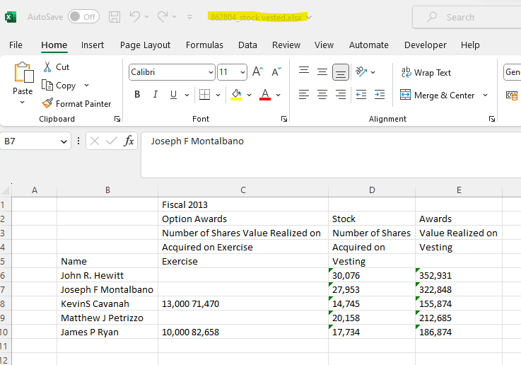

**Screenshot No-5**

1. Main Template along with the column headers.



1. If the two or more columns/ rows are merged, then keep these columns information as blank (don’t insert any data points in the main template.
2. If the keywords are part of column headers, then copy those entries data in the main template under the appropriate sheet.
3. Then upload the data in stagging table.
4. Kay words File



**WIRE FRAME: -**

|  |  |  |  |  |  |
| --- | --- | --- | --- | --- | --- |
| **Master IDs available for Data Cleaning** |  |  |  |  |  |
| **Master Ids Data Cleaned** |  |  |  |  |  |
| **Master Ids Data Verified Today** |  |  |  |  |  |
| **Total** |  |  |  |  |  |
|  |  |  |  |  |  |
| *filters* | *filters* | *filters* | *filters* | *filters* | *filters* |
| Country | Company Id | File Master Id | Priority | Production_Date | Data Cleaning Status |
|  |  |  |  |  |  |
|  |  |  |  |  |  |
|  |  |  |  |  |  |
|  |  |  |  |  |  |
|  |  |  |  |  |  |
|  |  |  |  |  |  |
|  |  |  |  |  |  |

* + **Acceptance Criteria: -**
* Columns should be mapped appropriately as per Key Word and copy data in Main Template.
* Merged columns and rows data should not mapped with any column.
* Auto matched entries data should get auto updated in stagging table.
* Status of available file master ids data cleaning completed and data cleaning is pending should reflect on UI.