|  |
| --- |
| 27th February 2023 |

|  |
| --- |
| www.decimalpointanalytics.com |

Corporate Data Non Financial Process- User Stories

|  |  |  |
| --- | --- | --- |
| **QMS Document ID:** | **DPA/PRJ/ / /** | **Version No. 1.0** |

|  |  |  |  |
| --- | --- | --- | --- |
| **Date** | **Prepared By** | **Reviewed By** | **Approved By** |
| **27-02-2023** | **Kailas Palde** | **Shyam Pardeshi** |  |
|  |  |  |  |
|  |  |  |  |

**Document Revision History**

|  |  |  |
| --- | --- | --- |
| **Version** | **Date** | **Details** |
| 1.0 | 27-02-2023 | Corporate Data Process – Download reports from portal and convert html files in PDF. |

**User story – To create a downloading of Financial and Non-Fnancial Reports from Sec, Sedar and NSM**

We would like to develop an application which will download the company financial and non financial reports from Sedar portals out of their daily fillings for the companies which are in the SQL table (Company Master).

**Functional Flow –**

**For Corporate Pulse users–**

Need to download latest reports from website from today’s fillings here are the reports type:-

(*scrape records only once do not create duplicate entries)*

|  |
| --- |
| Management information circular - English |
| Audited annual financial statements - English |
| Annual report on Form 10-K - English |
| Interim financial statements/report - English |

1. By accessing the link, Hit on new fillings

Link – <https://www.sedar.com>

1. Then Hit on All New Company Fillings

1. Then below screen will appear (will get company name, date of filling , time of filling and document type from this page, there are changes for one company multiple reports will publish in one day, please check screen shot # 2

1- screenshot

2 - screenshot

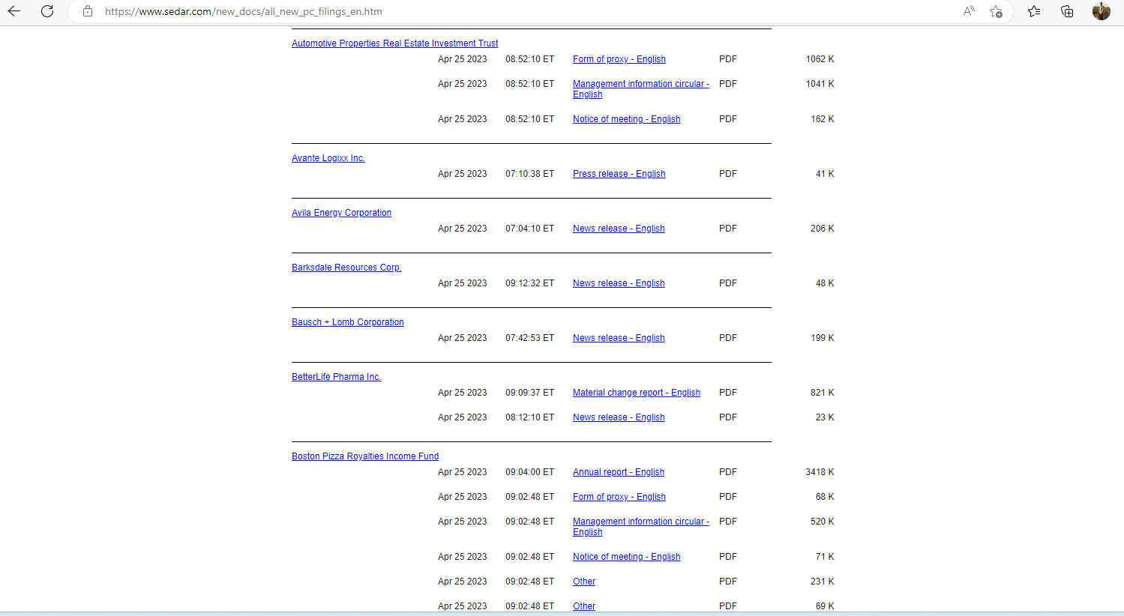

1. Tool should pull the today’s filling along with previous 2 days date of fillings.

(*do not create duplicate entries, create entry only newly published reports*)

1. Scrape only English reports from the url.
2. Update below fields in staging table

*Reports link, file type / document type, date of filling (mm-dd-yyyy), time of filling, report download date (mm-dd-yyyy and time stamp),*

Staging table sample - SQL TABLES.xlsx