1. Install Power BI Desktop and share the final screenshot of the report view page which appears when power desktop starts.

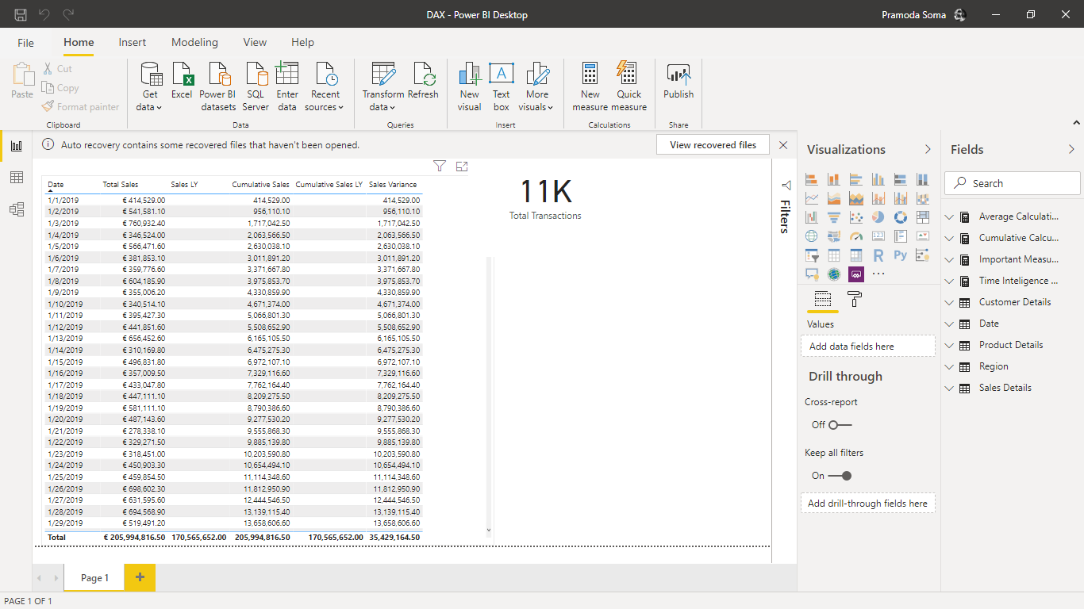

1. Prepare a document and with the following screenshot − Report View − Data View − Model View − Power Query Editor − Advance Editor
2. Report view:

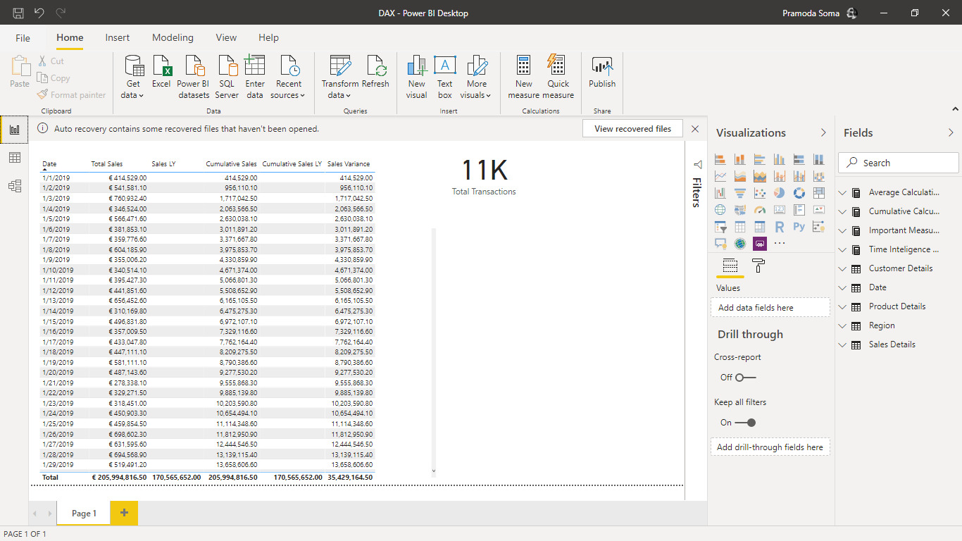

1. Data View:

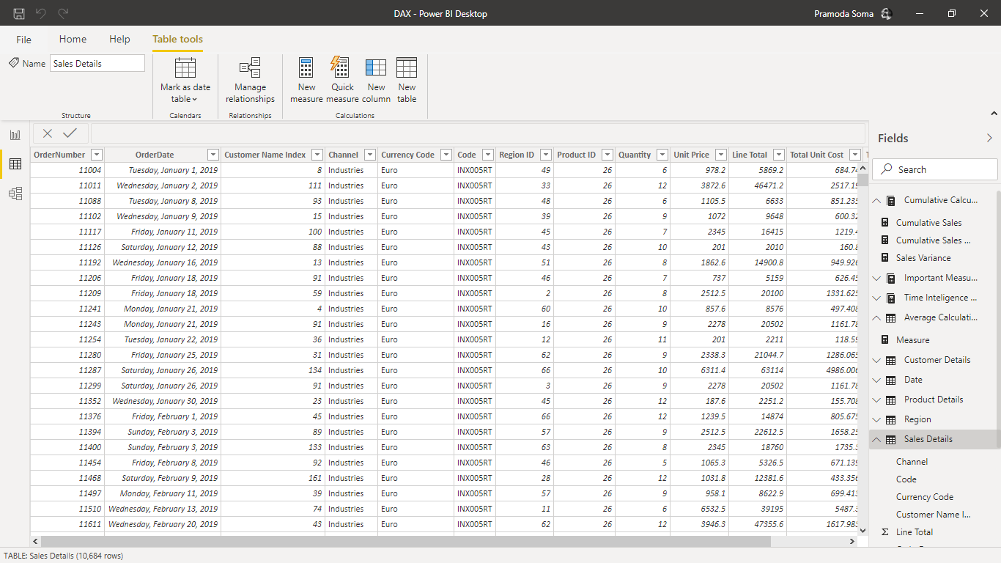

1. Model View:

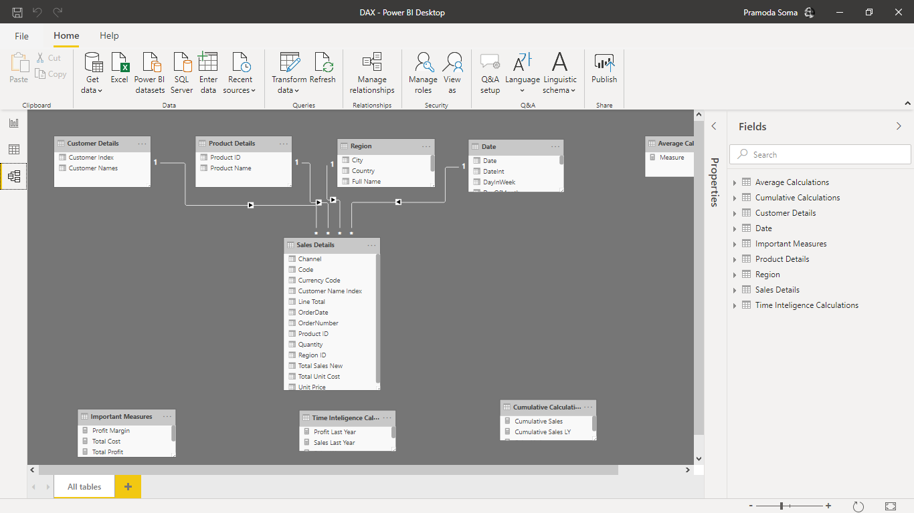

1. Power Query Editor:

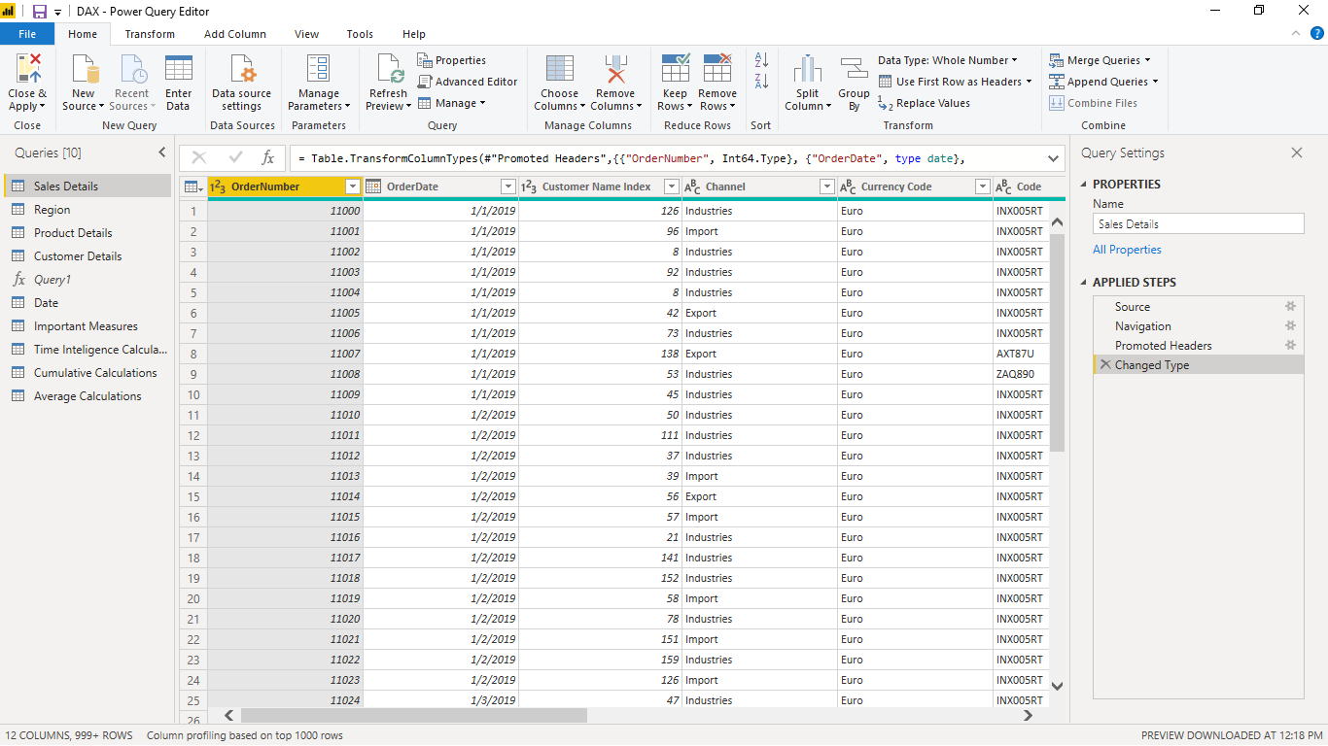

1. Advanced Editor:

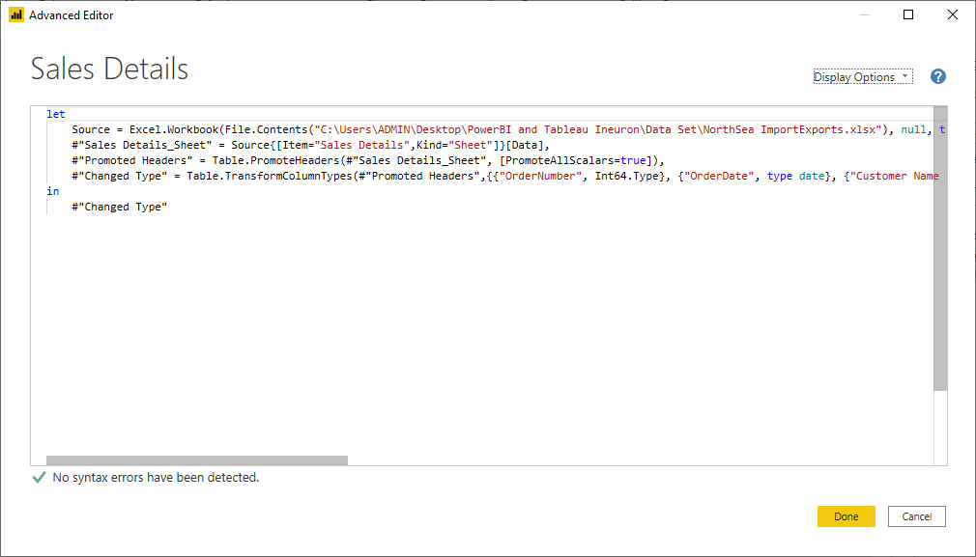

1. Prepare a document with details of the following along with their price − Power BI Desktop − Power BI Pro − Power BI Premium.

**Power BI Desktop:**

Microsoft Power BI Desktop is built for the analyst. It combines state-of-the-art interactive visualizations, with industry-leading data query and modeling built-in. Create and publish your reports to Power BI. Power BI Desktop helps you empower others with timely critical insights, anytime, anywhere.

Power BI Free enables you to connect to 70+ data sources, publish to the web, and export to excel. There are some limitations to the free version. For example, you can’t do peer-to-peer sharing and you can’t create App workspaces. However, the free version is great if you are doing your own analysis and don’t need to distribute the analysis to other end users. You also have connectivity options such as DirectQuery, live connection, and the use of the gateway. The same visualizations that are available in Power BI Pro are available in Power BI Free.

**Price**: Free For individual users

**Power BI PRO:**

Power BI Pro is the full version of Power BI, which means it comes complete with the ability to use Power BI for both building dashboards, reports and unlimited viewing, sharing and consumption of your created reports (and reports shared by others) which is not possible with Power BI Desktop.

The biggest difference of Power BI Pro vs. Free is the fact that with Pro you have the option and the ability to share the data, reports, and dashboards with a large number of other users that also have a Power BI Pro license while also being able to create an app based workspace. Furthermore, in Power BI Pro vs. Free you have a 10 GB per Pro user data storage limit.

**Price**: 9.99$ per month per user.

**Power BI Premium:**

The Power BI Premium license is not a per-user license like a Free or Pro License. Instead, Power BI Premium license provides a dedicated unit of capacity for all users in the organization. This dedicated capacity (aka Premium Workspace) can be used to host large datasets up to 50GB while offering a total storage of 100TB in the cloud.

It enables your organization to use your own dedicated capacity and hardware rather than relying on Microsoft’s shared capacity. Although you will in fact need to determine said capacity accurately and ensure that it has the capabilities to handle your reporting and analysis needs. This allows for much larger scale and better performance if you size the capacity properly. Microsoft offers three sizes for Premium capacity and each come with a different number of v-cores and memory size.

**Price**: The Premium plan starts at $4,995 a month per dedicated cloud compute and storage resource. This does not include the cost of licensing for individual Pro and Free licenses required for each user in your organization.